**DATE:02/02/2022**

**AIM:** PROGRAMS ON CONVOLUTIONAL NEURAL NETWORK TO CLASSIFY IMAGES FROM ANY STANDARD DATASET IN THE PUBLIC DOMAIN.

**PROGRAM**

import numpy as np

import pandas as pd

import matplotlib.pyplot as plt

import tensorflow as tf

from tensorflow import keras

np.random.seed(42)

# tf.set.random. seed(42)

fashion_mnist = keras.datasets.fashion_mnist

(X_train, y_train), (X_test, y_test) = fashion_mnist.load_data()

print(X_train.shape, X_test.shape)

X_train = X_train / 255.0

X_test = X_test / 255.0

plt.imshow(X_train[1], cmap='binary')

plt.show()

np.unique(y_test)

class_names = ['T-Shirt/Top', 'Trouser', 'Pullover', 'Dress', 'Coat', 'Sandal', 'Shirt', 'Sneaker', '8ag', 'Ankle Boot']

n_rows = 5

n_cols = 10

plt.figure(figsize=(n_cols * 1.4, n_rows * 1.6))

for row in range(n_rows):

for col in range(n_cols):

index = n_cols * row + col

plt.subplot(n_rows, n_cols, index + 1)

plt.imshow(X_train[index], cmap='binary', interpolation='nearest')

plt.axis('off')

plt.title(class_names[y_train[index]])

plt.show()

model_CNN = keras.models.Sequential()

model_CNN.add(keras.layers.Conv2D(filters=32, kernel_size=7, padding='same', activation='relu', input_shape=[28, 28, 1]))

model_CNN.add(keras.layers.MaxPooling2D(pool_size=2))

model_CNN.add(keras.layers.Conv2D(filters=64, kernel_size=3, padding='same', activation='relu'))

model_CNN.add(keras.layers.MaxPooling2D(pool_size=2))

model_CNN.add(keras.layers.Conv2D(filters=32, kernel_size=3, padding='same', activation='relu'))

model_CNN.add(keras.layers.MaxPooling2D(pool_size=2))

model_CNN.summary()

model_CNN.add(keras.layers.Flatten())

model_CNN.add(keras.layers.Dense(units=128, activation='relu'))

model_CNN.add(keras.layers.Dense(units=64, activation='relu'))

model_CNN.add(keras.layers.Dense(units=10, activation='softmax'))

model_CNN.summary()

model_CNN.compile(loss='sparse_categorical_crossentropy', optimizer='adam', metrics=['accuracy'])

X_train = X_train[..., np.newaxis]

X_test = X_test[..., np.newaxis]

history_CNN = model_CNN.fit(X_train, y_train, epochs=2, validation_split=0.1)

pd.DataFrame(history_CNN.history).plot()

plt.grid(True)

plt.xlabel('epochs')

plt.ylabel('loss/accuracy')

plt.title('Training and validation plot')

plt.show()

test_loss, test_accuracy = model_CNN.evaluate(X_test, y_test)

print(' Test Loss :{}, Test Accuracy : {}'.format(test_loss, test_accuracy))

**OUTPUT**

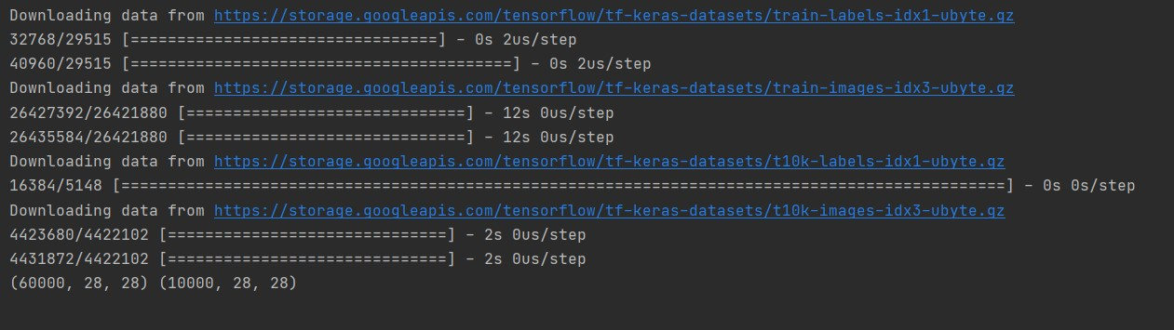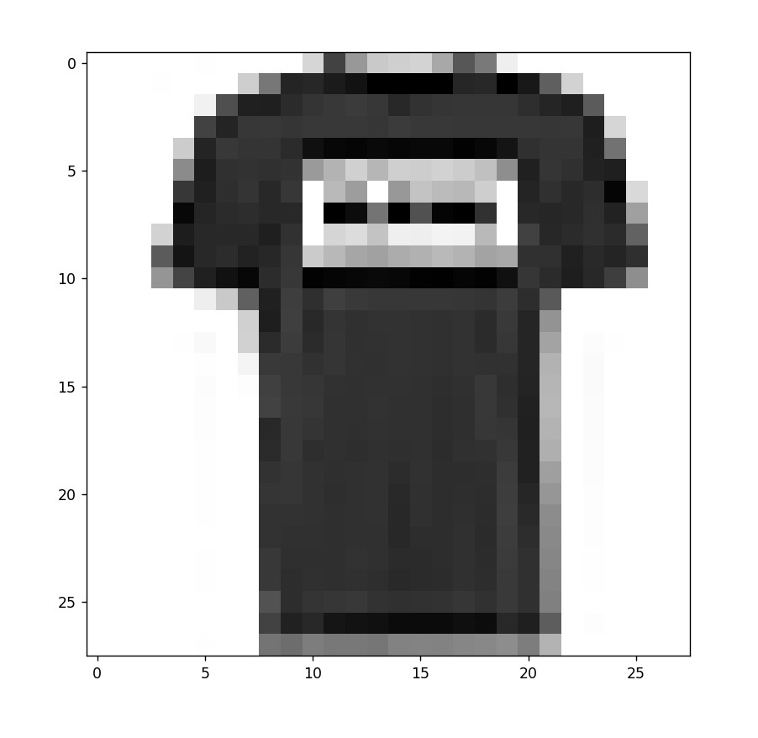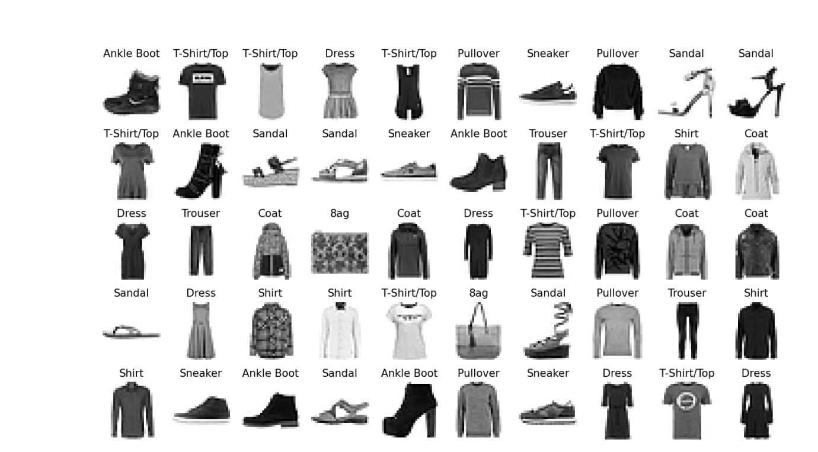

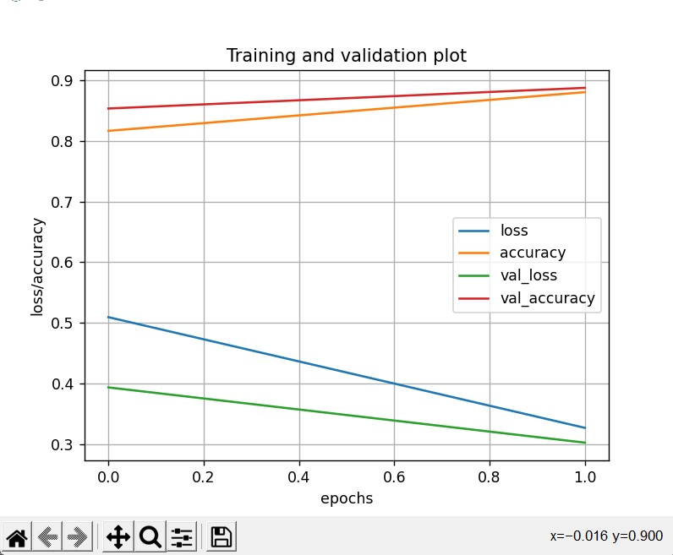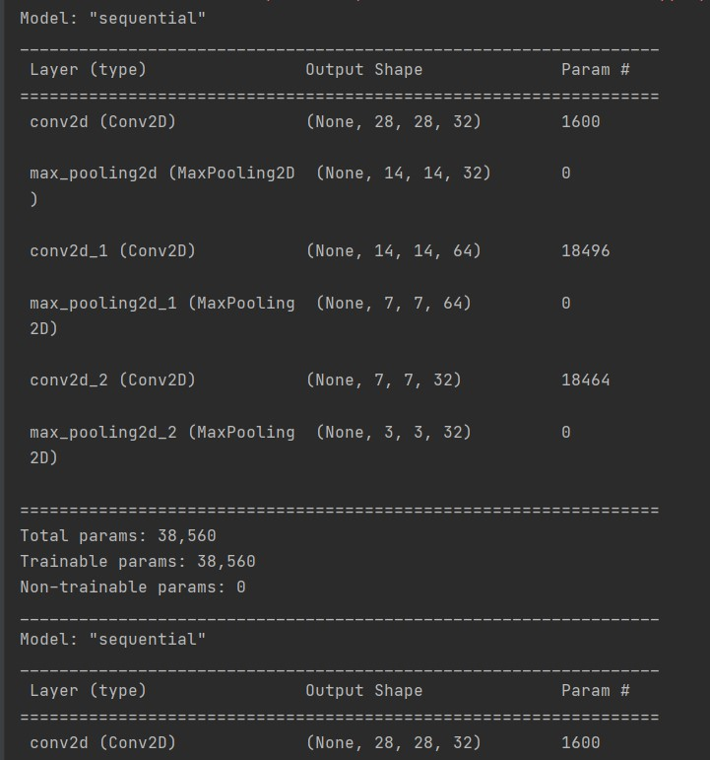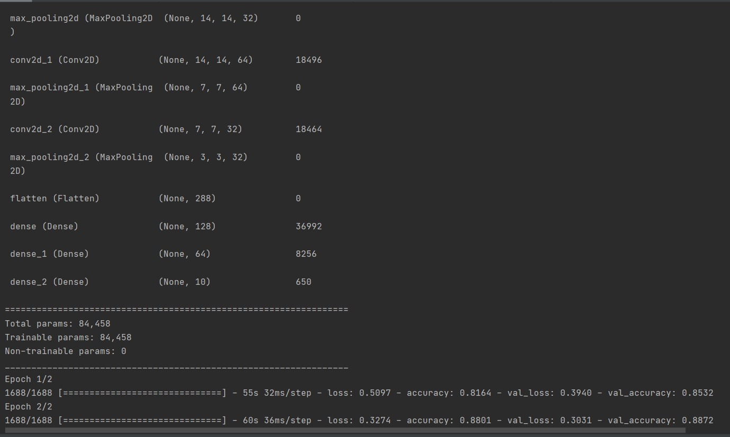

**RESULT:** THE PROGRAM HAS BEEN EXECUTED AND OUTPUT VERIFIED