**PROGRAM NO: 13                        DATE:19/01/2022**

AIM: PROGRAMS ON FEEDFORWARD NETWORK TO CLASSIFY ANY STANDARD DATASET AVAILABLE IN THE PUBLIC DOMAIN

**Program**

from tensorflow import keras

print('Tensorflow/keras : %s'%keras.version)

from keras.models import Sequential

from keras import Input

from  keras.layers import Dense

import pandas as pd

print('pandas : %s' %pd.version)

import numpy as np

print('numpy : %s' %np.version)

import sklearn

print('sklearn : %s' %sklearn.version)

from sklearn.model_selection import train_test_split

from sklearn.metrics import classification_report

import plotly

import plotly.express as px

import plotly.graph_objects as go

print('plotly : %s' %plotly.version)

pd.options.display.max_columns=50

df=pd.read_csv('weatherAUS.csv', encoding='utf-8')

df=df[pd.isnull(df['RainTomorrow'])==False]

#df=df.fillna(df.mean())

df['RainTodayFlag']=df['RainToday'].apply(lambda x: 1 if x=='Yes' else 0)

df['RainTomorrowFlag']=df['RainTomorrow'].apply(lambda x: 1 if x=='Yes' else 0)

print(df)

X = df[['Humidity3pm']]

Y = df['RainTomorrowFlag'].values

X_train, X_test, Y_train, Y_test = train_test_split(X,Y, test_size=0.2, random_state=0)

model = Sequential(name="Model-with-One-Input")

model.add(Input(shape=(1,), name='Input-Layer'))

model.add(Dense(2, activation='softplus', name='Hidden-Layer'))

model.add(Dense(1, activation='sigmoid', name='Output-Layer'))

OUTPUT

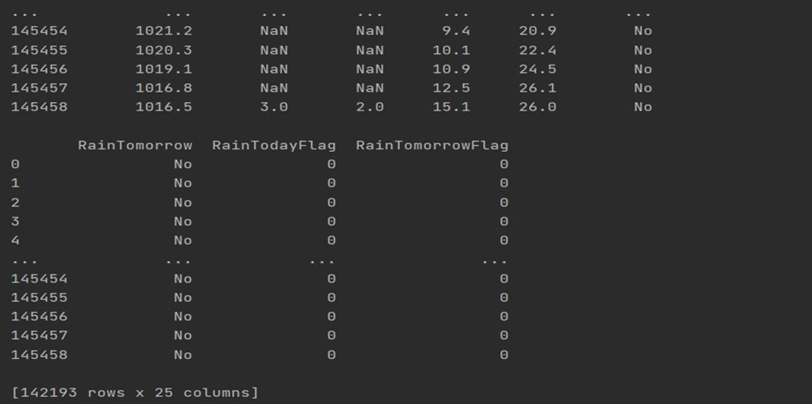

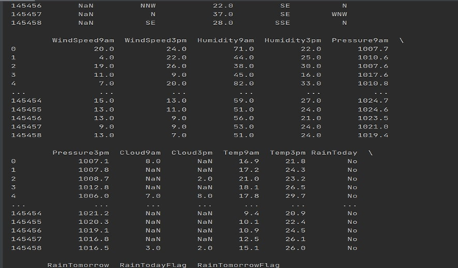

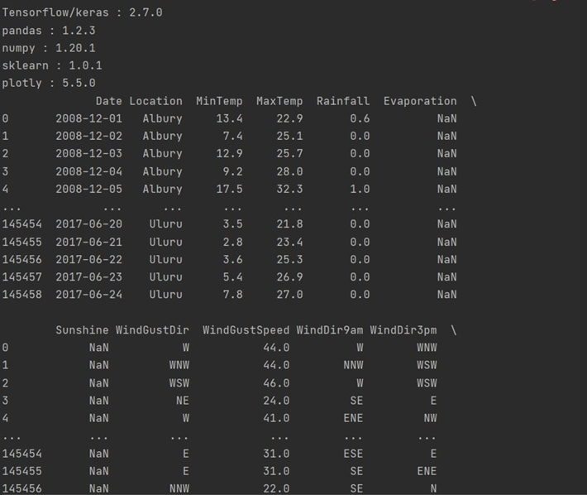

**RESULT:** THE PROGRAM HAS BEEN EXECUTED AND OUTPUT VERIFIED