Pet Adoption Portal –

Business Requirements Document (BRD)

Version: 1.0

Author: Jeena V P

**Table of Contents**

1. Introduction

2. Business Objectives

3. Background

4. Stakeholders

5. Business Requirements

6. Assumptions & Constraints

7. Success Criteria

8. Risks

9. Appendix: Visual References / Link

# 1. Introduction

The This Business Requirements Document (BRD) outlines the high-level business needs and objectives for a digital Pet Adoption Portal. This is a learning-based project aimed at replacing the manual processes used by NGOs to manage pet adoption, donations, and fostering.

# 2. Business Objectives

• Increase adoption efficiency by providing centralized access to pet data

• Reduce manual work for NGO staff by automating key workflows

• Enable real-time tracking of donations and foster arrangements

• Promote virtual sponsorship and fostering options (Future Phase)

# 3. Background

Currently, pet adoption processes are managed using Excel and WhatsApp. This leads to inconsistent record-keeping, difficulty in tracking pet status, and lack of actionable data insights. This project aims to demonstrate how a digital platform could resolve these issues.

# 4. Stakeholders

|  |  |
| --- | --- |
| Role | Description |
| NGO Admin | Manages backend operations and approvals |
| Adopter | Individual seeking to adopt a pet |
| Foster Parent | Volunteer offering temporary pet care |
| Donor | Individual or organization contributing funds |

# 5. Business Requirements

• Users shall be able to search and filter pets by attributes

• Users shall be able to submit an adoption application

• Users shall be able to apply to foster pets

• Donors shall be able to make one-time or recurring donations

• Admins shall be able to manage pet profiles and user data

# 6. Assumptions & Constraints

• This is a sample project; implementation is simulated.

• Budget and infrastructure are not applicable in this phase

• Platform must demonstrate mobile responsiveness in mockup only

# 7. Success Criteria

• Centralized data management for pets and stakeholders

• Demonstration of Power BI insights and CRM configuration

• UI mockup showing intuitive user journey

# 8. Risks

• Data migration is not part of this phase

• Limited technical implementation; focus is on analysis and design.

# 9. Appendix: Visual References / Link

Link: Figma Mockup - Home Page

[Pet Adoption Portal - Home Page](https://www.figma.com/design/JlXSlstLJYbwA3lqfUPNwu/Pet-Adoption-Website---Home-Page-Mockup?node-id=0-1&t=cNkhWg1uwynorPxW-1))

Figure 1: Adoption Form Screenshot

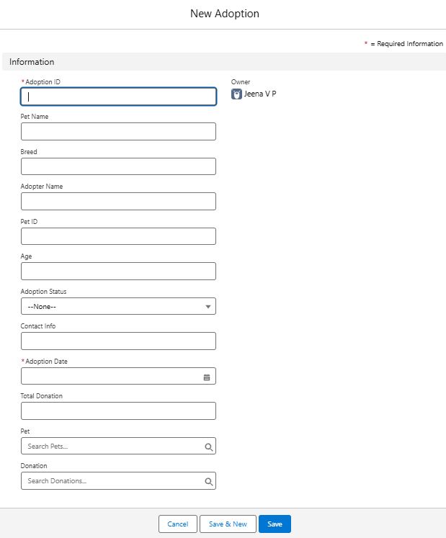

Description: The form collects adopter and pet details.

Figure 2: Power BI Dashboard – Overview

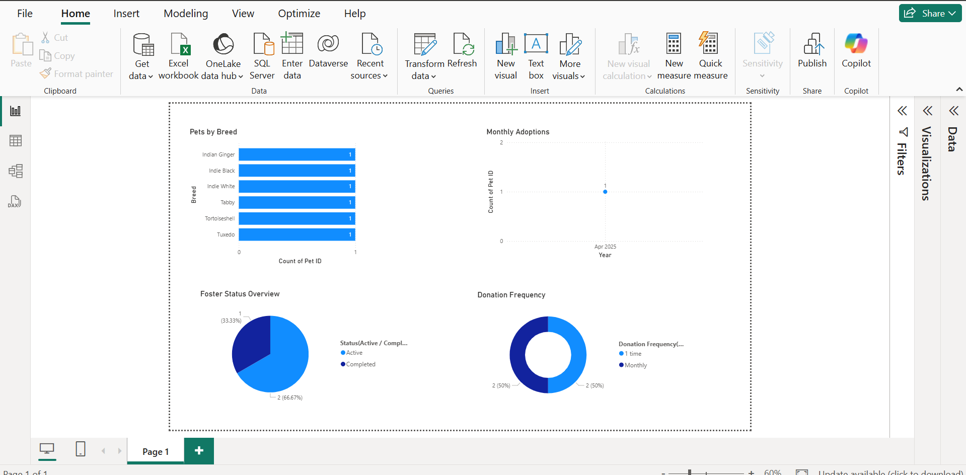

Description: Shows key metrics for monthly adoptions, donation frequency, foster activities over time and pet details.