Pet Adoption Portal

Functional Requirements Document (FRD)

Version: 1.0

Author: Jeena V P

**Table of Contents**

1. Introduction

2. Scope

3. Functional Requirements

4. Non-Functional Requirements

5. Use Case Scenarios

6. UI/UX Requirements

7. Dependencies

8. Glossary

9. Supporting Visuals

# 1. Introduction

The Functional Requirements Document defines system behavior and detailed functionality for the proposed Pet Adoption Portal. This document reflects a non-implemented, learning-based project.

# 2. Scope

**In Scope**:

• Pet listing with search and filter

• Online application forms for adoption and fostering

• Basic donation module (simulation only)

• Admin dashboard mockup for data insights

**Out of Scope / Future Phase**:

• Payment gateway integration

• Virtual adoption sponsorship feature

• Automated email communication

• Mobile responsiveness beyond design mockup

# 3. Functional Requirements

• Users can search and view pets by filters

• Adopters can submit adoption application forms

• Volunteers can submit foster application forms

• Donors can simulate donations

• Admins can view pet, adoption, and donation data

# 4. Non-Functional Requirements

• Role-based access control (designed only)

• Intuitive and simple interface for all roles (shown in mockup)

• Design intended for desktop users

# 5. Use Case Scenarios

**Use Case 1 – Pet Search**  
Flow: Filter → View → Click → View Pet Details

**Use Case 2 – Adoption Application**  
Flow: Click 'Adopt Now' → Fill Form → Submit → Confirmation

# 6. UI/UX Requirements

• Clean homepage design with clear CTA (via Figma mockup)

• Consistent layout across user journeys

# 7. Dependencies

• Salesforce CRM setup for structured recordkeeping.

• Power BI configured for reporting views.

**8. Glossary**

• **CRM** – Customer Relationship Management

• **CTA** – Call to Action

• **FRD** – Functional Requirements Document

• **NGO** – Non-Governmental Organization

**9. Supporting Visuals**

Figure 1: Salesforce Custom Objects

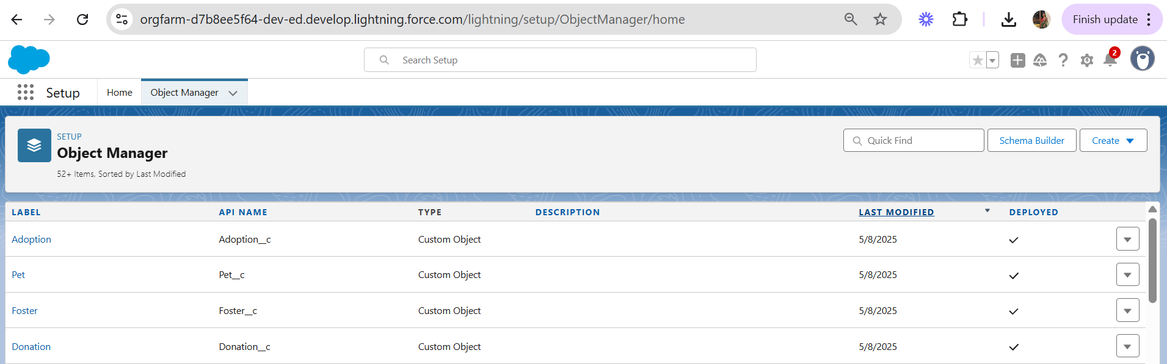

Description: Depicts custom objects created for Adoption, Pet, Foster and Donation

Figure 2: Adoption and Donation Records in Salesforce

