HOSPITAL PATIENT CARE ANALYTICS
Case Study Problem & Solution
Data Engineering

Project Item | Description
Problem | Hospital data comes from multiple systems and needs to be converted into useful information.
Solution | A simple end-to-end data engineering pipeline using Python/Pandas and SQL.
Main Data | Patients, appointments, laboratory reports, wearable data and consultations.
Main Outputs | Clean data, analysis, SQL tables, SQL queries and hospital insights.

1. Case Study Problem
A multi-specialty hospital collects information from different systems such as patient registration, appointment scheduling, laboratory reports, wearable health devices and doctor consultations. The hospital wants to use this information to improve patient care, understand waiting times and identify patients who may need more attention.
The main data engineering problem is that the information is separated into different datasets. Before useful analysis can be done, the data needs to be collected, checked, cleaned, transformed, connected and stored in an organized form.

Main Objectives
- Collect data from different hospital systems.
- Understand the raw data and its quality.
- Clean and transform the data.
- Connect related data using patient_id.
- Analyze waiting time and appointment information.
- Analyze laboratory and wearable data.
- Create a patient-level analytical view.
- Store processed data in SQL tables.
- Use SQL queries to calculate useful hospital metrics.
- Validate that Python and SQL results are consistent.

2. Proposed Solution
I use a simple end-to-end data engineering pipeline. The pipeline starts with CSV files, processes them in Python, stores the processed data in SQL tables, and then uses SQL queries for analysis.
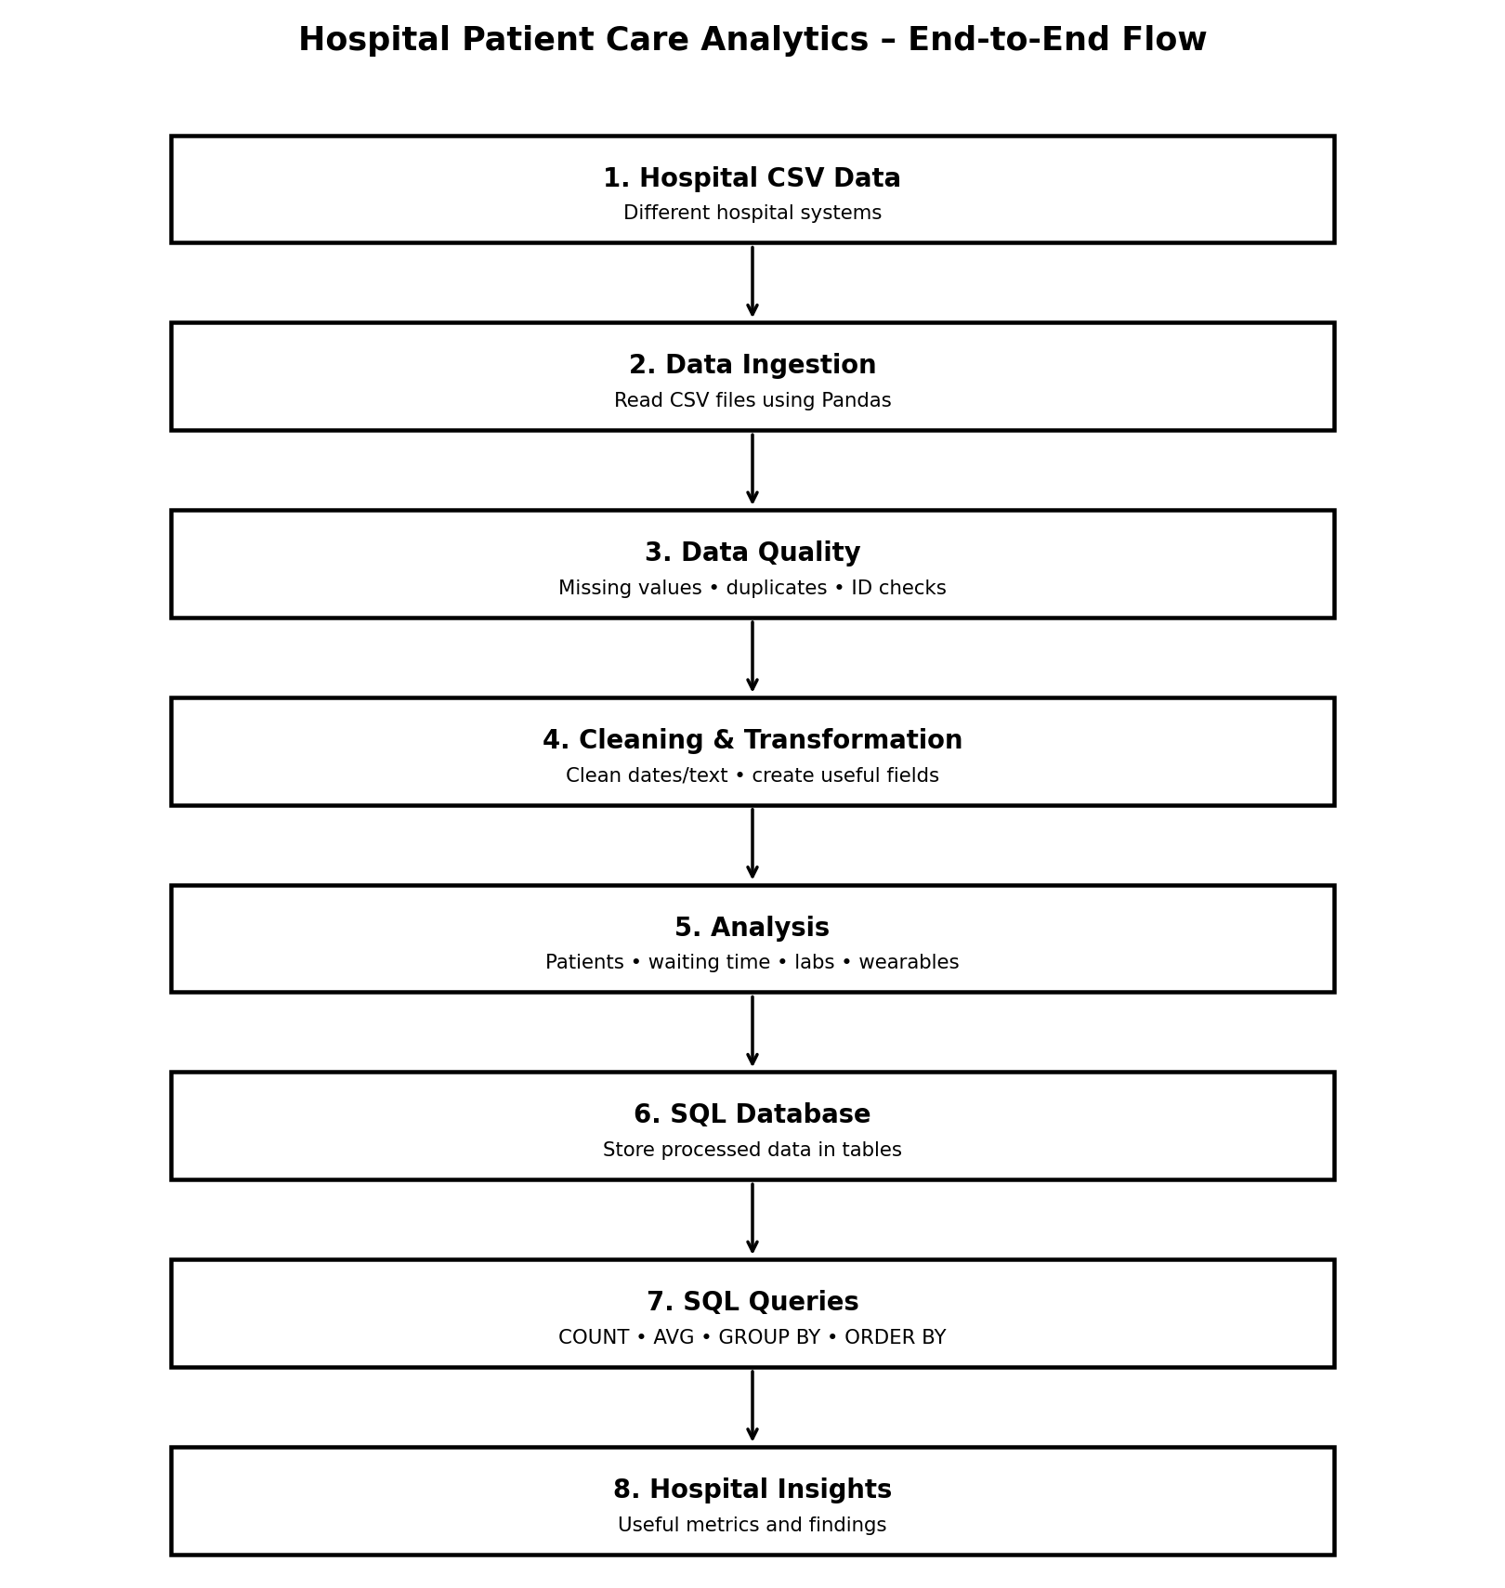
This flowchart shows the complete project from source data to final hospital insights.

3. Datasets Used
Dataset | Purpose | Main Fields
patients.csv | Patient registration | patient_id, age, gender, blood_group
appointments.csv | Appointments and waiting time | appointment_id, patient_id, department, status, waiting_time
lab_reports.csv | Laboratory measurements | lab_id, patient_id, blood_sugar, hemoglobin, cholesterol
wearable_data.csv | Wearable measurements | wearable_id, patient_id, heart_rate, steps, sleep_hours
consultations.csv | Doctor consultations | consultation_id, patient_id, doctor, diagnosis, consultation_date
The common field is patient_id. I use it to connect information belonging to the same patient across different datasets.

4. Solution Modules

Module 1 – Data Ingestion
What I do: Read the five CSV files using Pandas.

Module 2 – Data Understanding
What I do: Use head(), info(), describe() and missing-value checks.

Module 3 – Data Cleaning
What I do: Check duplicates, clean text and convert dates.

Module 4 – Data Quality
What I do: Check IDs and simple numeric ranges.

Module 5 – Patient Analysis
What I do: Analyze age, gender and blood group.

Module 6 – Appointment Analysis
What I do: Calculate average, maximum and department-wise waiting time.

Module 7 – Laboratory Analysis
What I do: Calculate simple averages and threshold counts.

Module 8 – Wearable Analysis
What I do: Analyze heart rate, steps and sleep.

Module 9 – Patient-Level Summary
What I do: Merge patient, lab and wearable data using patient_id.

Module 10 – Educational Attention Score
What I do: Create a simple rule-based score.

Module 11 – SQL Storage
What I do: Load processed DataFrames into SQL tables.

Module 12 – SQL Analytics
What I do: Use SELECT, COUNT, AVG, GROUP BY and ORDER BY.

Module 13 – Validation
What I do: Compare one Python result with the same SQL result.

5. Current Dataset Overview
Dataset | Number of Records
Patients | 30
Appointments | 30
Lab Reports | 30
Wearable Data | 30
Consultations | 30
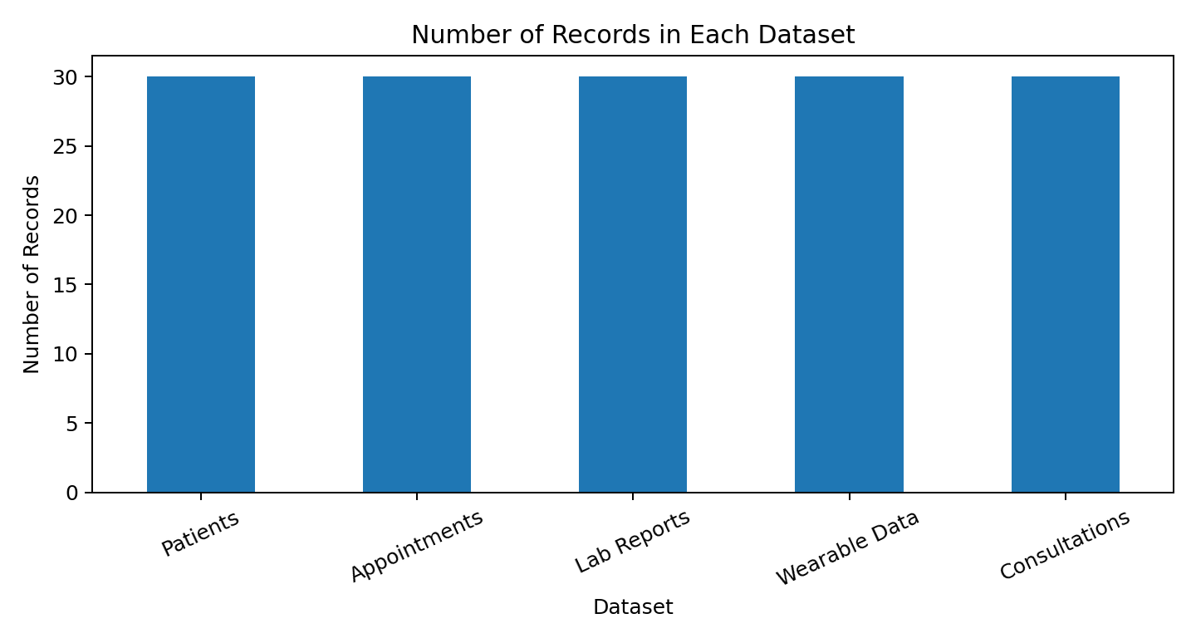

Graph 1: Number of records in each dataset.

6. Main Analysis

6.1 Waiting Time Analysis
The current appointments dataset contains 30 records. The average waiting time is 53.63 minutes and the maximum waiting time is 88 minutes.
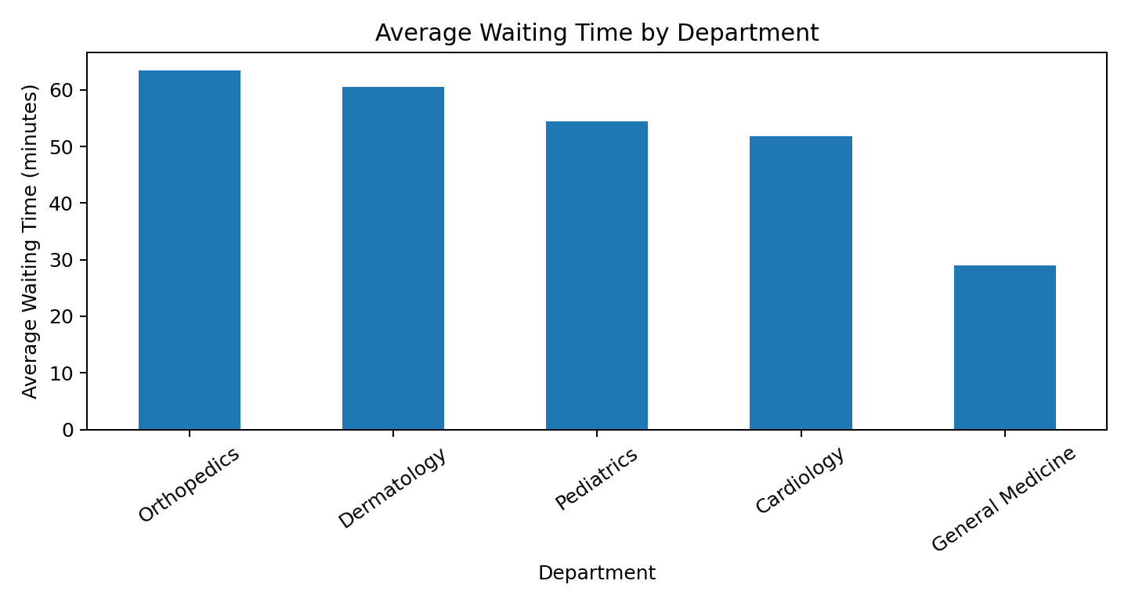
Graph 2: Average waiting time by department.
The graph helps compare departments using the same metric. It shows where waiting-time differences exist, but it does not by itself explain the reasons for those differences.

6.2 Appointment Status Analysis
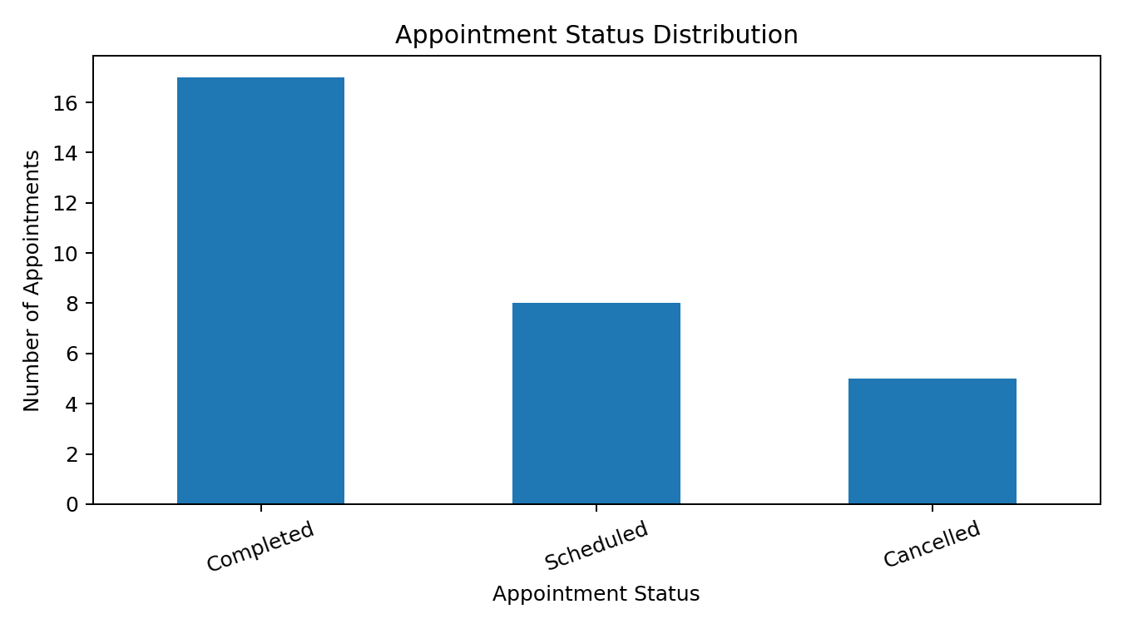
Graph 3: Appointment status distribution.
This shows the number of records in each appointment status and helps describe the operational dataset.

6.3 Laboratory Analysis
The laboratory dataset contains 30 records. The notebook calculates average blood sugar, hemoglobin and cholesterol values and demonstrates simple threshold-based counts.
Field | Purpose
blood_sugar | Average and simple project-level threshold count
hemoglobin | Average and simple project-level threshold count
cholesterol | Average laboratory value

6.4 Wearable Analysis
The wearable dataset contains 30 records. I calculate average heart rate, steps and sleep hours and visualize the data.
Field | Purpose
heart_rate | Understand recorded heart-rate distribution
steps | Summarize activity in the dataset
sleep_hours | Summarize recorded sleep duration

6.5 Educational Patient Attention Level
The simple rule-based score using three conditions: blood sugar above the project threshold, heart rate above the project threshold and hemoglobin below the project threshold. Each condition adds one point. A score of two or more is labelled High Attention.
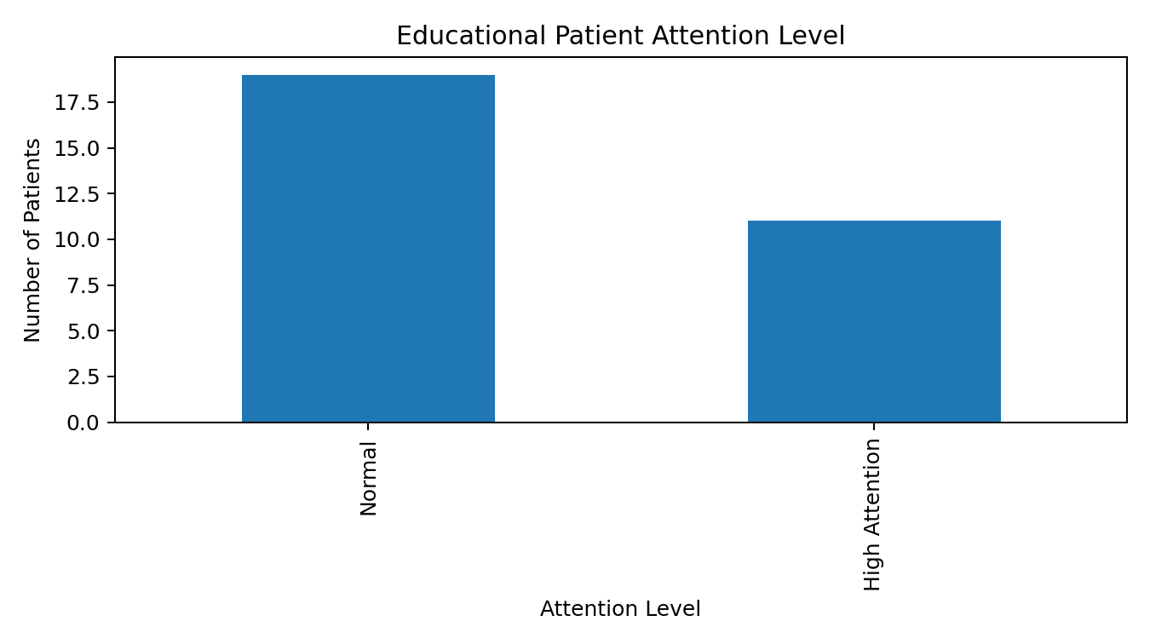
Graph 4: Educational patient attention level.

7. SQL Database Solution
After Python processing, the cleaned data is stored in separate SQL tables.
SQL Table | Purpose
patients | Patient master information
appointments | Appointment and waiting-time information
lab_reports | Laboratory measurements
wearable_data | Wearable measurements
consultations | Doctor consultation records
patient_summary | Combined patient-level analytical information
The important workflow is: Python cleans and transforms the data first. The processed DataFrames are then loaded into SQL tables. SQL queries are run on those stored tables.

7.1 Python to SQL Flow
Raw CSV → Pandas DataFrame → Cleaned DataFrame → to_sql() → SQL Table → SQL Query → Result

7.2 Main SQL Questions
Question | SQL Method
Total number of patients | COUNT(*)
Average waiting time | AVG(waiting_time)
Waiting time by department | GROUP BY department + AVG()
Appointment status counts | GROUP BY appointment_status + COUNT()
Attention-level counts | GROUP BY risk_level + COUNT()
Average laboratory values | AVG()
Appointments per patient | GROUP BY patient_id + COUNT()

8. Data Quality and Validation
- Check missing values.
- Check duplicate rows.
- Check duplicate patient IDs.
- Check whether related patient IDs exist in the patients table.
- Check simple numeric ranges.
- Compare selected Python and SQL results.
“I first check and prepare the data, then store it in SQL. This makes the SQL analysis more reliable.”

9. Final Outputs
- Cleaned CSV datasets.
- Patient-level analytical summary.
- Graphs and descriptive analysis.
- SQL database file.
- Separate SQL tables.
- SQL query results.
- Python-versus-SQL validation.
- Complete Jupyter Notebook.

10. Explanation
“My case study is Hospital Patient Care Analytics. The hospital receives data from multiple systems, so the main problem is that the data is separated and needs to be organized before analysis. I designed an end-to-end data engineering pipeline. First, I loaded five CSV files using Pandas. Then I inspected the data, checked duplicates and missing values, cleaned text and dates, and performed basic quality checks. After that, I analyzed patient, appointment, laboratory and wearable data. I used patient_id to connect related datasets and created a simple patient-level summary. Then I exported the processed data and stored it in SQL tables. Finally, I used SQL queries to calculate important metrics such as patient count, waiting time and appointment status. I also compared a Python result with a SQL result to validate the database step.”

11. Conclusion
This project demonstrates a complete and simple data engineering solution for hospital patient care analytics. The important idea is to move data through clear stages: collect, inspect, clean, transform, validate, analyze, store and query.
Python is mainly used for data preparation and transformation in this project, while SQL is used for structured storage and querying. The solution is intentionally simple so each step can be explained clearly.

