User Manual of Pahana Edu.

Advanced Programming.

Jeesa Mithsandi Abeyratne

CL/BSCSD/31/42

# **Documentation.**

# **User Documentation.**

## User Manual with Instructions.

This is the user manual for Pahana Edu Billing System. From this document you will be guided step by step about how to run this web application.

**Home Page**

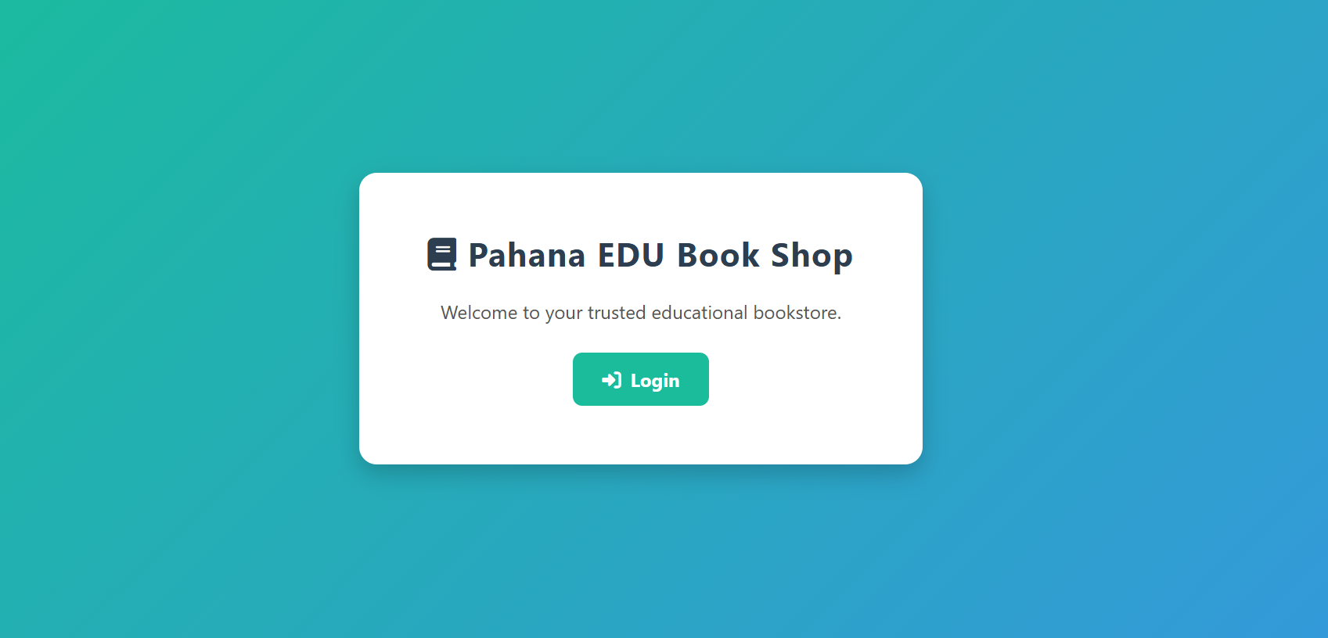

Login button- Both Admins and Cashiers can click this login button to redirected to Login Form.

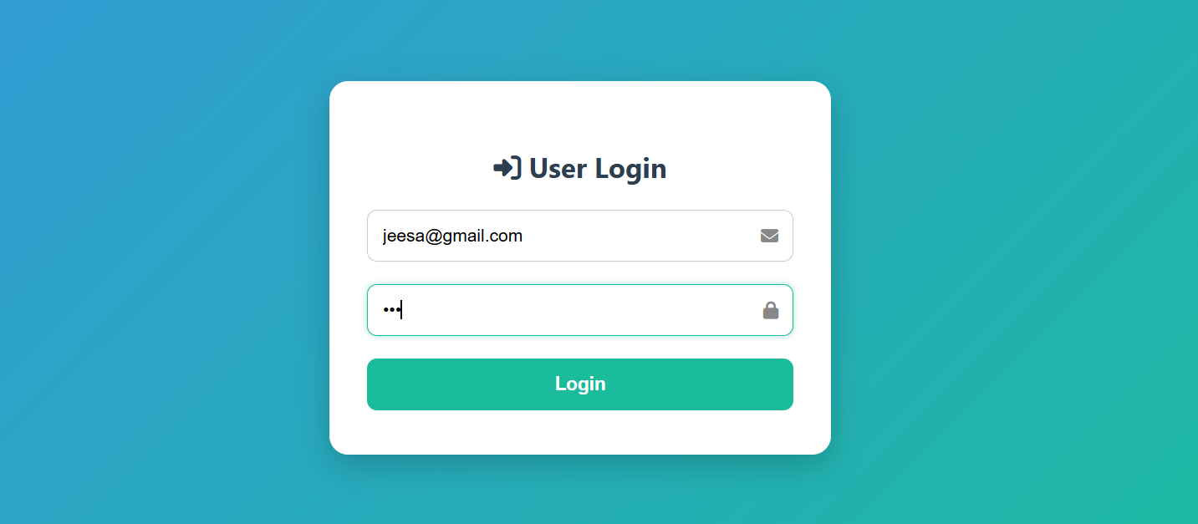

User Login- Users can Log in into their respective dashboard with correct credentials.

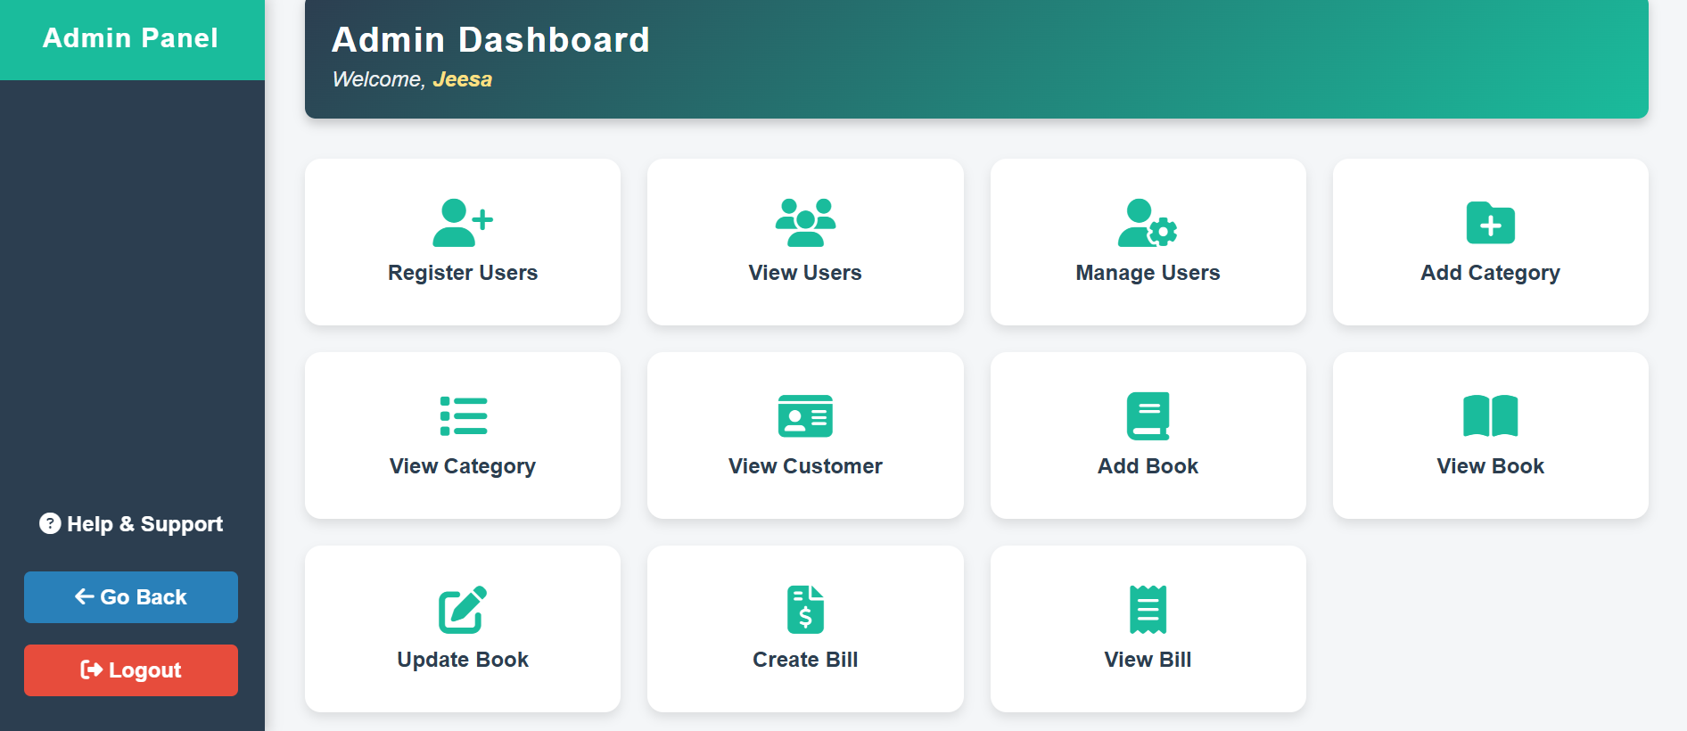

Admin Panel- This is the Dashboard for Admin. Admins get access to all these functions once they login to the Admin Panel. Also, they can logout from their system if needed.

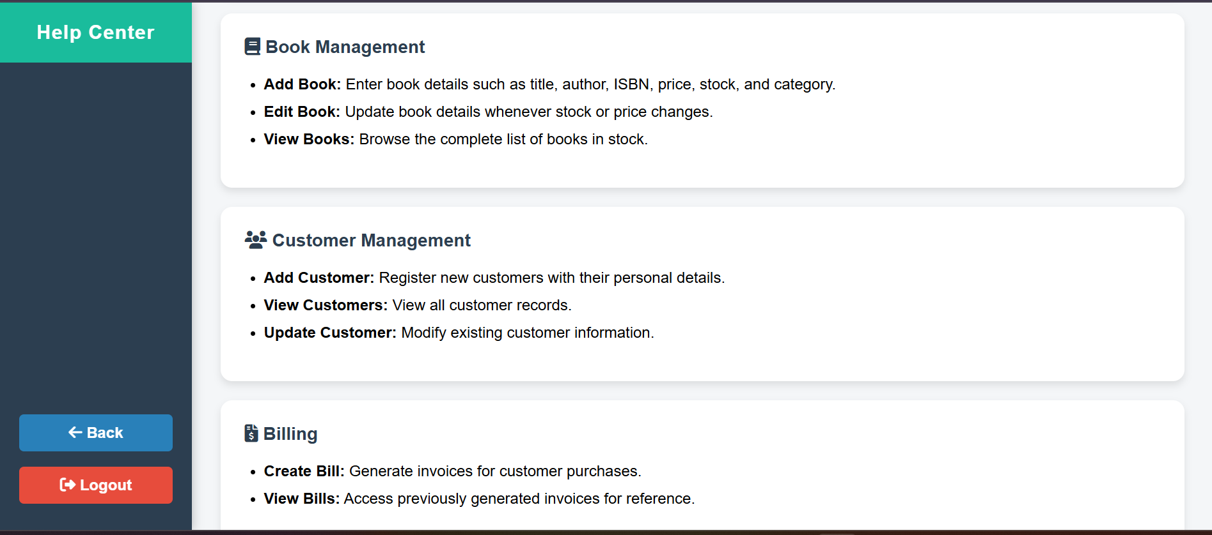

Help & Support- This is the help and support page which includes all the steps and functions for any concerns that’d raise from users.

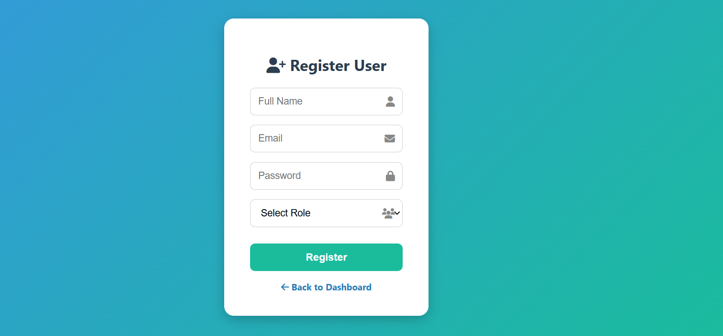

Register User- This is the Register User Form which only Admins get the access. Admins can Register another admin or a new cashier to the system.

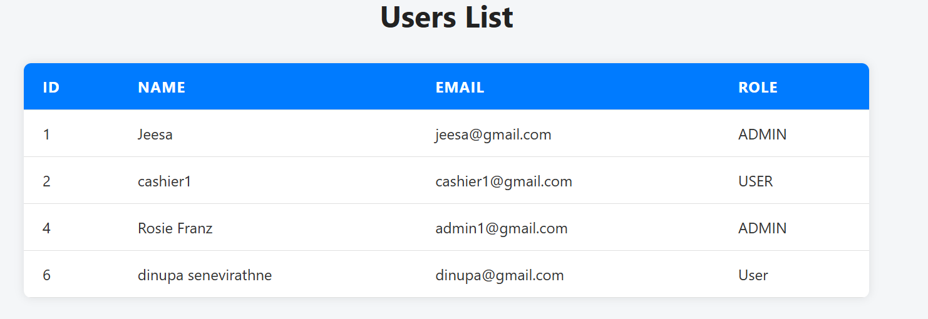

Users List- All the registered Admin and Cashier users will be displayed on this list.

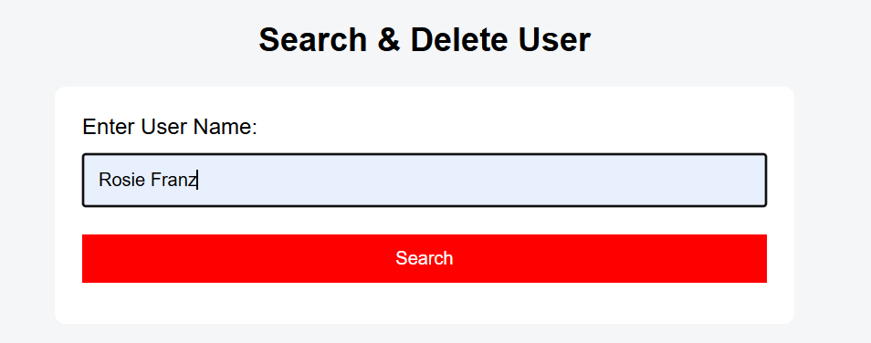

Search & Delete User- If Admins get the need to delete an user they have to search the name correctly of the user.

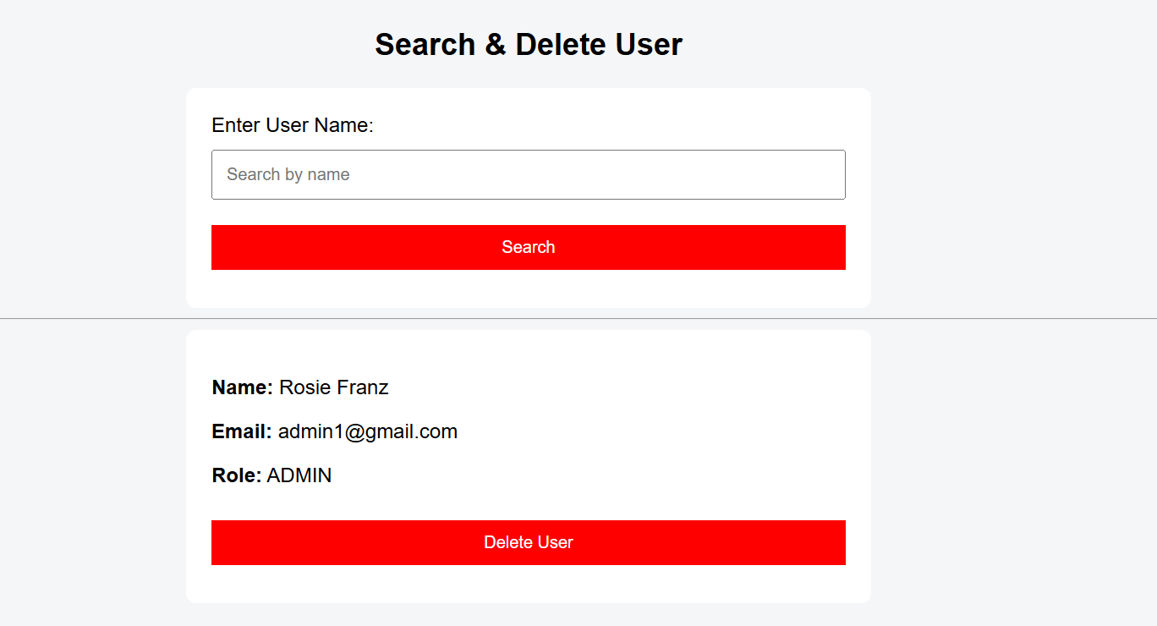  
When the searched user details verified and displayed Admin can delete the user by clicking Delete user button.

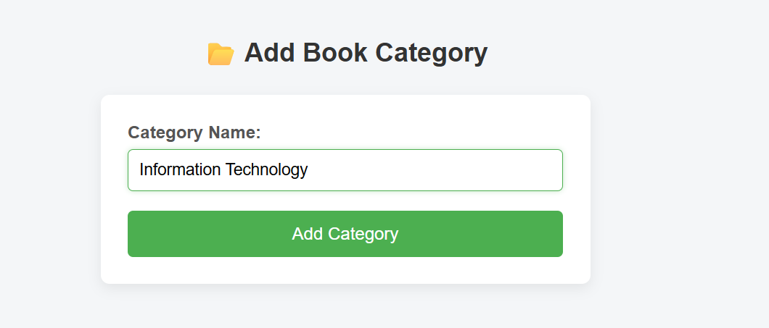

Add Category page- Admin has the ability to add any new book category to the system by using this page. Admin can click the Add Category button and add the new category to the system.

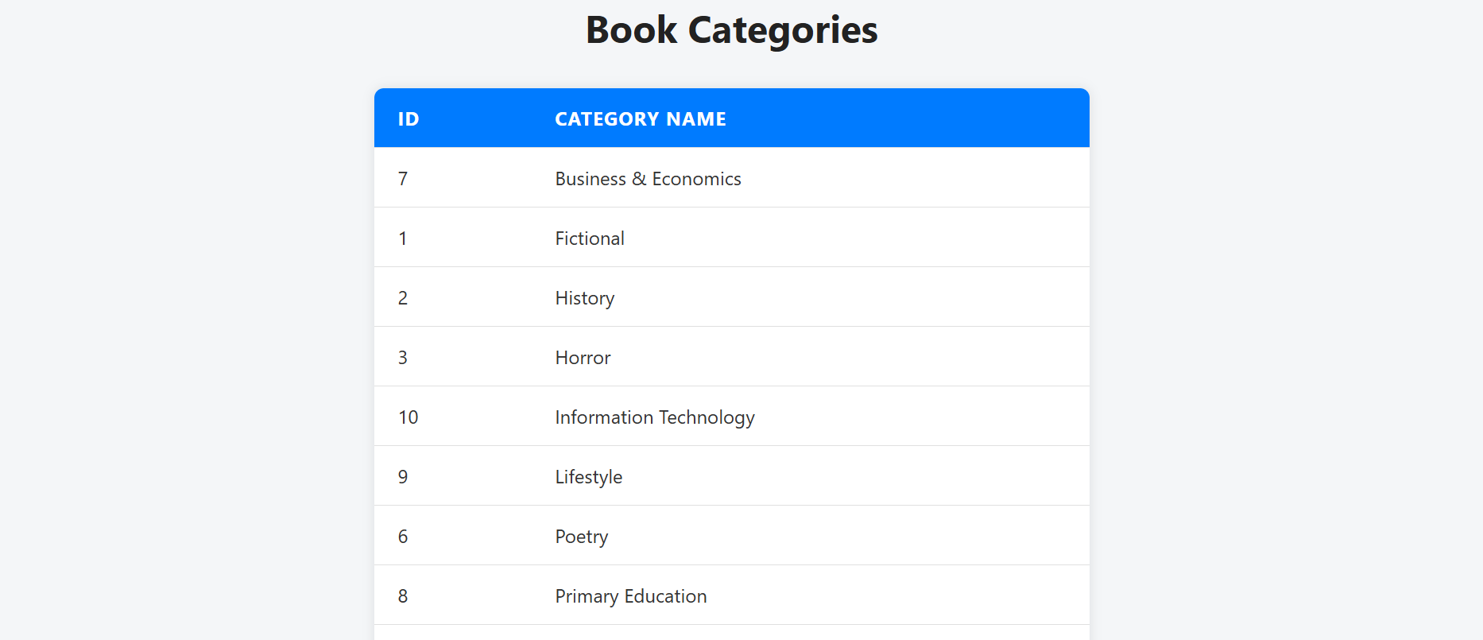

View Book Category- Admin and Cashier both users have the access to view book categories in the system.

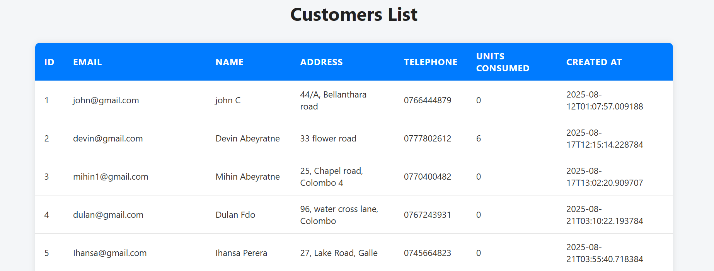

Customer List- Both Admin and Cashier have the ability to see all the registered customers in the system.

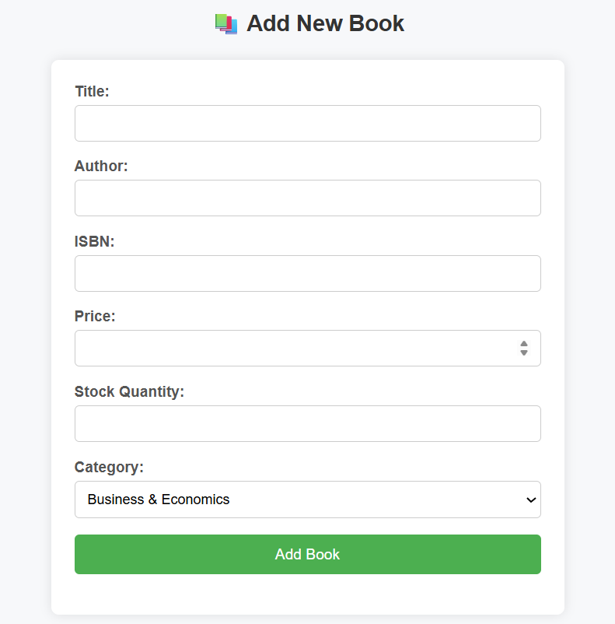

Add New Book- To Add New Books to system Admin have to enter all the details to this form and Click the Add Book Button.

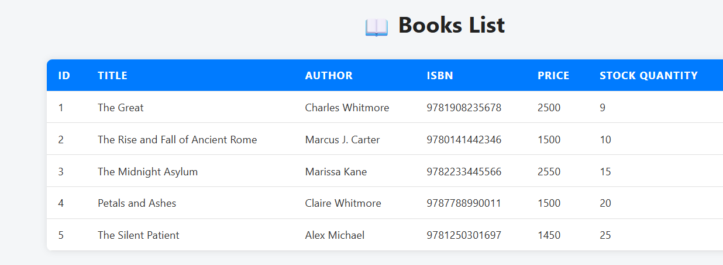

Book List- Admin and Cashier both can see the Book List page of details of all the books in the system.

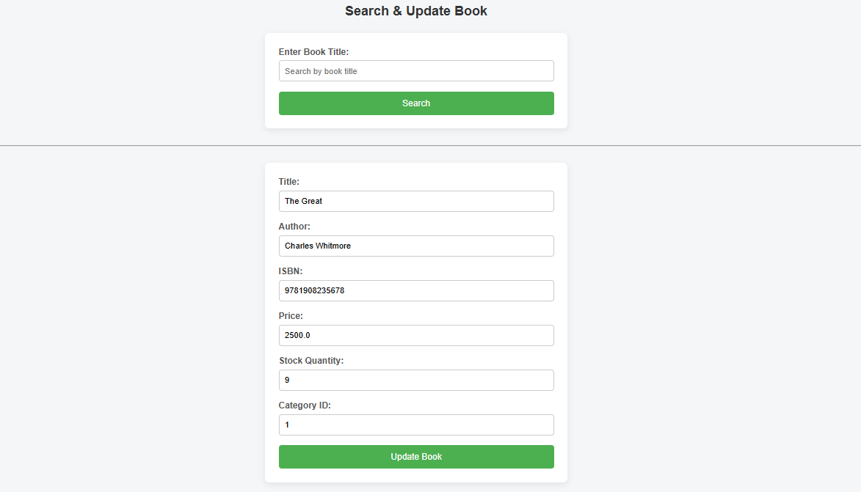

Update Book- Admin can update/edit book details of books that were already in the system.

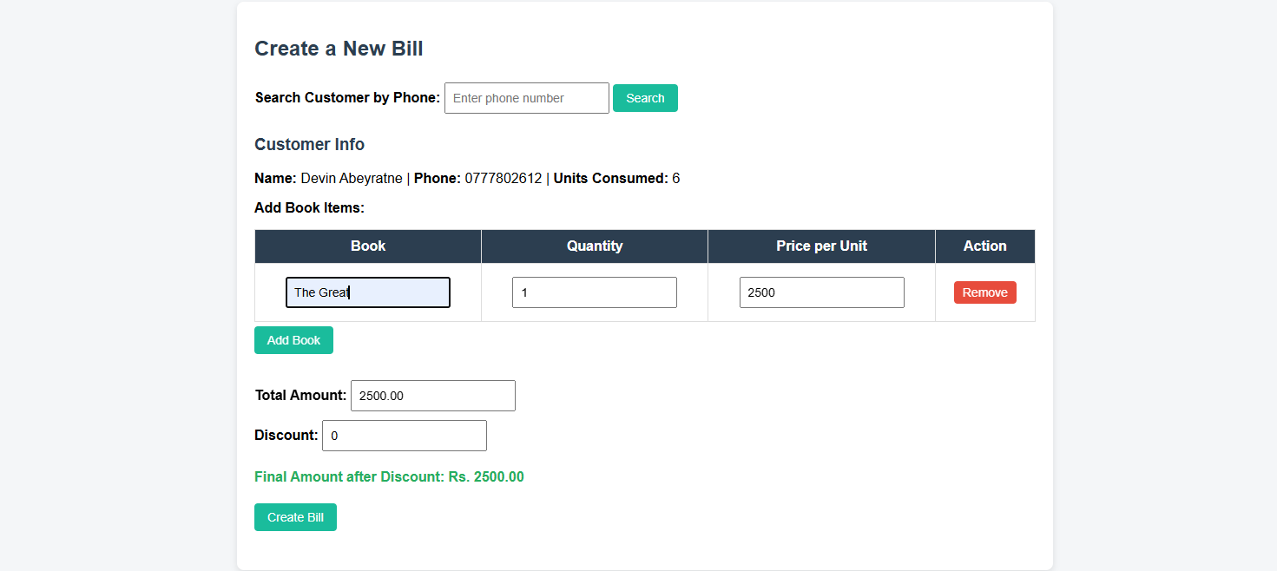

Create Bill- This is the create bill page of the system which both users get the access to do the billings.

Remove Button- Users can click the remove button in the same row as the Book Title and remove the relevant book.

Add Book Button- Users can add new books to the bill by searching the name of the book.

Quantity- Users can increase or decrease the quantity of the book items.

Discount- Admin or cashier can type discounts amount by the price and it will automatically calculate the bill by calculating the Discount price as well.

Create Bill Button- Once the create bill button is clicked the auto generated bill will be downloaded to the device.

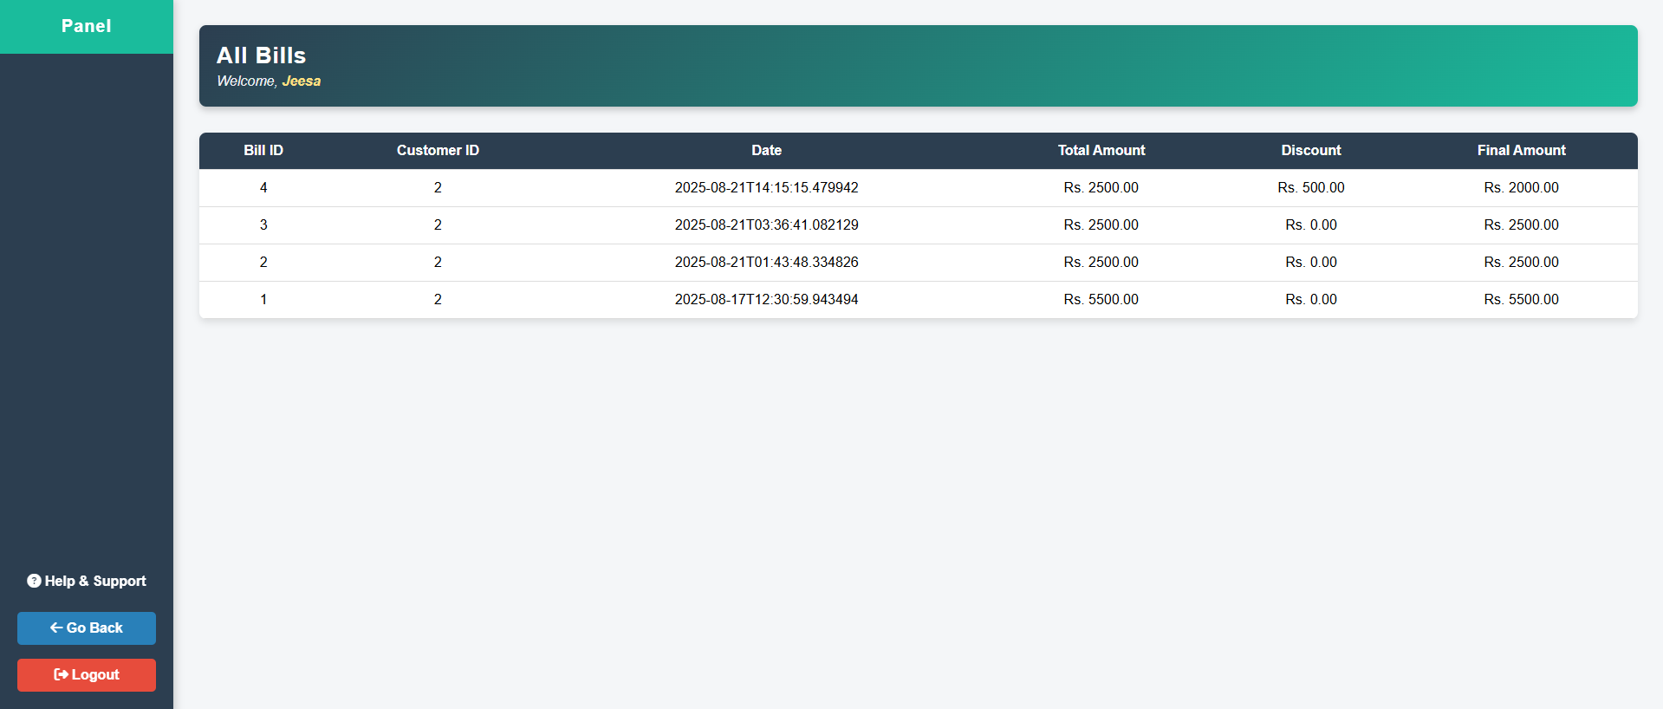

All Bills Panel- All the bills will be displayed in the system for both users.

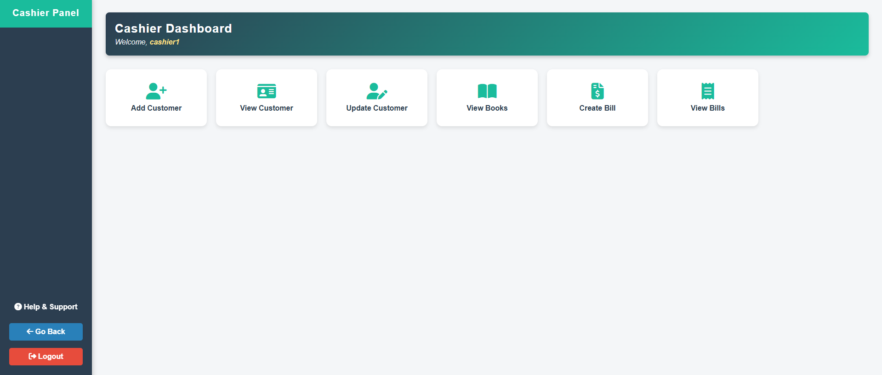

Cashier Panel- This is the Cashier dashboard for cashiers.

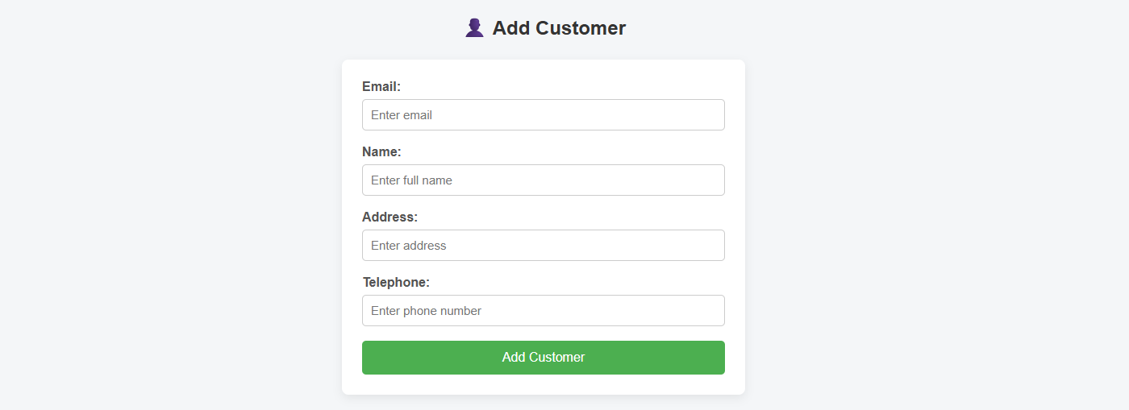

Add Customer- This is the Add Customer form to add customers to the system.

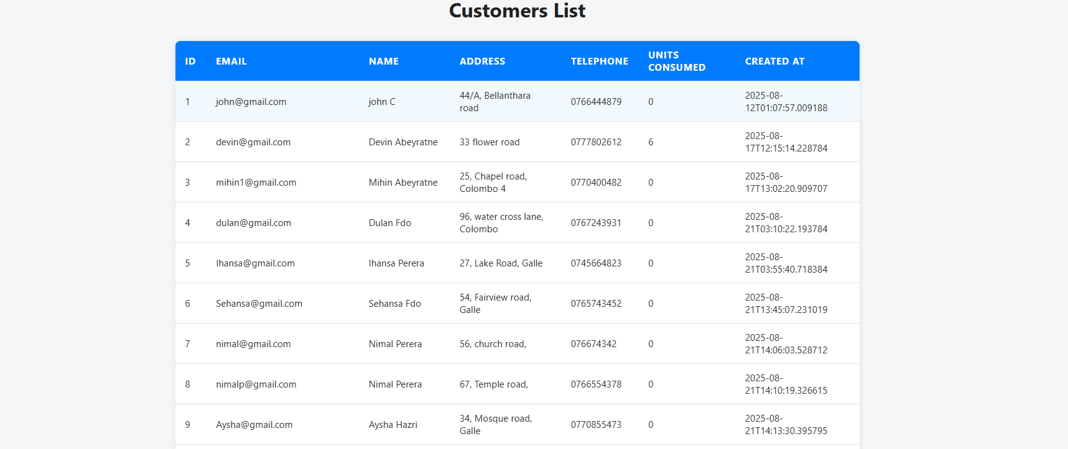

Customer List- This is the customer data list in the system.

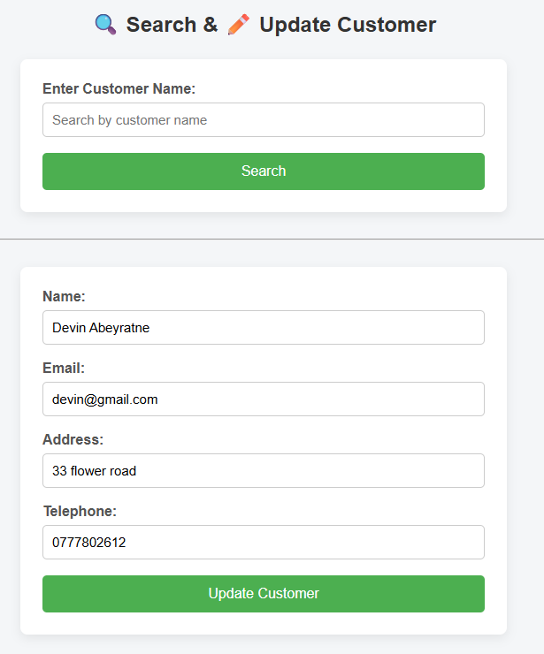

Update Customer- Users can update customer details from this form.

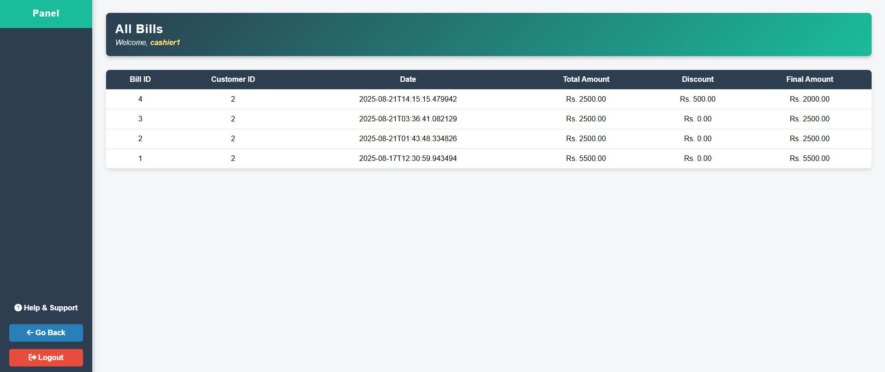

This is the View Bill Panel for Cashiers.

### System architecture.

The online billing system of Pahana Edu system consist of three tier architectures,

1. Frontend – Comprises with the user interface.

Implemented using HTML, CSS and JavaScript.

1. Backend- Handles the data processing.

Developed using Java EEE.

1. Database- Stores the data in a database.

Constructed using MySQL.