Q-GUARD
A Static-Analysis Prototype for Post-Quantum Cryptography Readiness
Project Report
Quiskit Fall Fest 2026 Hackathon
Q Phase 1
Track: Quantum Cryptography and Post-Quantum Cryptography

Repository: https://github.com/Jeeshma6995/q-guard
Prepared from the repository’s visible implementation and dependency file. No code changes were made for this report.

Abstract
Q-Guard is a lightweight, browser-based static-analysis prototype intended to help developers notice source-code patterns that may be relevant to post-quantum cryptography (PQC) readiness. It provides a Streamlit interface for scanning built-in demonstration samples or uploaded source files, then presents potential matches with file and line evidence, algorithm labels, quantum-risk categories, and recommendations. The implementation is organised around a scanner, a curated rule set, and a small risk-processing layer. Its interface also includes a findings/report view, a quantum-risk guide, and an advisory migration roadmap. The tool is deliberately a triage aid: a textual match does not prove that an algorithm is actively used, insecure in context, or exposed at runtime. This report describes only the functionality visible in the repository and does not claim cryptographic implementation, automated code migration, or measured benchmark performance.

1. Problem Statement
Teams preparing for the quantum era need to understand where classical cryptographic algorithms and related API references appear in their code. Finding these references manually across several source files can be time-consuming, especially when a team is at an early assessment stage. At the same time, a simple text match can be misleading: it may occur in comments, examples, tests, unused imports, or documentation rather than in an active security-sensitive path.
Q-Guard addresses the first step of this problem by scanning selected source files for curated cryptographic patterns and organising the results for human review. It does not attempt to replace a full cryptographic inventory, code review, penetration test, or formal PQC migration assessment.

2. Objectives
- Provide a simple Streamlit interface for running a scan against bundled demo samples or user-uploaded source files.
- Detect potential cryptographic references using a transparent, curated set of patterns.
- Show findings with useful context such as file, line number, language, algorithm, family, risk label, confidence note, evidence, and recommendation.
- Summarise scan outcomes through dashboard metrics, filters, and report-oriented views.
- Offer an explanatory quantum-risk guide and a prioritised, advisory migration roadmap based on findings.
- Keep the tool non-destructive: the repository explicitly states that it does not automatically edit source code or certify a system as quantum-safe.

3. Proposed Solution
The implemented solution combines rule-based source scanning with a small presentation and triage layer. A user chooses either the built-in demo samples or uploads one or more supported files, then starts a scan. The scanner checks source lines against compiled regular-expression patterns from rules.py. Each match is returned as a structured finding. The risk-processing functions prioritise findings and prepare summary information for the Streamlit interface. Users can inspect the results and use the roadmap as a starting point for further manual review.
The proposal is intentionally practical rather than autonomous: Q-Guard helps a developer decide what to inspect next, but leaves interpretation and any migration decision to a human reviewer.

4. System Architecture
The repository separates the main responsibilities into app.py (user interface and workflow), scanner.py (file traversal and pattern matching), rules.py (curated detection rules), and risk_engine.py (finding prioritisation and summaries). The interface uses Streamlit session state to retain the latest scan status and findings while the user navigates between pages.
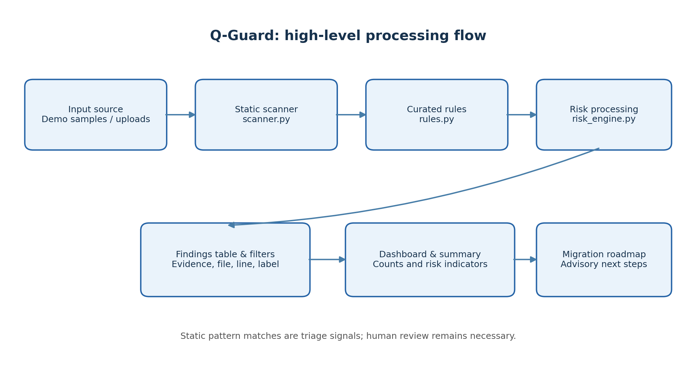
Figure 1. High-level architecture reconstructed from the repository’s module responsibilities.
Main data flow:
- Input selection: demo sample directory or uploaded .py, .java, .c, and .h files.
- Scanning: supported source lines are checked against compiled rule patterns.
- Finding creation: matching lines become structured records with evidence and metadata.
- Triage and summaries: the risk layer prioritises findings and aggregates counts.
- Presentation: the dashboard, findings/report view, guide, and roadmap display the scan output.

5. Technologies Used
Technology / component | Role in Q-Guard | Evidence in repository
Python | Application and scanner implementation language | app.py, scanner.py, rules.py, risk_engine.py
Streamlit (>=1.35) | Interactive multi-page-style web interface and controls | requirements.txt; app.py
pandas (>=2.0) | Tabular representation and display of findings | requirements.txt; app.py
re (regular expressions) | Pattern compilation and source-line matching | scanner.py
pathlib / tempfile | Filesystem traversal and temporary handling of uploaded files | scanner.py; app.py
The declared runtime dependencies in requirements.txt are Streamlit and pandas. Python standard-library modules are also used. No dedicated post-quantum cryptographic library is listed in the dependency file; the repository implements a static pattern scanner rather than cryptographic primitives.AI tools such as ChatGPT & Antigravity were used to assist with coding, debugging, testing and project development.

6. Implementation Details

6.1 User interface and scan inputs
app.py configures a wide Streamlit layout and provides navigation for Dashboard, Scan Files, Findings & Reports, Quantum Risk Guide, and Migration Roadmap. The sidebar allows the user to select built-in demo samples or upload source files. Uploads are restricted by the interface to Python, Java, C, and C header extensions. Uploaded files are written to a temporary directory for scanning; the application keeps scan status and results in Streamlit session state.

6.2 Scanner and supported files
scanner.py defines the supported extension mapping and compiles the rule patterns for reuse. scan_file(path) checks a file and returns potential findings; scan_path(path, max_files=5000) accepts a file or recursively walks a directory while skipping common generated or environment directories such as .git, virtual environments, node_modules, build, dist, and __pycache__. The recursive scan has a default cap of 5,000 candidate files.
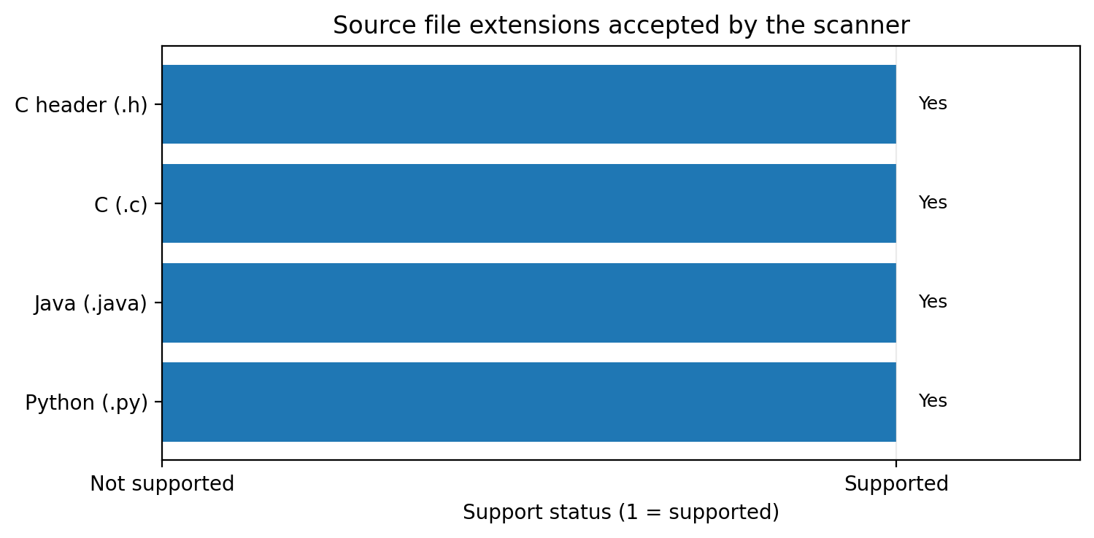
Figure 2. Four source-file extensions are explicitly supported by the scanner.

6.3 Curated rules and confidence labels
rules.py stores algorithm names, regular-expression patterns, default purpose, quantum-risk label, and a recommendation for each rule. The visible rules include classical public-key references such as RSA and ECDSA and also account for post-quantum algorithm terminology in the roadmap logic. The scanner records a lower confidence label when a match appears on a comment/documentation line and a medium pattern-match label for other matching lines. These labels are lightweight heuristics, not calibrated probabilities.

6.4 Risk processing and roadmap
risk_engine.py provides prioritisation and summary functions used by app.py. The interface reports files scanned, potential findings, high quantum-risk matches, and distinct algorithm labels. The migration roadmap converts findings into suggested review steps. The application’s own guidance explains that priority is a triage suggestion based on text matches, not a formal risk rating, and that recommendations are advisory rather than automatic code changes.

6.5 Reporting and user guidance
The findings area presents readable tables and filtering controls. The Quantum Risk Guide explains how to interpret matches and warns that a reference may be a comment, unused import, fixture, or unrelated identifier. The roadmap advises confirming actual use, examining protocol and configuration context, checking library provenance, and testing interoperability and performance before any production migration.

7. Testing and Performance Metrics
The public repository contains a samples directory and a scan workflow that supports demo-based exploration. However, the reviewed repository pages do not provide a documented automated test suite, recorded test execution output, a benchmark report, or measured accuracy/recall results. For that reason, this report does not invent test pass rates, detection accuracy, scan times, memory use, or throughput.
Metric / check | What the repository exposes | Evidence status
Files scanned | Displayed as a runtime dashboard metric | Available during a scan; no fixed benchmark published
Potential findings | Count of generated match records | Available during a scan; not a precision score
High quantum-risk matches | Count based on scanner classifications | Available during a scan; heuristic classification
Distinct algorithm labels | Count of labels present in findings | Available during a scan
Detection accuracy / false positives | Not established by the repository evidence reviewed | Not measured/documented
Latency / throughput / memory | No benchmark figures included | Not measured/documented
A responsible validation plan would use labelled test files containing known positive and negative examples, verify expected file/line evidence, measure scan duration across increasing repository sizes, and record false positives and missed detections. These are suggested evaluation steps, not claims that such tests have already been completed.

8. Results and Discussion
The repository implements a coherent first-pass workflow: users can provide source files, run a scan, review line-level matches, see summary counts, and follow contextual guidance toward a manual migration review. Its main strength is explainability: each match is linked to a source location and a visible rule, so a reviewer can inspect the evidence rather than relying on an opaque score.
The result should be interpreted as a list of potential signals, not a definitive cryptographic inventory. A matching token may be inactive or unrelated to a cryptographic operation, while indirect use, aliases, generated code, complex build paths, or unsupported languages may escape detection. The application’s own warnings correctly state that a scan with no findings does not prove that a project is quantum-safe.
Because scan counts depend on the selected inputs and no fixed benchmark output is supplied, this report describes the result format and capabilities rather than presenting fabricated counts or a sample run as measured evidence.

9. Limitations and Future Scope

Current limitations evidenced by the implementation
- Pattern-based static analysis can produce false positives and false negatives; matches do not establish runtime use or exploitability.
- The explicitly supported source extensions are Python, Java, C, and C header files; other languages are outside the documented scanner scope.
- The scanner does not automatically modify code, perform a cryptographic protocol migration, or certify quantum safety.
- The repository does not document quantitative detection-accuracy results, benchmark measurements, or a formal security evaluation. The scanner's recursive directory scan uses a default limit of 5,000 supported source-file candidates to bound the scan scope. This limit is configurable through the "max_files" parameter.

Future scope (not currently claimed as implemented)
Possible future work, if the team chooses to pursue it, includes building a labelled test corpus and publishing reproducible benchmarks; adding syntax-aware or language-server-assisted analysis; expanding language coverage; improving rule provenance and versioning; adding exportable machine-readable scan reports; and supporting reviewer feedback to tune rule quality. These are recommendations only and are not presented as existing repository features.

10. Performance, Resource Usage and Architecture Impact
The architecture is lightweight: the scanner reads source files, applies compiled regular-expression patterns, and produces structured records that pandas can present in Streamlit. The core scanning workflow uses local file processing, compiled regular-expression rules, and a lightweight risk-processing layer. The reviewed implementation does not show a database integration, a separate backend network service, or a cryptographic computation engine in the scanning path. Instead, it identifies potential cryptographic references in source code and presents the findings for human review. The Streamlit interface provides the application's web-based user interface. For ordinary small-to-medium source sets, this design is straightforward to run locally, but actual runtime and memory use depend on file count, file size, rule count, and the environment.
The code compiles rule patterns once at module import and reuses them during scanning, which avoids recompiling each expression for every source line. Directory scans skip common generated directories and stop after the configured file cap. These implementation choices shape resource use, but without controlled measurements they should not be interpreted as a quantified performance claim.
No benchmark values are reported here because none were available in the repository evidence reviewed. The dashboard’s operational counts are scan outputs, not speed or resource metrics.

11. Conclusion
Q-Guard is a useful hackathon-stage starting point for raising awareness of post-quantum readiness in existing source code. Its Streamlit interface, curated pattern rules, line-level evidence, summaries, and advisory migration roadmap help turn an otherwise manual first look into a more organised review process. The implementation is also clear about its boundaries: it is a static-analysis prototype, not a cryptographic library or a complete security audit. The next meaningful step is to validate its rules against labelled examples and publish reproducible quality and performance measurements, while keeping human review central to any migration decision.

12. References

Primary project resource — team implementation
[1] Q-Guard team repository, “q-guard” — the team’s own implementation and primary source for the project-specific architecture, features, and code descriptions. GitHub. https://github.com/Jeeshma6995/q-guard

Implementation files consulted
[2] Q-Guard repository, app.py — user interface and scan workflow. https://github.com/Jeeshma6995/q-guard/blob/main/app.py
[3] Q-Guard repository, scanner.py — supported extensions and static pattern scanner. https://github.com/Jeeshma6995/q-guard/blob/main/scanner.py
[4] Q-Guard repository, rules.py — curated detection rules. https://github.com/Jeeshma6995/q-guard/blob/main/rules.py
[5] Q-Guard repository, risk_engine.py — prioritisation and summary functions. https://github.com/Jeeshma6995/q-guard/blob/main/risk_engine.py
[6] Q-Guard repository, requirements.txt — declared dependencies. https://github.com/Jeeshma6995/q-guard/blob/main/requirements.txt

External background reference
[7] National Institute of Standards and Technology (NIST), “Migration to Post-Quantum Cryptography” project resources. https://pages.nist.gov/nccoe-migration-post-quantum-cryptography/
Scope note: The Q-Guard GitHub repository is the team’s primary project resource and was used to describe the implementation. External references are included only for background context. This report does not modify project code and does not assert tests or performance results that are not documented.

