**ASSINGMENT-2**

[1]**AGILE MODEL**(Movie Distribution System):

-Agile development model is also a type of Incremental model.

-Agile Methods break the product into small incremental builds.

-These builds are provided in iterations.

-Every iteration involves cross functional teams working simultaneously on various areas like planning, requirements analysis, design, coding, unit testing, and acceptance testing and at the end of the iteration a working product is displayed to the customer and important stakeholders.

-Extreme Programming (XP) is currently one of the most well known agile development life cycle model.

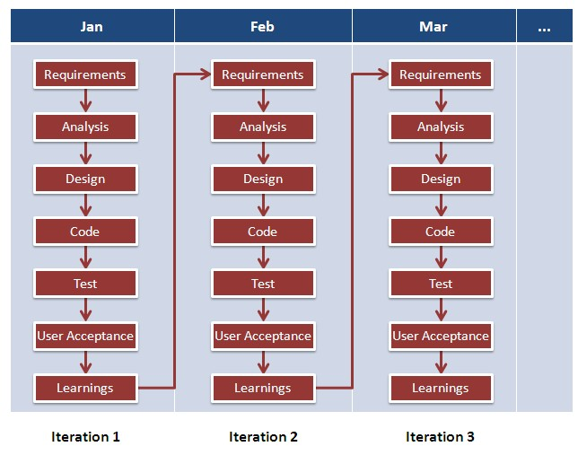

**Pros :**

* Customer satisfaction by rapid, continuous delivery of useful software.
* Regular adaptation to changing circumstances.
* Even late changes in requirements are welcomed!

**Agile model of Movie Distribution System:**

#Iteration1:

-Requirements are To watch anything anytime anywhere, To prevent piracy

-Analysis is that our services should be user friendly

-Design should be efficient.

-Coding the process of definition and classification via various technologies can be Java or HTML/CSS or any.

-User acceptance in software development, user acceptance testing (UAT) is a phase of software development in which the software is tested in the real.

#Iteration2:

-Some requirements can be added like to prevent piracy,Make it available for all devices.

-Analysis is that service should be realtime.

-Design ‘ld be effective and system-friendly.

-Testing can be done more accuracy with increase no. of users.

-From this Iteration we know user requirments more perfectly.

#Iteration3:

-Some more req. to make it available for end devices like phones,tab,pc,laptop,TV set,Set-up box.

-fast internet speed, min 0.5mbps.

-By Design web site can be more responsive and more attractive.

-Coding can be improve via using HTML5 and Fontawesome or new kind of tech.

-Testing is done via searching movie on website by movie name and try to stream it from System itself.(via localHost)

The experiences of the early users are forwarded back to the developers who make final changes before releasing the software commercially.