PBL-I REPORT
Entitled
KHETI CONNECT
A Digital Platform Connecting Farmers and Buyers
Submitted by
KUSHWAHA ANKITKUMAR - 2502031830005
JEET RANPARIYA - 2502031830037
HET NAKRANI - 2502031830040
YASH MAKWANA - 2502031830048
RAJDIPSINH CHAUHAN - 2502031830017

Under the Guidance of
MS. VAISHNAVI GUPTA
Assistant Professor, Department of Computer Engineering

Department of Computer Engineering
College of Technology
Silver Oak University
Ahmedabad, Gujarat
Academic Year: 2026–27

CERTIFICATE
This is to certify that the Problem Based Learning-I (PBL-I) report entitled "Kheti Connect – A Digital Platform Connecting Farmers and Buyers" has been successfully carried out and submitted by Kushwaha Ankitkumar (Enrollment No. 2502031830005), Jeet Ranpariya (Enrollment No. 2502031830037), Het Nakrani (Enrollment No. 2502031830040), Yash Makwana (Enrollment No. 2502031830048) and Rajdipsinh Chauhan (Enrollment No. 2502031830017), of the Department of Computer Engineering, College of Technology, Silver Oak University, Ahmedabad, during the Academic Year 2026–27.
The work presented in this report has been carried out under my guidance and supervision of Ms. Vaishnavi Gupta, as a part of the academic requirements of the prescribed curriculum. To the best of my knowledge, the work reported herein is the original work of the student(s) and has been completed satisfactorily.
The student(s) have demonstrated appropriate understanding of the identified problem, followed a systematic problem-solving methodology, and documented the outcomes of the project in accordance with the guidelines of Problem Based Learning.

Date: ________________________________________
Place: ________________________________________
____________________________
Faculty Guide
Ms. Vaishnavi Gupta
Department of Computer Engineering
____________________________
Head of Department
Department of Computer Engineering

DECLARATION
We hereby declare that the PBL report entitled "Kheti Connect – A Digital Platform Connecting Farmers and Buyers" submitted to the Department of Computer Engineering, College of Technology, Silver Oak University, Ahmedabad, is an original record of the work carried out by us during the Academic Year 2026–27 under the guidance of Ms. Vaishnavi Gupta.
We further declare that this report has been prepared for academic purposes as part of the Problem Based Learning activity and has not been submitted, either wholly or partially, to any other university, institution, or organization for the award of any degree, diploma, certificate, or other academic qualification. We have acknowledged all sources of information, references, data, figures, software tools, and other materials used in the preparation of this report. Wherever the work of others has been referred to, appropriate credit has been given.
We understand that any violation of academic integrity, including plagiarism, fabrication, falsification, or unauthorized use of another person's work, may result in action as per the academic rules and regulations of the University.

Sr. No. | Enrollment No. | Student Name | Signature
1 | 2502031830005 | Kushwaha Ankitkumar
2 | 2502031830037 | Jeet Ranpariya
3 | 2502031830040 | Het Nakrani
4 | 2502031830048 | Yash Makwana
5 | 2502031830017 | Rajdipsinh Chauhan

Date: ________________________
Place: ________________________

ACKNOWLEDGEMENT
We would like to express our sincere gratitude to Silver Oak University, Ahmedabad, and the Department of Computer Engineering, College of Technology, for providing us with the opportunity, facilities, and academic environment required to undertake this Problem Based Learning (PBL) project.
We are deeply thankful to our project guide, Ms. Vaishnavi Gupta, for valuable guidance, continuous encouragement, constructive suggestions, and technical support throughout the planning, development, testing, and documentation of this project. Their guidance helped us to understand the problem systematically and develop an appropriate solution.
We extend our sincere thanks to the Head of the Department and all faculty members of the Department of Computer Engineering for their support, technical inputs, and encouragement during the course of this work.
We also acknowledge the assistance provided by our classmates, laboratory staff, friends, and all those who contributed directly or indirectly to the successful completion of this project. Their cooperation and suggestions were valuable during the various stages of the work.
Finally, we are grateful to our parents and family members for their constant encouragement, support, and motivation throughout the completion of this academic project.

— PBL Project Team
Kushwaha Ankitkumar
Jeet Ranpariya
Het Nakrani
Yash Makwana
Rajdipsinh Chauhan

ABSTRACT
Farmers in India often depend on intermediaries to sell their produce, which limits their market access and reduces the price they receive. They also lack timely market information, learning resources and visibility of transport. This project, Kheti Connect, addresses these problems by proposing a digital platform that connects farmers directly with buyers and consumers. The platform brings direct selling, farmer education, market price information, and order and transport tracking into one system. Access is free for farmers, and platform revenue is planned to come from buyers/consumers and related services rather than from farmers.
The work followed the Problem Based Learning cycle. The team identified the problem, studied existing digital agriculture platforms such as e-NAM, Kisan Mandi, Miraitu and the Farmers’ Portal, analysed the requirements and planned the farmer and buyer workflows. The system was modelled using UML use case, class and sequence diagrams covering four actors – farmer, buyer/consumer, admin and transport partner – and the order, payment and delivery process. A prototype-based implementation was carried out in which the user interface and website modules were developed, following a one-week plan from problem identification to documentation.
The key outcomes to date are: (i) a clearly defined problem and solution scope; (ii) a complete set of UML models describing the users, data entities and the order-to-delivery flow; and (iii) a prototype of the user interface and website modules for farmers and buyers. The study also showed that existing platforms mainly focus on online trading and market information, and do not combine direct selling, farmer education and logistics tracking in a single platform.
Future scope includes integrating a live payment gateway and backend database, real-time GPS-based transport tracking, multilingual and mobile-application support, price-trend prediction, and pilot testing with real farmers and buyers.
KEYWORDS
1. Kheti Connect
2. Digital Agriculture Platform
3. Farmer–Buyer Marketplace
4. Direct Market Access
5. Order and Transport Tracking
6. Farmer Education
7. UML Modelling

LIST OF FIGURES
Figure No. | Title / Caption of Figure | Page No.
Figure 1 | Use Case Diagram of Kheti Connect | 16
Figure 2 | Class Diagram of Kheti Connect | 20
Figure 3 | Sequence Diagram – Buyer Places an Order | 21
Figure 4 | One-Week Project Timeline Chart | 29

LIST OF TABLES
Table No. | Title / Description of Table | Page No.
Table 1 | Root Cause Analysis of Farmers’ Problems | 12
Table 2 | Stakeholder Analysis | 13
Table 3 | Benchmark Study of Existing Platforms | 13
Table 4 | Major Modules of Kheti Connect | 17
Table 5 | Hardware Requirements | 17
Table 6 | Software Requirements | 17
Table 7 | Functional and Non-Functional Requirements | 18
Table 8 | Status Values Used in the Order, Payment and Delivery Logic | 21
Table 9 | Test Plan and Observation Table | 23
Table 10 | Comparison of Existing Platforms and Kheti Connect | 24
Table 11 | Team Members and Roles | 25
Table 12 | Individual Contribution of Team Members | 25
Table 13 | Project Timeline (One-Week Plan) | 29
Table 14 | Gantt Chart of the Project | 30
Table 15 | Work Carried Out Till Date | 30
Table 16 | Review Meetings | 30
Table 17 | Risk Identification and Mitigation | 30
Table 18 | Achievement of Objectives | 32

LIST OF ABBREVIATIONS
Abbreviation | Full Form
PBL | Problem Based Learning
CE | Computer Engineering
CSE | Computer Science & Engineering
UML | Unified Modeling Language
UI | User Interface
e-NAM | National Agriculture Market (electronic)
SDG | Sustainable Development Goal
FK | Foreign Key
COD | Cash on Delivery
UPI | Unified Payments Interface
GPS | Global Positioning System
IEEE | Institute of Electrical and Electronics Engineers

TABLE OF CONTENTS
No. | Chapter | Page No.
1. | Cover Page | 1
2. | Certificate | 2
3. | Declaration | 3
4. | Acknowledgement | 4
5. | Abstract | 5
6. | Keywords | 5
7. | List of Figures | 6
8. | List of Tables | 7
9. | List of Abbreviations | 8
10. | Table of Contents | 9
11. | Chapter 1 – Introduction | 10
12. | Chapter 2 – Problem Study & Literature Review | 12
13. | Chapter 3 – Proposed Solution | 15
14. | Chapter 4 – Implementation / Development | 19
15. | Chapter 5 – Testing & Results | 23
16. | Chapter 6 – PBL Learning & Team Contribution | 25
17. | Chapter 7 – Impact & Future Scope | 27
18. | Chapter 8 – Project Management | 29
19. | Chapter 9 – Conclusion | 32
20. | References | 33
21. | Annexures | 33

CHAPTER 1 – INTRODUCTION

1.1 Background of the PBL
Problem Based Learning (PBL) asks students to start from a real-world problem, study it, build an engineering solution, test it and reflect on what was learnt. This PBL-I project was carried out by Group 5 of the Department of Computer Engineering (Computer Science & Engineering branch) under the guidance of Ms. Vaishnavi Gupta.
The chosen problem area is agriculture. Farmers produce the food that reaches every household, yet many of them still depend on traditional selling channels where they have little control over price, information or delivery. Kheti Connect is a digital platform that connects farmers directly with buyers, helping improve market access and provide fairer pricing. It also provides farmer education, market information and transport tracking in one platform.

1.2 Problem Identification
Through discussion and study of the farming sector, the team identified that farmers commonly face the following challenges:
- limited direct market access for the produce they grow;
- dependence on intermediaries between the farmer and the final buyer;
- lack of proper and timely information, such as market prices and farming knowledge; and
- transportation difficulties and no easy way to track the delivery of orders.

1.3 Problem Statement
Farmers do not have a single, reliable digital platform through which they can sell their produce directly to buyers at fair prices, access market and educational information, and track the transport and delivery of their orders.

1.4 Motivation
Farmers often face limited direct market access, dependence on intermediaries and lack of proper information. Kheti Connect is motivated by the need to give farmers one digital platform for selling, learning and tracking their deliveries. Existing tools usually solve only one part of this problem, so a farmer has to use several different channels. A combined platform reduces this effort and gives farmers a more transparent route to the buyer.

1.5 Objectives
The objectives of the project are:
- To develop a direct marketplace for farmers and buyers.
- To provide better market access and fair pricing for farmers.
- To offer educational and advisory resources.
- To enable transport and order tracking.
- To provide free platform access for farmers.
- To generate platform revenue from buyers/consumers and related services, not from farmers.

1.6 Scope of the PBL
The scope of this PBL-I work covers the study of the problem, analysis of requirements and features, planning of the farmer and buyer workflows, UML modelling of the system, and a prototype-based implementation of the user interface and website modules. Deployment at production scale, live payment processing and real-time vehicle tracking are outside the boundary of this prototype and are listed under future scope.

CHAPTER 2 – PROBLEM STUDY & LITERATURE REVIEW

2.1 Existing System / Current Practice
In the current practice, farmers mostly sell their produce through local markets and intermediaries, who then pass it on to the final buyers. Several digital agriculture platforms are also available. Examples include Miraitu [1], Kisan Mandi [2], the National Agriculture Market (e-NAM) [3] and the Farmers’ Portal of the Government of India [4]. These platforms provide online trading, market information or farming information, but each focuses on only a part of the farmer’s needs.

2.2 Problems in Existing System
- Farmers have limited direct access to buyers and depend on intermediaries.
- Farmers do not always get proper information about market conditions and prices.
- Educational and advisory resources are kept separate from the place where produce is sold.
- Transport is arranged separately, and there is no simple way for farmer and buyer to track an order.
- Most digital solutions do not combine direct selling, farmer education and logistics tracking in one platform.

2.3 Root Cause Analysis
Table 1 links each problem faced by farmers to its underlying cause and the effect it has.
Table 1: Root Cause Analysis of Farmers’ Problems
Problem | Root Cause | Effect on Farmers
Limited market access | No direct channel between farmer and buyer; reliance on local selling routes | Fewer buying options and weaker bargaining position
Dependence on intermediaries | Intermediaries control the link between farmer and the final buyer | Reduced share of the final price reaching the farmer
Lack of information | Market information and learning resources are scattered or hard to reach | Decisions on selling and farming taken without full knowledge
Transport difficulty | Delivery is arranged separately with no common tracking system | Uncertainty about order status and delivery
Fragmented digital tools | Platforms focus on trading or information only | Farmer must use several channels for one workflow

2.4 Stakeholder Analysis
Table 2: Stakeholder Analysis
Stakeholder | Role in the System | Main Need
Farmer | Sells products, accesses education resources, tracks orders | Fair price, direct buyers, free access, useful information
Buyer / Consumer | Browses products, places orders, makes payments, gives ratings | Direct access to farm produce, easy ordering and tracking
Transport Partner | Delivers orders and updates delivery status | Clear delivery assignments and a simple way to update status
Admin | Manages users, products, orders and content; views reports | Control, monitoring and analytics of the platform

2.5 Literature Review
A study of existing digital agriculture platforms was carried out to understand what is already available. Miraitu presents itself as a platform for smart farming [1]. Kisan Mandi positions itself as a way of connecting fields to families [2]. e-NAM, run by the Government of India, is an online trading platform for agricultural commodities [3], and the Farmers’ Portal of the Department of Agriculture and Farmers Welfare provides information services for farmers [4].
The overall finding of this survey is that existing digital agriculture platforms mainly focus on online trading and market information. Most of them do not combine direct selling, farmer education and logistics tracking in a single platform.

2.6 Existing Solutions / Benchmark Study
Table 3: Benchmark Study of Existing Platforms
Platform | Primary Focus | Reference
Miraitu | Smart farming (“The Future of Smart Farming”) | [1] www.miraitu.in
Kisan Mandi | Connecting fields to families | [2] kisanmandi.in
e-NAM | Online trading of agricultural commodities (Government of India) | [3] National Agriculture Market
Farmers’ Portal | Information for farmers (Dept. of Agriculture and Farmers Welfare) | [4] Farmers’ Portal, Government of India

2.7 Identified Gap
The gap identified is the absence of one platform that brings together (a) a direct marketplace between farmers and buyers, (b) education and advisory resources for farmers, and (c) transport and order tracking, while keeping access free for farmers. Kheti Connect is proposed to fill this gap.

CHAPTER 3 – PROPOSED SOLUTION

3.1 Proposed Solution
Kheti Connect is a digital platform, available as a website, that connects farmers directly with buyers. Farmers list their products, buyers browse and order them, and the platform manages payment, order status and delivery tracking. The platform also gives farmers education resources and market price information. Farmers use the platform free of charge; revenue is generated from buyers/consumers and related services.

3.2 Conceptual Framework
The solution is built on four connected pillars, each answering one root cause identified in Chapter 2:
- Direct marketplace – farmers sell to buyers without intermediaries.
- Education and advisory – learning resources and news managed by the admin.
- Market information – farmers can view market prices before selling.
- Order and transport tracking – transport partners update delivery status, and buyers and farmers can track it.

3.3 Block Diagram / System Architecture
Figure 1 shows the use case diagram of the Kheti Connect system with its four actors – Farmer, Buyer/Consumer, Admin and Transport Partner – and the services they use. Common functions such as Login, Manage Profile, Search/Browse Products, Place Order, Make Payment and Track Order are shared through «include» relationships.
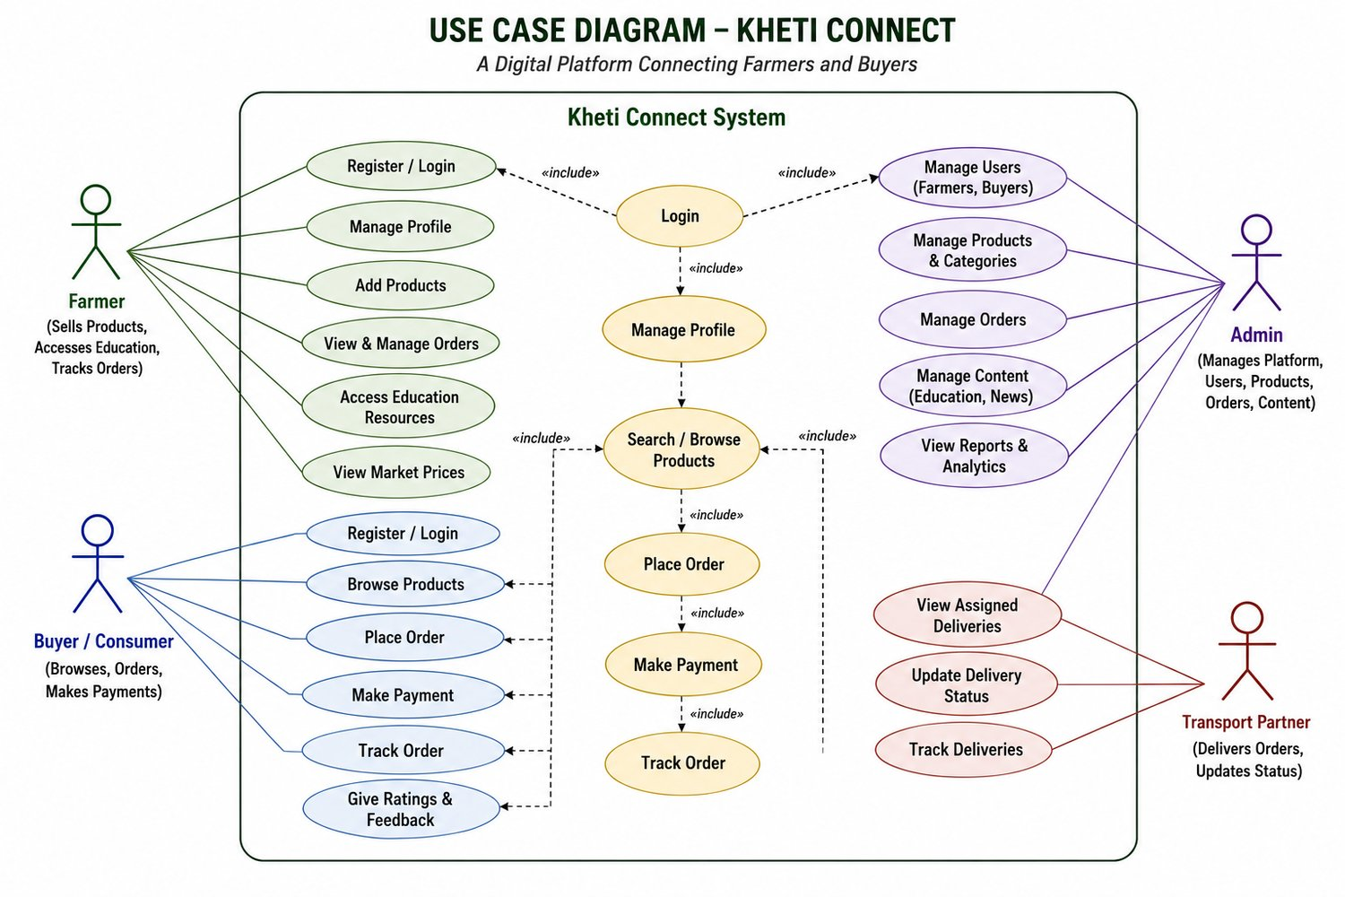
Figure 1: Use Case Diagram of Kheti Connect
At the architecture level, the platform has the following layers, as seen in the sequence diagram (Figure 3):
- Presentation layer – the Kheti Connect web/mobile interface used by farmers, buyers, admin and transport partners;
- Application layer – the Order Service and Payment Service that process orders and payments;
- Data layer – the database that stores users, products, orders, payments and deliveries; and
- External actor – the transport partner who receives delivery requests and returns tracking details.

3.4 Working Principle
Farmer workflow: register/login → manage profile → add products → view and manage orders → access education resources and market prices.
Buyer workflow: register/login → browse or search products → place order → make payment → track order → give ratings and feedback.
Delivery workflow: after payment is confirmed, a delivery request is sent to a transport partner, who updates the status until the order is delivered. The admin monitors users, products, orders and content.

3.5 Major Components
Table 4: Major Modules of Kheti Connect
Module | Description
User Management | Registration, login and profile management for farmers, buyers, admin and transport partners
Product Catalogue | Farmers add and manage products under categories; buyers search and browse
Order Management | Buyers place orders; farmers view and manage them; orders carry a status
Payment | Payment for an order using methods such as COD, UPI, card, net banking and wallet
Delivery and Tracking | Assignment of deliveries to transport partners and status updates
Education and Market Info | Education resources, news and market prices for farmers
Admin Panel | Manage users, products, categories, orders, content and view reports

3.6 Hardware Requirements
Table 5: Hardware Requirements
Component | Requirement
Client device | Computer, laptop, tablet or smartphone with a modern web browser
Network | Internet connection
Development machine | Standard laptop/desktop used by team members for development and testing

3.7 Software Requirements
[Team to confirm the exact technology stack used in the prototype and edit the table below.]
Table 6: Software Requirements
Item | Requirement
Operating system | Windows / Linux / macOS
Web browser | Chrome, Edge or Firefox (latest versions)
Front-end | [e.g., HTML, CSS, JavaScript – confirm]
Back-end / Database | [Planned for full system – confirm technology]
Design / Modelling tools | UML diagramming and UI design tools
Code editor | [e.g., VS Code – confirm]

3.8 Technical Specifications
Table 7: Functional and Non-Functional Requirements
Type | Requirement
Functional | Role-based login for farmer, buyer, admin and transport partner
Functional | Add, update and delete products; search and browse products by category
Functional | Place order, make payment, update order status and track order
Functional | Assign deliveries and update delivery status
Functional | Access education resources, news and market prices
Non-functional | Free access for farmers; simple and easy-to-use interface
Non-functional | Secure handling of user data and payments; reliable order records
Non-functional | Responsive layout usable on desktop and mobile browsers

3.9 Design Calculations
Not Applicable. Kheti Connect is a software platform and does not involve engineering design calculations.

CHAPTER 4 – IMPLEMENTATION / DEVELOPMENT

4.1 Methodology
The project followed the PBL cycle: problem identification, problem study, solution development, implementation, testing, evaluation and reflection. Work was planned as a one-week schedule (Chapter 8). The team first analysed requirements, then designed the workflows and UML models, then developed the UI and website modules.

4.2 Project Development Steps
- Understand the problem and define the project idea.
- Study existing solutions and collect relevant information.
- Analyse requirements and finalise key features.
- Design wireframes and UI for the website.
- Develop the website modules and integrate functionalities.
- Test the website, fix bugs and improve performance.
- Prepare the final documentation and report.

4.3 Diagram / Schematic
The class diagram (Figure 2) describes the data model. A User class (with name, email, phone, password, role and status) is specialised into Buyer, Admin, FarmerUser and BuyerUser. A Farmer owns many Products, and each Product belongs to a Category. An Order contains OrderItems, has Payments and has Deliveries, and a Delivery is handled by a TransportPartner.
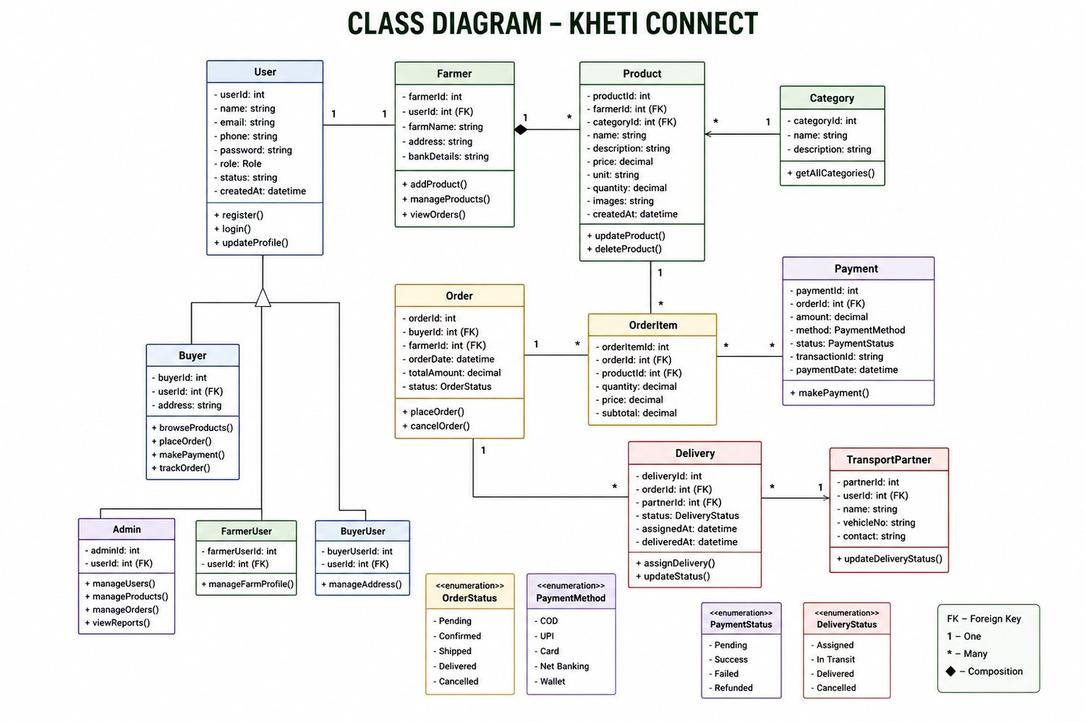
Figure 2: Class Diagram of Kheti Connect
The sequence diagram (Figure 3) shows the scenario in which a buyer places an order. The buyer browses and searches products, adds to the cart and places the order. The Order Service saves the order as Pending in the database and returns an order confirmation. The Payment Service then processes the payment and updates the payment status. After successful payment the order status is changed to Confirmed, a delivery request is sent to the transport partner, and the order is confirmed to the buyer with a Tracking ID.
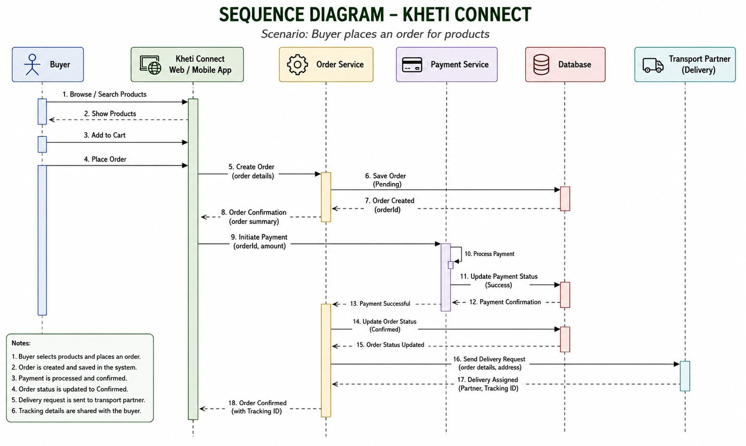
Figure 3: Sequence Diagram – Buyer Places an Order

4.4 Hardware Implementation
Not Applicable. The project is software-based and no hardware circuit was built.

4.5 Software / Programming / Control Logic
The prototype implements the user interface and website modules for the farmer and buyer workflows. The control logic of the system is driven by status values stored for orders, payments and deliveries, as shown in Table 8.
Table 8: Status Values Used in the Order, Payment and Delivery Logic
Entity | Status Values | Related Information
Order status | Pending, Confirmed, Shipped, Delivered, Cancelled | Set to Pending on creation; Confirmed after payment
Payment status | Pending, Success, Failed, Refunded | Payment methods: COD, UPI, Card, Net Banking, Wallet
Delivery status | Assigned, In Transit, Delivered, Cancelled | Updated by the transport partner

4.6 Simulation Model
Not Applicable. No simulation was required; the UML diagrams in Section 4.3 serve as the design models for the system.

4.7 Prototype Development
A prototype-based implementation was carried out. The UI and website modules were developed for the platform, and the farmer and buyer workflows were planned and reflected in the interface.
[Insert screenshots of the developed website pages here, each with a numbered figure caption – e.g., Home page, Farmer dashboard, Product listing, Order tracking.]

4.8 Safety Considerations
Although no physical safety issues apply, the following protection measures are considered in the design of the platform:
- role-based access so that each user sees only the functions of their role;
- secure storage of passwords and personal details such as bank details and addresses;
- secure payment processing and confirmation before an order is confirmed; and
- validation of user inputs to avoid wrong or harmful data entering the system.

CHAPTER 5 – TESTING & RESULTS

5.1 Testing Methodology
Testing of the prototype is done module by module. Each function in the use case diagram is checked against its expected behaviour (functional testing), followed by a check of the interface on desktop and mobile screens (usability and responsiveness). Defects found are fixed and the test is repeated. This corresponds to Day 6 of the project plan.

5.2 Test Conditions
Tests are carried out on a standard computer and a smartphone with an internet connection, using the latest versions of common web browsers, with sample (dummy) farmer, buyer, product and order data.

5.3 Experimental / Simulation Results
Not Applicable. The project is a software prototype with no experimental or simulation set-up. The outcomes of functional testing are recorded in Section 5.4.

5.4 Observation Table
[Team to fill the “Observed Result” and “Status” columns after testing.]
Table 9: Test Plan and Observation Table
No. | Test Case | Expected Result | Observed Result | Status
1 | Register / Login | User can register and log in with role-based access | [ ] | [ ]
2 | Add product (Farmer) | Product appears in the catalogue with price and quantity | [ ] | [ ]
3 | Search / browse products (Buyer) | Matching products are displayed | [ ] | [ ]
4 | Place order | Order is created with status Pending | [ ] | [ ]
5 | Make payment | Payment status updates and order becomes Confirmed | [ ] | [ ]
6 | Track order | Delivery status is visible to buyer and farmer | [ ] | [ ]
7 | Access education and market prices | Resources and prices are displayed to the farmer | [ ] | [ ]
8 | Responsive layout | Pages display correctly on mobile and desktop | [ ] | [ ]

5.5 Performance Parameters
- Functional correctness – number of test cases passed out of those executed;
- Usability – ease with which farmers and buyers can complete a task;
- Responsiveness – correct display on different screen sizes; and
- Page loading behaviour of the website modules.

5.6 Graphs / Charts
Not Applicable at this stage. Charts of test outcomes may be added once the observation table is completed.

5.7 Result Analysis
At the present stage, the team has completed the problem and solution definition, requirement analysis, study of existing platforms, UML modelling, planning of the farmer and buyer workflows, and the development of the UI and website modules. The design shows that all six objectives can be supported by the proposed modules. The results of functional testing will be analysed after the observation table is completed.

5.8 Comparison with Existing System
Table 10: Comparison of Existing Platforms and Kheti Connect
Feature | Existing Platforms (as surveyed) | Kheti Connect
Direct selling between farmer and buyer | Online trading is the main focus | Direct marketplace for farmers and buyers
Market information | Provided by many platforms | Market prices available to farmers
Farmer education / advisory | Generally not combined with selling | Education and advisory resources on the same platform
Transport and order tracking | Generally not combined with selling | Delivery assignment and order tracking
Cost to farmer | Varies | Free access for farmers

5.9 Validation of Proposed Solution
The proposed solution is validated by checking that each objective in Section 1.5 is covered by a module and a test case (Table 18), and by collecting feedback from the guide and from sample farmers and buyers during review. Feedback received is to be recorded in Chapter 6.

CHAPTER 6 – PBL LEARNING & TEAM CONTRIBUTION

6.1 Team Members and Roles
Table 11: Team Members and Roles
Sr. | Student Name | Enrollment No. | Role
1 | Kushwaha Ankitkumar | 2502031830005 | [Role]
2 | Jeet Ranpariya | 2502031830037 | [Role]
3 | Het Nakrani | 2502031830040 | [Role]
4 | Yash Makwana | 2502031830048 | [Role]
5 | Rajdipsinh Chauhan | 2502031830017 | [Role]

Group ID: 5. Guide: Ms. Vaishnavi Gupta. Branch: Computer Science & Engineering (CSE).

6.2 Individual Contribution
[Each member must describe his/her own contribution. Edit the table below.]
Table 12: Individual Contribution of Team Members
Sr. | Student Name | Contribution
1 | Kushwaha Ankitkumar | [Describe contribution]
2 | Jeet Ranpariya | [Describe contribution]
3 | Het Nakrani | [Describe contribution]
4 | Yash Makwana | [Describe contribution]
5 | Rajdipsinh Chauhan | [Describe contribution]

6.3 PBL Learning Outcomes
- Ability to identify a real-world problem and state it clearly.
- Ability to study existing solutions and find a gap.
- Ability to model a system using UML use case, class and sequence diagrams.
- Ability to plan, develop and document a prototype within a fixed schedule.

6.4 Skills Developed
- Requirement analysis and system design;
- UI design and website development;
- Teamwork, communication and time management; and
- Technical documentation and referencing.

6.5 Mentor Review / Feedback
[To be filled after review by Ms. Vaishnavi Gupta.]

6.6 Student Reflection
Working on Kheti Connect helped the team see how a real problem faced by farmers can be broken into smaller parts – market access, information and transport – and addressed through one connected system. The team learnt that a clear problem statement and well-planned workflows make design and development easier, and that regular discussion within the group and with the guide improves the quality of the work.

CHAPTER 7 – IMPACT & FUTURE SCOPE

7.1 Innovation / Novelty
The novelty of Kheti Connect lies in combining direct selling, farmer education and market information, and transport/order tracking in one platform, together with a model in which farmers pay nothing and revenue comes from buyers/consumers and related services.

7.2 Social Impact
The platform can help farmers reach buyers directly, get fairer prices and make better-informed decisions, and gives consumers direct access to farm produce.

7.3 Environmental Impact
A direct farmer-to-buyer channel with organised delivery can reduce unnecessary handling steps in the supply chain. A detailed environmental assessment is not part of this prototype.

7.4 Economic Impact
By reducing dependence on intermediaries, a larger share of the price can reach the farmer. The platform also creates business for transport partners and a revenue stream from buyers/consumers and related services.

7.5 Sustainability
Sustainability rests on a model in which the platform earns from buyers/consumers and related services while remaining free for farmers, so that farmer adoption is not blocked by cost.

7.6 SDG / Viksit Bharat Relevance
- SDG 1 (No Poverty) and SDG 2 (Zero Hunger) – by supporting farmers’ incomes and access to markets;
- SDG 8 (Decent Work and Economic Growth) – by creating digital market opportunities; and
- Viksit Bharat – by supporting digital inclusion of the farming community.

7.7 Limitations
- The current work is a prototype; it has not been deployed or tested at large scale.
- Live payment gateway and real-time tracking are not yet integrated.
- Use of the platform depends on internet access and the digital familiarity of farmers.

7.8 Future Scope
- Integration of a live payment gateway and a full backend database;
- Real-time GPS-based tracking of deliveries;
- Multilingual interface and a dedicated mobile application;
- Price-trend prediction and advisory based on market data; and
- Pilot testing with real farmers, buyers and transport partners.

CHAPTER 8 – PROJECT MANAGEMENT

8.1 Project Timeline
The project was planned as a one-week schedule, shown in Figure 4 and Table 13.
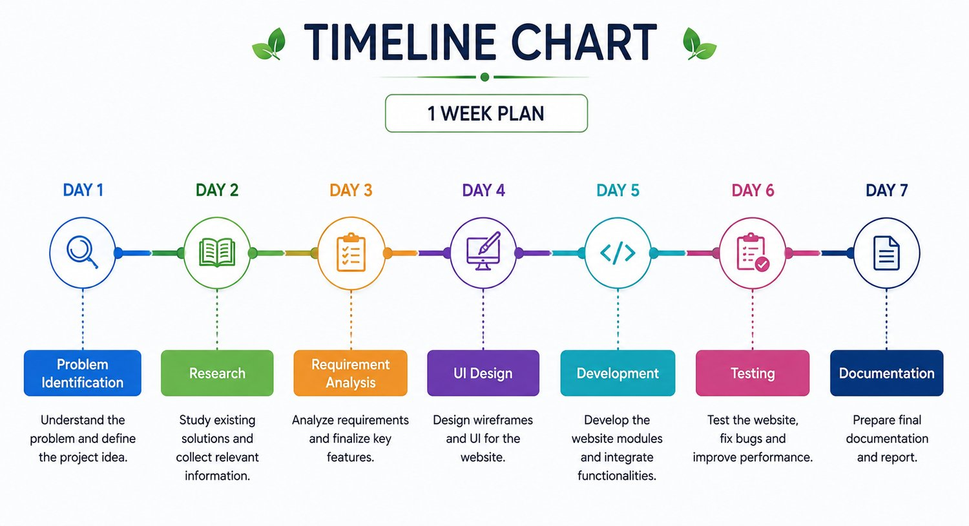
Figure 4: One-Week Project Timeline Chart
Table 13: Project Timeline (One-Week Plan)
Day | Phase | Activity
Day 1 | Problem Identification | Understand the problem and define the project idea
Day 2 | Research | Study existing solutions and collect relevant information
Day 3 | Requirement Analysis | Analyse requirements and finalise key features
Day 4 | UI Design | Design wireframes and UI for the website
Day 5 | Development | Develop website modules and integrate functionalities
Day 6 | Testing | Test the website, fix bugs and improve performance
Day 7 | Documentation | Prepare final documentation and report

8.2 Gantt Chart
Table 14: Gantt Chart of the Project
Phase | Day 1 | Day 2 | Day 3 | Day 4 | Day 5 | Day 6 | Day 7
Problem Identification
Research
Requirement Analysis
UI Design
Development
Testing
Documentation

8.3 Milestones Achieved
Table 15: Work Carried Out Till Date
Area | Work Carried Out
Conceptual | Problem and solution identified
Analytical | Requirements and features analysed
Theoretical | Existing platforms studied
Computational | UI and website modules developed
Methodological | Farmer and buyer workflow planned
Boundary | Prototype-based implementation

8.4 Review Meetings
[Record the dates and outcomes of review meetings with the guide.]
Table 16: Review Meetings
No. | Date | Discussion / Outcome
1 | [ ] | [ ]
2 | [ ] | [ ]
3 | [ ] | [ ]

8.5 Risk Identification and Mitigation
Table 17: Risk Identification and Mitigation
Risk | Mitigation
Short one-week schedule | Keep scope to a prototype; divide modules among team members
Requirements changing during work | Finalise key features on Day 3 before UI design starts
Bugs found late | Reserve a full day for testing and bug fixing
Low digital familiarity of farmers | Keep the interface simple and provide education resources
Data and payment security | Use role-based access and secure payment handling in the full system

CHAPTER 9 – CONCLUSION

9.1 Conclusion
Farmers face limited direct market access, dependence on intermediaries, lack of proper information and transport difficulties. Kheti Connect proposes one digital platform where farmers can sell directly to buyers, learn, view market information and track deliveries, with free access for farmers. The team identified the problem, studied existing platforms, analysed requirements, modelled the system with UML diagrams and developed a prototype of the UI and website modules.

9.2 Achievement of Objectives
Table 18: Achievement of Objectives
Objective | Status / How Addressed
Direct marketplace for farmers and buyers | Designed (use case, class and sequence diagrams); UI modules developed
Better market access and fair pricing | Direct farmer–buyer flow without intermediaries designed
Educational and advisory resources | Education resources and market prices included in farmer workflow
Transport and order tracking | Delivery and order status flow designed
Free platform access for farmers | Defined in the platform model
Revenue from buyers/consumers and related services, not farmers | Defined in the platform model

9.3 Final Outcome
The final outcome of this PBL-I work is a clearly defined problem and solution, a complete set of UML models, a one-week project plan and a prototype of the Kheti Connect user interface and website modules, together with this report. Testing, validation with users and the future enhancements listed in Chapter 7 will carry the work forward.

REFERENCES
[1] Miraitu, “The Future of Smart Farming.” [Online]. Available: www.miraitu.in
[2] Kisan Mandi, “Connecting Fields to Families.” [Online]. Available: kisanmandi.in
[3] Government of India, “National Agriculture Market (e-NAM).” [Online]. Available: e-NAM Official Website
[4] Department of Agriculture and Farmers Welfare, Government of India, “Farmers’ Portal.” [Online]. Available: Farmers’ Portal

ANNEXURES
Annexure A – Survey / Questionnaire – Not Applicable
Annexure B – Raw Data – Not Applicable
Annexure C – Detailed Calculations – Not Applicable
Annexure D – Diagram – Figures 1 to 3 (Chapters 3 and 4)
Annexure E – Simulation Results – Not Applicable
Annexure F – Source Code – [To be attached]
Annexure G – Prototype Photographs / Screenshots – [To be attached]
Annexure H – Review / Feedback Sheets – [To be attached]
Annexure I – Individual Contribution – See Section 6.2

