Face Recognition Challenge
(Biometric System)

Kartavya Bhatt (201501009)
Information and Communication Technology
School of Engineering and Applied Science
Ahmedabad University
kartavya.b.btechi15@ahduni.edu.in

Jeet Jivrajani (201501039)
Information and Communication Technology
School of Engineering and Applied Science
Ahmedabad University
jeet.ji.btechi15@ahduni.edu.in

Raj Bhensadadia (201501011)
Information and Communication Technology
School of Engineering and Applied Science
Ahmedabad University
raj.b.btechi15@ahduni.edu.in

Dhwani Mehta (201501054)
Information and Communication Technology
School of Engineering and Applied Science
Ahmedabad University
dhwani.m.btechi15@ahduni.edu.in

Abstract— Due to increasing demand of security issues, technology needs to step forward to fulfill required necessities. These inventions of technology is required to be simple, user friendly, uncomplicated and acceptable to the end users. Thus, the demand of lucid systems which can secure our assets and our privacy without losing identity is increasing exponentially, which lead to engender of biometrics system. Face Recognition is one type of biometric system in which we decreased the dimensions of images using Principal Component Analysis (PCA) and fed those images to Neural Network for training of the model. Thus, giving us acceptable accuracy in detecting the face of an individual.
Keywords—biometrics, PCA, neural network, accuracy, covariance.

Introduction To Facial Recognition
Biometrics is based on two major characteristics of any individual: physical or behavioral characteristics. Facial Recognition is widely acceptable, collectable, and accessible system. Face recognition primarily uses the same principle as humans in distinguishing one from another i.e. faces. This approach is based on the working of human visual system and the mechanism by which humans represent faces in order to discriminate different identities with high accuracy. Face recognition softwares are capable of uniquely identifying or verifying a face by comparing and analyzing patterns based on the person’s facial contours. Facial recognition is further implemented in two phases: (i) Face detection (ii) Face recognition.

Face Detection: It includes identifying and locating a face in an image.
Face Recognition: It extracts features from face, which discriminates one face from another. This information is saved, and matched, and is recognized based on the face database.
Now, whenever any new image is passed as an input, first of all a face needs to be extracted leaving behind the unnecessary background and other parts. Now, features which are given in the extracted part of image are determined and compared with the features which are obtained from the training data set. The face whose most features match with the features of test image is the result of process. The matched face is the face of the person in input image.

Existing Approach In Face Recognition

There are three methods that are used for face recognition: (i) Holistic Matching Method (ii) Feature-based(structural) methods (iii) Hybrid Methods.

Holistic Method
In Holistic approach, whole face region is taken into consideration while giving input in face recognition system. Most widely used methods are Eigenfaces, Principal Component Analysis, Linear Discriminant Analysis and independent component analysis, etc. Eigenfaces approach treats input image as two dimensional recognition system. The first stage is to insert a set of images into database termed as training set which will be used while comparing images and while creating eigenfaces. The second stage is to create eigenfaces which are extracted from images through a mathematical tool called Principal Component Analysis(PCA). The weight of incoming unknown image is found and then compared to the weights of those already in the system. If the image in the database has the weight closest to given image then it will be returned as a hit.

Feature Based (structural) Method
In Feature based Methods, local features such as eyes, nose and mouth are extracted and their locations and local statistics are classified structurally. It is difficult to retrieve features that are invisible due to large variations. There are three methods of feature extraction: (i) Generic methods based on edges, lines, and curves (ii) Feature-template-based methods (iii) Structural matching methods that take into consideration geometrical constraints on the features.

Hybrid Method
In Hybrid methods, both holistic and feature extraction methods are combined. Hybrid uses input images in three dimensions. Then it proceeds with detection, position, measurement, representation and matching.

Novelty Factor
For the classification we used the method of Principal component analysis. The main idea of the PCA is to reduce the dimensionality of a data set consisting of many variables correlated with each other, either heavily or lightly, while retaining the variation present in the dataset, up to the maximum extent. PCA can supply the user with a lower-dimensional picture or a projection of the object when viewed from its most covariant viewpoint. So, we plotted the graph of variance vs number of components (data) for analyzing that after what value of the principal components the graph was constant and we set that value of variance as threshold and took the corresponding principal component. Then we plotted the graph again of selected principal components and verified our intuition. We also attempted for non-neural network approach. For that we tried to use K-means clustering algorithm to find centroids for the clusters, where each cluster will have set of images belonging to the same person. But this intuition went wrong and the accuray was very negligible. So we excluded this approach from our work.

Accuracy Metric System
Manual error calculated can be defined as the number of wrong recognitions per 100 test pairs.

Error = (Actual label - Predicted label)/100

Flowchart
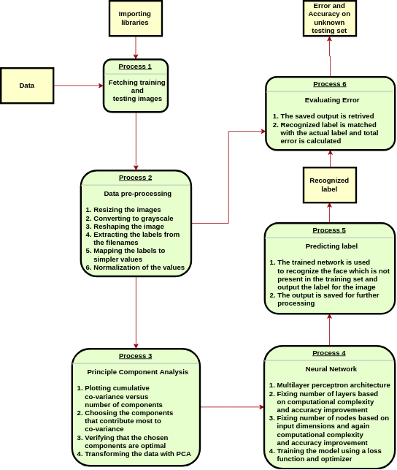

Experimental Results
The dataset consisted of the mixed images i.e. both original and pencil sketch. Each of the image including all the poses and type were taken into the training set. Then during pre-processing they were converted to a grayscale image. Then they were resized and saved in an array. Also images were labeled by the corresponding student’s roll number. The roll number is a huge number and so they were mapped to lower numbers. The images were resized to 50*50 as per the analysis carried out with different resolutions. The pixel values were then normalized. After principle component analysis we decide to reduce the components to 150 as per the method shown in flowchart. After many iterations the final values for number of layers and number of nodes in each layer are 1 and 108 respectively. Input layer and hidden layer neurons have “Rectified Linear Unit” as their activation function while output layer neurons have “Softmax”. Batch size set to 100 due to memory constraints and the network was trained for 100 epochs.The error was calculated manually by matching the predicted and actual labels for test dataset. The test dataset was constructed by taking new pictures and containing both original and pencil sketch.

Data of subject in training data set before and after PCA | Data of subject in test data set before and after PCA
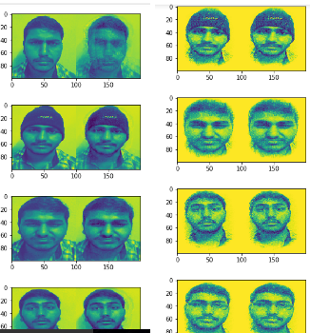 | 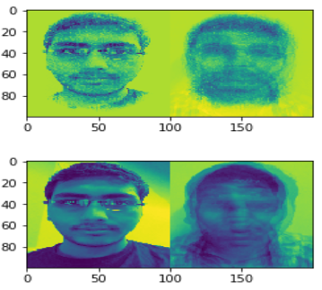

Conclusion

Based on the results of our face recognition model, it was observed that for 2 external testing images the resolution and accuracy tradeoff is as follows:
Resolution | Accuracy
500*500 | 0
400*400 | 1
200*200 | 0.5
100*100 | 1
50*50 | 0.5

Problems that were Faced
The main problem that we faced in whole process was while training model. We have trained our system using keras. First error that we got was due to not matching of dimensions of output. But, when we replaced the output dimensions with 40 as the number of output roll numbers of result were 40, model was successfully executed and trained.
After model execution, another problem we faced was in the accuracy of our model. Initially we got only 3% percent accuracy using loss as categorical_crossentropy and categorical_accuracy metric system. We were confused between spare and categorical_crossentropy. At last, after setting loss to sparse_categorical_crossentropy and metric to accuracy, 100% accuracy was achieved in same data set.

References

- https://machinelearningmastery.com/handwritten-digit-recognition-using-convolutional-neural-networks-python-keras/
- https://keras.io/losses/
- https://keras.io/optimizers/
- https://www.dezyre.com/data-science-in-python-tutorial/principal-component-analysis-tutorial
- https://www.youtube.com/watch?v=xNj6s5p6H0s- For K-means clustering

