Measurement Of Impurities In Any Liquid Media Inside the flow vessel Using Piezoelectric Sensing
Pragyaditya Das
Under-Graduate Student.
Department Of Instrumentation And Control Engineering.
National Institute Of Technology, Trichy.
Email: pragyaditya.das94@gmail.com
1. Abstract :
In this proposal, I extend my idea on how do we sense and accurately measure the amount of impurities in any liquid media.I am planning on using the principles of Piezoelectric Sensing to do it.The basic idea is to use the voltage output from a piezoelectric strip (say S) to sense the amount of impurities (Say ImL) in the Liquid Media (say L). What I intend to do is, I would use an adhesive layer (say Ah) which would be reactive to the impurity we are trying to measure. I want to fix a layer of Ah on S. Then I would fix on end of S to the wall of the container in which the liquid is flowing.S will now act as a Cantilever Beam. Now, L flows through the pipe. The impurities present in L will settle and adhere on S, due to the adhesive property of Ah. The settling of impurities of some mass , will bend S and generate an output voltage (say V).
Here the strip is acting like a cantilever beam.

Key Words:
Impurities In Liquid Media, Adhesive Layer, Piezoelectric Sensing, Internet Of Things, Process Instrumentation.
Mathematics: (All units are in SI.)
2.1. INITIAL ASSUMPTIONS:
Let the length of the Piezoelectric Strip be = L m.
Let the breadth be = B m.
Let the Height be = H m.
Let the velocity of the fluid be = v m/s.
Let the flow rate of the fluid be = Q cu.mtr/s
Let the area of obstruction in the flow be = A sq.cm.
Let the area of the Adhesive layer be = A_{a} sq.cm.
Let the Power of Adhesion of the adhesive layer be = P units.
Let the amount of mass settled on the Piezoelectric Strip be = M units.
Let the flow rate be = F units.
Let the voltage output from the Piezoelectric strip be = V Volts.

2.2. STRIP SPECIFICATIONS:
Now, we follow the following convention for the strip work properly as a Cantilever Beam:
L > B -------------------------- (1)
As we know that, the strip will be on the path of the fluid flow. Thus the velocity of the fluid will be affected. Thus might cause a significant alteration in the flow rate of the Fluid as,
Flow rate = K * v.
F = K * v --------------------------(2)
[K is a contstant]
Equation (2) essentially means that Flow rate is directly proportional to the velocity of the fluid.
We know that, any obstruction in the fluid flow, results in significant pressure loss in the head, this is mainly due to the formation of Vena Contracta.
Now, Vena Contracta has direct dependence on the Area of the Obstruction (A).
In our setup, L*H is the area of contact.

L is already fixed and it cannot be changed, as it plays an important role in the Piezoelectric sensing.
Thus, we will have to keep H very small, that will in turn keep A small.
Hence,
A = L*H ------------------------------(3)
We cannot decrease L after a certain value, because, if L < H or L< B, this setup shall fail to function as a Cantilever Beam.
Therefore,
L >> H --------------------------------(4)
also,
for the strip to have a considerable area for the impurities to settle, we fix,
B >> H --------------------------------(5)
From equations (1) , (4) and (5),
L >> B >> H ----------------------------(6).
Equation (6) gives us the relative idea of the Piezoelectric Strip (S).
2.3. AHESIVE LAYER:
The adhesive layer will be placed on the Piezoelectric strip, this means, the area of the adhesive layer is less than or equal to the strip area.
A_{a} = L*B ---------------------------(7a)
Or A_{a} < L*B ----------------------------(7b).

For best results, we use the first condition i.e., Equation 7a.
Note :
We are using L * B as the Area for fixing the primary sensing element (the adhesive layer) because it clearly has more surface area exposed to the liquid than L*H.
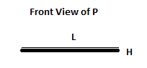
L * H L * B

2.4. SENSING
Now that the area of the adhesive layer is set, we shall have a look at the Power of Adhesion(P) of the Adhesive. From some basic understanding, I can conclude that, P will depend on the factor of how well the impurities will react with the Adhesive Layer. P will also be affected by Area available for adhesion and the velocity at which the fluid is flowing. As far as the design is concerned, there is not much we can do with the adhesive layer, we can however focus on Material Selection and choose better Adhesive Layer, which will have better P. We can also look after the durability of the Adhesive Layer (Ah), and its cost effectiveness.
We shall now move on to the determination of the amount of mass settled on S.
Clearly, M is a function of multiple parameters. I am going to try to formulate an equation, which would relate the parameters and M.
M is a
Function of Adhesive Power (P).
Function of Area of the Adhesive Layer (A_{a}).
Function of the Velocity of Fluid Flow (v).
Function of the Area of the Piezoelectric Strip(A) (if we use equation 7(b)).
Function of the flow rate (F).
Function of the amount of Impurities in the fluid (ImL).
Therefore,
M = f ( P, A_{a}, v, A, F, ImL).------------------------------------(8a)
[Now, we have already mentioned in section 2.3, that for optimal results, we need
to use A_{a} = A]

Thus, to reduce redundancy
M = f ( P, A, v, F, ImL ).---------------------------------------(8b)
Now from equation 2, we can see that,
F = K * v [ K = constant ].
This can be written as,
K = F/v. ----------------------------------------------------------(9).
[Intuitively, we can notice that K has the dimensions of length, as we have considered F as the volumetric flow rate].
This revelation shall again change Equation 8b as follows,
M = g( P, A, v, ImL). -----------------------------------(10).

Now, in section 2.2, we have fixed the constraints for L, B and H of the strip. Thus, the strip area ( L*B = A ) is also a constant.
Thus,
M = h(P, v, ImL) --------------------------------------(11).

Note:
1. There are basically 4 possible combinations of K and A in the resulting equations, they are as follows:
i) Both in numerator : K * A
ii) Both are in the denominator : 1/(K * A).
iii) K in the numerator and A in the denominator ( K/A = Dimensions of Length in the Denominator)
iv) A in the numerator and K in the denominator ( Dimensions of Length in the Numerator)
2. In the first two cases, we can conclude that M clearly has dependence on K or L or B or K*L*B.

3. Design :
I shall now show the arrangement in which the Piezoelectric strip can be used ,
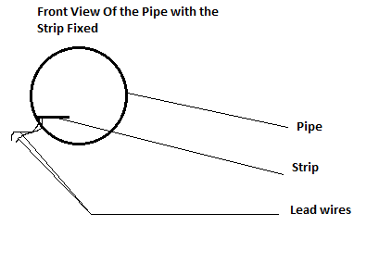
The lead wires are made as small as possible to diminish the Cable Capacitance.
**Proposed experimental setup.
4. Output Analysis:
For our process, the variable to be measured is M, that means M is the input.
This means, the voltage output from the piezoelectric strip will the output.
Thus,
Bending stress of the Cantilever Beam (strip ) will be directly proportional to M.
Bending stress will be directly proportional to V.
M directly proportional to V.
With some mathematical analysis, we can find the exact equation that governs this idea.

5. Conclusion:
- We are using a very small and thin piezoelectric strip. Hence, reducing the cost, in case we use it on a “use-and-throw” basis.The method being cheap, we have already taken care of the problem of Impurity Stagnation on it.
2. Another problem is, how do we fix the strip. If we look into the solution I have said, we need to remove the pipe fittings each time we need to change the strip. I am hereby extending one possible solution :
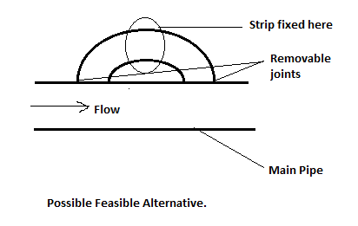
Here, we are diverting a part of flow into a by pass tube and measuring the impurities.

6. References :
[1]. https://en.wikipedia.org/wiki/Piezoelectric_sensor
[2]. http://nzic.org.nz/ChemProcesses/polymers/10H.pdf
[3]. Signal Conditioning Piezoelectric Sensors, Texas Instruments.

