

##### SHRI BHAGUBHAI MAFATLAL POLYTECHNIC

###### SUMMER INPLANT / INTERNSHIP REPORT

Prepared at

COMPANY NAME: Archer Print Innovations

COMPANY ADDRESS: 204/205, Devendra Industrial Estate, Lokmanya Nagar, Pada No.2, Near Yashodhan Nagar Bus Stop, Thane West.

SUBMITTED BY: **JEET PANKAJ SHAH**

ROLL NO: 1991048

SEMESTER: **IV**

GUIDED BY: **MR. ABHIJIT DONGAONKAR**

DURATION

**1ST JULY, 2021 TO 10TH AUGUST, 2021**

DIPLOMA IN

**INFORMATION TECHNOLOGY**

 

###### Shri Vile Parle Kelvani Mandal’s

**SHRI BHAGUBHAI MAFATLAL POLYTECHNIC**

**SUMMER INTERNSHIP DISSERTATION REPORT**

Submitted in partial fulfilment of the requirements of the DIPLOMA Programme by:

|  |  |
| --- | --- |
| NAME OF THE STUDENT | **: Jeet Shah** |
| ROLLNO | **: 1991048** |
| EXAM SEAT NO | **: 1991048** |
| PROGRAMME | **: INFORMATION TECHNOLOGY** |
| SEMESTER | **: IV** |
| ACADEMIC YEAR | **: 2020-2021** |
| NAME OF DEPARTMENT | **: DEPARTMENT NAME IN COMPANY** |
| NAME OF COMPANY | **: Archer Print Innovations** |
| ADDRESS OF COMPANY | **: 204/205, Devendra Industrial Estate, Lokmanya Nagar, Pada No.2, Near Yashodhan Nagar Bus Stop, Thane West** |
| TRAINING PERIOD | **: 1ST JULY 2021- 10TH AUGUST 2021** |

###### THIS IS TO CERTIFY THAT

MR. **JEET PANKAJ SHAH**, Exam Seat No – 1991048 has

satisfactorily completed his summer in plant internship and submitted the DISSERTATION REPORT.

**SUPERVISOR HEAD OF DEPARTMENT (I.T.) PRINCIPAL**

 

###### Shri Vile Parle Kelvani Mandal’s

**SHRI BHAGUBHAI MAFATLAL POLYTECHNIC**

THIS IS TO CERTIFY THAT

**JEET PANKAJ SHAH**

EXAM SEAT NO: 1991048

HAS PREPARED HIS SUMMER INPLANT INTERNSHIP DISSERTION REPORT IN

PARTIAL FULFILMENT OF DIPLOMA PROGRAM IN INFORMATION TECHNOLOGY ENGINEERING,

AND THE SAME IS ASSESSED BY: 1.

2.

I, **JEET PANKAJ SHAH**, ROLL NO **1991048,** A STUDENT OF IV SEMESTER OF DIPLOMA IN INFORMATION TECHNOLOGY HUMBLY STATE THAT, I HAVE COMPLETED FROM TIME TO TIME SUMMER INPLANT INTERNSHIP WORK AS DESCRIBED IN THIS REPORT BY MY OWN SKILLS AND HAS WORKED FROM 1ST JULY, 2021 TO 10TH AUGUST, 2021.

AS PER INSTRUCTIONS AND GUIDANCE OF **MR. UDAY.**

**DATE: SIGNATURE:**

 

###### Shri Vile Parle Kelvani Mandal’s

**SHRI BHAGUBHAI MAFATLAL POLYTECHNIC**

IRLA, VILE PARLE (WEST), MUMBAI – 400 056

CERTIFICATE

THIS IS TO CERTIFY THAT

MR. JEET PANKAJ SHAH

HAS SATISFACTORILY COMPELETED HER INPLANT TRAINING FROM **1ST JULY, 2021 TO 10TH AUGUST, 2021**

AT

Archer Print Innovations

IN PARTIAL FULFILMENT FOR THE DIPOLMA PROGRAMME IN

INFORMATION TECHNOLOGY

**SUPERVISOR H.O.D. (IT) PRINCIPAL**

**Vision of polytechnic:**

**VISION & MISSION**

SBM Polytechnic aspires to be the lead institute in providing need based technical education.

**Mission of polytechnic:**

* To provide state-of-the-art infrastructure and latest equipments for providing a stimulating learning environment.
* To prepare students to meet the dynamic needs of the industry by periodic reviewing and upgradation of curriculum through an interactive process with industry.
* To inculcate a spirit of excellence in terms of academic performance, research and innovation in faculty by providing appropriate support and incentive systems.
* To promote and support Co-Curricular, extra-curricular activities and industry interaction to make students socially sensitive and employable.

Vision of Information Technology Department:

To create a vibrant environment that nurtures logical thinking, dynamism and innovation to transform students into competent IT professionals.

Mission of Information Technology Department:

* To offer high quality, up-to-date knowledge through curriculum, infrastructure and teaching learning process in IT field.
* To equip students with latest skills in the field of technologies supplemented with Practical Oriented approach to face ever evolving challenges in IT industry.
* To facilitate faculty members to keep pace with rapid development through training and higher education, mutually      benefitting students and staff.
* To develop healthy interaction between faculty, students and industry professionals.
* To instil ethical values combined with winning attitude contributing to the welfare of the society while being committed to Life-long Learning

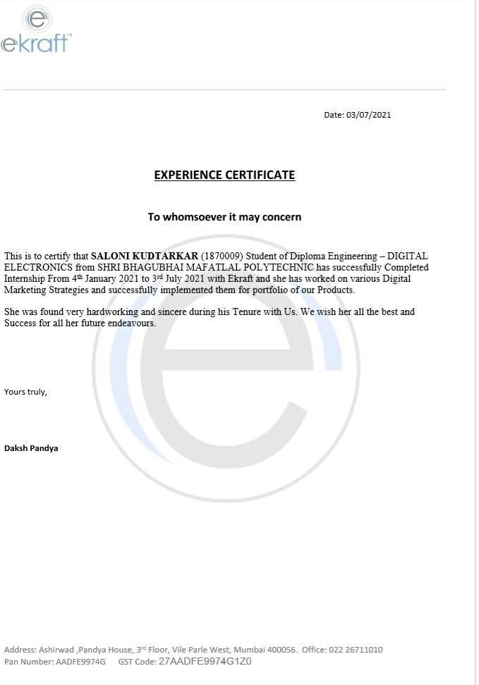

ACKNOWLEDGEMENT

The success and outcome of this internship were possible by the guidance and support from many people. I am incredibly privileged to have got all this along with the achievement of my internship. It required a lot of effort from each individual involved with me for the successful completion of the internship. I would like to express my gratitude towards all the people who have lent support and helped me to undergo this internship successfully.

I appreciate and thanks **Mr Mohammed Zafar Shaikh** (Principal), **Mrs. Neeta Kadukar** (H.O.D.) and also my training supervisor **Mr. Abhijit Dongaonkar** of **SHRI BHAGUBHAI MAFATLAL POLYTECHNIC** for granting me the opportunity to undergo this internship successfully and providing us with all support and leadership I perceive this opportunity as a big milestone in my career development. I will strive to use gained skills and knowledge in the best possible way, and will continue to work on their improvement, in order to attain desired career objectives.

It is a great pleasure to present this report, a written testimony of real fruitful & valuable internship. I offer my profound gratitude to the management of **Archer Print Innovations** for providing me with summer in-plant internship in their _______**department.** On completion of my internship, I have personally experienced the linkage between theoretical knowledge and its practical implication.

I am extremely thankful to **Mr. Uday** who gave me an opportunity to work in such a highly esteemed organization with their ever-helpful guidance, motivations throughout the internship period. His valuable support helped me to complete my task successfully.

# INDEX

|  |  |  |
| --- | --- | --- |
| **Sr. No.** | **CONTENTS** | **Page. No** |
| **1.** | **Company Profile, work domain and product/services** |  |
| **2.** | **Work Assigned by the Company:**   1. **Problem Definition** 2. **Requirements** |  |
| **3.** | **Platforms/ Technologies:**   1. **Front End Technologies** 2. **Back End Technologies** |  |
| **4.** | **Modules Implemented during Internship**   1. **Modules** 2. **Coding(optional) & Control/Design Flow diagrams** |  |
| **5.** | **Snapshots of work done with brief description** |  |
| **6.** | **Experience/Learning from Internship** |  |
| **7.** | **Conclusion** |  |

**LOGO OF COMPANY**

PROFILE,WORKDOMAIN AND PRODUCTS/SERVICES OF COMPANY NAME