|  |  |  |
| --- | --- | --- |
|  | Shri Vile-Parle Kelavani Mandal’s  **Shri Bhagubhai Mafatlal Polytechnic**  **INTERNSHIP 2021** | **C:\Users\nitin.farkade\Desktop\Home_Home_logo1.jpg** |

**INTERNSHIP QUIZ #2**

**Programme:- Diploma in Information Technology**

|  |  |
| --- | --- |
| **Name of the Student : Jeet Shah** | **Roll Number : 1991048** |
| **Name of the Internal Supervisor: Mr Abhijit Dongaokar** | **Company: Archer Print Innovation** |
| **Name of the Company Supervisor: Mr. Uday** | **Date of Joining: 2nd July 2021** |

**Q1) Role and responsibilities?**

=

Our main role is to make the website for this gift shop and responsibility is to complete the work given by the company on time.

**Q2) Outline of design and technology used?**

=

Outline of the design

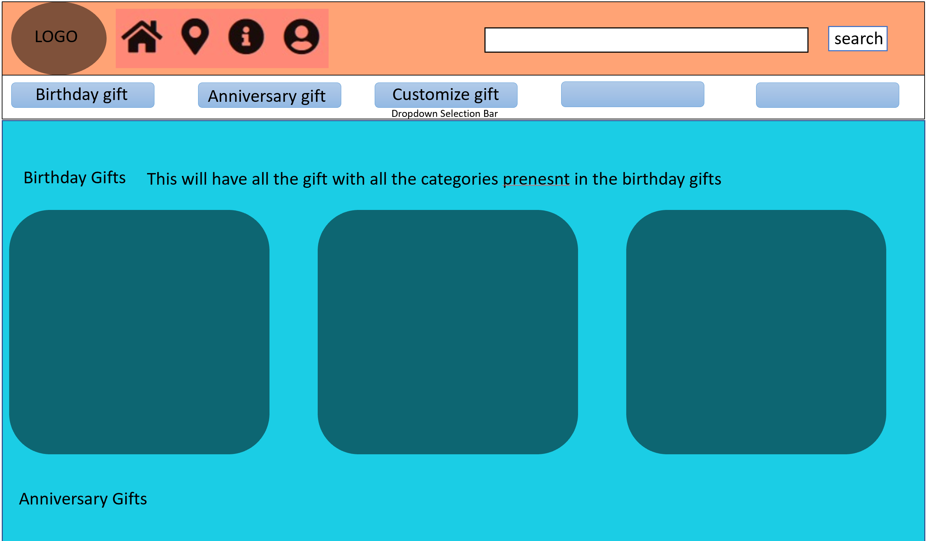

Technology used – HTML5, CSS3, Bootstrap 4, Javascript.

**Q3) Tools and coding strategy?**

=

Tool used is VS Code to do the coding part because it is easier to use and we have divided the coding part among us so the work can be done simultaneously.

**Q4) Work done till now?**

=

Till now we have created Home page, navbar, selection bar, made it responsive and designed it using CSS.

**Q5) Screenshot of the work done**

=

