EDA REPORT
Factory Reallocation & Shipping Optimization
Recommendation System
Nassau Candy Distributor
Exploratory Data Analysis • Business Insights • Data Quality • Decision Intelligence
_________________________________________________________________________________________________

1. Executive Summary
The analysis is designed to move Nassau Candy Distributor from descriptive reporting toward decision intelligence: understanding shipping performance, identifying operational variation, predicting lead time, and recommending an alternative factory when the predicted lead time improves sufficiently.
- The cleaned analytical dataset contains 10,194 rows and 25 columns in the recommendation-engine workflow, with 8,549 unique orders and 15 products.
- Actual Lead_Time is available for 4,130 rows in the preprocessing workflow; its mean is 1,366.01 days, median 1,361 days, and 90th percentile 1,785 days.
- The five-factory scenario engine expands 10,194 observations into 50,970 factory scenarios—five candidate factories for each observation.
- The improved Random Forest lead-time model is the strongest tested model: MAE 138.59, RMSE 172.15, and R² 0.687.
- The recommendation engine marks 4,163 of 8,549 orders for reassignment and 4,386 to remain at their current factory.
- At product level, 8 of 15 products are recommended for reassignment, giving 53.33% recommendation coverage.
- Across the evaluated orders, average predicted lead time falls from 1,486.41 to 1,479.30 days: an average reduction of 7.11 days, or 0.48%.
Business message: The system finds many order-level reassignment opportunities, but the overall average predicted improvement is modest. Therefore, recommendations should be prioritized by product/order-level improvement rather than treating every reassignment as equally valuable.

2. Dataset Understanding
The preprocessing notebook starts from the Nassau Candy Distributor data and cleans it for modeling. The original raw extract has 10,194 records and 18 columns. The modeling dataset adds engineered shipping and profitability variables, resulting in 23 columns at the preprocessing stage and 25 columns in the recommendation-engine dataset after factory/location fields are included.
Data area | Key fields
Order & shipment | Order ID, Order Date, Ship Date, Ship Mode
Customer geography | Country/Region, City, State/Province, Postal Code, Region
Product | Product ID, Product Name, Division
Financial | Sales, Units, Gross Profit, Cost, Unit Price, Profit Margin, Cost Percentage
Operational / modeling | Factory, Factory latitude/longitude, Lead_Time
The recommendation model uses categorical variables such as Product ID, Product Name, Division, Region, State/Province, Ship Mode and Factory, plus numerical variables such as Sales, Units, Cost, Gross Profit, Profit Margin, Cost Percentage, Unit Price and engineered order-date features.

3. Data Quality & Preprocessing Findings
The preprocessing notebook reports no missing values in the initial 18-column raw extract. However, after date conversion and Lead_Time creation, only 4,130 rows have non-null Order Date/Lead_Time in the analyzed workflow. This is a material analytical issue because actual shipping lead-time analysis and model validation depend on those parsed dates.
- The notebooks explicitly parse Order Date and Ship Date into datetime and calculate Lead_Time as Ship Date minus Order Date.
- The preprocessing output shows 10,194 rows, but only 4,130 non-null Order Date values and 4,130 non-null Lead_Time values after conversion.
- The notebooks contain date-parsing warnings, including ambiguity around day-first date formats. This should be resolved before production deployment.
- Ship Date values extend to 2030 in the preprocessing output, while Order Date values cover 2024–2025. This creates extremely large observed lead times and should be validated against the source business system.
- Duplicate removal is performed before feature engineering.
- Profit Margin = Gross Profit / Sales; Cost Percentage = Cost / Sales; Unit Price = Sales / Units.
- The factory assignment is derived from a product-to-factory mapping for the five-factory optimization framework.
Recommendation: Standardize the source date format (for example, ISO YYYY-MM-DD), validate shipment dates against order dates, and reconcile why a large share of rows loses Lead_Time after parsing. This is the highest-priority data-quality control.

4. Univariate & Distribution Analysis

4.1 Shipping Lead Time
Statistic | Lead_Time (days)
Minimum | 613.00
25th percentile | 1155.00
Median | 1361.00
Mean | 1366.01
75th percentile | 1598.00
90th percentile | 1785.00
95th percentile | 1870.00
99th percentile | 1932.00
Maximum | 1965.00
The actual Lead_Time distribution is wide: from 613 to 1,965 days. The median is close to the mean, but the upper tail remains substantial, with 10% of observed values above 1,785 days. For operations, this indicates that the dataset contains a large long-lead-time segment rather than a narrow, stable delivery process.

4.2 Financial and Volume Variables
Metric | Mean | Minimum | Maximum
Sales | 13.9085 | 1.2500 | 260.0000
Units | 3.7918 | 1.0000 | 14.0000
Gross Profit | 9.1665 | 0.2500 | 130.0000
Cost | 4.7421 | 0.6000 | 130.0000
Profit Margin | 0.6651 | 0.0769 | 0.8000
Cost Percentage | 0.3349 | 0.2000 | 0.9231
Unit Price | 3.6543 | 1.2500 | 20.0000
The dataset is dominated by small transaction-level quantities: mean Units is about 3.79 and median Units is 3. Profitability is generally strong in the derived fields, with mean Profit Margin around 66.5%, but the wide range indicates meaningful product/order-level variation.

5. Regional Analysis
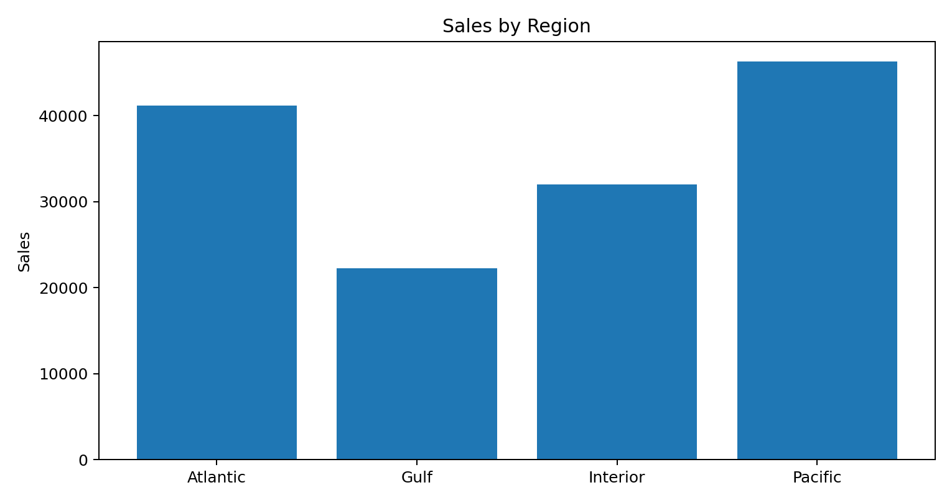
Region | Sales | Profit | Average Lead Time
Atlantic | $41,197.24 | $26,973.70 | 1323.48
Gulf | $22,247.26 | $14,700.67 | 1309.43
Interior | $32,037.60 | $21,282.49 | 1310.29
Pacific | $46,301.53 | $30,485.94 | 1327.09
Pacific has the highest sales ($46,301.53) and profit ($30,485.94), followed by Atlantic. Gulf has the lowest sales and profit among the four regions. Average lead time varies much less by region than financial performance: Pacific is highest at about 1,327.09 days, while Gulf is lowest at about 1,309.43 days.
Business insight: Regional demand concentration matters for factory allocation, but region alone does not explain the full shipping problem. Product, factory, ship mode and geography should be considered together.

6. Product-Level Analysis
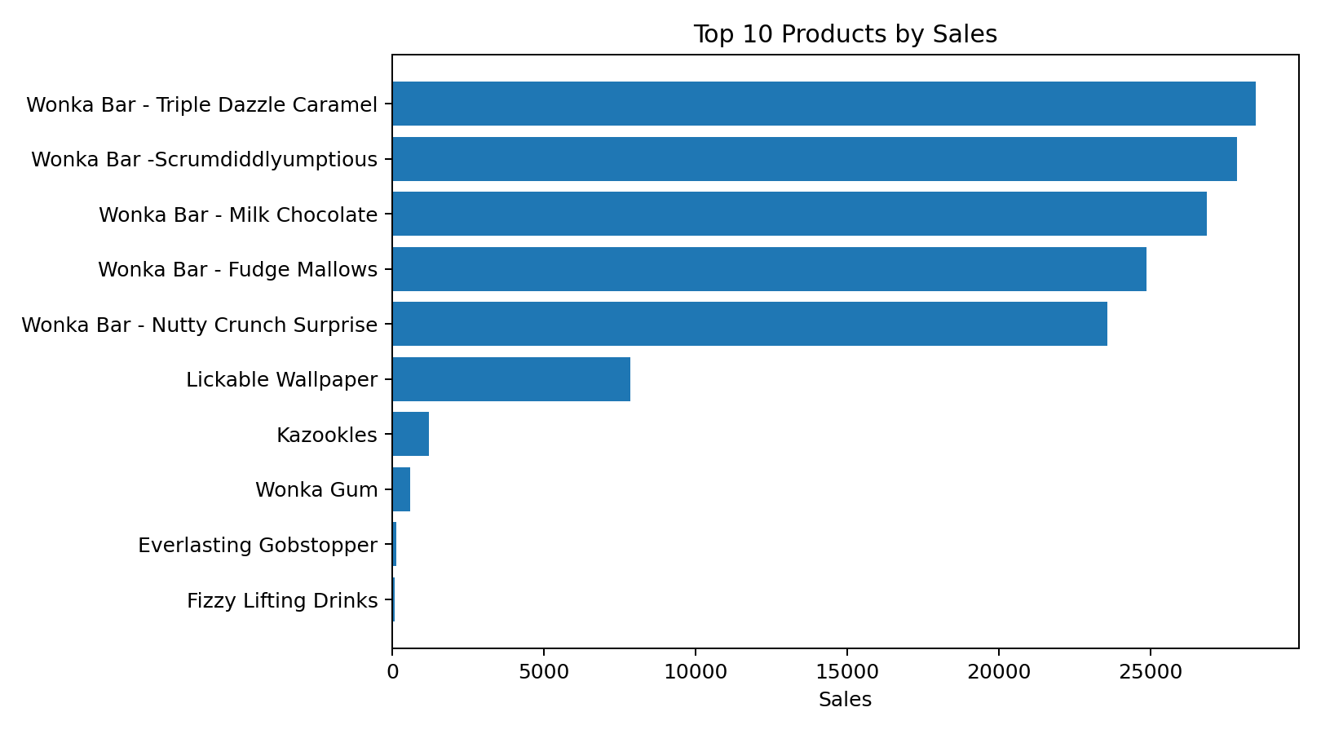
The product portfolio is highly concentrated in five Wonka Bar products. These products account for the overwhelming majority of the sales shown in the EDA product aggregation.
Product | Orders | Sales | Profit | Avg Lead (days) | Sales Share %
Wonka Bar - Triple Dazzle Caramel | 1677 | $28,485.00 | $18,610.20 | 1331.80 | 20.09%
Wonka Bar -Scrumdiddlyumptious | 1704 | $27,874.80 | $19,357.50 | 1321.18 | 19.66%
Wonka Bar - Milk Chocolate | 1768 | $26,867.75 | $17,443.37 | 1306.02 | 18.95%
Wonka Bar - Fudge Mallows | 1527 | $24,890.40 | $16,593.60 | 1315.15 | 17.56%
Wonka Bar - Nutty Crunch Surprise | 1529 | $23,574.95 | $16,819.95 | 1319.57 | 16.63%
- Wonka Bar - Triple Dazzle Caramel leads sales at $28,485 and generates $18,610.20 profit.
- Wonka Bar -Scrumdiddlyumptious generates the highest product-level profit in the EDA table at $19,357.50.
- Wonka Bar - Milk Chocolate has the highest order count at 1,768 and an average lead time of about 1,306 days.
- Fizzy Lifting Drinks, Hair Toffee and Laffy Taffy show relatively high average lead times but very small sales bases, so their operational priority should depend on service criticality rather than revenue alone.
- Lickable Wallpaper is the largest non-Wonka-Bar sales contributor in the EDA table at $7,860.

7. Factory & Reallocation Analysis

7.1 Current Factory Concentration
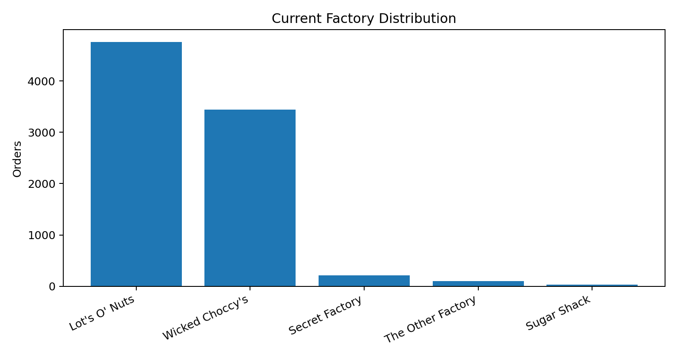
Current Factory | Orders
Lot's O' Nuts | 4760
Wicked Choccy's | 3445
Secret Factory | 213
The Other Factory | 98
Sugar Shack | 33
Current assignments are heavily concentrated in Lot's O' Nuts and Wicked Choccy's. Together they account for 8,205 of 8,549 unique evaluated orders (about 96.0%). This concentration creates a strong opportunity for load balancing if alternative factories can provide better predicted service.

7.2 Recommended Reassignment Mix
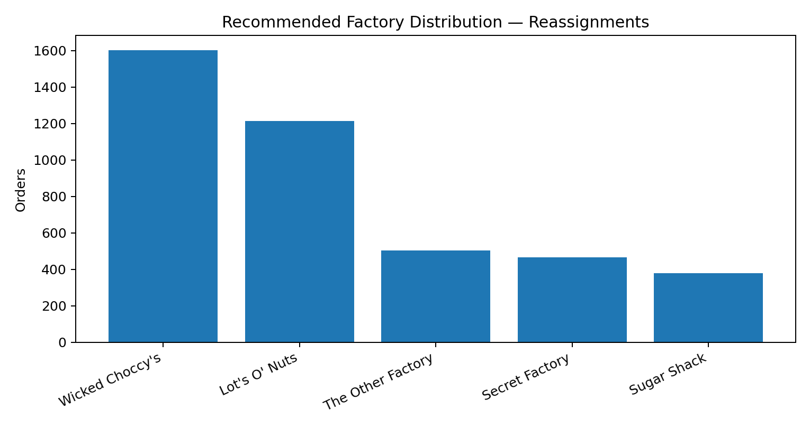
Recommended Factory | Reassigned Orders
Wicked Choccy's | 1602
Lot's O' Nuts | 1213
The Other Factory | 503
Secret Factory | 465
Sugar Shack | 380
Among reassigned orders, Wicked Choccy's receives the largest recommended share (1,602), followed by Lot's O' Nuts (1,213). The Other Factory, Secret Factory and Sugar Shack also absorb recommendations, indicating that the engine can diversify assignments rather than simply moving all work to one facility.

8. Recommendation Engine KPIs
KPI | Value
Orders evaluated | 8,549
Orders to reassign | 4,163
Orders to keep | 4,386
Reassignment rate | 48.70%
Products evaluated | 15
Products recommended | 8
Product recommendation coverage | 53.33%
Avg current predicted lead time | 1,486.41 days
Avg recommended predicted lead time | 1,479.30 days
Avg predicted reduction | 7.11 days
Overall predicted reduction | 0.48%
The recommendation logic requires a factory change and at least a 0.10% predicted lead-time improvement. This is a deliberately low threshold, so a high reassignment count does not necessarily mean a large business benefit.
Important interpretation: The 48.70% reassignment rate and 0.48% overall average reduction should not be presented as a 48.70% service improvement. They measure recommendation volume and average predicted lead-time change, respectively.

9. Predictive Model Findings
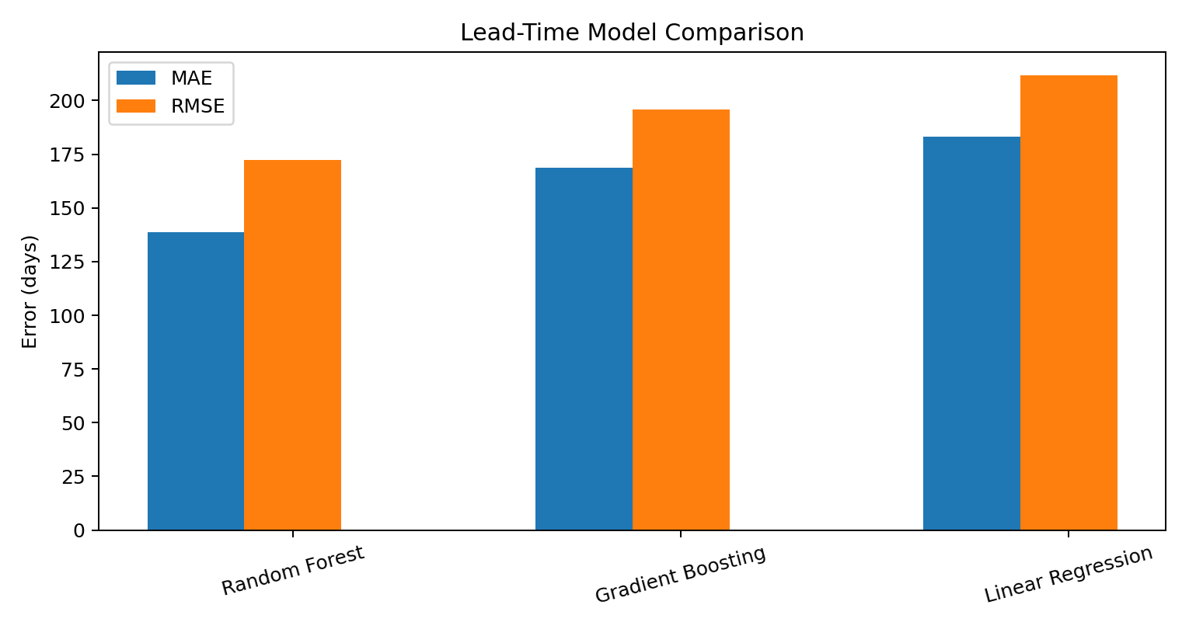
Model | MAE | RMSE | R2
Random Forest | 138.59 | 172.15 | 0.69
Gradient Boosting | 168.66 | 195.80 | 0.60
Linear Regression | 183.32 | 211.91 | 0.53
The improved Random Forest model is the best-performing tested model. Its R² of 0.687 indicates that it explains about 68.7% of the variance in the held-out Lead_Time target under the notebook's train/test setup. Its MAE is 138.59 days and RMSE is 172.15 days.
- The first model version performed poorly: Linear Regression had R² -0.008, Gradient Boosting -0.037, and Random Forest -0.174.
- The improved workflow adds product, state, ship mode and factory categorical features plus Order Year, Month, Quarter and Day of Week.
- The improved Random Forest substantially outperforms Gradient Boosting and Linear Regression on the reported test split.
- Because the target has very large day-scale values and the date parsing has known issues, model performance should be revalidated after date-quality correction.

10. Business Insights & Recommended Actions
Prioritize high-value reassignment opportunities: Rank recommendations by predicted Lead_Time Reduction, revenue, gross profit and service criticality. Do not treat every reassignment equally.
Reduce factory concentration: Lot's O' Nuts and Wicked Choccy's dominate the current order allocation. Use validated reassignment opportunities to balance load across the five factories.
Protect the core Wonka Bar portfolio: The five leading Wonka Bar products drive most of the EDA sales. Even small service improvements for these products can have greater business impact than optimizing low-volume SKUs.
Create a minimum-improvement policy: The current 0.10% threshold can generate marginal reassignments. Consider a business-approved threshold such as a minimum number of days saved, combined with profit and operational constraints.
Validate factory feasibility: A recommendation should be executed only if the destination factory can actually manufacture the product, has capacity, and meets quality/service requirements. The notebook's scenario engine changes Factory as a what-if variable; it does not demonstrate real capacity constraints.
Fix date quality before production: The mismatch between raw date availability and parsed Lead_Time availability can distort both EDA and model training. Standardize dates and reconcile future shipment dates.
Monitor model drift: Track MAE/RMSE and actual-versus-predicted lead time by factory, product and region after deployment.
Use a decision score: A production recommendation can combine service gain, profit protection, factory capacity and reassignment cost into one business score.

11. Analytical Limitations
- The supplied notebooks are the authoritative basis for this report; no external business data was used.
- The report uses the outputs already recorded in the notebooks rather than inventing unavailable raw-data statistics.
- The scenario engine evaluates five candidate factories per observation, but the supplied workflow does not demonstrate production capacity, manufacturing constraints, inventory availability, or explicit reassignment cost.
- The notebook notes that region centroids may be used when customer coordinates are unavailable; this assumption should be stated when geographic distance is used in the decision process.
- The recommendation engine's overall 0.48% reduction is based on predicted lead time, not realized post-reallocation performance.
- Date parsing warnings and missing Lead_Time after conversion require resolution before treating the model as production-ready.

12. Conclusion
The EDA establishes a clear decision-intelligence opportunity: shipping performance varies substantially, product demand is concentrated, and current factory assignments are highly concentrated. The improved Random Forest model provides a materially stronger lead-time prediction than the initial tested models, enabling a five-factory what-if simulation. The recommendation engine identifies 4,163 order-level reassignment opportunities across 8 of 15 products. However, the overall predicted average improvement is only 0.48%, so the business value will come from prioritizing the strongest individual opportunities and adding real-world constraints—not from maximizing the number of reassignments.

Source Files Used
- EDA.ipynb — exploratory regional, product, lead-time and correlation analysis.
- Data_preprocessing (1).ipynb — cleaning, feature engineering and data-quality outputs.
- Model_Training.ipynb — model training and evaluation.
- Factory_Optimization.ipynb — five-factory scenario simulation.
- Recommendation_engine.ipynb — order/product recommendations and KPI summaries.

