Software Testing Report - Login Module
Module: Login
Test Case ID: Practice
Tester: Jeet
Description: Verify the Login page functionality.

Preconditions
- Network stability
- Browser open on login page
- Windows environment

Test Execution Summary
ID | Step | Expected | Actual | Status | Remarks
M1 | Enter username | Accepted | Entered successfully | Pass | OK
M2 | Enter password | Accepted | Entered successfully | Pass | OK
M3 | Submit | Login submitted | Submitted | Pass | OK
M4 | Check UI | Attractive UI | Not attractive | Fail | Improve UI
M5 | Consistency | Consistent | Not consistent | Fail | Fix styling
M6 | Navigation | Accessible | Accessible | Pass | OK
M7 | Home & Contact | Available | Not available | Fail | Add pages
M8 | Logout | Logout | Logged out | Pass | OK

Scenario ID: M1
Scenario: Enter username
Test Step: Enter username
Screenshot:
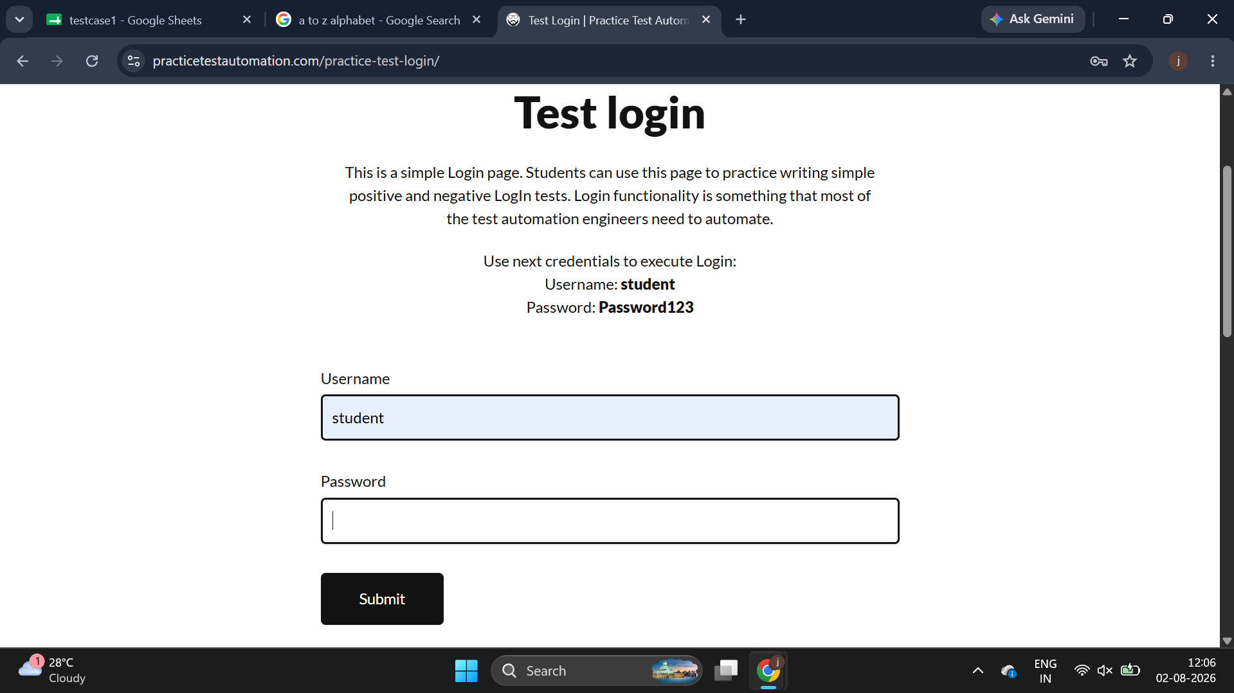

Scenario ID: M2
Scenario: Enter Password
Test Step: Enter Password
Screenshot:

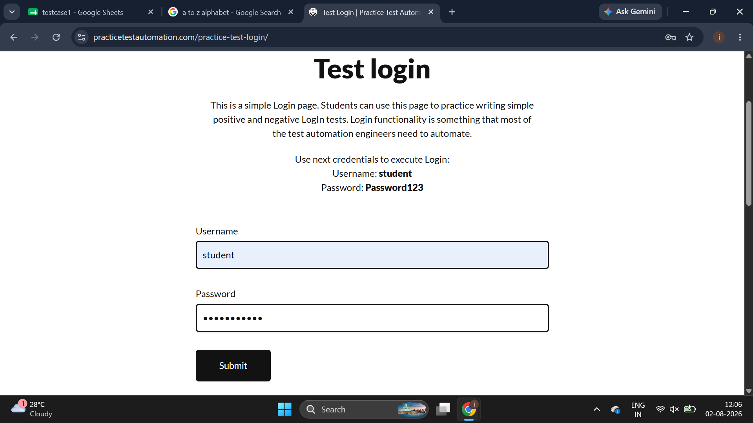
Scenario ID: M3
Scenario: Click on Submit
Test Step: Click on Submit
Screenshot:
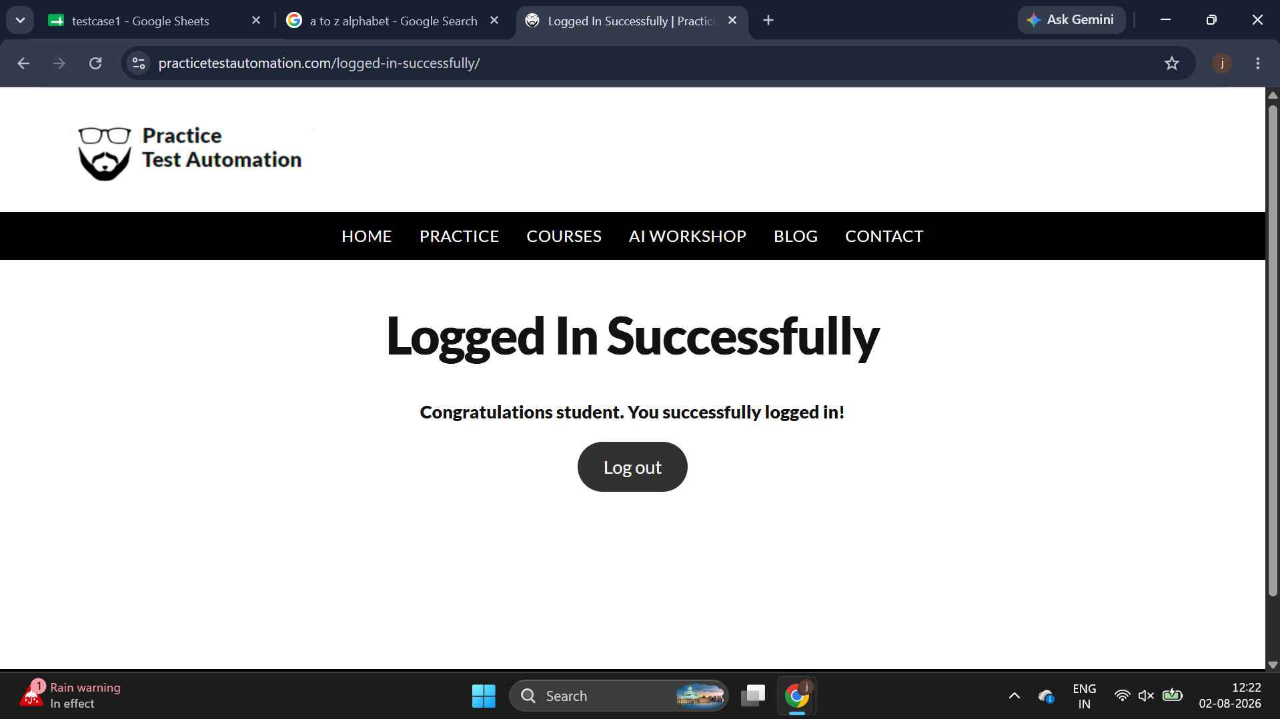

Scenario ID: M4
Scenario: Check UI
Test Step: Attractive website colors, text
Screenshot:

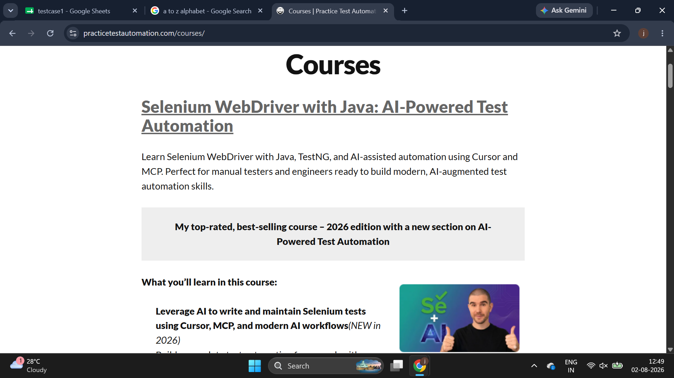
Scenario ID: M5
Scenario: Check consistancy
Test Step: Attractive pages
Screenshot:

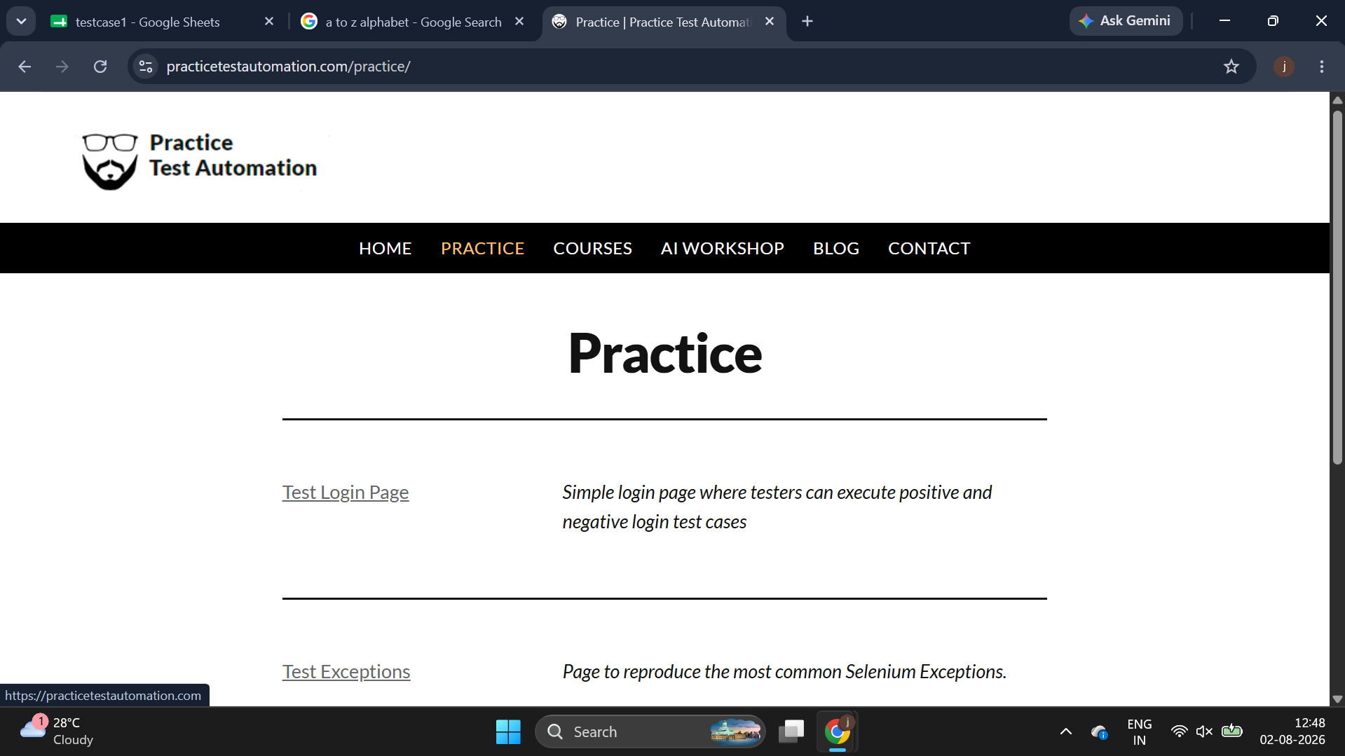
Scenario ID: M6
Scenario: Navigation
Test Step: Accessable navvigation bar
Screenshot:
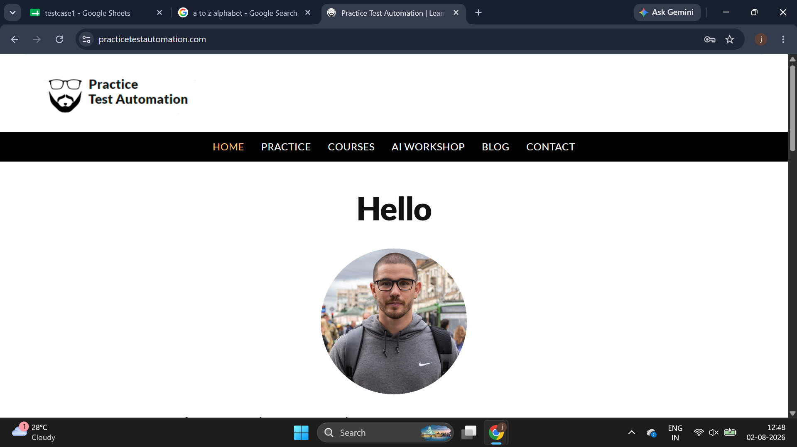
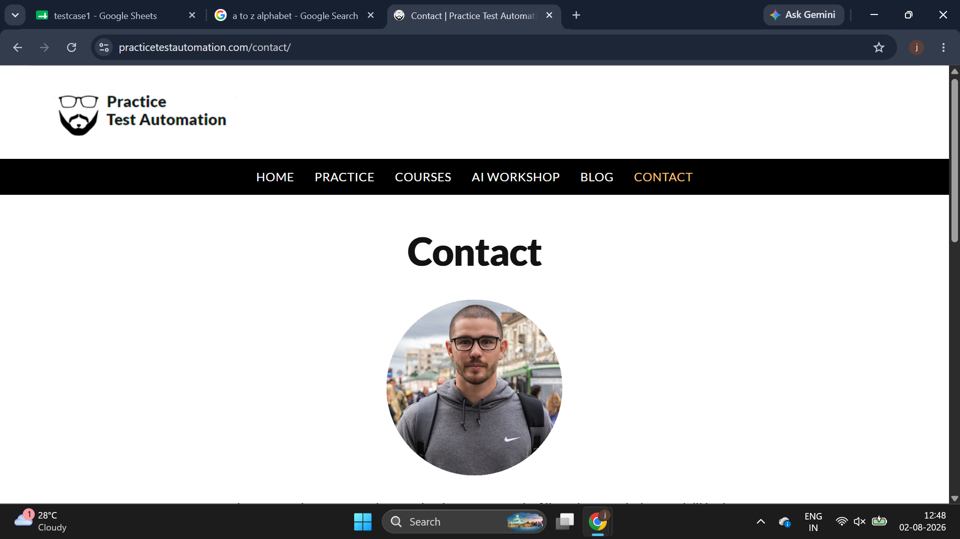
Scenario ID: M7
Scenario: Home and Contact page
Test Step: Required information
Screenshot:

Scenario ID: M8
Scenario: Click on Logout
Test Step: Click on Logout
Screenshot:

Summary
Total: 8
Passed: 5
Failed: 3
Pass Rate: 62.5%

Recommendations
- Improve UI design.
- Ensure text/color consistency.
- Implement Home and Contact pages.
- Re-test failed cases after fixes.

