MANUAL TEST EXECUTION REPORT

Demo Web Application – SauceDemo

1. Aim
To execute manual test cases for the SauceDemo web application, verify the login and shopping workflow, compare expected and actual results, and prepare a Test Execution Report and Test Summary Report with screenshots.

2. Application Details
Field | Details
Project Name | Demo Web Application
Application / Software | Web-Based Application
Module Name | Login and Shopping
SDLC Model | Agile Model
Programming Language | Java, Python, JavaScript
IDE / Tool Used | Google Sheets, Google Docs
Input / Test Data | Username, Password, Product Details, Order Information
Website | https://www.saucedemo.com/

3. Test Execution Report
Scenario ID | Test Steps | Test Inputs | Expected Result | Actual Result | Status
M1 | Open website | Login page | Login page displayed | Displayed | Pass
M2 | Enter username | standard_user | Valid username entered | Valid | Pass
M3 | Enter password | secret_sauce | Valid password entered | Valid | Pass
M4 | Click Login | Entered credentials | Products page displayed | Entered | Pass
M5 | Select product / Add to cart | Add product to cart | Product added to cart | Added to cart | Pass
M6 | Remove from cart | Remove product from cart | Product removed from cart | Removed | Pass
M7 | Place order | Order information page | Page displayed | Displayed | Pass
M8 | Input information | Enter valid information | Information entered | Entered | Pass
M9 | Checkout overview | Product information for order placement | Information displayed | Entered | Pass
M10 | Order placed | Successfully place order | Order placed | Order placed | Pass
Note: The actual results and statuses above are transcribed from your supplied spreadsheet screenshots. They have not been independently retested.

4. Screenshot Evidence

Screenshot 1: Test Cases M1–M8
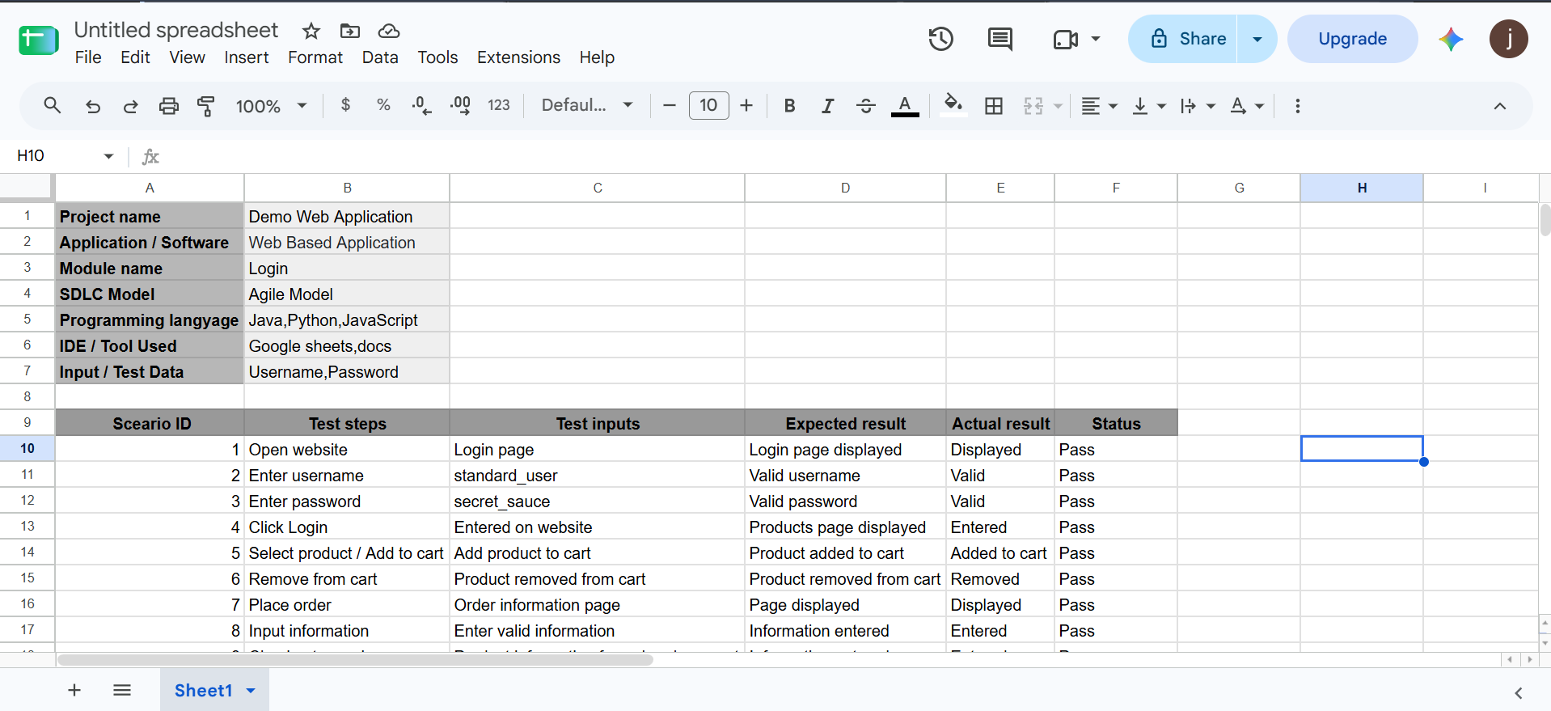

Screenshot 2: Test Cases M1–M10
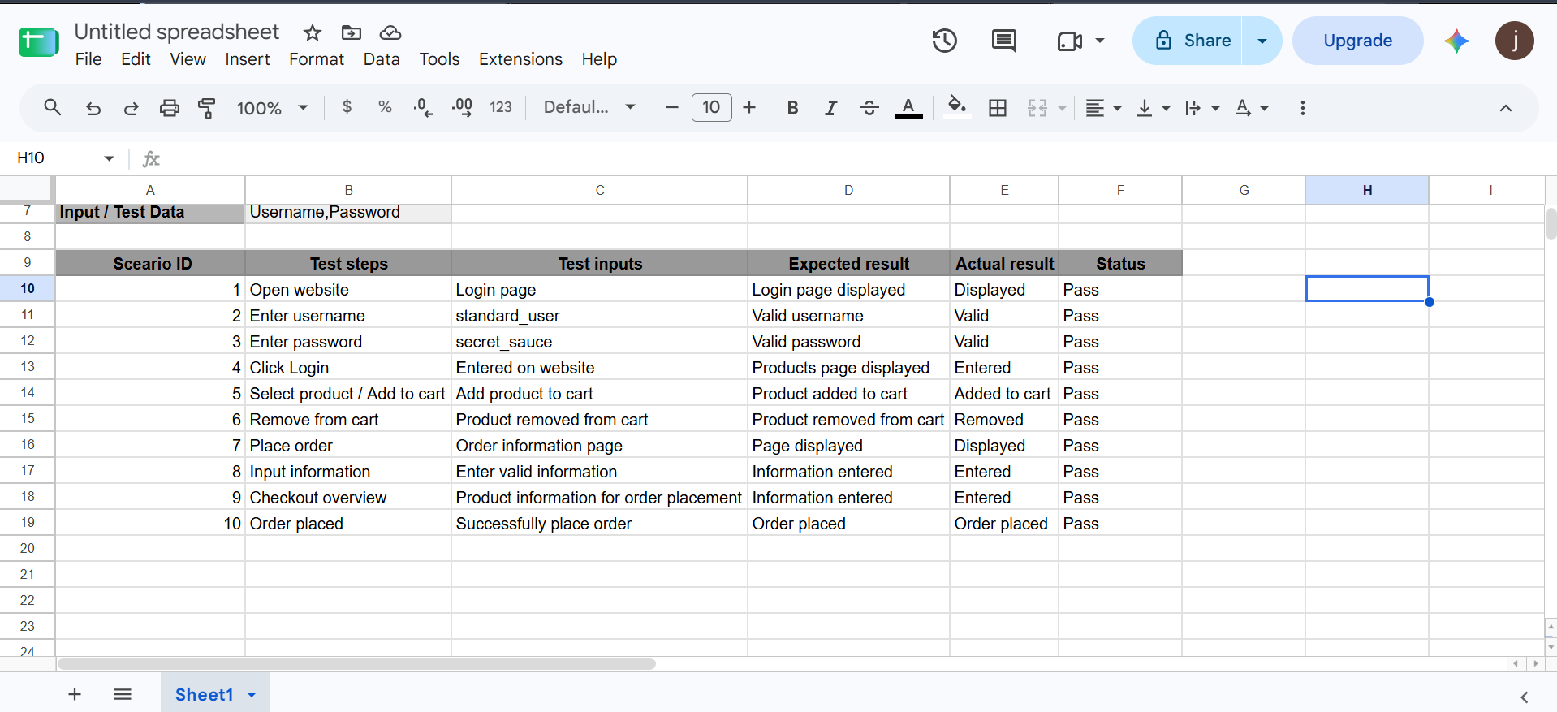

5. Individual Test Case Screenshot Sections
Add the corresponding actual SauceDemo application screenshot under each test case when preparing the final report.

M1 – Open Website
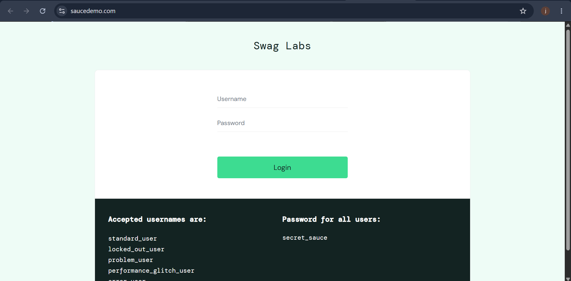

M2 – Enter Username
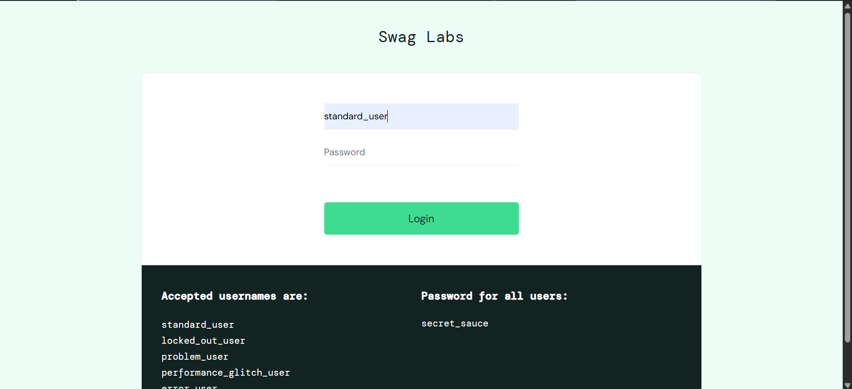

M3 – Enter Password
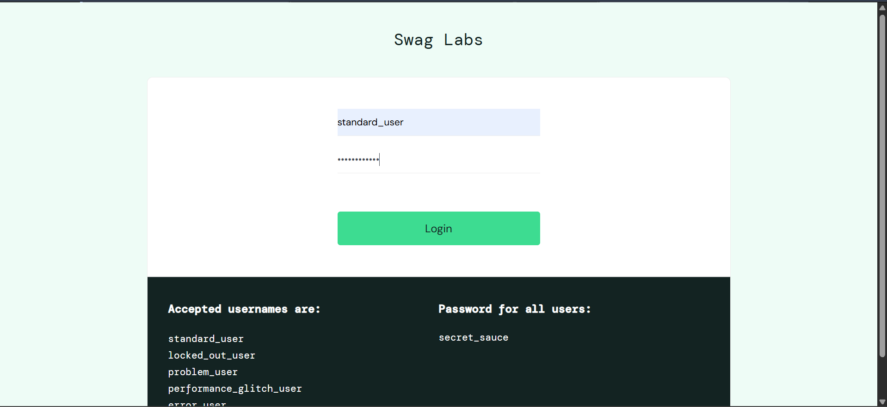

M4 – Click Login
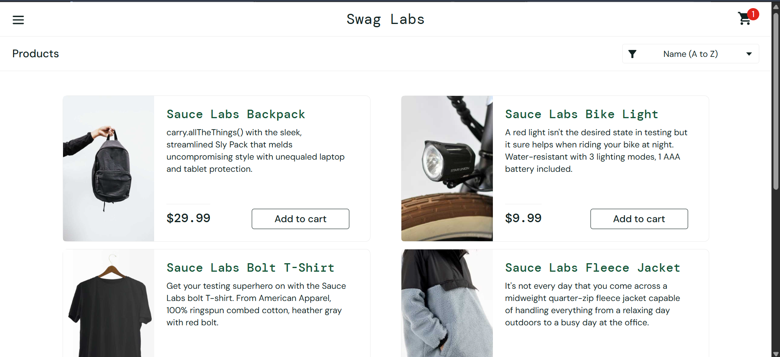

M5 – Add Product to Cart
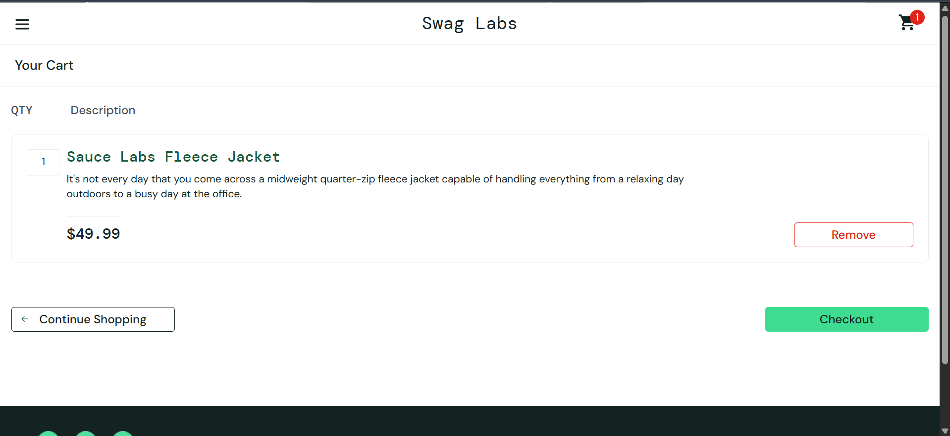

M6 – Remove Product from Cart
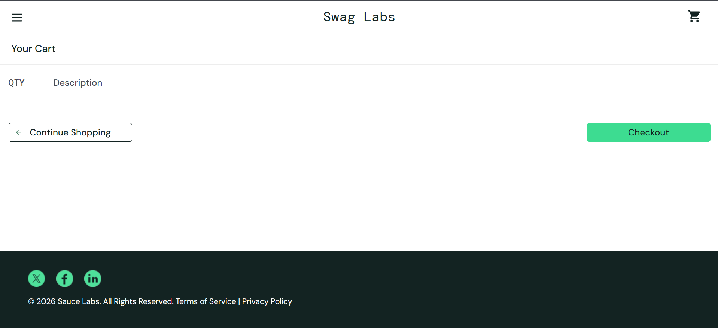

M7 – Place Order
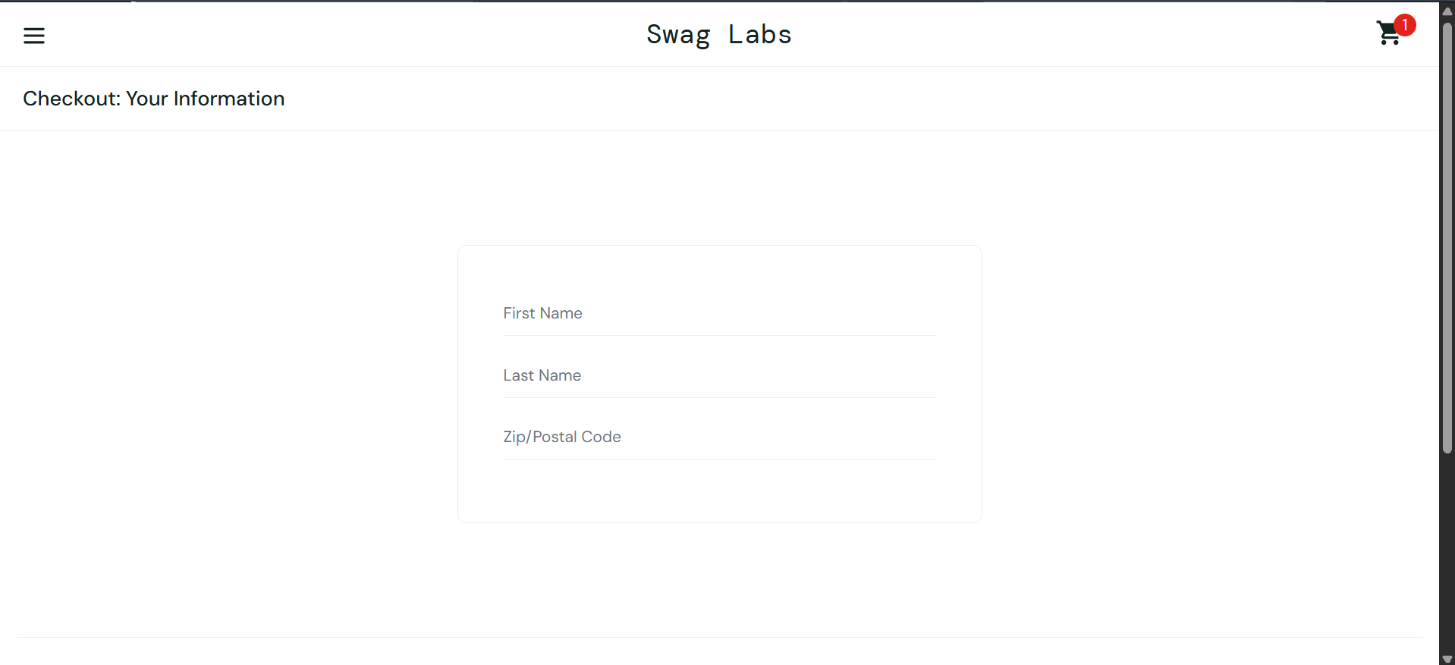

M8 – Input Information
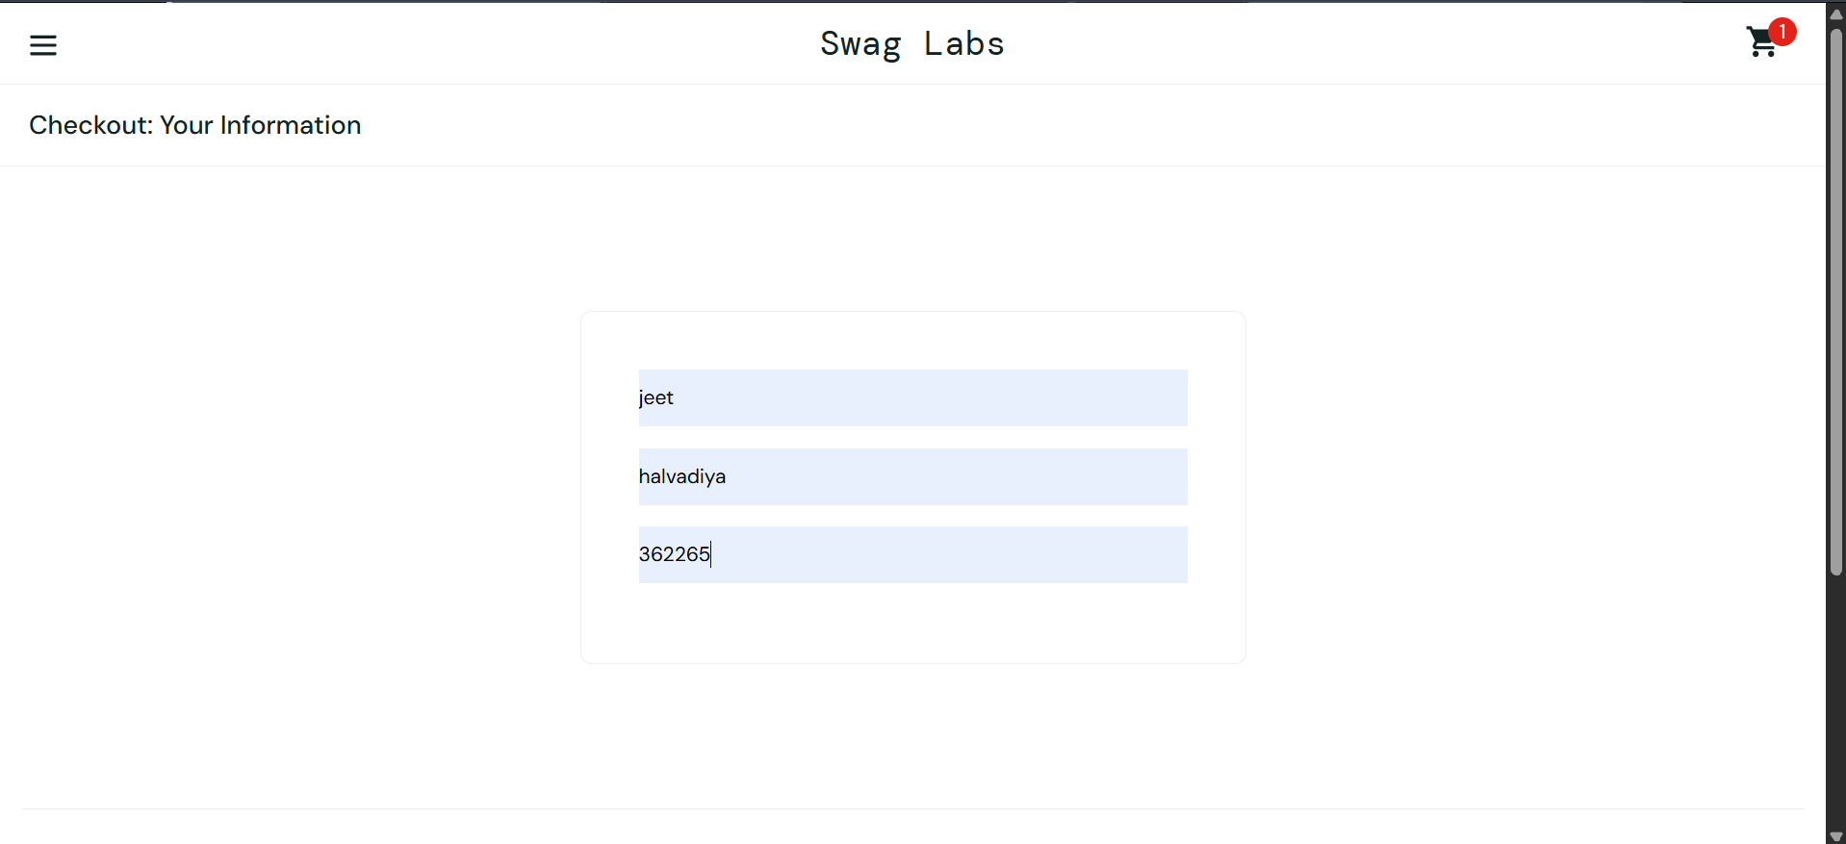

M9 – Checkout Overview
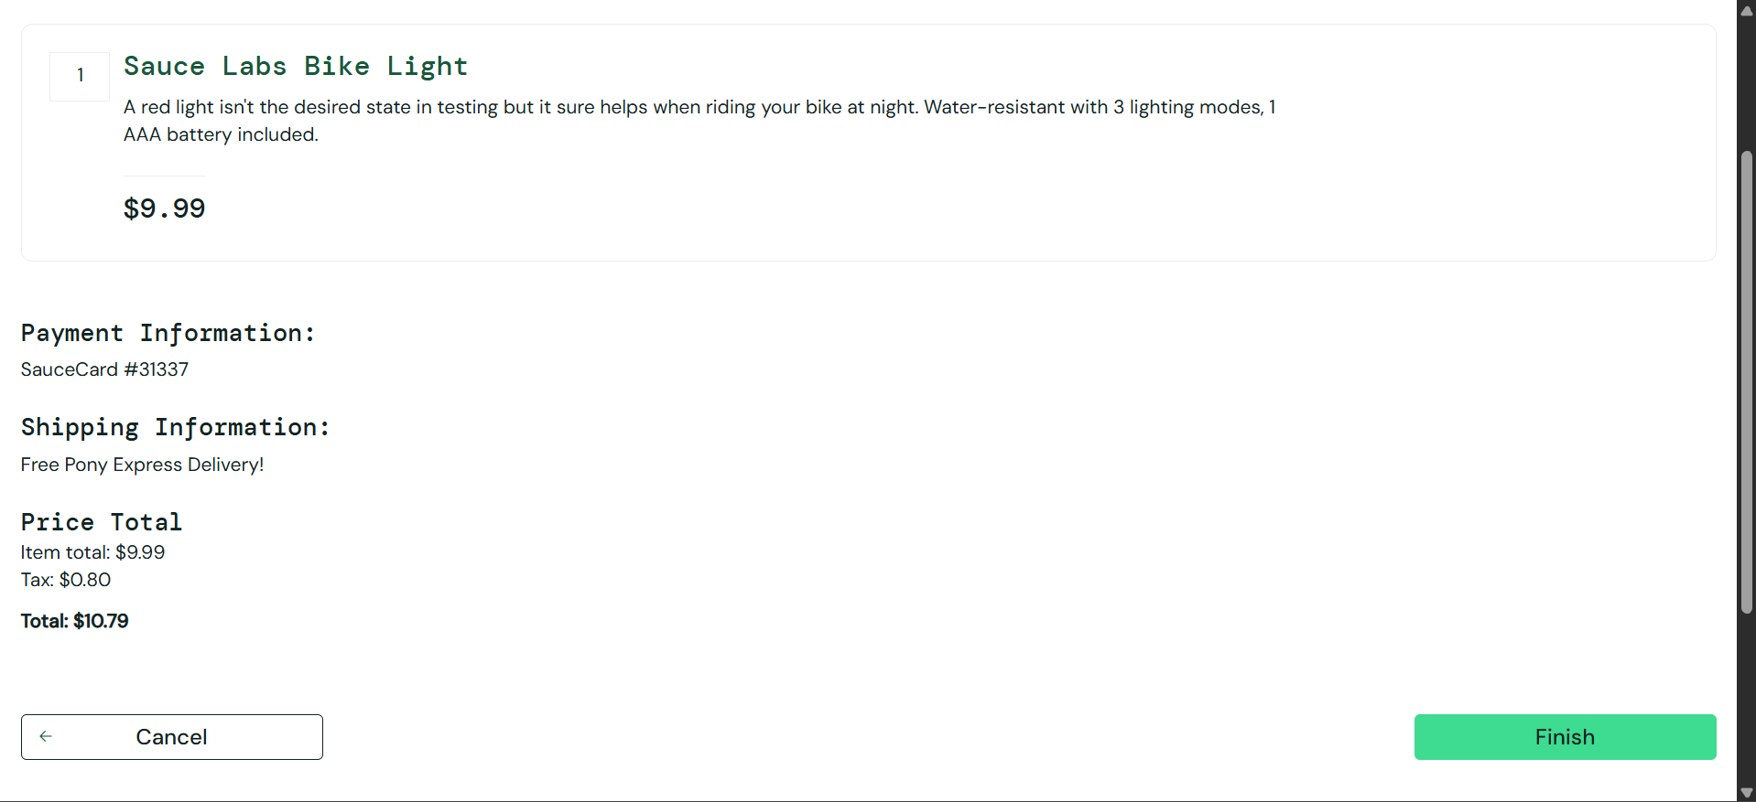

M10 – Order Placed
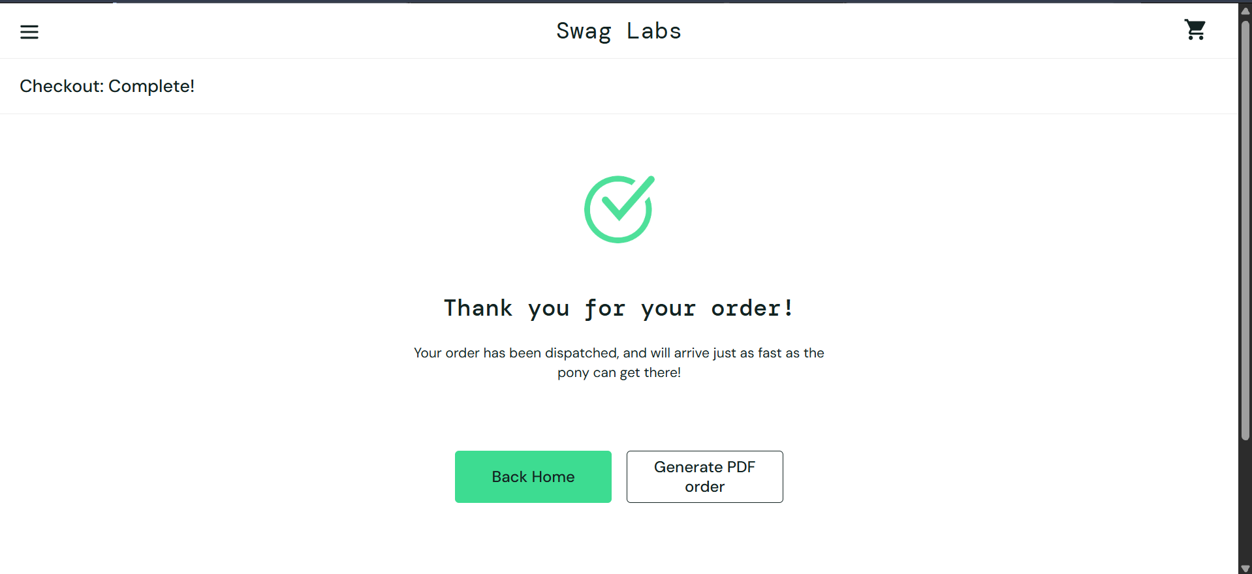

6. Test Summary Report
Test Summary | Result
Total Test Cases | 10
Passed Test Cases | 10
Failed Test Cases | 0
Blocked Test Cases | 0
Pass Percentage | 100%*
*Calculated from the statuses recorded in your spreadsheet.

7. Conclusion
Manual testing was documented for 10 test cases covering website access, login credentials, product addition and removal, checkout information, checkout overview, and order completion. According to the supplied spreadsheet, all 10 test cases passed.
Screenshot note: The two uploaded images are screenshots of the Google Sheets test report, not screenshots of each individual application test. Place the original spreadsheet screenshots in Section 4 and capture the actual SauceDemo pages for the individual evidence sections in Section 5. No bug report is included, as requested.

