Software Testing Report - Login Module (MJ002)
1. Test Case Information
Module Name: Login
Test Case ID: MJ002
Tester: Jeet
Description: To check the login page
Environment: Windows
Preconditions:
- Stable Network
- Browser opened on Login page
2. Test Case Screenshot
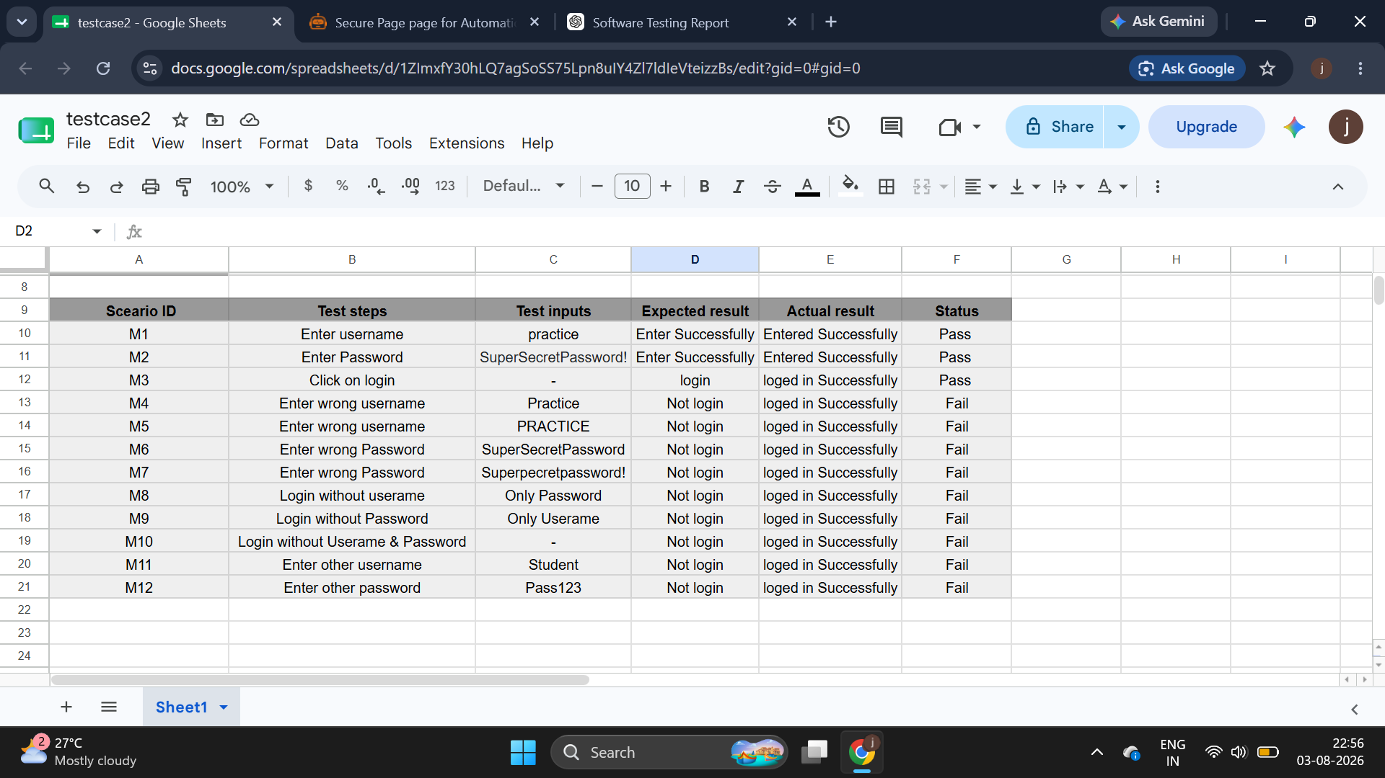

Scenario ID: M1
Scenario: Enter Username
Test Step: Enter Username
Screenshot:
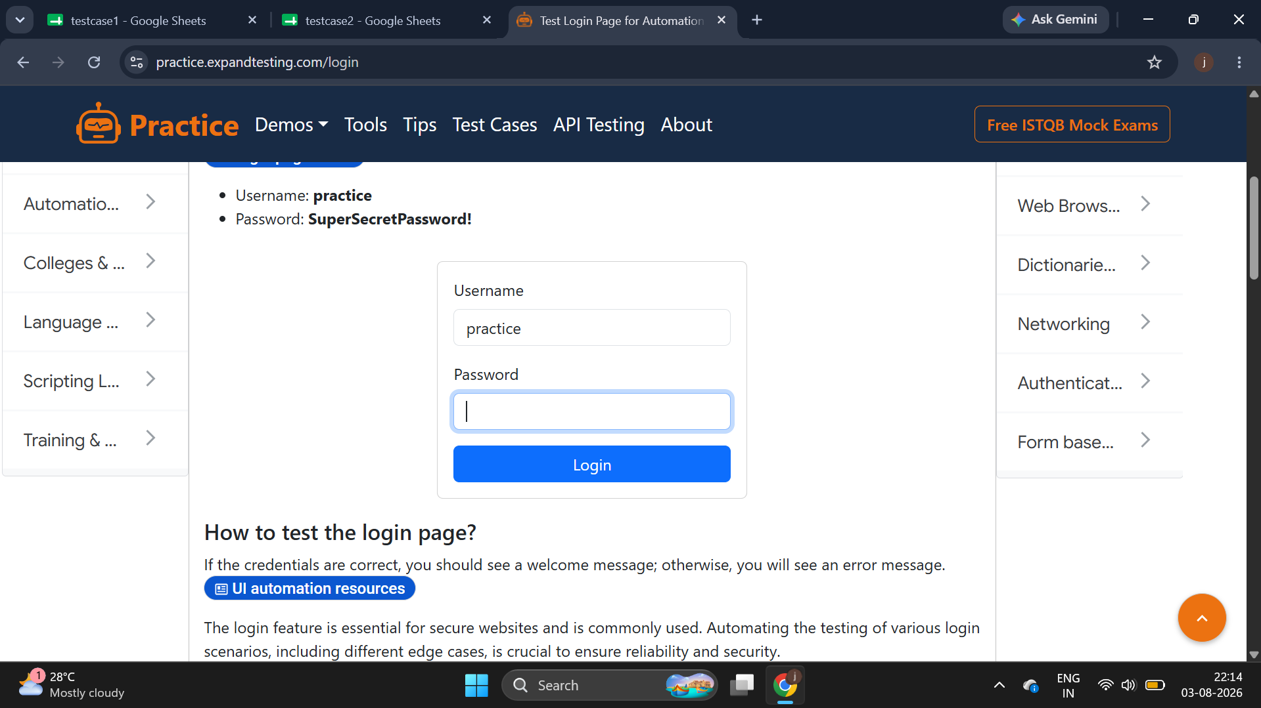
Scenario ID: M2
Scenario: Enter Password
Test Step: Enter Password
Screenshot:
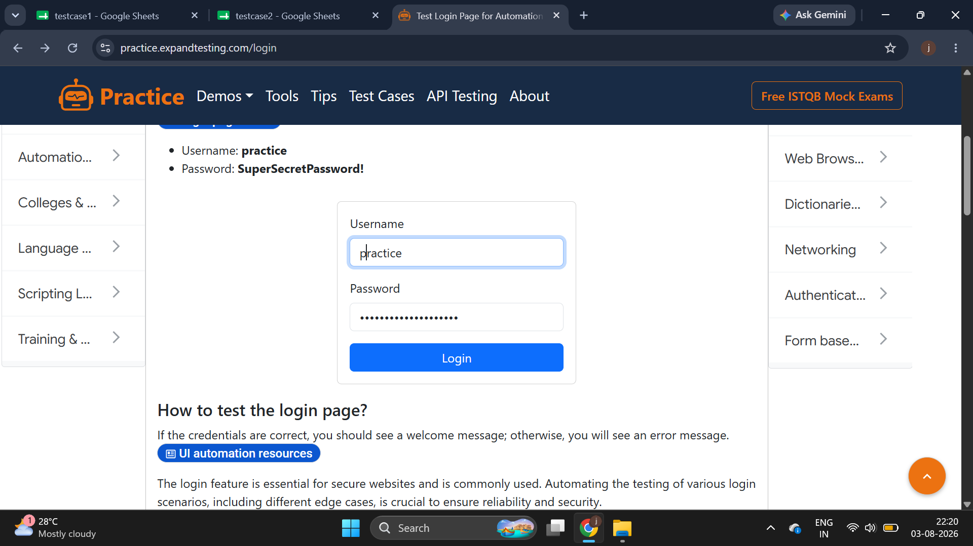
Scenario ID: M3
Scenario: Click on login
Test Step:Click on login
Screenshot:
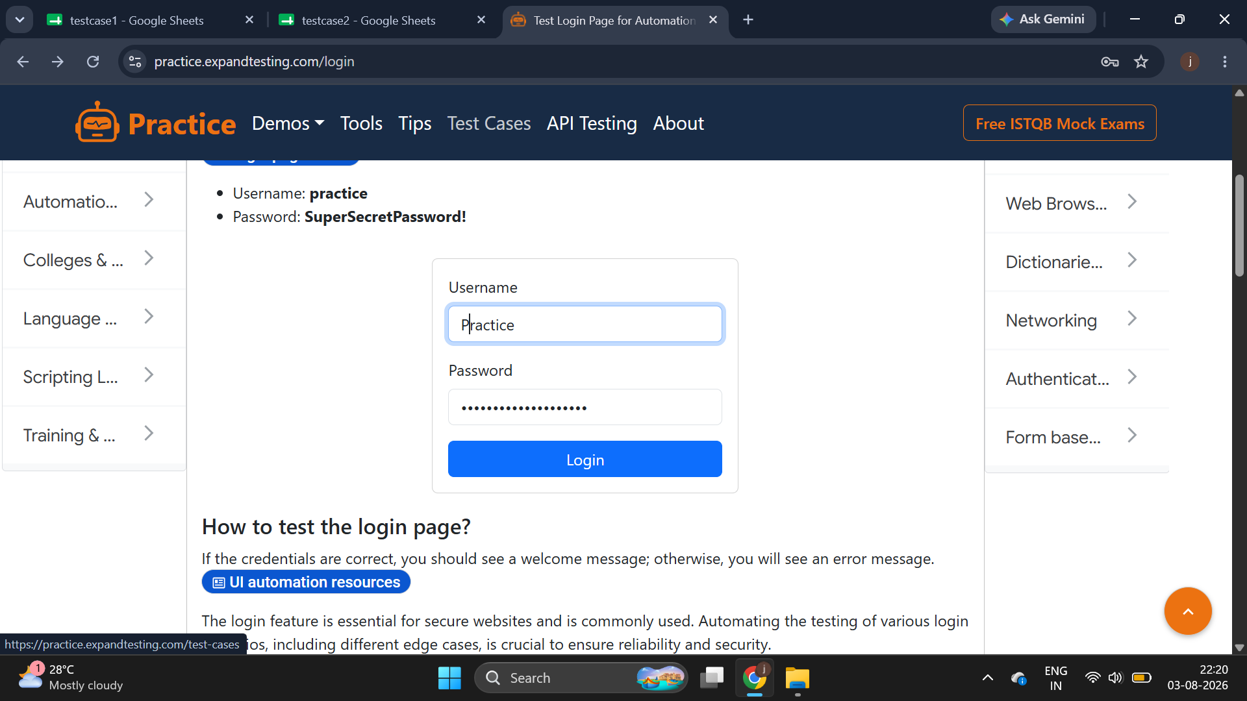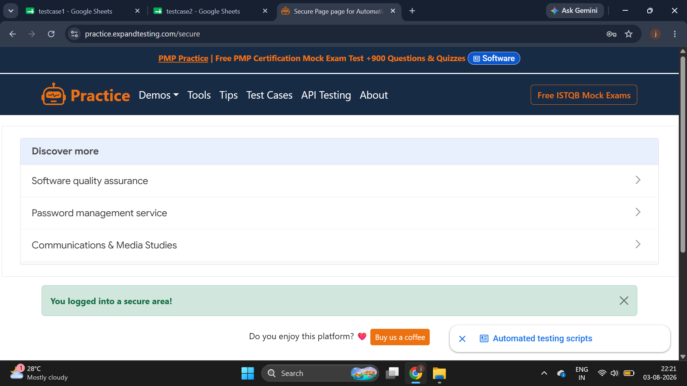
Scenario ID: M4
Scenario: Enter wrong username
Test Step:Enter wrong username:Practice
Screenshot:

Scenario ID: M5
Scenario: Enter wrong username
Test Step:Enter wrong username :PRACTICE
Screenshot:
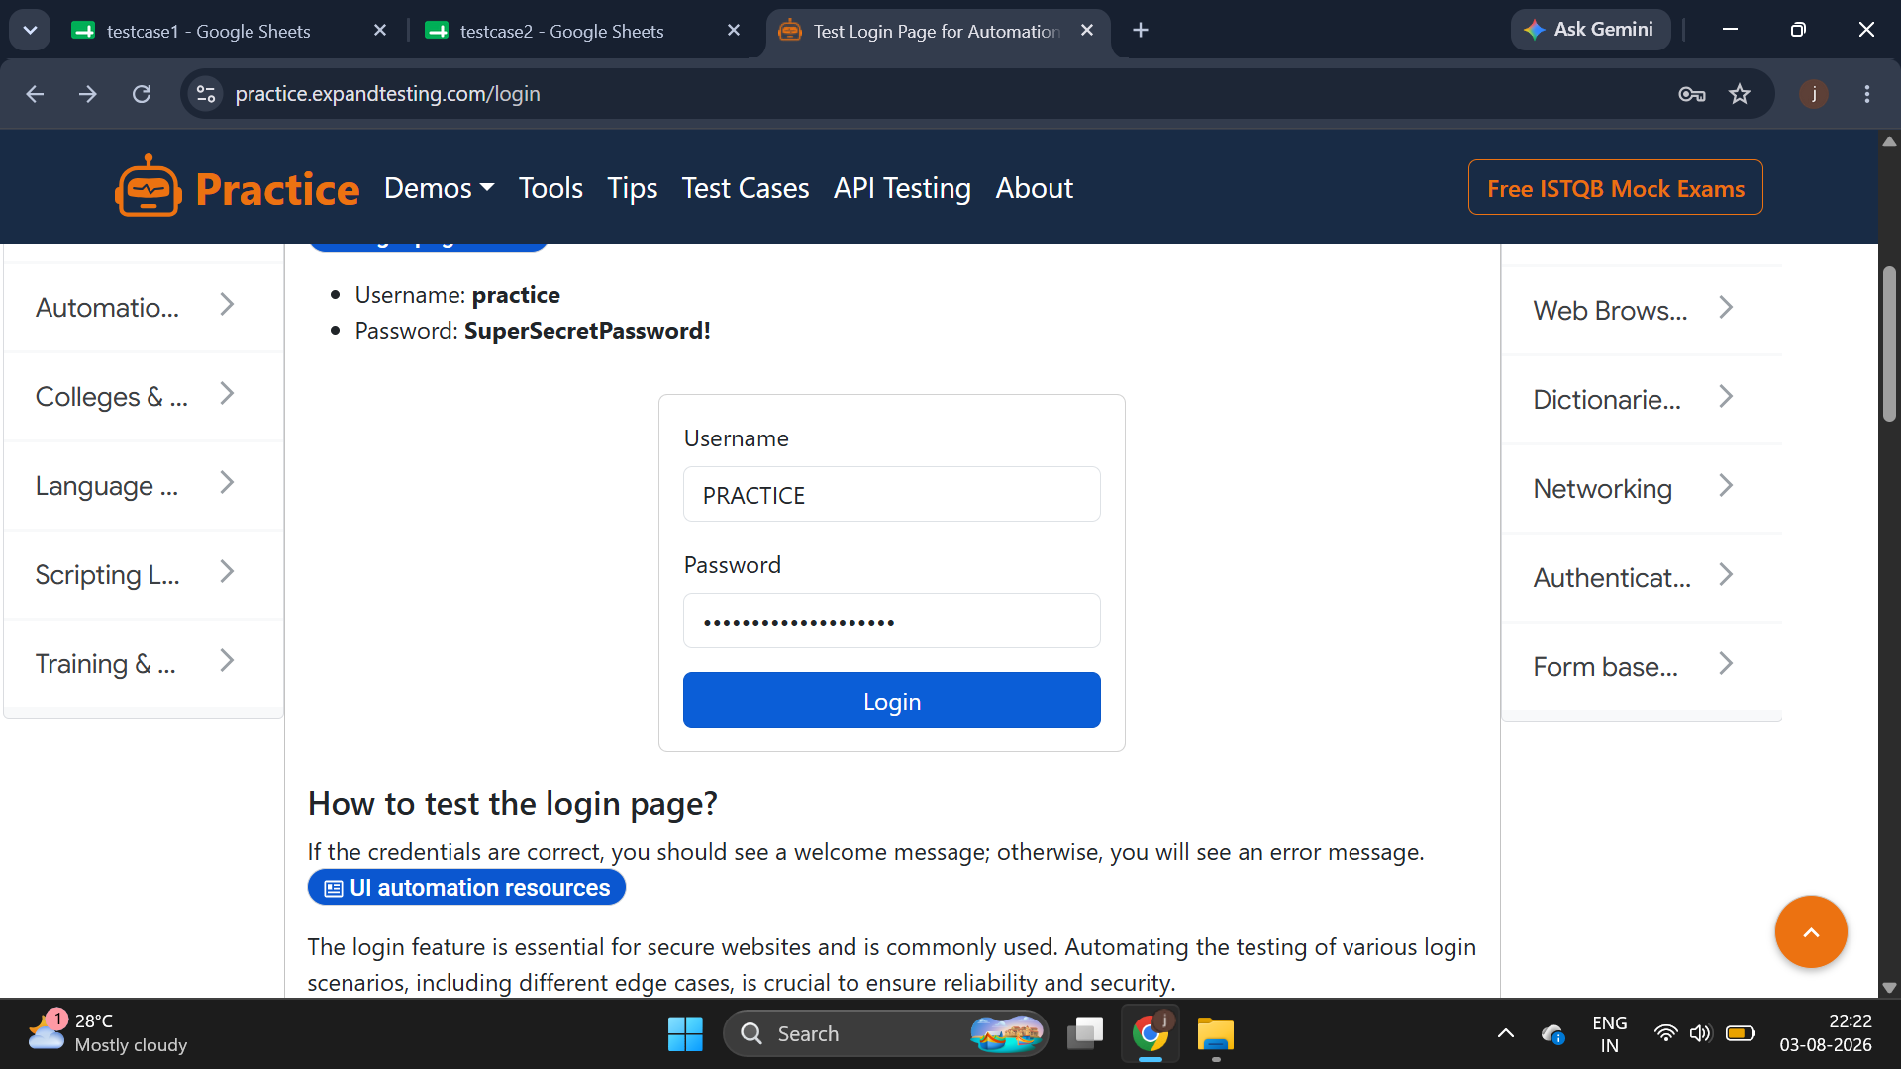
Scenario ID: M6
Scenario: Enter wrong Password
Test Step:Enter wrong Password :SuperSecretPassword
Screenshot:
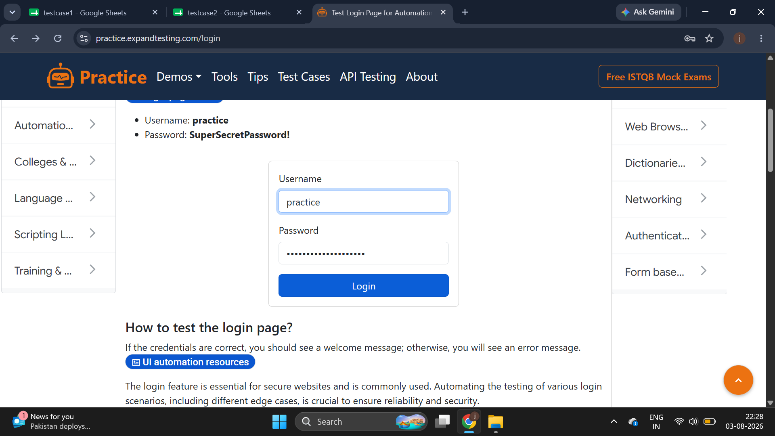
Scenario ID: M7
Scenario: Enter wrong Password
Test Step:Enter wrong Password :Superpecretpassword!
Screenshot:
Scenario ID: M8
Scenario: Login without username
Test Step:Login without username
Screenshot:
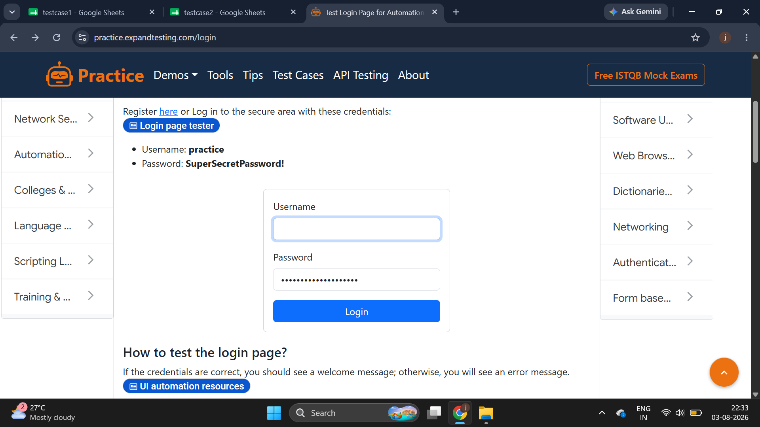
Scenario ID: M9
Scenario: Login without password
Test Step:Login without password
Screenshot:
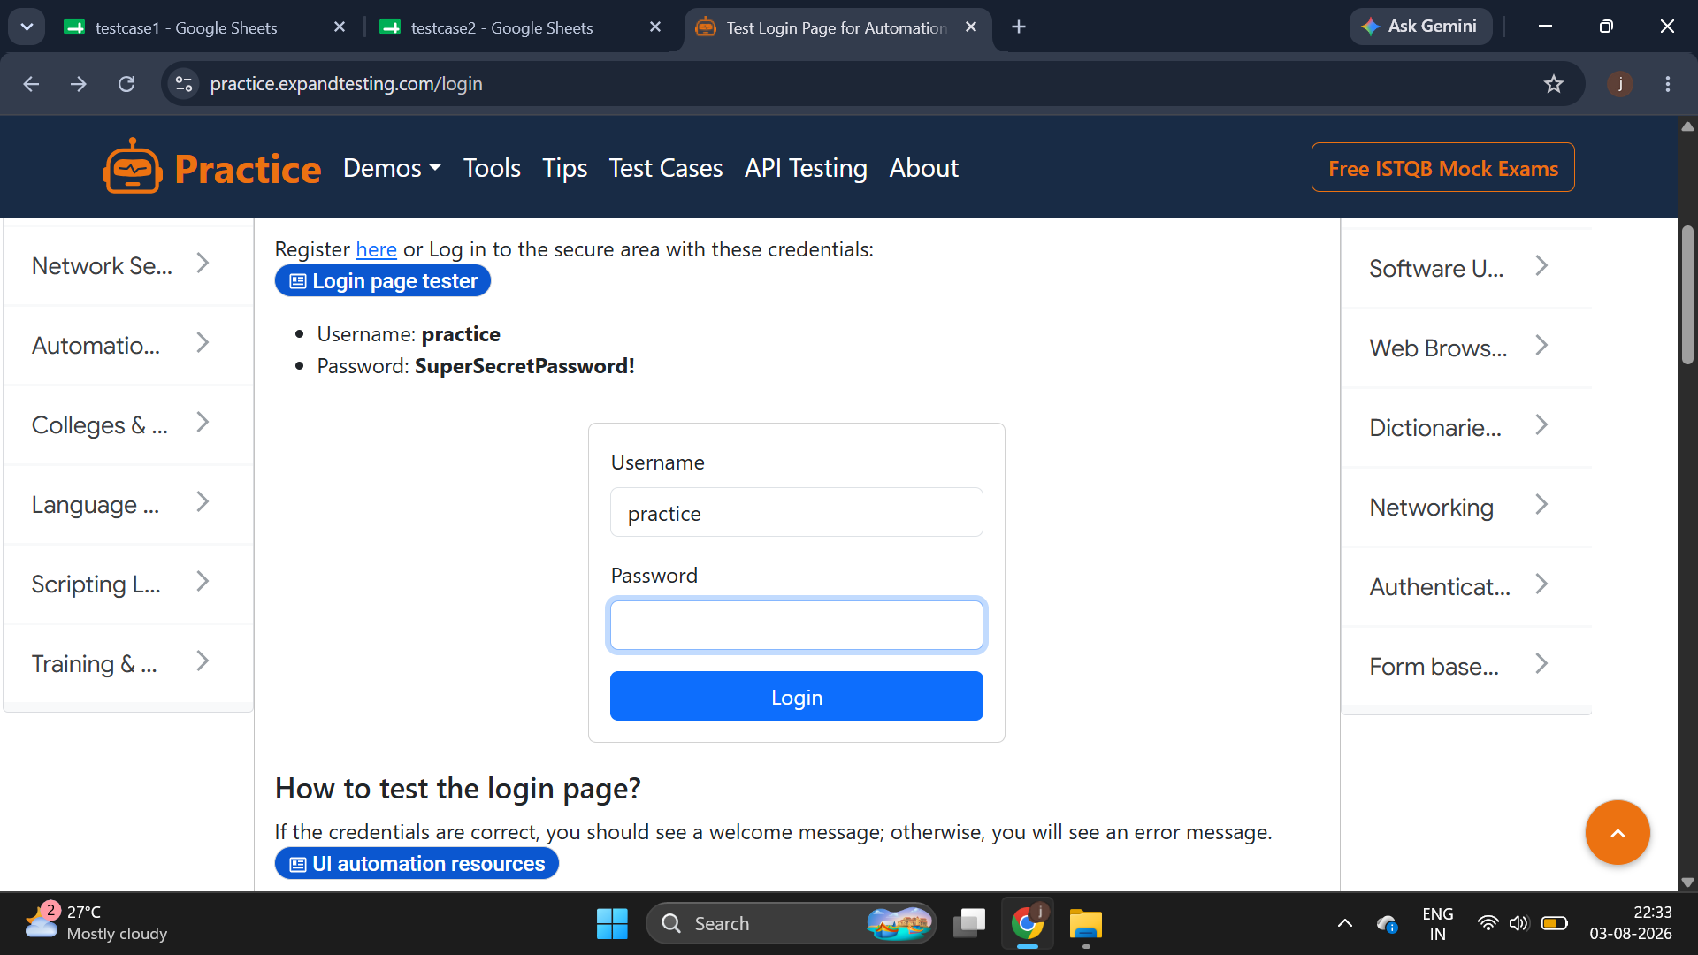
Scenario ID: M10
Scenario: Login without Username & Password
Test Step:Login without Username & Password
Screenshot:
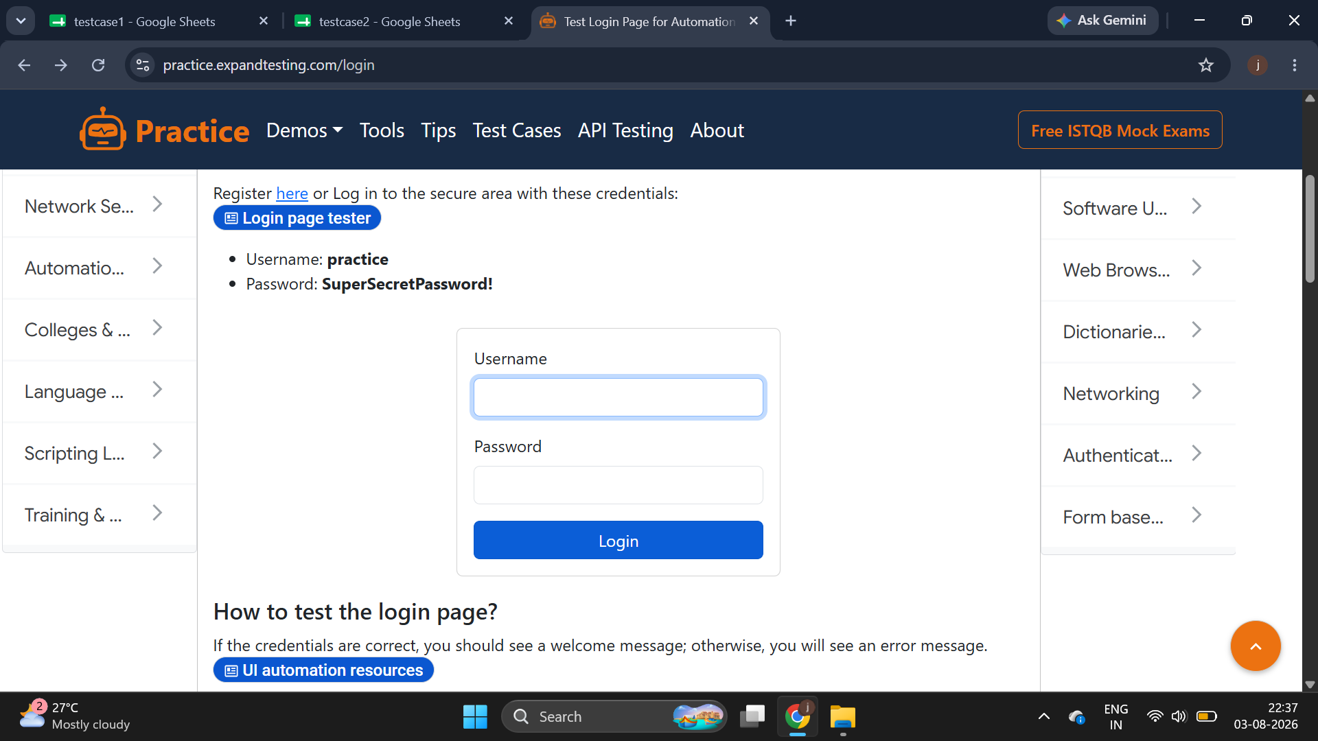
Scenario ID: M11
Scenario: Enter other username
Test Step:Enter other username :Student
Screenshot:
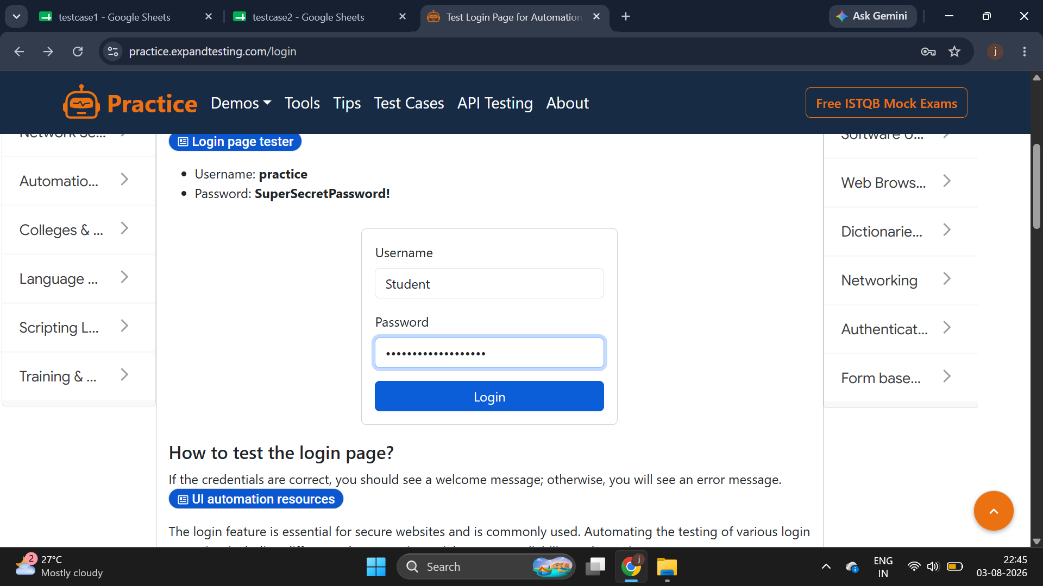
Scenario ID: M12
Scenario: Enter other password
Test Step:Enter other password :Pass123
Screenshot:
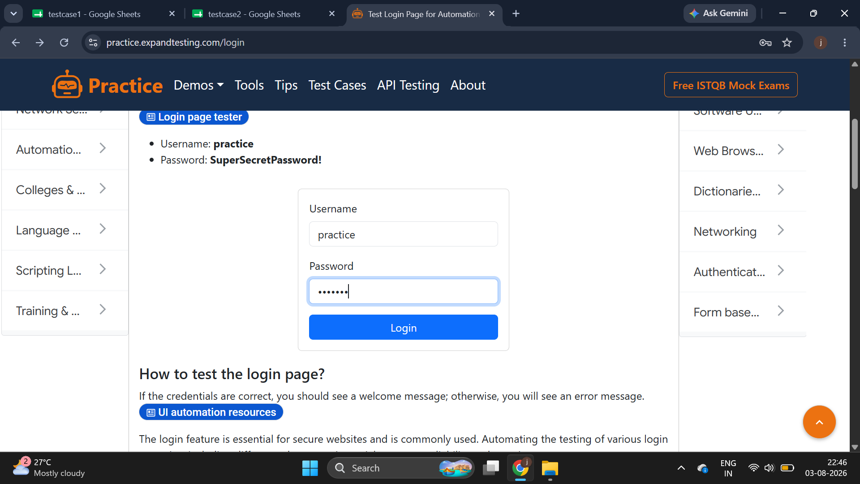

3. Test Execution Summary
Total Test Cases: 12
Passed: 3
Failed: 9
Pass Percentage: 25%
Failed cases indicate the application allows login with invalid or empty credentials.
4. Defects
• Invalid username accepted.
• Invalid password accepted.
• Empty username/password validation missing.
• Authentication logic requires correction.
5. Conclusion
Core login works with valid credentials, but security validation fails for most negative test cases. The application should not be released until these defects are fixed and regression testing is completed.

