Software Testing Report - Login Module
1. Test Case Information
Project name | Demo Web Application
Application / Software | Web Based Application
Module name | Login
SDLC Model | LoginModel
Programming language | Python
IDE / Tool Used | Google sheets,docs
Input / Test Data | Username , Password , details

2. Test Case Screenshots

3. Test Execution Results
Scenario ID | Test steps | Test inputs | Expected result | Actual result | Status
M1 | 1. Open login page  2. Click Username field  3. Enter student | student | Username student should be entered successfully | Username was entered successfully | Pass
M2 | 1. Enter incorrectUser  2. Enter Password123  3. Click Submit | Username: incorrectUser  Password: Password123 | Error message "Your username is invalid!" should be displayed | Error message was displayed | Pass
M3 | 1. Click Password field  2. Enter Password123 | Password123 | Password should be accepted and displayed as masked characters | Password was entered successfully | Pass
M4 | 1. Enter student  2. Enter incorrectPassword  3. Click Submit | Username: student  Password: incorrectPassword | Error message "Your password is invalid!" should be displayed | Error message was displayed | Pass
M5 | 1. Enter student in Username  2. Enter Password123 in Password  3. Click Submit | Username: student  Password: Password123 | User should be logged in successfully | User was logged in successfully | Pass
M6 | 1. Enter invalid username  2. Enter valid password  3. Click Submit | Username: incorrectUser  Password: Password123 | Your username is invalid! should be displayed | Your username is invalid! was displayed | Pass

4. Test Scenario and Test Input Details
Scenario ID: M1
Test Scenario: 1. Open login page 2. Click Username field 3. Enter student
Test Input: student
Expected Result: Username student should be entered successfully
Actual Result: Username was entered successfully
Status: Pass
Scenario ID: M2
Test Scenario: 1. Enter incorrectUser 2. Enter Password123 3. Click Submit
Test Input: Username: incorrectUser; Password: Password123
Expected Result: Error message "Your username is invalid!" should be displayed
Actual Result: Error message was displayed
Status: Pass
Scenario ID: M3
Test Scenario: 1. Click Password field 2. Enter Password123
Test Input: Password123
Expected Result: Password should be accepted and displayed as masked characters
Actual Result: Password was entered successfully
Status: Pass
Scenario ID: M4
Test Scenario: 1. Enter student 2. Enter incorrectPassword 3. Click Submit
Test Input: Username: student; Password: incorrectPassword
Expected Result: Error message "Your password is invalid!" should be displayed
Actual Result: Error message was displayed
Status: Pass
Scenario ID: M5
Test Scenario: 1. Enter student in Username 2. Enter Password123 in Password 3. Click Submit
Test Input: Username: student; Password: Password123
Expected Result: User should be logged in successfully
Actual Result: User was logged in successfully
Status: Pass
Scenario ID: M6
Test Scenario: 1. Enter invalid username 2. Enter valid password 3. Click Submit
Test Input: Username: incorrectUser; Password: Password123
Expected Result: Your username is invalid! should be displayed
Actual Result: Your username is invalid! was displayed
Status: Pass

5. Test Case Screenshots by Execution
Scenario ID: M1
Test Scenario: 1. Open login page 2. Click Username field 3. Enter student
Test Input: student
Screenshot:
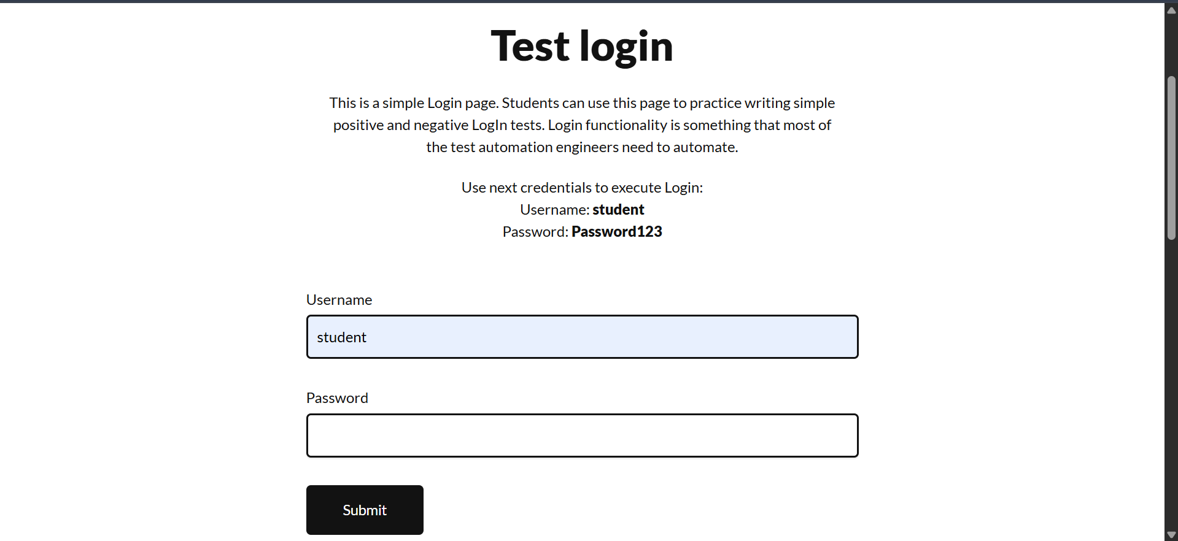
Scenario ID: M2
Test Scenario: 1. Enter incorrectUser 2. Enter Password123 3. Click Submit
Test Input: Username: incorrectUser; Password: Password123
Screenshot:
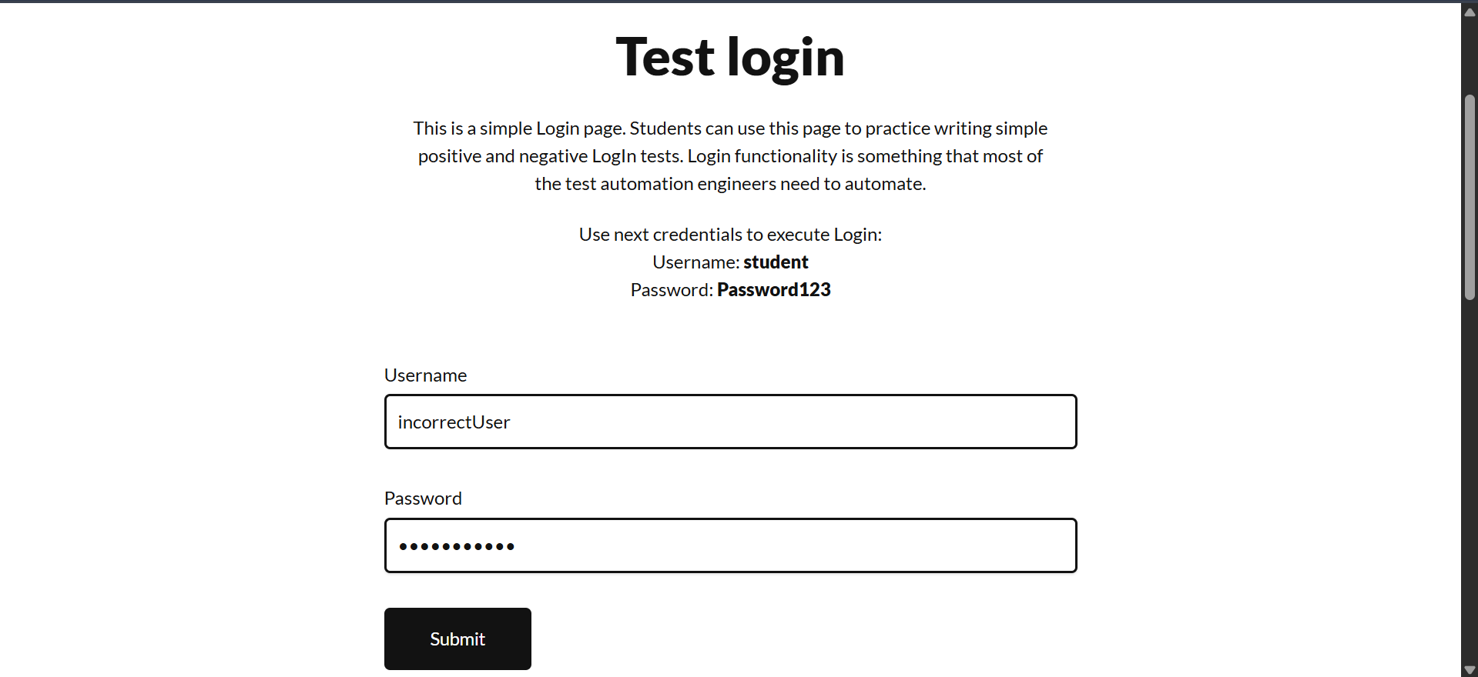
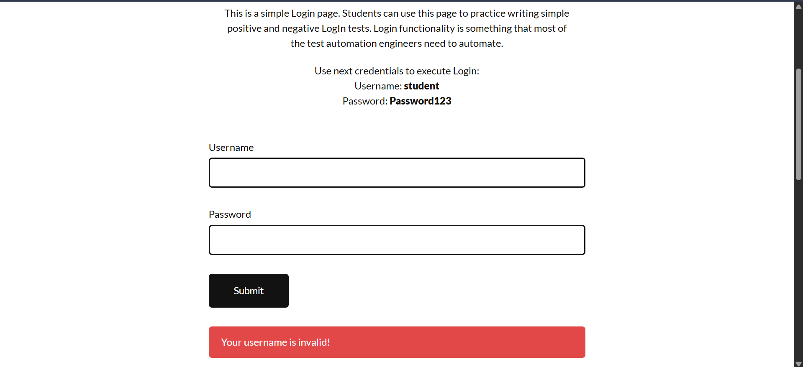

Scenario ID: M3
Test Scenario: 1. Click Password field 2. Enter Password123
Test Input: Password123
Screenshot:
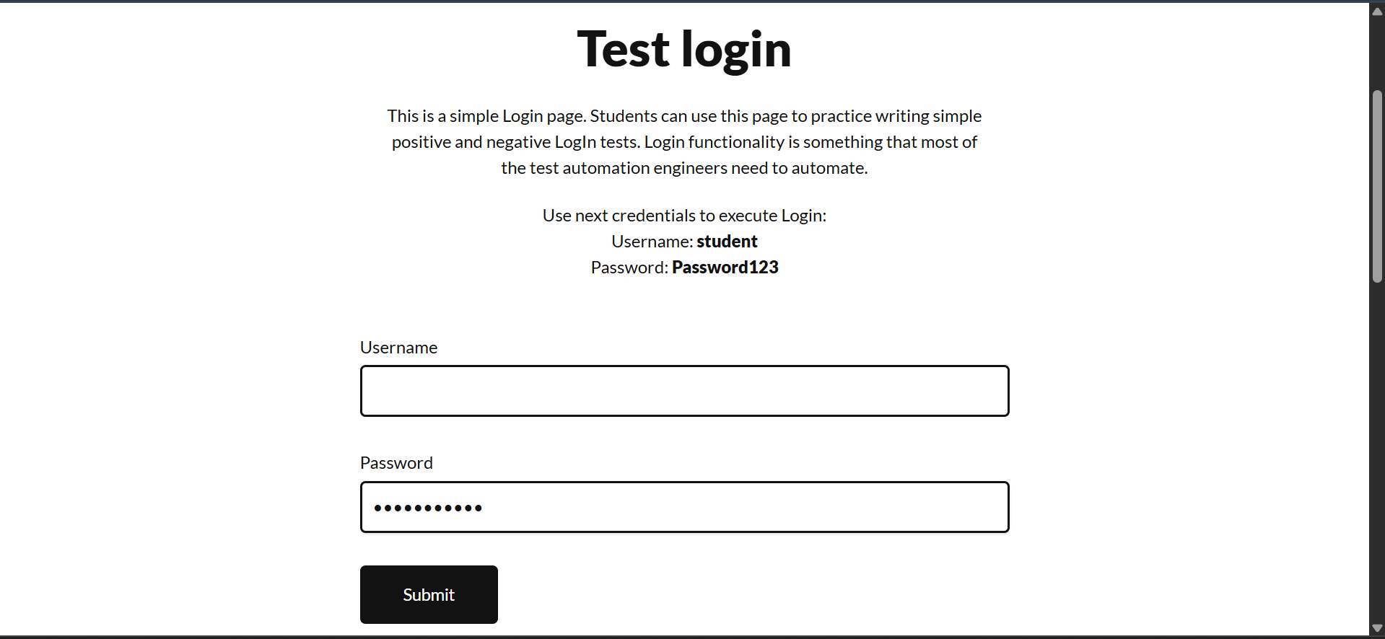
Scenario ID: M4
Test Scenario: 1. Enter student 2. Enter incorrectPassword 3. Click Submit
Test Input: Username: student; Password: incorrectPassword
Screenshot:
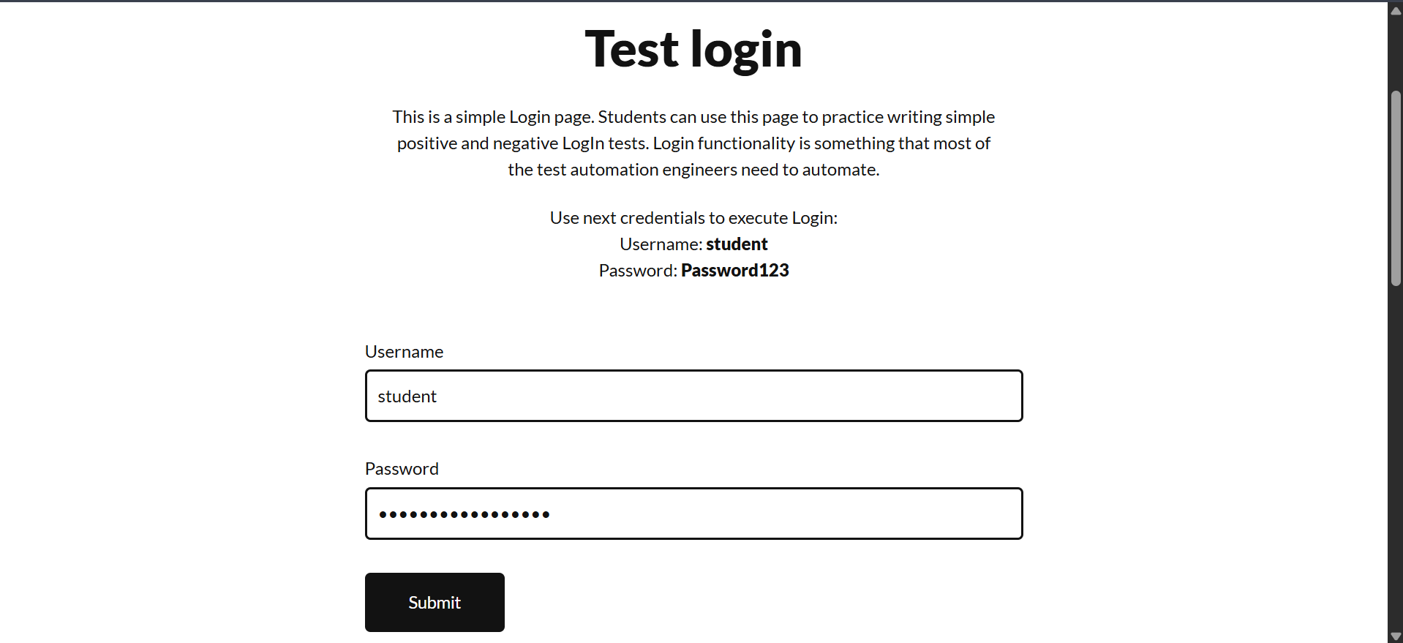
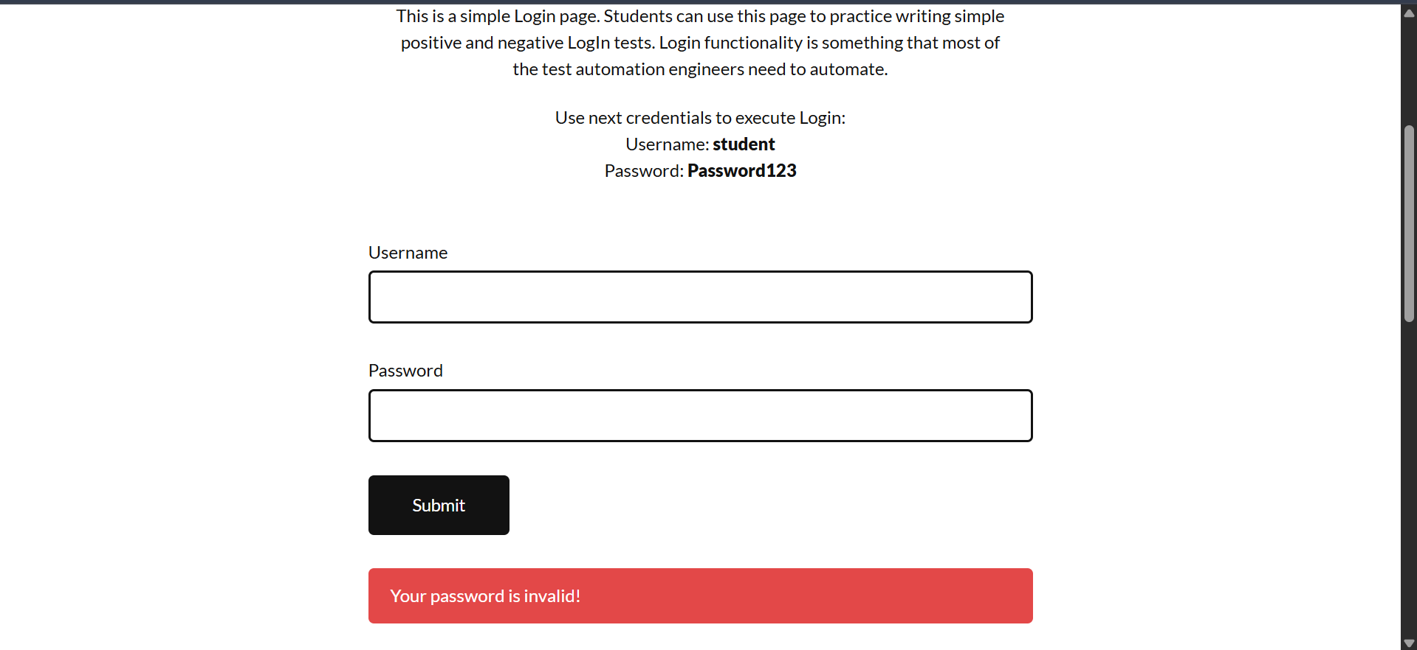

Scenario ID: M5
Test Scenario: 1. Enter student in Username 2. Enter Password123 in Password 3. Click Submit
Test Input: Username: student; Password: Password123
Screenshot:
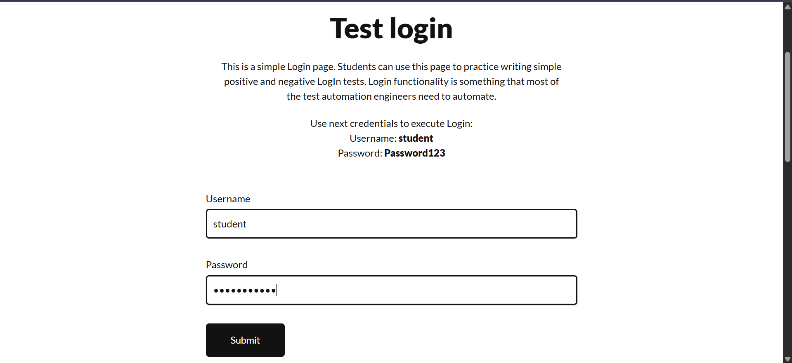
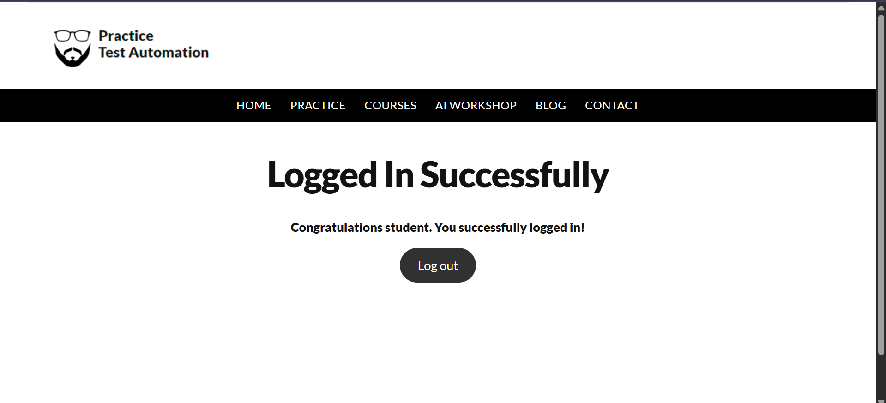
Scenario ID: M6
Test Scenario: 1. Enter invalid username 2. Enter valid password 3. Click Submit
Test Input: Username: Student; Password: Password123
Screenshot:
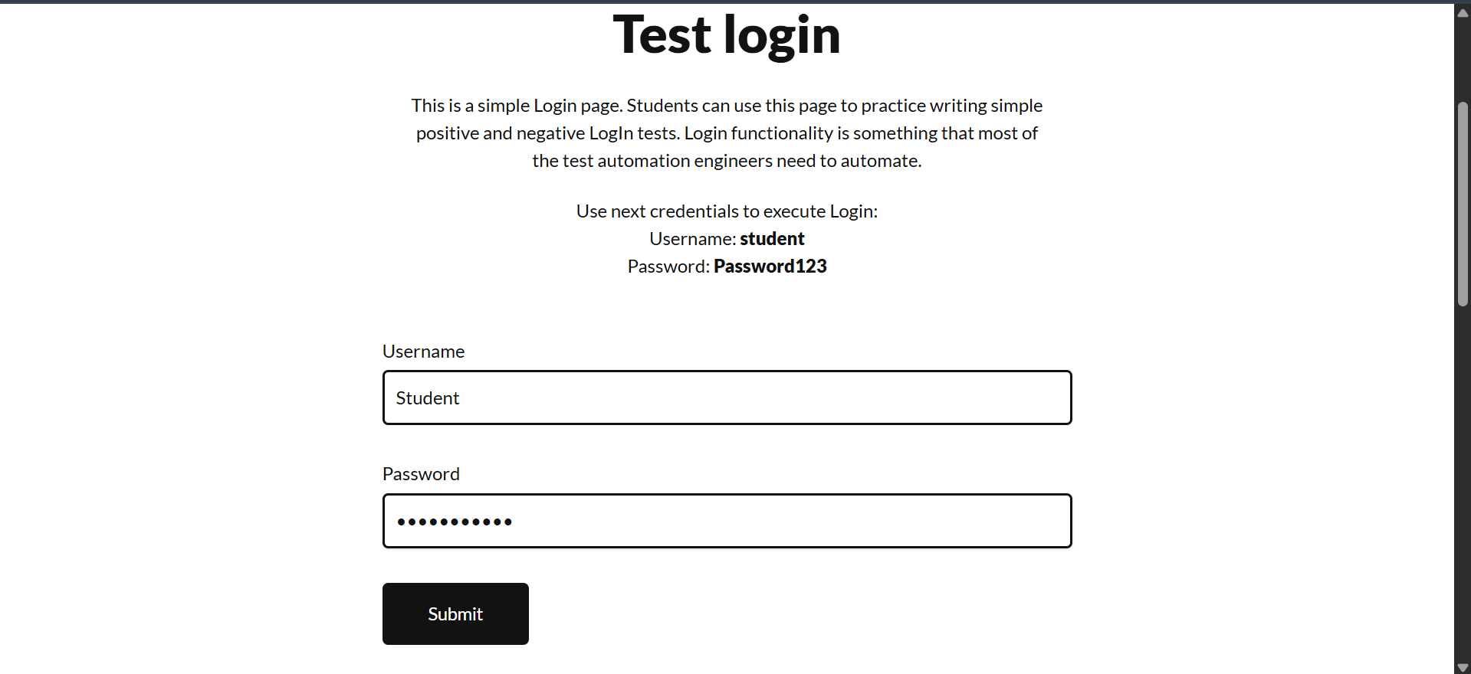
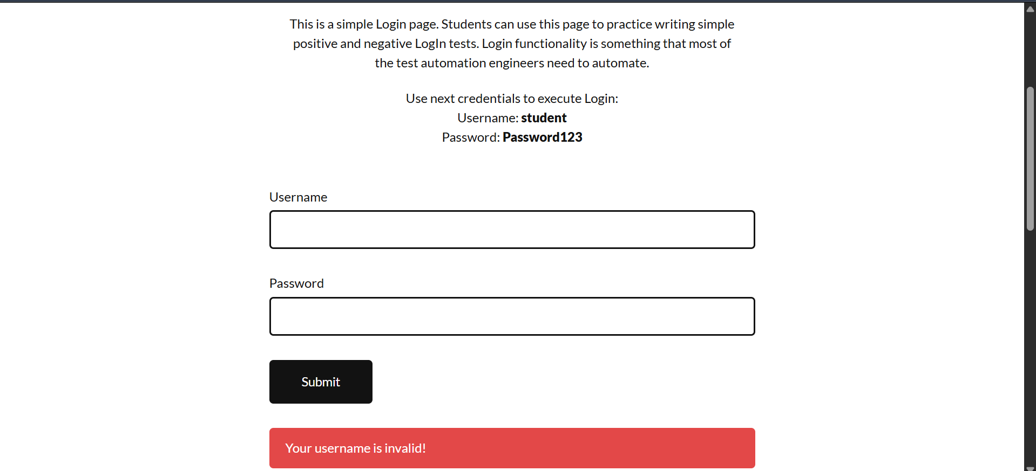

6. Test Summary
Total Test Cases | 6
Passed | 6
Failed | 0
Pass Percentage | 100%
Fail Percentage | 0%
7. Defect Summary
No defects were identified during this test execution. All six test scenarios produced the expected results.
8. Recommendations
1. Continue regression testing after future changes.
2. Perform cross-browser testing.
3. Test additional username and password validation cases.
4. Verify login security, session handling, and unauthorized access protection.
9. Conclusion
The Login module successfully passed all six executed test scenarios. Username entry, invalid username validation, password entry and masking, invalid password validation, successful login, and invalid username handling behaved as expected. Based on the recorded results, the tested Login functionality is operating correctly.

