Software Testing Report - Login Module

1. Test Case Information
Module Name | Login
Test Case ID | MJ003
Tester Name | Jeet
Test Case Description | To check the login page
Pre-requirements | Network Stability, Browser, Demo Login
Environment Information | Windows
Test Scenario | To check the login page

2. Test Case Screenshots

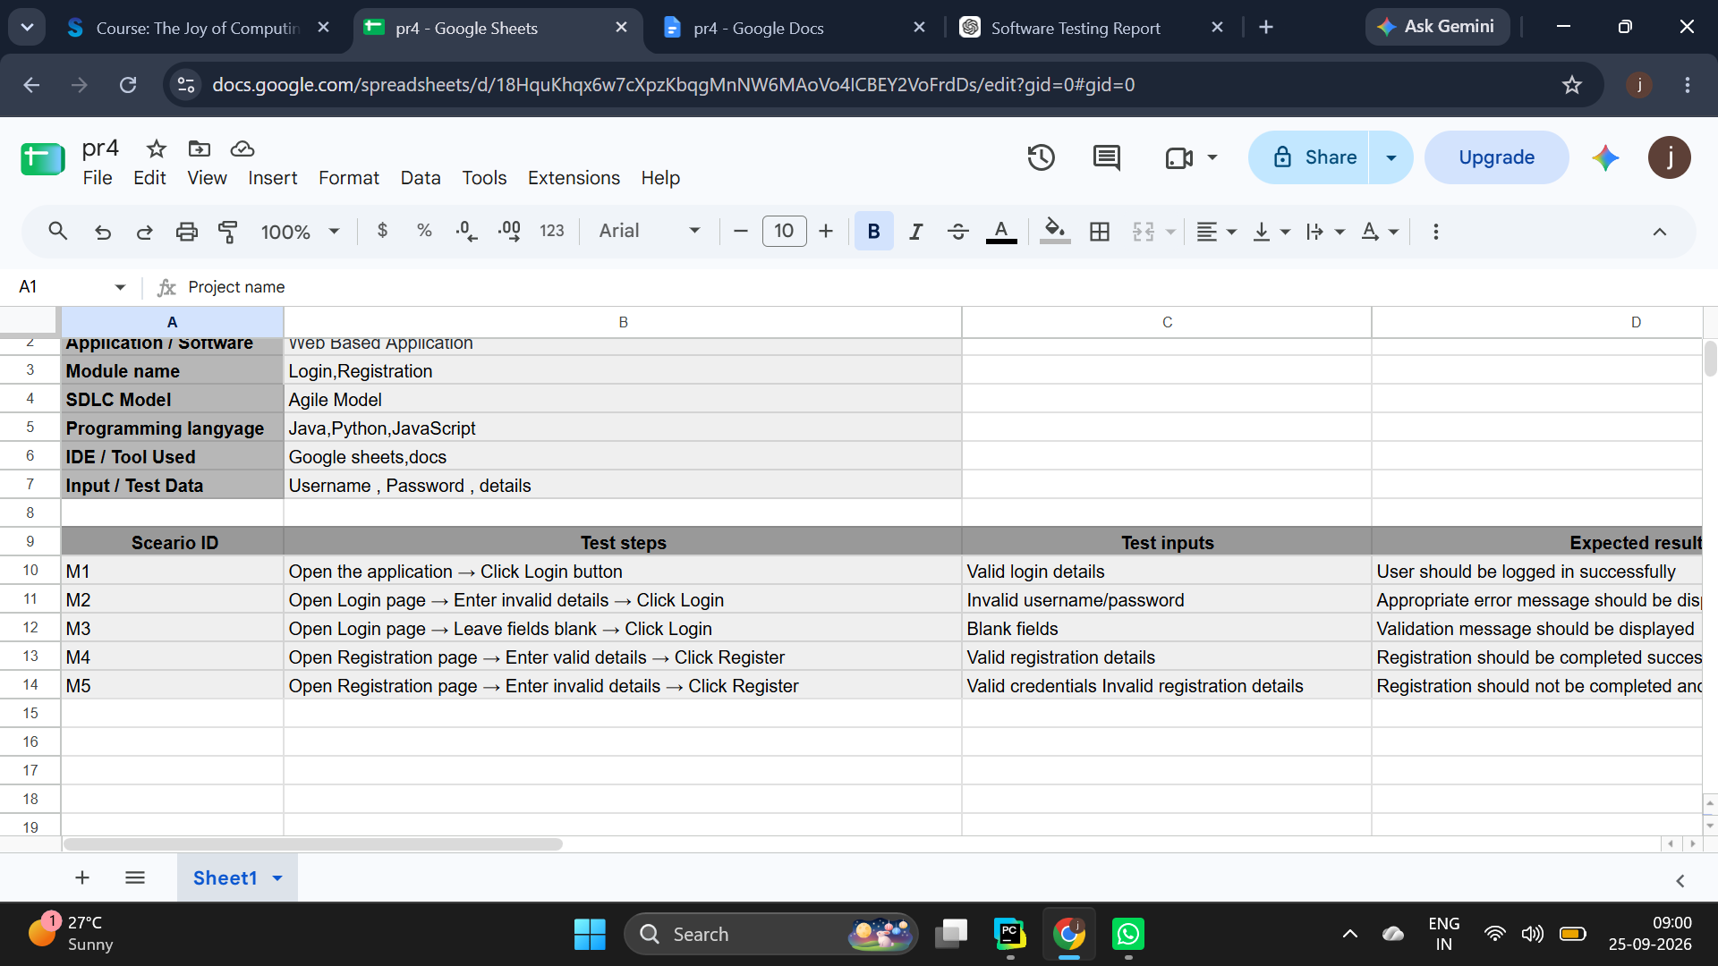
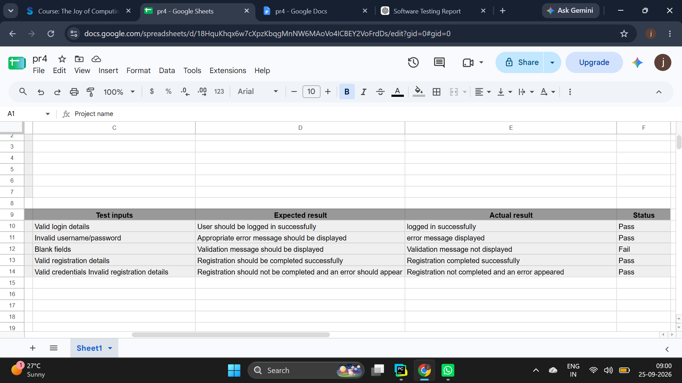

3. Test Execution Results
Scenario ID | Test Step | Test Input | Expected Result | Actual Result | Status
M1 | Enter valid username and valid password. | Username: student, Password: Password123 | Redirects to a secure dashboard; session token generated. | Redirected to a secure dashboard; session token generated. | Pass
M2 | Leave the input fields empty. | Username: , Password: | Throws a visible inline validation error warning the user. | Threw a visible inline validation error warning the user. | Pass
M3 | Enter an invalid username or incorrect password. | Username: wronguser, Password: wrongpassword | Rejects access; displays a generic authentication error. | Rejected access; displayed a generic authentication error. | Pass
M4 | Check field masks (asterisks or dots) on passwords. | Username: student, Password: password123 | Character entry remains hidden from plain view. | Character entry remained hidden from plain view. | Pass
M5 | Click the visible "Log Out" button. | N/A | Destroys the active session token; prevents page-back actions. | Destroyed the active session token; prevented page-back actions. | Pass
Scenario ID: M1
Scenario: Enter valid username and valid password.
Test Step: Username: practice, Password:SuperSecretPassword!
Screenshot:
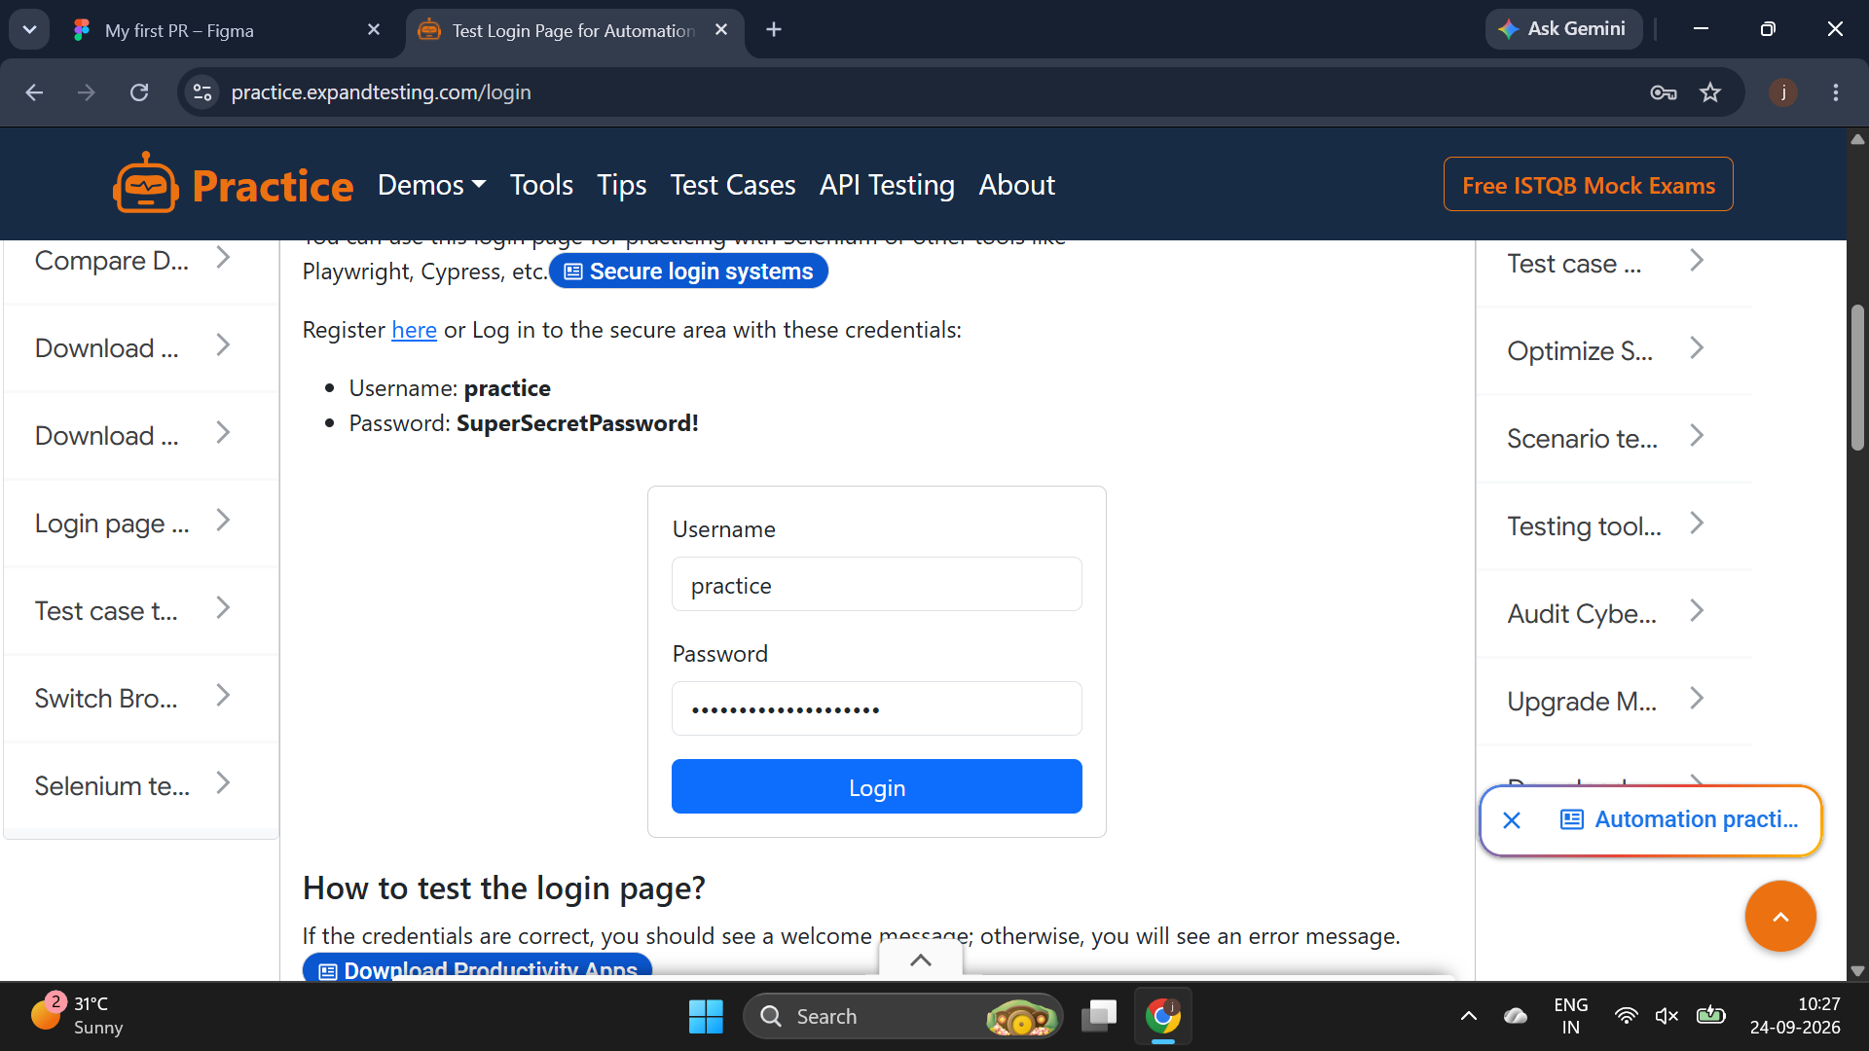
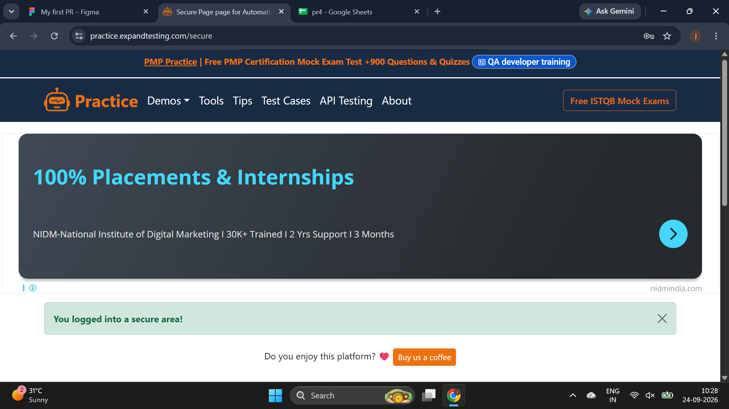

Scenario ID: M2
Scenario: Leave the input fields empty.
Test Step: Username: , Password:
Screenshot:
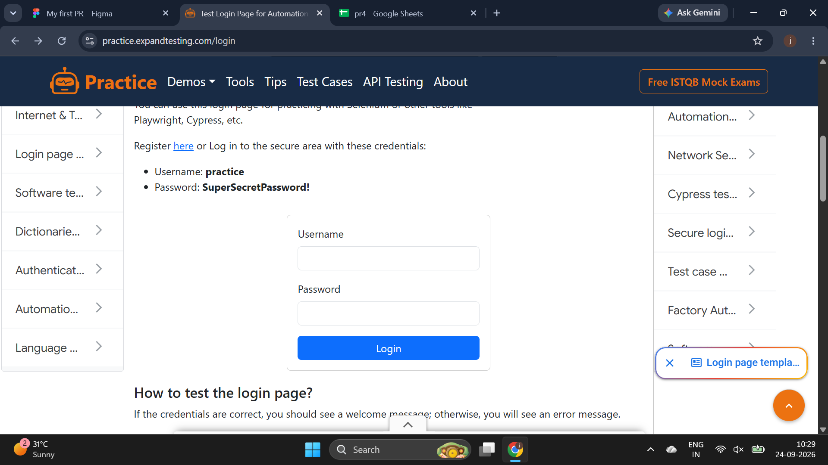
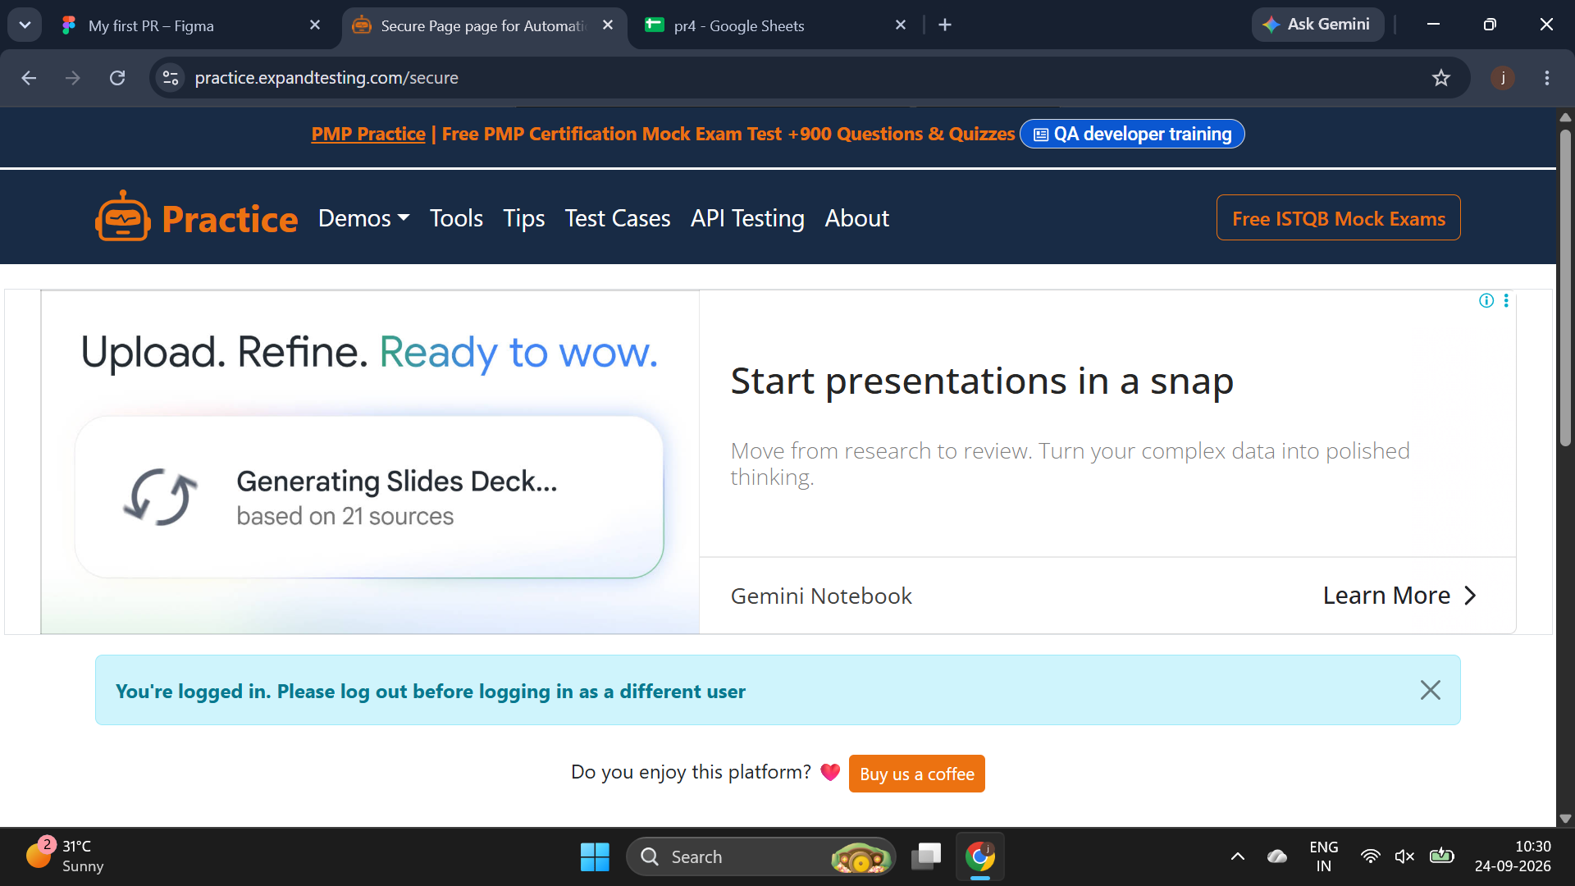
Scenario ID: M3
Scenario: Enter an invalid username or incorrect password.
Test Step: Username: wronguser, Password: wrongpassword
Screenshot:
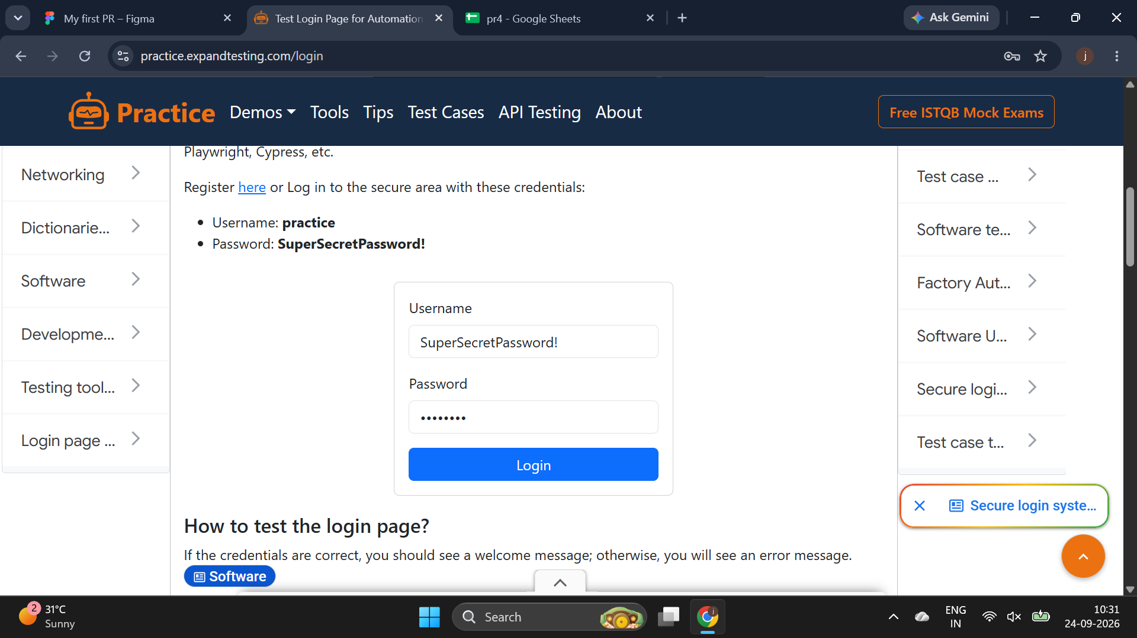
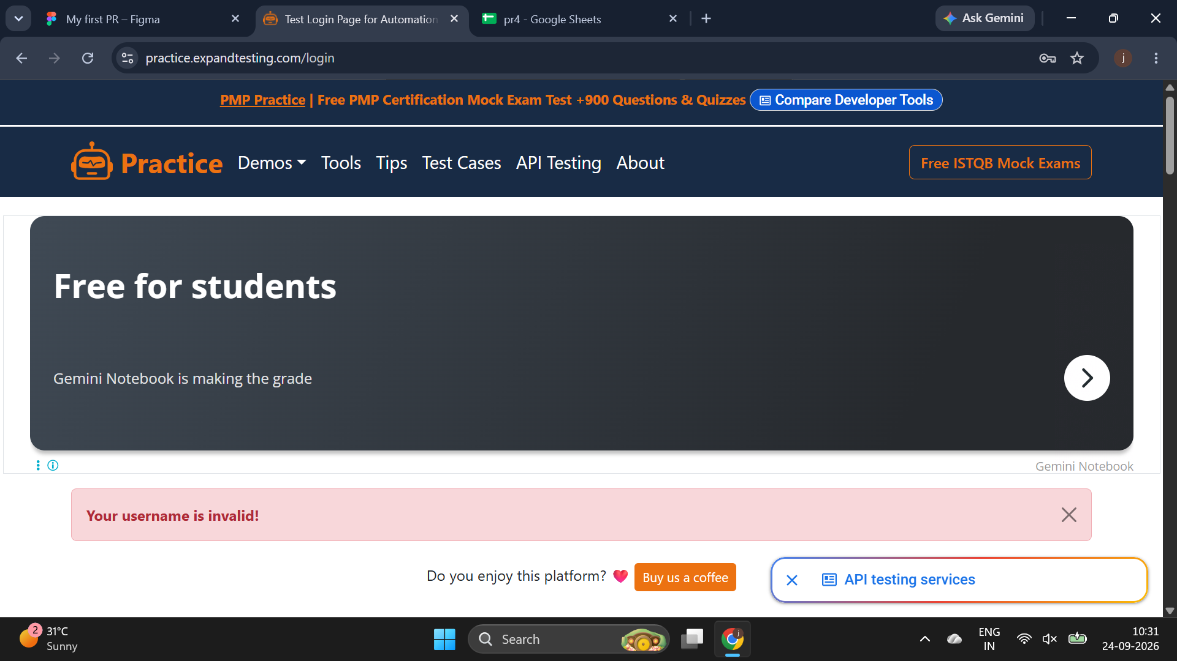
Scenario ID: M4
Scenario: Check field masks (asterisks or dots) on passwords.
Test Step: Username: student, Password: password123
Screenshot:
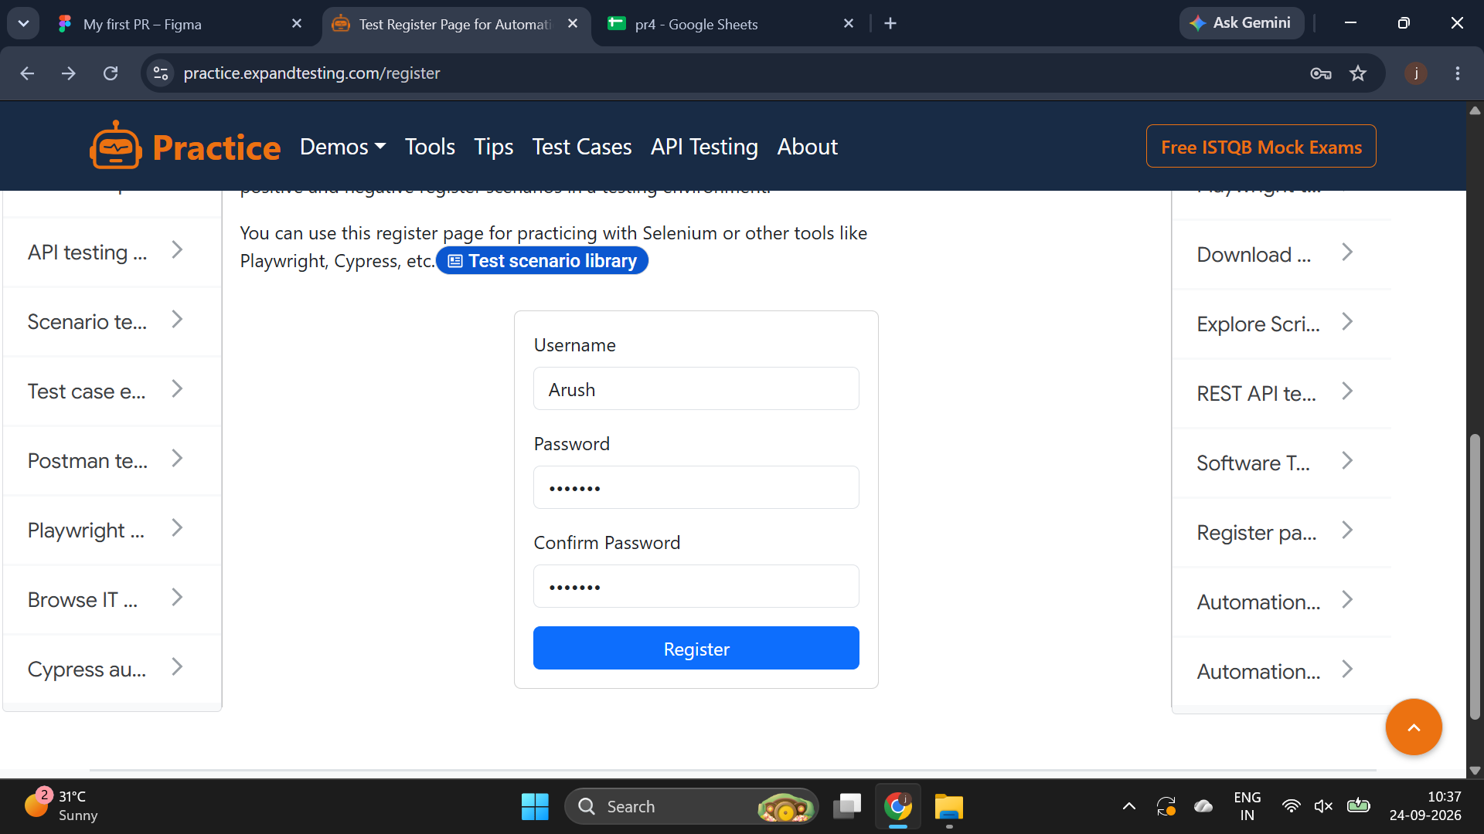
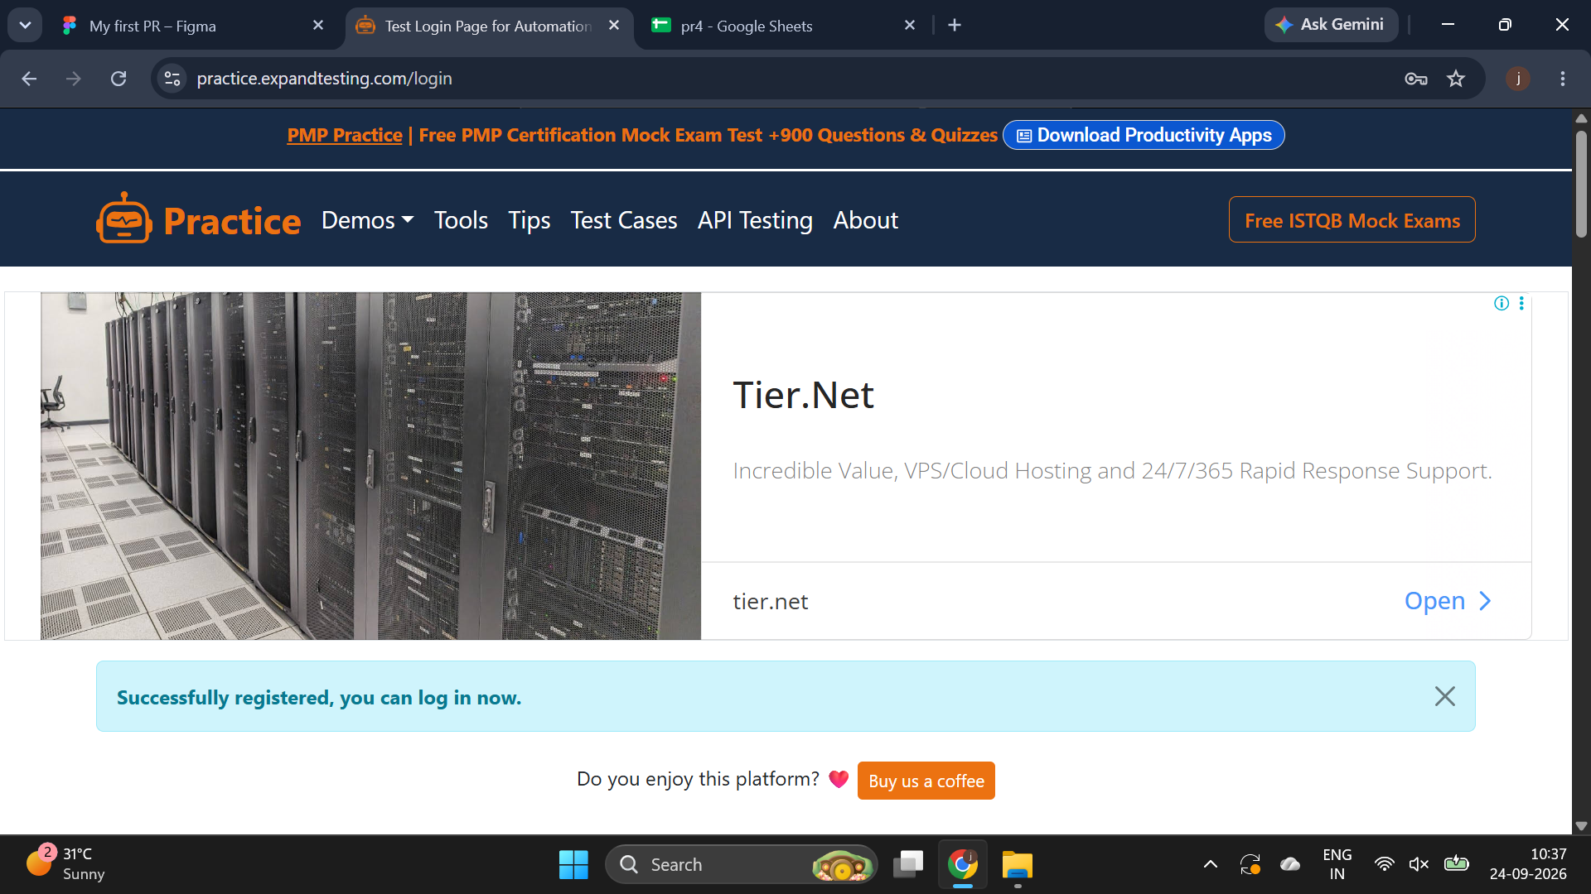
Scenario ID: M5
Scenario: Click the visible "Log Out" button.
Test Step: N/A
Screenshot:
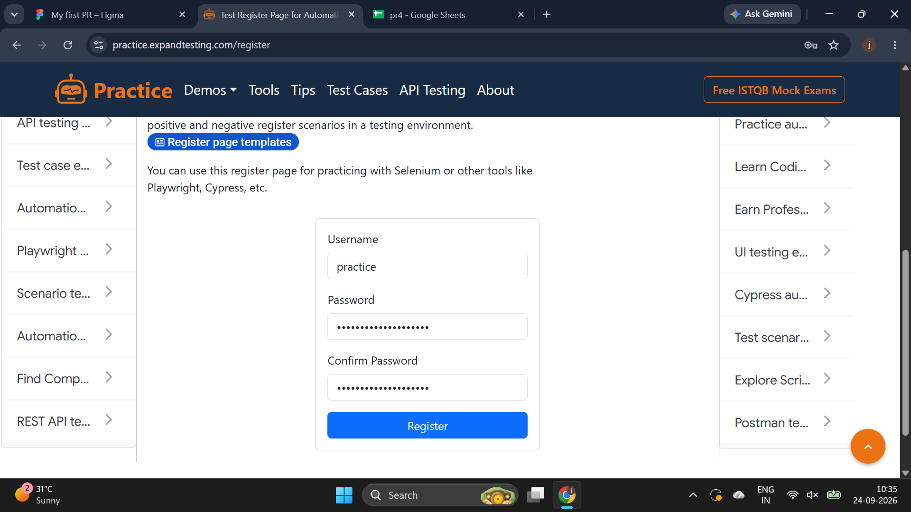
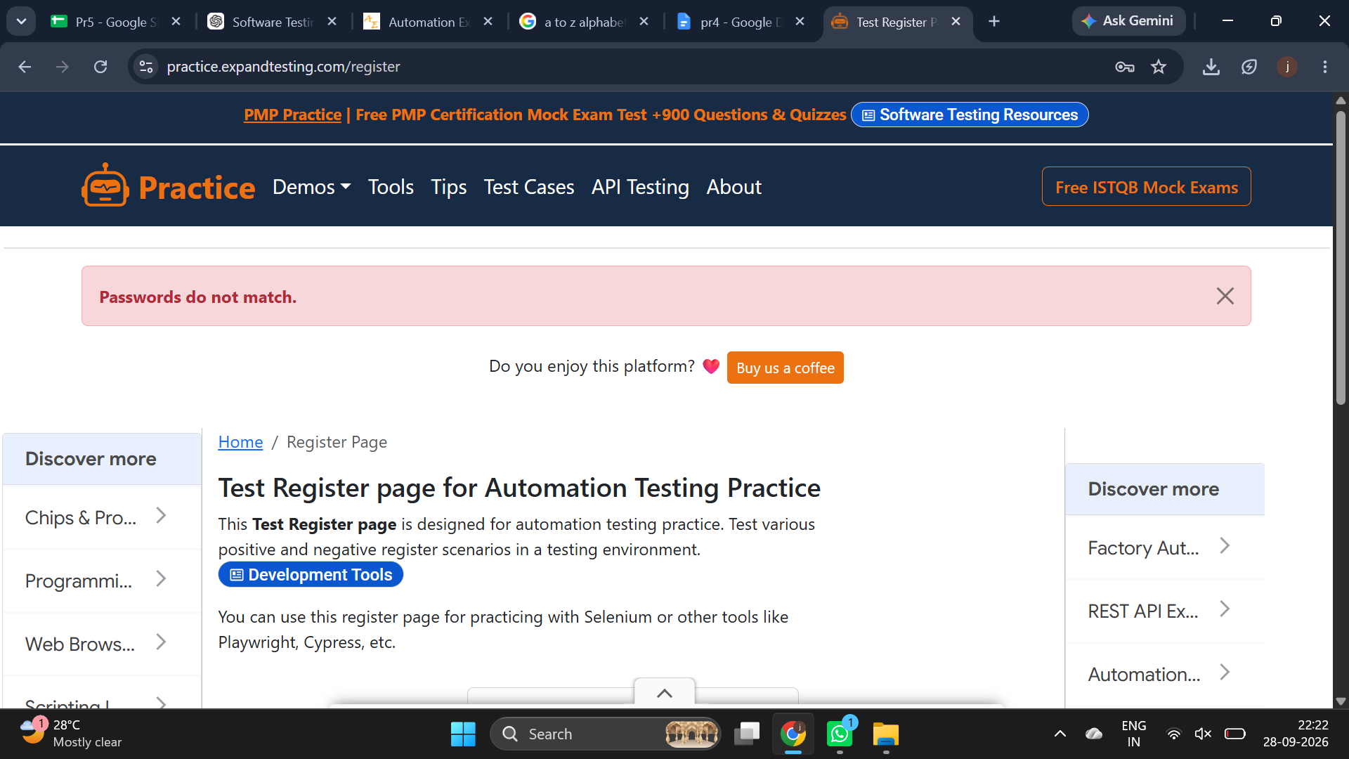

4. Test Summary
Total Test Cases: 5
Passed: 5
Failed: 0
Pass Percentage: 100%
Fail Percentage: 0%

5. Defect Summary
No defects were identified during this test execution. All five test scenarios produced the expected results.

6. Recommendations
1. Continue regression testing after future changes.
2. Perform cross-browser testing.
3. Conduct additional authentication and session-security testing.
4. Verify session expiration and unauthorized page-access protection.

7. Conclusion
The Login module successfully passed all five executed test scenarios. Valid login, empty-field validation, invalid credential handling, password masking, and logout/session protection behaved as expected. Based on the recorded results, the tested Login functionality is operating correctly.

