Software Testing Report - Demo Web Application
1. Test Case Information
Project name | Demo Web Application
Application / Software | Web Based Application
Module name | Login, Registration
SDLC Model | Agile Model
Programming language | Java,Python,JavaScript
IDE / Tool Used | Google sheets,docs
Input / Test Data | Username , Password , details
2. Test Case Screenshots
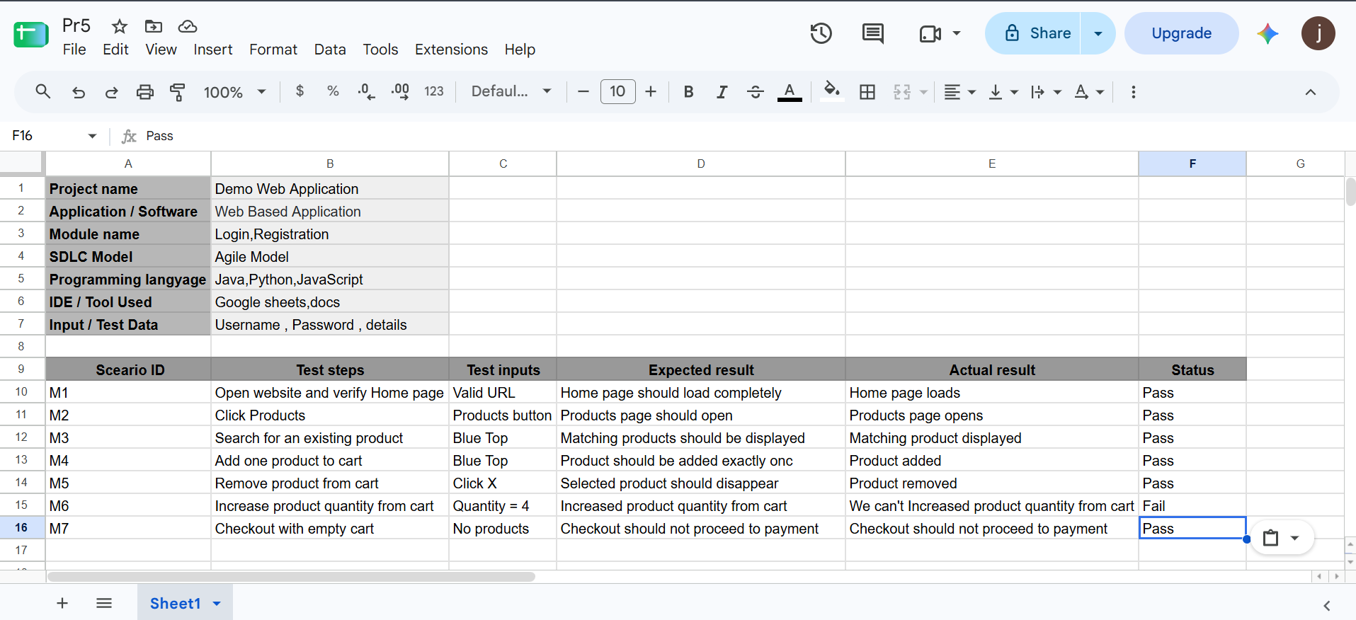
3. Test Execution Results
Scenario ID | Test steps | Test inputs | Expected result | Actual result | Status
M1 | Open website and verify Home page | Valid URL | Home page should load completely | Home page loads | Pass
M2 | Click Products | Products button | Products page should open | Products page opens | Pass
M3 | Search for an existing product | Blue Top | Matching products should be displayed | Matching product displayed | Pass
M4 | Add one product to cart | Blue Top | Product should be added exactly once | Product added | Pass
M5 | Remove product from cart | Click X | Selected product should disappear | Product removed | Pass
M6 | Increase product quantity from cart | Quantity = 4 | Increased product quantity from cart | We can't Increased product quantity from cart | Fail
M7 | Checkout with empty cart | No products | Checkout should not proceed to payment | Checkout should not proceed to payment | Pass

Scenario ID: M1
Test Scenario: Open website and verify Home page
Test Input: Valid URL
Expected Result: Home page should load completely
Actual Result: Home page loads
Status: Pass
Screenshot:
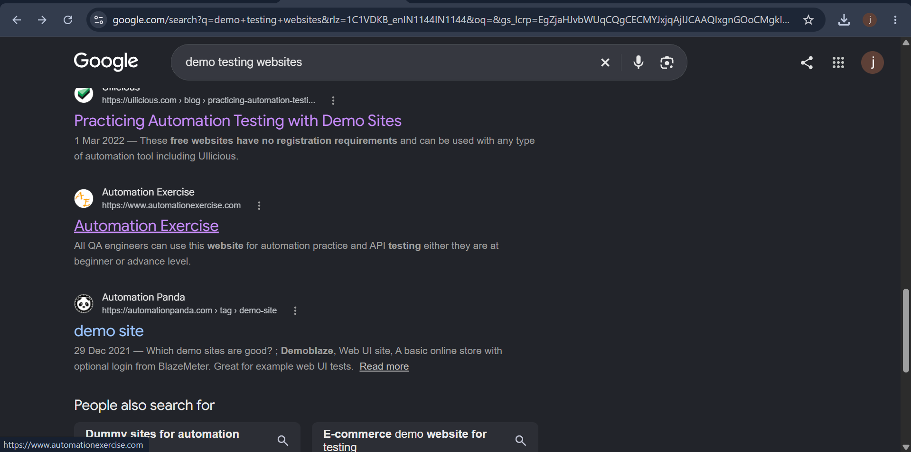
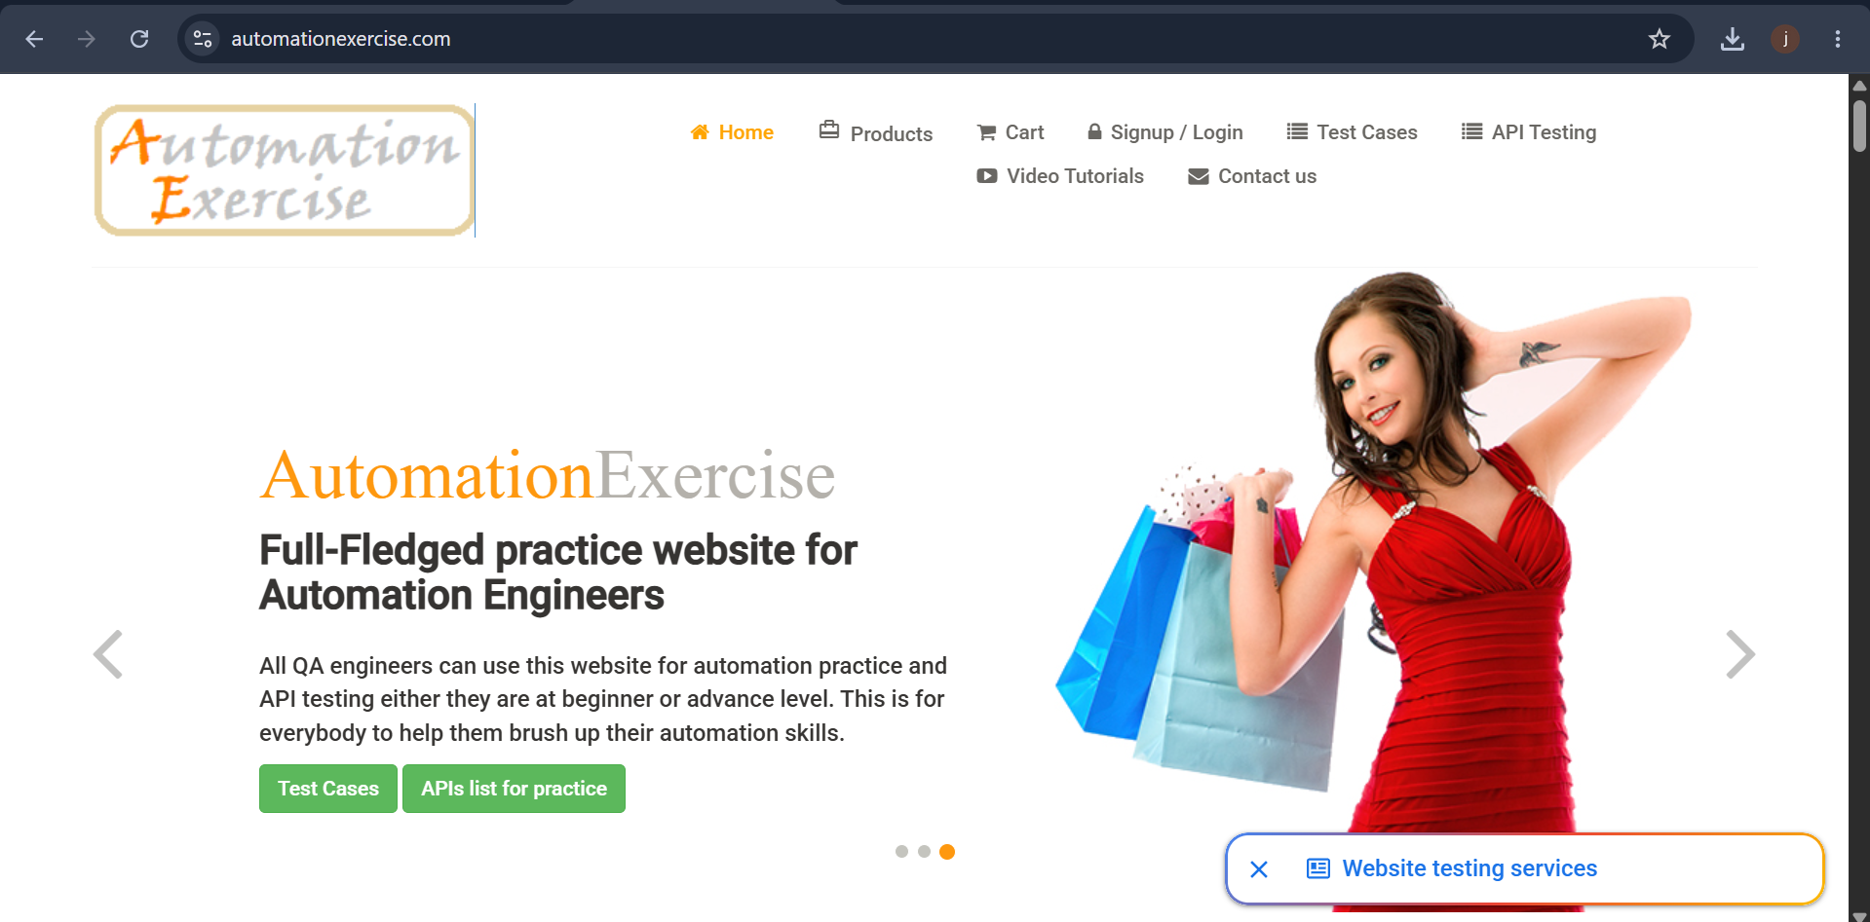

Scenario ID: M2
Test Scenario: Click Products
Test Input: Products button
Expected Result: Products page should open
Actual Result: Products page opens
Status: Pass
Screenshot:
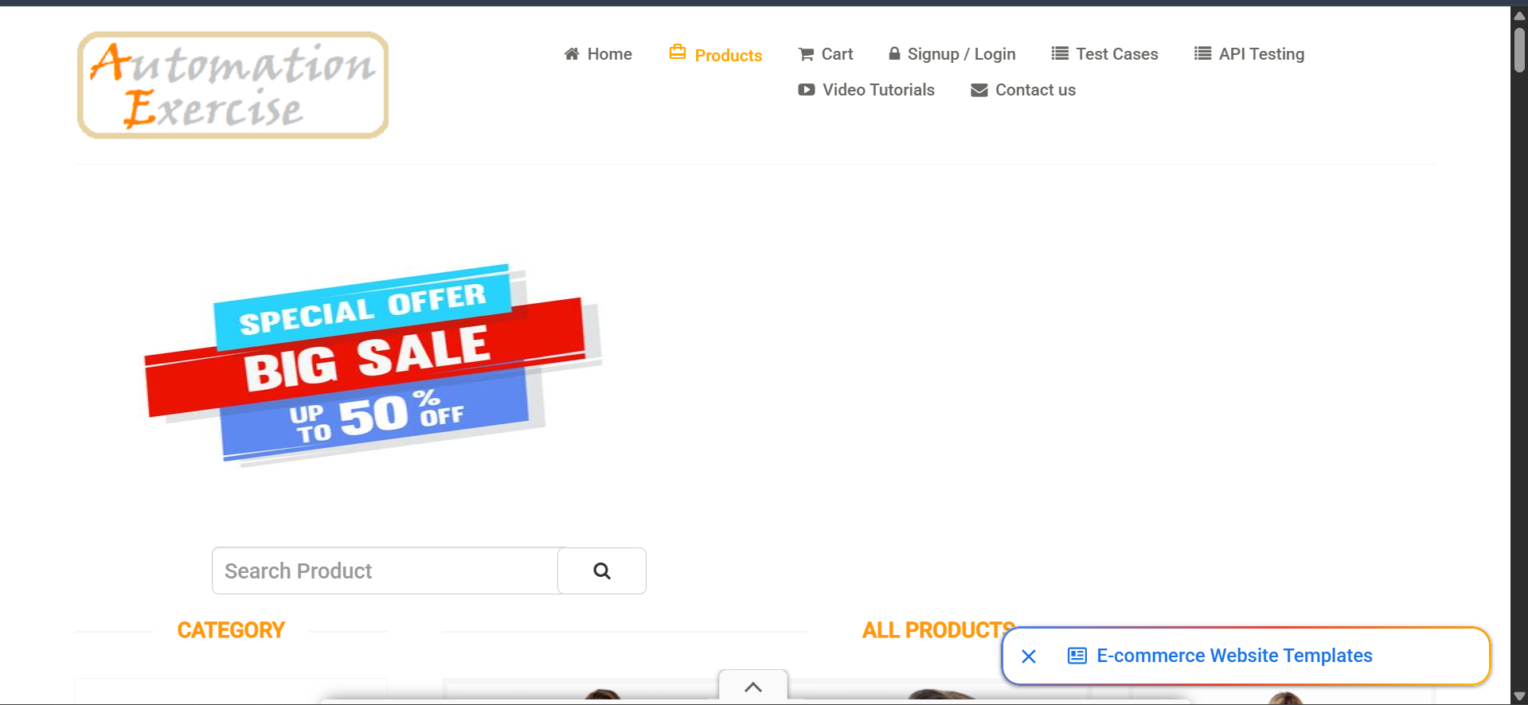
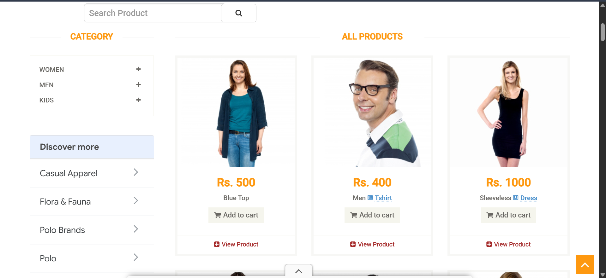

Scenario ID: M3
Test Scenario: Search for an existing product
Test Input: Blue Top
Expected Result: Matching products should be displayed
Actual Result: Matching product displayed
Status: Pass
Screenshot:
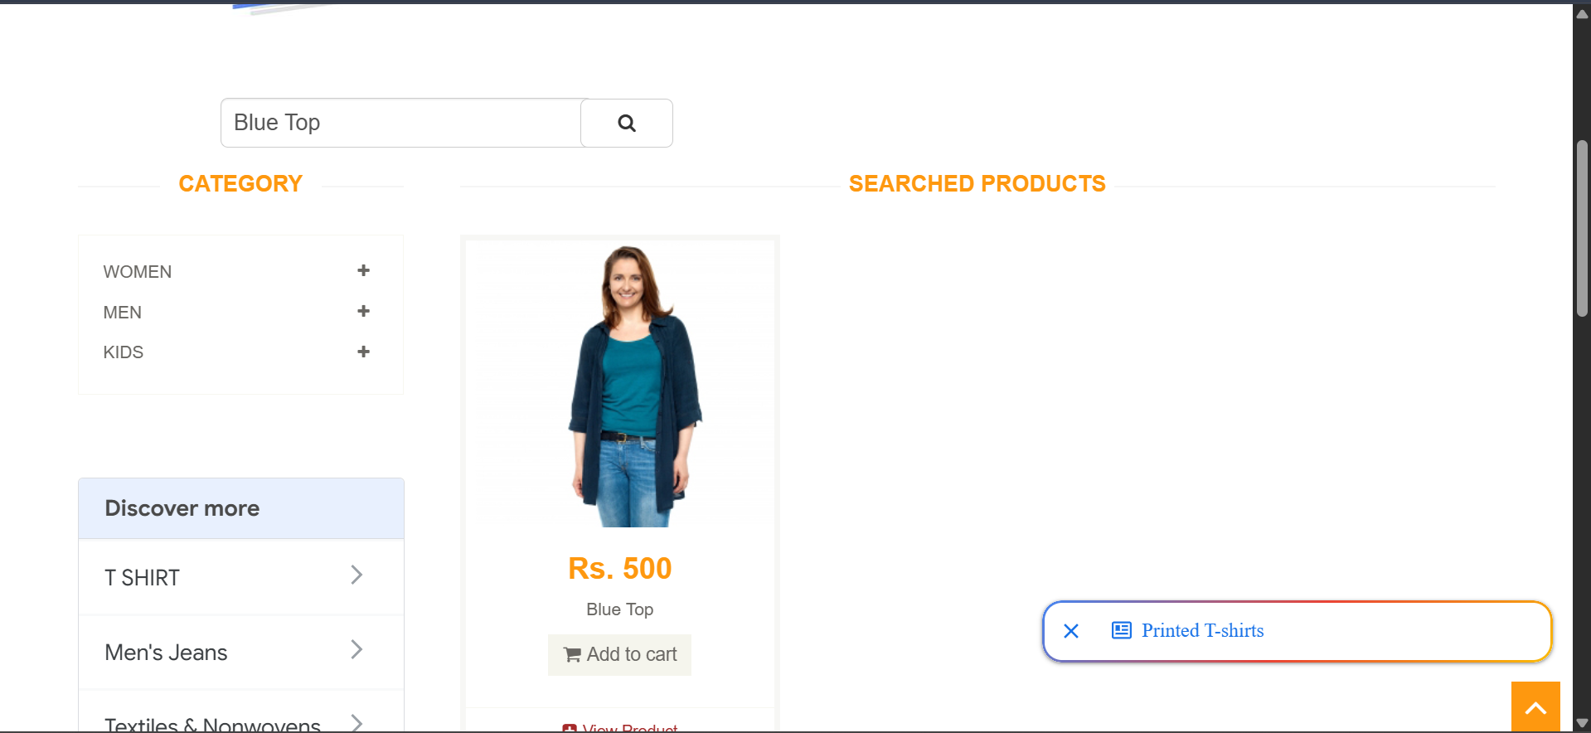

Scenario ID: M4
Test Scenario: Add one product to cart
Test Input: Blue Top
Expected Result: Product should be added exactly once
Actual Result: Product added
Status: Pass
Screenshot:
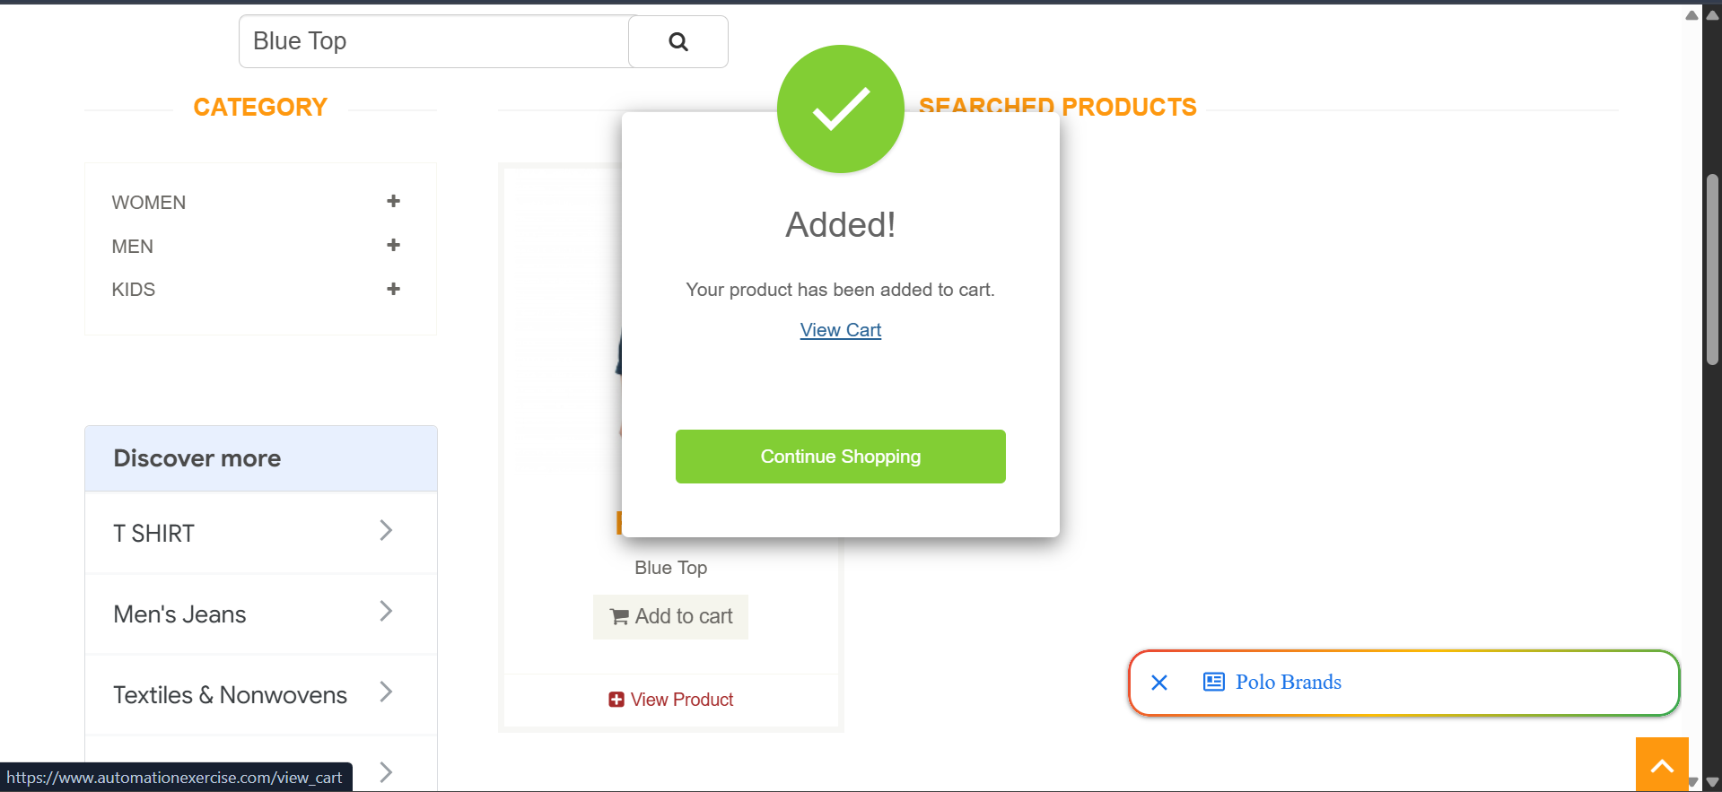
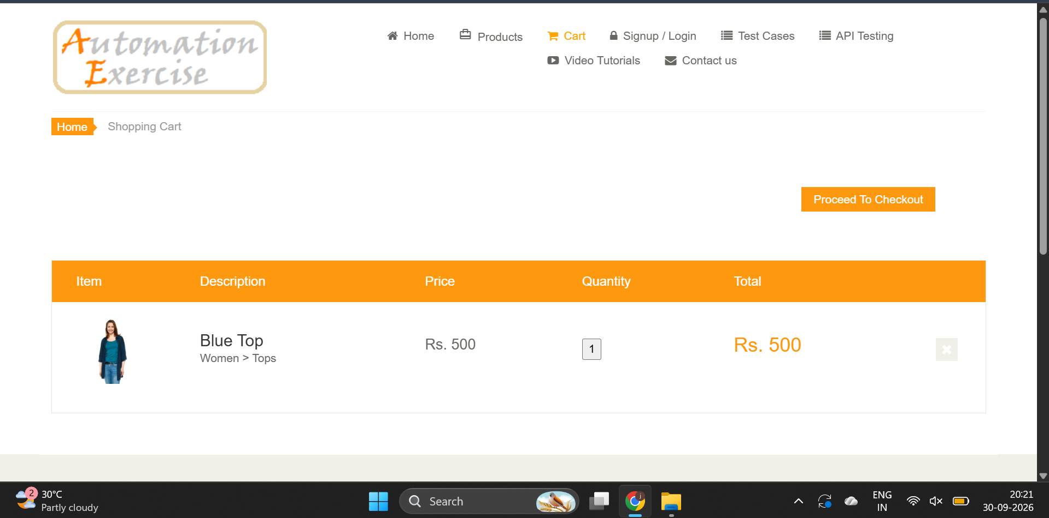

Scenario ID: M5
Test Scenario: Remove product from cart
Test Input: Click X
Expected Result: Selected product should disappear
Actual Result: Product removed
Status: Pass
Screenshot:
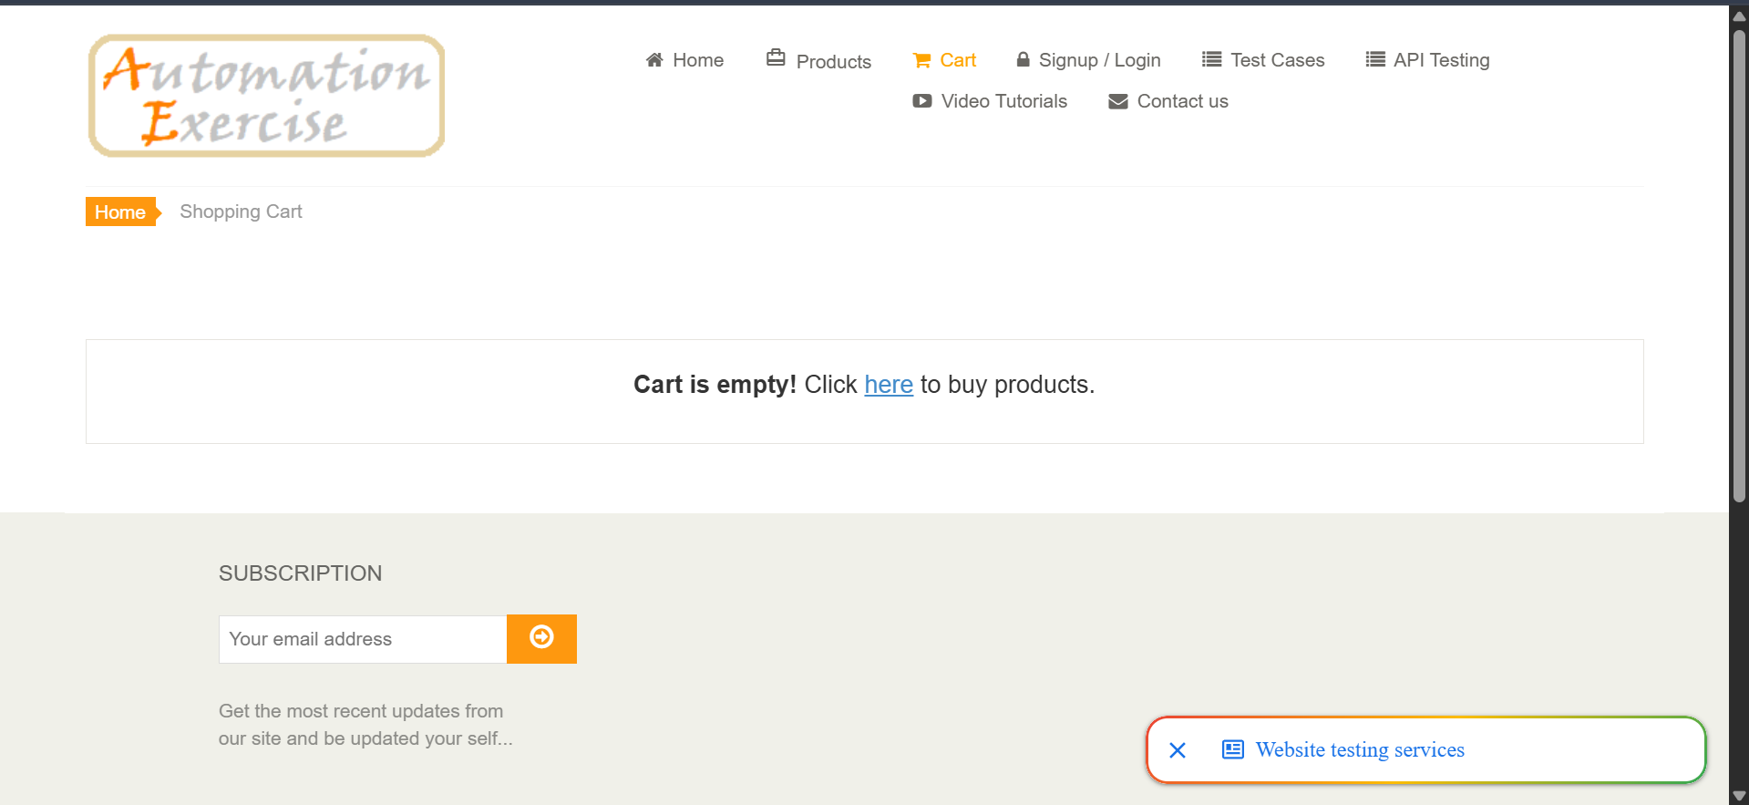

Scenario ID: M6
Test Scenario: Increase product quantity from cart
Test Input: Quantity = 4
Expected Result: Increased product quantity from cart
Actual Result: We can't Increased product quantity from cart
Status: Fail
Screenshot:
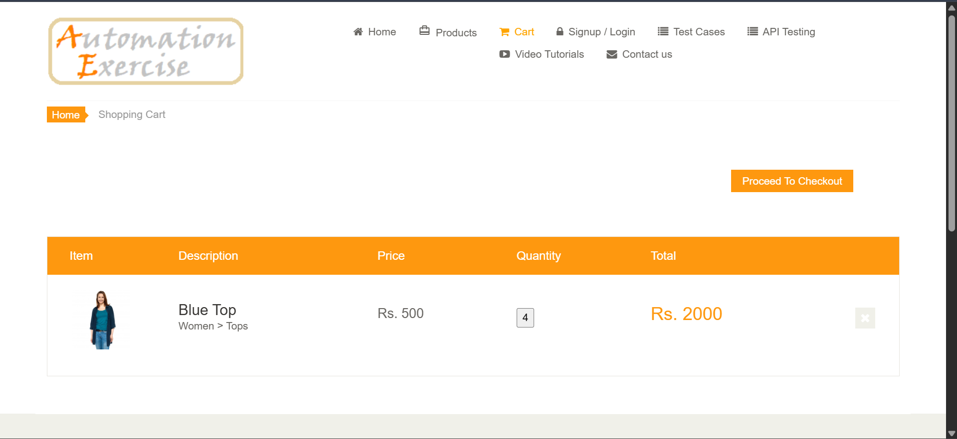

Scenario ID: M7
Test Scenario: Checkout with empty cart
Test Input: No products
Expected Result: Checkout should not proceed to payment
Actual Result: Checkout should not proceed to payment
Status: Pass
Screenshot:
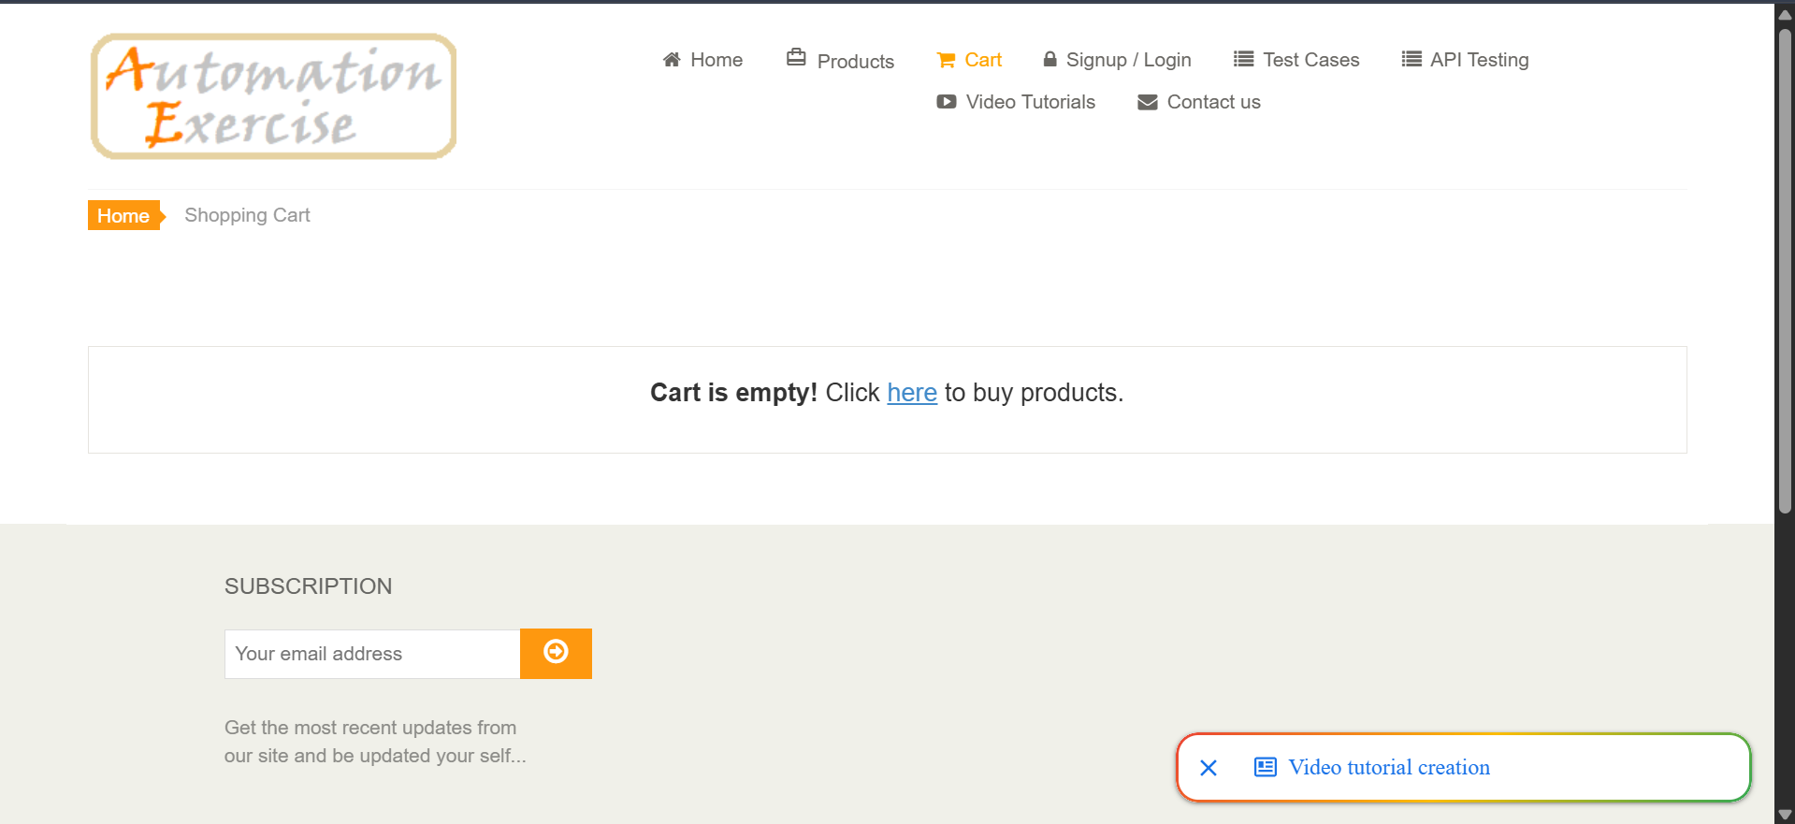

4. Test Summary
Total Test Cases | 7
Passed | 6
Failed | 1
Pass Percentage | 85.71%
Fail Percentage | 14.29%
5. Defect Summary
M6 – Increase product quantity from cart: The expected result was to increase the product quantity from the cart. The recorded actual result states: "We can't Increased product quantity from cart". Therefore, M6 is marked Fail.
6. Recommendations
1. Investigate the product quantity increase function in the cart.
2. Verify that the quantity control updates the cart quantity correctly.
3. Retest the cart quantity feature after correction.
4. Perform regression testing for product, cart, and checkout functions.
7. Conclusion
The Demo Web Application was tested using seven recorded scenarios. Six test scenarios passed and one test scenario failed. The failure was recorded for M6, which checks increasing product quantity from the cart. The remaining scenarios for the home page, products, search, add-to-cart, remove-from-cart, and empty-cart checkout produced the expected results.

