TUTORIAL – 6: MANUAL TEST EXECUTION
Test Execution Report – DemoBlaze Website
1. Aim
To execute manual test cases for the DemoBlaze website, compare expected and actual results, identify defects, and prepare a test execution report with screenshot evidence.
2. Application Details
Project Name | Demo Web Application
Application / Software | Web Based Application
Module Name | Login, Registration, Product Cart and Order Placement
SDLC Model | Agile Model
Programming Language | Python (as listed in the provided sheet)
IDE / Tool Used | Google Sheets / Docs; manual browser testing
Website | https://www.demoblaze.com/
Input / Test Data | Username, password, product details and customer/payment details
3. Test Cases and Execution Results
Scenario ID | Test Scenario | Test Input | Expected Result | Actual Result | Status
M1 | Open Website | Valid website URL | Homepage loads successfully. | Homepage opened successfully. | Pass
M2 | User Registration | Unique username and valid password | Account is created successfully. | Account created successfully. | Pass
M3 | Registration with Existing Username | Already registered username | Error message is displayed. | Error message displayed. | Pass
M4 | Registration with Empty Fields | Blank username and password | Registration is rejected. | Registration rejected. | Pass
M5 | Login with Valid Credentials | Registered username and correct password | User logs in successfully. | Login successful. | Pass
M6 | Login with Invalid Password | Registered username and incorrect password | Error message is displayed. | Error message displayed. | Pass
M7 | Login with Empty Fields | Blank username and password | Login is rejected. | Login rejected. | Pass
M8 | Add Product to Cart | Select a product and click “Add to cart” | Product is added to the cart. | Product added successfully. | Pass
M9 | Remove Product from Cart | Add a product and click “Delete” | Product is removed from the cart. | Product removed successfully. | Pass
M10 | Place an Order | Enter valid customer and payment details | Order confirmation is displayed. | Order confirmation displayed. | Pass
4. Overall Spreadsheet Screenshots

Screenshot 1 – Application details and first test cases
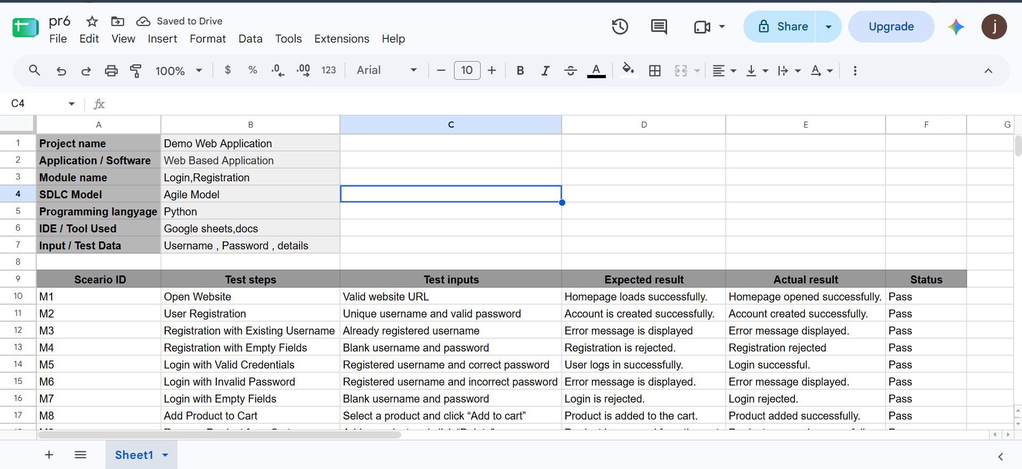
Screenshot 2 – Test cases M1–M10 and recorded statuses
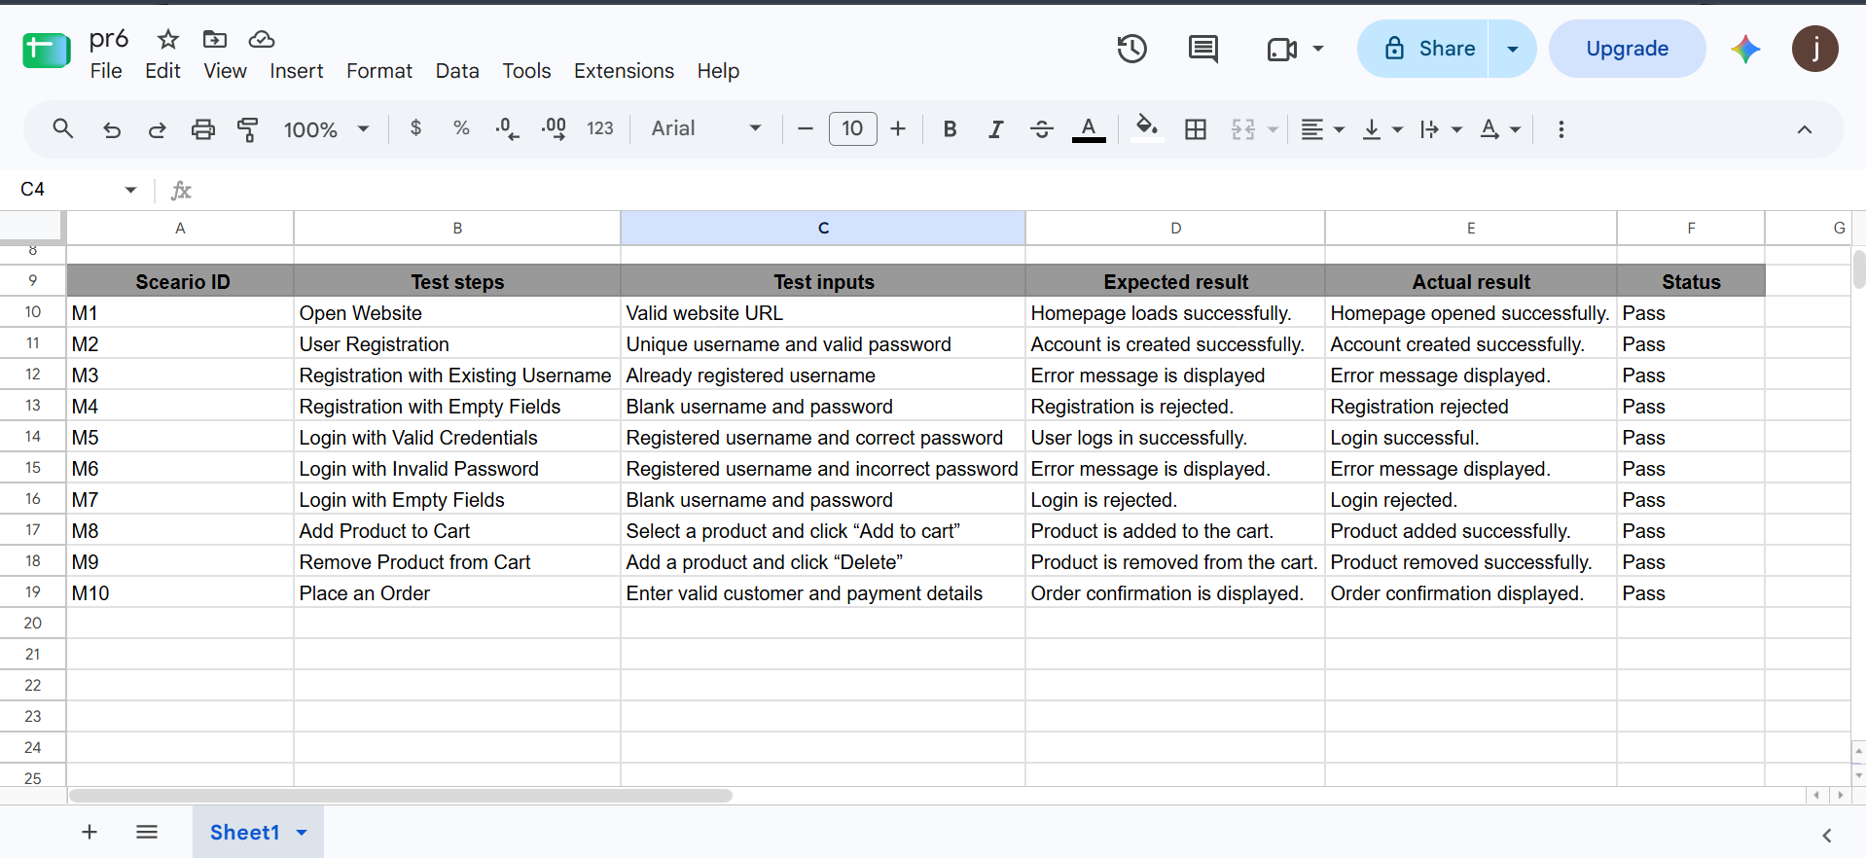
5. Individual Screenshot Evidence (One Section for Each Test Case)
Insert the corresponding website screenshot in each evidence area. The two uploaded images are spreadsheet screenshots only, so separate live website screenshots are still needed for complete evidence.
M1 – Open Website
Screenshot:
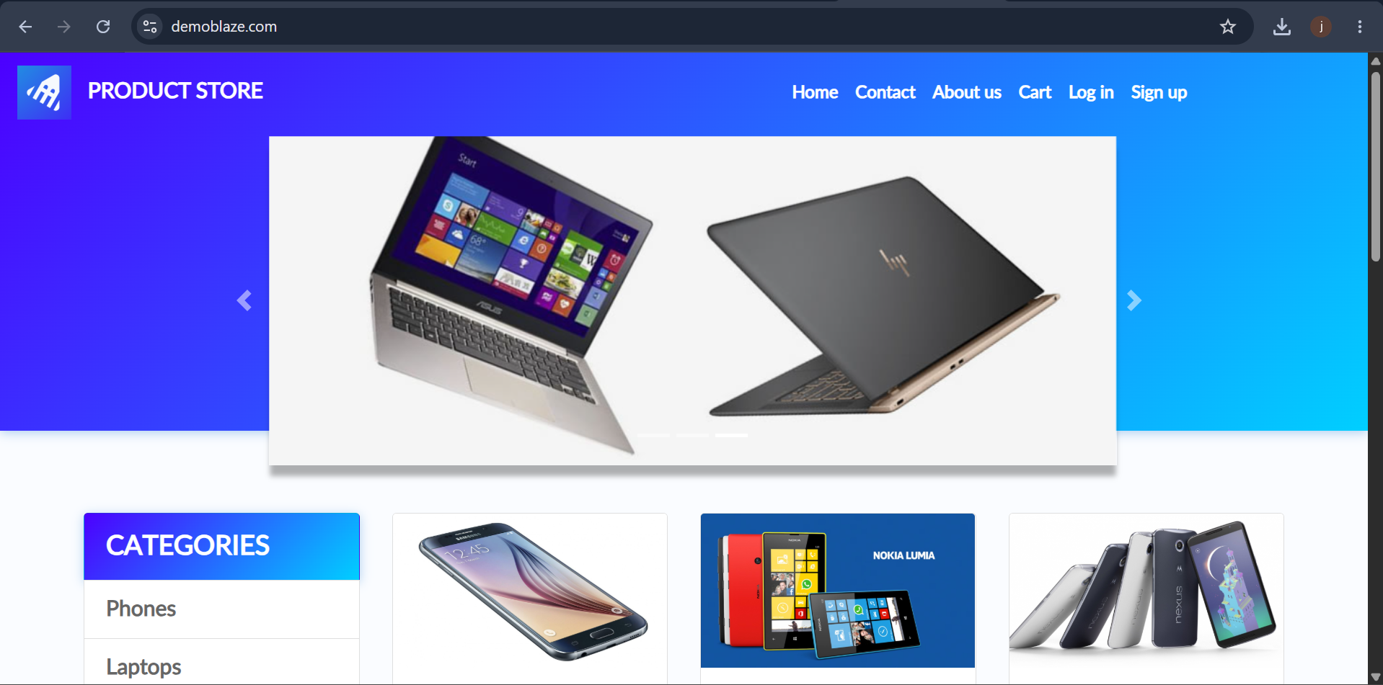
M2 – User Registration
Screenshot:
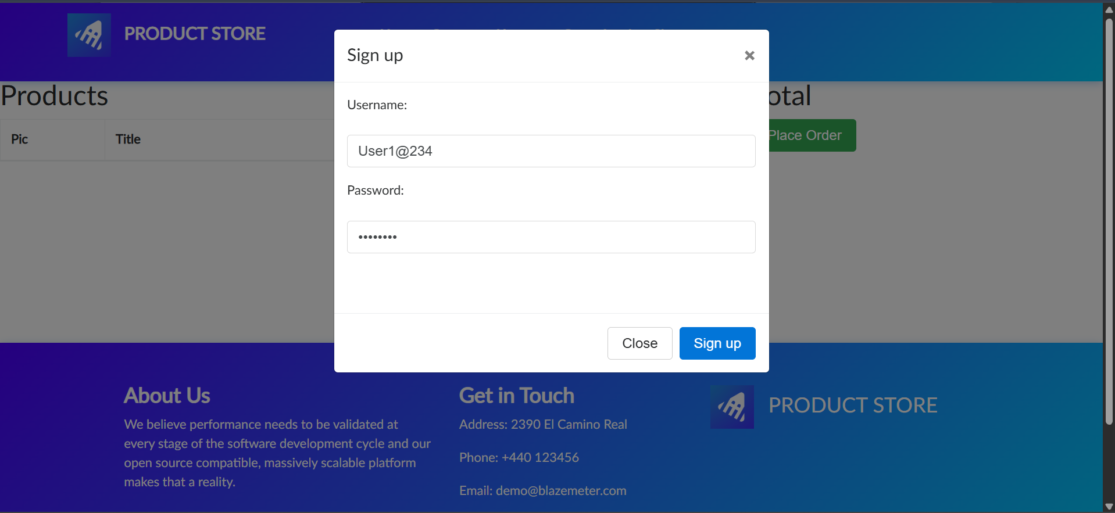
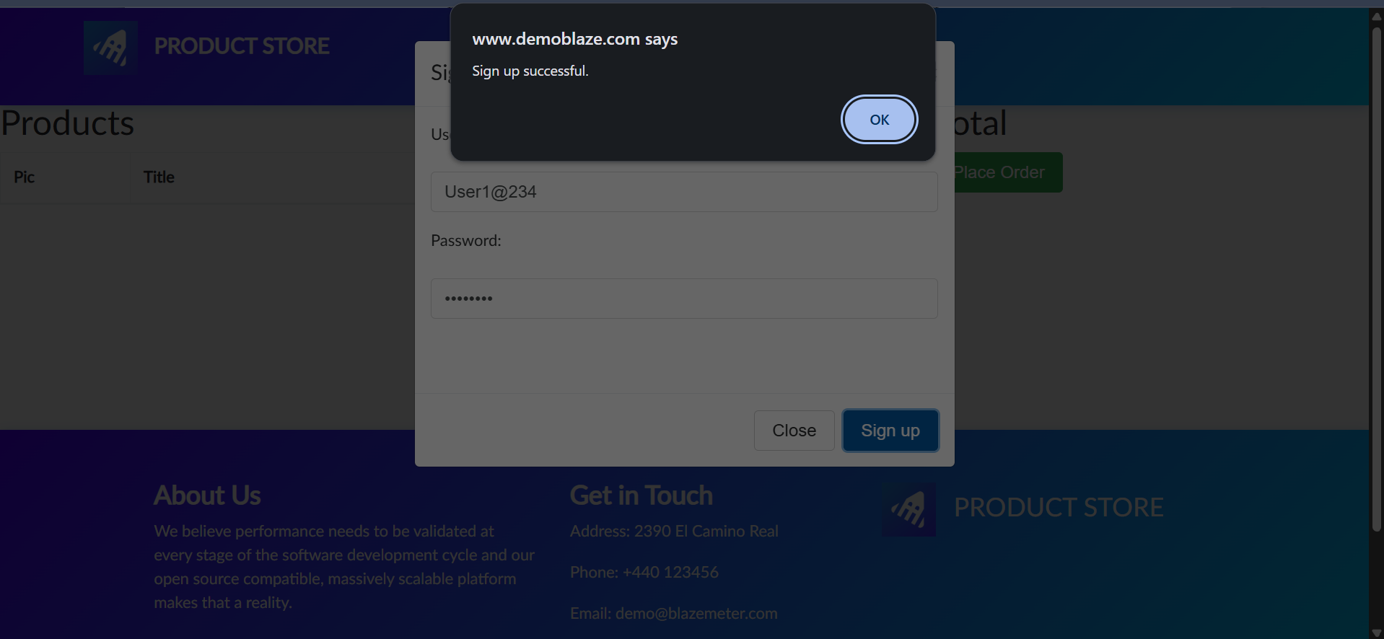
M3 – Registration with Existing Username
Screenshot:
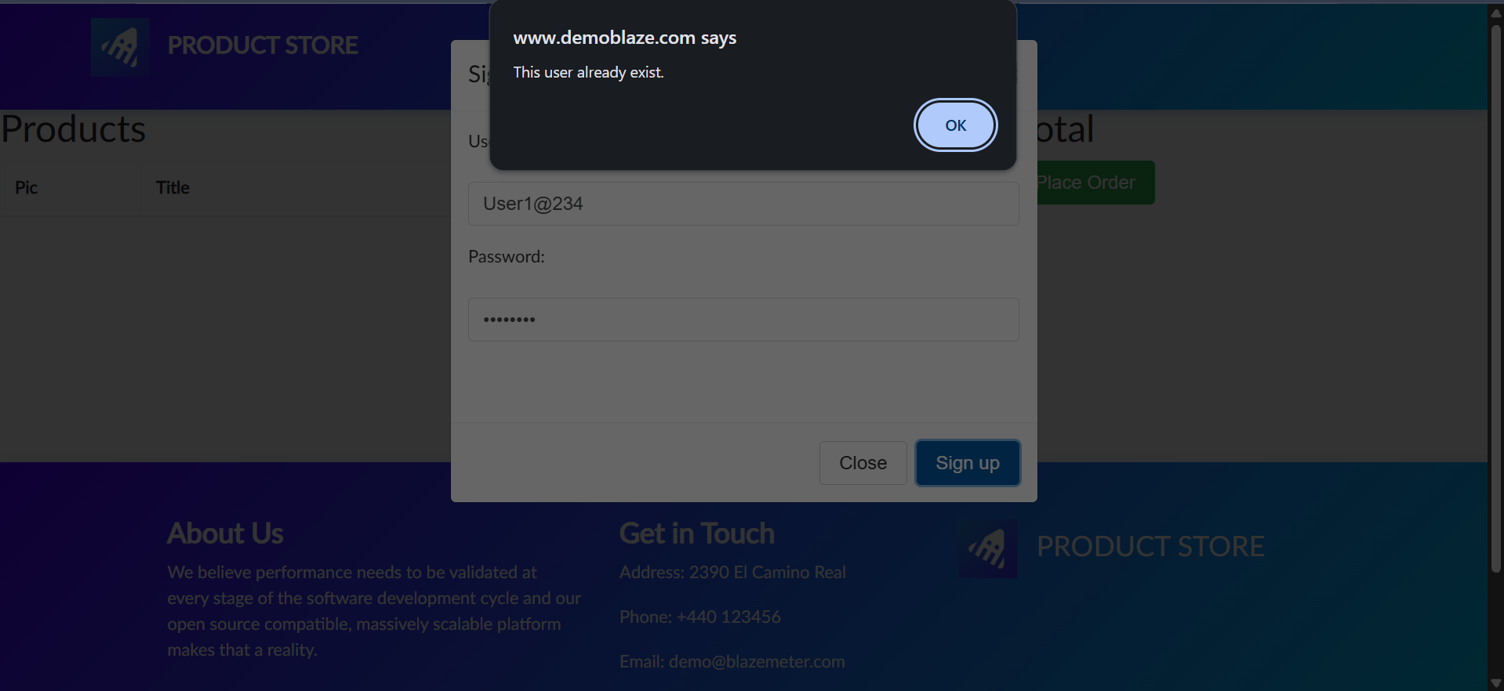
M4 – Registration with Empty Fields
Screenshot:
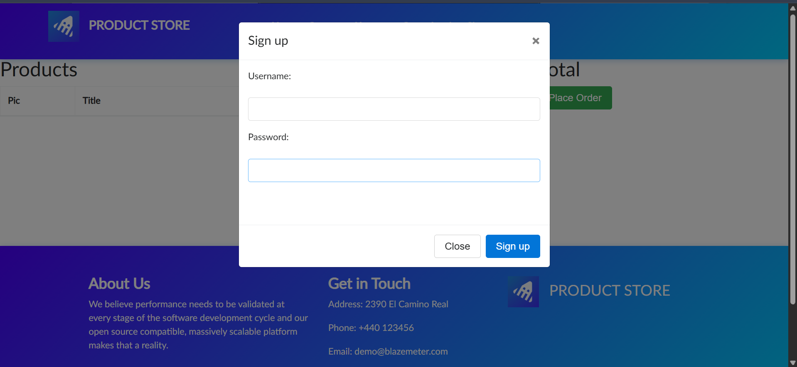
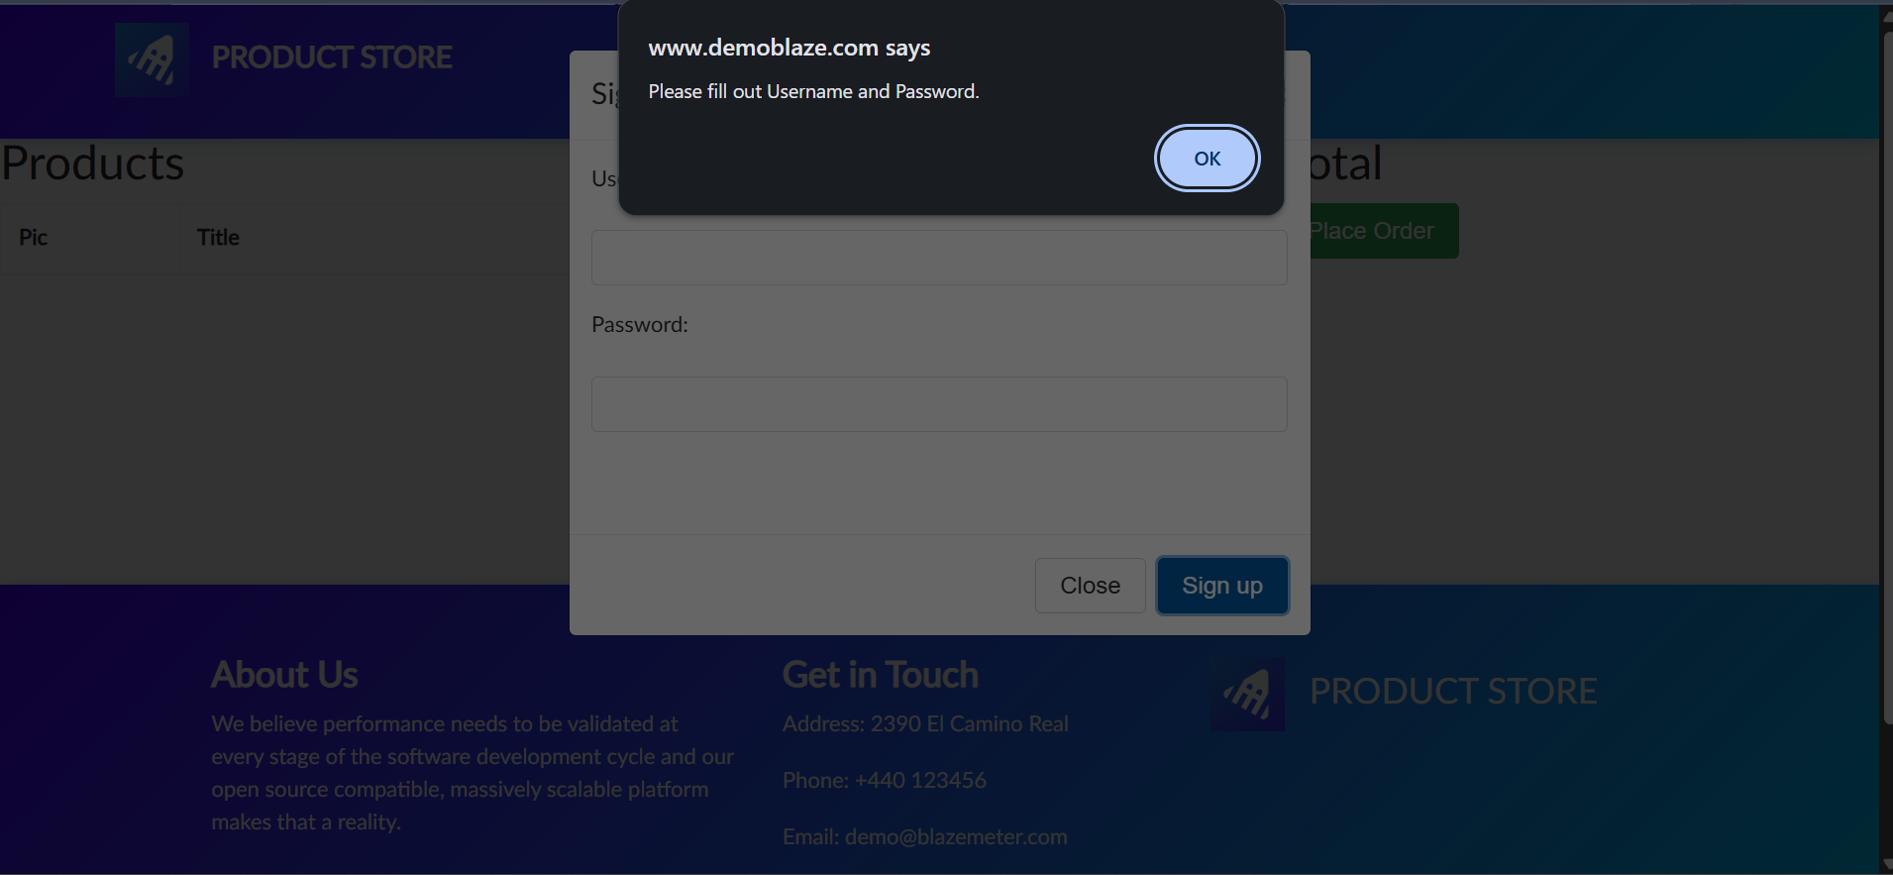
M5 – Login with Valid Credentials
Screenshot:
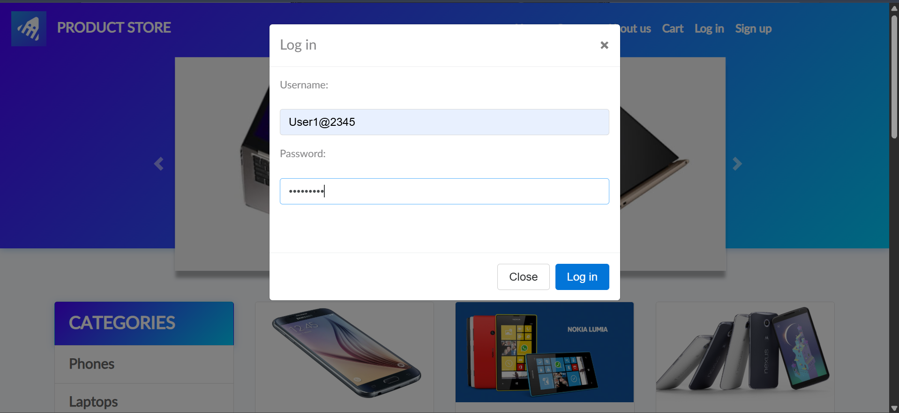
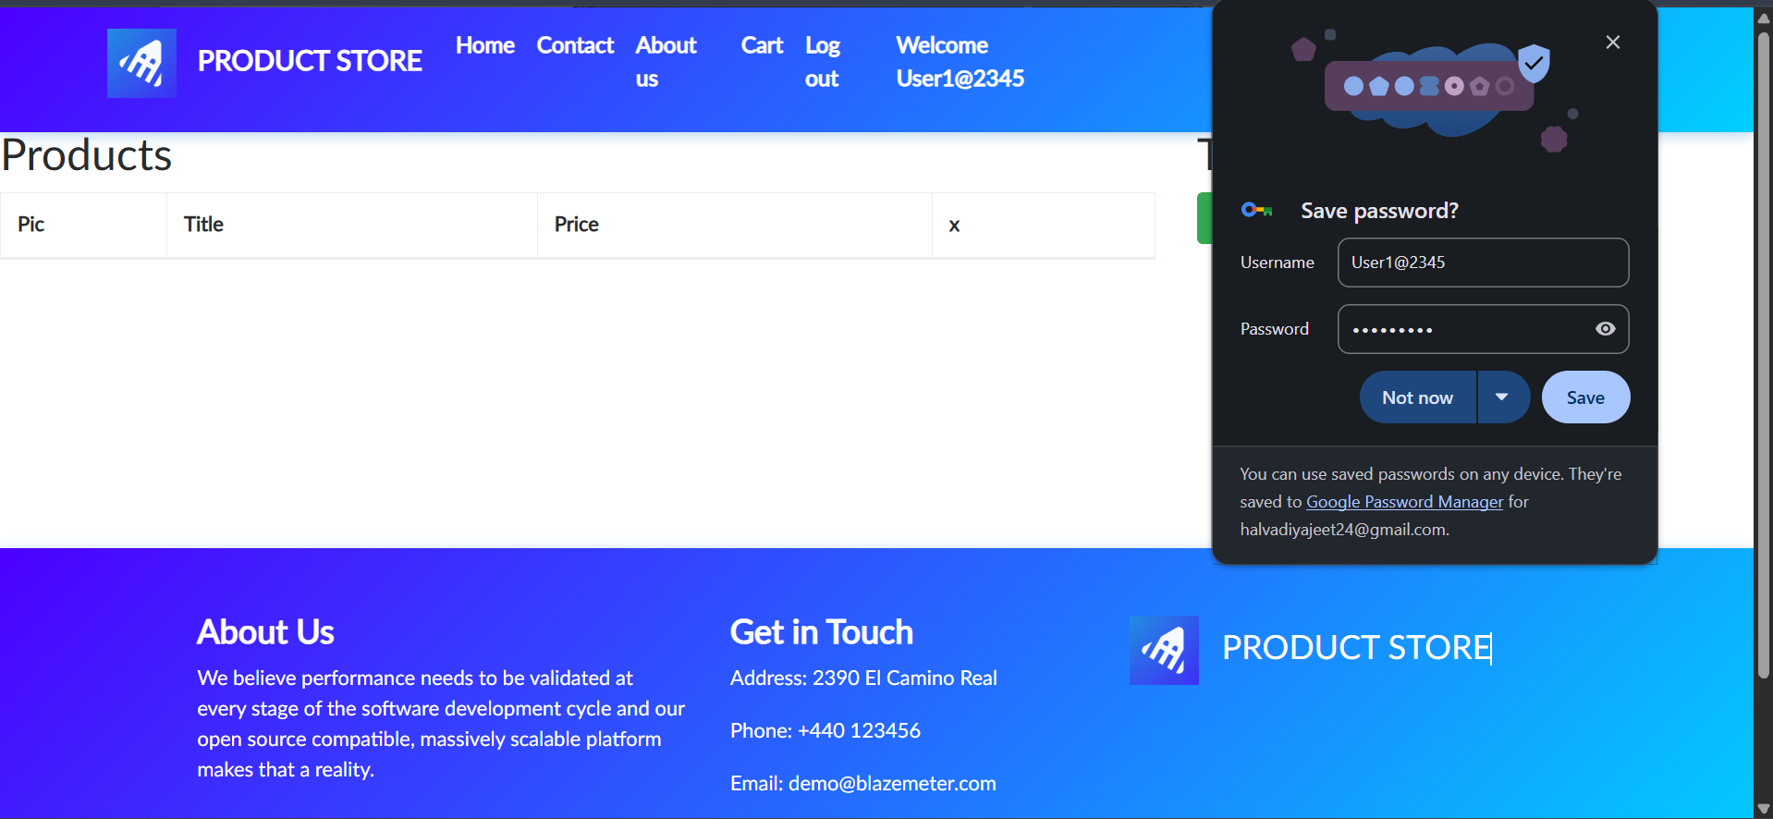
M6 – Login with Invalid Password
Screenshot:
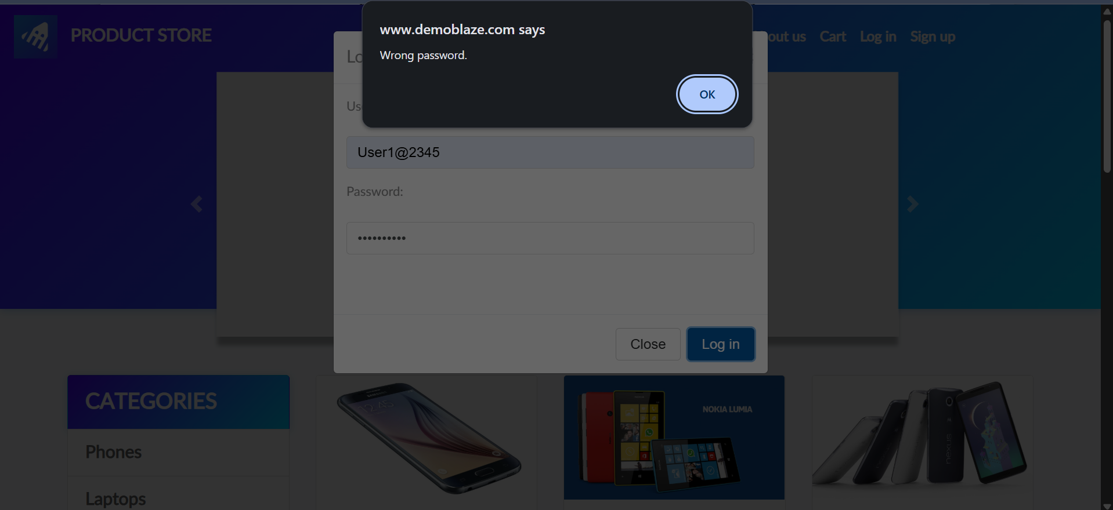
M7 – Login with Empty Fields
Screenshot:
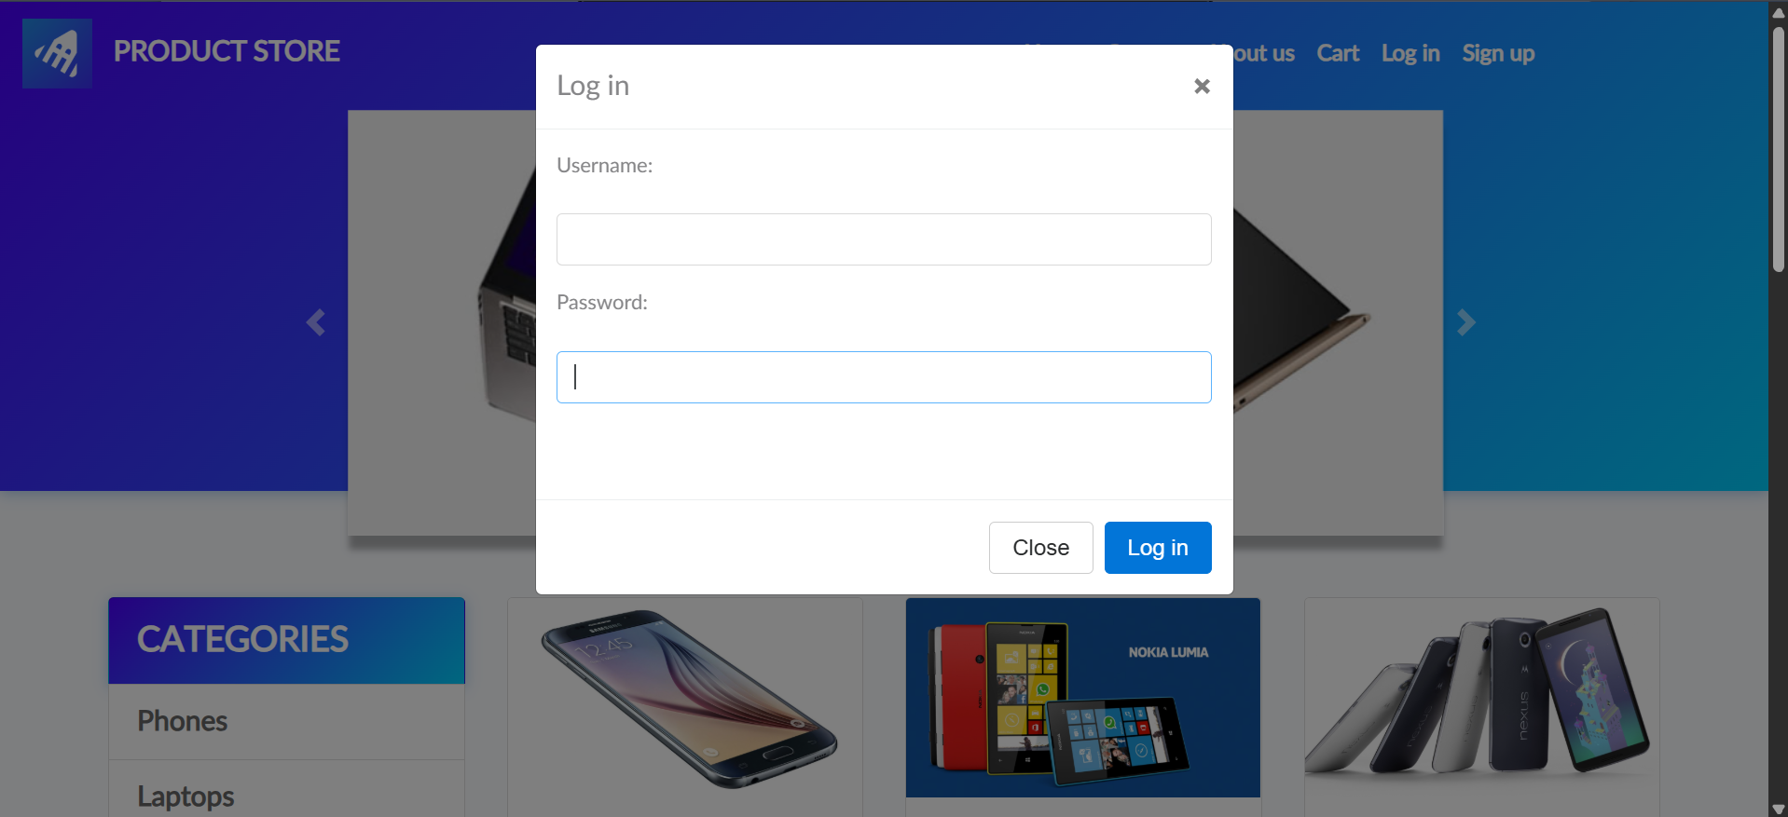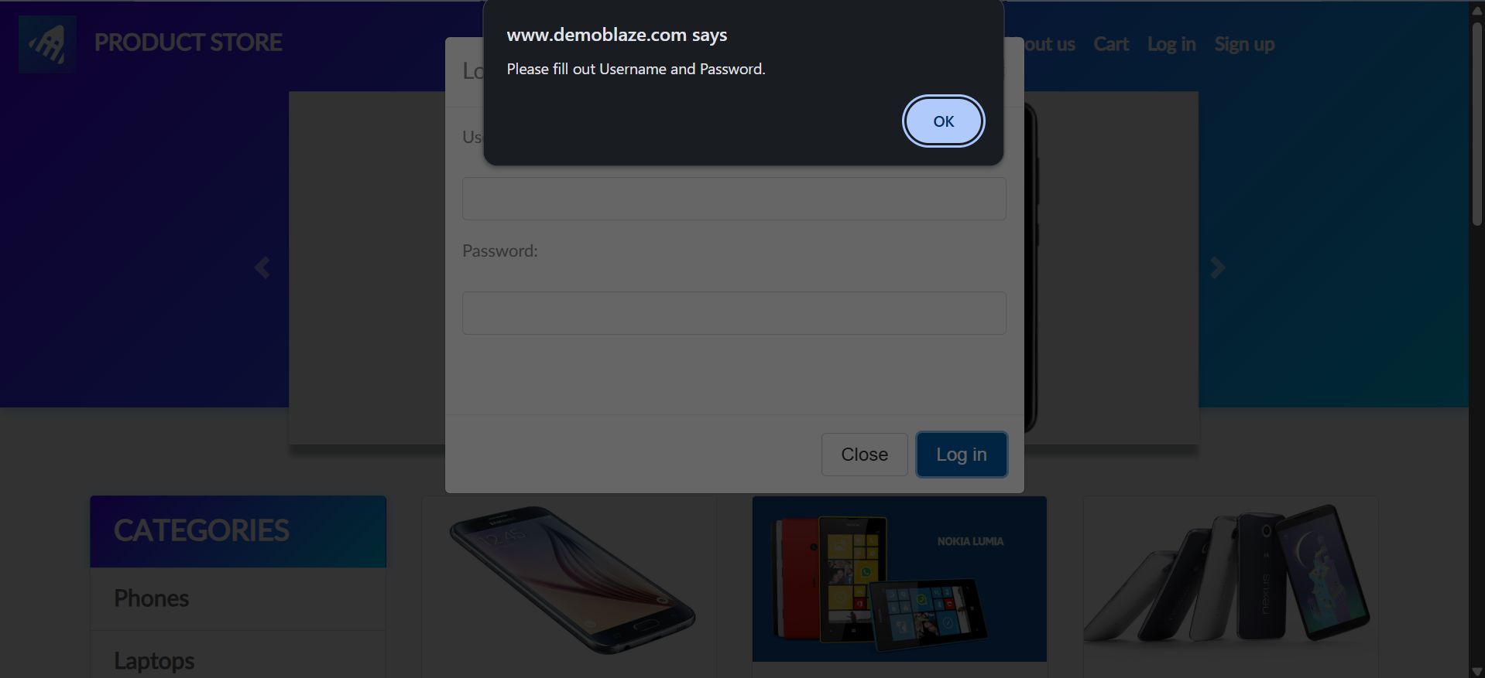
M8 – Add Product to Cart
Screenshot:
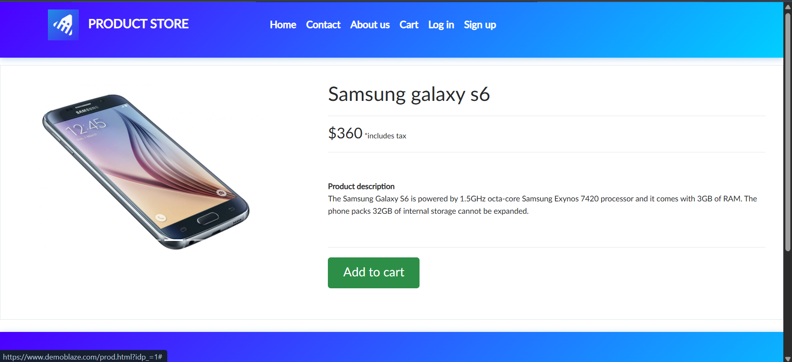
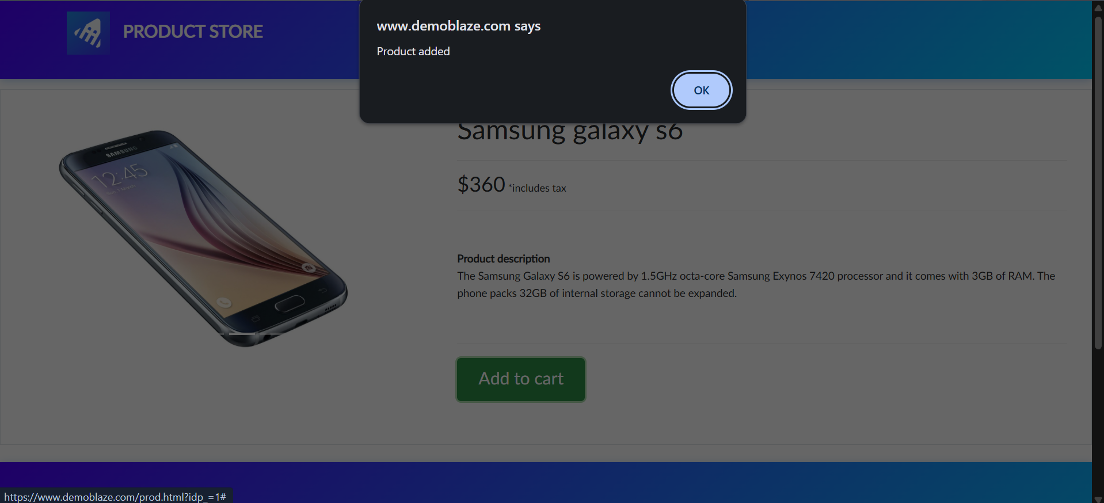
M9 – Remove Product from Cart
Screenshot:
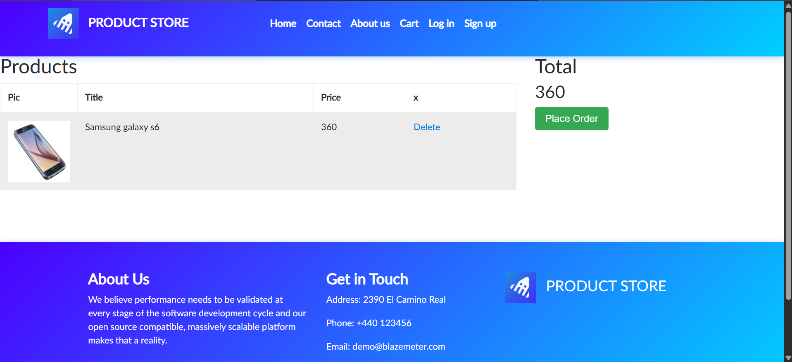
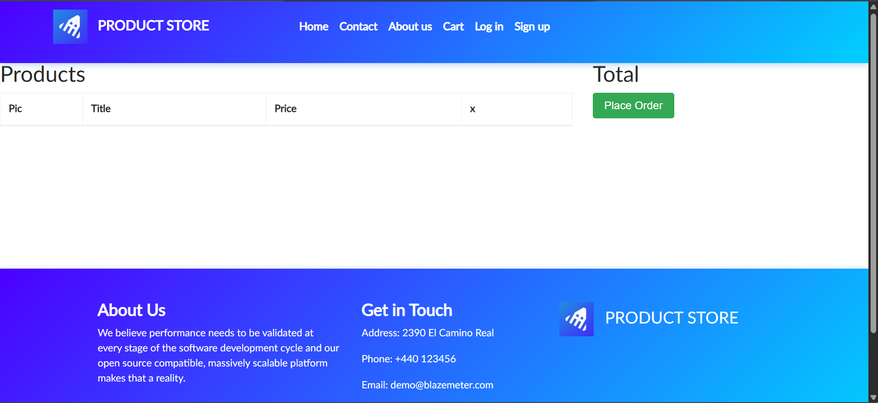
M10 – Place an Order
Screenshot:
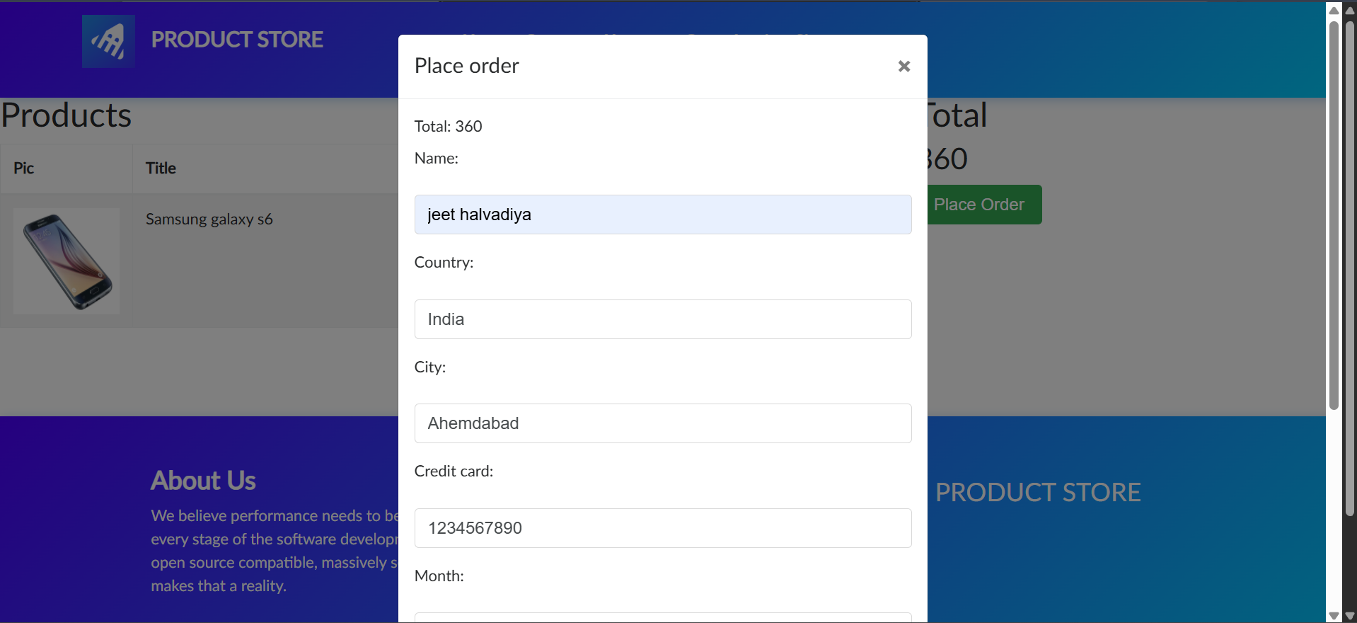
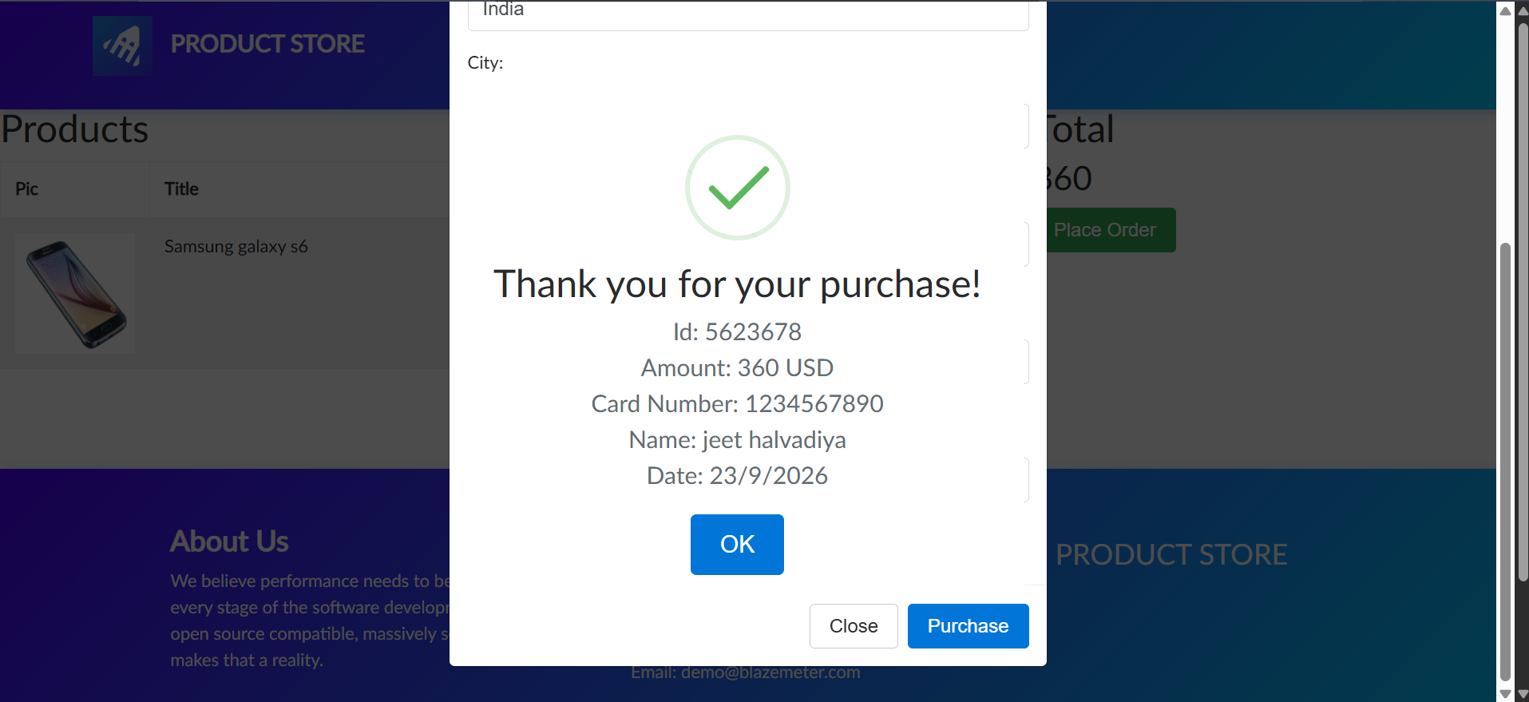
6. Defect Report
Defect ID | Scenario ID | Description | Severity | Status
— | — | No defects confirmed from the provided spreadsheet screenshots. | — | Requires live verification
7. Test Summary Report
Total test cases | 10
Passed (as recorded in spreadsheet) | 10
Failed (as recorded in spreadsheet) | 0
Blocked | 0
Defects confirmed | 0 confirmed; live verification required
8. Conclusion
Ten manual test cases are documented for the DemoBlaze website. The report includes the supplied overview screenshots and a separate screenshot evidence section for every test case.

