TUTORIAL – 7: BOUNDARY VALUE ANALYSIS (BVA) & EQUIVALENCE PARTITIONING (EP)
Test Report – Demo Web Application

1. Aim
To document username validation test cases, compare expected and actual results, identify defects, and prepare a test report with screenshot evidence.

2. Application Details
Field | Details
Project Name | Demo Web Application
Application / Software | Web Based Application
Module Name | Login
SDLC Model | Agile Model
Programming Language | Java, Python, JavaScript
IDE / Tool Used | Google Sheets, Docs
Input / Test Data | Username
Website | https://www.demoblaze.com/ (confirm this is the website used during testing)

3. Test Execution Results
Scenario ID | Test Steps | Test Inputs | Expected Result | Actual Result | Status
1 | Open Web site | URL | Home page opens | Opened | Pass
2 | Enter Username | hello | Validation message appears | Appeared | Pass
3 | Enter Username | me@gmail.com | Username entered | Entered | Pass
4 | Enter Username | itsme@gmail.com | Username entered | Entered | Pass
5 | Enter Username | helloguys@gmail.com | Username entered | Entered | Pass
6 | Enter Username | helloguysitsme@gmail.com | Validation message appears | Appeared | Fail
7 | Login | Valid credentials | Logged in | Logged in | Pass
Note: Results and statuses above are transcribed from the supplied spreadsheet screenshot and have not been independently re-tested.

4. Original Spreadsheet Screenshot
Screenshot of the test record supplied by the user.

5. Individual Screenshot Evidence for Each Test Case
A separate evidence area is provided below for every test case. Insert the corresponding screenshot from the website/browser into each marked area. The supplied image is a spreadsheet screenshot, so it cannot serve as the live website evidence for each individual case.

Scenario 1: Open Web site
Screenshot:
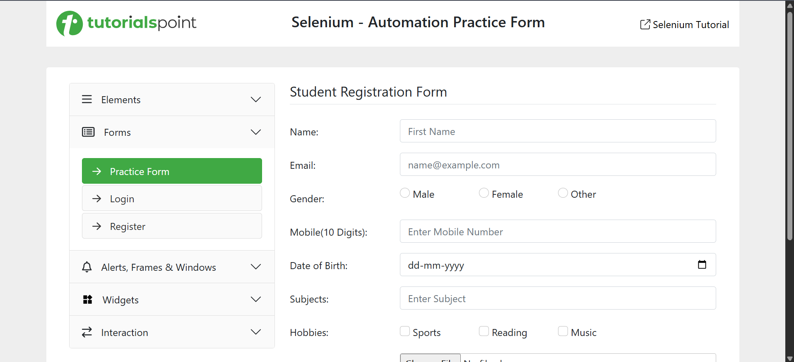

Scenario 2: Enter Username
Screenshot:
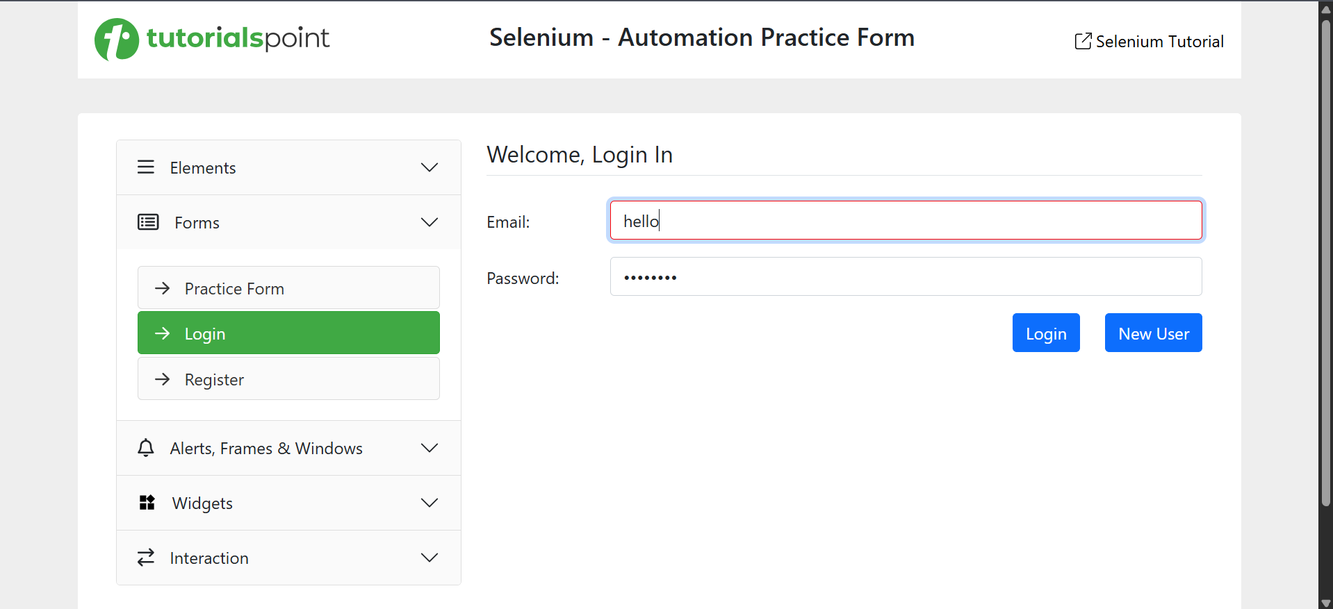

Scenario 3: Enter Username
Screenshot:
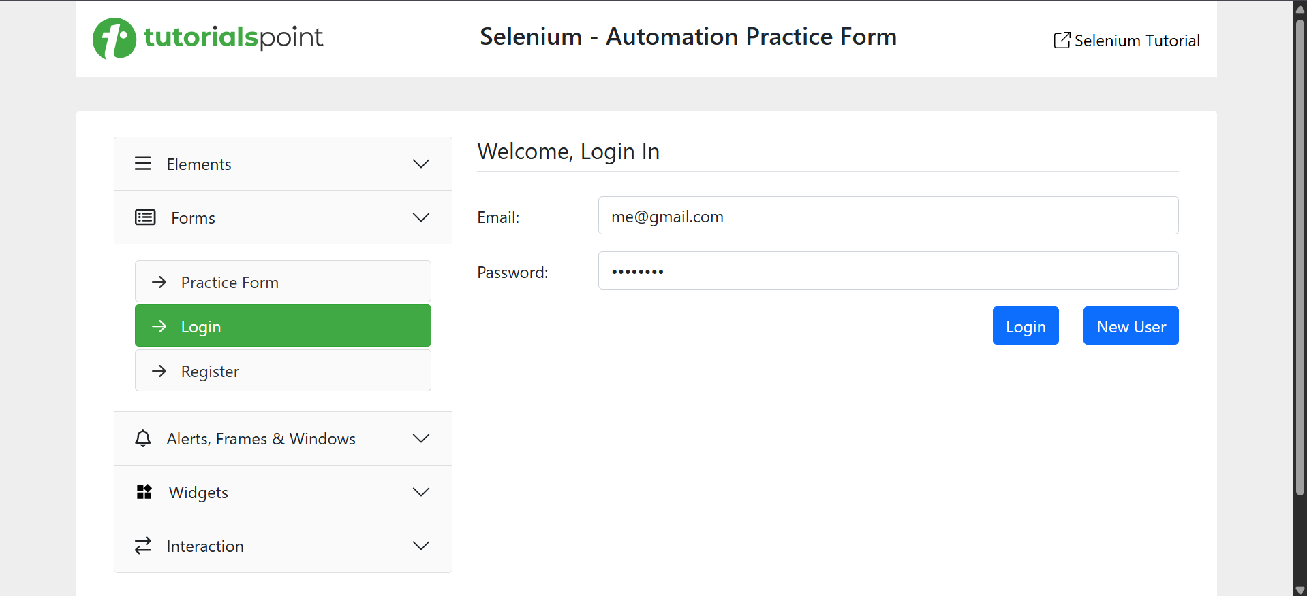

Scenario 4: Enter Username
Screenshot:
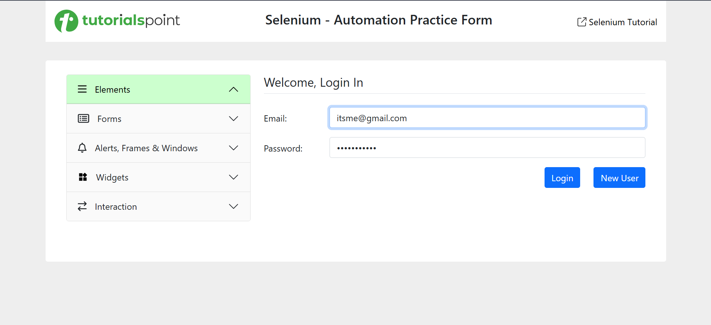

Scenario 5: Enter Username
Screenshot:
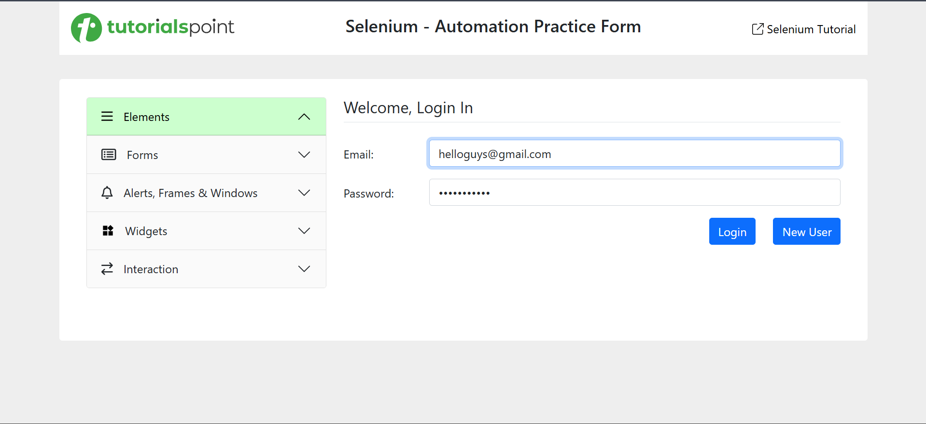

Scenario 6: Enter Username
Screenshot:
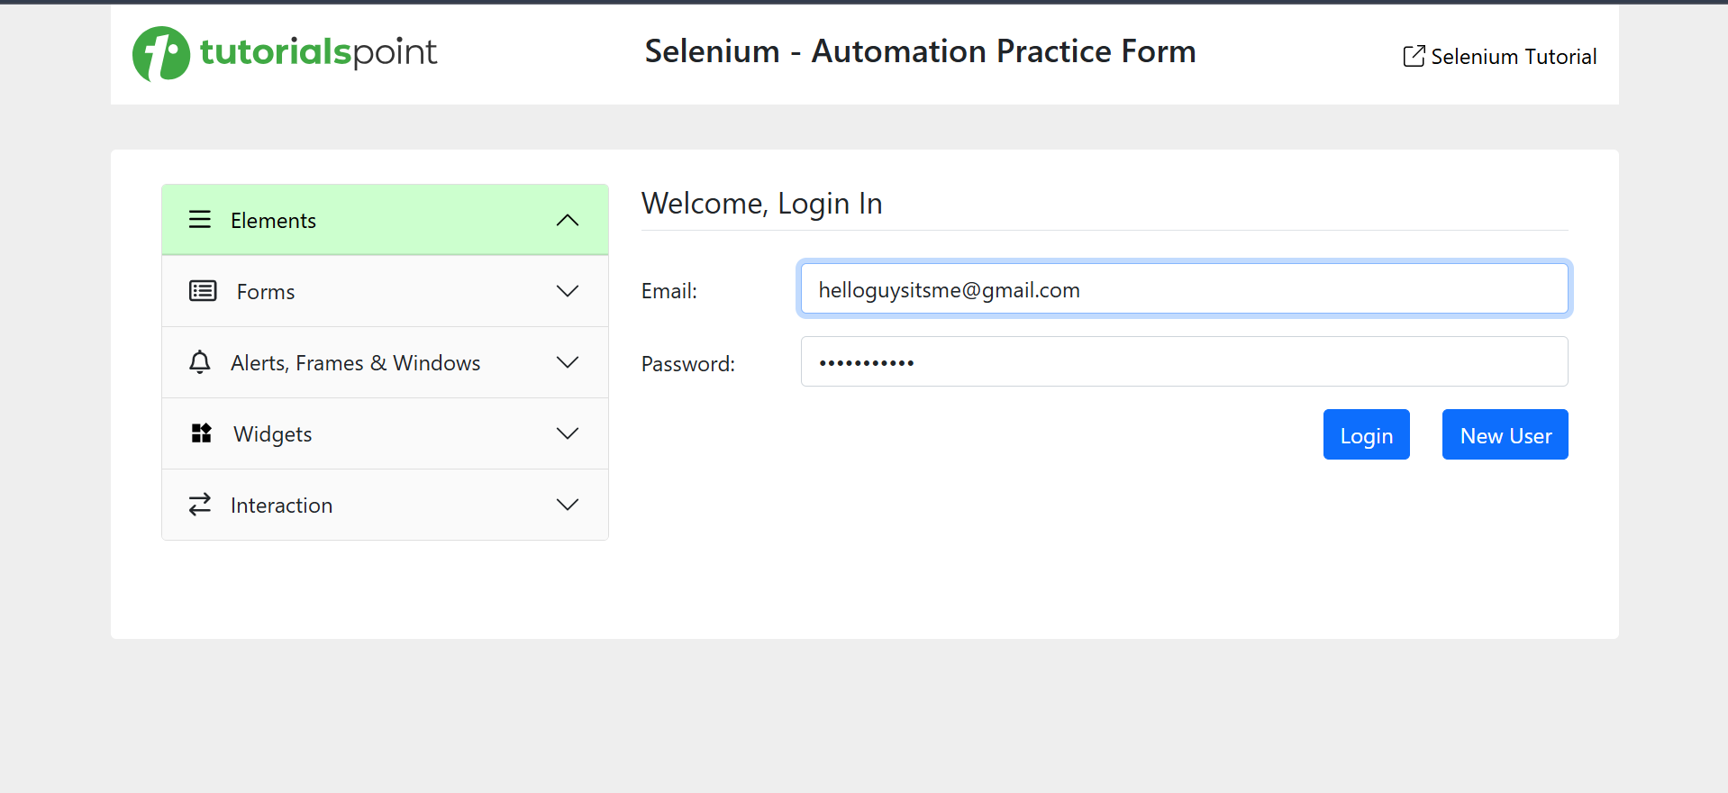

Scenario 7: Login
Screenshot:
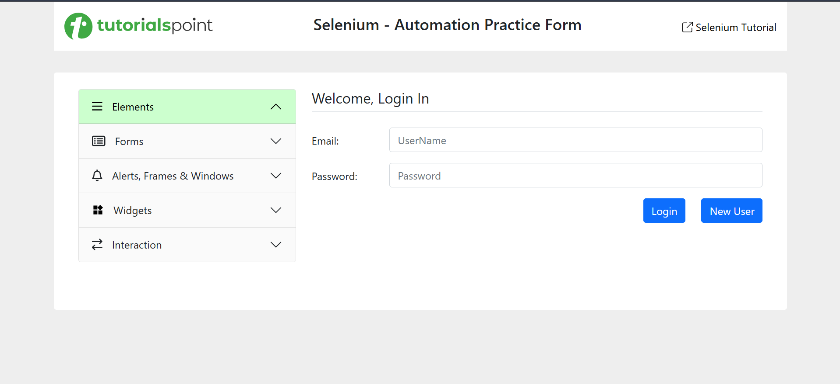

6. Bug Report
Bug ID | Scenario ID | Observed Issue | Severity | Status
BUG-01 | 6 | Scenario marked Fail although actual result “Appeared” seems to match expected result “Validation message appears”; failure reason is not stated. | To be assessed | Needs investigation

7. Test Summary Report
Metric | Count
Total test cases | 7
Passed (as recorded) | 6
Failed (as recorded) | 1
Blocked | 0
Pass percentage | 85.7%

8. Conclusion
The supplied sheet records seven test scenarios: six Pass and one Fail. The report includes the original spreadsheet screenshot and separate screenshot placeholders for each scenario. Add real browser screenshots for each executed case and investigate Scenario 6 before final submission.

