Manual Test Execution Report – SauceDemo

Application Details
Field | Details
Project Name | Demo Web Application
Application / Software | Web Based Application
Module Name | Login
SDLC Model | Agile Model
Programming Language | Java, Python, JavaScript
IDE / Tool Used | Google Sheets, Google Docs
Website | https://www.saucedemo.com/
Input / Test Data | Username, Password

Test Execution Report
Scenario ID | Test Steps | Test Inputs | Expected Result | Actual Result | Status
M1 | Open SauceDemo website | Website URL | Login page should open | Opened | Pass
M2 | Enter valid login | Username: standard_user | Username should be entered | Entered | Pass
M3 | Enter valid password | Password: secret_sauce | Password should be entered | Entered | Pass
M4 | Log in successfully | Valid username and password | User should be logged in | Logged in | Pass
M5 | Leave username and password blank | Empty username and password | Required-field error message should be displayed | Displayed message | Pass
M6 | Add product to cart | Select a product and click Add to Cart | Product should be added to the cart | Added to cart | Pass
M7 | Remove product from cart | Click Remove | Product should be removed from the cart | Removed | Pass
M8 | Place order | Proceed to checkout | Checkout process should begin | Checkout process should begin | Pass

Screenshot Evidence

Original Test Record
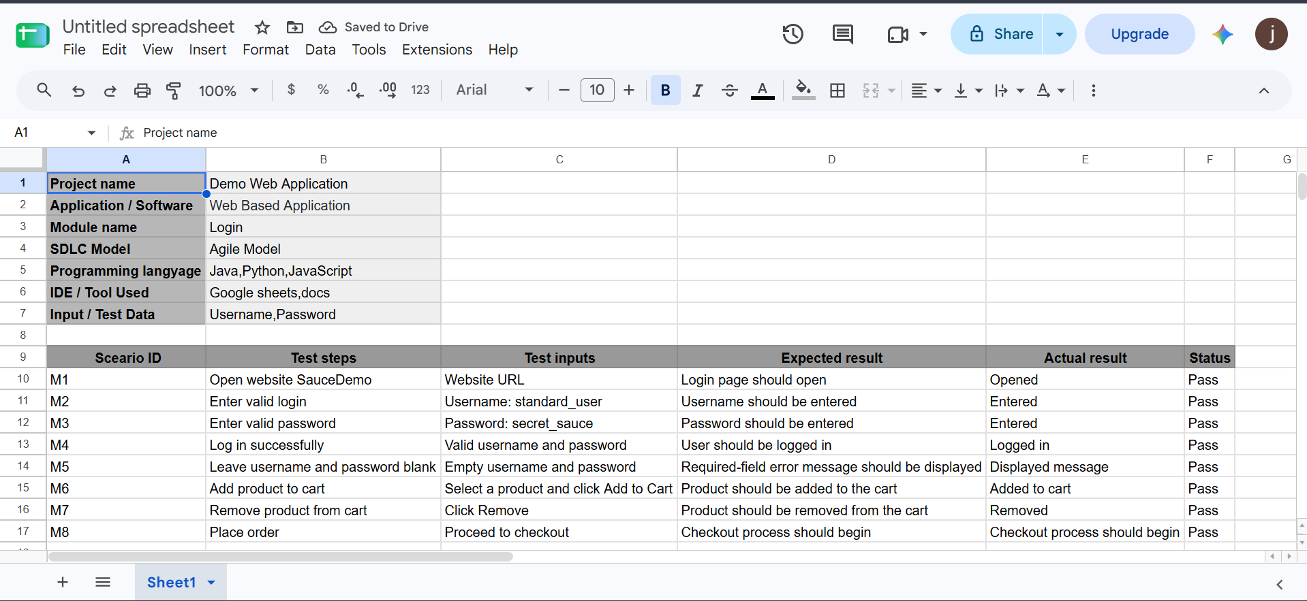

Individual Screenshot Sections
M1 – Open SauceDemo Website
- Screenshot: Login page after opening the URL.
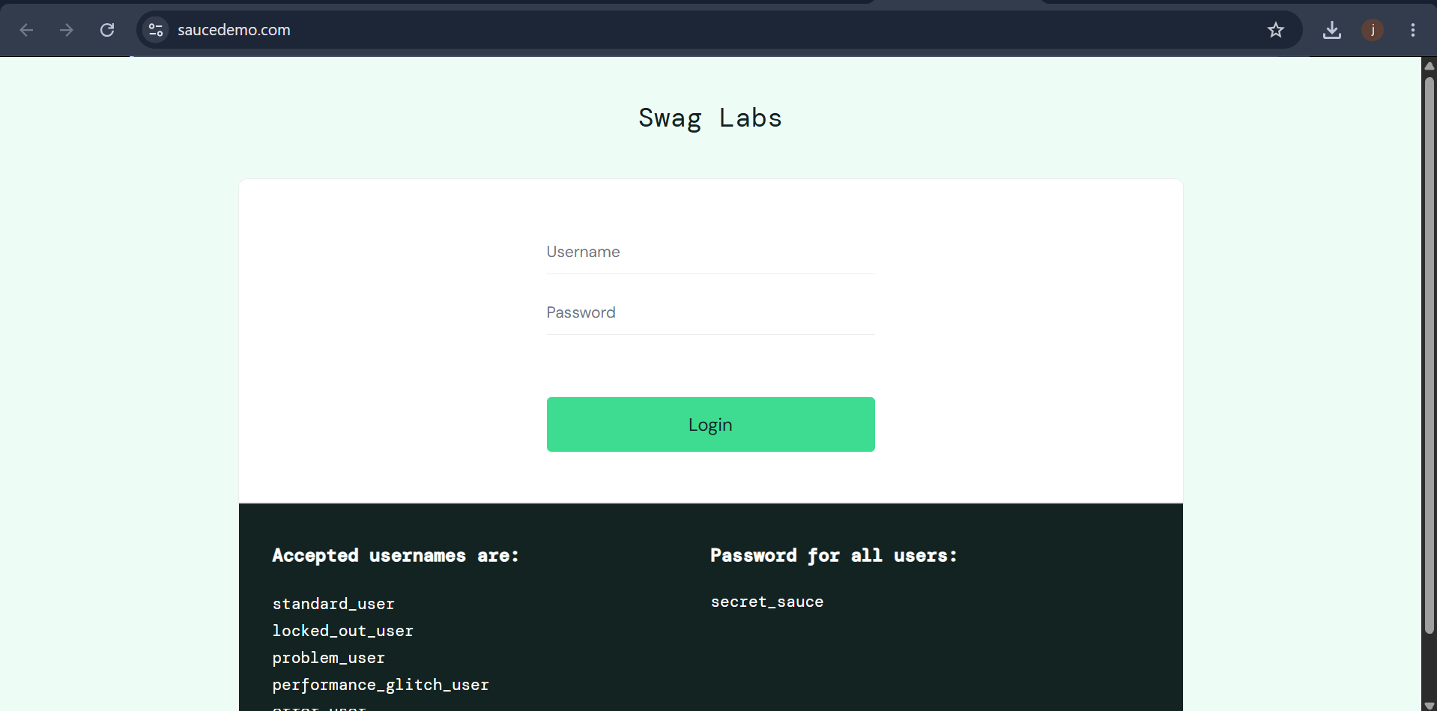
M2 – Enter Valid Username
- Screenshot: Username field with standard_user.
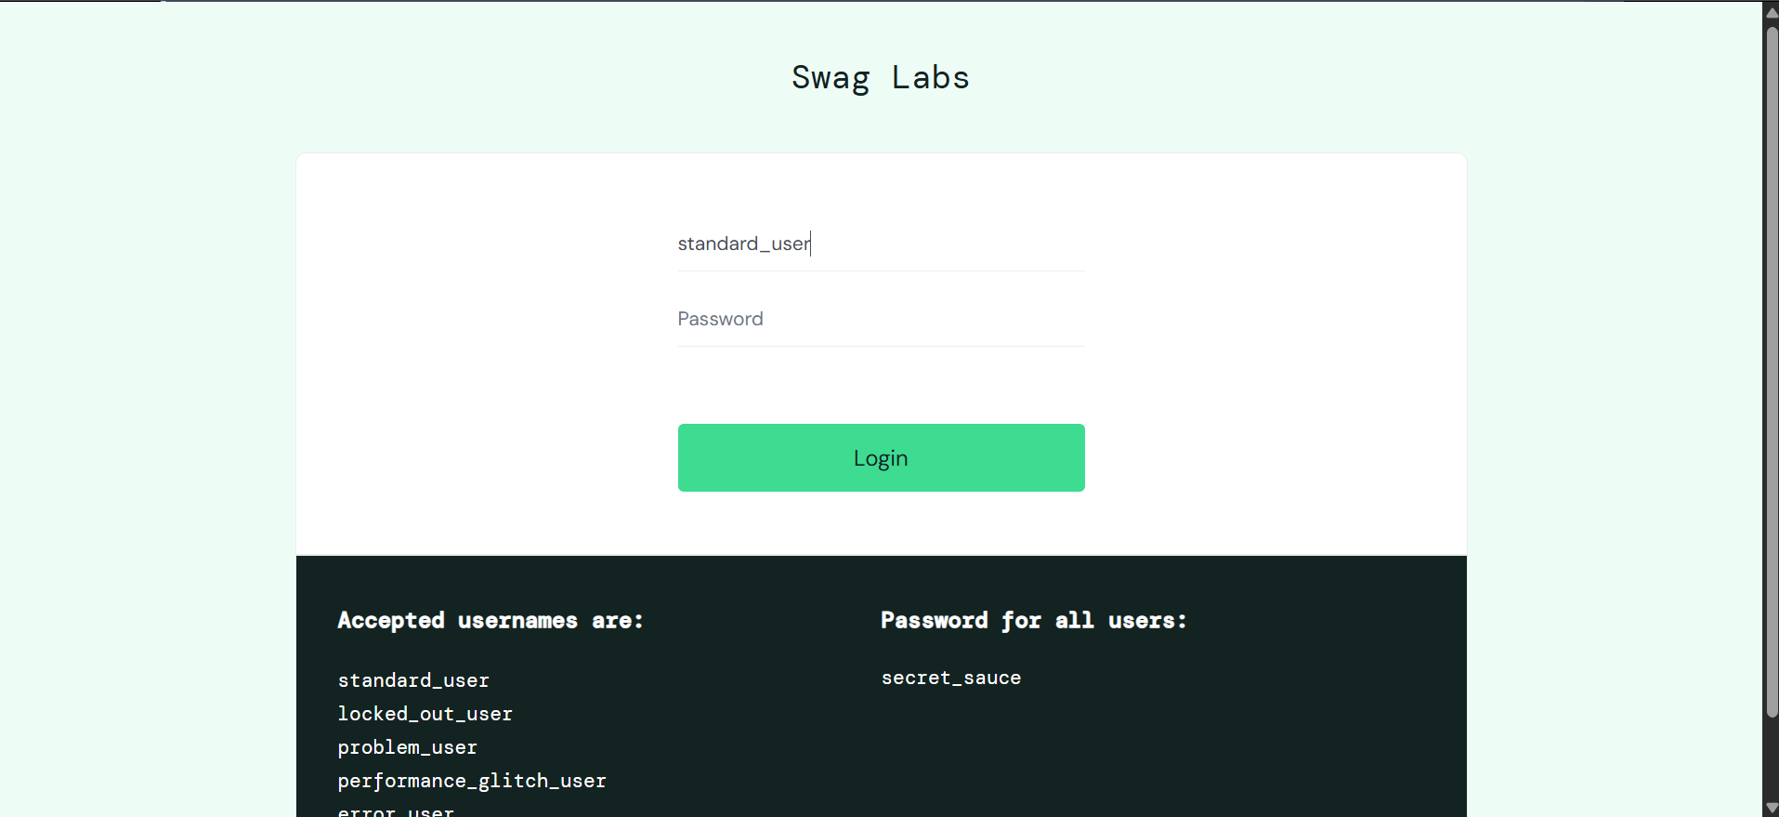
M3 – Enter Valid Password
- Screenshot: Password field filled (masked).
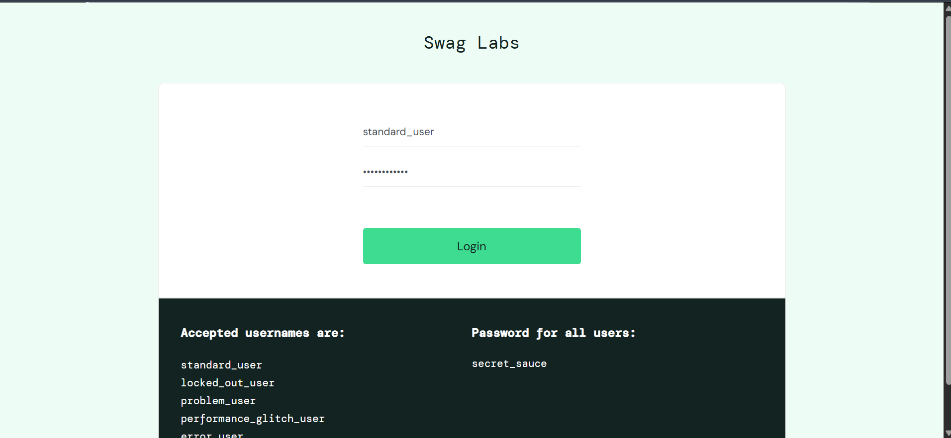
M4 – Successful Login
- Screenshot: Inventory/Products page after login.
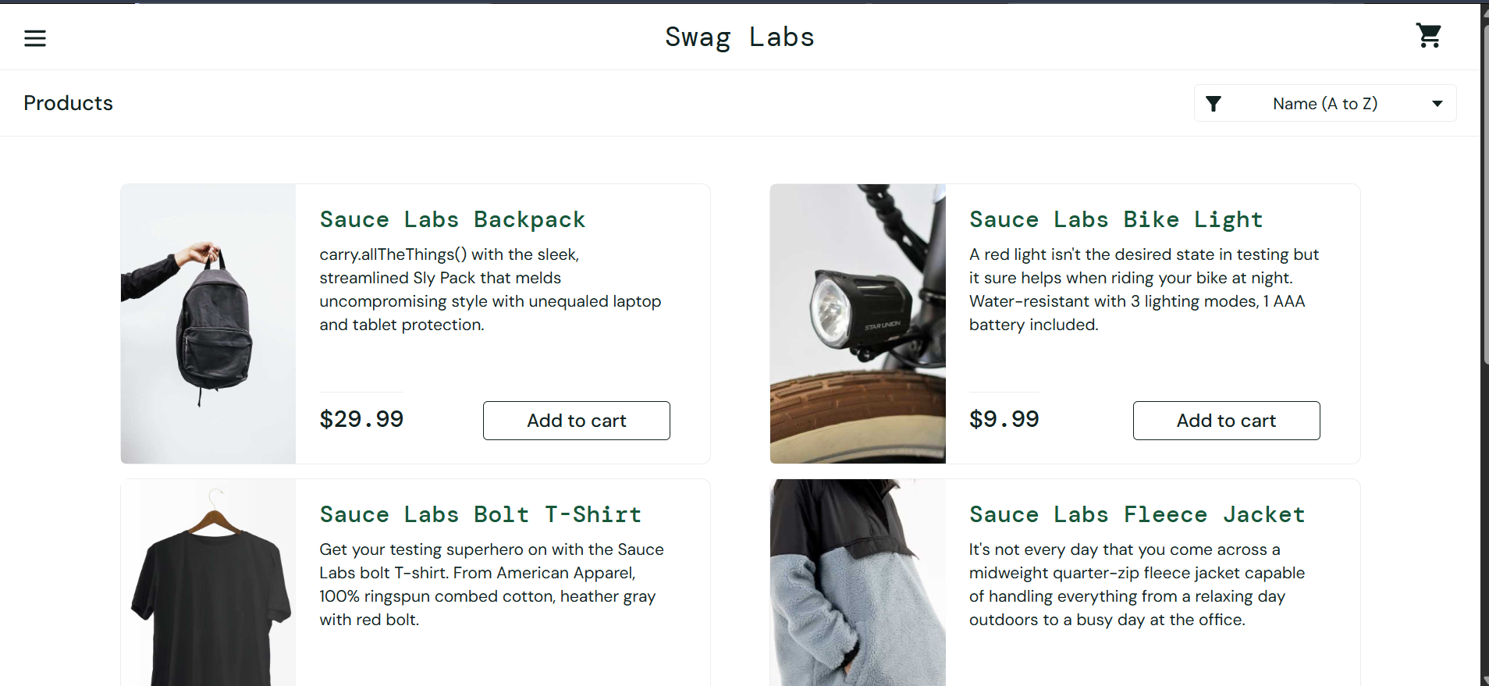
M5 – Empty Login Validation
- Screenshot: Error message displayed for blank username and password.
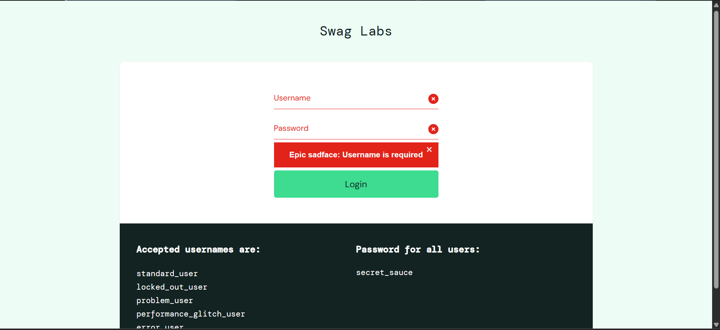
M6 – Add Product to Cart
- Screenshot: Product added to cart with cart badge.
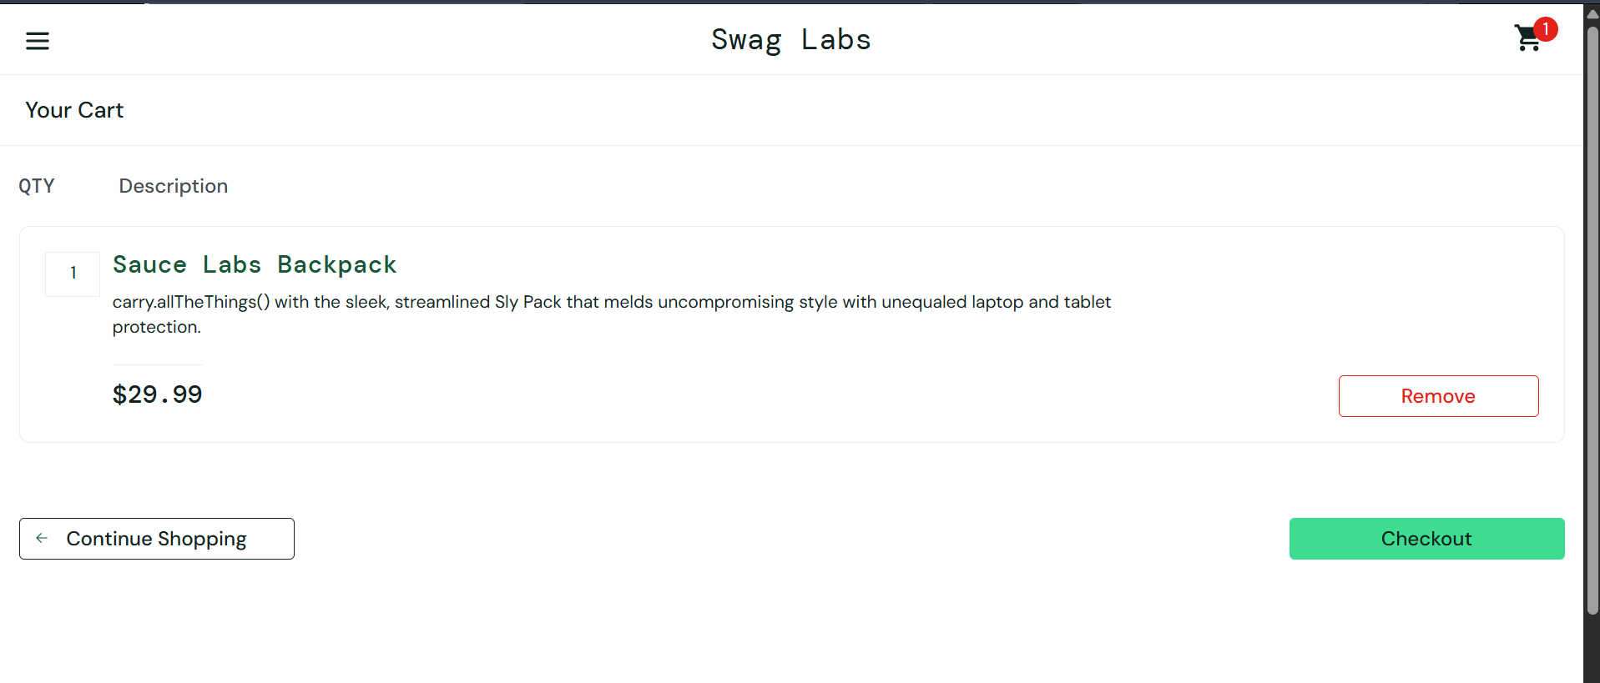
M7 – Remove Product from Cart
- Screenshot: Cart after removing the product.
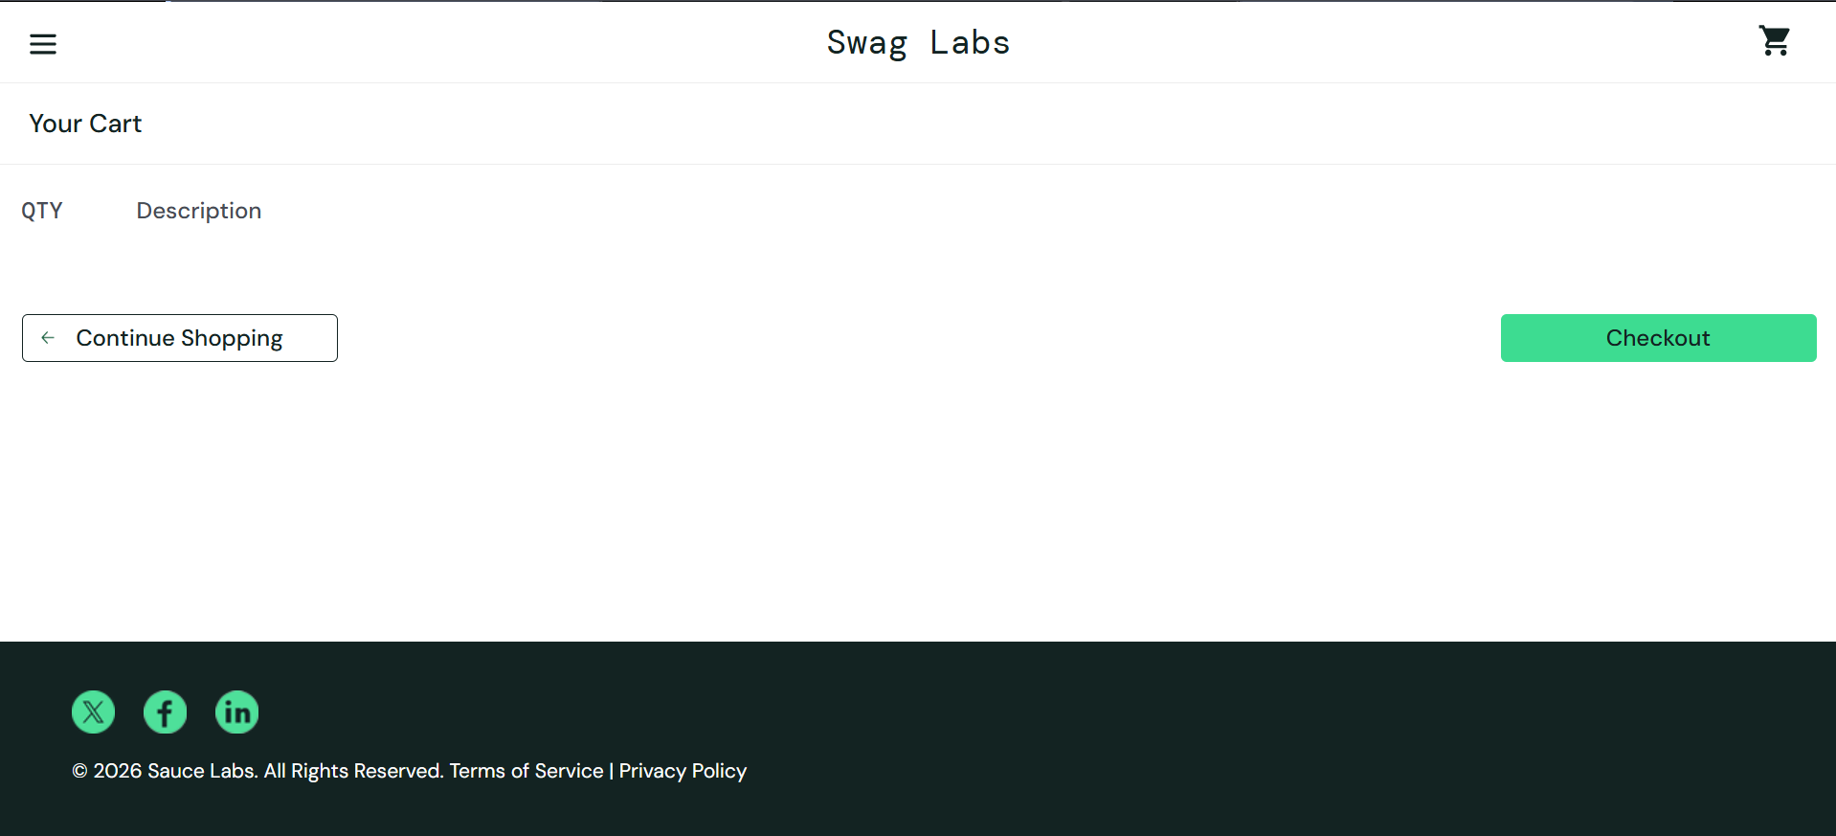
M8 – Place Order
- Screenshot: Checkout page after proceeding to checkout.
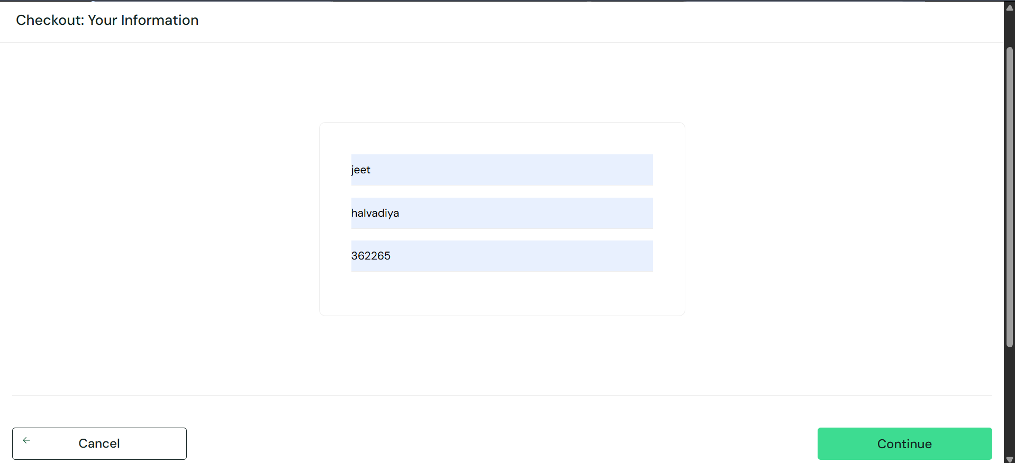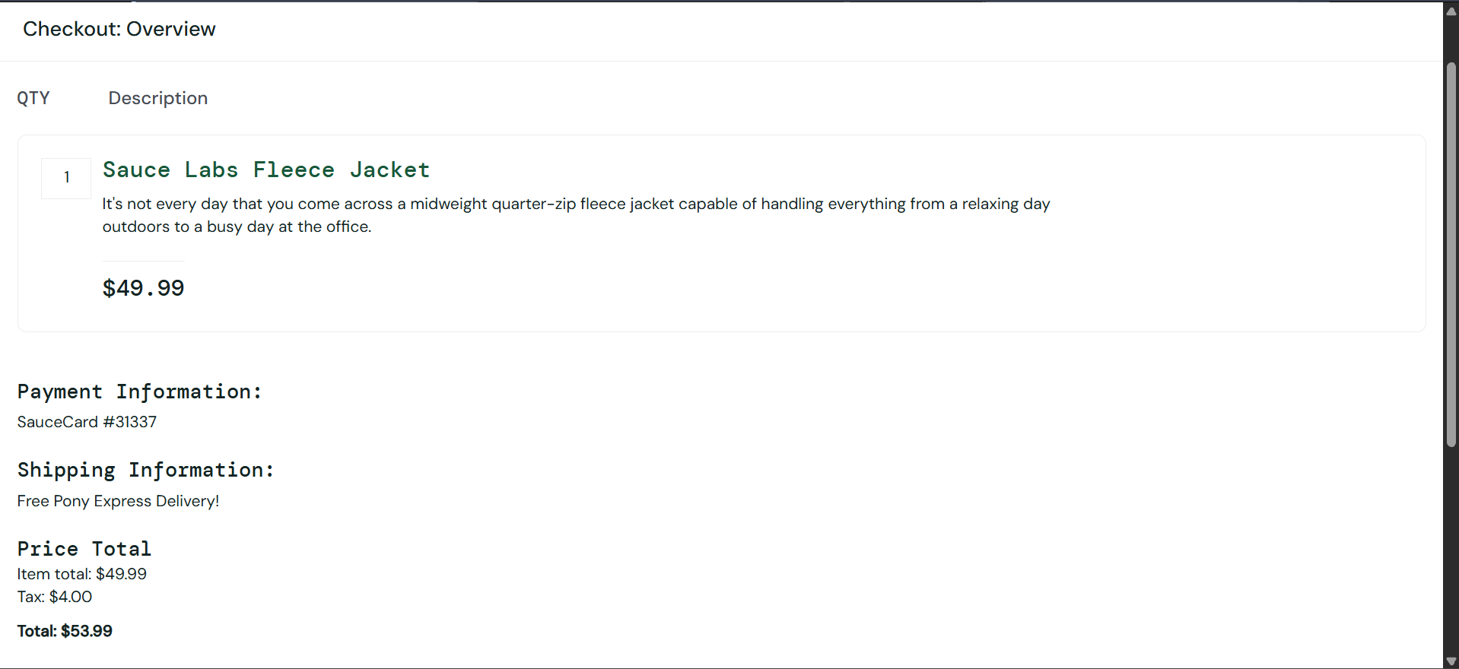

Test Summary Report
Metric | Count
Total Test Cases | 8
Passed | 8
Failed | 0
Blocked | 0

Conclusion
The SauceDemo login and shopping workflow was tested using eight manual test cases. All recorded test cases passed successfully, covering login, validation, cart operations, and checkout initiation. Attach the corresponding website screenshots in each section before submission.

