TUTORIAL – MANUAL TEST EXECUTION REPORT

1. Aim
To execute manual test cases for the Login Module, compare expected and actual results, identify defects if any, and prepare a Test Execution Report and Test Summary Report.

2. Application Details
Field | Details
Project Name | Demo Web Application
Application / Software | Web Based Application
Module Name | Login
SDLC Model | Agile Model
Programming Language | Java, Python, JavaScript
IDE / Tool Used | Google Sheets, Google Docs
Input / Test Data | Username, Password

3. Test Execution Report
Scenario ID | Test Steps | Test Inputs | Expected Result | Actual Result | Status
M1 | Website login page | Login page displayed | Login page displayed | Displayed | Pass
M2 | Valid username | Admin | Username entered | Entered | Pass
M3 | Valid password | admin123 | Password entered | Entered | Pass
M4 | Logged in | Valid login credentials | Dashboard displayed | Displayed | Pass
M5 | Valid username | Admin | Username entered | Entered | Pass
M6 | Invalid password | 12345678 | Password entered | Entered | Pass
M7 | Error message for invalid login | Invalid login credentials | Error message shown | Error message shown | Pass
M8 | Verify if/else condition | Check true/false condition | Condition checked successfully | Condition checked successfully | Pass
M9 | Dashboard display | Check true/false condition | Dashboard displayed | Dashboard displayed | Pass
M10 | System testing | Verify complete system | System works smoothly | System works smoothly | Pass
Note: The test case details and statuses above are taken from your supplied Google Sheets screenshots.

4. Screenshot Evidence – Original Test Cases
Screenshot 1: Test cases M1–M8
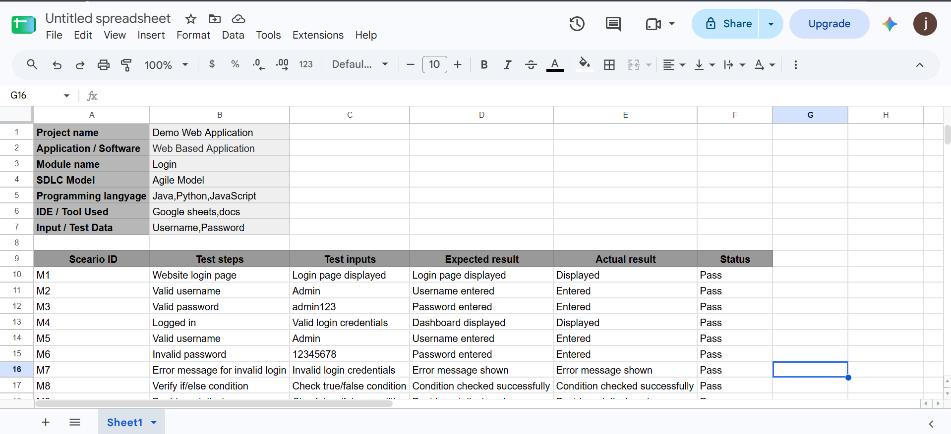
Screenshot 2: Test cases M1–M10
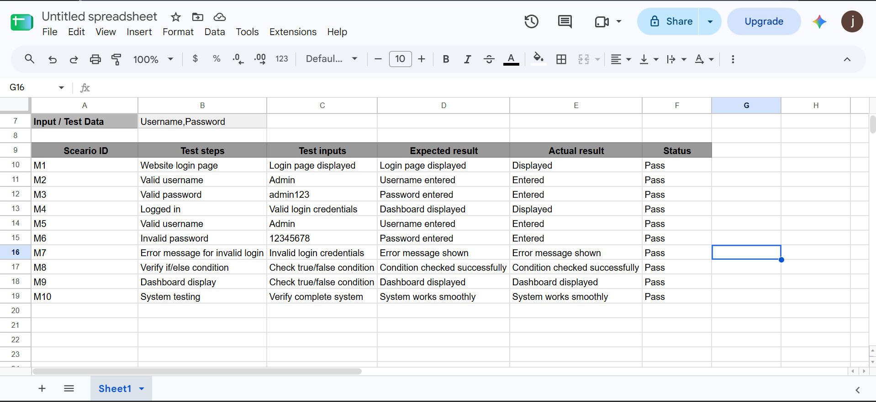

5. Individual Screenshot Evidence

M1 – Website Login Page
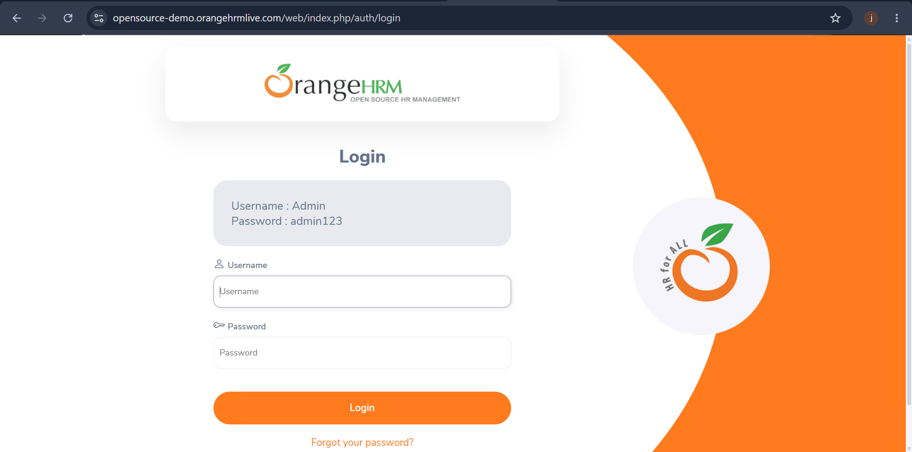

M2 – Valid Username

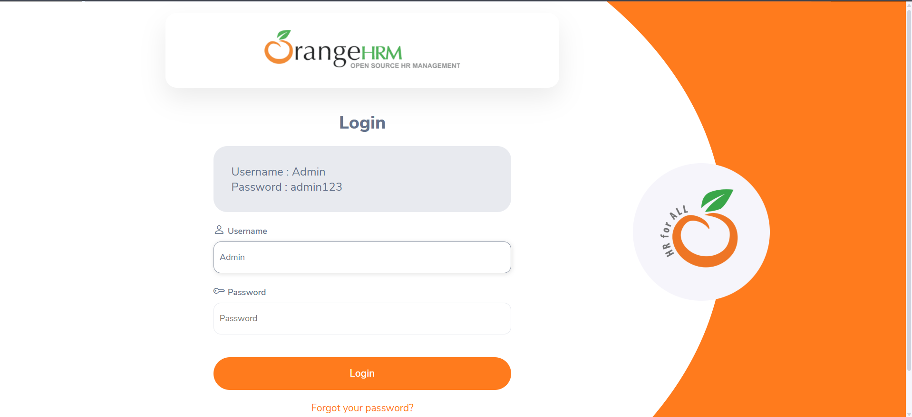

M3 – Valid Password
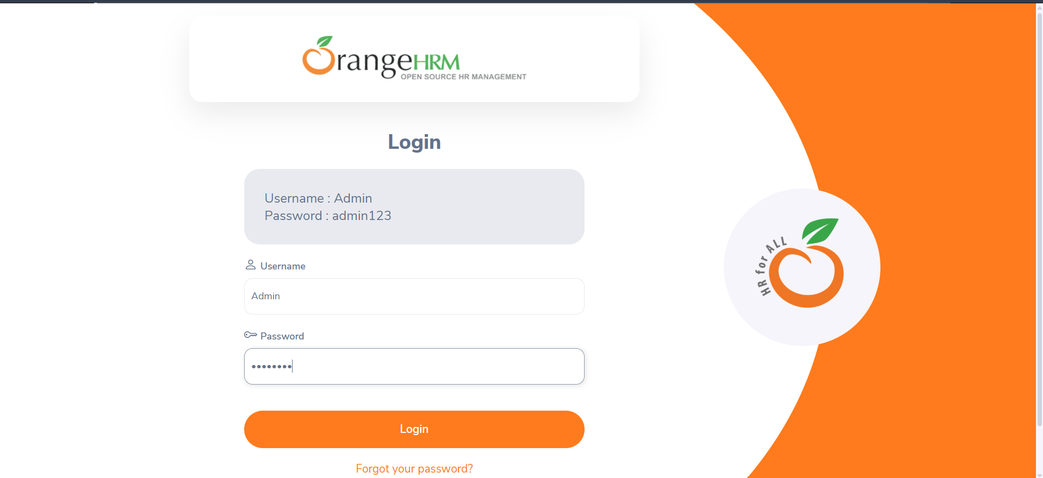

M4 – Successful Login
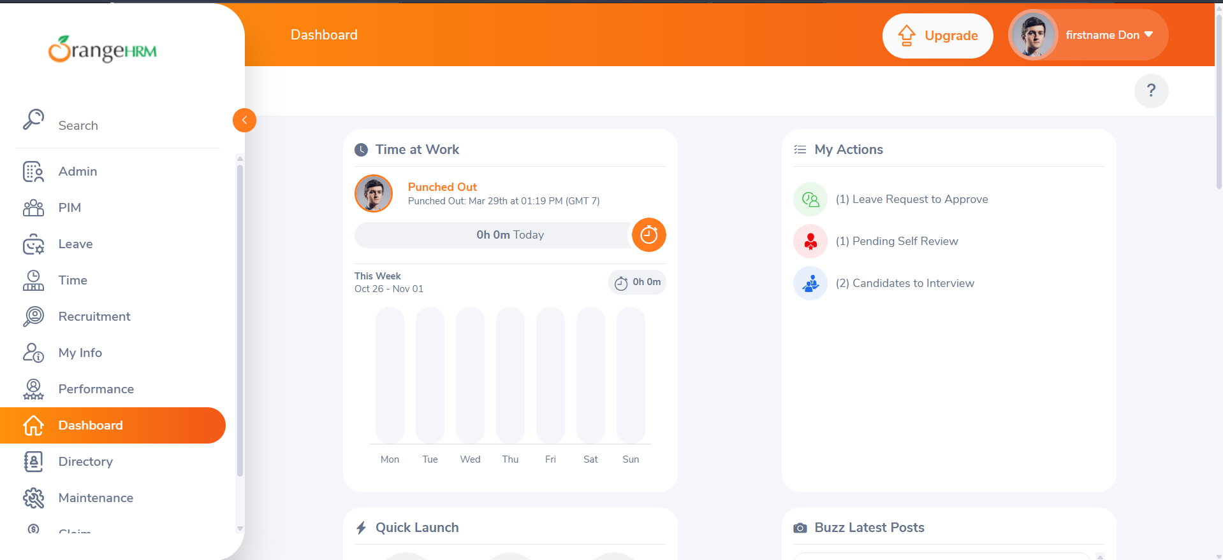

M5 – Valid Username Verification

M6 – Invalid Password
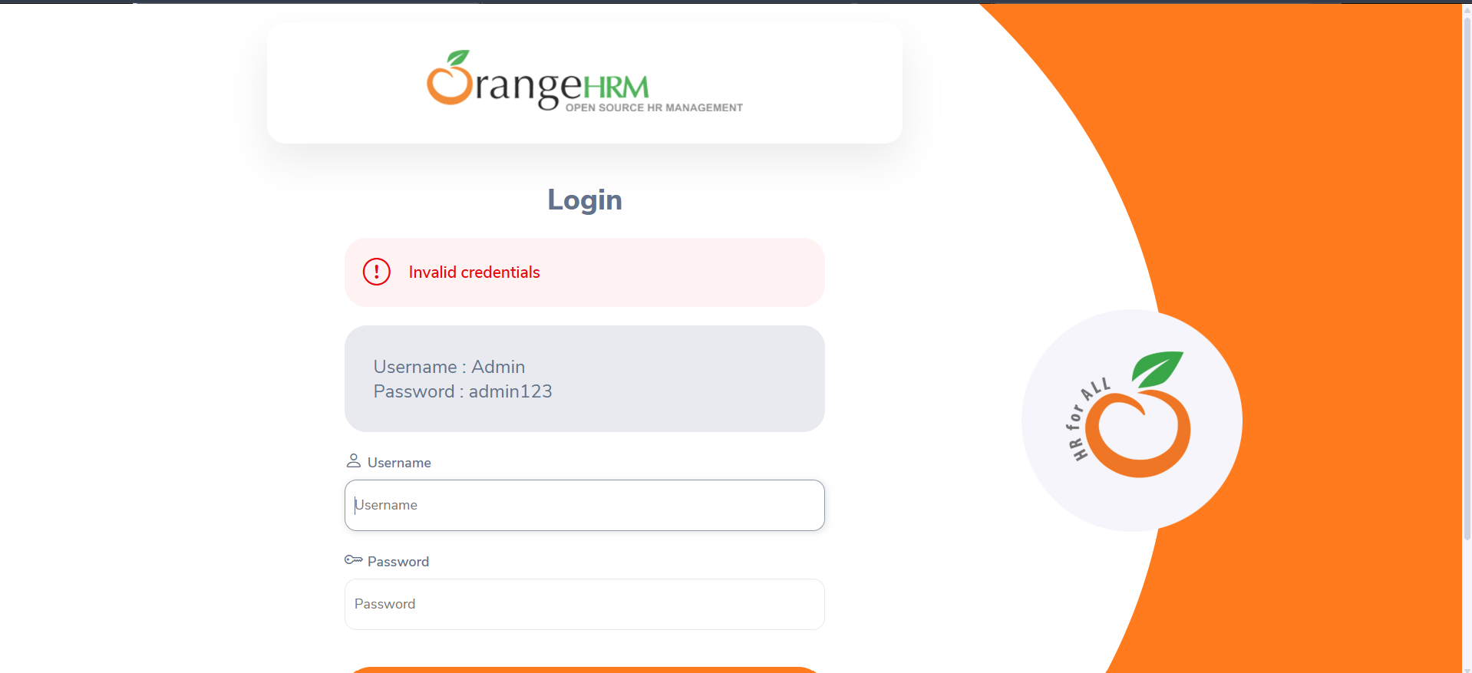

M7 – Error Message for Invalid Login

M8 – Verify If/Else Condition
- Test Input: Check true/false condition.
- Expected Result: Condition should be checked successfully.
- Actual Result: Condition checked successfully.
- Status: Pass

M9 – Dashboard Display

M10 – System Testing
- Test Input: Verify complete system.
- Expected Result: System should work smoothly.
- Actual Result: System works smoothly.
- Status: Pass

6. Test Summary Report
Metric | Count
Total Test Cases | 10
Passed | 10
Failed | 0
Blocked | 0

7. Conclusion
Manual testing was documented for 10 test cases covering the login page, username and password entry, successful login, invalid login validation, conditional checks, dashboard display, and overall system testing. All 10 test cases are marked Pass in the supplied spreadsheet.
Note: The supplied screenshots show the test case spreadsheet. Insert actual application screenshots into the individual sections above to complete the screenshot evidence. The results have not been independently re-tested.

