***Storj & Diagram_as_a_code***

---------------------------------

sudo apt-get update

sudo apt-get -y upgrade

**Installing go,**

wget https://dl.google.com/go/go1.17.7.linux-amd64.tar.gz

sudo tar -xvf go1.17.7.linux-amd64.tar.gz

sudo mv go /usr/local

export GOROOT=/usr/local/go

export GOPATH=$HOME/go

export PATH=$GOPATH/bin:$GOROOT/bin:$PATH

add above commands to “vi ~/.bashrc”

go version

sudo apt install build-essential

gcc –version

-----------------------------------------------

**Diagram as a code python**

Steps to be followed after spinning ec2 instance :

Step 0: sudo apt-get update -y

Step 1: python3 --version

Step 2: sudo apt-get install -y graphviz

Step 3: sudo apt install python3-pip

Step 4: pip3 --version

Step 5: pip3 install diagrams

Now, you need to create a python file using below command

$ touch python.py

$ vi python.py

and paste below python script in this python file.

Python.py script:

from diagrams import Diagram

from diagrams.aws.compute import EC2

from diagrams.aws.database import RDS

from diagrams.aws.network import ELB

with Diagram("Web Service", show=False):

ELB("lb") >> EC2("web") >> RDS("userdb")

Here, now to exit vim editer, you need to press below buttons.

Esc => :wq!

And you will get below like output.

Now to view this output file (png) you need to create IAM role for EC2 ==> s3,

now to upload output file to s3 we are going to create python script.

Let’s begin

upload.py script

import boto3

s3 = boto3.resource('s3')

bucket = s3.Bucket('bucket name')

with open('file name.png', 'rb') as data:

bucket.upload_fileobj(data, 'filename.png')

now, you need to run this script to upload your output file to s3, by below command.

$ python3 upload.py

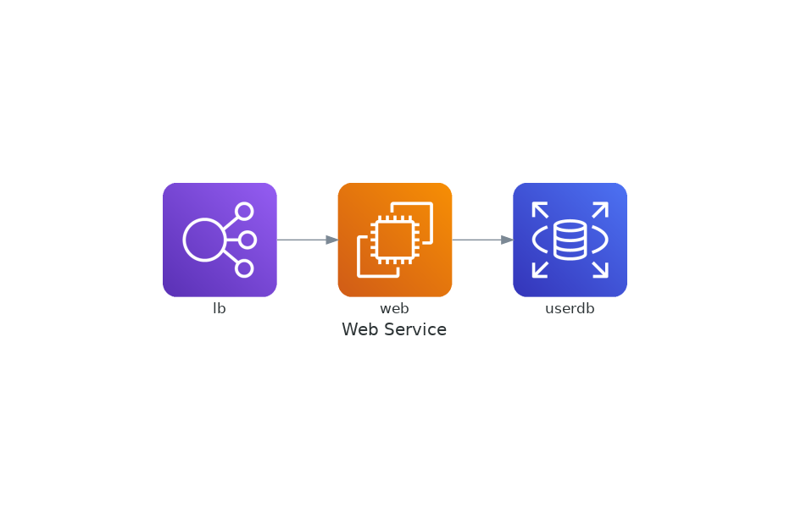

Now let’s build other chart.

Now, you need to create a python file using below command

$ touch organization.py

$ vi organization.py

and paste below python script in this python file.

Organization script:

from diagrams import Diagram

from diagrams.aws.compute import EC2

from diagrams.aws.database import RDS

from diagrams.aws.network import ELB

with Diagram("Grouped Workers", show=False, direction="TB"):

ELB("BOSS") >> [EC2("Jeet"),

EC2("Vedant"),

EC2("Shreyas"),

EC2("Siddhid"),

EC2("Urvi")] >> RDS("Projects")

~

Here, now to exit vim editer, you need to press below buttons.

Esc => :wq!

Now run this script, by below command.

$ python3 upload.py

And you will get below like output file in your home directory.

