Architecture of how the working of CloudSim occurs:

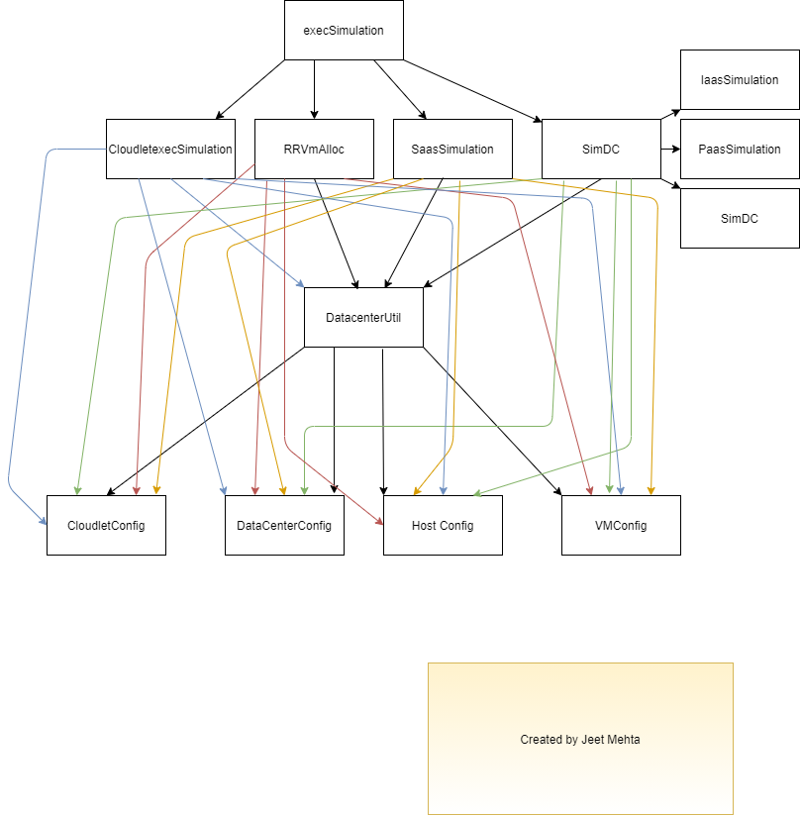

Config Parameters to be used are:

|  |
| --- |
| cloudSimulator { |
|  | utilizationRatio = 0.5 |
|  | host { |
|  | mipsCapacity = 20000 |
|  | RAMInMBs = 10000 |
|  | StorageInMBs = 100000 |
|  | BandwidthInMBps = 100000 |
|  | } |
|  | vm { |
|  | mipsCapacity = 1000 |
|  | RAMInMBs = 1000 |
|  | StorageInMBs = 1000 |
|  | BandwidthInMBps = 1000 |
|  | } |
|  | cloudlet { |
|  | size = 10000 |
|  | PEs = 1 |
|  | } |
|  | } |

Similarly, we load these values in the various config files that we have. The values are parsed via DataCenterConfig, HostConfig, VMConfig, CloudletConfig from the config files to the datacenters.

CloudletexecSimulation:

Simulates different schedulers in CloudSim.

The policy to be implemented are either time shared or space shared which depend on the instances.

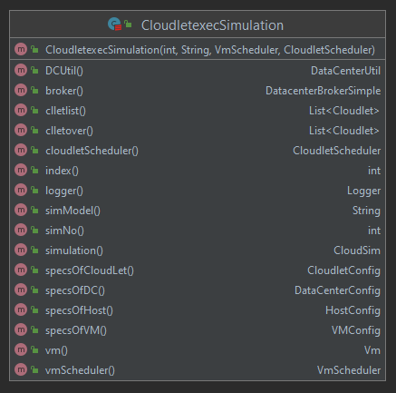

RRVmAlloc:

This is used to assign VMs to the hosts.

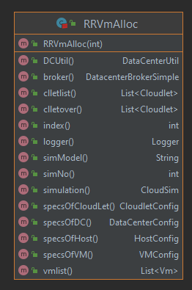

SaasSimulation:

This will be used to execute data Center using a Software as a service model.

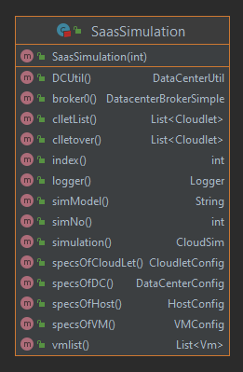

SimDC:

Three data centers are created. All of them are based on iaas, paas & saas models. Connect DataCenter connects the DataCenter and DataCenterBroker using a brite topology.

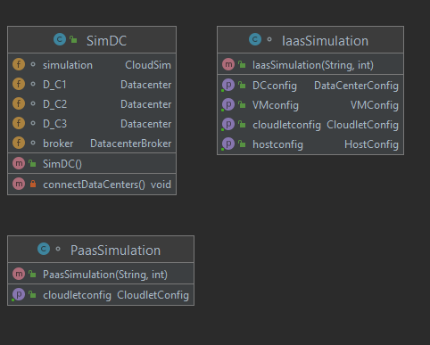

DataCenterUtil:

This loads data from the various config files.

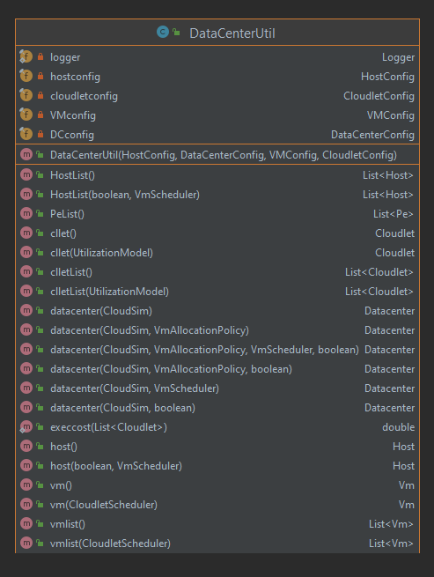

Finally you execute the execSimulation.