Results:

Space Shared vs Time Shared.

Timeshared is more costly because when there is a scarcity of VMs to run cloudlets, all of them are allocated the same VM this they run simultaneously.

Time Shared:

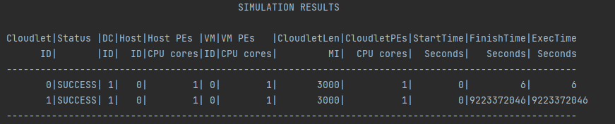

Space Shared:

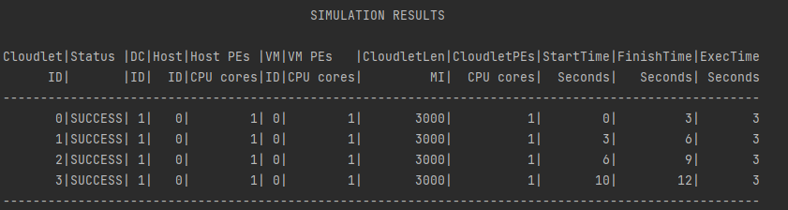

Future Work: A hybrid model can be used to overcome this cost factor.

RoundRobin Vm allocation:

In this simulation the day Center has 8 hosts, 4VMs & 6 Cloudlets. The values are abnormally high because cloudlets do not have enough RAM available in the VM to run, this happens. I tried playing around with the utilization value and even to UtilizationModelFull but that didn’t help because from my understanding the cloudlets are assigned to the VM which is ultimately causing lower availability of the RAM.

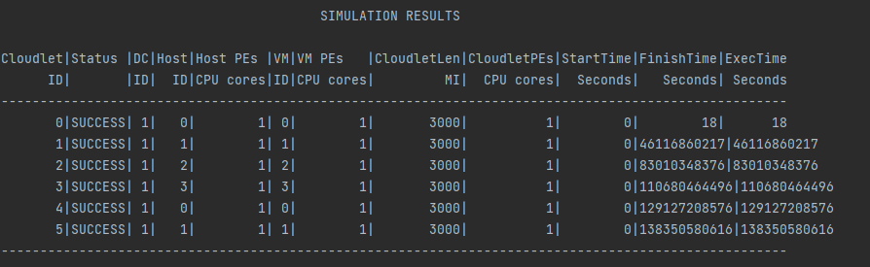

Iaas Simulation:

The user is in complete control of the entire infrastructure. Values are inputted from DCsimul.conf.

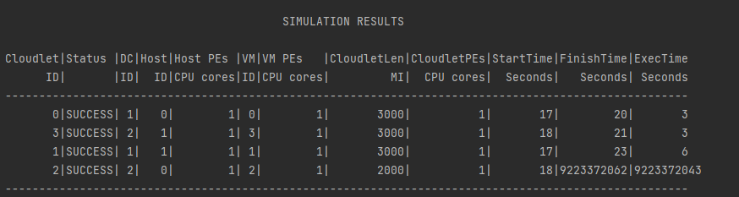

Saas Simulation:

The most efficient stack is used which reduce overall cost of the service.

Here we have used two datacenters with 12 hosts, 5 VMs & 2 cloudlets.

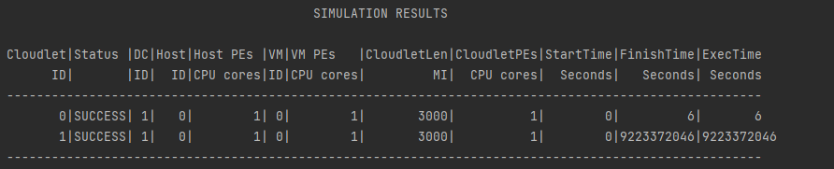

Paas Simulation:

The provider sets up the environment.

The user uses the cloud environment to compile and run. This used the application.conf which are the default parameters.

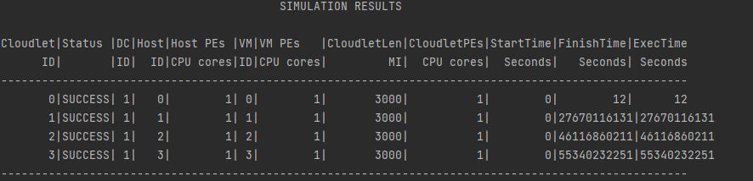

Analysis of Results:

This simulation gives us a lot of clarity on various resources running the different service models and thus all of them having different costs.