Project Sprint #1

The Solitaire game is described in CS449HomeworkOverview. You should read the description very carefully.

In this assignment, you aim to specify the requirements (i.e., user stories and acceptance criteria) of the target software that allows a human player to play a Solitaire game. These requirements will be fully implemented by the end of sprint 3. The minimum features include choosing the board size and type, starting a new game, making a move, determining if a game is over. The following is a sample GUI layout.

Board size
7
Board Type  - English  - Hexagon  - Diamond | 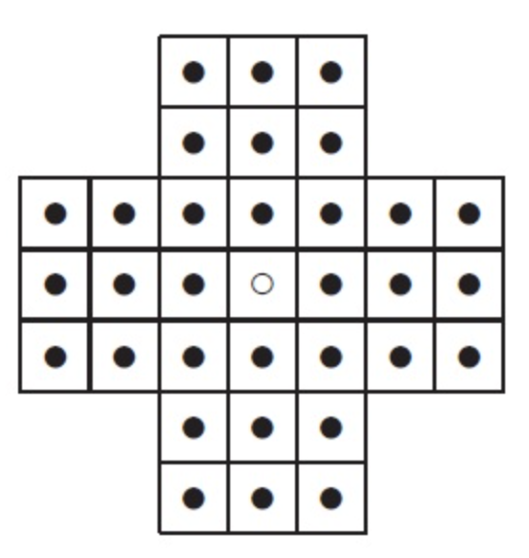 | New Game
Figure 1. Sample GUI layout of the first working program by the end of Sprint 3

Use the following tables to document your user stories and acceptance criteria.

You are required to use the free ChatGPT or another LLM to complete two user stories and two of their respective acceptance criteria. You must ensure that the generated user stories are correct and fix them if not. At the end of the submission, provide screenshots of your LLM prompts and answers, along with the description of errors the LLM made that you had to correct. Points will be deducted if no screenshots/description are provided.

For the other user stories and acceptance criteria, you are not required to use LLM.

- User Stories (3 points)

- User Story Template: As a <role>, I want <goal> [so that <benefit>]

ID | User Story Name | User Story Description | Priority | Estimated effort (hours)
1 | Choose a board size | As a player, I want to choose a board size so that I can play on a board that suits my preference. | High | 4
2 | Choose the board type | As a player, I want to choose a board type so that I can play using the layout I prefer. | High | 4
3 | Start a new game of the chosen board size and type | As a player, I want to start a new game with my chosen board size and type so that I can play using those selection. | High | 5
4 | Make a move in a game | As a player, I want to make moves on the board so that I can play Solitaire. | High | 8
5 | A game is over | As a player, I want to know when the game is over so that I do not keep trying to make moves that are no longer possible. | High | 5

- Acceptance Criteria (AC) (12 points): Add/delete rows as needed.

User Story ID and Name | AC  ID | Description of Acceptance Criterion | Status (completed, toDo, inPprogress)
1. Choose a board size | 1.1 | AC 1.1 Select an available board size  Given: The player is setting up a new game  And: The available board sizes are shown  When: The player selects one of the available size  Then: That size is visibly marked as the current selection | To Do
1. Choose a board size | 1.2 | AC 1.2 Change the selected board size  Given: The player has selected a board size  And another size is available  When: The player selects the other size  Then: The new size is visibly marked as the current selection  And: the previous size is no longer marked as selected | To Do
1. Choose a board size | …
2. Choose the board type | 2.1 | AC 2.1 Select the English Board  Given: The player is setting up a new game  And: English, Hexagon, and Diamond are shown as board type  When: the player selects English  Then: English is visibly marked as the current board type | To Do
2. Choose the board type | 2.2 | AC 2.2 Change the selected board type  Given: The player had selected English  When: The player selects Hexagon  Then: Hexagon is visibly marked as the current board type  And English is no longer marked as selected. | To Do
3. Start a new game of the chosen board size and type | 3.1 | AC 3.1 Start a game with the selected options  Given: The player has selected an available board size and board type.  When: The player tarts a new game  Then: The displayed board matches the selected size and type  And: The board shows the starting arrangement specified for theat combination | To Do
 | 3.2 | AC 3.2 Start over after making a move  Given: A game is in progress  And: the board has changed since it started  When: The player starts a new game  Then: The board returns to the starting arrangement for the currently selected size and type  And: The changes made during the precious game are no long shown. | To Do
4. Make aa move in a Game | 4.1 | AC 4.1 Make a valid move  Given: A game is in progress  And: A peg can jump over an adjacent peg into an empty position in an allowed direction  When: The player selects that peg and the empty destination  Then: the starting position becomes empty  And: the jumped over peg is removed  And: the destination contains the moved peg. | To Do
 | 4.2 | AC 4.2 Attempt an invalid move  Given: A game is in progress  When; The player selects a starting positions and destination that do not form a legal move.  Then: The board remains unchanged  And: The player sees that the move was not accepted | To Do
5. Determine when a Game is Over | 5.1 | AC 5.1 Recognize that no legal moves remain  Given: A game is in progress and a legal move is available  When: The player makes the move  And: no legal moves remain on the resulting board  Then: The player sees a message that the game is over  And: The final board arrangement remains visible | To Do
 | 5.2 | AC 5.2 Continue when a legal move remains  Given: a game is in progress  And At least one legal move remains  When: The game checks the board after a move  Then: The game does not display a game-over message  And: The player can continue selecting moves | To Do

LLM Prompt/Results Screenshots

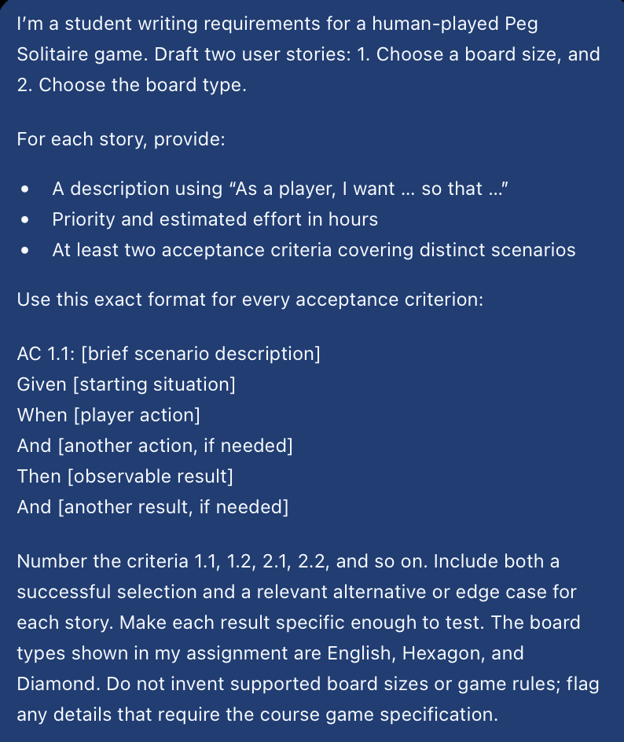

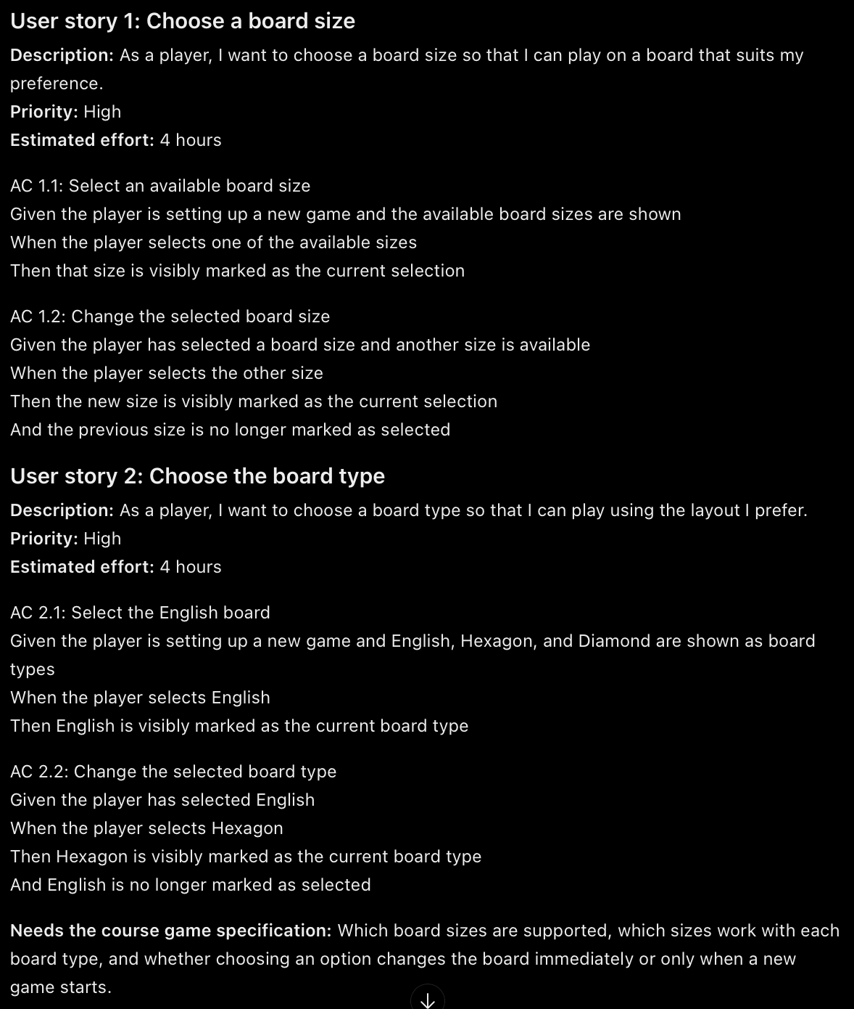

I reviewed the LLM-generated stories for choosing a board size and board type. The descriptions followed the required user story format, and I did not identify any clear factual error based on the Sprint 1 requirement. However, some acceptance criteria combined multiple conditions in one Given statement. I separated these conditions into Given and And lines to match the class example and make each condition easier to test. I left the supported board sizes unspecified because they weren't listed in the Sprint 1 document.

