Project Sprint #2

The Solitaire game is described in CS449HomeworkOverview.docx. You should read the description very carefully.

Your submission must include the GitHub link to your project, and you must ensure that the instructor has the proper access to your project. You will receive no points otherwise.

GitHub link:

In this assignment, you aim to implement the minimum features including choosing the board size and type, starting a new game, making a move, determining if a game is over. The following is a sample GUI layout.

The implementation of a GUI is required. You should make every attempt to make your code easy to extend. It is required to separate the user interface code and the game logic code into different classes (refer to the TicTacToe example). xUnit tests are required.

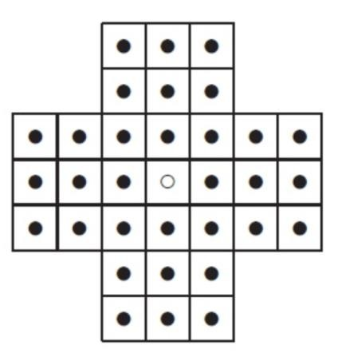

Board size

Board Type

English

Hexagon

Diamond

New Game

7

Figure 1. Sample GUI layout of the Sprint 2 program

Deliverables:

Demonstration (8 points)

Submit a link to a video of no more than three minutes, clearly demonstrating that you have implemented the required features and written some automated unit tests. In the video, you must explain what is being demonstrated. No points will be given without a video link.
YouTube/Panopto link: https://umsystem.hosted.panopto.com/Panopto/Pages/Viewer.aspx?id=316190d8-610a-4582-816e-b4f1000c3933

 | Feature
1 | Choose board size and type
2 | Start a new game of the chosen board size and type
3 | Making a move
4 | Checking the end of game
5 | Automated unit tests

Summary of Source Code (1 points)

Source code file name | Production code or test code? | # lines of code
src/solitaire_game.py | Production | 145
src/solitaire_gui.py | Production | 264
src/game_rating.py | Production | 20
test/test_solitaire_game.py | Test | 107
test/test_game_rating.py | Test | 35
 | Total | 571

You must submit all source code to get any credit for this assignment.

Production Code vs User stories/Acceptance Criteria (3 points)

Update your user stories and acceptance criteria from the previous assignment (if required) and ensure they adequately capture the requirements. Summarize how each of the following user story/acceptance criteria is implemented in your production code (class name and method name etc.). If you are not using an OOP, then adapt the tables accordingly.

User Story ID | User Story
1 | Choose board size and type
2 | Start a new game of the chosen board size and type
3 | Making a move
4 | Checking the end of game

User Story ID and Name | AC  ID | Class Name(s) | Method Name(s) | Status (complete or not) | Notes (optional)
1 | 1.1 | GUI | create_interface | Complete | Read only size selector display the selected size
 | 1.2 | GUI | create_interface | Complete | The same StringVar holds the new size; the old size is replaced
 | …
2 | 2.1 | GUI | Create_interface; update_status | Complete | English radio button shows the English selection
 | 2.2 | GUI | Create_internface; update_status | Complete | One shared StringVar makes selecting Hexagon deselect English
 | …
3 | 3.1 | GUI; Game | Start_new_game; new_game; is:playable_position; draw_board | Complete | Use selected setting; fills playable holes expect the center
 | 3.2 | GUI; Game | Start_new_game; new_game; draw_board | Complete | Recreate the board and clears the selected peg
4 | 4.1 | GUI; Game | On_hole_click; is_valid_move; make_move; draw_board | Complete | Move the peg, remove the jumped peg, and redraws the board
 | 4.2 | GUI; Game | On_hole_click; is_valid_move;make_move | Partial | Illegal jumps to empty holes show. Invalid move and preserve the board. Clicking an occupied destination reselects a peg without an explicit rejection message.
5 | 5.1 | Game; GUI | Has_valid_moves; game_result; on_hole_clock; update_game_status | Complete | After a move, shows. You won or No moves remain and keeps the final board visible.
 | 5.2 | Game; GUI | Game_result; on_hole_click; update_game_status | Complete | Playing result keeps selection enabled and show instructions rather than a final result.

Tests vs User stories/Acceptance Criteria (3 points)

Summarize how each of the user story/acceptance criteria is tested by your test code (class name and method name) or manually performed tests.

User Story ID | User Story
1 | Choose board size and type
2 | Start a new game of the chosen board size and type
3 | Making a move
4 | Checking the end of game

4.1 Automated tests directly corresponding to the acceptance criteria of the above user stories
You are required to use ChatGPT to create at least 2 unit tests. You also need to ensure that the generated test cases are correct and refine them if not. At the end of the submission, provide the screenshots of your ChatGPT prompts and answers, along with errors ChatGPT made and you fixed. You may also use another LLM, including hosted locally. Points will be deducted if no screenshots are provided.

User Story ID and Name | Acceptance  Criterion ID | Class Name (s) of the Test Code | Method Name(s) of the Test Code | Status (Pass/Fail/In  Progress)
1 | 1.1 | No Submitted widget unit test | No Submitted widget unit test | Manual check pending: change 7 to 9. The supplied Diamond 9 screenshot confirms the final section only
 | 1.2 | No Submitted widget unit test | No Submitted widget unit test | Manual check pending: change 7 to 9. The supplied Diamond 9 screenshot confirms the final section only
 | …
2 | 2.1 | No Submitted widget unit test | No Submitted widget unit test | Manuel English to Hexagon check pending. Supplied screenshots show English and diamond selection
3 | 3.1 | TestSolitaireGame | Test_borad_type_and size | Pass: six configuration, peg count, hole counts, and empty centers. Rendered geometry is not checked
 | 3.2 | TestSolitaireGame | Test_new_game_resets_board_and_chnage_setting | Pass: after a move, reset as Diamond 9. Also checked through GUI handlers with drawing mocked.
4 | 4.1 | TestSolitaireGame | Test_valid_jump_updates_all_three_holes | Pass: all three holes and count 31. The supplied English 7 screenshot supports the result
 | 4.2 | TestSolitaireGame | Test_invalid_moves_leave_board_unchange | Pass for five invalid model cases. Message behavior is not unit tested. Occupied peg reselection remains a UI limitation.
5 | 5.1 | TestSolitaireGame | Test_last_jump_produces_a_win  Test_separated_pegs_produce_no_moves_result | Pass: find jump win and a prepared blocked board. The blocked test omits the post move transition. Visible final board needs checking
 | 5.2 | TestSolitaireGame | Test_new_board_is_still_playable | Pass on the initial board. Post move continuation was also checked through GUI handlers with drawing mocked.

4.2 Manual tests directly corresponding to the acceptance criteria of the above user stories (if any)

User Story ID and Name | Acceptance  Criterion ID | Test Case Input | Test Oracle  (Expected Output) | Notes
1 | 1.1 | Select 7, then 9; | expect the size control to show only the latest choice | Diamond 9 screenshot confirm final selection. Repeat the full selection sequence visually.
 | 1.2 | Select 7, then 9; | expect the size control to show only the latest choice | Diamond 9 screenshot confirm final selection. Repeat the full selection sequence visually.
 | …
2 | 2.1 | Select English, Then Hexagon | Expect only the current radio button to be selected | English screenshot confirms English selection. English to Hexagon sequence still pending
 | 2.2 | Select English, Then Hexagon | Expect only the current radio button to be selected
 | …
3 | 3.1 | Select Dimond 9 and New Game | Expect a diamond, empty center, and 40 peg | Observed to supplied screenshot
 | 3.2 | Make a move and restart | Expect starting arrangement with previous change removed | GUI handler reset passed with drawing mocked: physical visual check pending
4 | 4.1 | English 7; jump (1,3) to (3,3) | Expect start and middle empty,destination filled | Observed in supplied screenshot, with 31 peg remaining
 | 4.2 | Try a wrong distance jump into the center | Expect Invalid move and no board change | Model rejection passe. Visual message check pending, occupied destination reselects a peg
5 | 5.1 | Finish a game | Expect a result with final board visible. While moves remain, expect continued selection | Result and continuation handlers passed with drawing mocked. Full visual check pending.
 | 5.2 | Finish a game | Expect a result with final board visible. While moves remain, expect continued selection

4.3 Other automated or manual tests not corresponding to the acceptance criteria of the above user stories (if any)

Number | Test Input | Expected Result | Class Name of the Test Code | Method Name of the Test Code

LLM Prompt Responses and Review:

ChatGPT generated seven methods in test_solitaire_game.py after I shared the English board screenshot. The appendix contains the wider response and complete generated test screenshots. I reviewed the assertions and the 12 test results. The test names stay unchanged; their acceptance criterion mapping now follows this Sprint 1 document. A screenshot showing the input within the actual chat is still needed.

def test_valid_jump_updates_all_three_holes(self):
game = SolitaireGame()

moved = game.make_move((1, 3), (3, 3))

self.assertTrue(moved)
self.assertFalse(game.board[(1, 3)])
self.assertFalse(game.board[(2, 3)])
self.assertTrue(game.board[(3, 3)])
self.assertEqual(game.peg_count(), 31)

def test_last_jump_produces_a_win(self):
game = SolitaireGame()

for position in game.board:
game.board[position] = False

game.board[(3, 1)] = True
game.board[(3, 2)] = True

self.assertTrue(game.make_move((3, 1), (3, 3)))
self.assertEqual(game.peg_count(), 1)
self.assertEqual(game.game_result(), "win")

Screenshots of Program and Test Results

Program screenshot supplied during development: Diamond 9 at initialization, followed by an English 7 board after a legal jump. These show observed examples, not a complete manual test of every board.

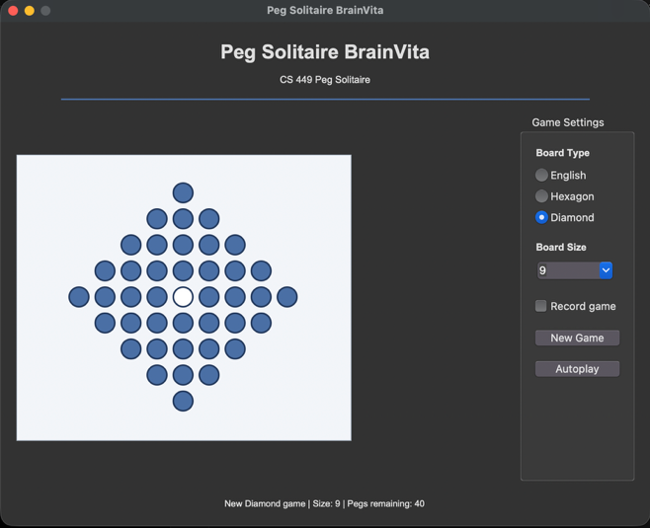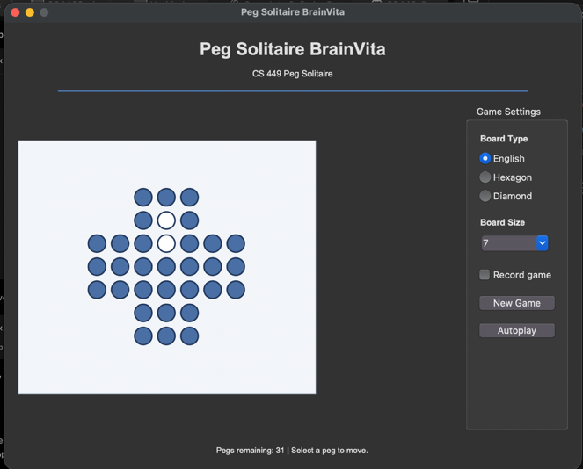

Terminal result supplied from the Mac: all 12 unit tests passed.
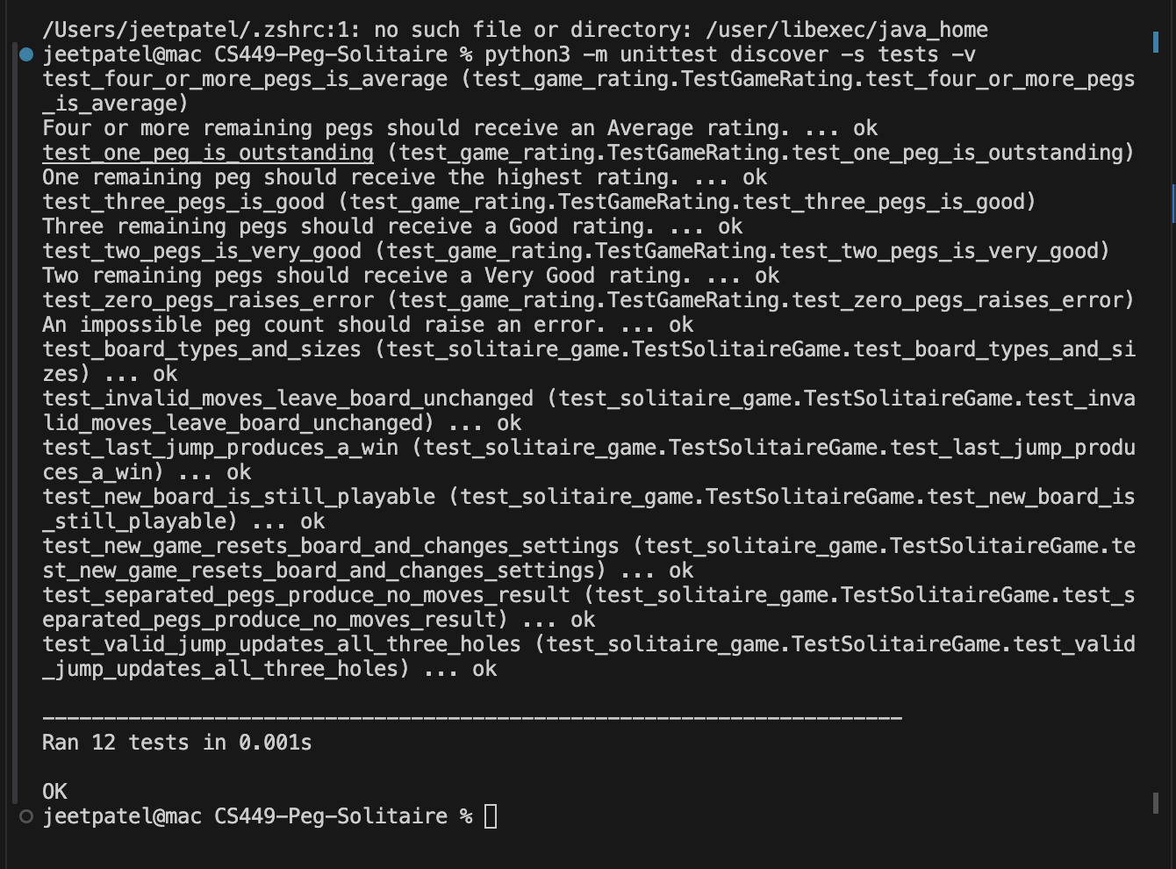

The wider screenshot idenifiies the response that provided tests/test_solitaire_game.py.
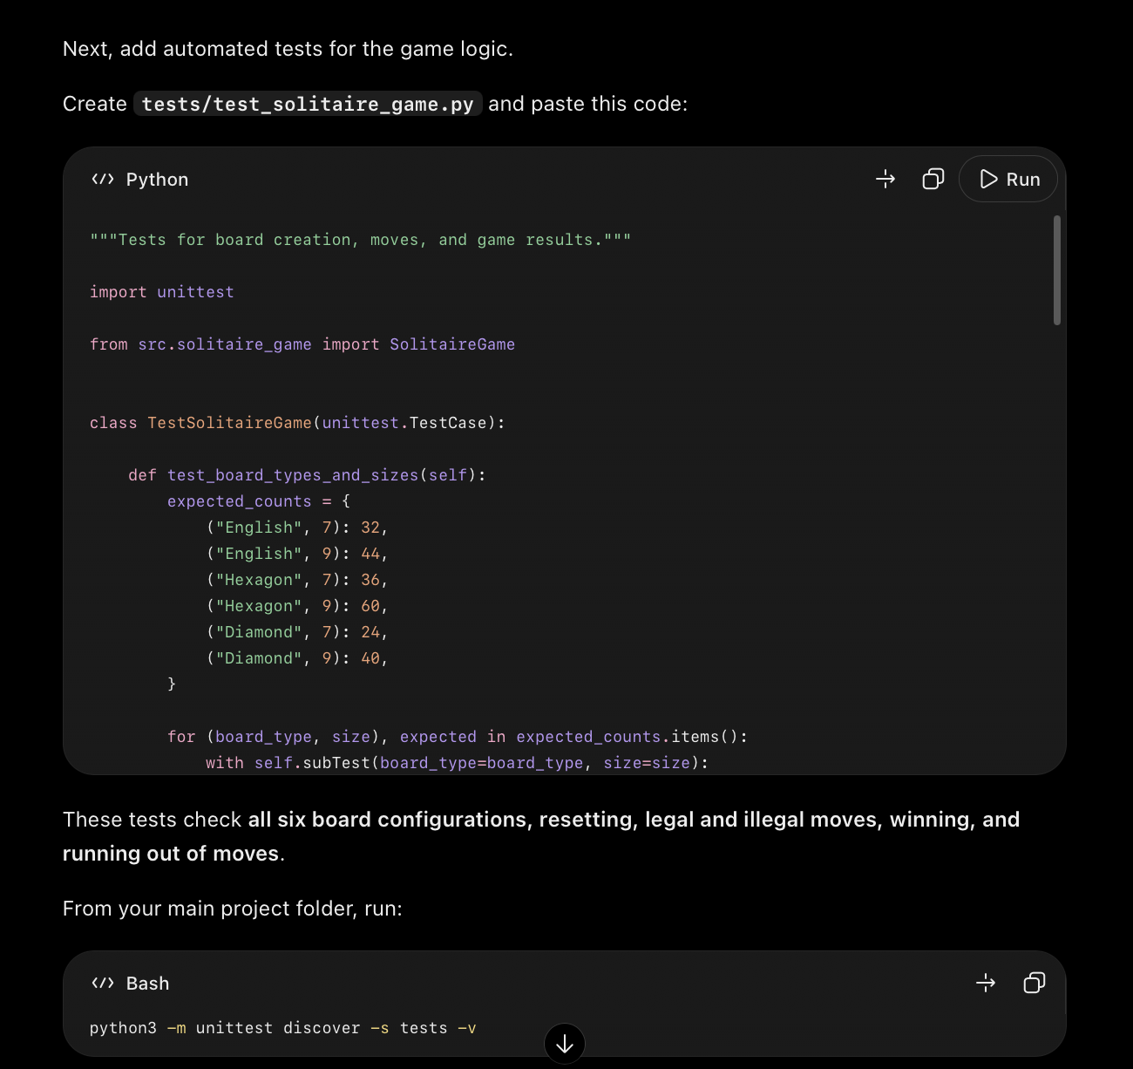

Reset test: Changing to Dimond 9 checks the new setting.peg count, and empty center
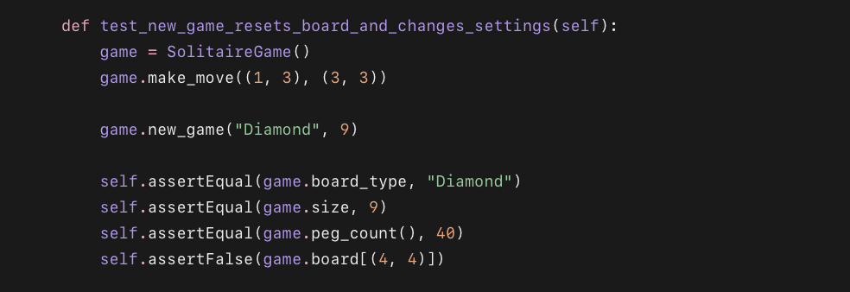

Legal jump test: check the starting hole, jumped hole, destination and remaining count.
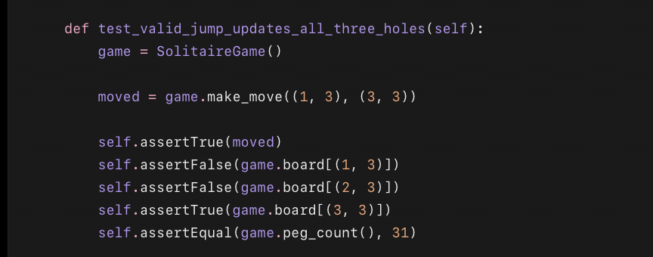

The invalid move test spans these two screenshot, with overlapping lines showing the continuation.
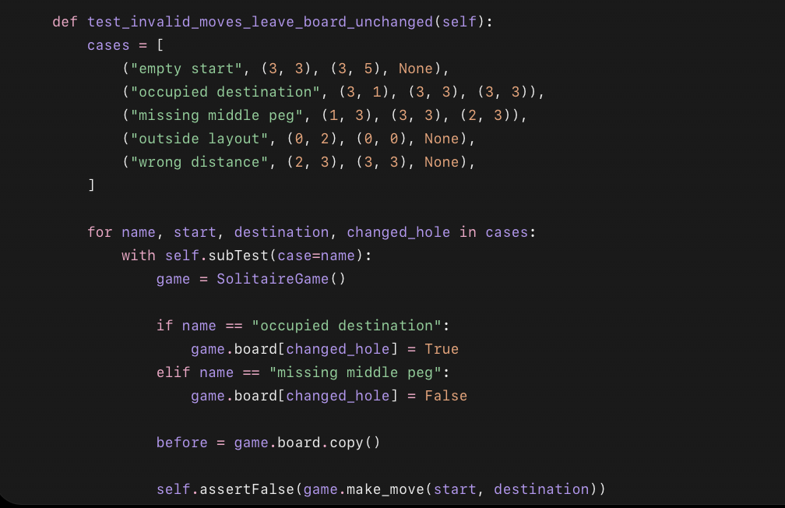

Contains the complete final jump win test

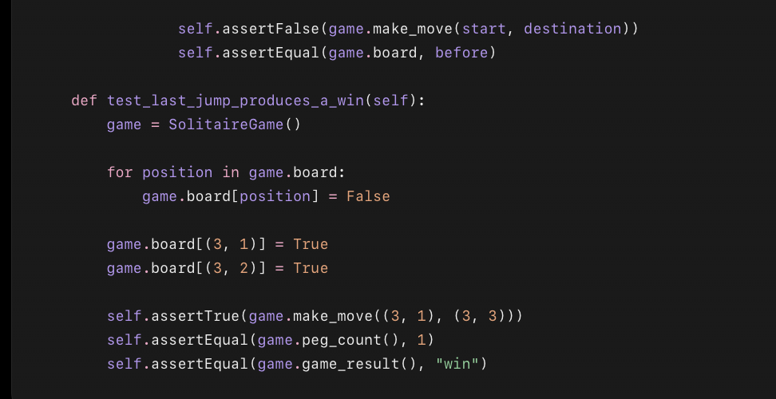

Submission Guidelines:
Each student must independently upload LastName_FirstName_Sprint2.docx to Canvas. Include:
- Your name
- GitHub repository link containing all production code and automated tests. Ensure that the link is public.
- Demonstration video link — a narrated video of no more than 3 minutes showing the required features and automated tests (again the link should be public).
- Source-code summary table — filenames, production/test classification, line counts, and total.
- Updated user stories and acceptance criteria, mapped to implementation classes and methods, with completion status.
- Testing tables — automated test mappings and results, plus manual or additional tests where applicable.
- LLM evidence — screenshots of prompts and responses used to generate at least two unit tests, with an explanation of how you checked them and corrected any errors.
Mark unused optional sections “Not applicable.” Before submitting, verify that the instructor can access your GitHub repository and video.

