GitHub Repository: github.com/JeetPatel23/CS449-Peg-Solitaire

Sprint #0 Report

Instructions

Objectives
- Make decisions on the Solitaire software development project.
- Learn unit testing and GUI programming in the language of your choice.

Deliverables and Grading Policy
Read the “CS 449 Homework Overview” document carefully and make the key decisions for the software development. Use the following template to complete your report.

- Key Decisions of the Solitaire Project (2 points)

Topic | Decision
Object-oriented programming language (if not using OOP, then justify the use of the language) | Python 3.11
GUI library (strongly encouraged) | Tkinter
IDE (Integrated Development Environment) | VS Code
xUnit framework (e.g., JUnit for Java) | Python unittest
Programming style guide (must read it carefully) | Google Python Style Guide
Project hosting site | Github.com
Other decisions if applicable | Git version control and separation of GUI from gaem logic.

Sample programming style guides:
- Google Java Style Guide: https://google.github.io/styleguide/javaguide.html
- Google C++ Style Guide: https://google.github.io/styleguide/cppguide.html
- Google Python Style Guide: https://google.github.io/styleguide/pyguide.html

- Unit testing (4 points)

Find a tutorial on the unit test framework you have chosen and write at least two xUnit tests of a program you have written or found elsewhere. Attach here (1) the screenshot of your program execution and (2) the source code of your program.

For example, Junit5 user guide: https://docs.junit.org/5.10.3/user-guide/index.html

Python Unittest:

I used Python’s built in unitest framework to test the game rating compoinent of the Peg Solitaire program. Five test verify the rating for different number of remaining pegs and confirm that an invalid peg count raises an erro. All five tests passed.

Unit Test:
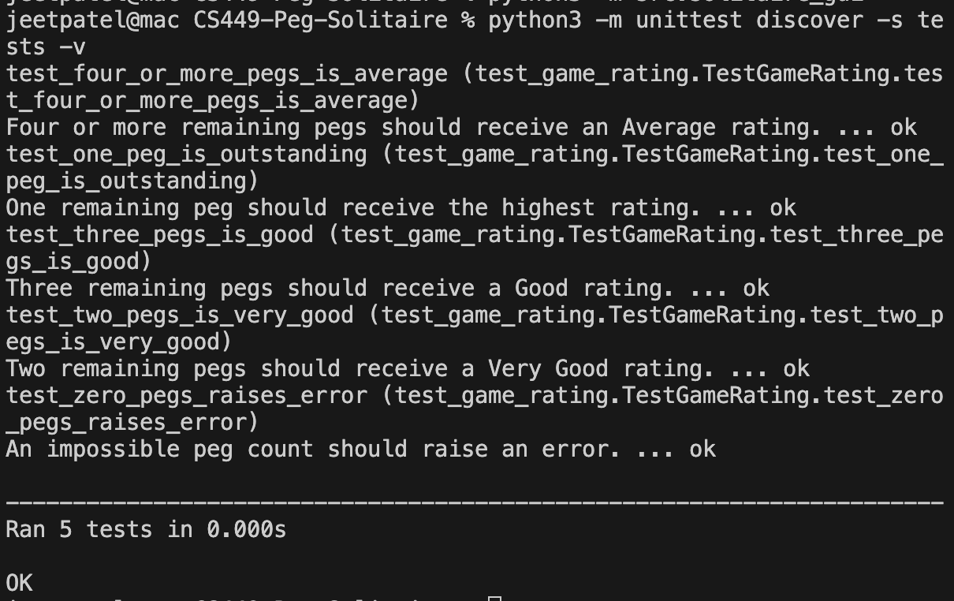

Game_rating source Code:
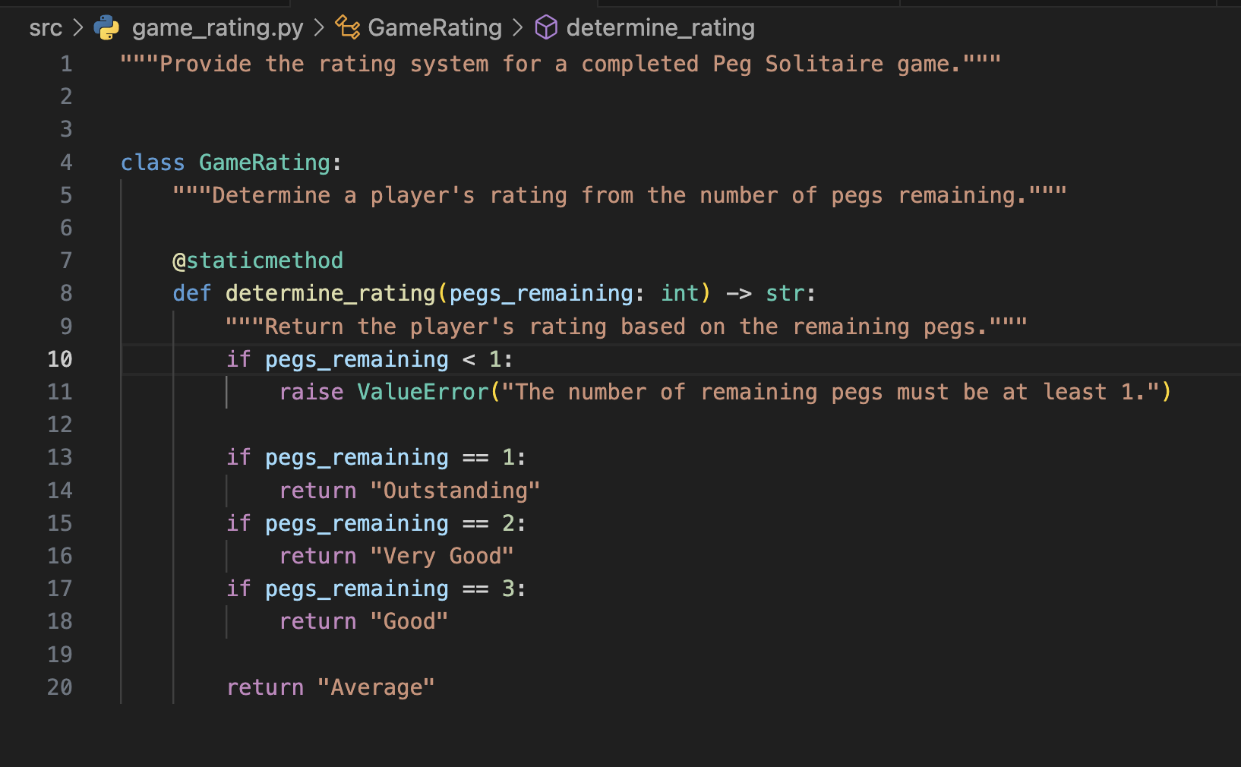

Test_Game_Rating source code:
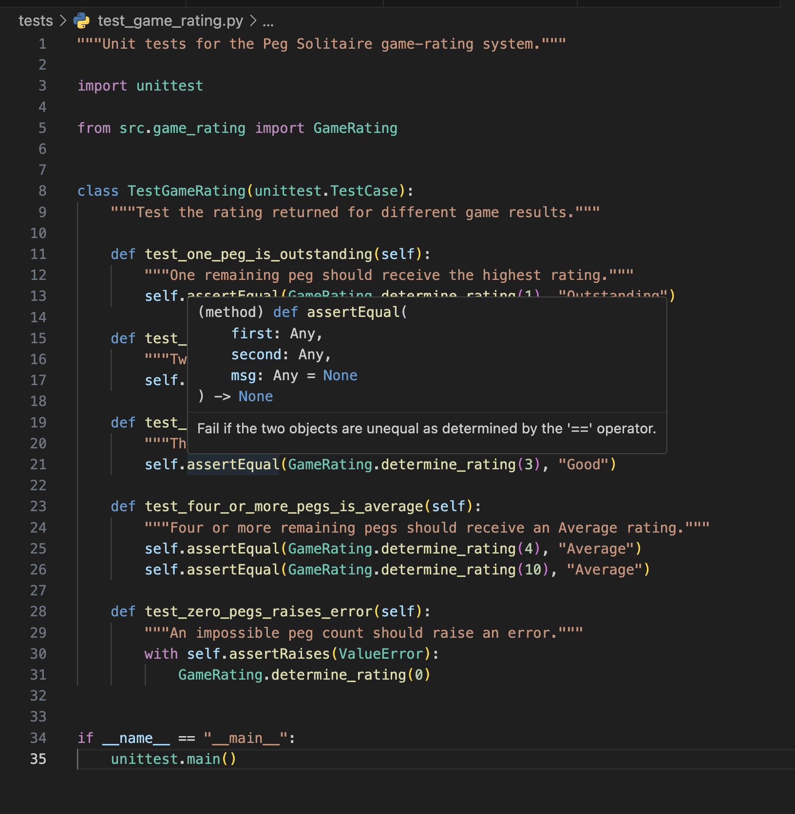

- GUI programming (4 points)

Write a GUI program in the language you have chosen for your Solitaire project. The GUI of your program must include text, lines, a check box, and radio buttons. In this assignment, any GUI program of your own work is acceptable.

Attach here (1) the screenshot of your program execution and (2) the source code of your program.

I created a Peg Solitaire GUI prototype using Python’s Tkinter library. The interface includes text labels, a horizontal line, a radio button for selecting a board type, a checkbox for recording the game, control buttons, and a visual representation of an English Solitaire board.

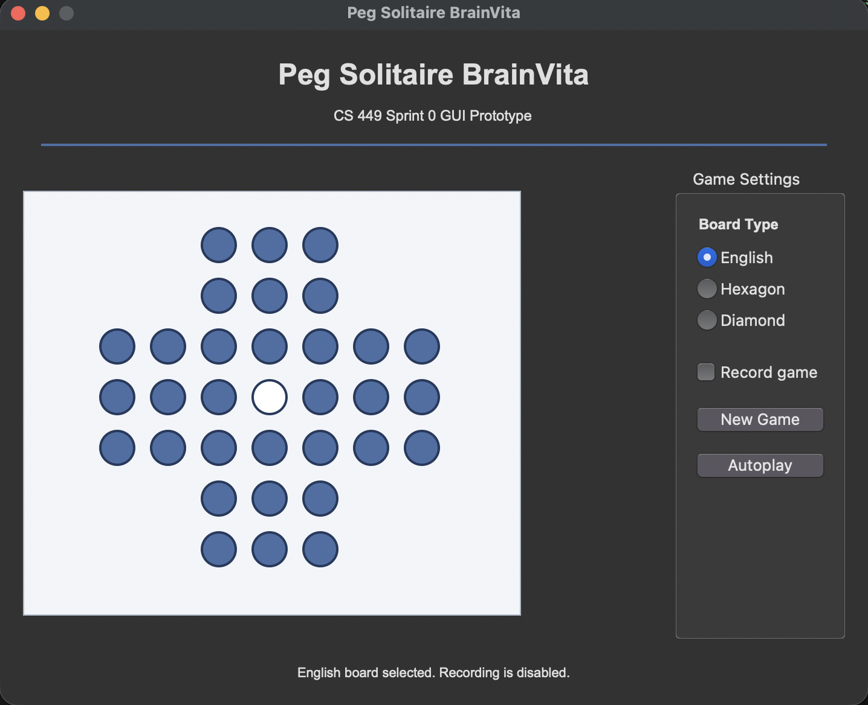

Source Code:
