

[Compiler Practical](https://www.studocu.com/in/document/gujarat-technological-university/compiler-design/compiler-practical/40584307?utm_campaign=shared-document&utm_source=studocu-document&utm_medium=social_sharing&utm_content=compiler-practical)

[Compiler design (Gujarat Technological University)](https://www.studocu.com/in/course/gujarat-technological-university/compiler-design/4982467?utm_campaign=shared-document&utm_source=studocu-document&utm_medium=social_sharing&utm_content=compiler-practical)



Scan to open on Studocu

Studocu is not sponsored or endorsed by any college or university

Practical-1

AIM: Implementation of Finite Automata and String Validation.

#include<stdio.h> int main() {

int length;

printf("Enter length of a string: "); scanf("%d",&length);

char str[length]; int i,flag='0';

printf("Enter a string to be checked: "); scanf("%s",str);

for(i=0;str[i]!='\0';i++) {

if(str[i]=='\0' || str[i]=='\1') { flag=1;

}

else { flag=0; break;

}

}

if(flag==1) {

if(str[length-1]=='1' && str[length-2]=='\0') { printf("String is accepted");\

}

else {

printf("String is not accepted");

}

}

else{

{

printf("String is not accepted");

}

}

Output:

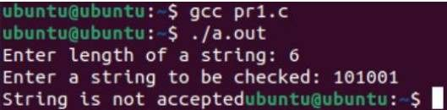

**What is Lex?**

Practical-2

AIM: Introduction to Lex tools

* Lex is a program that generates lexical analyzer. It is used with YACC parser generator.
* The lexical analyzer is a program that transforms an input stream into a sequence of

tokens.

* It reads the input stream and produces the source code as output through implementing

the lexical analyzer in the C program.

# The function of Lex

* Firstly lexical analyzer creates a program lex.1 in the Lex language.

Then Lex compiler

runs the lex.1 program and produces a C program lex.yy.c.

* Finally C compiler runs the lex.yy.c program and produces an object program a.out.
* a.out is lexical analyzer that transforms an input stream into a sequence of tokens.

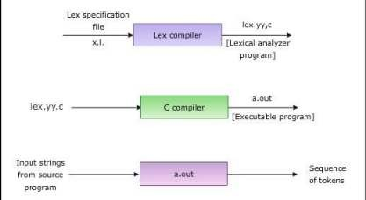

The structure of Lex programs

A Lex program is separated into three sections by %% delimiters. A Lex program consists of

three sections : Declarations, Rules and Auxiliary functions. The formal of Lex source is as

follows:

DECLARATIONS

%% RULES

%%

AUXILIARY FUNCTIONS

# Declarations

* The declarations section consists of two parts, auxiliary declarations and regular

definitions.

* The auxiliary declarations are copied as such by Lex to the output lex.yy.c file. This C

code consists of instructions to the C compiler and are not processed by the Lex tool.

The auxiliary declarations are written in C language and are enclosed within ' %{ ' and ' %} '. It is generally used to declare functions, include header files, or define global

variables and constants.

* Lex allows the use of short-hands and extensions to regular expressions for the regular

definitions. Example:

/*Declarations section start here*/

/* Auxiliary declarations start here*/

%{

#include <stdio.h> int global_variable;

%}

/*Auxiliary declarations end & Regular definitions start here*/

number [0-9]+ //Regular definition op [-|+|*|/|^|=] //Regular definition

/*Declarations section ends here*/

%%

/* Rules */

%%

/* Auxiliary functions */

# Rules

* Rules in a Lex program consist of two parts :

1. The pattern to be matched
2. The corresponding action to be executed

* The pattern to be matched is specified as a regular expression. Example:

/* Declarations*/

%%

{number} {printf(“ number”);}

{op} {printf(“ operator”);}

%%

/* Auxiliary functions */

# Auxiliary functions

* Lex generates C code for the rules specified in the Rules section and places this code into

a single function called yylex(). (To be discussed in detail later). In addition to this Lex

generated code, the programmer may wish to add his own code to the lex.yy.c file. The

auxiliary functions section allows the programmer to achieve this. Example:

/* Declarations */

%%

/* Rules */

%%

int main()

{

yylex(); return 1;

}

# The yyvariables

The following variables are offered by Lex to aid the programmer in designing sophisticated

lexical analyzers. These variables are accessible in the Lex program and are automatically

declared by Lex in lex.yy.c.

1. yyin is a variable of the type FILE* and points to the input file. yyin is defined by Lex

automatically. If the programmer assigns an input file to yyin in the auxiliary functions

section, then yyin is set to point to that file. Otherwise Lex assigns yyin to stdin(console

input).

1. yytext is of type char* and it contains the lexeme currently found.

A lexeme is a sequence

of characters in the input stream that matches some pattern in the Rules Section. (In fact, it

is the first matching sequence in the input from the position pointed to by yyin.) Each

invocation of the function yylex() results in yytext carrying a pointer to the lexeme found in

the input stream by yylex(). The value of yytext will be overwritten after the next yylex()

invocation.

1. yyleng is a variable of the type int and it stores the length of the lexeme pointed to by yytext.

# The yyfunctions

1. yylex()

* yylex() is a function of return type int. Lex automatically defines yylex() in lex.yy.c but

does not call it. The programmer must call yylex() in the Auxiliary functions section of

the Lex program. Lex generates code for the definition of yylex() according to the rules

specified in the Rules section.

* yylex() need not necessarily be invoked in the Auxiliary Functions Section of Lex

program when used with YACC.

1. yywrap()

* Lex declares the function yywrap() of return-type int in the file lex.yy.c. Lex does not

provide any definition for yywrap(). yylex() makes a call to yywrap() when it encounters

the end of input.

* If yywrap() returns zero (indicating false) yylex() assumes there is more input and it

continues scanning from the location pointed to by yyin. If yywrap() returns a non-zero

value (indicating true), yylex() terminates the scanning process and returns 0.

# Example of Lex Tool

%{

#include<stdio.h>

%}

%%

"hi" {printf("bye");}

.* {printf("Wrong Input");}

%%

void main()

{

printf("Enter IP"); yylex();

}

Output:

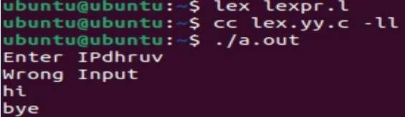

Practical-3

AIM: Implement following Programs Using Lex.

# Generate Count of words

Code:

%{

#include<stdio.h> #include<string.h> int i = 0;

%}

%%

([a-zA-Z0-9])* {i++;}

"\n" {printf("%d\n", i); i = 0;}

%%

int yywrap(void){} int main()

{

yylex(); return 0;

}

output:

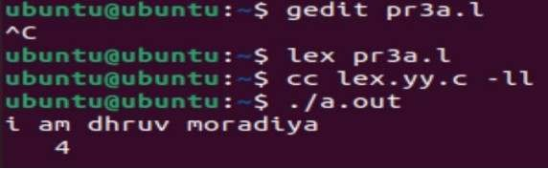

# Ceasor Cypher

Code:

%{

#include<stdio.h>

%}

%%

[a-z] {char ch = yytext[0]; ch += 3;

if (ch> 'z') ch -= ('z'+1- 'a'); printf ("%c" ,ch );

}

[A-Z] { char ch = yytext[0] ; ch += 3;

if (ch> 'Z') ch -= ('Z'+1- 'A');

printf("%c",ch);

}

%%

void main()

{

printf("Enter Input Message: "); yylex();

}

Output:

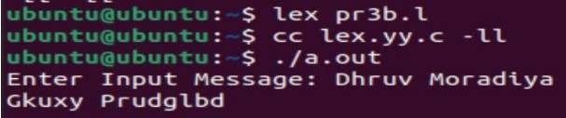

1. Extract single and multiline comments from C Program.

**Input file:** #include<stdio.h> void main()

{

//Single-line comment

/*Multiline comment

*/

printf("Dhruv Moradiya");

}

# Code

%{

#include<stdio.h>

%}

%%

\/\/(.*) {};

\/\*(.*\n)*.*\*\/ {};

%%

int yywrap()

{

return 1;

}

void main()

{

yyin=fopen("input.c","r");

yyout=fopen("output.c","w"); yylex();

}

Output :

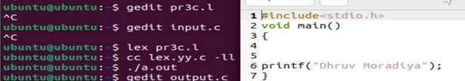

Practical-4

AIM: Implement following Programs Using Lex.

# Convert Roman to Decimal

Code:

WS [ \t]+

%{

int total=0;

%}

%%

I total += 1; IV total += 4; V total += 5; IX total += 9; X total += 10;

XL total += 40; L total += 50; XC total += 90; C total += 100;

CD total += 400; D total += 500; CM total += 900; M total += 1000;

{WS} |

\n return total;

%%

int main (void) { int number; number = yylex ();

printf ("%d\n", number); return 0;

}

Output:

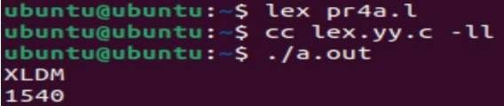

1. Check weather given statement is compound or simple. Code:

%{

#include<stdio.h> int flag=0;

%}

%%

and | or | but |

because | if |

then |

nevertheless { flag=1; }

. ;

\n { return 0; }

%%

int main()

{

printf("Enter your sentence:\n"); yylex();

if(flag==0)

printf("Simple sentence\n");

else

printf("compound sentence\n");

}

int yywrap( )

{

return 1; output:

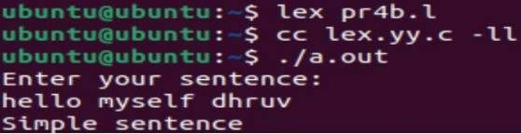

# Extract html tags from .html file. 39.html:

<html>

<head>

</head>

<body>

<p>

<a href="https://[www.coursera.org/](http://www.coursera.org/)">Dhruv Moradiya</a>

</p>

</body>

</html>

# Code:

%{

#include<stdio.h>

%}

%%

"<"[^>]*> {printf("%s\n", yytext); }

.;

%%

int yywrap(){}

int main(int argc, char*argv[])

{

yyin = fopen("39.html","r");

yylex(); return 0;

}

Output:

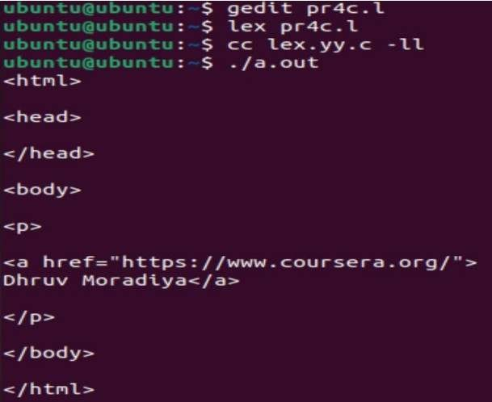

Practical-5

AIM: Implementation of Recursive Descent Parser without backtracking.

Input: The string to be parsed.

Output: Whether string parsed successfully or not.

Explanation: Students have to implement the recursive procedure for

RDP for a typical grammar. The production no. are displayed as they

are used to derive the string.

#include<stdio.h> char str[20];

int p=0; char l;

int flag = 0;

void getString(){

printf("The Production rules are as follows: - \nE -> iE'\nE' ->

+tE/^\nEnter a String : "); scanf("%[^\n]%*c", str);

}

void error(){ flag = 0;

}

int match(char t){ if(l == '$'){

flag = 1;

return 0;

}

if(l == t){ p++;

l = str[p];

}

else{ error(); return 0;

}

}

void Edesh(){ if(l == '+'){

match('+');

match('i'); E();

}

else{ error();

}

}

void E(){

l = str[p]; match('i');

if(l != '$'){ Edesh();

}

}

void main(){ getString(); E();

match('$'); if(flag == 1){

printf("ACCEPTED\n");

}else{

printf("NOT ACCEPTED\n");

}

}

Output:

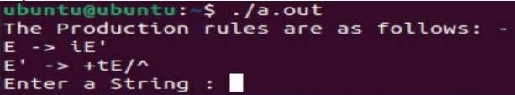

Practical-6

Aim: Finding “First” set Input: The string consists of grammar symbols.

Output: The First set for a given string.

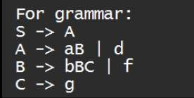

#include<stdio.h> #include<string.h> char first[100]; char c;

void FiS()

{ FiA();

}

void FiA()

{

c = '{';

strncat(first,&c,1); c = 'a'; strncat(first,&c,1);

c = ',';

strncat(first,&c,1); c = ' ';

strncat(first,&c,1); c = 'd'; strncat(first,&c,1); c = '}';

strncat(first,&c,1);

}

void FiB()

{

c = '{';

strncat(first,&c,1); c = 'b'; strncat(first,&c,1); c = ',';

strncat(first,&c,1); c = ' ';

strncat(first,&c,1); c = 'f'; strncat(first,&c,1); c = '}';

strncat(first,&c,1);

}

void FiC()

{

c = '{';

strncat(first,&c,1); c = 'g'; strncat(first,&c,1); c = '}';

strncat(first,&c,1);

}

void main()

{

char r;

printf("Enter your Non Terminal:\n"); scanf("%c",&r);

if(r=='S')

{ FiS();

}

else if(r=='A')

{ FiA();

}

else if(r=='B')

{

FiB();

}

else if(r=='C')

{ FiC();

}

else

{

printf("INVALID NON TERMINAL");

}

printf("First of \'%c\' is:",r); puts(first);

}

Output:

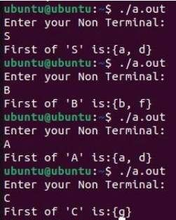

Practical-7

Aim: Generate 3-tuple intermediate code for given infix expression

#include<stdio.h> #include<string.h> void pm();

void plus(); void div();

int i,ch,j,l,addr=100;

char ex[10], exp[10] ,exp1[10],exp2[10],id1[5],op[5],id2[5]; void main()

{

printf("\nEnter the expression with arithmetic operator:"); scanf("%s",ex);

strcpy(exp,ex); l=strlen(exp); exp1[0]='\0'; for(i=0;i<l;i++)

{

if(exp[i]=='+'||exp[i]=='-')

{

if(exp[i+2]=='/'||exp[i+2]=='*')

{

pm(); break;

}

else

{

plus(); break;

}

}

else if(exp[i]=='/'||exp[i]=='*')

{

div(); break;

}

}

}

void pm()

{

strrev(exp); j=l-i-1;

strncat(exp1,exp,j); strrev(exp1);

printf("Three address code:\ntemp=%s\ntemp1=%c

%ctemp\n",exp1,exp[j+1],exp[j]);

}

void div()

{

strncat(exp1,exp,i+2);

printf("Three address code:\ntemp=%s\ntemp1=temp%c

%c\n",exp1,exp[i+2],exp[i+3]);

}

void plus()

{

strncat(exp1,exp,i+2);

printf("Three address code:\ntemp=%s\ntemp1=temp%c

%c\n",exp1,exp[i+2],exp[i+3]);

}

Output:

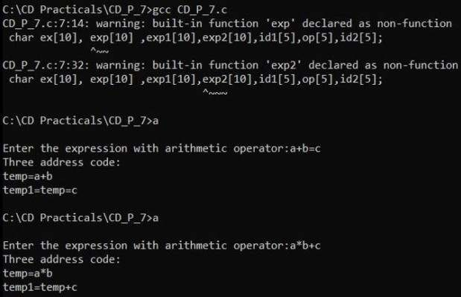

Practical-8

Aim: Extract Predecessor and Successor from given Control Flow Graph

package cd_p_8; class CD_P_8{ static class Node

{

int key;

Node left, right; public Node()

{}

public Node(int key)

{

this.key = key;

this.left = this.right = null;

}

};

static Node pre = new Node(), suc = new Node(); static void findPreSuc(Node root, int key)

{

if (root == null) return;

if (root.key == key)

{

if (root.left != null)

{

Node tmp = root.left; while (tmp.right != null) tmp = tmp.right;

pre = tmp;

}

if (root.right != null)

{

Node tmp = root.right; while (tmp.left != null) tmp = tmp.left;

suc = tmp;

}

return;

}

if (root.key > key)

{

suc = root; findPreSuc(root.left, key);

}

else

{

pre = root; findPreSuc(root.right, key);

}

}

static Node insert(Node node, int key)

{

if (node == null) return new Node(key); if (key < node.key)

node.left = insert(node.left, key); else

node.right = insert(node.right, key); return node;

}

public static void main(String[] args)

{

int key = 32;

Node root = new Node(); root = insert(root, 10); insert(root, 70);

insert(root, 40);

insert(root, 60);

insert(root, 80);

insert(root, 90);

insert(root, 20); findPreSuc(root, key); if (pre != null)

System.out.println("Predecessor is " + pre.key); else

System.out.println("No Predecessor"); if (suc != null)

System.out.println("Successor is " + suc.key); else

System.out.println("No Successor");

}

}

Output:

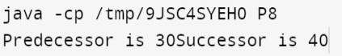

Practical-9

Aim: Introduction to YACC and generate Calculator Program

* 1. YACC (Yet Another Compiler Compiler) is a tool used to generate a parser.
  2. This document is a tutorial for the use of YACC to generate a parser for ExpL.
  3. YACC translates a given Context Free Grammar (CFG) specifications (input in input_file.y) into a C implementation (y.tab.c) of a corresponding push down automaton (i.e., a finite state machine with a stack).
  4. This C program when compiled, yields an executable parser.

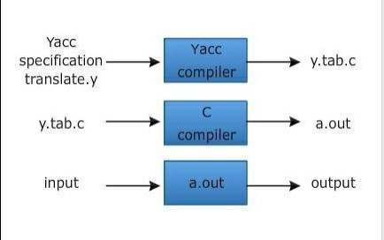

# How yacc works?

* The input to yacc describes the rules of a grammar.
* yacc uses these rules to produce the source code for a program

that parses the grammar.

* You can then compile this source code to obtain a program that

reads input, parses it according to the grammar, and takes action based on the result.

* The source code produced by yacc is written in the C

programming language.

* It consists of a number of data tables that represent the grammar, plus a C function named yyparse().
* By default, yacc symbol names used begin with yy.
* This is an historical convention, dating back to yacc's

predecessor, UNIX yacc.

* You can avoid conflicts with yacc names by avoiding symbols that start with yy.

# The structure of YACC programs:

* A YACC program consists of three sections: Declarations, Rules and Auxiliary functions.

(Note the similarity with the structure of LEX programs).

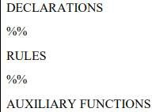

# CD_P_9.l

%{

/* Definition section */ #include<stdio.h> #include "y.tab.h" extern int yylval;

%}

/* Rule Section */

%%

[0-9]+ {

yylval=atoi(yytext); return NUMBER;

}

[\t] ;

[\n] return 0;

. return yytext[0];

%%

int yywrap()

{

return 1;

}

# CD_P_9.y

%{

/* Definition section */ #include<stdio.h>

int flag=0;

%}

%token NUMBER

%left '+' '-'

%left '*' '/' '%'

%left '(' ')'

/* Rule Section */

%%

ArithmeticExpression: E{ printf("\nResult=%d\n", $$); return 0;

};

E:E'+'E {$$=$1+$3;}

|E'-'E {$$=$1-$3;}

|E'*'E {$$=$1*$3;}

|E'/'E {$$=$1/$3;}

|E'%'E {$$=$1%$3;}

|'('E')' {$$=$2;}

| NUMBER {$$=$1;};

%%

//driver code

void main()

{

printf("\nEnter Any Arithmetic Expression which can have operations Addition, Subtraction,

Multiplication, Division, Modulus and Round brackets:\n"); yyparse();

if(flag==0)

printf("\nEntered arithmetic expression is Valid\n\n");

}

void yyerror()

{

printf("\nEntered arithmetic expression is Invalid\n\n"); flag=1;

}

Output:

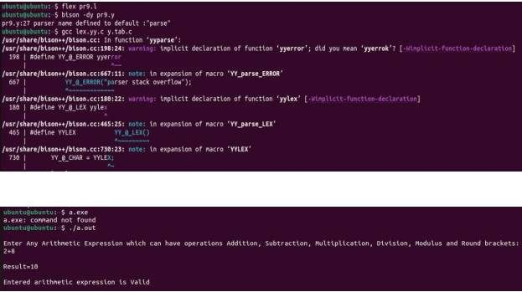

Practical-10

Aim: Finding “Follow” set Input: The string consists of grammar symbols.

Output: The Follow set for a given string.

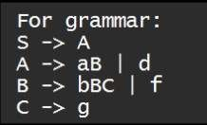

#include<stdio.h> char follow[100]; char c;

void FoS()

{

c = '{';

strncat(follow,&c,1); c = '$'; strncat(follow,&c,1);

}

void FoA()

{ FoS();

}

void FoB()

{ FoA();

FiC();

}

void FoC()

{ FoB();

}

void FiC()

{

c = ',';

strncat(follow,&c,1); c = ' ';

strncat(follow,&c,1); c = 'b';

strncat(follow,&c,1);

}

void main()

{

char r;

printf("Enter your Non Terminal:\n"); scanf("%c",&r);

if(r=='S')

{ FoS();

}

else if(r=='A')

{ FoA();

}

else if(r=='B')

{ FoB();

}

else if(r=='C')

{ FoC();

}

else

{

printf("INVALID NON TERMINAL");

}

c = '}';

strncat(follow,&c,1); printf("Follow of \'%c\' is:",r); puts(follow);

}

Output:

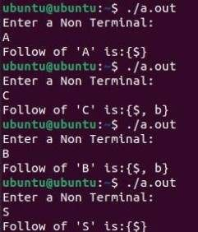

Practical-11

Aim: Implement a C program for constructing LL (1) parsing.

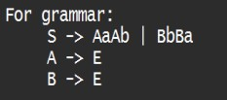

#include<stdio.h> #include<string.h> int stackPointer = 0; int inputPointer = 0; int stackLength = 0;

char stack[20], input[10]; int LL1Parse()

{

int s = 0; if(stack[stackPointer]=='S')

{

if(input[inputPointer]=='a')

{

stack[stackPointer] = 'b'; stackPointer++; stack[stackPointer] = 'A'; stackPointer++; stack[stackPointer] = 'a'; stackPointer++; stack[stackPointer] = 'A';

}

else if(input[inputPointer]=='b')

{

stack[stackPointer] = 'a'; stackPointer++; stack[stackPointer] = 'B'; stackPointer++; stack[stackPointer] = 'b'; stackPointer++; stack[stackPointer] = 'B';

}

}

else if(stack[stackPointer]=='A')

{

if(input[inputPointer]=='a')

{

stack[stackPointer] = 'x'; stackPointer—;

}

else if(input[inputPointer]=='b')

{

stack[stackPointer] = 'x'; stackPointer--;

}

}

else if(stack[stackPointer]=='B')

{

if(input[inputPointer]=='a')

{

stack[stackPointer] = 'x'; stackPointer--;

}

else if(input[inputPointer]=='b')

{

stack[stackPointer] = 'x'; stackPointer--;

}

}

else if(stack[stackPointer]=='a' && input[inputPointer]=='a')

{

stack[stackPointer] = 'x'; stackPointer--; inputPointer++;

}

else if(stack[stackPointer]=='b' && input[inputPointer]=='b')

{

stack[stackPointer] = 'x'; stackPointer--; inputPointer++;

}

else if(stack[stackPointer]=='b' && input[inputPointer]=='a')

{

printf("Input rejected"); s = 2;

}

else if(stack[stackPointer]=='a' && input[inputPointer]=='b')

{

printf("Input rejected"); s = 2;

}

else if(input[inputPointer]=='$')

{

if(stack[stackPointer]=='$')

{

printf("Input accepted"); s = 1;

}

else

{

printf("Input rejected"); s = 2;

}

}

else if(stack[stackPointer]=='$')

{

if(input[inputPointer]=='$')

{

printf("Input accepted"); s = 1;

}

else

{

printf("Input rejected"); s = 2;

}

}

return s;

}

void main()

{

int i,j,status=0; stack[stackPointer] = '$'; stackPointer++; stack[stackPointer] = 'S'; printf("Enter your string: "); gets(input); input[strlen(input)] = '$'; while(status!=1)

{

status = LL1Parse(); if(status==2) break;

}

}

Output:

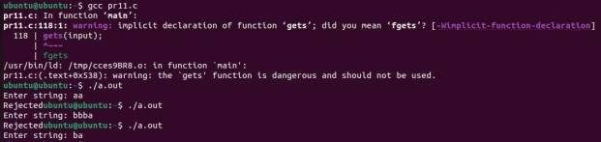

Practical-12

Aim: Implement a C program for constructing LALR parsing.

#include<stdio.h> #include<stdlib.h> #include<string.h> #include<conio.h>

void push(char *, int *, char); char stacktop(char *);

void isproduct(char, char); int ister(char);

int isnter(char);

int isstate(char); void error();

void isreduce(char, char); char pop(char *, int *);

void printt(char *, int *, char[], int); void rep(char[], int);

struct action{ char row[6][5];

};

const struct action A[12] = {

{"sf", "emp", "emp", "se", "emp", "emp"},

{"emp", "sg", "emp", "emp", "emp", "acc"},

{"emp", "rc", "sh", "emp", "rc", "rc"},

{"emp", "re", "re", "emp", "re", "re"},

{"sf", "emp", "emp", "se", "emp", "emp"},

{"emp", "rg", "rg", "emp", "rg", "rg"},

{"sf", "emp", "emp", "se", "emp", "emp"},

{"sf", "emp", "emp", "se", "emp", "emp"},

{"emp", "sg", "emp", "emp", "sl", "emp"},

{"emp", "rb", "sh", "emp", "rb", "rb"},

{"emp", "rb", "rd", "emp", "rd", "rd"},

{"emp", "rf", "rf", "emp", "rf", "rf"}

};

struct gotol{

char r[3][4];

};

const struct gotol G[12] = {

{"b", "c", "d"},

{"emp", "emp", "emp"},

{"emp", "emp", "emp"},

{"emp", "emp", "emp"},

{"i", "c", "d"},

{"emp", "emp", "emp"},

{"emp", "j", "d"},

{"emp", "emp", "k"},

{"emp", "emp", "emp"},

{"emp", "emp", "emp"},

};

char ter[6] = {'i', '+', '*', ')', '(', '$'};

char nter[3] = {'E', 'T', 'F'};

char states[12] = {'a', 'b', 'c', 'd', 'e', 'f', 'g', 'h', 'm', 'j', 'k', 'l'}; char stack[100];

int top = -1; char temp[10]; struct grammar{ char left;

char right[5];

};

const struct grammar rl[6] = {

{'E', "e+T"}, {'E', "T"}, {'T', "T*F"}, {'T', "F"}, {'F', "(E)"}, {'F', "i"},

};

void main(){

char inp[80], x, p, dl[80], y, bl = 'a'; int i = 0, j, k, l, n, m, c, len;

printf(" Enter the input :"); scanf("%s", inp);

len = strlen(inp); inp[len] = '$';

inp[len + 1] = '\0'; push(stack, &top, bl); printf("\n stack \t\t\t input"); printt(stack, &top, inp, i);

do{

x = inp[i];

p = stacktop(stack); isproduct(x, p);

if (strcmp(temp, "emp") == 0) error();

if (strcmp(temp, "acc") == 0) break;

else{

if (temp[0] == 's') {

push(stack, &top, inp[i]); push(stack, &top, temp[1]); i++;

}

else{

if (temp[0] == 'r'){

j = isstate(temp[1]); strcpy(temp, rl[j - 2].right); dl[0] = rl[j - 2].left;

dl[1] = '\0';

n = strlen(temp);

for (k = 0; k < 2 * n; k++) pop(stack, &top);

for (m = 0; dl[m] != '\0'; m++)

push(stack, &top, dl[m]); l = top;

y = stack[l - 1]; isreduce(y, dl[0]);

for (m = 0; temp[m] != '\0'; m++) push(stack, &top, temp[m]);

}

}

}

printt(stack, &top, inp, i);

} while (inp[i] != '\0');

if (strcmp(temp, "acc") == 0) printf(" \n accept the input "); else

printf(" \n do not accept the input "); getch();

}

void push(char *s, int *sp, char item) { if (*sp == 100)

printf(" stack is full "); else{

*sp = *sp + 1; s[*sp] = item;

}

}

char stacktop(char *s) { char i;

i = s[top]; return i;

}

void isproduct(char x, char p) { int k, l;

k = ister(x);

l = isstate(p);

strcpy(temp, A[l - 1].row[k - 1]);

}

int ister(char x) { int i;

for (i = 0; i < 6; i++) if (x == ter[i]) return i + 1;

return 0;

}

int isnter(char x) { int i;

for (i = 0; i < 3; i++) if (x == nter[i]) return i + 1;

return 0;

}

int isstate(char p) { int i;

for (i = 0; i < 12; i++) if (p == states[i]) return i + 1;

return 0;

}

void error(){

printf(" error in the input "); exit(0);

}

void isreduce(char x, char p) { int k, l;

k = isstate(x); l = isnter(p);

strcpy(temp, G[k - 1].r[l - 1]);

}

char pop(char *s, int *sp) { char item;

if (*sp == -1)

printf(" stack is empty "); else{

item = s[*sp];

*sp = *sp - 1;

}

return item;

}

void printt(char *t, int *p, char inp[], int i) { int r;

printf("\n");

for (r = 0; r <= *p; r++) rep(t, r);

printf("\t\t\t");

for (r = i; inp[r] != '\0'; r++)

printf("%c", inp[r]);

}

void rep(char t[], int r) { char c;

c = t[r]; switch (c) { case 'a': printf("0"); break; case 'b': printf("1"); break; case 'c': printf("2"); break; case 'd': printf("3"); break; case 'e': printf("4"); break; case 'f':

printf("5"); break; case 'g': printf("6"); break; case 'h': printf("7"); break; case 'm': printf("8");

break; case 'j':

printf("9"); break; case 'k':

printf("10"); break;

case 'l': printf("11"); break; default:

printf("%c", t[r]); break;

}

}

Output:

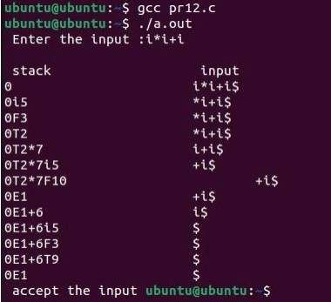

Practical-13

Aim: Implement a C program to implement operator precedence parsing.

#include<stdio.h> #include<string.h> #include<stdlib.h> char *input;

int i=0;

char lasthandle[6],stack[50],handles[] [5]={")E(","E*E","E+E","i","E^E"};

//(E) becomes )E( when pushed to stack int top=0,l;

char prec[9][9]={

/*input*/

/*stack + - * / ^ i ( ) $ */

/* + */ '>', '>','<','<','<','<','<','>','>',

/* - */ '>', '>','<','<','<','<','<','>','>',

/* * */ '>', '>','>','>','<','<','<','>','>',

/* / */ '>', '>','>','>','<','<','<','>','>',

/* ^ */ '>', '>','>','>','<','<','<','>','>',

/* i */ '>', '>','>','>','>','e','e','>','>',

/* ( */ '<', '<','<','<','<','<','<','>','e',

/* ) */ '>', '>','>','>','>','e','e','>','>',

/* $ */ '<', '<','<','<','<','<','<','<','>',

};

int getindex(char c)

{

switch(c)

{

case '+':return 0;

case '-':return 1;

case '*':return 2;

case '/':return 3;

case '^':return 4;

case 'i':return 5;

case '(':return 6;

case ')':return 7;

case '$':return 8;

}

}

int shift()

{

stack[++top]=*(input+i++); stack[top+1]='\0';

}

int reduce()

{

int i,len,found,t; for(i=0;i<5;i++)//selecting handles

{

len=strlen(handles[i]); if(stack[top]==handles[i][0]&&top+1>=len)

{

found=1; for(t=0;t<len;t++)

{

if(stack[top-t]!=handles[i][t])

{

found=0; break;

}

}

if(found==1)

{

stack[top-t+1]='E'; top=top-t+1;

strcpy(lasthandle,handles[i]); stack[top+1]='\0';

return 1;//successful reduction

}

}

}

return 0;

}

void dispstack()

{

int j; for(j=0;j<=top;j++) printf("%c",stack[j]);

}

void dispinput()

{

int j; for(j=i;j<l;j++)

printf("%c",*(input+j));

}

void main()

{

int j; input=(char*)malloc(50*sizeof(char)); printf("\nEnter the string\n"); scanf("%s",input); input=strcat(input,"$"); l=strlen(input);

strcpy(stack,"$"); printf("\nSTACK\tINPUT\tACTION"); while(i<=l)

{

shift(); printf("\n"); dispstack(); printf("\t"); dispinput(); printf("\tShift");

if(prec[getindex(stack[top])][getindex(input[i])]=='>')

{

while(reduce())

{

printf("\n"); dispstack(); printf("\t"); dispinput();

printf("\tReduced: E->%s",lasthandle);

}

}

}

if(strcmp(stack,"$E$")==0) printf("\nAccepted;"); else

printf("\nNot Accepted;");} output:

