**Practical: 1**

**Aim:** Implementation of Finite Automata and String Validation.

**Code:**

#include <stdio.h>

#include <string.h>

int main() {

int length;

printf("Enter length of the string: ");

scanf("%d", &length);

char str[length + 1]; // +1 to accommodate the null terminator

printf("Enter a string to be checked: ");

scanf("%s", str);

int flag = 0;

// Check if the string contains '0' or '1'

for (int i = 0; str[i] != '\0'; i++) {

if (str[i] == '0' || str[i] == '1') {

flag = 1;

break;

}

}

// Check the last two characters if the flag is set

if (flag == 1) {

if (str[length - 1] == '1' && str[length - 2] == '0') {

printf("String is accepted\n");

} else {

printf("String is not accepted\n");

}

} else {

printf("String is not accepted\n");

}

return 0;

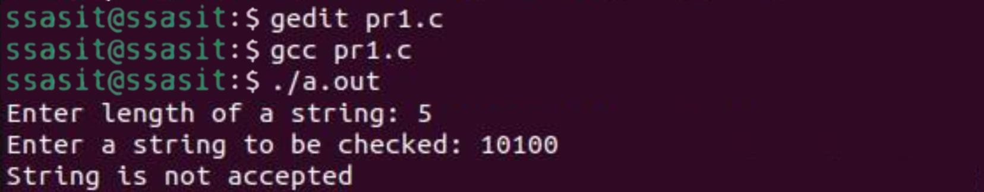**Output :**

**Practical: 2**

**Aim:** Introduction to Lex & Flex Tool.

* **Lex:**

Lex is a tool or a computer program that generates Lexical Analyzers (converts the stream of characters into tokens). The Lex tool itself is a compiler. The Lex compiler takes the input and transforms that input into input patterns. It is commonly used with YACC (Yet Another Compiler Compiler). It was written by Mike Lesk and Eric Schmidt.

**Function of Lex:**

1. In the first step the source code which is in the Lex language having the file name ‘File.l’ gives as input to the Lex Compiler commonly known as Lex to get the output as lex.yy.c.

2. After that, the output lex.yy.c will be used as input to the C compiler which gives the output in the form of an ‘a.out’ file, and finally, the output file a.out will take the stream of character and generates tokens as output.

lex.yy.c: It is a C program.  
File.l: It is a Lex source program  
a.out: It is a Lexical analyzer

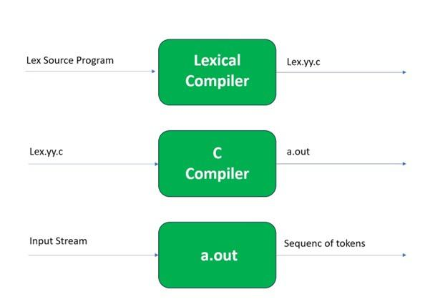

**Lex File Format:**

A Lex program consists of three parts and is separated by %% delimiters:-

Declarations  
%%  
Translation rules  
%%  
Auxiliary procedures

**Declarations:**The declarations include declarations of variables.

**Transition rules:** These rules consist of Pattern and Action.

**Auxiliary procedures:** The Auxilary section holds auxiliary functions used in the actions.

For example:

**declaration**  
number[0-9]  
%%  
**translation**  
if {return (IF);}  
%%  
**auxiliary function**  
int numberSum()

# **Flex:**

**FLEX (fast lexical analyzer generator)** is a tool/computer program for generating lexical analyzers

written by Vern Paxson in C around 1987. Flex and Bison both are more flexible than Lex and Yacc and produces faster code.   
Bison produces parser from the input file provided by the user. The function **yylex()** is automatically generated by the flex when it is provided with a **.l file** and this yylex() function is expected by parser to call to retrieve tokens from current/this token stream.

**Installing Flex on Ubuntu:**

sudo apt-get update

sudo apt-get install flex

Given image describes how the Flex is used:

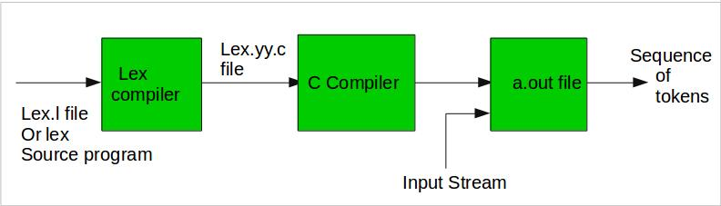

**Step 1:** An input file describes the lexical analyzer to be generated named lex.l is written in lex language. The lex compiler transforms lex.l to C program, in a file that is always named lex.yy.c.

**Step 2:** The C compiler compile lex.yy.c file into an executable file called a.out.

**Step 3:** The output file a.out take a stream of input characters and produce a stream of tokens.

**Program Structure:**

**In the input file, there are 3 sections:**

**1. Definition Section:** The definition section contains the declaration of variables, regular definitions, manifest constants. In the definition section, text is enclosed in “%{ %}” brackets. Anything written in this brackets is copied directly to the file lex.yy.c

**Syntax:**

%{

// Definitions

%}

**2. Rules Section:** The rules section contains a series of rules in the form: *pattern action* and pattern must be unintended and action begin on the same line in {} brackets. The rule section is enclosed in **“%% %%”**.

**Syntax:**

%%

pattern action

%%

**3. User Code Section:** This section contains C statements and additional functions. We can also compile these functions separately and load with the lexical analyzer.

Basic Program Structure:

%{

// Definitions

%}

%%

Rules

%%

User code section

**Output:**

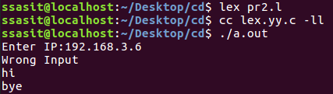

**Practical: 3**

**Aim:** Implementation following Programs Using Lex.

a. Generate Histogram of words

b.Check Cypher

c. Extract single and multiline comments from C Program

1. **Generate Histogram of words**

%{

#include<stdio.h>

#include<string.h>

int i = 0;

%}

/* Rules Section*/

%%

([a-zA-Z0-9])* {i++;} /* Rule for counting

number of words*/

"\n" {printf("%d\n", i); i = 0;}

%%

int yywrap(void){

int main()

{

// The function that starts the analysis

yylex();

return 0;

}

}

**Output:**

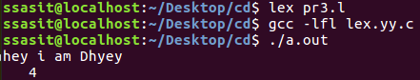

**b.Check Cypher**

%{

#include <stdio.h>

#include <stdlib.h>

void encrypt(char *text, int shift);

%}

%option noyywrap

%%

[a-zA-Z]+ {

encrypt(yytext, 3); // Shift by 3 positions for Caesar cipher

}

.|\n {

putchar(yytext[0]);

}

%%

void encrypt(char *text, int shift) {

while (*text) {

char c = *text;

if (c >= 'a' && c <= 'z') {

c = 'a' + (c - 'a' + shift) % 26;

} else if (c >= 'A' && c <= 'Z') {

c = 'A' + (c - 'A' + shift) % 26;

}

putchar(c);

text++;

}

}

int main() {

yylex();

return 0;

}

**Output:**

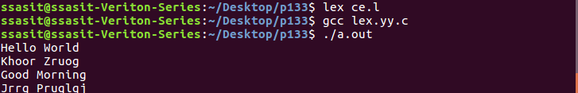

**c. Extract single and multiline comments from C Program**

%{

#include<stdio.h>

int sl=0,ml=0,c;

%}

%%

[/]{1}[/]{1}[a-zA-Z0-9_ ]* {sl++;} printf("Single line comment %d",sl);

[/]{1}[*]{1}[a-zA-Z0-9_ ]*[*]{1}[/]{1} {ml++;} printf("Multipleline comment%d",ml);

%%

int yywrap(void){return 1;}

int main()

{

yylex();

return 0;

}

**Output:**

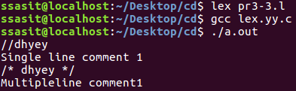

**Practical-4**

**Aim:** Implement following Programs Using Lex.

a. Convert Roman to Decimal

b. Check weather given statement is compound or simple

c. Extract html tags from .html file

**a. Convert Roman to Decimal**

#include<stdio.h>

int total=0;

%}

WS [ \t]+

%%

I total += 1;

IV total += 4;

V total += 5;

IX total += 9;

X total += 10;

XL total += 40;

L total += 50;

XC total += 90;

C total += 100;

CD total += 400;

D total += 500;

CM total += 900;

M total += 1000;

{WS} |

\n return total;

%%

int main (void)

{

int first;

printf("Enter Roman Number: ");

first = yylex ();

printf("Decimal Number is: %d\n", first);

return 0;

}

int yywrap(void)

{

return 1;

}

**Output:**

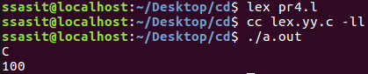

**b. Check weather given statement is compound or simple**

%{

#include<stdio.h>

int flag=0;

%}

%%

and |

or |

but |

because |

if |

then |

nevertheless { flag=1; }

. ;

\n { return 0; }

%%

int main()

{

printf("Enter your sentence:\n");

yylex();

if(flag==0)

printf("Simple sentence\n");

else

printf("compound sentence\n");

}

int yywrap( )

{

return 1;

}

**Output:**

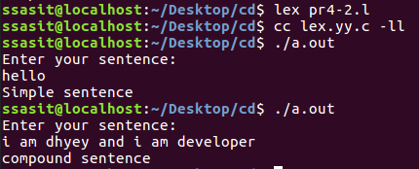

**c. Extract html tags from .html file.**

**Pr4c.html**

<html>

<head>

</head>

<body>

<p>

<a href="https:/[/www](http://www.coursera.org/).[youtube.com/"](http://www.coursera.org/)>Dhyey Chauhan</a>

</p>

</body>

</html>

**Code:**

/* Declaration section*/

%{

#include<stdio.h>

%}

%%

"<"[^>]*> {printf("%s\n", yytext); } /* if anything enclosed in these < > occur print text*/

. ; // else do nothing

%%

int yywrap(){}

int main(int argc, char*argv[])

{

// Open tags.txt in read mode

extern FILE *yyin = fopen("Pr4c.html","r");

// The function that starts the analysis

yylex();

return 0;

}

**Output:**

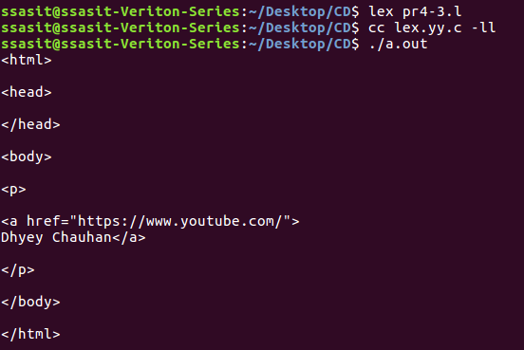

**Practical-5**

**Aim:** Implementation of Recursive Descent Parser without backtracking.

Input: The string to be parsed.

Output: Whether string parsed successfully or not.

Explanation: Students have to implement the recursive procedure for

RDP for a typical grammar. The production no. is displayed as it is used to derive the string.

**Code:**

    #include <stdio.h>

    #include <string.h>

    #define SUCCESS 1

    #define FAILED 0

    int E(), Edash(), T(), Tdash(), F();

    const char *cursor;

    char string[64];

    int main()

    {

        puts("Enter the string :");

         scanf("%s", string);

        //sscanf("i+(i+i)*i", "%s", string);

        cursor = string;

        puts("");

        puts("Input      Action");

        puts("--------------------------------");

        if (E() && *cursor == '\0') {

            puts("--------------------------------");

            puts("String is successfully parsed");

            return 0;

        } else {

            puts("--------------------------------");

            puts("Error in parsing String");

            return 1;

        }

    }

    int E()

    {

        printf("%-16s E -> T E'\n", cursor);

        if (T()) {

            if (Edash())

                return SUCCESS;

            else

                return FAILED;

        } else

            return FAILED;

    }

    int Edash()

    {

        if (*cursor == '+') {

            printf("%-16s E' -> + T E'\n", cursor);

            cursor++;

            if (T()) {

                if (Edash())

                    return SUCCESS;

                else

                    return FAILED;

            } else

                return FAILED;

        } else {

            printf("%-16s E' -> $\n", cursor);

            return SUCCESS;

        }

    }

    int T()

    {

        printf("%-16s T -> F T'\n", cursor);

        if (F()) {

            if (Tdash())

                return SUCCESS;

            else

                return FAILED;

        } else

            return FAILED;

    }

    int Tdash()

    {

        if (*cursor == '*') {

            printf("%-16s T' -> * F T'\n", cursor);

            cursor++;

            if (F()) {

                if (Tdash())

                    return SUCCESS;

                else

                    return FAILED;

            } else

                return FAILED;

        } else {

            printf("%-16s T' -> $\n", cursor);

            return SUCCESS;

        }

    }

    int F()

    {

        if (*cursor == '(') {

            printf("%-16s F -> ( E )\n", cursor);

            cursor++;

            if (E()) {

                if (*cursor == ')') {

                    cursor++;

                    return SUCCESS;

                } else

                    return FAILED;

            } else

                return FAILED;

        } else if (*cursor == 'i') {

            cursor++;

            printf("%-16s F ->i\n", cursor);

            return SUCCESS;

        } else

            return FAILED;

    }

**Output:**

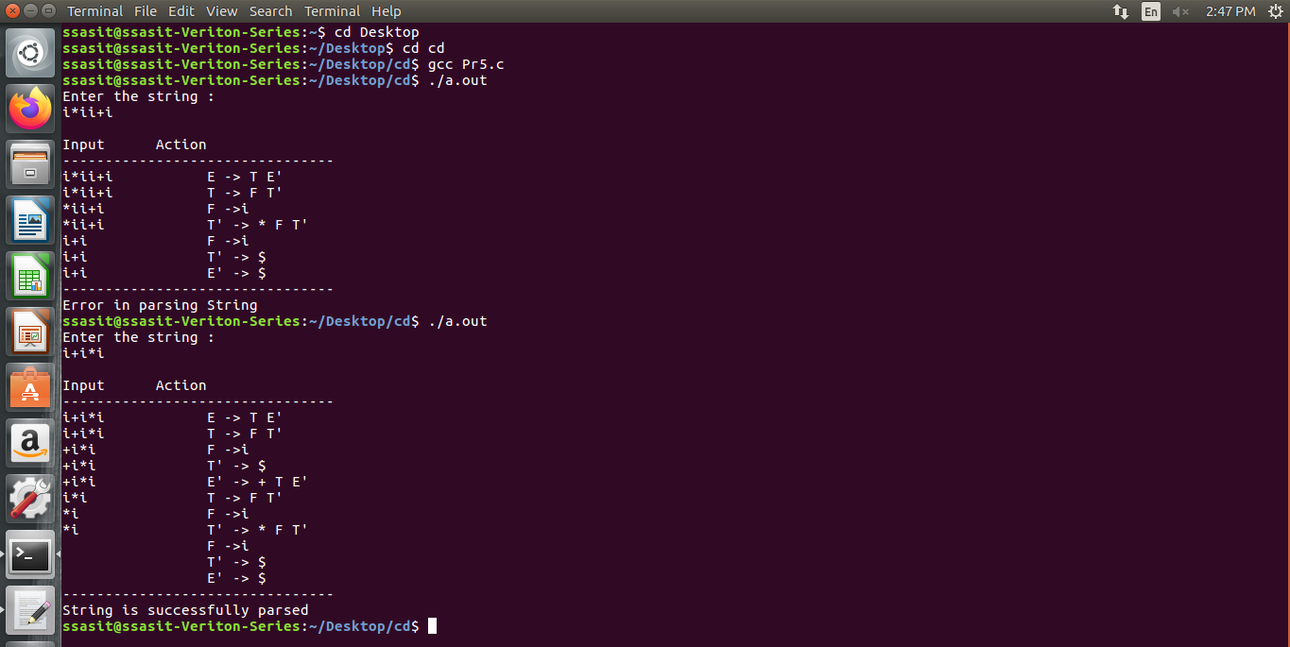

**Practical-6**

**Aim:** Find the “First” set. Input: The string consists of grammar symbols.

Output: The First set for a given string.

**Code:**

#include <stdio.h>

#include <ctype.h>

#include <string.h>

#define MAX 10

void findFirst(char, int, int);

void addToResultSet(char);

int numOfProductions;

char productionSet[MAX][MAX];

char firstSet[MAX];

int main() {

    int i, choice;

    char c, ch;

    printf("Enter the number of productions: ");

    scanf("%d", &numOfProductions);

    printf("Enter the productions (e.g., E=TR):\n");

    for (i = 0; i < numOfProductions; i++) {

        scanf("%s", productionSet[i]);

    }

    do {

        printf("Enter the symbol to find First set: ");

        scanf(" %c", &c);

        findFirst(c, 0, 0);

        printf("First(%c) = { ",c);

        for (i = 0; firstSet[i] != '\0'; i++) {

            printf("%c ", firstSet[i]);

        }

        printf("}\n");

        firstSet[0] = '\0';

        printf("Do you want to find another First set? (1 for Yes / 0 for No): ");

        scanf("%d", &choice);

    } while(choice == 1);

    return 0;

}

void findFirst(char c, int q1, int q2) {

    int j;

    if (!(isupper(c))) {

        addToResultSet(c);

    }

    for (j = 0; j < numOfProductions; j++) {

        if (productionSet[j][0] == c) {

            if (productionSet[j][2] == '$') {

                if (productionSet[q1][q2] == '\0') {

                    addToResultSet('$');

                } else if (productionSet[q1][q2] != '\0' && (q1 != 0 || q2 != 0)) {

                    findFirst(productionSet[q1][q2], q1, (q2 + 1));

                } else {

                    addToResultSet('$');

                }

            } else if (!isupper(productionSet[j][2])) {

                addToResultSet(productionSet[j][2]);

            } else {

                findFirst(productionSet[j][2], j, 3);

            }

        }

    }

}

void addToResultSet(char c) {

    int i;

    for (i = 0; firstSet[i] != '\0'; i++) {

        if (firstSet[i] == c) {

            return;

        }

    }

    firstSet[i] = c;

    firstSet[i + 1] = '\0';

}

**Output:**

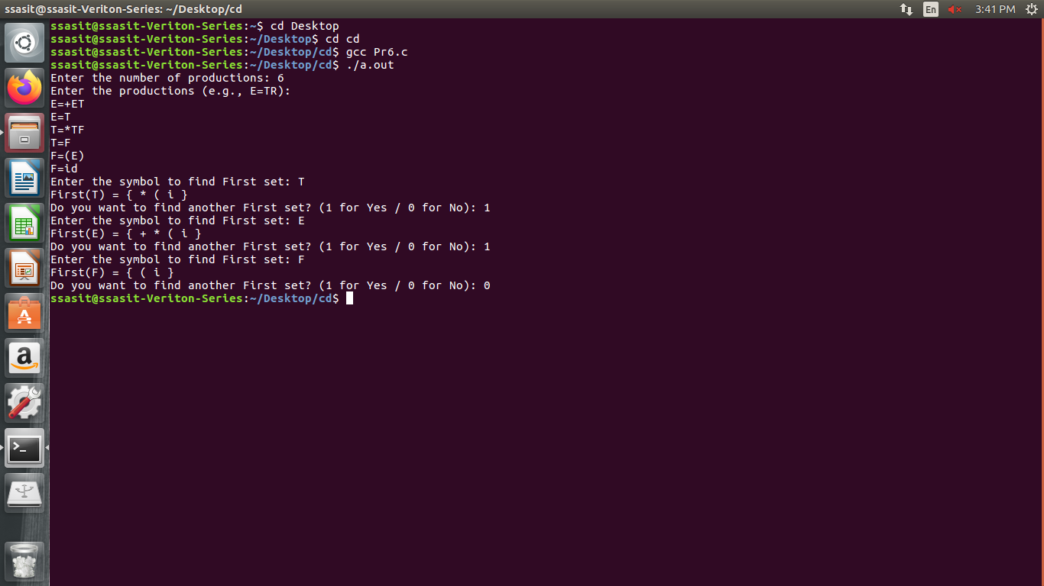

**Practical-10**

**Aim:** Finding “Follow” set Input: The string consists of grammar symbols. Output: The Follow set for a given string. Explanation: The student has to assume a typical grammar. The program when run will ask for the string to be entered. The program will find the Follow set of the given string.

**Code:**

#include <stdio.h>

#include <string.h>

#include <ctype.h>

#define MAX_PRODUCTIONS 10

#define MAX_LENGTH 10

int n, m = 0;

char productions[MAX_PRODUCTIONS][MAX_LENGTH];

char followSet[MAX_LENGTH];

void follow(char c);

void first(char c);

int main() {

int z;

char c, ch;

printf("Enter the no. of productions: ");

scanf("%d", &n);

printf("Enter the productions (epsilon=$):\n");

for (int i = 0; i < n; i++) {

scanf("%s%c", productions[i], &ch);

}

do {

m = 0; // Reset follow set size

printf("Enter the element whose FOLLOW is to be found: ");

scanf(" %c", &c); // Notice the space before %c to consume any newline

follow(c);

printf("FOLLOW(%c) = { ", c);

for (int i = 0; i < m; i++) {

printf("%c ", followSet[i]);

}

printf("}\n");

printf("Do you want to continue (0/1)? ");

scanf("%d%c", &z, &ch);

} while (z == 1);

return 0;

}

void follow(char c) {

if (productions[0][0] == c) {

followSet[m++] = '$';

}

for (int i = 0; i < n; i++) {

for (int j = 2; j < strlen(productions[i]); j++) {

if (productions[i][j] == c) {

// Check the next character

if (productions[i][j + 1] != '\0') {

first(productions[i][j + 1]);

}

// If there's no next character, find the follow of the left-hand side

if (productions[i][j + 1] == '\0' && c != productions[i][0]) {

follow(productions[i][0]);

}

}

}

}

}

void first(char c) {

if (!isupper(c)) {

followSet[m++] = c; // Add terminal to follow set

}

for (int k = 0; k < n; k++) {

if (productions[k][0] == c) {

if (productions[k][2] == '$') {

follow(productions[k][0]); // Follow the left-hand side

} else if (islower(productions[k][2])) {

followSet[m++] = productions[k][2]; // Add terminal to follow set

} else {

first(productions[k][2]); // Recursive call for non-terminal

}

}

}

}

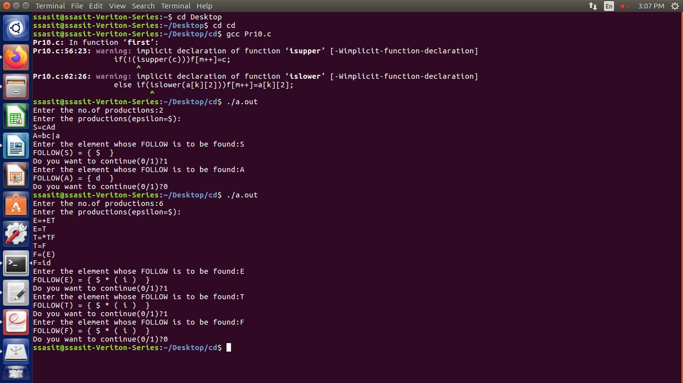**Output:**

**Practical-11**

**Aim:** Implement a C program for constructing LL (1) parsing.

**Code:**

#include<stdio.h>

#include<ctype.h>

#include<string.h>

#include<stdlib.h>

void followfirst(char , int , int);

void findfirst(char , int , int);

void follow(char c);

int count,n=0;

char calc_first[10][100];

char calc_follow[10][100];

int m=0;

char production[10][10], first[10];

char f[10];

int k;

char ck;

int e;

int main(int argc,char **argv)

{

int jm=0;

int km=0;

int i,choice;

char c,ch;

printf("How many productions ? :");

scanf("%d",&count);

printf("\nEnter %d productions in form A=B where A and B are grammar symbols :\n\n",count);

for(i=0;i<count;i++)

{

scanf("%s%c",production[i],&ch);

}

int kay;

char done[count];

int ptr = -1;

for(k=0;k<count;k++){

for(kay=0;kay<100;kay++){

calc_first[k][kay] = '!';

}

}

int point1 = 0,point2,xxx;

for(k=0;k<count;k++)

{

c=production[k][0];

point2 = 0;

xxx = 0;

for(kay = 0; kay <= ptr; kay++)

if(c == done[kay])

xxx = 1;

if (xxx == 1)

continue;

findfirst(c,0,0);

ptr+=1;

done[ptr] = c;

printf("\n First(%c)= { ",c);

calc_first[point1][point2++] = c;

for(i=0+jm;i<n;i++){

int lark = 0,chk = 0;

for(lark=0;lark<point2;lark++){

if (first[i] == calc_first[point1][lark]){

chk = 1;

break;

}

}

if(chk == 0){

printf("%c, ",first[i]);

calc_first[point1][point2++] = first[i];

}

}

printf("}\n");

jm=n;

point1++;

}

printf("\n");

printf("-----------------------------------------------\n\n");

char donee[count];

ptr = -1;

for(k=0;k<count;k++){

for(kay=0;kay<100;kay++){

calc_follow[k][kay] = '!';

}

}

point1 = 0;

int land = 0;

for(e=0;e<count;e++)

{

ck=production[e][0];

point2 = 0;

xxx = 0;

for(kay = 0; kay <= ptr; kay++)

if(ck == donee[kay])

xxx = 1;

if (xxx == 1)

continue;

land += 1;

follow(ck);

ptr+=1;

donee[ptr] = ck;

printf(" Follow(%c) = { ",ck);

calc_follow[point1][point2++] = ck;

for(i=0+km;i<m;i++){

int lark = 0,chk = 0;

for(lark=0;lark<point2;lark++){

if (f[i] == calc_follow[point1][lark]){

chk = 1;

break;

}

}

if(chk == 0){

printf("%c, ",f[i]);

calc_follow[point1][point2++] = f[i];

}

}

printf(" }\n\n");

km=m;

point1++;

}

char ter[10];

for(k=0;k<10;k++){

ter[k] = '!';

}

int ap,vp,sid = 0;

for(k=0;k<count;k++){

for(kay=0;kay<count;kay++){

if(!isupper(production[k][kay]) && production[k][kay]!= '#' && production[k][kay] != '=' && production[k][kay] != '\0'){

vp = 0;

for(ap = 0;ap < sid; ap++){

if(production[k][kay] == ter[ap]){

vp = 1;

break;

}

}

if(vp == 0){

ter[sid] = production[k][kay];

sid ++;

}

}

}

}

ter[sid] = '$';

sid++;

printf("\n\t\t\t\t\t\t\t The LL(1) Parsing Table for the above grammer :-");

printf("\n\t\t\t\t\t\t\t^^^^^^^^^^^^^^^^^^^^^^^^^^^^^^^^^^^^^^^^^^^^^^^^^^\n");

printf("\n\t\t\t=====================================================================================================================\n");

printf("\t\t\t\t|\t");

for(ap = 0;ap < sid; ap++){

printf("%c\t\t",ter[ap]);

}

printf("\n\t\t\t=====================================================================================================================\n");

char first_prod[count][sid];

for(ap=0;ap<count;ap++){

int destiny = 0;

k = 2;

int ct = 0;

char tem[100];

while(production[ap][k] != '\0'){

if(!isupper(production[ap][k])){

tem[ct++] = production[ap][k];

tem[ct++] = '_';

tem[ct++] = '\0';

k++;

break;

}

else{

int zap=0;

int tuna = 0;

for(zap=0;zap<count;zap++){

if(calc_first[zap][0] == production[ap][k]){

for(tuna=1;tuna<100;tuna++){

if(calc_first[zap][tuna] != '!'){

tem[ct++] = calc_first[zap][tuna];

}

else

break;

}

break;

}

}

tem[ct++] = '_';

}

k++;

}

int zap = 0,tuna;

for(tuna = 0;tuna<ct;tuna++){

if(tem[tuna] == '#'){

zap = 1;

}

else if(tem[tuna] == '_'){

if(zap == 1){

zap = 0;

}

else

break;

}

else{

first_prod[ap][destiny++] = tem[tuna];

}

}

}

char table[land][sid+1];

ptr = -1;

for(ap = 0; ap < land ; ap++){

for(kay = 0; kay < (sid + 1) ; kay++){

table[ap][kay] = '!';

}

}

for(ap = 0; ap < count ; ap++){

ck = production[ap][0];

xxx = 0;

for(kay = 0; kay <= ptr; kay++)

if(ck == table[kay][0])

xxx = 1;

if (xxx == 1)

continue;

else{

ptr = ptr + 1;

table[ptr][0] = ck;

}

}

for(ap = 0; ap < count ; ap++){

int tuna = 0;

while(first_prod[ap][tuna] != '\0'){

int to,ni=0;

for(to=0;to<sid;to++){

if(first_prod[ap][tuna] == ter[to]){

ni = 1;

}

}

if(ni == 1){

char xz = production[ap][0];

int cz=0;

while(table[cz][0] != xz){

cz = cz + 1;

}

int vz=0;

while(ter[vz] != first_prod[ap][tuna]){

vz = vz + 1;

}

table[cz][vz+1] = (char)(ap + 65);

}

tuna++;

}

}

for(k=0;k<sid;k++){

for(kay=0;kay<100;kay++){

if(calc_first[k][kay] == '!'){

break;

}

else if(calc_first[k][kay] == '#'){

int fz = 1;

while(calc_follow[k][fz] != '!'){

char xz = production[k][0];

int cz=0;

while(table[cz][0] != xz){

cz = cz + 1;

}

int vz=0;

while(ter[vz] != calc_follow[k][fz]){

vz = vz + 1;

}

table[k][vz+1] = '#';

fz++;

}

break;

}

}

}

for(ap = 0; ap < land ; ap++){

printf("\t\t\t %c\t|\t",table[ap][0]);

for(kay = 1; kay < (sid + 1) ; kay++){

if(table[ap][kay] == '!')

printf("\t\t");

else if(table[ap][kay] == '#')

printf("%c=#\t\t",table[ap][0]);

else{

int mum = (int)(table[ap][kay]);

mum -= 65;

printf("%s\t\t",production[mum]);

}

}

printf("\n");

printf("\t\t\t---------------------------------------------------------------------------------------------------------------------");

printf("\n");

}

int j;

printf("\n\nPlease enter the desired INPUT STRING = ");

char input[100];

scanf("%s%c",input,&ch);

printf("\n\t\t\t\t\t===========================================================================\n");

printf("\t\t\t\t\t\tStack\t\t\tInput\t\t\tAction");

printf("\n\t\t\t\t\t===========================================================================\n");

int i_ptr = 0,s_ptr = 1;

char stack[100];

stack[0] = '$';

stack[1] = table[0][0];

while(s_ptr != -1){

printf("\t\t\t\t\t\t");

int vamp = 0;

for(vamp=0;vamp<=s_ptr;vamp++){

printf("%c",stack[vamp]);

}

printf("\t\t\t");

vamp = i_ptr;

while(input[vamp] != '\0'){

printf("%c",input[vamp]);

vamp++;

}

printf("\t\t\t");

char her = input[i_ptr];

char him = stack[s_ptr];

s_ptr--;

if(!isupper(him)){

if(her == him){

i_ptr++;

printf("POP ACTION\n");

}

else{

printf("\nString Not Accepted by LL(1) Parser !!\n");

exit(0);

}

}

else{

for(i=0;i<sid;i++){

if(ter[i] == her)

break;

}

char produ[100];

for(j=0;j<land;j++){

if(him == table[j][0]){

if (table[j][i+1] == '#'){

printf("%c=#\n",table[j][0]);

produ[0] = '#';

produ[1] = '\0';

}

else if(table[j][i+1] != '!'){

int mum = (int)(table[j][i+1]);

mum -= 65;

strcpy(produ,production[mum]);

printf("%s\n",produ);

}

else{

printf("\nString Not Accepted by LL(1) Parser !!\n");

exit(0);

}

}

}

int le = strlen(produ);

le = le - 1;

if(le == 0){

continue;

}

for(j=le;j>=2;j--){

s_ptr++;

stack[s_ptr] = produ[j];

}

}

}

printf("\n\t\t\t=======================================================================================================================\n");

if (input[i_ptr] == '\0'){

printf("\t\t\t\t\t\t\t\tYOUR STRING HAS BEEN ACCEPTED !!\n");

}

else

printf("\n\t\t\t\t\t\t\t\tYOUR STRING HAS BEEN REJECTED !!\n");

printf("\t\t\t=======================================================================================================================\n");

}

void follow(char c)

{

int i ,j;

if(production[0][0]==c){

f[m++]='$';

}

for(i=0;i<10;i++)

{

for(j=2;j<10;j++)

{

if(production[i][j]==c)

{

if(production[i][j+1]!='\0'){

followfirst(production[i][j+1],i,(j+2));

}

if(production[i][j+1]=='\0'&&c!=production[i][0]){

follow(production[i][0]);

}

}

}

}

}

void findfirst(char c ,int q1 , int q2)

{

int j;

if(!(isupper(c))){

first[n++]=c;

}

for(j=0;j<count;j++)

{

if(production[j][0]==c)

{

if(production[j][2]=='#'){

if(production[q1][q2] == '\0')

first[n++]='#';

else if(production[q1][q2] != '\0' && (q1 != 0 || q2 != 0))

{

findfirst(production[q1][q2], q1, (q2+1));

}

else

first[n++]='#';

}

else if(!isupper(production[j][2])){

first[n++]=production[j][2];

}

else {

findfirst(production[j][2], j, 3);

}

}

}

}

void followfirst(char c, int c1 , int c2)

{

int k;

if(!(isupper(c)))

f[m++]=c;

else{

int i=0,j=1;

for(i=0;i<count;i++)

{

if(calc_first[i][0] == c)

break;

}

while(calc_first[i][j] != '!')

{

if(calc_first[i][j] != '#'){

f[m++] = calc_first[i][j];

}

else{

if(production[c1][c2] == '\0'){

follow(production[c1][0]);

}

else{

followfirst(production[c1][c2],c1,c2+1);

}

}

j++;

}

}

}

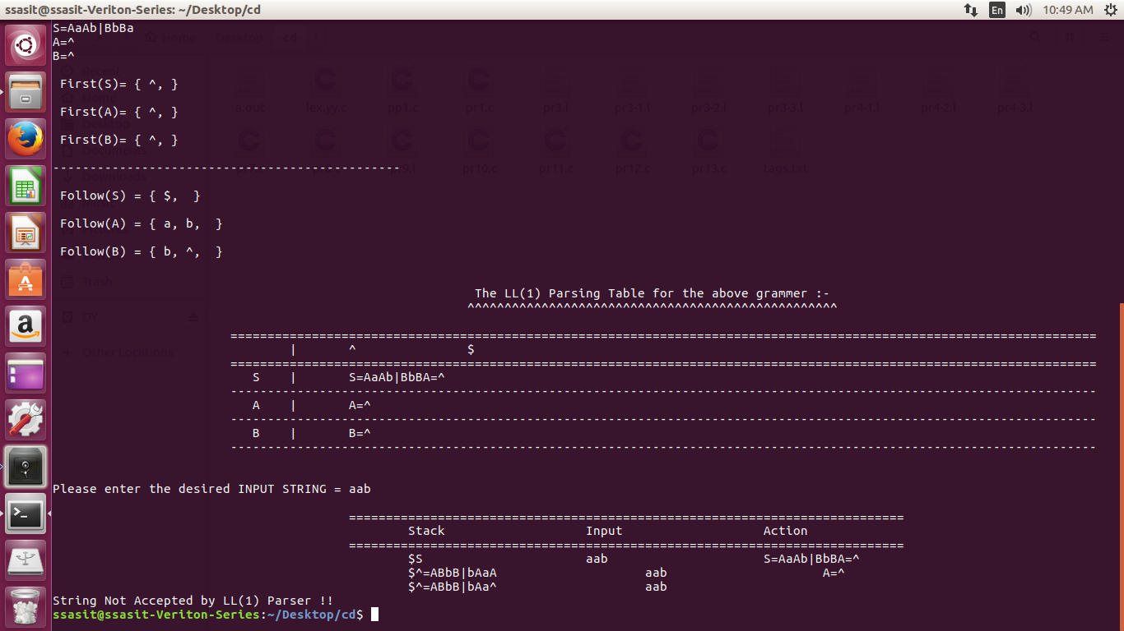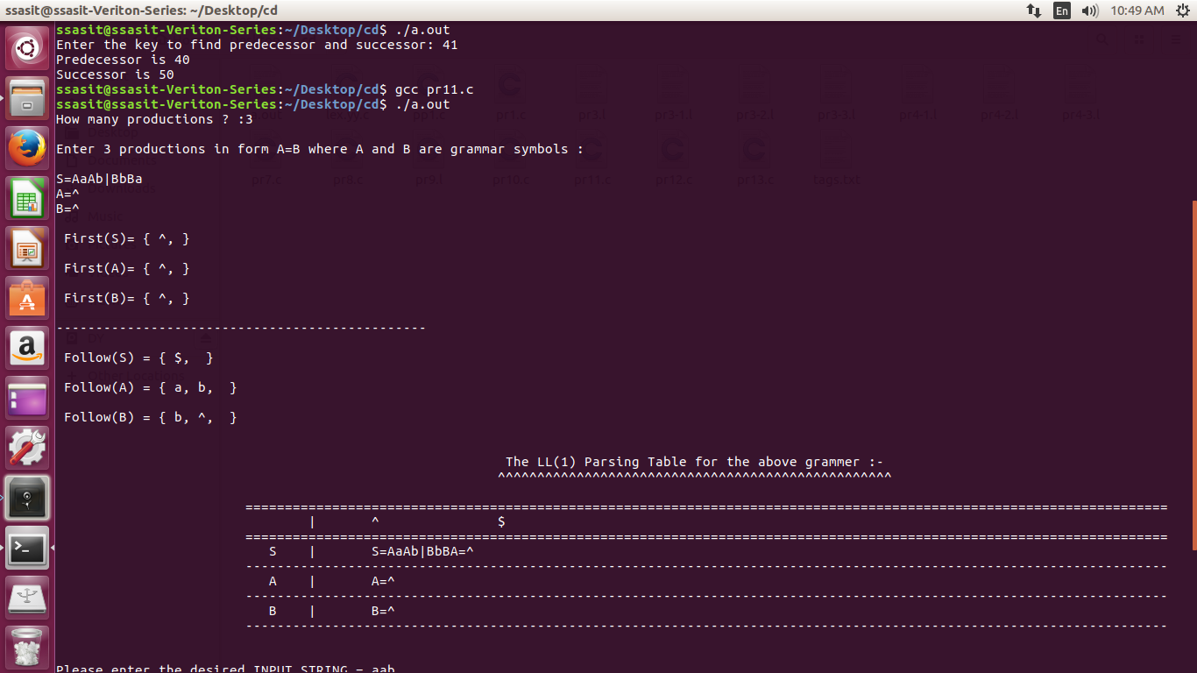**Output:**

**Practical-7**

**Aim:** Generate 3-tuple intermediate code for given infix expression.

**Code:**

#include <stdio.h>

#include <string.h>

void pm();

void plus();

void div();

int i, j, l;

char ex[20], expr[20], expr1[20], id1[5], op[5], id2[5];

void reverse_string(char *str);

int main() {

printf("Enter the expression with an arithmetic operator: ");

scanf("%19s", ex); // Limit input size to avoid buffer overflow

strcpy(expr, ex); // Copy the expression into expr

l = strlen(expr); // Get the length of the expression

expr1[0] = '\0'; // Initialize expr1 as an empty string

// Parse the input expression

for (i = 0; i < l; i++) {

if (expr[i] == '+' || expr[i] == '-') {

// Check if the next operator has higher precedence

if (expr[i + 2] == '/' || expr[i + 2] == '*') {

pm(); // Handle precedence case

break;

} else {

plus(); // Handle + or - operation

break;

}

} else if (expr[i] == '/' || expr[i] == '*') {

div(); // Handle division or multiplication

break;

}

}

return 0;

}

// Function to handle precedence (pm)

void pm() {

reverse_string(expr); // Reverse the expression

j = l - i - 1; // Calculate the position from where to cut the expression

strncpy(expr1, expr, j); // Copy the relevant part

expr1[j] = '\0'; // Null-terminate the string

reverse_string(expr1); // Reverse back the expression

printf("Three address code:\n");

printf("temp = %s\n", expr1);

printf("temp1 = %c %c temp\n", expr[j + 1], expr[j]);

}

// Function to handle division or multiplication (div)

void div() {

strncpy(expr1, expr, i + 2); // Copy the part of the expression up to the operator

expr1[i + 2] = '\0'; // Null-terminate the string

printf("Three address code:\n");

printf("temp = %s\n", expr1);

printf("temp1 = temp %c %c\n", expr[i + 2], expr[i + 3]);

}

// Function to handle addition or subtraction (plus)

void plus() {

strncpy(expr1, expr, i + 2); // Copy the part of the expression up to the operator

expr1[i + 2] = '\0'; // Null-terminate the string

printf("Three address code:\n");

printf("temp = %s\n", expr1);

printf("temp1 = temp %c %c\n", expr[i + 2], expr[i + 3]);

}

// Helper function to reverse a string

void reverse_string(char *str) {

int len = strlen(str);

for (int i = 0; i < len / 2; i++) {

char temp = str[i];

str[i] = str[len - i - 1];

str[len - i - 1] = temp;

}

}

**Output:**

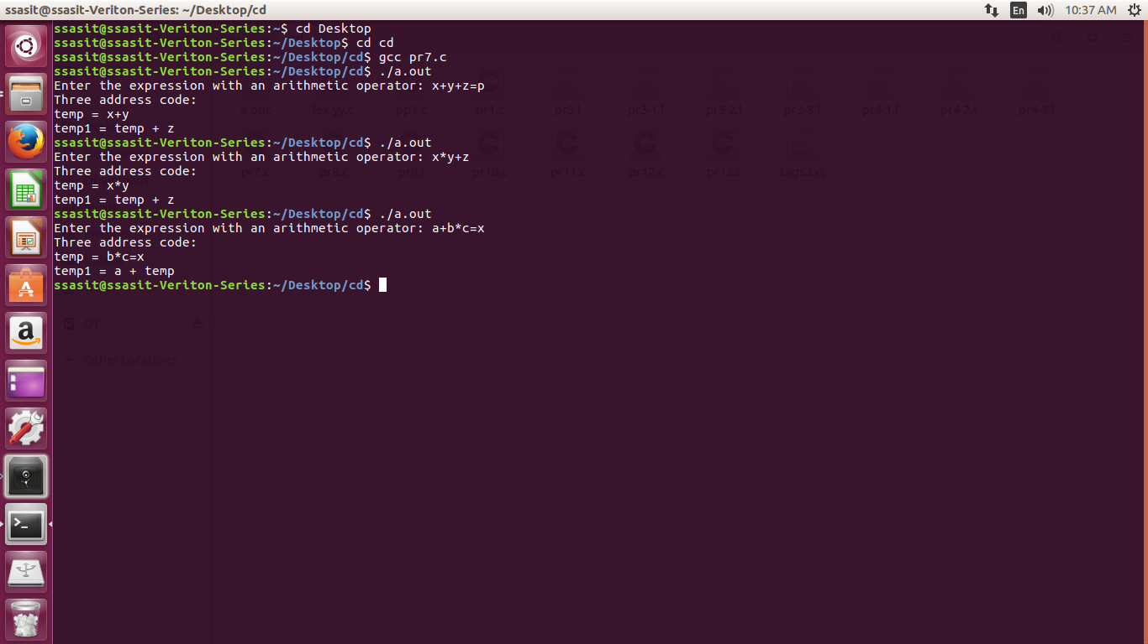

**Practical-8**

**Aim:** Extract Predecessor and Successor from given Control Flow Graph

**Code:**

#include <stdio.h>

#include <stdlib.h>

struct Node {

int key;

struct Node* left;

struct Node* right;

};

struct Node* pre = NULL;

struct Node* suc = NULL;

void findPreSuc(struct Node* root, int key) {

if (root == NULL)

return;

if (root->key == key) {

if (root->left != NULL) {

struct Node* tmp = root->left;

while (tmp->right != NULL)

tmp = tmp->right;

pre = tmp;

}

if (root->right != NULL) {

struct Node* tmp = root->right;

while (tmp->left != NULL)

tmp = tmp->left;

suc = tmp;

}

return;

}

if (root->key > key) {

suc = root;

findPreSuc(root->left, key);

} else {

pre = root;

findPreSuc(root->right, key);

}

}

struct Node* insert(struct Node* node, int key) {

if (node == NULL) {

struct Node* newNode = (struct Node*)malloc(sizeof(struct Node));

newNode->key = key;

newNode->left = newNode->right = NULL;

return newNode;

}

if (key < node->key)

node->left = insert(node->left, key);

else if (key > node->key)

node->right = insert(node->right, key);

return node;

}

int main() {

int key;

printf("Enter the key to find predecessor and successor: ");

scanf("%d", &key);

struct Node* root = NULL;

root = insert(root, 50);

insert(root, 30);

insert(root, 20);

insert(root, 40);

insert(root, 70);

insert(root, 60);

insert(root, 80);

findPreSuc(root, key);

if (pre != NULL)

printf("Predecessor is %d\n", pre->key);

else

printf("No Predecessor\n");

if (suc != NULL)

printf("Successor is %d\n", suc->key);

else

printf("No Successor\n");

return 0;

}

**Output:**

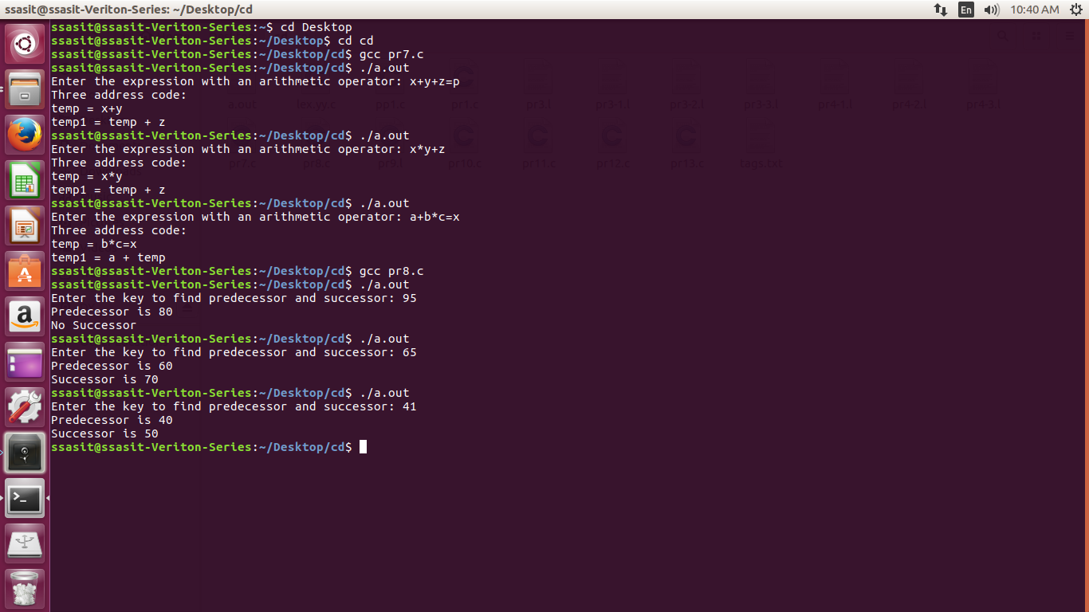

**Practical-9**

**Aim:** Introduction to YACC and generate Calculator Program.

* YACC (Yet Another Compiler Compiler) is a tool used to generate a parser. This document is a tutorial for the use of YACC to generate a parser for ExpL. YACC translates a given Context Free Grammar (CFG) specifications (input in input_file.y) into a C implementation (y.tab.c) of a corresponding push down automaton (i.e., a finite state machine with a stack). This C program when compiled, yields an executable parser.

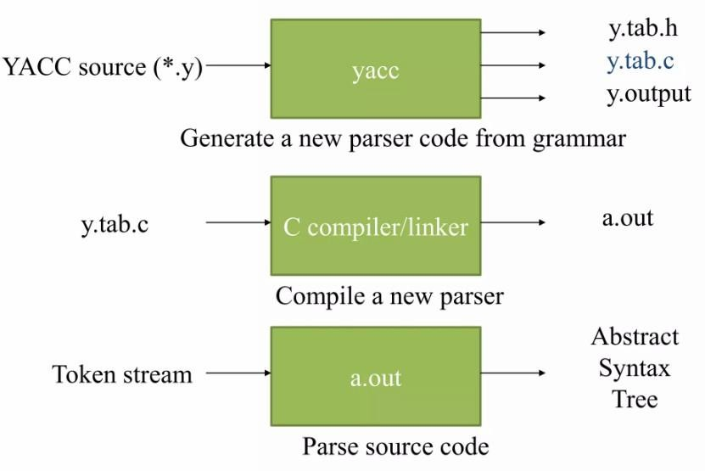

### **How yacc works?**

* The input to **yacc** describes the rules of a grammar. **yacc** uses these rules to produce the source code for a program that parses the grammar. You can then compile this source code to obtain a program that reads input, parses it according to the grammar, and takes action based on the result.
* The source code produced by **yacc** is written in the C programming language. It consists of a number of data tables that represent the grammar, plus a C function named **yyparse()**. By default, **yacc** symbol names used begin with **yy**. This is an historical convention, dating back to **yacc**'s predecessor, UNIX **yacc**. You can avoid conflicts with **yacc** names by avoiding symbols that start with **yy**.

**The structure of YACC programs:**

* A YACC program consists of three sections: Declarations, Rules and Auxiliary functions. (Note the similarity with the structure of LEX programs).

DECLARATIONS

%% RULES

%%

AUXILIARY FUNCTIONS

### **Input File: Definition Part:**

* The definition part includes information about the tokens used in the syntax definition.
* The definition part can include C code external to the definition of the parser and variabledeclarations, within **%{** and **%}** in the first column.

### **Input File: Rule Part:**

* The rules part contains grammar definitions in a modified BNF form.
* Actions is C code in { } and can be embedded inside (Translation schemes).

### **Input File: Auxiliary Routines Part:**

* The auxiliary routines part is only C code.
* It includes function definitions for every function needed in the rules part.
* It can also contain the main() function definition if the parser is going to be run as aprogram.
* The main() function must call the function yyparse().

**Code:**

## **Pr9.l**

/* Definition section */

#include <stdio.h>

#include "y.tab.h"

#include <ctype.h>

extern int yylval;

/* Rule Section */

%%

[0-9]+ {

yylval = atoi(yytext);

return NUMBER;

}

[\t] ;

[\n] return 0;

. return yytext[0];

%%

int yywrap() {

return 1;

}

## **Pr9.y**

%{

/* Definition section */

#include <stdio.h>

int flag = 0;

%}

%token NUMBER

%left '+' '-'

%left '*' '/' '%'

%left '(' ')'

/* Rule Section */

%%

ArithmeticExpression:

E {

printf("\nResult = %d\n", $$);

return 0;

}

;

E:

E '+' E { $$ = $1 + $3; }

| E '-' E { $$ = $1 - $3; }

| E '*' E { $$ = $1 * $3; }

| E '/' E { $$ = $1 / $3; }

| E '%' E { $$ = $1 % $3; }

| '(' E ')' { $$ = $2; }

| NUMBER { $$ = $1; }

;

%%

/* Driver Code */

void main() {

printf("\nEnter any arithmetic expression with addition, subtraction, multiplication, division, modulus, and round brackets:\n");

yyparse();

if (flag == 0) {

printf("\nEntered arithmetic expression is valid.\n\n");

}

}

void yyerror() {

printf("\nEntered arithmetic expression is invalid.\n\n");

flag = 1;

}

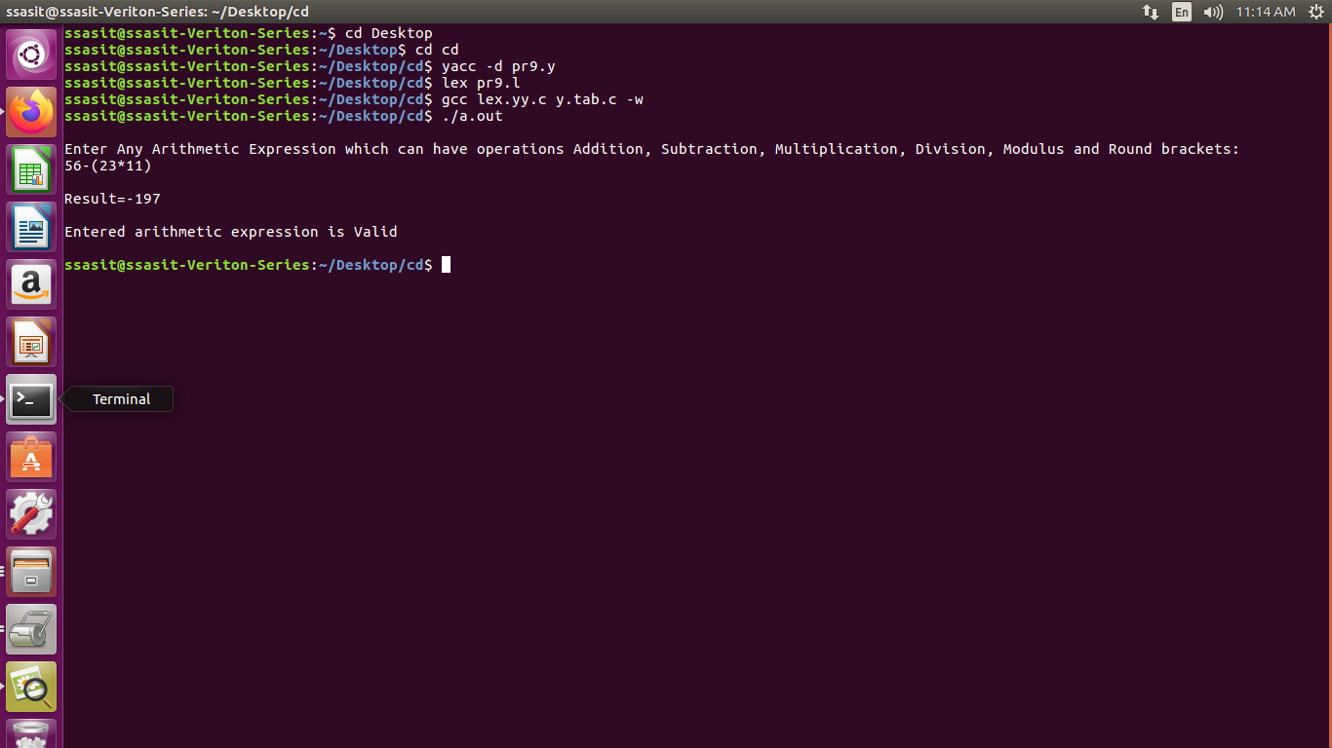**Output:**

**Practical-12**

**Aim:** Implement a C program to implement LALR parsing.

**Code:**

#include <stdio.h>

#include <stdlib.h>

#include <string.h>

// Function prototypes

void push(char *, int *, char);

char stacktop(char *);

void isproduct(char, char);

int ister(char);

int isnter(char);

int isstate(char);

void error();

void isreduce(char, char);

char pop(char *, int *);

void printt(char *, int *, char[], int);

void rep(char[], int);

// Structures for action and goto tables

struct action {

char row[6][5];

};

struct gotol {

char r[3][4];

};

// Action and Goto tables

const struct action A[12] = {

{"sf", "emp", "emp", "se", "emp", "emp"},

{"emp", "sg", "emp", "emp", "emp", "acc"},

{"emp", "rc", "sh", "emp", "rc", "rc"},

{"emp", "re", "re", "emp", "re", "re"},

{"sf", "emp", "emp", "se", "emp", "emp"},

{"emp", "rg", "rg", "emp", "rg", "rg"},

{"sf", "emp", "emp", "se", "emp", "emp"},

{"sf", "emp", "emp", "se", "emp", "emp"},

{"emp", "sg", "emp", "emp", "sl", "emp"},

{"emp", "rb", "sh", "emp", "rb", "rb"},

{"emp", "rb", "rd", "emp", "rd", "rd"},

{"emp", "rf", "rf", "emp", "rf", "rf"}

};

const struct gotol G[12] = {

{"b", "c", "d"},

{"emp", "emp", "emp"},

{"emp", "emp", "emp"},

{"emp", "emp", "emp"},

{"i", "c", "d"},

{"emp", "emp", "emp"},

{"emp", "j", "d"},

{"emp", "emp", "k"},

{"emp", "emp", "emp"},

{"emp", "emp", "emp"}

};

// Terminal and non-terminal symbols

char ter[6] = {'i', '+', '*', ')', '(', '$'};

char nter[3] = {'E', 'T', 'F'};

char states[12] = {'a', 'b', 'c', 'd', 'e', 'f', 'g', 'h', 'm', 'j', 'k', 'l'};

char stack[100];

int top = -1;

char temp[10];

// Grammar rules

struct grammar {

char left;

char right[5];

};

const struct grammar rl[6] = {

{'E', "e+T"},

{'E', "T"},

{'T', "T*F"},

{'T', "F"},

{'F', "(E)"},

{'F', "i"}

};

// Push function to add an item to the stack

void push(char *s, int *sp, char item) {

if (*sp == 100) {

printf("Stack is full\n");

} else {

*sp = *sp + 1;

s[*sp] = item;

}

}

// Get the top item of the stack

char stacktop(char *s) {

return s[top];

}

// Determine the product action based on input and stack top

void isproduct(char x, char p) {

int k = ister(x);

int l = isstate(p);

strcpy(temp, A[l - 1].row[k - 1]);

}

// Check if the character is a terminal

int ister(char x) {

for (int i = 0; i < 6; i++) {

if (x == ter[i]) return i + 1;

}

return 0;

}

// Check if the character is a non-terminal

int isnter(char x) {

for (int i = 0; i < 3; i++) {

if (x == nter[i]) return i + 1;

}

return 0;

}

// Check if the character is a state

int isstate(char p) {

for (int i = 0; i < 12; i++) {

if (p == states[i]) return i + 1;

}

return 0;

}

// Error handling function

void error() {

printf("Error in the input\n");

exit(0);

}

// Perform reduction based on the state and non-terminal

void isreduce(char x, char p) {

int k = isstate(x);

int l = isnter(p);

strcpy(temp, G[k - 1].r[l - 1]);

}

// Pop function to remove and return the top item from the stack

char pop(char *s, int *sp) {

if (*sp == -1) {

printf("Stack is empty\n");

return '\0';

}

return s[(*sp)--];

}

// Print the current state of the stack and input

void printt(char *t, int *p, char inp[], int i) {

printf("\n");

for (int r = 0; r <= *p; r++) rep(t, r);

printf("\t\t\t");

for (int r = i; inp[r] != '\0'; r++) printf("%c", inp[r]);

}

// Helper function to represent states

void rep(char t[], int r) {

char c = t[r];

switch (c) {

case 'a': printf("0"); break;

case 'b': printf("1"); break;

case 'c': printf("2"); break;

case 'd': printf("3"); break;

case 'e': printf("4"); break;

case 'f': printf("5"); break;

case 'g': printf("6"); break;

case 'h': printf("7"); break;

case 'm': printf("8"); break;

case 'j': printf("9"); break;

case 'k': printf("10"); break;

case 'l': printf("11"); break;

default: printf("%c", t[r]); break;

}

}

// Main function

int main() {

char inp[80], x, p, dl[80], y, bl = 'a';

int i = 0, j, k, l, n, m;

printf("Enter the input: ");

if (scanf("%79s", inp) != 1) {

printf("Error reading input\n");

return 1;

}

// Append termination symbol

int len = strlen(inp);

inp[len] = '$';

inp[len + 1] = '\0';

// Initialize the stack

push(stack, &top, bl);

printf("\nStack \t\t\t Input");

printt(stack, &top, inp, i);

do {

x = inp[i];

p = stacktop(stack);

isproduct(x, p);

if (strcmp(temp, "emp") == 0) {

error();

}

if (strcmp(temp, "acc") == 0) {

break;

}

// Shift action

if (temp[0] == 's') {

push(stack, &top, inp[i]);

push(stack, &top, temp[1]);

i++;

}

// Reduce action

else if (temp[0] == 'r') {

j = isstate(temp[1]);

strcpy(temp, rl[j - 2].right);

dl[0] = rl[j - 2].left;

dl[1] = '\0';

n = strlen(temp);

for (k = 0; k < 2 * n; k++) pop(stack, &top);

for (m = 0; dl[m] != '\0'; m++) push(stack, &top, dl[m]);

l = top;

y = stack[l - 1];

isreduce(y, dl[0]);

for (m = 0; temp[m] != '\0'; m++) push(stack, &top, temp[m]);

}

printt(stack, &top, inp, i);

} while (inp[i] != '\0');

// Final acceptance check

if (strcmp(temp, "acc") == 0) {

printf("\nAccept the input\n");

} else {

printf("\nDo not accept the input\n");

}

return 0;

}

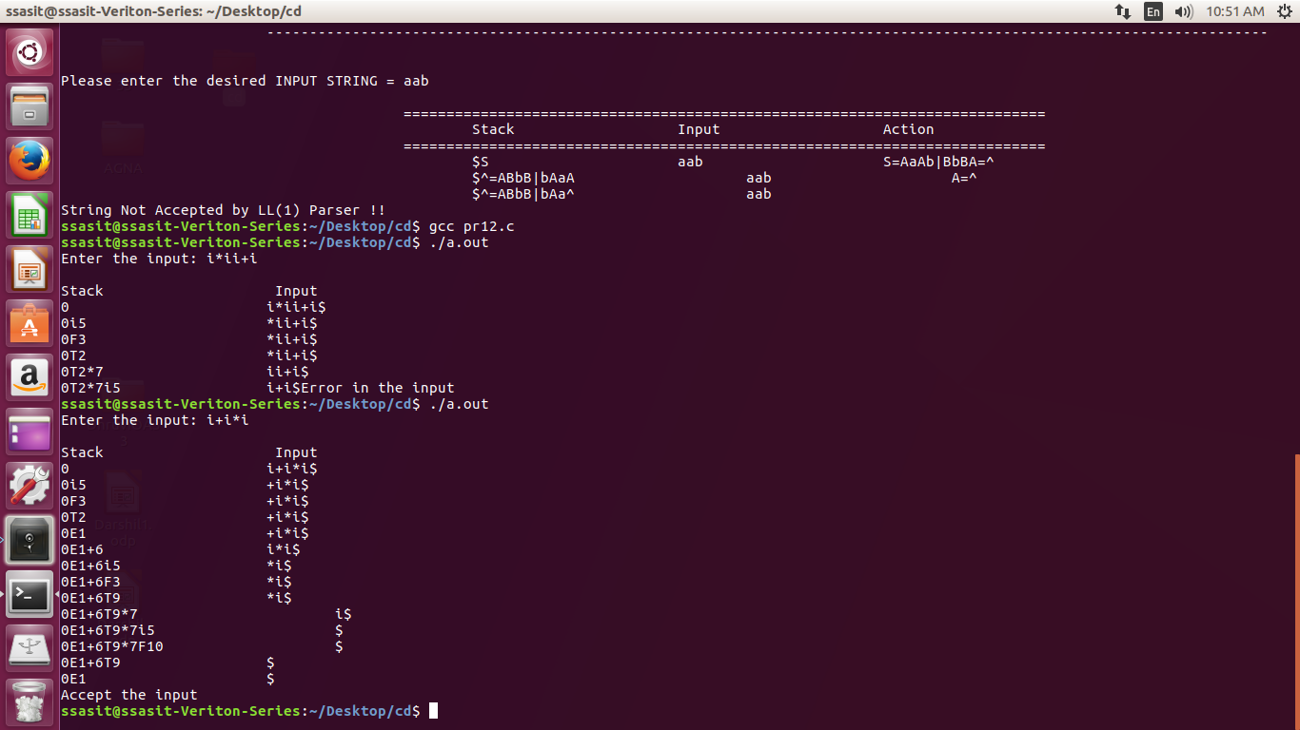**Output:**

**Practical-13**

**Aim:** Implement a C program to implement operator precedence parsing.

**Code:**

#include<stdio.h>

#include<string.h>

#include<stdlib.h>

char *input; int

i=0;

char lasthandle[6],stack[50],handles[][5]={")E(","E*E","E+E","i","E^E"}; //(E)

becomes )E( when pushed to stack

int top=0,l;

char prec[9][9]={

/*stack + - * / ^ i ( ) $ */

/* + */ '>', '>','<','<','<','<','<','>','>',

/* - */ '>', '>','<','<','<','<','<','>','>',

/* * */ '>', '>','>','>','<','<','<','>','>',

/* / */ '>', '>','>','>','<','<','<','>','>',

/* ^ */ '>', '>','>','>','<','<','<','>','>',

/* i */ '>', '>','>','>','>','e','e','>','>',

/* ( */ '<', '<','<','<','<','<','<','>','e',

/* ) */ '>', '>','>','>','>','e','e','>','>',

/* $ */ '<', '<','<','<','<','<','<','<','>',

};

int getindex(char c)

{ switch(c)

{

case '+':return 0;

case '-':return 1;

case '*':return 2;

case '/':return 3; case

'^':return 4; case

'i':return 5; case

'(':return 6; case

')':return 7; case

'$':return 8;

}

}

int shift()

{

stack[++top]=*(input+i++);

stack[top+1]='\0';

}

int reduce()

{

int i,len,found,t;

for(i=0;i<5;i++)//selecting handles

{

len=strlen(handles[i]);

if(stack[top]==handles[i][0]&&top+1>=len)

{

found=1;

for(t=0;t<len;t++){

if(stack[top-t]!=handles[i][t]) {

found=0;

break;

}

}

if(found==1){

stack[top-t+1]='E';

top=top-t+1;

strcpy(lasthandle,handles[i]);

stack[top+1]='\0';

return 1;//successful reduction

}

}

}

return 0;

}

void dispstack(){

int j;

for(j=0;j<=top;j++)

printf("%c",stack[j]);

}

void dispinput(){

int j;

for(j=i;j<l;j++)

printf("%c",*(input+j)); }

void main(){

int j;

input=(char*)malloc(50*sizeof(char));

printf("\nEnter the string\n");

scanf("%s",input);

input=strcat(input,"$");

l=strlen(input);

strcpy(stack,"$");

printf("\nSTACK\tINPUT\tACTION");

while(i<=l){

shift();

printf("\n");

dispstack();

printf("\t");

dispinput();

printf("\tShift");

if(prec[getindex(stack[top])][getindex(input[i])]=='>'){

while(reduce()){

printf("\n");

dispstack();

printf("\t");

dispinput();

printf("\tReduced: E->%s",lasthandle);

}

}

}

if(strcmp(stack,"$E$")==0)

printf("\nAccepted;"); else

printf("\nNot Accepted;");

}

**Output:**

