**Practical 1**

**AIM: Implement Caesar cipher encryption-decryption.**

Caesar cipher is one of the simplest and oldest method of encrypting message.

It was developed by Julius Caesar to protect military communication.

This technique involves shifting the letter of alphabet by fix number. which is known as “Shift/Key”.

It’s simplest type of substitution Cipher. In which each letter of given text is replaced by a shift or key position alphabet.

**CODE:**

def caesar_cipher_encrypt(msg, shift):

ciphertext = ""

for char in msg:

if char.isalpha():

if char.isupper(): #Checks if the character is alphabetic

shifted_char = chr((ord(char) - ord('A') + shift) % 26 + ord('A'))

else:

shifted_char = chr((ord(char) - ord('a') + shift) % 26 + ord('a'))

ciphertext += shifted_char

else:

ciphertext += char

return ciphertext

def caesar_cipher_decrypt(ciphertext, shift):

msg = ""

for char in ciphertext:

if char.isalpha():

if char.isupper():

shifted_char = chr((ord(char) - ord('A') - shift) % 26 + ord('A'))

else:

shifted_char = chr((ord(char) - ord('a') - shift) % 26 + ord('a'))

msg += shifted_char

else:

msg += char

return msg

msg = input("Enter the message: ")

shift = int(input("Enter the shift value: "))

encrypted_text = caesar_cipher_encrypt(msg, shift)

print("Encrypted:", encrypted_text)

decrypted_text = caesar_cipher_decrypt(encrypted_text, shift)

print("Decrypted:", decrypted_text)

**OUTPUT:**

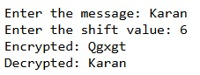

**Practical 2**

**AIM: Implement Monoalphabetic cipher encryption-decryption.**

Monoalphabetic cipher is substitution technique in which a single alphabet is used for message.

It provides protection from brute force attack.

In Monoalphabetic cipher the mapping is done randomly not in uniform format.

**CODE:**

import numpy as np

import random

import string

def generate_monoalphabetic_key():

"""Generate a random Monoalphabetic cipher key."""

letters = list(string.ascii_uppercase)

key = {}

for char in string.ascii_uppercase:

random_char = random.choice(letters)

key[char] = random_char

letters.remove(random_char) # Remove selected character to ensure unique mapping

return key

def encrypt_monoalphabetic(message, key):

"""Encrypt a message using a Monoalphabetic cipher."""

encrypted_message = []

capitalization_info = []

for char in message:

if char.upper() in key:

encrypted_char = key[char.upper()]

encrypted_message.append(encrypted_char)

capitalization_info.append(char.isupper())

else:

encrypted_message.append(char) # if character is not in the key, add it as-is

capitalization_info.append(False) # mark as non-alphabetic or lowercase

return ''.join(encrypted_message), capitalization_info

def decrypt_monoalphabetic(encrypted_message, capitalization_info, key):

"""Decrypt a message encrypted with a Monoalphabetic cipher."""

decrypted_message = []

reverse_key = {v: k for k, v in key.items()} # create reverse key for decryption

for i, char in enumerate(encrypted_message):

if char.upper() in reverse_key:

decrypted_char = reverse_key[char.upper()]

if capitalization_info[i]:

decrypted_char = decrypted_char.upper()

else:

decrypted_char = decrypted_char.lower()

decrypted_message.append(decrypted_char)

else:

decrypted_message.append(char) # if character is not in the key, add it as-is

return ''.join(decrypted_message)

def analyze_frequency(message):

"""Analyze the frequency of characters in a message."""

frequency = np.zeros((26,), dtype=int)

for char in message.upper():

if char.isalpha():

frequency[ord(char) - ord('A')] += 1

return frequency

# Generate a random Monoalphabetic key

key = generate_monoalphabetic_key()

print("Generated Monoalphabetic Key:")

print(key)

# Encrypt a message

message = input("Enter the message: ")

encrypted_message, capitalization_info = encrypt_monoalphabetic(message, key)

print("Original Message:", message)

print("Encrypted Message:", encrypted_message)

# Decrypt the message

decrypted_message = decrypt_monoalphabetic(encrypted_message, capitalization_info, key)

print("Decrypted Message:", decrypted_message)

# Analyze the frequency of characters in the original and encrypted messages

original_frequency = analyze_frequency(message)

encrypted_frequency = analyze_frequency(encrypted_message)

**OUTPUT:**

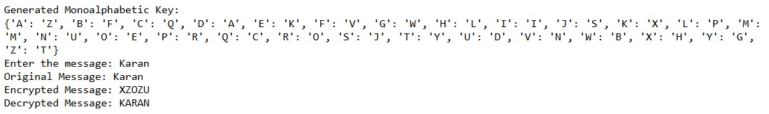

**Practical 3**

**AIM: Implement Playfair cipher encryption-decryption.**

Playfair cipher was invented by Charles Wheatstone. But later in 90’s lord playfair make it more useful and popular, so the name “Playfair cipher”.

It’s also substitution technique. Unlike a single alphabet substitution in encryption it replaces pair of alphabet.

**Encryption:**

**Steps:**

1) Generate a key square of 5x5 for encryption the plain text. In this table we have to omit any single character and consider as “J”.

2) Keep the alphabet in the key square unit. That no alphabet should be repeated. Place the key first in the key square and then remaining alphabet in order.

3) Encrypt the plain text. The plain text is split into pair of two letter called “Diagraph”.

* No alphabet remain single. It makes the plain text of even. Suppose any plain text has odd number then add any dummy letter.
* If any letter appears more than one time, then side by side then place any dummy letter to make it unique.
* If both the letter are in the same column take the letter below each one. If it’s bottom, then take it to top.
* If both the letter are in the same row take the letter to the immediate right of each one. If it’s at last position, then take it back to the first.
* If neither of the above rule is true form a rectangle with the two letters and take the letters on the horizontal opposite corner of the rectangle.

**Decryption:**

It is same as encryption but the steps are applied in reverse order.

**Steps:**

1) Split the plain text into diagraph.

2) Construct the 5x5 key matrix.

3) It will traverse the key matrix step by step and find the corresponding encipher for the pair.

**CODE:**

def generate_key_matrix(key):

key = key.upper().replace('J', 'I')

matrix = []

used = set()

# Add unique letters from the key

for char in key:

if char not in used and char.isalpha():

used.add(char)

matrix.append(char)

# Add remaining letters of the alphabet

for char in 'ABCDEFGHIKLMNOPQRSTUVWXYZ':

if char not in used:

used.add(char)

matrix.append(char)

# Convert to 5x5 matrix

return [matrix[i:i+5] for i in range(0, 25, 5)]

def print_matrix(matrix):

for row in matrix:

print(' '.join(row))

print() # For better readability

def preprocess_text(text):

text = text.upper().replace('J', 'I')

text = ''.join(filter(str.isalpha, text))

digraphs = []

i = 0

while i < len(text):

if i + 1 < len(text):

if text[i] == text[i + 1]:

digraphs.append(text[i] + 'X')

i += 1

else:

digraphs.append(text[i] + text[i + 1])

i += 2

else:

digraphs.append(text[i] + 'X')

i += 1

return digraphs

def find_position(matrix, char):

for r, row in enumerate(matrix):

if char in row:

return (r, row.index(char))

return None

def encrypt_digraph(matrix, digraph):

pos1 = find_position(matrix, digraph[0])

pos2 = find_position(matrix, digraph[1])

if pos1[0] == pos2[0]:

return matrix[pos1[0]][(pos1[1] + 1) % 5] + matrix[pos2[0]][(pos2[1] + 1) % 5]

elif pos1[1] == pos2[1]:

return matrix[(pos1[0] + 1) % 5][pos1[1]] + matrix[(pos2[0] + 1) % 5][pos2[1]]

else:

return matrix[pos1[0]][pos2[1]] + matrix[pos2[0]][pos1[1]]

def decrypt_digraph(matrix, digraph):

pos1 = find_position(matrix, digraph[0])

pos2 = find_position(matrix, digraph[1])

if pos1[0] == pos2[0]:

return matrix[pos1[0]][(pos1[1] - 1) % 5] + matrix[pos2[0]][(pos2[1] - 1) % 5]

elif pos1[1] == pos2[1]:

return matrix[(pos1[0] - 1) % 5][pos1[1]] + matrix[(pos2[0] - 1) % 5][pos2[1]]

else:

return matrix[pos1[0]][pos2[1]] + matrix[pos2[0]][pos1[1]]

def playfair_cipher(key, text, mode='encrypt'):

matrix = generate_key_matrix(key)

digraphs = preprocess_text(text)

if mode == 'encrypt':

print("Key Matrix:")

print_matrix(matrix)

process_digraph = encrypt_digraph

elif mode == 'decrypt':

process_digraph = decrypt_digraph

else:

raise ValueError("Mode must be 'encrypt' or 'decrypt'")

processed_text = ''.join(process_digraph(matrix, digraph) for digraph in digraphs)

return processed_text

key = input("Enter the key: ")

plaintext = input("Enter the message: ")

ciphertext = playfair_cipher(key, plaintext, mode='encrypt')

print("Encrypted:", ciphertext)

decrypted_text = playfair_cipher(key, ciphertext, mode='decrypt')

print("Decrypted:", decrypted_text)

**OUTPUT:**

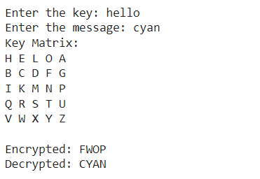

**Practical 4**

**AIM: Implement hill cipher encryption-decryption.**

Hill cipher is polygraphic substitution cipher, based on linear algebra. This algorithm use matrix multiplication, and factorization.

**Encryption:**

**Step:**

1) Create the matrix of a key and convert that, into a numerical value.

2) Convert plain text into vector form and do the matrix multiplication.

3) Multiply the key matrix with each plain text vector and take the modulo of result, then concate the result to get the cipher text.

**CODE:**

import numpy as np

# Helper function to convert text to numbers and vice versa

def text_to_numbers(text):

return [ord(char) - ord('A') for char in text.upper()]

def numbers_to_text(numbers):

return ''.join(chr(num + ord('A')) for num in numbers)

# Encrypt function

def hill_encrypt(plaintext, key_matrix):

plaintext_numbers = text_to_numbers(plaintext)

plaintext_vector = np.array(plaintext_numbers).reshape(-1, 5)

ciphertext_vector = np.dot(plaintext_vector, key_matrix) % 26

ciphertext_numbers = ciphertext_vector.flatten()

return numbers_to_text(ciphertext_numbers)

# Decrypt function

def hill_decrypt(ciphertext, key_matrix):

ciphertext_numbers = text_to_numbers(ciphertext)

ciphertext_vector = np.array(ciphertext_numbers).reshape(-1, 5)

# Calculate inverse of the key matrix modulo 26

determinant = int(round(np.linalg.det(key_matrix)))

determinant_inv = pow(determinant, -1, 26)

key_matrix_inv = determinant_inv * np.round(determinant * np.linalg.inv(key_matrix)).astype(int) % 26

plaintext_vector = np.dot(ciphertext_vector, key_matrix_inv) % 26

plaintext_numbers = plaintext_vector.flatten()

return numbers_to_text(plaintext_numbers)

# Function to input the 5x5 key matrix from user

def input_key_matrix():

print("Enter the 5x5 key matrix (each row separated by a space):")

matrix = []

for i in range(5):

row = list(map(int, input(f"Row {i+1}: ").strip().split()))

if len(row) != 5:

raise ValueError("Each row must have exactly 5 integers.")

matrix.append(row)

return np.array(matrix)

# Function to input the plaintext from user

def input_plaintext():

plaintext = input("Enter the plaintext: ").upper().replace(" ", "")

if len(plaintext) % 5 != 0:

padding_length = 5 - (len(plaintext) % 5)

plaintext += 'X' * padding_length

return plaintext

# Main function to execute the encryption and decryption

def main():

key_matrix = input_key_matrix()

plaintext = input_plaintext()

ciphertext = hill_encrypt(plaintext, key_matrix)

decrypted_text = hill_decrypt(ciphertext, key_matrix)

print(f"\nPlaintext: {plaintext}")

print(f"Ciphertext: {ciphertext}")

print(f"Decrypted text: {decrypted_text}")

if __name__ == "__main__":

main()

**OUTPUT:**

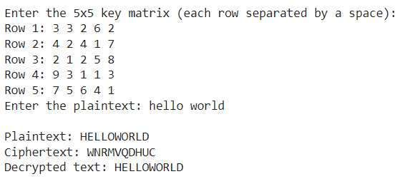

**Practical 5**

**AIM: Implement polyalphabetic Cipher.**

Polyalphabetic cipher is a substitution alphabetic technique using multiple substitution alphabet. We can use more than one substitution for the same alphabet.

Encryption= Ei =(Pi+ki) mod 26

Decryption= Di = Ei-Ki

There are various technique to implement poly alphabetic. One of them is Vigenere . Which is Simplest and most popular method. Whenever a vigenere table is not given then it will be performed by formula given.

**CODE:**

def generate_vigenere_table():

"""Generate a Vigenère cipher table."""

table = []

for i in range(26):

row = [(chr((j + i) % 26 + ord('A'))) for j in range(26)]

table.append(row)

return table

def vigenere_encrypt(plaintext, keyword):

"""Encrypt plaintext using the Vigenère cipher with the given keyword."""

table = generate_vigenere_table()

plaintext = plaintext.upper()

keyword = keyword.upper()

encrypted_text = []

keyword_length = len(keyword)

keyword_index = 0

for char in plaintext:

if char.isalpha():

row = ord(keyword[keyword_index]) - ord('A')

col = ord(char) - ord('A')

encrypted_char = table[row][col]

encrypted_text.append(encrypted_char)

keyword_index = (keyword_index + 1) % keyword_length

else:

encrypted_text.append(char)

return ''.join(encrypted_text)

def vigenere_decrypt(ciphertext, keyword):

"""Decrypt ciphertext using the Vigenère cipher with the given keyword."""

table = generate_vigenere_table()

ciphertext = ciphertext.upper()

keyword = keyword.upper()

decrypted_text = []

keyword_length = len(keyword)

keyword_index = 0

for char in ciphertext:

if char.isalpha():

row = ord(keyword[keyword_index]) - ord('A')

col = table[row].index(char)

decrypted_char = chr(col + ord('A'))

decrypted_text.append(decrypted_char)

keyword_index = (keyword_index + 1) % keyword_length

else:

decrypted_text.append(char)

return ''.join(decrypted_text)

# Example usage

plaintext = input("Plaintext: ")

key = input("Key: ")

encrypted = vigenere_encrypt(plaintext, key)

print("Encrypted:", encrypted)

decrypted = vigenere_decrypt(encrypted, key)

print("Decrypted:", decrypted)

**OUTPUT:**

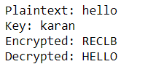

**Practical 6**

**AIM: Implement rail fence cipher encryption decryption.**

It is also known as zigzag cipher. It is form of substitution cipher.

**Encryption:**

**steps:**

1) In rail fence cipher plaintext is written in downwards and diagonally on succesive raise of imaginary fence.

2) After reaching at bottom rail move upward diagonally. After reaching top move towards bottom diagonally. That create the alphabetical zigzag.

3) After each alphabet has been written the individual raws are combine to obtain the cipher text.

**CODE:**

def print_matrix(matrix):

for row in matrix:

print(' '.join(char if char != '' else ' ' for char in row))

print()

def rail_fence_encrypt(message, num_rails):

if num_rails == 1:

return message

rails = [['' for _ in range(len(message))] for _ in range(num_rails)]

direction = 1

rail = 0

for i in range(len(message)):

rails[rail][i] = '*'

rail += direction

if rail == 0 or rail == num_rails - 1:

direction *= -1

print_matrix(rails)

rails = [['' for _ in range(len(message))] for _ in range(num_rails)]

direction = 1

rail = 0

index = 0

for i in range(len(message)):

rails[rail][i] = message[index]

index += 1

rail += direction

if rail == 0 or rail == num_rails - 1:

direction *= -1

print("Filled Encryption Matrix:")

print_matrix(rails)

encrypted_message = ''.join(''.join(row).strip() for row in rails)

return encrypted_message

def rail_fence_decrypt(encrypted_message, num_rails):

if num_rails == 1:

return encrypted_message

length = len(encrypted_message)

rails = [['' for _ in range(length)] for _ in range(num_rails)]

direction = 1

rail = 0

for i in range(length):

rails[rail][i] = '*'

rail += direction

if rail == 0 or rail == num_rails - 1:

direction *= -1

print("Rail Fence Decryption Matrix (marked positions):")

print_matrix(rails)

index = 0

for r in range(num_rails):

for c in range(length):

if rails[r][c] == '*':

rails[r][c] = encrypted_message[index]

index += 1

print("Filled Decryption Matrix:")

print_matrix(rails)

decrypted_message = []

rail = 0

direction = 1

for i in range(length):

decrypted_message.append(rails[rail][i])

rail += direction

if rail == 0 or rail == num_rails - 1:

direction *= -1

return ''.join(decrypted_message)

def main():

message = input("Enter the message to be encrypted: ").replace(' ', '').upper()

num_rails = int(input("Enter the number of rails: "))

if num_rails <= 0:

print("Error: Number of rails must be greater than 0.")

return

encrypted_message = rail_fence_encrypt(message, num_rails)

print("Encrypted message:", encrypted_message)

decrypted_message = rail_fence_decrypt(encrypted_message, num_rails)

print("Decrypted message:", decrypted_message)

if __name__ == "__main__":

main()

**OUTPUT:**

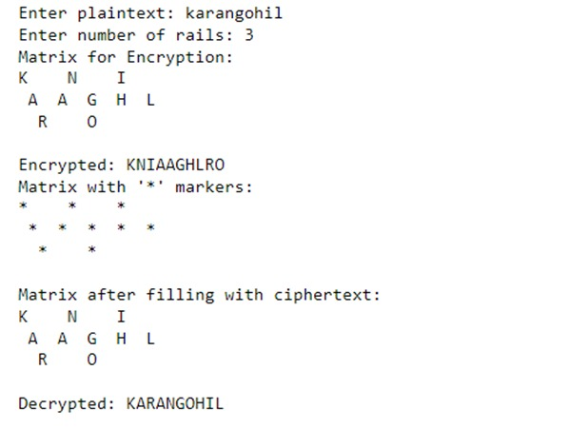

**Practical 7**

**AIM: Implement columnar transposition cipher encryption decryption.**

**CODE:**

def encrypt(plaintext, keyword):

# Remove spaces from the plaintext

plaintext = plaintext.replace(' ', '')

# Fill in the grid with the plaintext and padding

num_cols = len(keyword)

num_rows = -(-len(plaintext) // num_cols) # Ceiling division

padded_plaintext = plaintext.ljust(num_cols * num_rows, 'X')

# Create a matrix

matrix = [padded_plaintext[i:i + num_cols] for i in range(0, len(padded_plaintext), num_cols)]

# Create a dictionary to map column order

keyword_order = sorted(range(len(keyword)), key=lambda x: keyword[x])

keyword_order_dict = {char: idx for idx, char in enumerate(sorted(keyword))}

# Read columns in the order determined by the sorted keyword

ciphertext = ''

for col_index in keyword_order:

for row in matrix:

ciphertext += row[col_index]

return ciphertext

def decrypt(ciphertext, keyword):

# Calculate number of columns and rows

num_cols = len(keyword)

num_rows = len(ciphertext) // num_cols

# Create a matrix with empty values

matrix = [['' for _ in range(num_cols)] for _ in range(num_rows)]

# Create a dictionary to map column order

keyword_order = sorted(range(len(keyword)), key=lambda x: keyword[x])

# Fill the matrix column by column in the order determined by the keyword

index = 0

for col_index in keyword_order:

for row in range(num_rows):

matrix[row][col_index] = ciphertext[index]

index += 1

# Read rows to get the plaintext

plaintext = ''.join([''.join(row) for row in matrix])

# Remove padding characters

return plaintext.rstrip('X')

# Example usage

plaintext = input("Plain Text: ")

keyword = input("Key: ")

encrypted = encrypt(plaintext, keyword)

print(f"Encrypted: {encrypted}")

decrypted = decrypt(encrypted, keyword)

print(f"Decrypted: {decrypted}")

**OUTPUT:**

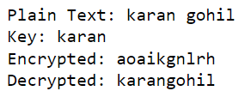

**Practical 8**

**AIM: Implement Diffie-Hellman cipher encryption decryption.**

**CODE:**

# Power function to return value of a^b mod P

def power(a, b, p):

if b == 1:

return a

else:

return pow(a, b) % p

# Main function

def main():

# Both persons agree upon the public keys G and P

# A prime number P is taken

P = 23

print("The value of P:", P)

# A primitive root for P, G is taken

G = 9

print("The value of G:", G)

# Alice chooses the private key a

# a is the chosen private key

a = 4

print("The private key a for Alice:", a)

# Gets the generated key

x = power(G, a, P)

# Bob chooses the private key b

# b is the chosen private key

b = 3

print("The private key b for Bob:", b)

# Gets the generated key

y = power(G, b, P)

# Generating the secret key after the exchange of keys

ka = power(y, a, P) # Secret key for Alice

kb = power(x, b, P) # Secret key for Bob

print("Secret key for Alice is:", ka)

print("Secret key for Bob is:", kb)

if __name__ == "__main__":

main()

**OUTPUT:**

