Practical 11

Aim: Use Firebase to perform CRUID operation .\Code:
activity_main.xml:
<?xml version="1.0" encoding="utf-8"?>

<androidx.constraintlayout.widget.ConstraintLayout xmlns:android="http://schemas.android.com/apk/res/android" xmlns:tools="http://schemas.android.com/tools" xmlns:app="http://schemas.android.com/apk/res-auto" android:layout_width="match_parent" android:layout_height="match_parent" tools:context=".MainActivity">

<TextView android:layout_width="match_parent" android:layout_height="wrap_content" android:gravity="center_horizontal"
android:text="Shree Swami Atmanand Saraswati Institute of Technology" android:textSize="20dp"
android:fontFamily="sans-serif-black" android:layout_marginBottom="50dp"/>
<EditText android:id="@+id/name"
android:layout_width="wrap_content" android:layout_height="wrap_content" android:ems="10" android:inputType="textPersonName" android:hint="Name" app:layout_constraintBottom_toBottomOf="parent" app:layout_constraintEnd_toEndOf="parent" app:layout_constraintHorizontal_bias="0.412" app:layout_constraintStart_toStartOf="parent" app:layout_constraintTop_toTopOf="parent" app:layout_constraintVertical_bias="0.081" />

<EditText android:id="@+id/last_name"
android:layout_width="wrap_content" android:layout_height="wrap_content" android:ems="10" android:inputType="textPersonName" android:hint="Last Name" app:layout_constraintBottom_toBottomOf="parent"

app:layout_constraintEnd_toEndOf="parent" app:layout_constraintHorizontal_bias="0.412" app:layout_constraintStart_toStartOf="parent" app:layout_constraintTop_toBottomOf="@+id/name" app:layout_constraintVertical_bias="0.094" />

<EditText android:id="@+id/age"
android:layout_width="wrap_content" android:layout_height="wrap_content" android:ems="10" android:inputType="number" android:hint="Age"
app:layout_constraintBottom_toBottomOf="parent" app:layout_constraintEnd_toEndOf="parent" app:layout_constraintHorizontal_bias="0.412" app:layout_constraintStart_toStartOf="parent" app:layout_constraintTop_toBottomOf="@+id/last_name" app:layout_constraintVertical_bias="0.127" />

<EditText android:id="@+id/phone"
android:layout_width="wrap_content" android:layout_height="wrap_content" android:ems="10" android:inputType="phone" android:hint="Phone number"
app:layout_constraintBottom_toBottomOf="parent" app:layout_constraintEnd_toEndOf="parent" app:layout_constraintHorizontal_bias="0.412" app:layout_constraintStart_toStartOf="parent" app:layout_constraintTop_toBottomOf="@+id/age" app:layout_constraintVertical_bias="0.171" />

<Button
android:id="@+id/btn_insert" android:layout_width="210dp" android:layout_height="54dp" android:text="Insert Data"

app:layout_constraintBottom_toBottomOf="parent" app:layout_constraintEnd_toEndOf="parent" app:layout_constraintHorizontal_bias="0.412" app:layout_constraintStart_toStartOf="parent" app:layout_constraintTop_toBottomOf="@+id/phone" app:layout_constraintVertical_bias="0.303" />

<Button
android:id="@+id/btn_delete" android:layout_width="210dp" android:layout_height="54dp" android:text="Delete Data"

app:layout_constraintBottom_toBottomOf="parent" app:layout_constraintEnd_toEndOf="parent" app:layout_constraintHorizontal_bias="0.412" app:layout_constraintStart_toStartOf="parent" app:layout_constraintTop_toBottomOf="@+id/btn_insert" app:layout_constraintVertical_bias="0.181" />

<Button
android:id="@+id/btn_update" android:layout_width="210dp" android:layout_height="54dp" android:text="Update Data"

app:layout_constraintBottom_toBottomOf="parent" app:layout_constraintEnd_toEndOf="parent" app:layout_constraintHorizontal_bias="0.412" app:layout_constraintStart_toStartOf="parent" app:layout_constraintTop_toBottomOf="@+id/btn_delete" app:layout_constraintVertical_bias="0.303" />

</androidx.constraintlayout.widget.ConstraintLayout>

MainActivity.java:
package com.ssasit.pr11; import android.os.Bundle;

import androidx.appcompat.app.AppCompatActivity;

import androidx.appcompat.app.AppCompatActivity; import android.os.Bundle;
import android.util.Log; import android.view.View; import android.widget.Button;
import android.widget.EditText; import android.widget.Toast;

import com.google.firebase.database.DatabaseReference; import com.google.firebase.database.FirebaseDatabase;

import java.util.Objects;

public class MainActivity extends AppCompatActivity { EditText Name,Last_name,Age,Phone,Email;
Button InsertData,DeleteData,UpdateData; DatabaseReference ref;
MemberData member; Long M_phone; @Override
protected void onCreate(Bundle savedInstanceState) { super.onCreate(savedInstanceState); setContentView(R.layout.activity_main); Name=(EditText) findViewById(R.id.name); Last_name=(EditText) findViewById(R.id.last_name); Age=(EditText) findViewById(R.id.age); Phone=(EditText) findViewById(R.id.phone); InsertData=(Button) findViewById(R.id.btn_insert); UpdateData=(Button) findViewById(R.id.btn_update); DeleteData=(Button) findViewById(R.id.btn_delete);
ref= FirebaseDatabase.getInstance().getReference().child("Member"); member = new MemberData();

InsertData.setOnClickListener(new View.OnClickListener() { @Override
public void onClick(View view) {
int M_age=Integer.parseInt(Age.getText().toString().trim()); M_phone=Long.parseLong(Phone.getText().toString().trim()); member.setName(Name.getText().toString().trim()); member.setLast_name(Last_name.getText().toString().trim()); member.setAge(M_age);
member.setPhone(M_phone); if(!Objects.equals(ref.child(M_phone.toString()).getKey(), M_phone.toString())){
ref.child(M_phone.toString()).setValue(member);

Toast.makeText(MainActivity.this, "Data Inserted", Toast.LENGTH_SHORT).show();

}
else{
Toast.makeText(MainActivity.this, "Data Already Available!", Toast.LENGTH_SHORT).show();
}

}
});

DeleteData.setOnClickListener(new View.OnClickListener() { @Override
public void onClick(View v) { M_phone=Long.parseLong(Phone.getText().toString().trim()); ref.child(M_phone.toString()).removeValue(); Toast.makeText(MainActivity.this, "Data Deleted",
Toast.LENGTH_SHORT).show();
}
});

UpdateData.setOnClickListener(new View.OnClickListener() { @Override
public void onClick(View v) {
int M_age=Integer.parseInt(Age.getText().toString().trim()); M_phone=Long.parseLong(Phone.getText().toString().trim()); member.setName(Name.getText().toString().trim()); member.setLast_name(Last_name.getText().toString().trim()); member.setAge(M_age);
member.setPhone(M_phone);

ref.child(M_phone.toString()).setValue(member); Toast.makeText(MainActivity.this, "Data Updated",
Toast.LENGTH_SHORT).show();
}
});

}
}

MemberData.java:
package com.ssasit.pr11; public class MemberData {
private String Name; private String Last_name; private Integer Age; private Long phone;

public MemberData()
{

}

public String getName() { return Name;
}

public void setName(String name) { Name = name;
}

public String getLast_name() { return Last_name;
}

public void setLast_name(String last_name) { Last_name = last_name;
}

public Integer getAge() { return Age;
}

public void setAge(Integer age) { Age = age;
}

public Long getPhone() { return phone;
}

public void setPhone(Long phone) { this.phone = phone;
}
}

Output:
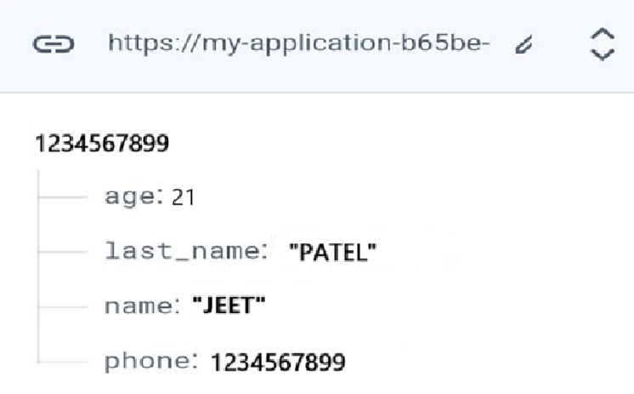

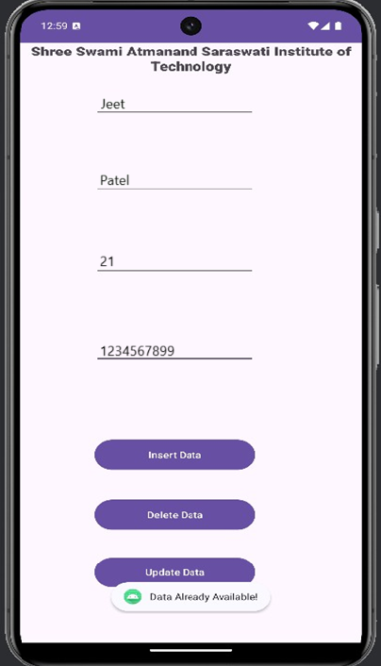
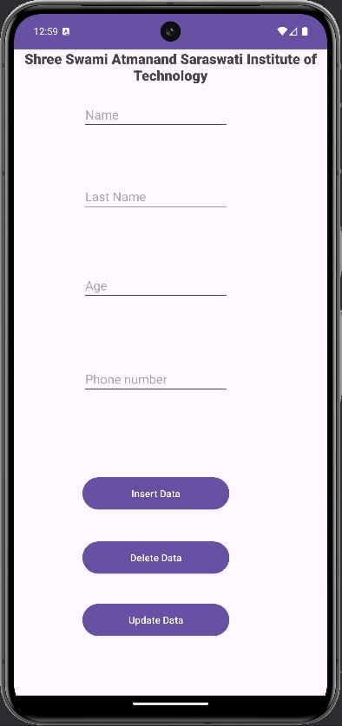

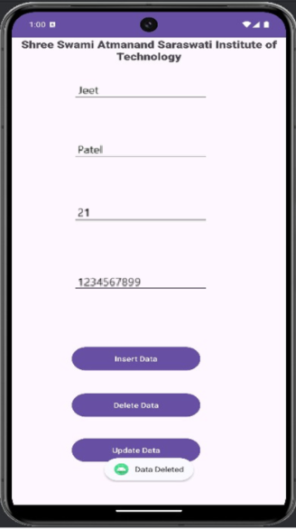
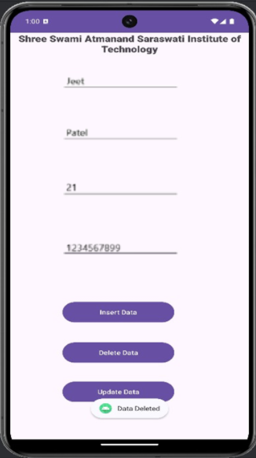

Practical 12

Aim: BroadcastReceiver Code: activity_main.xml:
<?xml version="1.0" encoding="utf-8"?>
<androidx.constraintlayout.widget.ConstraintLayout xmlns:android="http://schemas.android.com/apk/res/android"
xmlns:app="http://schemas.android.com/apk/res-auto" xmlns:tools="http://schemas.android.com/tools" android:id="@+id/main" android:layout_width="match_parent" android:layout_height="match_parent" tools:context=".MainActivity">

<TextView android:id="@+id/tv_status"
android:layout_width="wrap_content" android:layout_height="wrap_content" android:text="Hello World!" app:layout_constraintBottom_toBottomOf="parent" app:layout_constraintEnd_toEndOf="parent" app:layout_constraintStart_toStartOf="parent" app:layout_constraintTop_toTopOf="parent" />

</androidx.constraintlayout.widget.ConstraintLayout>

MainActivity.java:
package com.ssasit.pr12;
import androidx.appcompat.app.AppCompatActivity; import android.content.Intent;
import android.content.IntentFilter; import android.os.Bundle;
import android.widget.TextView;

public class MainActivity extends AppCompatActivity { TextView status;
AirplaneModeChangeReceiver airplaneModeChangeReceiver ;

@Override

protected void onCreate(Bundle savedInstanceState) { super.onCreate(savedInstanceState); setContentView(R.layout.activity_main); status=findViewById(R.id.tv_status);
airplaneModeChangeReceiver = new AirplaneModeChangeReceiver(status);

}

@Override
protected void onStart() { super.onStart();
IntentFilter fa = new IntentFilter(Intent.ACTION_AIRPLANE_MODE_CHANGED); registerReceiver(airplaneModeChangeReceiver, fa);

}

@Override
protected void onStop() { super.onStop();
unregisterReceiver(airplaneModeChangeReceiver);
}
}

AirplaneModeChangeReceiver.java:

package com.ssasit.pr12;

import android.content.BroadcastReceiver; import android.content.Context;
import android.content.Intent; import android.provider.Settings; import android.widget.TextView; import android.widget.Toast;

import org.w3c.dom.Text;

public class AirplaneModeChangeReceiver extends BroadcastReceiver { TextView tv;
public AirplaneModeChangeReceiver(TextView s){ tv=s;
}
@Override
public void onReceive(Context context, Intent intent) {

if (isAirplaneModeOn(context.getApplicationContext())) {
Toast.makeText(context, "AirPlane mode is on", Toast.LENGTH_SHORT).show(); tv.setText("AirPlane mode is on");

}
else {
Toast.makeText(context, "AirPlane mode is off", Toast.LENGTH_SHORT).show(); tv.setText("AirPlane mode is off");
}
}

private static boolean isAirplaneModeOn(Context context) { return Settings.System.getInt(context.getContentResolver(),
Settings.Global.AIRPLANE_MODE_ON, 0) != 0;
}
}

Output:

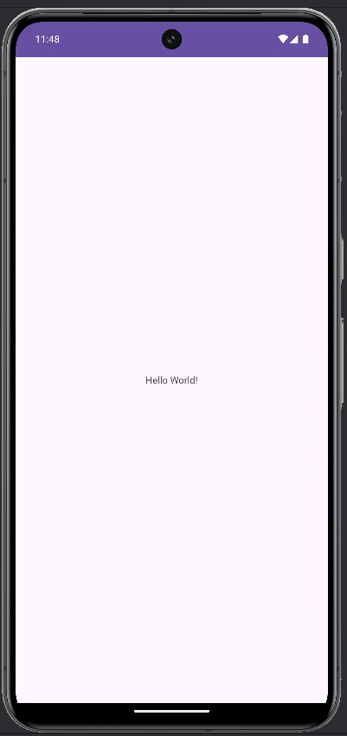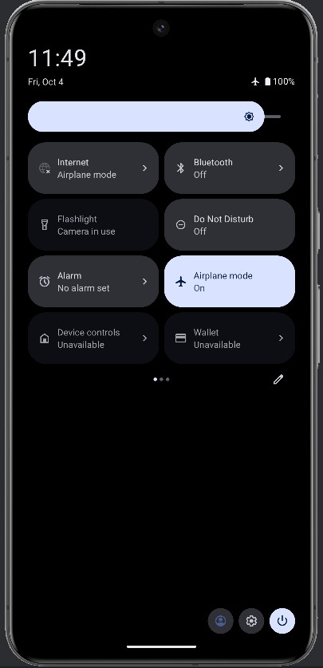

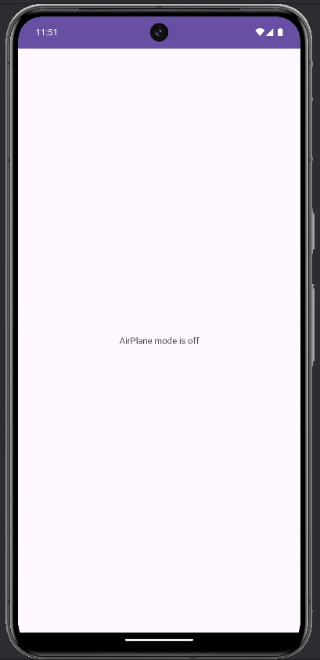
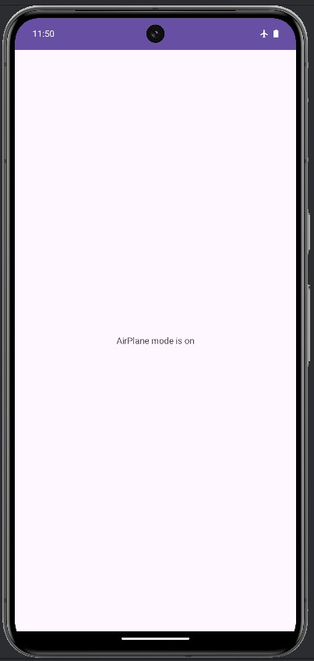

Practical 13

Aim: Notifications Code: activity_main.xml:
<?xml version="1.0" encoding="utf-8"?>
<RelativeLayout xmlns:android="http://schemas.android.com/apk/res/android" xmlns:app="http://schemas.android.com/apk/res-auto" xmlns:tools="http://schemas.android.com/tools" android:layout_width="match_parent" android:layout_height="match_parent"
android:orientation="vertical" tools:context=".MainActivity">

<TextView android:id="@+id/textView2" android:layout_width="wrap_content" android:layout_height="wrap_content" android:layout_alignParentTop="true" android:layout_centerHorizontal="true" android:layout_marginTop="50dp" android:gravity="center" android:text="Notification" android:textSize="30sp" />

<ImageView android:id="@+id/imageView" android:layout_width="200dp" android:layout_height="200dp" android:layout_below="@id/textView2" android:layout_centerInParent="true" android:src="@drawable/notification" />

</RelativeLayout>

MainActivity.java:
package com.example.pr13;

import android.Manifest;
import android.app.Notification;
import android.app.NotificationChannel; import android.app.NotificationManager;
import android.content.pm.PackageManager; import android.graphics.Bitmap;
import android.graphics.drawable.BitmapDrawable; import android.graphics.drawable.Drawable;
import android.os.Build; import android.os.Bundle;

import androidx.annotation.NonNull;
import androidx.appcompat.app.AppCompatActivity; import androidx.core.app.ActivityCompat;
import androidx.core.app.NotificationCompat; import androidx.core.content.ContextCompat; import androidx.core.content.res.ResourcesCompat;

public class MainActivity extends AppCompatActivity {

private static final String CHANNEL_ID = "My_Channel_ID"; private static final int NOTIFICATION_ID = 100;
private static final int REQUEST_NOTIFICATION_PERMISSION = 1;

@Override
protected void onCreate(Bundle savedInstanceState) { super.onCreate(savedInstanceState); setContentView(R.layout.activity_main);

// Check notification permission for Android 13+ (API level 33)
if (Build.VERSION.SDK_INT >= Build.VERSION_CODES.TIRAMISU) {
if (ContextCompat.checkSelfPermission(this, Manifest.permission.POST_NOTIFICATIONS)
!= PackageManager.PERMISSION_GRANTED) { ActivityCompat.requestPermissions(this, new
String[]{Manifest.permission.POST_NOTIFICATIONS},
REQUEST_NOTIFICATION_PERMISSION);
} else {
showNotification();
}
} else {
// For devices below Android 13, show the notification directly showNotification();
}
}

private void showNotification() {
// Get the large icon for the notification
Drawable drawable = ResourcesCompat.getDrawable(getResources(), R.drawable.img, null);
BitmapDrawable bitmapDrawable = (BitmapDrawable) drawable; Bitmap largeIcon = bitmapDrawable.getBitmap();

// Get the NotificationManager service NotificationManager nm = (NotificationManager)
getSystemService(NOTIFICATION_SERVICE);

if (nm == null) {
return; // If NotificationManager is null, exit
}

// Create a notification NotificationCompat.Builder builder;

// Check if the device runs Android O or higher (API level 26+)
if (Build.VERSION.SDK_INT >= Build.VERSION_CODES.O) {
// Create NotificationChannel for Android O and above NotificationChannel channel = new NotificationChannel(
CHANNEL_ID,
"My Channel", NotificationManager.IMPORTANCE_HIGH
);
channel.setDescription("Channel for general notifications");

// Register the channel with the system nm.createNotificationChannel(channel);

// Build the notification for Android O and above
builder = new NotificationCompat.Builder(this, CHANNEL_ID)
.setLargeIcon(largeIcon)
.setSmallIcon(R.drawable.img)
.setContentTitle("New Message")
.setContentText("New message from jeet!")
.setPriority(NotificationCompat.PRIORITY_HIGH)
.setSubText("Click to see more")
.setAutoCancel(true); // Dismiss the notification when clicked
} else {
// Build the notification for pre-Oreo devices builder = new NotificationCompat.Builder(this)
.setLargeIcon(largeIcon)
.setSmallIcon(R.drawable.img)
.setContentTitle("New Message")
.setContentText("New message from jeet!")
.setPriority(NotificationCompat.PRIORITY_HIGH)
.setSubText("Click to see more")
.setAutoCancel(true); // Dismiss the notification when clicked

}

// Issue the notification nm.notify(NOTIFICATION_ID, builder.build());
}

// Handle the result of the permission request @Override
public void onRequestPermissionsResult(int requestCode, @NonNull String[] permissions, @NonNull int[] grantResults) {
super.onRequestPermissionsResult(requestCode, permissions, grantResults); if (requestCode == REQUEST_NOTIFICATION_PERMISSION) {
if (grantResults.length > 0 && grantResults[0] == PackageManager.PERMISSION_GRANTED) {
showNotification();
}
}
}
}

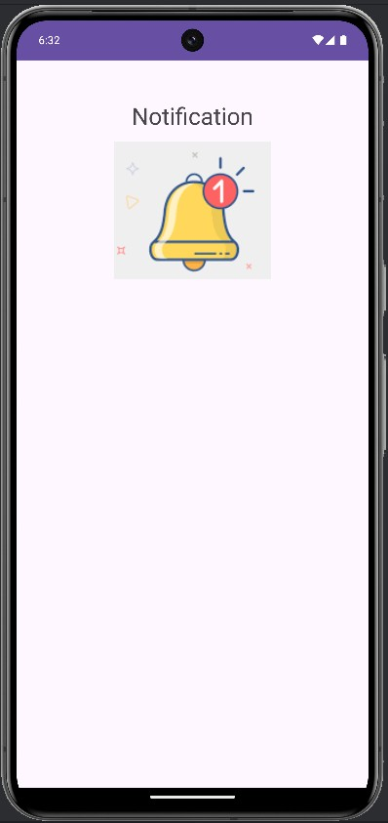
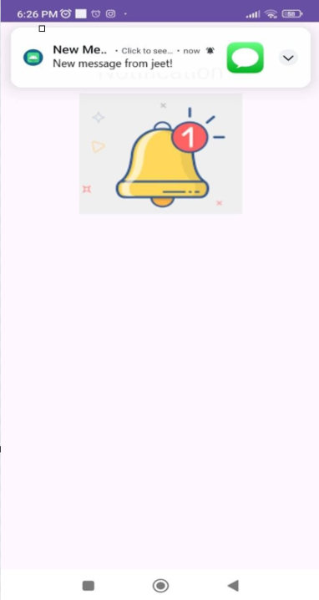
Output:
Practical 14

Aim: Get and Save User Preferences Code:
activity_main.xml:

<?xml version="1.0" encoding="utf-8"?>
<RelativeLayout xmlns:android="http://schemas.android.com/apk/res/android" xmlns:app="http://schemas.android.com/apk/res-auto" xmlns:tools="http://schemas.android.com/tools"
android:layout_width="match_parent" android:layout_height="match_parent" android:orientation="vertical" android:gravity="center_horizontal" tools:context=".MainActivity">

<TextView android:layout_width="match_parent" android:layout_height="45dp" android:layout_alignParentBottom="true" android:layout_marginTop="20dp" android:layout_marginBottom="410dp" android:gravity="center" android:text="REGISTER" android:textSize="25dp" />

<EditText android:id="@+id/enroll"
android:layout_width="match_parent" android:layout_height="74dp" android:layout_alignParentBottom="true" android:layout_marginBottom="306dp" android:hint="Enter Enrollment" android:inputType="text" />

<EditText android:id="@+id/registerpassword" android:layout_width="match_parent" android:layout_height="71dp" android:layout_alignParentBottom="true" android:layout_marginBottom="201dp" android:hint="Enter Password" android:inputType="textPassword" />

<Button
android:id="@+id/registerSubmitBtn" android:layout_width="match_parent" android:layout_height="82dp" android:layout_alignParentBottom="true" android:layout_marginBottom="78dp" android:text="submit" />

<ImageView android:id="@+id/imageView2" android:layout_width="wrap_content" android:layout_height="wrap_content" android:layout_alignParentEnd="true" android:layout_alignParentBottom="true" android:layout_marginEnd="108dp" android:layout_marginBottom="470dp" app:srcCompat="@drawable/regi" />
</RelativeLayout>

MainActivity.java:
package com.example.p13;

import androidx.appcompat.app.AppCompatActivity; import android.content.Intent;
import android.os.Bundle; import android.view.View; import android.widget.Button; import android.widget.EditText; import android.widget.Toast;

public class MainActivity extends AppCompatActivity { @Override
protected void onCreate(Bundle savedInstanceState) { super.onCreate(savedInstanceState);

// Check if user is already registered
UserPreference userPreferences = new UserPreference(MainActivity.this); if (userPreferences.isUserRegistered()) {
// If the user is already registered, go directly to login
Intent intent = new Intent(MainActivity.this, Activity_login.class); startActivity(intent);
finish(); // Close registration activity return;
}

setContentView(R.layout.activity_main);

EditText name, pass;
name = findViewById(R.id.enroll);
pass = findViewById(R.id.registerpassword);
Button submit = findViewById(R.id.registerSubmitBtn);

submit.setOnClickListener(new View.OnClickListener() { @Override
public void onClick(View view) {
if (name.getText().toString().isEmpty() || pass.getText().toString().isEmpty()) { Toast.makeText(MainActivity.this, "Please enter all details",
Toast.LENGTH_SHORT).show();
} else {
userPreferences.registerUser(name.getText().toString(), pass.getText().toString());
Toast.makeText(MainActivity.this, "Registration Successful! Please log in.", Toast.LENGTH_SHORT).show();
Intent intent = new Intent(MainActivity.this, Activity_login.class); startActivity(intent);
finish(); // Close registration activity
}
}
});
}
}

Activity_login.xml:
<?xml version="1.0" encoding="utf-8"?>
<RelativeLayout xmlns:android="http://schemas.android.com/apk/res/android" xmlns:app="http://schemas.android.com/apk/res-auto" xmlns:tools="http://schemas.android.com/tools" android:layout_width="match_parent" android:layout_height="match_parent"
android:orientation="vertical" android:gravity="center_horizontal" tools:context=".MainActivity">

<TextView android:layout_width="match_parent" android:layout_height="53dp" android:layout_alignParentBottom="true" android:layout_marginTop="20dp" android:layout_marginBottom="374dp" android:gravity="center" android:text="LOGIN"

android:textSize="25dp" />

<EditText android:id="@+id/loginenroll" android:layout_width="match_parent" android:layout_height="67dp"
android:layout_alignParentBottom="true" android:layout_marginBottom="246dp" android:hint="Enter Enrollment" android:inputType="text" />

<EditText android:id="@+id/loginpassword" android:layout_width="match_parent" android:layout_height="65dp" android:layout_alignParentBottom="true" android:layout_marginBottom="144dp" android:hint="Enter Password" android:inputType="textPassword" />

<Button
android:id="@+id/loginSubmitBtn" android:layout_width="match_parent" android:layout_height="63dp" android:layout_alignParentBottom="true" android:layout_marginBottom="45dp" android:text="login" />

<ImageView android:id="@+id/imageView" android:layout_width="wrap_content" android:layout_height="wrap_content" android:layout_alignParentEnd="true" android:layout_alignParentBottom="true" android:layout_marginEnd="90dp" android:layout_marginBottom="466dp" app:srcCompat="@drawable/regi" />

</RelativeLayout>

Activity_login.java:
package com.example.p13;

import androidx.appcompat.app.AppCompatActivity; import android.content.Intent;

import android.os.Bundle; import android.view.View; import android.widget.Button; import android.widget.EditText;
public class Activity_login extends AppCompatActivity { @Override
protected void onCreate(Bundle savedInstanceState) {
super.onCreate(savedInstanceState); setContentView(R.layout.activity_login);

EditText name, pass;
name = findViewById(R.id.loginenroll); pass = findViewById(R.id.loginpassword);
Button submit = findViewById(R.id.loginSubmitBtn);

submit.setOnClickListener(new View.OnClickListener() { @Override
public void onClick(View view) {
UserPreference userPreferences = new UserPreference(Activity_login.this); boolean loginSuccessful = userPreferences.verifyUser(name.getText().toString(),
pass.getText().toString());

if (loginSuccessful) {
// If login is successful, navigate to SecondActivity
Intent intent = new Intent(Activity_login.this, SecondActivity.class); intent.putExtra("username", name.getText().toString()); // Pass the username startActivity(intent);
finish(); // Optional: Close login activity to prevent going back
}
}
});

}
}

Activity_second.xml:
<?xml version="1.0" encoding="utf-8"?>
<RelativeLayout xmlns:android="http://schemas.android.com/apk/res/android" xmlns:app="http://schemas.android.com/apk/res-auto" android:layout_width="match_parent" android:layout_height="match_parent"
android:orientation="vertical" android:gravity="center"

android:padding="16dp">

<TextView android:id="@+id/welcomeTextView" android:layout_width="309dp" android:layout_height="139dp"

android:layout_alignParentStart="true" android:layout_alignParentTop="true" android:layout_alignParentEnd="true" android:layout_alignParentBottom="true" android:layout_marginStart="44dp" android:layout_marginTop="417dp" android:layout_marginEnd="42dp" android:layout_marginBottom="159dp" android:text="Welcome to app" android:textSize="35dp" android:textStyle="bold" />

<ImageView android:id="@+id/imageView3" android:layout_width="wrap_content" android:layout_height="wrap_content" android:layout_alignParentEnd="true" android:layout_alignParentBottom="true" android:layout_marginEnd="82dp" android:layout_marginBottom="546dp" app:srcCompat="@drawable/regi" />

</RelativeLayout>

SecondActivity.java:
package com.example.p13;

import androidx.appcompat.app.AppCompatActivity; import android.os.Bundle;
import android.widget.TextView;
public class SecondActivity extends AppCompatActivity { @Override
protected void onCreate(Bundle savedInstanceState) { super.onCreate(savedInstanceState); setContentView(R.layout.activity_second);

// Retrieve the username from the Intent
String username = getIntent().getStringExtra("username"); TextView welcomeText = findViewById(R.id.welcomeTextView);
// Set the welcome message with the username welcomeText.setText("Welcome to the app, " + username + "!");
}

}

UserPreference.java:
package com.example.p13;

import android.content.Context;
import android.content.SharedPreferences; import android.widget.Toast;

public class UserPreference {
private SharedPreferences userSession; private SharedPreferences.Editor editor; private Context context;
private static final String KEY_NAME = "enroll"; private static final String KEY_PASS = "userpass";
private static final String IS_REGISTERED = "isRegistered";

public UserPreference(Context context) { this.context = context;
userSession = context.getSharedPreferences("userLoginSession", Context.MODE_PRIVATE);
editor = userSession.edit();
}

// Register user and set registration flag
public void registerUser(String name, String pass) { editor.putString(KEY_NAME, name); editor.putString(KEY_PASS, pass); editor.putBoolean(IS_REGISTERED, true); editor.commit();
}

// Verify user credentials and return true if login is successful public boolean verifyUser(String name, String pass) {
String storedName = userSession.getString(KEY_NAME, null); String storedPass = userSession.getString(KEY_PASS, null);

if (storedName != null && storedPass != null) {
if (name.equals(storedName) && pass.equals(storedPass)) { Toast.makeText(context, "Login Successful", Toast.LENGTH_SHORT).show(); return true; // Login successful
} else {
Toast.makeText(context, "Invalid Enrollment or password", Toast.LENGTH_SHORT).show();
return false; // Login failed
}
} else {
Toast.makeText(context, "Invalid Enrollment or password", Toast.LENGTH_SHORT).show();
return false; // Login failed
}
}

// Check if user is already registered public boolean isUserRegistered() {
return userSession.getBoolean(IS_REGISTERED, false);
}
}

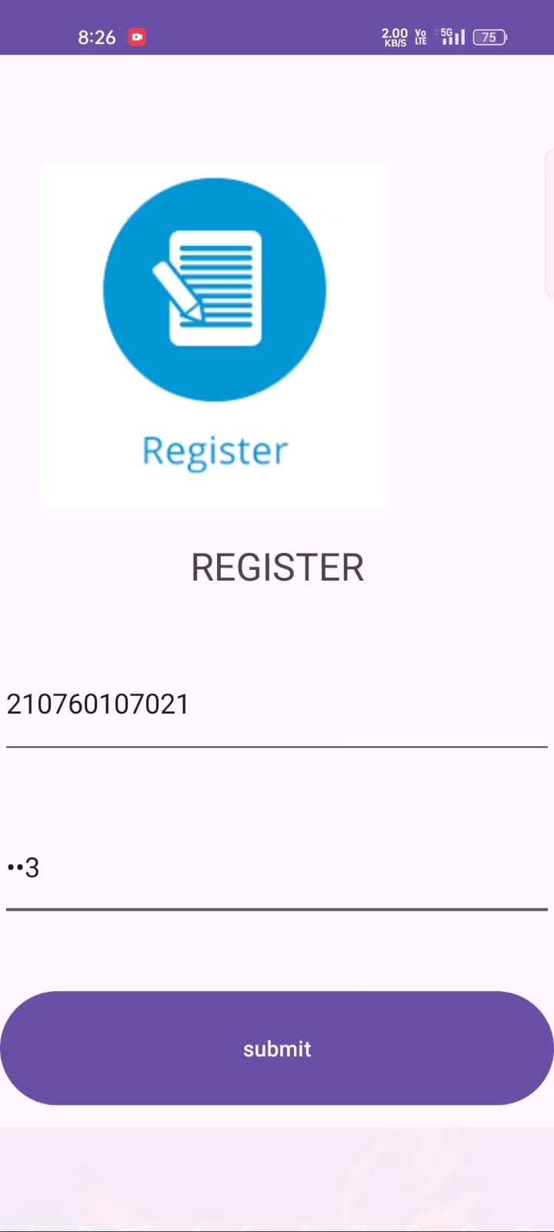
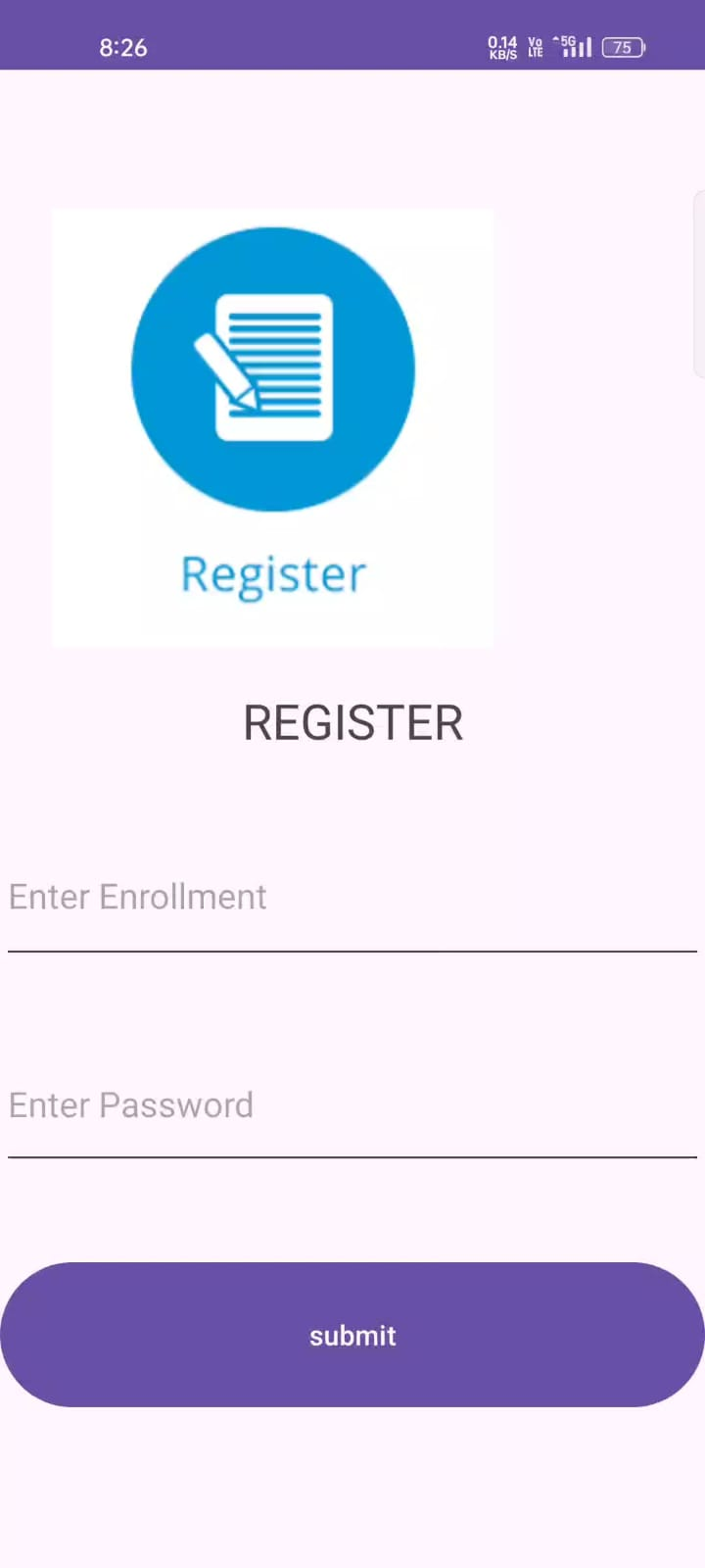
Output:

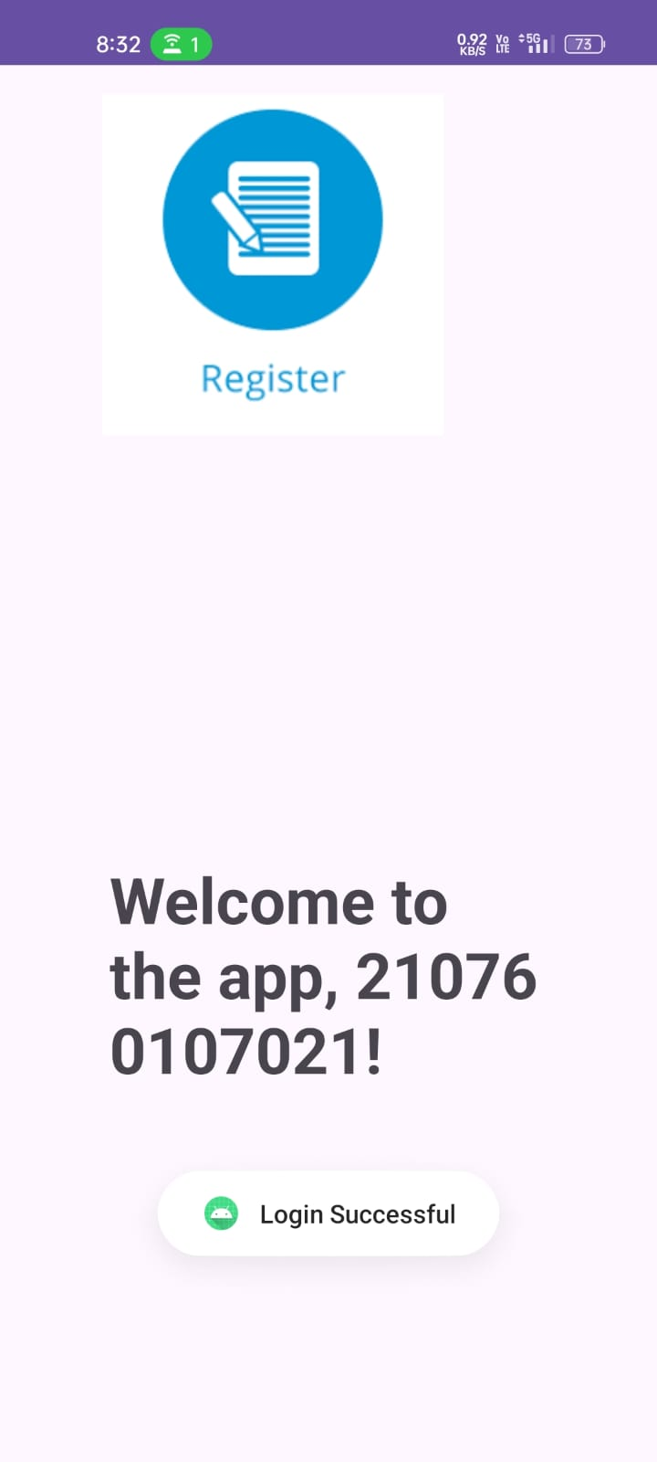
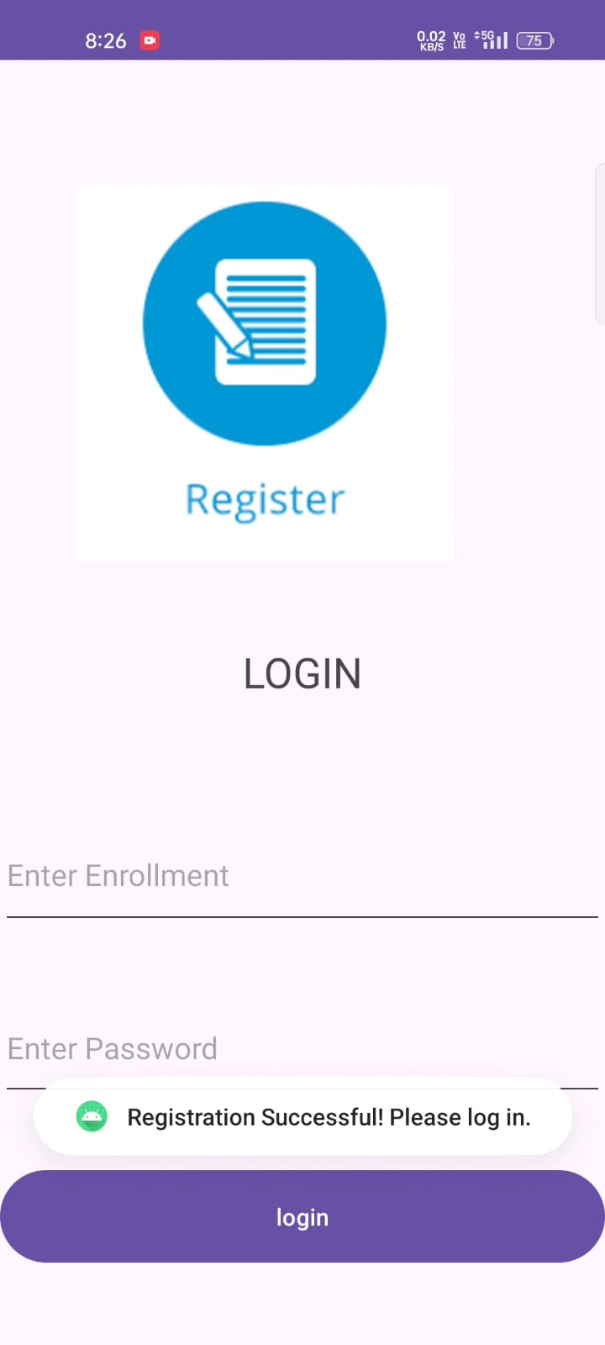
Practical 15

Aim: Make a use of android system Code:
activity_main.xml:
<?xml version="1.0" encoding="utf-8"?>
<LinearLayout xmlns:android="http://schemas.android.com/apk/res/android" xmlns:app="http://schemas.android.com/apk/res-auto" xmlns:tools="http://schemas.android.com/tools"
android:id="@+id/main" android:layout_width="match_parent" android:layout_height="match_parent" tools:context=".MainActivity" android:orientation="vertical" android:gravity="center_horizontal" >

<Button
android:id="@+id/camera_button" android:layout_width="100dp" android:layout_height="50dp" android:layout_marginTop="20dp" android:text="Camera" />
<ImageView android:id="@+id/click_image" android:layout_width="match_parent" android:layout_height="0dp" android:layout_weight="1" android:layout_margin="20dp"
/>

</LinearLayout>

MainActivity.java:
package com.ssasit.pr15;

import android.content.Intent;
import android.content.pm.PackageManager; import android.graphics.Bitmap;
import android.os.Bundle;
import android.provider.MediaStore; import android.view.View;
import android.widget.*; import android.Manifest;

import androidx.annotation.Nullable;
import androidx.appcompat.app.AppCompatActivity; import androidx.core.app.ActivityCompat;
import androidx.core.content.ContextCompat;

public class MainActivity extends AppCompatActivity { Button btnCapture;
ImageView imgCapture; int CAM_CODE=100;
@Override
protected void onCreate(Bundle savedInstanceState) { super.onCreate(savedInstanceState); setContentView(R.layout.activity_main); btnCapture=findViewById(R.id.camera_button); imgCapture=findViewById(R.id.click_image);

btnCapture.setOnClickListener(new View.OnClickListener() { @Override
public void onClick(View v) { if (!checkcamPermission()){
askPermission();
}else {
captureImage();
}
}
});
}
private void captureImage() {
Intent camIntent=new Intent(MediaStore.ACTION_IMAGE_CAPTURE); startActivityForResult(camIntent,CAM_CODE);
}

private boolean checkcamPermission() {
return ContextCompat.checkSelfPermission(this, Manifest.permission.CAMERA)
== PackageManager.PERMISSION_GRANTED;
}

private void askPermission() { ActivityCompat.requestPermissions(this, new
String[]{Manifest.permission.CAMERA},CAM_CODE);
}
@Override
protected void onActivityResult(int requestCode, int resultCode, @Nullable Intent data) { if (requestCode==CAM_CODE &&resultCode==RESULT_OK){
Bitmap image=(Bitmap) data.getExtras().get("data");

imgCapture.setImageBitmap(image);
}
super.onActivityResult(requestCode, resultCode, data);
}
}

Output:
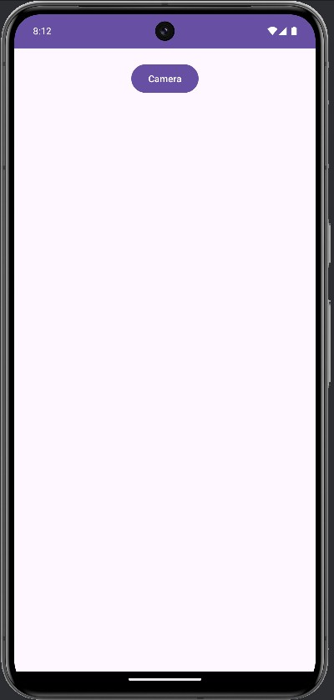
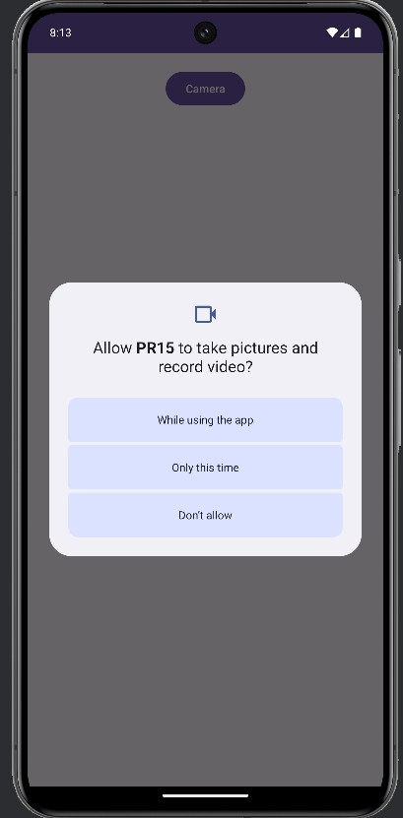
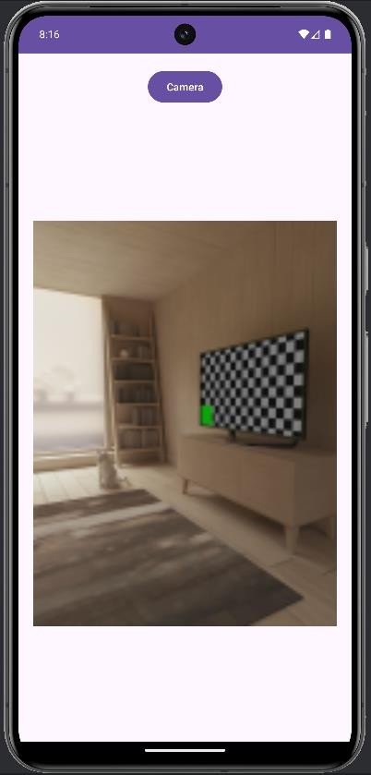

Practical 16

Aim: Using location service get the current location and display in TextView Code:
activity_main.xml:
<?xml version="1.0" encoding="utf-8"?>
<LinearLayout xmlns:android="http://schemas.android.com/apk/res/android" xmlns:app="http://schemas.android.com/apk/res-auto" xmlns:tools="http://schemas.android.com/tools"
android:id="@+id/main" android:layout_width="match_parent" android:layout_height="match_parent" tools:context=".MainActivity" android:orientation="vertical" android:padding="20dp">
<TextView android:layout_width="match_parent" android:layout_height="wrap_content"
android:text="Shree Swami Atmanand Saraswati Institute of Technology" android:gravity="center"
android:fontFamily="sans-serif-black" android:textSize="20dp"/>

<TextView android:layout_width="wrap_content" android:layout_height="wrap_content" android:fontFamily="sans-serif-black" android:text="Latitude:" />
<TextView android:id="@+id/latTextView" android:layout_width="wrap_content" android:layout_height="wrap_content" android:text="Latitude will be here! " android:textColor="#f5f5f5" />
<TextView android:layout_width="wrap_content" android:layout_height="wrap_content" android:fontFamily="sans-serif-black" android:text="Longitude:" />
<TextView android:id="@+id/lonTextView" android:layout_width="wrap_content" android:layout_height="wrap_content" android:text="Longitude will be here! "

android:textColor="#f5f5f5" />

<Button
android:id="@+id/btnloc" android:layout_width="match_parent" android:layout_height="wrap_content" android:text="Fetch Current Location"/>

</LinearLayout>

MainActivity.java:
package com.ssasit.pr16;

import android.annotation.SuppressLint; import android.content.Context;
import android.content.Intent;
import android.content.pm.PackageManager; import android.location.Location;
import android.location.LocationManager; import android.os.Bundle;
import android.os.Looper; import android.provider.Settings; import android.view.View; import android.widget.*;

import androidx.annotation.NonNull;
import androidx.appcompat.app.AppCompatActivity; import androidx.core.app.ActivityCompat;

import com.google.android.gms.location.FusedLocationProviderClient; import com.google.android.gms.location.LocationCallback;
import com.google.android.gms.location.LocationRequest; import com.google.android.gms.location.LocationResult; import com.google.android.gms.location.LocationServices; import com.google.android.gms.tasks.OnCompleteListener; import com.google.android.gms.tasks.Task;
import android.Manifest;

public class MainActivity extends AppCompatActivity { FusedLocationProviderClient mFusedLocationClient; TextView latitudeTextView, longitTextView;
Button loc_fetch;
int PERMISSION_ID = 44;

@Override
protected void onCreate(Bundle savedInstanceState) { super.onCreate(savedInstanceState);

setContentView(R.layout.activity_main);

latitudeTextView = findViewById(R.id.latTextView); longitTextView = findViewById(R.id.lonTextView); loc_fetch=findViewById(R.id.btnloc);

mFusedLocationClient = LocationServices.getFusedLocationProviderClient(this); loc_fetch.setOnClickListener(new View.OnClickListener() {
@Override
public void onClick(View v) { getLastLocation();
}
});

}

@SuppressLint("MissingPermission") private void getLastLocation() {
if (checkPermissions()) {
if (isLocationEnabled()) {

mFusedLocationClient.getLastLocation().addOnCompleteListener(new OnCompleteListener<Location>() {
@Override
public void onComplete(@NonNull Task<Location> task) { Location location = task.getResult();
if (location == null) { requestNewLocationData();
} else {
latitudeTextView.setText(location.getLatitude() + ""); longitTextView.setText(location.getLongitude() + "");
}
}
});

} else {
Toast.makeText(this, "Please turn on" + " your location...", Toast.LENGTH_LONG).show();
Intent intent = new Intent(Settings.ACTION_LOCATION_SOURCE_SETTINGS);
startActivity(intent);
}
} else {
requestPermissions();
}
}
@SuppressLint("MissingPermission") private void requestNewLocationData() {
LocationRequest mLocationRequest = new LocationRequest(); mLocationRequest.setPriority(LocationRequest.PRIORITY_HIGH_ACCURACY);

mLocationRequest.setInterval(5); mLocationRequest.setFastestInterval(0); mLocationRequest.setNumUpdates(1);
mFusedLocationClient = LocationServices.getFusedLocationProviderClient(this); mFusedLocationClient.requestLocationUpdates(mLocationRequest,
mLocationCallback,Looper.myLooper());
}
private LocationCallback mLocationCallback = new LocationCallback() { @Override
public void onLocationResult(LocationResult locationResult) { Location mLastLocation = locationResult.getLastLocation();
latitudeTextView.setText("Latitude: " + mLastLocation.getLatitude() + ""); longitTextView.setText("Longitude: " + mLastLocation.getLongitude() + "");
}
};
private boolean checkPermissions() { return
ActivityCompat.checkSelfPermission(this,Manifest.permission.ACCESS_COARSE_LOCATI ON) ==

PackageManager.PERMISSION_GRANTED&&ActivityCompat.checkSelfPermission(this, Manifest.permission.ACCESS_FINE_LOCATION) == PackageManager.PERMISSION_GRANTED;
}
private void requestPermissions() { ActivityCompat.requestPermissions(this, new String[]{
Manifest.permission.ACCESS_COARSE_LOCATION, Manifest.permission.ACCESS_FINE_LOCATION}, PERMISSION_ID);
}
private boolean isLocationEnabled() {
LocationManager locationManager = (LocationManager) getSystemService(Context.LOCATION_SERVICE);
return locationManager.isProviderEnabled(LocationManager.GPS_PROVIDER) || locationManager.isProviderEnabled(LocationManager.NETWORK_PROVIDER);
}
@Override public void
onRequestPermissionsResult(int requestCode, @NonNull String[] permissions, @NonNull int[] grantResults) {
super.onRequestPermissionsResult(requestCode, permissions, grantResults); if (requestCode == PERMISSION_ID) {
if (grantResults.length> 0 &&grantResults[0] == PackageManager.PERMISSION_GRANTED) {
getLastLocation();
}
}
}
@Override
public void onResume() { super.onResume();

if (checkPermissions()) { getLastLocation();
}
}
}

Output:
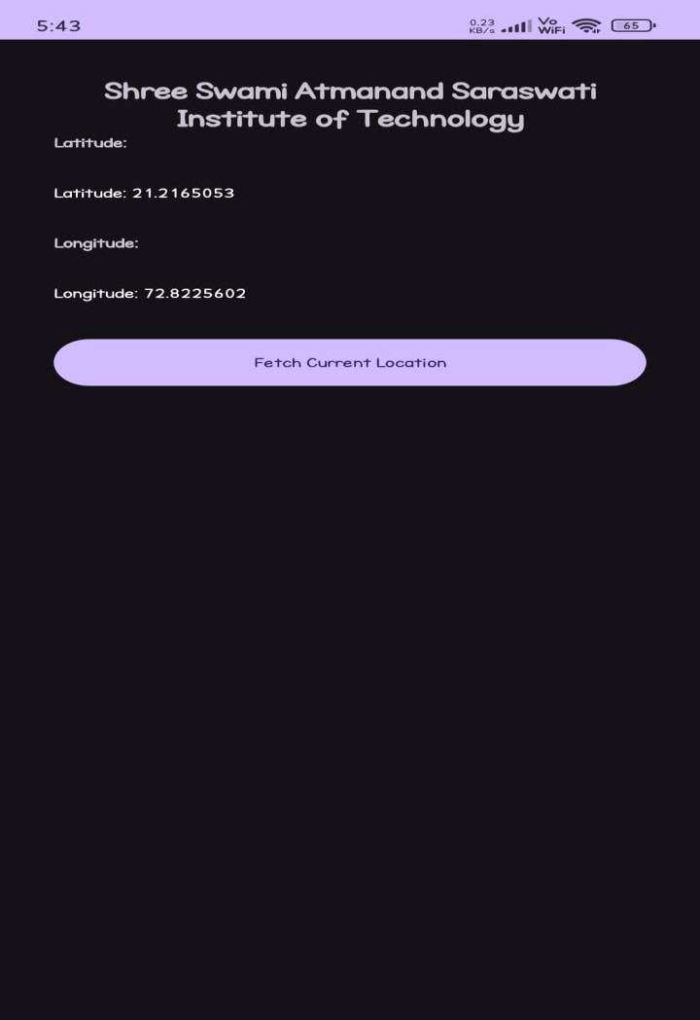

Practical 17

Aim: Display the use of animations Code:
activity_main.xml:
<?xml version="1.0" encoding="utf-8"?>
<LinearLayout xmlns:android="http://schemas.android.com/apk/res/android" xmlns:app="http://schemas.android.com/apk/res-auto" xmlns:tools="http://schemas.android.com/tools"
android:id="@+id/main" android:layout_width="match_parent" android:layout_height="match_parent" tools:context=".MainActivity" android:orientation="vertical" android:gravity="center_horizontal">
<ImageView android:id="@+id/imageview" android:layout_width="200dp" android:layout_height="200dp" android:layout_marginTop="20dp"
android:contentDescription="@string/app_name" android:src="@drawable/ic_launcher_background"
/>
<Button
android:id="@+id/animatedButton" android:layout_width="wrap_content" android:layout_height="wrap_content" android:text="Blink" android:layout_marginTop="20dp"
/>
<Button
android:id="@+id/rotateButton" android:layout_width="wrap_content" android:layout_height="wrap_content" android:text="Rotate" android:layout_marginTop="20dp"
/>
</LinearLayout>

MainActivity.java:
package com.ssasit.pr17;

import android.os.Bundle; import android.view.View;
import android.view.animation.Animation; import android.view.animation.AnimationUtils; import android.widget.*;
import androidx.appcompat.app.AppCompatActivity;

public class MainActivity extends AppCompatActivity { @Override
protected void onCreate(Bundle savedInstanceState) { super.onCreate(savedInstanceState); setContentView(R.layout.activity_main);
Button blinkBTN = findViewById(R.id.animatedButton); Button rtBTN = findViewById(R.id.rotateButton); ImageView imageView = findViewById(R.id.imageview);

blinkBTN.setOnClickListener(new View.OnClickListener() { @Override
public void onClick(View v) {
Animation animation = AnimationUtils.loadAnimation(getApplicationContext(), R.anim.blink);
imageView.startAnimation(animation);
}
});
rtBTN.setOnClickListener(new View.OnClickListener() { @Override
public void onClick(View v) {
Animation animation = AnimationUtils.loadAnimation(getApplicationContext(), R.anim.rotate);
imageView.startAnimation(animation);
}
});
}
}

Animation Files:
blink.xml
<?xml version="1.0" encoding="utf-8"?>
<set xmlns:android="http://schemas.android.com/apk/res/android">
<alpha android:fromAlpha="0.0" android:toAlpha="1.0"
android:interpolator="@android:anim/accelerate_interpolator" android:duration="600"
android:repeatMode="reverse" android:repeatCount="infinite"/>
</set>

rotate.xml
<?xml version="1.0" encoding="UTF-8"?>
<rotate xmlns:android="http://schemas.android.com/apk/res/android" android:duration="1600"
android:fromDegrees="0" android:interpolator="@android:anim/linear_interpolator" android:pivotX="50%"
android:pivotY="50%" android:repeatCount="infinite" android:toDegrees="358" />

Output:
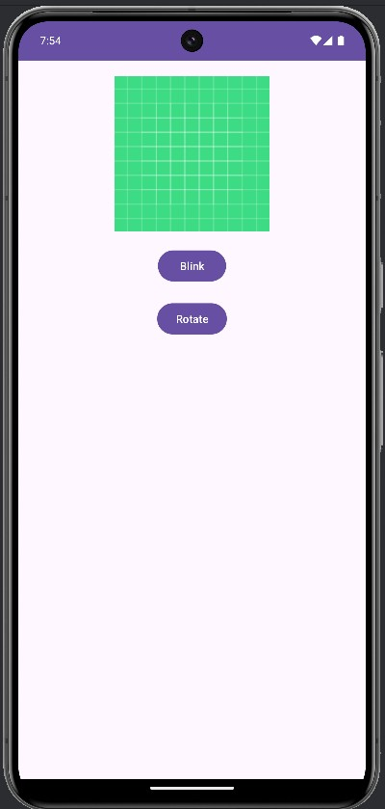
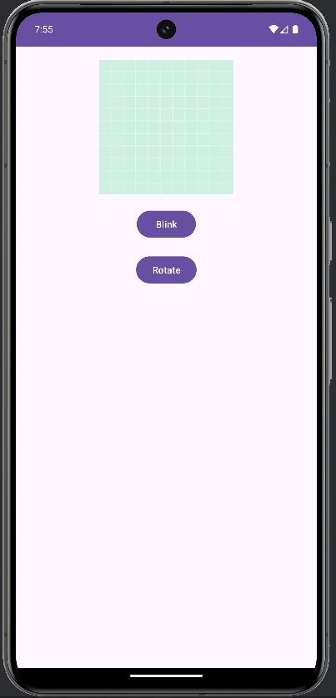

(Initial) (Blink)
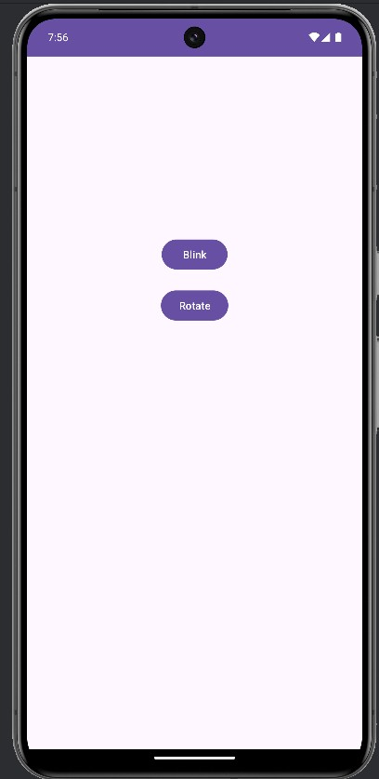
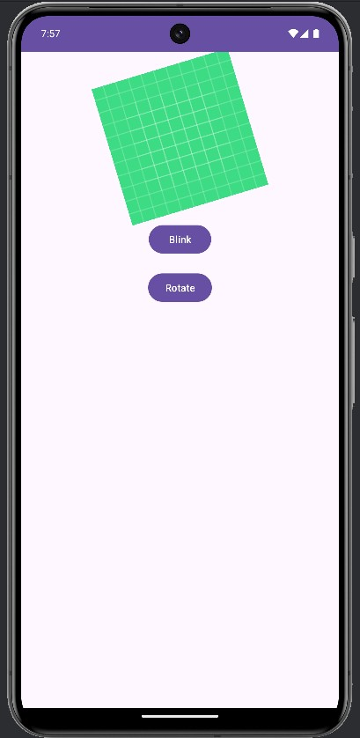
(Blink) (Rotate)

