Practical 1
Aim: Design Login activity and implement control events : Use EditText, Checkbox and Buttons
activity_main.xml:
<?xml version="1.0" encoding="utf-8"?>
<LinearLayout android:layout_margin="10dp" xmlns:android="http://schemas.android.com/apk/res/android"
xmlns:app="http://schemas.android.com/apk/res-auto"
xmlns:tools="http://schemas.android.com/tools"
android:layout_width="match_parent"
android:orientation="vertical"
android:layout_height="match_parent"
tools:context=".MainActivity">

<TextView
android:layout_width="match_parent"
android:layout_height="wrap_content"
android:gravity="center"
android:textSize="25dp"
android:text="Shree Swami Atmanand Saraswati Institute of Technology"
app:layout_constraintBottom_toBottomOf="parent"
app:layout_constraintEnd_toEndOf="parent"
app:layout_constraintStart_toStartOf="parent"
app:layout_constraintTop_toTopOf="parent" />

<ImageView
android:id="@+id/imageView"
android:layout_width="match_parent"
android:layout_height="271dp"
app:srcCompat="@drawable/ssasitlogo" />

<EditText
android:id="@+id/txt_u_name"
android:layout_width="match_parent"
android:layout_height="wrap_content"
android:ems="10"
android:inputType="text"
android:text="Enter Name" />

<EditText
android:id="@+id/txt_pass"
android:layout_width="match_parent"
android:layout_height="wrap_content"
android:hint="Password"
android:ems="10"
android:inputType="textPassword" />

<CheckBox
android:id="@+id/chk_rem"
android:layout_width="match_parent"
android:layout_height="wrap_content"
android:text="Remember me" />

<Button
android:id="@+id/btn_login"
android:layout_width="match_parent"
android:layout_height="wrap_content"
android:text="Login" />
</LinearLayout>

MainActivity.java:
package com.ssasit.pr1;
import androidx.appcompat.app.AppCompatActivity;
import android.os.Bundle;
import android.view.View;
import android.widget.Button;
import android.widget.CheckBox;
import android.widget.EditText;
import android.widget.Toast;

public class MainActivity extends AppCompatActivity {
EditText U_name;
EditText Pass;
CheckBox Remember;
Button login;
@Override
protected void onCreate(Bundle savedInstanceState) {
super.onCreate(savedInstanceState);
setContentView(R.layout.activity_main);
U_name = findViewById(R.id.txt_u_name);
Pass = findViewById(R.id.txt_pass);
Remember = findViewById(R.id.chk_rem);
login = findViewById(R.id.btn_login);

login.setOnClickListener(new View.OnClickListener() {
@Override
public void onClick(View view) {
if (Remember.isChecked()){
Toast.makeText(MainActivity.this, "Welcome "+U_name.getText().toString()+"!", Toast.LENGTH_SHORT).show();
}else{
Toast.makeText(MainActivity.this, "Me:(From future) I've never seen You before!!", Toast.LENGTH_SHORT).show();
}
}
});
}
}

Output:

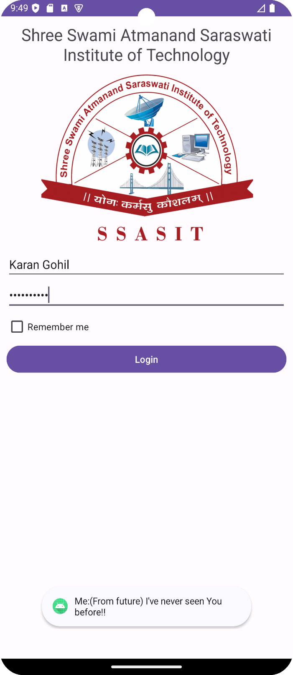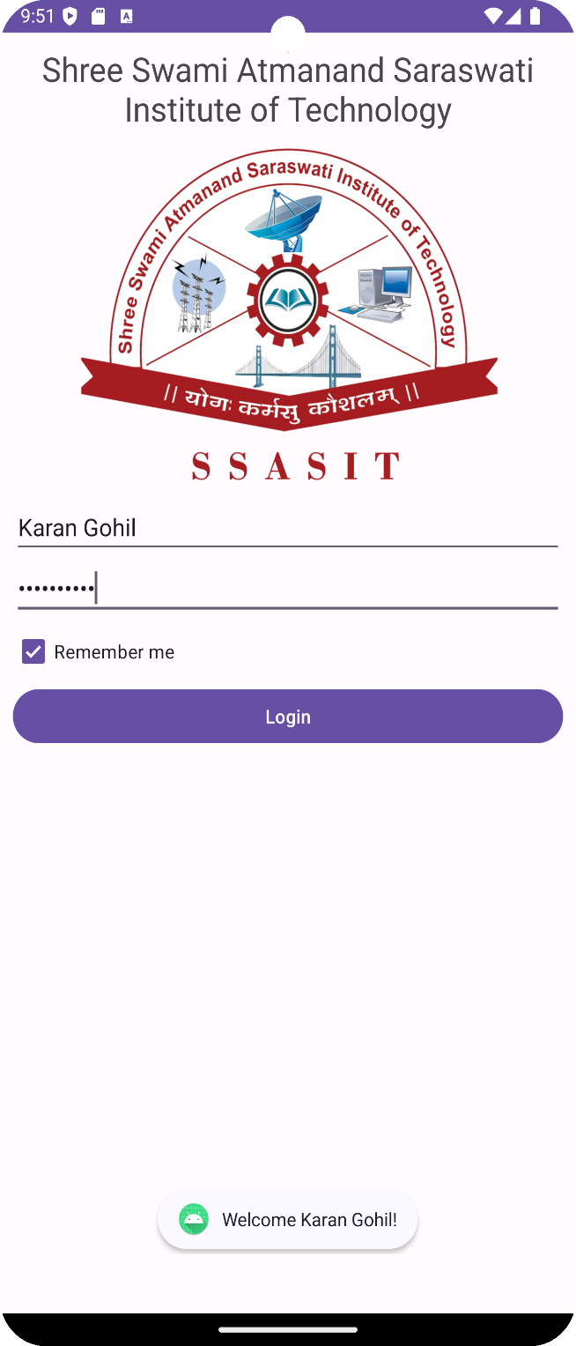
(without remember me button) (with remember me button)

Practical 2
Aim: Implement Practical 1 using following layouts:
1. Linear Layout
2. Relative Layout
3. Table Layout
Code:
- Linear Layout:
activity_main.xml:
<?xml version="1.0" encoding="utf-8"?>
<LinearLayout android:layout_margin="10dp" xmlns:android="http://schemas.android.com/apk/res/android"
xmlns:app="http://schemas.android.com/apk/res-auto"
xmlns:tools="http://schemas.android.com/tools"
android:layout_width="match_parent"
android:orientation="vertical"
android:layout_height="match_parent"
tools:context=".MainActivity">

<TextView
android:layout_width="match_parent"
android:layout_height="wrap_content"
android:gravity="center"
android:textSize="25dp"
android:text="Shree Swami Atmanand Saraswati Institute of Technology"
app:layout_constraintBottom_toBottomOf="parent"
app:layout_constraintEnd_toEndOf="parent"
app:layout_constraintStart_toStartOf="parent"
app:layout_constraintTop_toTopOf="parent" />

<ImageView
android:id="@+id/imageView"
android:layout_width="match_parent"
android:layout_height="271dp"
app:srcCompat="@drawable/ssasitlogo" />

<EditText
android:id="@+id/txt_u_name"
android:layout_width="match_parent"
android:layout_height="wrap_content"
android:ems="10"
android:inputType="text"
android:text="Enter Name" />
<EditText
android:id="@+id/txt_pass"
android:layout_width="match_parent"
android:layout_height="wrap_content"
android:hint="Password"
android:ems="10"
android:inputType="textPassword" />
<CheckBox
android:id="@+id/chk_rem"
android:layout_width="match_parent"
android:layout_height="wrap_content"
android:text="Remember me" />
<Button
android:id="@+id/btn_login"
android:layout_width="match_parent"
android:layout_height="wrap_content"
android:text="Login" />
</LinearLayout>

- Relative Layout:
activity_main.xml:
<?xml version="1.0" encoding="utf-8"?>
<RelativeLayout xmlns:android="http://schemas.android.com/apk/res/android"
xmlns:app="http://schemas.android.com/apk/res-auto"
xmlns:tools="http://schemas.android.com/tools"
android:layout_width="match_parent"
android:layout_height="match_parent"
android:layout_margin="10dp"
tools:context=".MainActivity">

<TextView
android:id="@+id/textView"
android:layout_width="match_parent"
android:layout_height="wrap_content"
android:gravity="center"
android:textSize="25dp"
android:text="Shree Swami Atmanand Saraswati Institute of Technology"
android:layout_centerHorizontal="true"
android:layout_alignParentTop="true" />
<ImageView
android:id="@+id/imageView"
android:layout_width="match_parent"
android:layout_height="271dp"
android:layout_below="@id/textView"
android:layout_marginTop="10dp"
app:srcCompat="@drawable/ssasitlogo" />
<EditText
android:id="@+id/txt_u_name"
android:layout_width="match_parent"
android:layout_height="wrap_content"
android:layout_below="@id/imageView"
android:layout_marginTop="10dp"
android:ems="10"
android:inputType="text"
android:text="Enter Name" />
<EditText
android:id="@+id/txt_pass"
android:layout_width="match_parent"
android:layout_height="wrap_content"
android:layout_below="@id/txt_u_name"
android:layout_marginTop="10dp"
android:hint="Password"
android:ems="10"
android:inputType="textPassword" />
<CheckBox
android:id="@+id/chk_rem"
android:layout_width="match_parent"
android:layout_height="wrap_content"
android:layout_below="@id/txt_pass"
android:layout_marginTop="10dp"
android:text="Remember me" />
<Button
android:id="@+id/btn_login"
android:layout_width="match_parent"
android:layout_height="wrap_content"
android:layout_below="@id/chk_rem"
android:layout_marginTop="10dp"
android:text="Login" />
</RelativeLayout>

- Table Layout:
activity_main.xml:
<?xml version="1.0" encoding="utf-8"?>
<TableLayout xmlns:android="http://schemas.android.com/apk/res/android"
xmlns:app="http://schemas.android.com/apk/res-auto"
xmlns:tools="http://schemas.android.com/tools"
android:layout_width="match_parent"
android:layout_height="match_parent"
android:layout_margin="10dp"
tools:context=".MainActivity"
android:stretchColumns="1">

<TableRow>
<TextView
android:layout_width="match_parent"
android:layout_height="wrap_content"
android:gravity="center"
android:textSize="25dp"
android:text="Shree Swami Atmanand Saraswati Institute of Technology"
android:layout_span="2"/>
</TableRow>

<TableRow>
<ImageView
android:id="@+id/imageView"
android:layout_width="match_parent"
android:layout_height="271dp"
android:layout_span="2"
app:srcCompat="@drawable/ssasitlogo" />
</TableRow>
<TableRow>
<EditText
android:id="@+id/txt_u_name"
android:layout_width="match_parent"
android:layout_height="wrap_content"
android:ems="10"
android:inputType="text"
android:text="Enter Name"
android:layout_span="2"/>
</TableRow>
<TableRow>
<EditText
android:id="@+id/txt_pass"
android:layout_width="match_parent"
android:layout_height="wrap_content"
android:hint="Password"
android:ems="10"
android:inputType="textPassword"
android:layout_span="2"/>
</TableRow>

<TableRow>
<CheckBox
android:id="@+id/chk_rem"
android:layout_width="match_parent"
android:layout_height="wrap_content"
android:text="Remember me"
android:layout_span="2"/>
</TableRow>

<TableRow>
<Button
android:id="@+id/btn_login"
android:layout_width="match_parent"
android:layout_height="wrap_content"
android:text="Login"
android:layout_span="2"/>
</TableRow>
</TableLayout>

MainActivity.java:
package com.ssasit.pr1;
import androidx.appcompat.app.AppCompatActivity;
import android.os.Bundle;
import android.view.View;
import android.widget.Button;
import android.widget.CheckBox;
import android.widget.EditText;
import android.widget.Toast;

public class MainActivity extends AppCompatActivity {
EditText U_name;
EditText Pass;
CheckBox Remember;
Button login;
@Override
protected void onCreate(Bundle savedInstanceState) {
super.onCreate(savedInstanceState);
setContentView(R.layout.activity_main);
U_name = findViewById(R.id.txt_u_name);
Pass = findViewById(R.id.txt_pass);
Remember = findViewById(R.id.chk_rem);
login = findViewById(R.id.btn_login);

login.setOnClickListener(new View.OnClickListener() {
@Override
public void onClick(View view) {
if (Remember.isChecked()){
Toast.makeText(MainActivity.this, "Welcome "+U_name.getText().toString()+"!", Toast.LENGTH_SHORT).show();
}else{
Toast.makeText(MainActivity.this, "Me:(From future) I've never seen You before!!", Toast.LENGTH_SHORT).show();
}
}
});
}
}

Output:

(without remember me button) (with remember me button)

Practical 3
Aim: Create Activities & implement following
1. Implicit intent
2. Explicit Intent
3. StartActivityForResult
Code:
activity_main.xml:
<?xml version="1.0" encoding="utf-8"?>
<RelativeLayout xmlns:android="http://schemas.android.com/apk/res/android"
xmlns:app="http://schemas.android.com/apk/res-auto"
xmlns:tools="http://schemas.android.com/tools"
android:layout_width="match_parent"
android:layout_margin="10dp"
android:layout_height="match_parent"
tools:context=".MainActivity">

<ImageView
android:id="@+id/imageView"
android:layout_width="278dp"
android:layout_height="wrap_content"
android:layout_alignParentStart="true"
android:layout_alignParentTop="true"
android:layout_alignParentEnd="true"
android:layout_alignParentBottom="true"
android:layout_marginStart="67dp"
android:layout_marginEnd="67dp"
android:layout_marginBottom="453dp"
app:srcCompat="@drawable/ssasitlogo" />

<EditText
android:id="@+id/txturl"
android:layout_width="match_parent"
android:layout_height="wrap_content"
android:layout_alignParentTop="true"
android:layout_alignParentBottom="true"
android:layout_marginTop="10dp"
android:layout_marginBottom="10dp"
android:ems="10"
android:hint="Enter URL"
android:inputType="text" />

<Button
android:id="@+id/btnimp"
android:layout_width="match_parent"
android:layout_height="wrap_content"
android:layout_alignParentStart="true"
android:layout_alignParentEnd="true"
android:layout_alignParentBottom="true"
android:layout_marginStart="113dp"
android:layout_marginEnd="109dp"
android:layout_marginBottom="254dp"
android:text="Implicit Intent" />

<Button
android:id="@+id/btnexp"
android:layout_width="match_parent"
android:layout_height="wrap_content"
android:layout_alignParentStart="true"
android:layout_alignParentEnd="true"
android:layout_alignParentBottom="true"
android:layout_marginStart="111dp"
android:layout_marginEnd="111dp"
android:layout_marginBottom="172dp"
android:text="Explicit Intent" />
</RelativeLayout>

MainActivity.java:
package com.ssasit.pr3;
import androidx.activity.result.contract.ActivityResultContracts;
import androidx.appcompat.app.AppCompatActivity;
import android.content.Intent;
import android.net.Uri;
import android.os.Bundle;
import android.view.View;
import android.widget.Button;
import android.widget.EditText;

public class MainActivity extends AppCompatActivity {

EditText url;
Button imp,exp;

@Override
protected void onCreate(Bundle savedInstanceState) {
super.onCreate(savedInstanceState);
setContentView(R.layout.activity_main);
url = findViewById(R.id.txturl);
imp = findViewById(R.id.btnimp);
exp = findViewById(R.id.btnexp);

exp.setOnClickListener(new View.OnClickListener() {
@Override
public void onClick(View view) {
Intent exintent = new Intent(MainActivity.this,SecondActivity.class);
startActivity(exintent);
}
});

imp.setOnClickListener(new View.OnClickListener() {
@Override
public void onClick(View view) {
Intent impintent = new Intent(Intent.ACTION_VIEW, Uri.parse("https://"+url.getText().toString()));
startActivity(impintent);
}
});
}
}

activity_second.xml:
<?xml version="1.0" encoding="utf-8"?>
<RelativeLayout xmlns:android="http://schemas.android.com/apk/res/android"
xmlns:app="http://schemas.android.com/apk/res-auto"
xmlns:tools="http://schemas.android.com/tools"
android:layout_width="match_parent"
android:layout_height="match_parent"
android:layout_margin="10dp"
tools:context=".SecondActivity">

<TextView
android:id="@+id/textView"
android:layout_width="wrap_content"
android:layout_height="wrap_content"
android:layout_alignParentEnd="true"
android:layout_alignParentBottom="true"
android:layout_marginEnd="91dp"
android:layout_marginBottom="373dp"
android:text="Second Activity"
android:textSize="80px" />
</RelativeLayout>

SecondActivity.java:
package com.ssasit.pr3;
import androidx.appcompat.app.AppCompatActivity;
import android.os.Bundle;
public class SecondActivity extends AppCompatActivity {
@Override
protected void onCreate(Bundle savedInstanceState) {
super.onCreate(savedInstanceState);
setContentView(R.layout.activity_second);
}
}

Output:
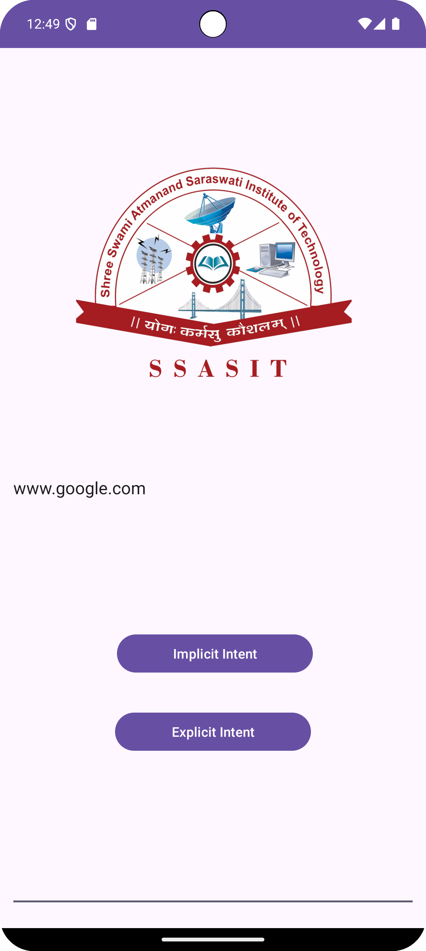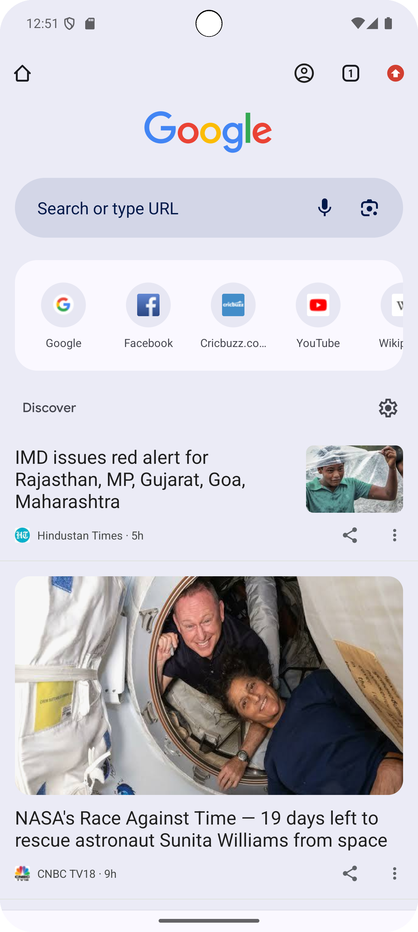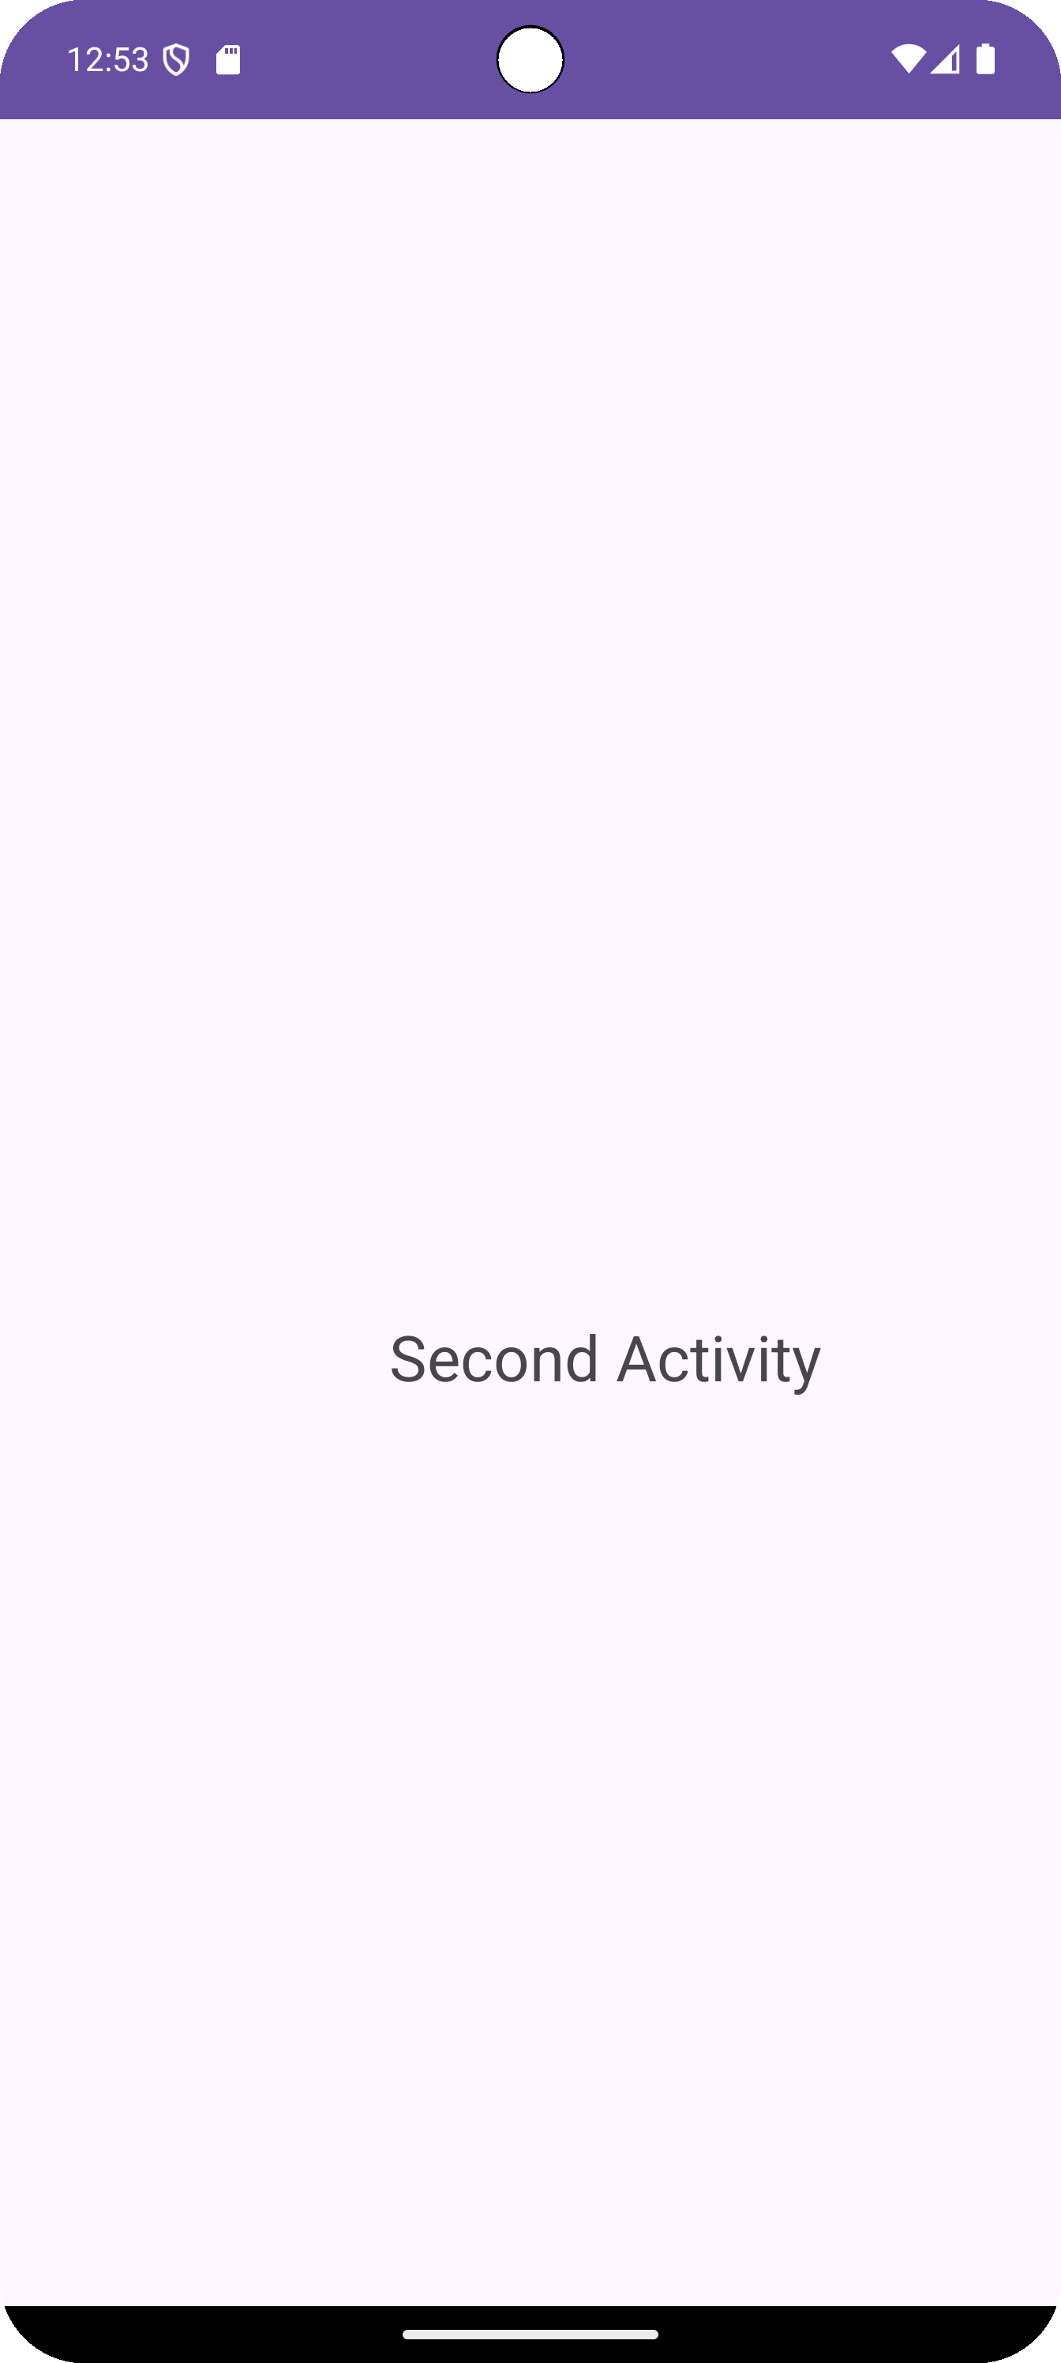
(Home page) (Implicit Intent) (Explicit Intent)

StartActivityForResult:
activity_main.xml:
<?xml version="1.0" encoding="utf-8"?>
<androidx.constraintlayout.widget.ConstraintLayout xmlns:android="http://schemas.android.com/apk/res/android"
xmlns:app="http://schemas.android.com/apk/res-auto"
xmlns:tools="http://schemas.android.com/tools"
android:layout_margin="10dp"
android:layout_width="match_parent"
android:layout_height="match_parent"
tools:context=".MainActivity">
<ImageView
android:id="@+id/imageView2"
android:layout_width="match_parent"
android:layout_height="wrap_content"
android:layout_weight="1"
app:layout_constraintEnd_toEndOf="parent"
app:layout_constraintStart_toStartOf="parent"
app:layout_constraintTop_toTopOf="parent"
app:srcCompat="@drawable/ssasit_logo" />
<TextView
android:id="@+id/txtname"
android:layout_width="107dp"
android:layout_height="91dp"
android:layout_marginTop="44dp"
android:layout_weight="1"
android:hint="Enter Message"
app:layout_constraintBottom_toTopOf="@+id/btnsub"
app:layout_constraintEnd_toEndOf="parent"
app:layout_constraintHorizontal_bias="0.501"
app:layout_constraintStart_toStartOf="parent"
app:layout_constraintTop_toBottomOf="@+id/imageView2"
app:layout_constraintVertical_bias="0.22" />
<Button
android:id="@+id/btnsub"
android:layout_width="wrap_content"
android:layout_height="wrap_content"
android:layout_marginBottom="208dp"
android:layout_weight="1"
android:text="Button"
app:layout_constraintBottom_toBottomOf="parent"
app:layout_constraintEnd_toEndOf="parent"
app:layout_constraintHorizontal_bias="0.501"
app:layout_constraintStart_toStartOf="parent" />
</androidx.constraintlayout.widget.ConstraintLayout>

MainActivity.java:
package com.ssasit.pr3_2;
import androidx.activity.result.contract.ActivityResultContracts;
import androidx.annotation.Nullable;
import androidx.appcompat.app.AppCompatActivity
import android.content.Intent;
import android.os.Bundle;
import android.view.View;
import android.widget.Button;
import android.widget.TextView;
public class MainActivity extends AppCompatActivity {
TextView tv;
Button btn;
@Override
protected void onCreate(Bundle savedInstanceState) {
super.onCreate(savedInstanceState);
setContentView(R.layout.activity_main);
tv = findViewById(R.id.txtname);
btn = findViewById(R.id.btnsub);
btn.setOnClickListener(new View.OnClickListener() {
@Override
public void onClick(View view) {
Intent intent = new Intent(MainActivity.this,second_activity.class);
startActivityForResult(intent,21);
}
});
}
@Override
protected void onActivityResult(int requestCode, int resultCode, @Nullable Intent data) {
super.onActivityResult(requestCode, resultCode, data);
String msg = data.getStringExtra("msg");
tv.setText(msg);
}
}

activity_second.xml:
<?xml version="1.0" encoding="utf-8"?>
<androidx.constraintlayout.widget.ConstraintLayout xmlns:android="http://schemas.android.com/apk/res/android"
xmlns:app="http://schemas.android.com/apk/res-auto"
xmlns:tools="http://schemas.android.com/tools"
android:layout_width="match_parent"
android:layout_height="match_parent"
android:layout_margin="10dp"
tools:context=".second_activity">
<EditText
android:id="@+id/etxtname"
android:layout_width="wrap_content"
android:layout_height="wrap_content"
android:ems="10"
android:inputType="text"
android:text="Second Activity"
app:layout_constraintBottom_toBottomOf="parent"
app:layout_constraintEnd_toEndOf="parent"
app:layout_constraintStart_toStartOf="parent"
app:layout_constraintTop_toTopOf="parent"
app:layout_constraintVertical_bias="0.272" />
<Button
android:id="@+id/btn"
android:layout_width="133dp"
android:layout_height="69dp"
android:text="Button"
app:layout_constraintBottom_toBottomOf="parent"
app:layout_constraintEnd_toEndOf="parent"
app:layout_constraintHorizontal_bias="0.501"
app:layout_constraintStart_toStartOf="parent"
app:layout_constraintTop_toBottomOf="@+id/etxtname"
app:layout_constraintVertical_bias="0.166" />
</androidx.constraintlayout.widget.ConstraintLayout>

SecondActivity.java:
package com.ssasit.pr3;
import androidx.appcompat.app.AppCompatActivity;
import android.os.Bundle;
public class SecondActivity extends AppCompatActivity
@Override
protected void onCreate(Bundle savedInstanceState) {
super.onCreate(savedInstanceState);
setContentView(R.layout.activity_second);
}
}

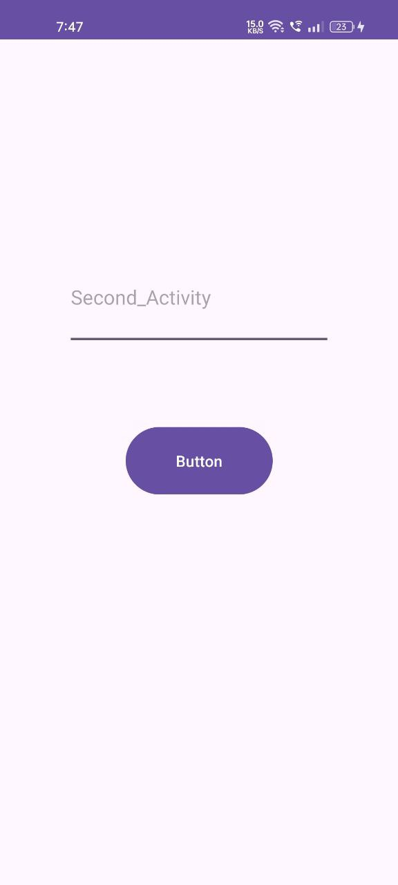
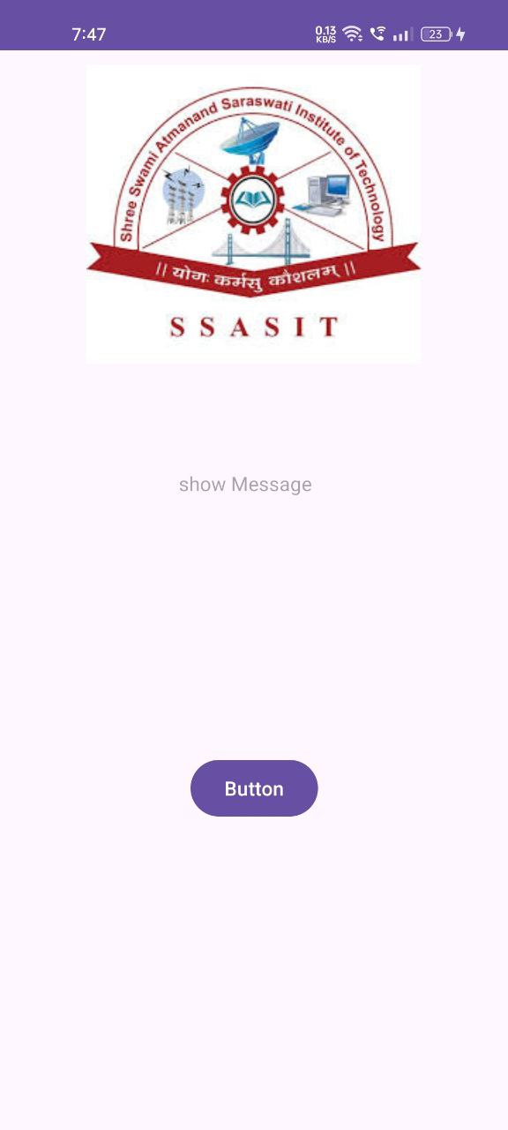
Output:
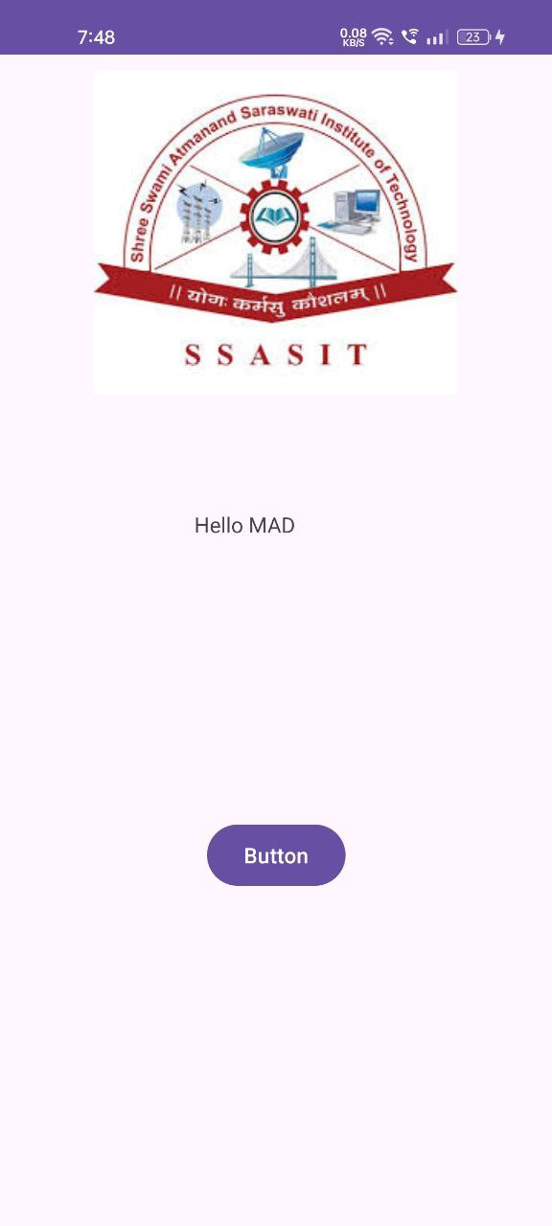


Practical 4
Aim: Implement activity Lifecycle and State Callbacks
Code:
MainActivity.java:
package com.ssasit.pr4;
import android.os.Bundle;
import android.util.Log;
import androidx.appcompat.app.AppCompatActivity;
public class MainActivity extends AppCompatActivity {
private static final String tag = "LifeCycle";
@Override
protected void onCreate(Bundle savedInstanceState) {
super.onCreate(savedInstanceState);
Log.d(tag, "onCreate");
// Initialize your activity here
}
@Override
protected void onStart() {
super.onStart();
Log.d(tag, "onStart");
}
@Override
protected void onResume() {
super.onResume();
Log.d(tag, "onResume");
}
@Override
protected void onPause() {
super.onPause();
Log.d(tag, "onPause");
}
@Override
protected void onStop() {
super.onStop();
Log.d(tag, "onStop");
}
@Override
protected void onDestroy() {
super.onDestroy();
Log.d(tag, "onDestroy");
}
@Override
protected void onRestart() {
super.onRestart();
Log.d(tag, "onRestart");
}
}

Output:
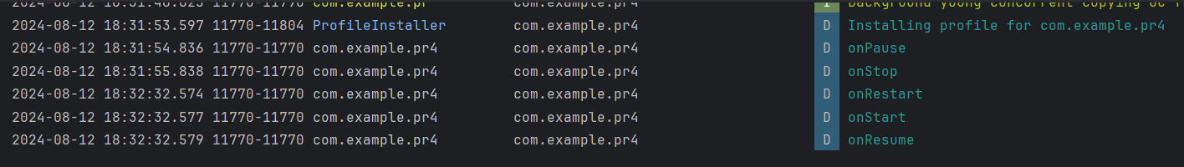

Practical 5
Aim: Use an Options Menu
Code:
activity_main.xml:
<?xml version="1.0" encoding="utf-8"?>
<androidx.constraintlayout.widget.ConstraintLayout xmlns:android="http://schemas.android.com/apk/res/android"
xmlns:app="http://schemas.android.com/apk/res-auto"
xmlns:tools="http://schemas.android.com/tools"
android:layout_width="match_parent"
android:layout_height="match_parent"
android:layout_margin="10dp"
tools:context=".MainActivity">

<com.google.android.material.appbar.MaterialToolbar
android:id="@+id/mtool"
android:layout_width="0dp"
android:layout_height="wrap_content"
app:layout_constraintBottom_toTopOf="@+id/imageView"
app:layout_constraintEnd_toEndOf="parent"
app:layout_constraintHorizontal_bias="0.0"
app:layout_constraintStart_toStartOf="parent"
app:layout_constraintTop_toTopOf="parent"
app:layout_constraintVertical_bias="0.0" />

<ImageView
android:id="@+id/imageView"
android:layout_width="285dp"
android:layout_height="271dp"
app:layout_constraintBottom_toBottomOf="parent"
app:layout_constraintEnd_toEndOf="parent"
app:layout_constraintHorizontal_bias="0.504"
app:layout_constraintStart_toStartOf="parent"
app:layout_constraintTop_toTopOf="parent"
app:layout_constraintVertical_bias="0.145"
app:srcCompat="@drawable/ssasit_logo" />
</androidx.constraintlayout.widget.ConstraintLayout>

MainActivity.java:
package com.ssasit.pr5;

import androidx.annotation.NonNull;
import androidx.appcompat.app.AppCompatActivity;
import androidx.appcompat.widget.Toolbar;
import android.os.Bundle;
import android.view.Menu;
import android.view.MenuInflater;
import android.view.MenuItem;
import android.widget.Toast;

public class MainActivity extends AppCompatActivity {
Toolbar mn;
@Override
protected void onCreate(Bundle savedInstanceState) {
super.onCreate(savedInstanceState);
setContentView(R.layout.activity_main);
mn = findViewById(R.id.mtool);
setSupportActionBar(mn);
}

@Override
public boolean onCreateOptionsMenu(Menu menu) {
MenuInflater mnu = getMenuInflater();
mnu.inflate(R.menu.menu_item,menu);
return super.onCreateOptionsMenu(menu);
}

@Override
public boolean onOptionsItemSelected(@NonNull MenuItem item) {
int id = item.getItemId();
if (id == R.id.profile){
Toast.makeText(this, "Profile", Toast.LENGTH_SHORT).show();
return true;
} else if (id == R.id.info) {
Toast.makeText(this, "info", Toast.LENGTH_SHORT).show();
return true;
} else if (id == R.id.setting) {
Toast.makeText(this, "setting", Toast.LENGTH_SHORT).show();
return true;
} else if (id == R.id.aboutus) {
Toast.makeText(this, "About US", Toast.LENGTH_SHORT).show();
return true;
} else {
Toast.makeText(this, "Logout", Toast.LENGTH_SHORT).show();
return super.onOptionsItemSelected(item);
}
}
}

Menu_item.xml:
<?xml version="1.0" encoding="utf-8"?>
<menu xmlns:app="http://schemas.android.com/apk/res-auto"
xmlns:android="http://schemas.android.com/apk/res/android">
<item android:title="Profile"
android:id="@+id/profile"/>
<item android:title="Info"
android:id="@+id/info"/>
<item android:title="Setting"
android:id="@+id/setting"/>
<item android:title="About Us"
android:id="@+id/aboutus"/>
<item android:title="Logout"
android:id="@+id/logout"/>
</menu>

Output:
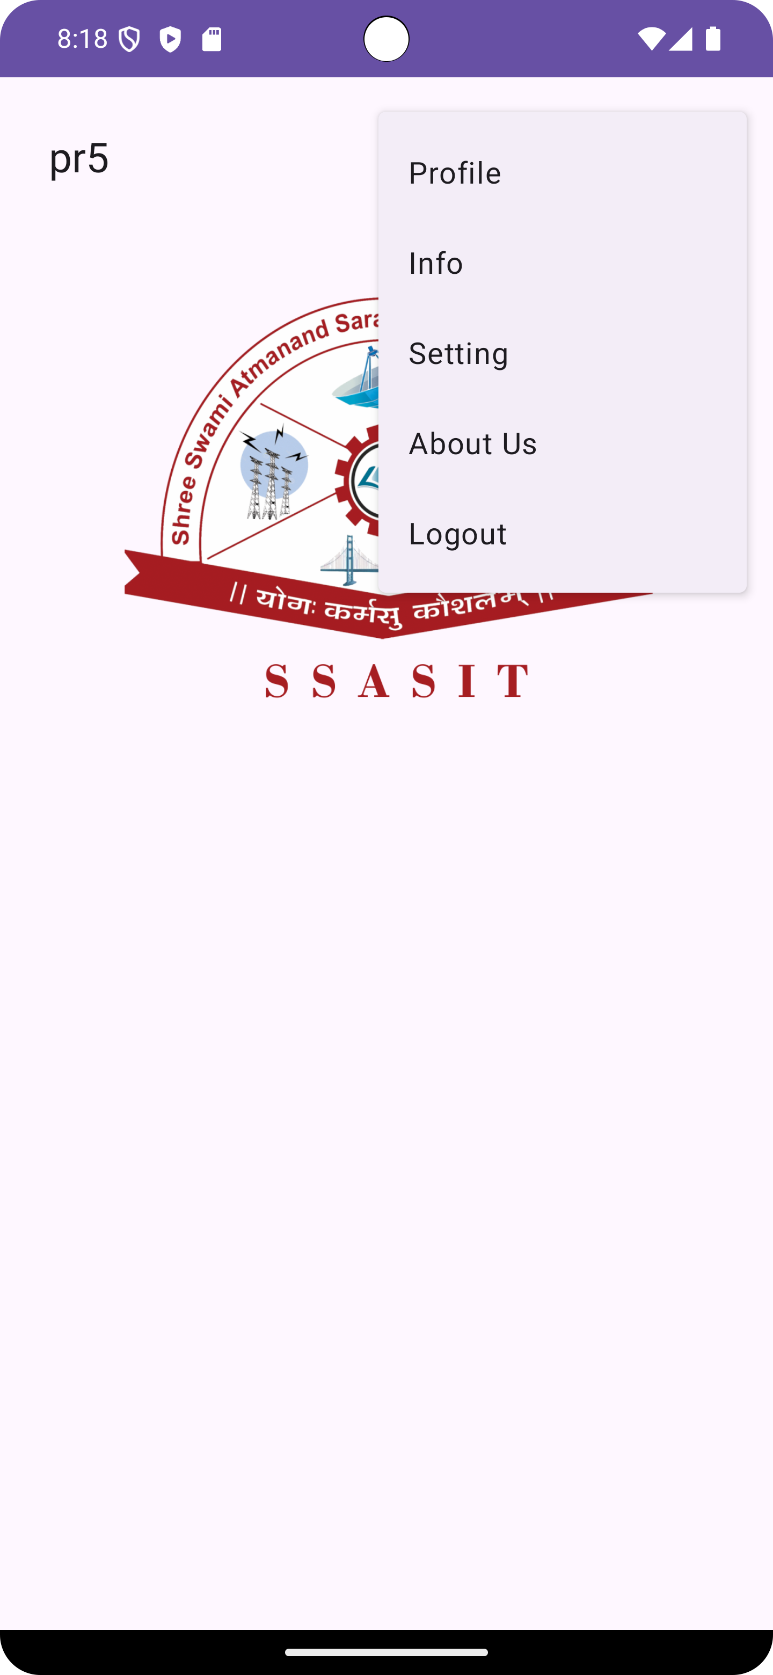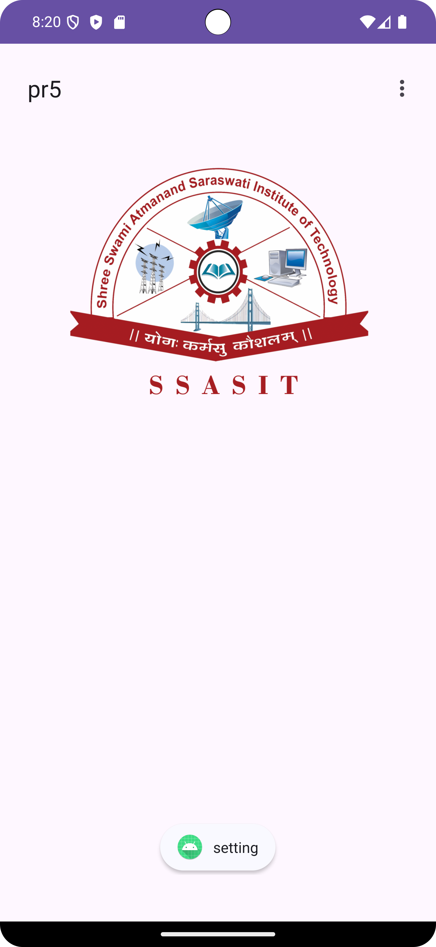

Practical 6
Aim: Create a Recycler View and list the details of student using following fields: 1. Name 2. Address 3. Photo (Image) 4. Delete ( Button Operation).
Code:
activity_main.xml:
<?xml version="1.0" encoding="utf-8"?>
<LinearLayout xmlns:android="http://schemas.android.com/apk/res/android"
xmlns:app="http://schemas.android.com/apk/res-auto"
xmlns:tools="http://schemas.android.com/tools"
android:layout_margin="10dp"
android:layout_width="match_parent"
android:layout_height="match_parent"
tools:context=".MainActivity">
<androidx.recyclerview.widget.RecyclerView
android:id="@+id/recycler_view"
android:layout_width="match_parent"
android:layout_height="match_parent" />
</LinearLayout>

student_item.xml:
<?xml version="1.0" encoding="utf-8"?>
<LinearLayout xmlns:android="http://schemas.android.com/apk/res/android"
xmlns:app="http://schemas.android.com/apk/res-auto"
xmlns:tools="http://schemas.android.com/tools"
android:layout_margin="10dp"
android:orientation="horizontal"
android:layout_width="match_parent"
android:layout_height="wrap_content"
tools:context=".MainActivity">
<ImageView
android:id="@+id/img"
android:layout_width="50dp"
android:layout_height="50dp"
app:srcCompat="@drawable/sssit1" />
<LinearLayout
android:layout_width="match_parent"
android:layout_height="wrap_content"
android:layout_weight="1"
android:orientation="vertical">
<TextView
android:id="@+id/txtname"
android:layout_width="wrap_content"
android:layout_height="match_parent"
android:text="Name"
android:textSize="20dp" />
<TextView
android:id="@+id/txtaddress"
android:layout_width="wrap_content"
android:layout_height="wrap_content"
android:text="Address" />
</LinearLayout>
<Button
android:id="@+id/btn"
android:layout_width="wrap_content"
android:layout_height="match_parent"
android:text="Delete" />
</LinearLayout>

MainActivity.java:
package com.ssasit.pr6;
import androidx.appcompat.app.AppCompatActivity;
import androidx.recyclerview.widget.LinearLayoutManager;
import androidx.recyclerview.widget.RecyclerView;
import android.os.Bundle;
import android.provider.CallLog;
import android.widget.Button;
import android.widget.TextView;
import java.util.ArrayList;
import java.util.List;
public class MainActivity extends AppCompatActivity {
private RecyclerView recyclerView;
private studentadapter adapter;
private List<student> studentlist; // Here, <student> is datatype of list &
// studentlist is object of list.
@Override
protected void onCreate(Bundle savedInstanceState) {
super.onCreate(savedInstanceState);
setContentView(R.layout.activity_main);
recyclerView = findViewById(R.id.recycler_view);
recyclerView.setLayoutManager(new LinearLayoutManager(this));
studentlist = new ArrayList<>(); // Generate Empty array list, to use during runtime.
studentlist.add(new student("Jeet","123, ABC Street, Surat",R.drawable.img1));
studentlist.add(new student("WIR","245, BBC Street, Delhi",R.drawable.img2));
studentlist.add(new student("GKD","765, HDS Street, Pune",R.drawable.img1));
studentlist.add(new student("ABC","356, FSE Street, Rajkot",R.drawable.img2));
studentlist.add(new student("PQR","687, YRE Street, Gandhinagar",R.drawable.img1));
studentlist.add(new student("XYZ","456, HFD Street, Baroda",R.drawable.img2));
studentlist.add(new student("LMA","344, HKG Street, Rajkot",R.drawable.img1));
studentlist.add(new student("SDK","234, LTK Street, Mumbai",R.drawable.img2));
studentlist.add(new student("KFD","133, PRE Street, Mumbai",R.drawable.img1));
studentlist.add(new student("AKR","456, HIT Street, Rajkot",R.drawable.img2));
adapter = new studentadapter(this,studentlist,this::onDeleteClick);
recyclerView.setAdapter(adapter);
}
public void onDeleteClick(int position){
studentlist.remove(position);
adapter.notifyItemRemoved(position);
}
}

student.java:
package com.ssasit.pr6;
public class student {
String name,address;
int image;
public student(String name, String address, int image) {
this.name = name;
this.address = address;
this.image = image;
}
public String getName() {
return name;
}
public void setName(String name) {
this.name = name;
}

public String getAddress() {
return address;
}
public void setAddress(String address) {
this.address = address;
}
public int getImage() {
return image;
}
public void setImage(int image) {
this.image = image;
}
}

studentadapter.java:
package com.ssasit.pr6;
import android.content.Context;
import android.view.LayoutInflater;
import android.view.View;
import android.view.ViewGroup;
import android.widget.Button;
import android.widget.ImageView;
import android.widget.TextView;
import androidx.annotation.NonNull;
import androidx.appcompat.view.menu.MenuView;
import androidx.recyclerview.widget.RecyclerView;
import java.util.List;
public class studentadapter extends RecyclerView.Adapter<studentadapter.studentviewholder> {
private Context context;
private List<student> studentlist;
private onDeleteClickListener onDeleteClickListener;
public studentadapter(Context context, List<student> studentlist, onDeleteClickListener onDeleteClickListener) {
this.context = context;
this.studentlist = studentlist;
this.onDeleteClickListener = onDeleteClickListener;
}
@NonNull
@Override
public studentviewholder onCreateViewHolder(@NonNull ViewGroup viewGroup, int i) { // Here, viewGroup is parent.
View view = LayoutInflater.from(context).inflate(R.layout.student_item,viewGroup,false); //pass the parent here.
return new studentviewholder(view,onDeleteClickListener);
}
@Override
public void onBindViewHolder(@NonNull studentviewholder studentviewholder, int i) { //Here, int i is the position.
student student = studentlist.get(i); // pass the position here.
studentviewholder.nametv.setText((student.getName()));
studentviewholder.addresstv.setText((student.getAddress()));
studentviewholder.photoid.setImageResource((student.getImage()));
}
@Override
public int getItemCount() {
return studentlist.size();
}
public interface onDeleteClickListener{
void onDeleteClick(int i); // Here, i is the position of item, which user wants to be deleted.
}
public class studentviewholder extends RecyclerView.ViewHolder{
TextView nametv,addresstv;
ImageView photoid;
Button deletebutton;
public studentviewholder(@NonNull View itemView, onDeleteClickListener onDeleteClickListener) {
super(itemView);
nametv = itemView.findViewById(R.id.txtname);
addresstv = itemView.findViewById(R.id.txtaddress);
photoid = itemView.findViewById(R.id.img);
deletebutton = itemView.findViewById(R.id.btn);
deletebutton.setOnClickListener(new View.OnClickListener() {
@Override
public void onClick(View view) {
if (onDeleteClickListener != null){
int position = getAdapterPosition();
if (position != RecyclerView.NO_POSITION){
onDeleteClickListener.onDeleteClick(position);
}
}
}
});
}
}
}

Output:
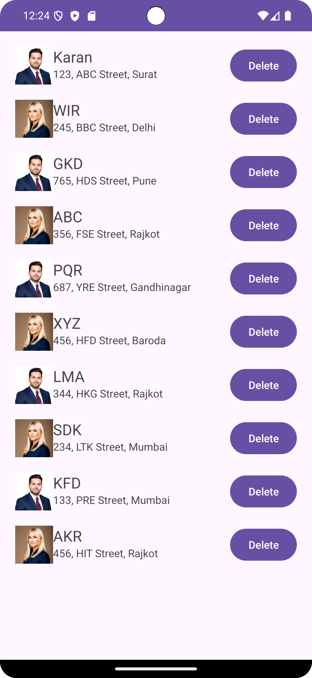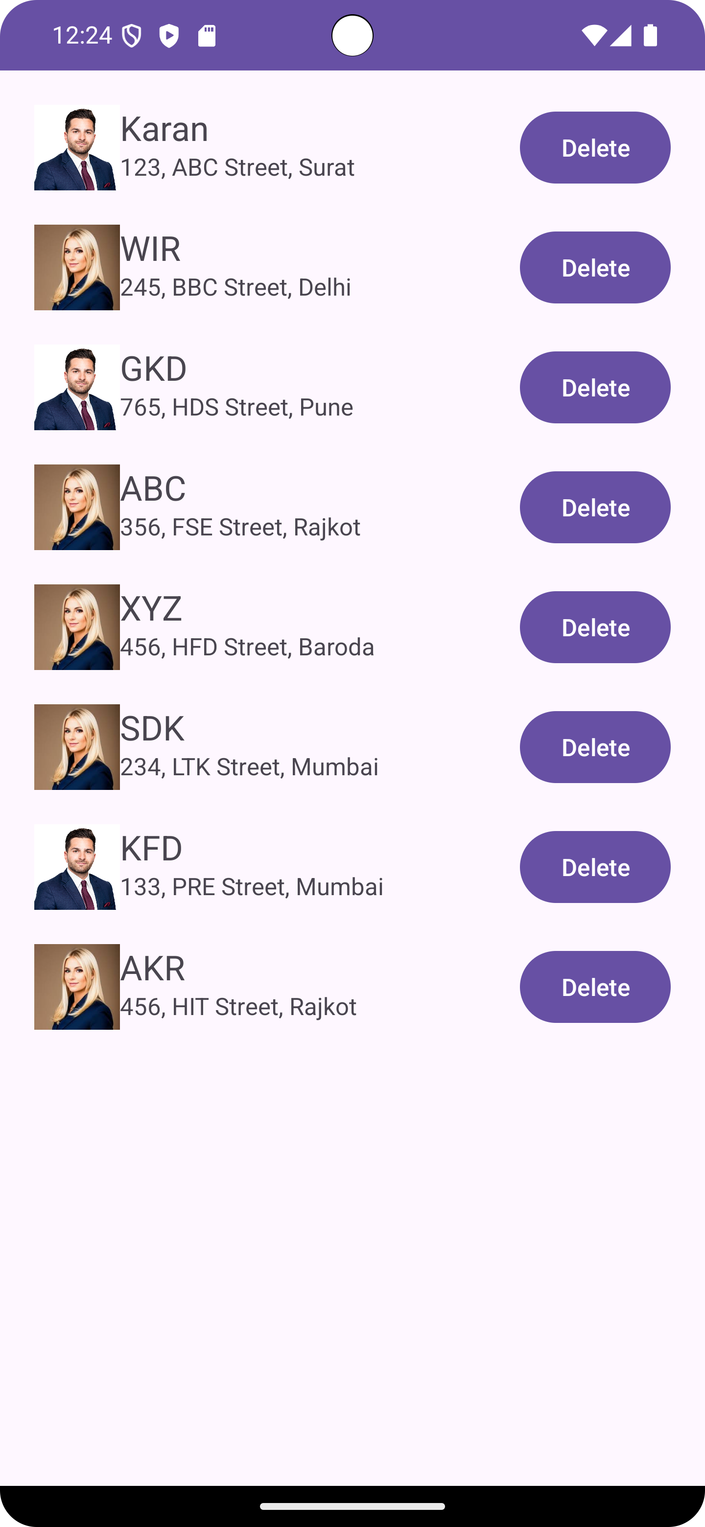
(Initial Screen) (After Delete)

