Practical 7

Aim: Practical: Theme, Custom Styles, Drawables. Code:
activity_main.xml:
<?xml version="1.0" encoding="utf-8"?>
<LinearLayout xmlns:android="http://schemas.android.com/apk/res/android" xmlns:app="http://schemas.android.com/apk/res-auto" xmlns:tools="http://schemas.android.com/tools"
android:id="@+id/main" android:layout_width="match_parent" android:layout_height="match_parent" android:layout_margin="10dp" android:orientation="vertical" tools:context=".MainActivity">
<RelativeLayout android:layout_width="match_parent" android:layout_height="0dp" android:layout_margin="10dp" android:layout_weight="1">
<ImageButton android:id="@+id/Ibtn_t1_Up" android:layout_width="70dp" android:layout_height="70dp" android:layout_centerVertical="true" android:layout_alignParentLeft="true" android:onClick="IncreaseScore" style="@style/PlusButtons"/>
<ImageButton android:id="@+id/Ibtn_t1_DOWN" android:layout_width="70dp" android:layout_height="70dp" android:layout_alignParentRight="true" android:layout_centerVertical="true" android:onClick="DecreaseScore" style="@style/MinusButtons"/>
<TextView android:id="@+id/tv_t1_score" android:layout_width="wrap_content"
android:layout_height="wrap_content" android:layout_centerVertical="true" android:layout_centerHorizontal="true" android:textSize="25dp" style="@style/ScoreText" android:text="0"/>
<TextView android:id="@+id/tv_t1"
android:layout_width="wrap_content" android:layout_height="wrap_content" android:text="Team 1" android:textSize="50dp" style="@style/TeamText" android:layout_centerHorizontal="true"/>
</RelativeLayout>

<RelativeLayout android:layout_width="match_parent" android:layout_height="0dp" android:layout_margin="10dp" android:layout_weight="1">
<ImageButton android:id="@+id/Ibtn_t2_UP" android:layout_width="70dp" android:layout_height="70dp" android:layout_centerVertical="true" android:layout_alignParentLeft="true" android:onClick="IncreaseScore" style="@style/PlusButtons" />
<ImageButton android:id="@+id/Ibtn_t2_DOWN" android:layout_width="70dp" android:layout_height="70dp" android:layout_centerVertical="true" android:layout_alignParentRight="true" android:onClick="DecreaseScore" style="@style/MinusButtons" />
<TextView android:id="@+id/tv_t2_score" android:layout_width="wrap_content"

android:layout_height="wrapandroid:layout_centerVertical="true" android:layout_centerHorizontal="true" android:textSize="25dp" style="@style/ScoreText" android:text="0" />
<TextView android:id="@+id/tv_t2"
android:layout_width="wrap_content" android:layout_height="wrap_content" android:text="Team 2" android:textSize="50dp" style="@style/TeamText" android:layout_centerHorizontal="true"/>
</RelativeLayout>
</LinearLayout>

MainActivity.java:
package com.example.pr7;

import android.os.Bundle; import android.view.View;
import android.widget.ImageButton; import android.widget.TextView; import androidx.activity.EdgeToEdge;
import androidx.appcompat.app.AppCompatActivity; import androidx.core.graphics.Insets;
import androidx.core.view.ViewCompat;
import androidx.core.view.WindowInsetsCompat; public class MainActivity extends AppCompatActivity {
ImageButton t1_up,t2_up,t1_down, t2_down; TextView t1_score, t2_score;
int t1=0,t2=0;

@Override
protected void onCreate(Bundle savedInstanceState) { super.onCreate(savedInstanceState); EdgeToEdge.enable(this);
setContentView(R.layout.activity_main);

t1_score=findViewById(R.id.tv_t1_score); t2_score=findViewById(R.id.tv_t2_score);
}
public void IncreaseScore (View view) { int id = view.getId();
if (id == R.id.Ibtn_t1_Up) { t1 += 1;
t1_score.setText(String.valueOf(t1));
} else if (id == R.id.Ibtn_t2_UP) { t2 += 1;
t2_score.setText(String.valueOf(t2));
}
}
public void DecreaseScore (View view) { int id = view.getId();
if (id == R.id.Ibtn_t1_DOWN) { t1 -= 1;
t1_score.setText(String.valueOf(t1));
} else if (id == R.id.Ibtn_t2_DOWN) { t2 -= 1;
t2_score.setText(String.valueOf(t2));
}
}
}

Themes.xml:
<resources xmlns:tools="http://schemas.android.com/tools">
<style name="Base.Theme.Practical7" parent="Theme.Material3.DayNight.NoActionBar">
<!-- Customize your base theme here -->
</style>

<style name="Theme.Pr7" parent="Base.Theme.Practical7">
<!-- Additional customization for Theme.Pr7 -->
</style>

<style name="ScoreButtons" parent="Base.Theme.Practical7">
<item name="android:background">@drawable/button_background</item>
</style>
<style name="PlusButtons" parent="ScoreButtons">
<item name="android:src">@android:drawable/arrow_up_float</item>
</style>
<style name="MinusButtons" parent="ScoreButtons">
<item name="android:src">@android:drawable/arrow_down_float</item>
</style>
<style name="ScoreText">
<item name="android:textAppearance">@style/TextAppearance.AppCompat.Display 3</item>
</style>
<style name="TeamText">
<item name="android:textAppearance">@style/TextAppearance.AppCompat.Display 1</item>
</style>
</resources>

Button_background.xml:
<?xml version="1.0" encoding="utf-8"?>
<shape xmlns:android="http://schemas.android.com/apk/res/android" android:shape="oval">
<stroke android:width="2dp" android:color="@color/design_default_color_primary"></stroke>
</shape>

Output:
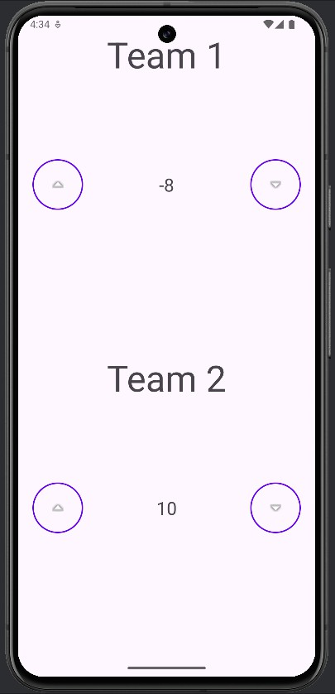

Practical 8

Aim: Practical: Save user data in the database.

Code:
activity_main.xml:
<?xml version="1.0" encoding="utf-8"?>
<RelativeLayout xmlns:android="http://schemas.android.com/apk/res/android" xmlns:app="http://schemas.android.com/apk/res-auto" xmlns:tools="http://schemas.android.com/tools"
android:id="@+id/main" android:layout_width="match_parent" android:layout_margin="10dp" android:layout_height="match_parent" tools:context=".MainActivity">

<EditText android:id="@+id/nameEditText" android:layout_width="match_parent" android:layout_height="wrap_content" android:hint="Name" />

<EditText android:id="@+id/ageEditText" android:layout_width="match_parent" android:layout_height="wrap_content"
android:layout_below="@id/nameEditText" android:hint="Age" android:inputType="number" />

<EditText android:id="@+id/emailEditText" android:layout_width="match_parent" android:layout_height="wrap_content" android:layout_below="@id/ageEditText" android:hint="Email" />

<Button
android:id="@+id/registerButton" android:layout_width="wrap_content"
android:layout_height="wrap_content" android:layout_below="@id/emailEditText" android:text="Register" />

<Button
android:id="@+id/viewButton" android:layout_width="wrap_content" android:layout_height="wrap_content" android:layout_below="@id/registerButton" android:text="View Students" />

</RelativeLayout>

MainActivity.java:
package com.ssasit.p8;

import android.content.Intent; import android.os.Bundle; import android.view.View; import android.widget.Button; import android.widget.EditText; import android.widget.Toast;

import androidx.activity.EdgeToEdge;
import androidx.appcompat.app.AppCompatActivity; import androidx.core.graphics.Insets;
import androidx.core.view.ViewCompat;
import androidx.core.view.WindowInsetsCompat;

public class MainActivity extends AppCompatActivity { private StudentRepository studentRepository; @Override
protected void onCreate(Bundle savedInstanceState) { super.onCreate(savedInstanceState); EdgeToEdge.enable(this); setContentView(R.layout.activity_main); studentRepository = new StudentRepository(this); studentRepository.open();

final EditText nameEditText = findViewById(R.id.nameEditText);
final EditText ageEditText = findViewById(R.id.ageEditText); final EditText emailEditText = findViewById(R.id.emailEditText); Button registerButton = findViewById(R.id.registerButton); Button viewButton = findViewById(R.id.viewButton);

registerButton.setOnClickListener(new View.OnClickListener() { @Override
public void onClick(View view) {
String name = nameEditText.getText().toString();
int age = Integer.parseInt(ageEditText.getText().toString()); String email = emailEditText.getText().toString();

studentRepository.addStudent(name, age, email); Toast.makeText(MainActivity.this, "Student Registered!",
Toast.LENGTH_SHORT).show();
}
});

viewButton.setOnClickListener(new View.OnClickListener() { @Override
public void onClick(View view) {
Intent intent = new Intent(MainActivity.this, ViewActivity.class); startActivity(intent);
}
});
}
}

ActivityView.xml:
<?xml version="1.0" encoding="utf-8"?>
<RelativeLayout xmlns:android="http://schemas.android.com/apk/res/android" xmlns:app="http://schemas.android.com/apk/res-auto" xmlns:tools="http://schemas.android.com/tools"
android:id="@+id/main" android:layout_width="match_parent" android:layout_height="match_parent" tools:context=".ViewActivity">

<TextView android:id="@+id/studentListTextView"
android:layout_width="match_parent" android:layout_height="wrap_content" android:text="Student List" android:textSize="18sp" />

</RelativeLayout>

ViewActivity.java:
package com.ssasit.p8;

import android.database.Cursor; import android.os.Bundle;
import android.widget.TextView;
import androidx.appcompat.app.AppCompatActivity; public class ViewActivity extends AppCompatActivity {
private StudentRepository studentRepository;

@Override
protected void onCreate(Bundle savedInstanceState) { super.onCreate(savedInstanceState); setContentView(R.layout.activity_view);

studentRepository = new StudentRepository(this); studentRepository.open();

TextView studentListTextView = findViewById(R.id.studentListTextView);

Cursor cursor = studentRepository.getAllStudents(); StringBuilder builder = new StringBuilder();
while (cursor.moveToNext()) {
String name = cursor.getString(cursor.getColumnIndex("name")); int age = cursor.getInt(cursor.getColumnIndex("age"));
String email = cursor.getString(cursor.getColumnIndex("email"));

builder.append("Name: ").append(name)
.append(", Age: ").append(age)
.append(", Email: ").append(email)
.append("\n");
}
cursor.close();

studentListTextView.setText(builder.toString());
}

@Override
protected void onDestroy() { super.onDestroy(); studentRepository.close();
}
}

Dbhelper.java:
package com.ssasit.p8;

// DatabaseHelper.java
import android.content.Context;
import android.database.sqlite.SQLiteDatabase; import android.database.sqlite.SQLiteOpenHelper;

public class dbhelper extends SQLiteOpenHelper {

private static final String DATABASE_NAME = "studentdb.db"; private static final int DATABASE_VERSION = 1;

private static final String TABLE_CREATE = "CREATE TABLE students (" +
"id INTEGER PRIMARY KEY AUTOINCREMENT, " +
"name TEXT, " + "age INTEGER, " +
"email TEXT);";

public dbhelper(Context context) {
super(context, DATABASE_NAME, null, DATABASE_VERSION);
}

@Override
public void onCreate(SQLiteDatabase db) {
db.execSQL(TABLE_CREATE);
}

@Override
public void onUpgrade(SQLiteDatabase db, int oldVersion, int newVersion)
{
db.execSQL("DROP TABLE IF EXISTS students"); onCreate(db);
}
}

StudentRepository.java:
package com.ssasit.p8;

// StudentRepository.java
import android.content.ContentValues; import android.content.Context; import android.database.Cursor;
import android.database.sqlite.SQLiteDatabase;

public class StudentRepository { private SQLiteDatabase database; private dbhelper dbHelper;

public StudentRepository(Context context) { dbHelper = new dbhelper(context);
}

public void open() {
database = dbHelper.getWritableDatabase();
}

public void close() { dbHelper.close();
}

public void addStudent(String name, int age, String email) { ContentValues values = new ContentValues(); values.put("name", name);
values.put("age", age);
values.put("email", email); database.insert("students", null, values);
}

public Cursor getAllStudents() {
return database.query("students", null, null, null, null, null, null);
}
}

Output:
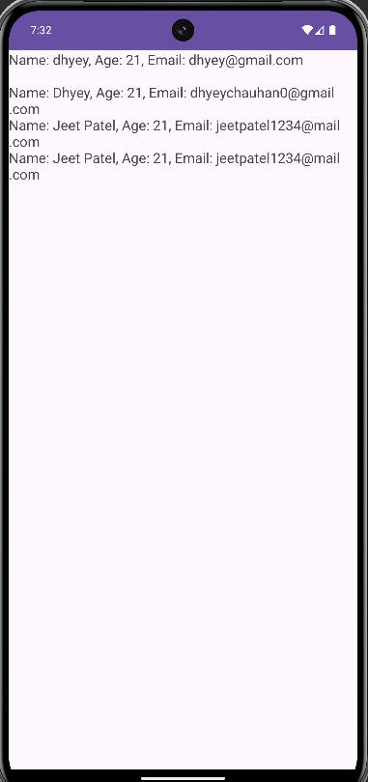
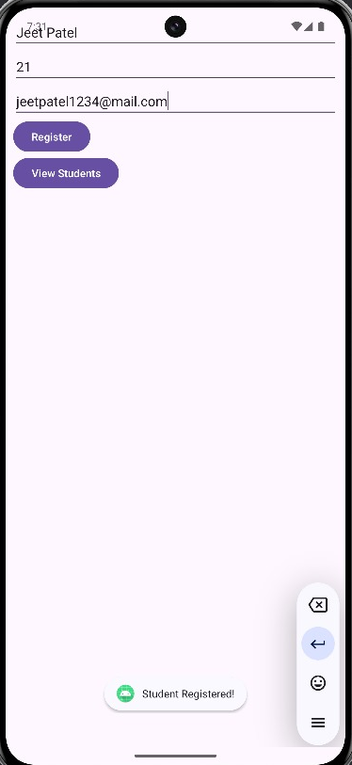

Practical 9
Aim: Use an AsyncTask to access a remote database (make use of a simple PHP Web service).
Code:
activity_main.xml:
<?xml version="1.0" encoding="utf-8"?>
<androidx.constraintlayout.widget.ConstraintLayout xmlns:android="http://schemas.android.com/apk/res/android"
xmlns:app="http://schemas.android.com/apk/res-auto" xmlns:tools="http://schemas.android.com/tools" android:id="@+id/main" android:layout_width="match_parent" android:layout_height="match_parent" tools:context=".MainActivity">

<ListView android:id="@+id/listView"
android:layout_width="match_parent" android:layout_height="match_parent" />

</androidx.constraintlayout.widget.ConstraintLayout>

MainActivity.java:
package com.ssasit.pr9;

import android.os.Bundle; import android.util.Log;
import android.widget.ArrayAdapter; import android.widget.ListView;
import androidx.appcompat.app.AppCompatActivity; import org.json.JSONArray;
import org.json.JSONObject;
public class MainActivity extends AppCompatActivity { private ListView listView;
private ArrayAdapter<String> adapter; @Override
protected void onCreate(Bundle savedInstanceState) { super.onCreate(savedInstanceState); setContentView(R.layout.activity_main);
listView = findViewById(R.id.listView);
adapter = new ArrayAdapter<>(this, android.R.layout.simple_list_item_1); listView.setAdapter(adapter);
String url = "http://192.168.1.6/MAD/index.php"; new FetchStudentsTask(this).execute(url);
}
public void updateUI(JSONArray jsonArray) { adapter.clear(); Log.d("arraysize:",String.valueOf(jsonArray.length())); try {
for (int i = 0; i < jsonArray.length(); i++) {
JSONObject jsonObject = jsonArray.getJSONObject(i); String student = "ID: " + jsonObject.getInt("id") +
", Name: " + jsonObject.getString("name") + ", Age: " + jsonObject.getInt("age") +
", Email: " + jsonObject.getString("email"); adapter.add(student);
}
} catch (Exception e) { e.printStackTrace();
}
}
}

FetchStudentsTask.java:
package com.ssasit.pr9;

// FetchStudentsTask.java import android.os.AsyncTask; import android.util.Log; import org.json.JSONArray;

import java.io.BufferedReader; import java.io.InputStreamReader; import java.net.HttpURLConnection;
import java.net.URL;
public class FetchStudentsTask extends AsyncTask<String, Void, String> { private static final String TAG = "FetchStudentsTask";
private MainActivity activity;

public FetchStudentsTask(MainActivity activity) { this.activity = activity;
}

@Override
protected String doInBackground(String... params) { String response = "";
HttpURLConnection urlConnection = null;

try {
URL url = new URL(params[0]);
urlConnection = (HttpURLConnection) url.openConnection(); BufferedReader reader = new BufferedReader(new
InputStreamReader(urlConnection.getInputStream()));

StringBuilder result = new StringBuilder(); String line;
while ((line = reader.readLine()) != null) { result.append(line);
}

response = result.toString();
Log.d(TAG, "Response: " + response); // Log response for debugging
} catch (Exception e) {
Log.e(TAG, "Error fetching data", e);
} finally {
if (urlConnection != null) { urlConnection.disconnect();
}
}

return response;
}
@Override
protected void onPostExecute(String result) { super.onPostExecute(result);

try {
JSONArray jsonArray = new JSONArray(result); activity.updateUI(jsonArray);
} catch (Exception e) {
Log.e(TAG, "Error parsing JSON", e);
}
}
}

Network_security_config.java:
<?xml version="1.0" encoding="utf-8"?>
<network-security-config>
<domain-config cleartextTrafficPermitted="true">
<domain includeSubdomains="true">192.168.1.6</domain>
</domain-config>
</network-security-config>

Index.php:
<?php
$connect=mysqli_connect('localhost','root','','mad');
$query="SELECT * from student";
$result=mysqli_query($connect,$query); while($i=mysqli_fetch_arraY($result))
{
$data[] = array( 'id' => $i['id'],
'name' => $i['name'],
'age' => $i['age'],
'email' => $i['email'],
);
}
echo json_encode($data); mysqli_close($connect);
?>

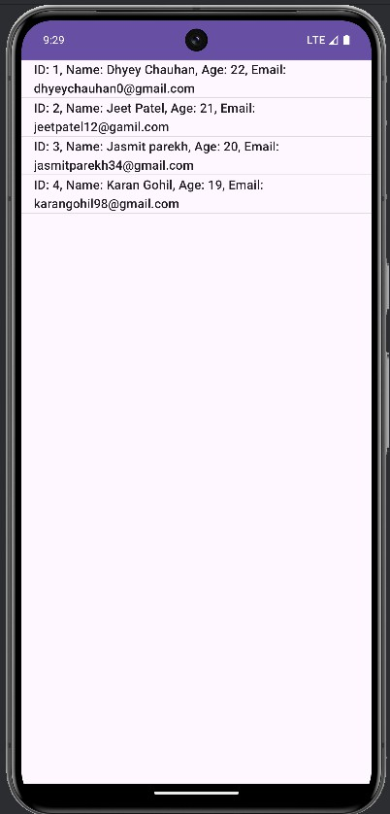
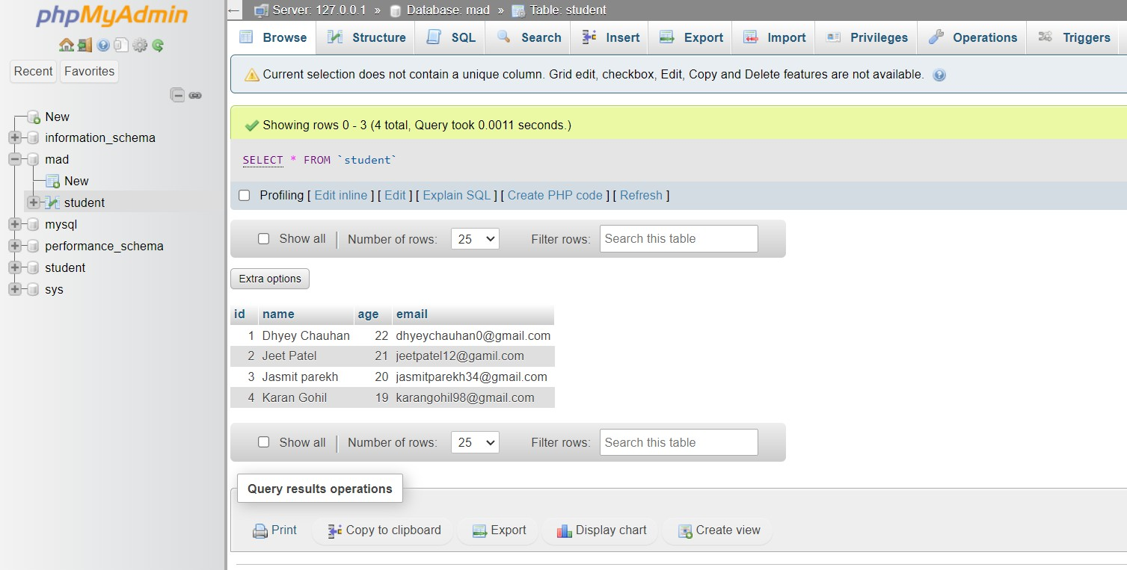
Output:

Practical 10
Aim: Use Retrofit to access remote database (make a use of simple PHP Web service).
Code:
activity_main.xml:
<?xml version="1.0" encoding="utf-8"?>
<androidx.constraintlayout.widget.ConstraintLayout xmlns:android="http://schemas.android.com/apk/res/android"
xmlns:app="http://schemas.android.com/apk/res-auto" xmlns:tools="http://schemas.android.com/tools" android:id="@+id/main" android:layout_width="match_parent" android:layout_height="match_parent" tools:context=".MainActivity">

<ListView android:layout_width="wrap_content" android:layout_height="wrap_content"
android:id="@+id/listView" app:layout_constraintBottom_toBottomOf="parent" app:layout_constraintEnd_toEndOf="parent" app:layout_constraintStart_toStartOf="parent" app:layout_constraintTop_toTopOf="parent" />

</androidx.constraintlayout.widget.ConstraintLayout>

MainActivity.java:
package com.ssasit.pr10; import android.os.Bundle;
import androidx.activity.EdgeToEdge;
import androidx.appcompat.app.AppCompatActivity; import androidx.core.graphics.Insets;
import androidx.core.view.ViewCompat;
import androidx.core.view.WindowInsetsCompat;
import android.os.Bundle;
import android.util.Log;
import android.widget.ArrayAdapter; import android.widget.ListView; import android.widget.Toast;
import androidx.appcompat.app.AppCompatActivity; import java.util.List;
import retrofit2.Call; import retrofit2.Callback; import retrofit2.Response; import retrofit2.Retrofit;
import retrofit2.converter.gson.GsonConverterFactory; public class MainActivity extends AppCompatActivity {
private ListView listView;
private ArrayAdapter<String> adapter; private ApiService apiService;

@Override
protected void onCreate(Bundle savedInstanceState) { super.onCreate(savedInstanceState); setContentView(R.layout.activity_main);

listView = findViewById(R.id.listView);

// Initialize Retrofit
// Retrofit retrofit = RetrofitClient.getClient("https://192.168.3.25/MAD/");
// Update with your server's URL
Retrofit retrofit = new Retrofit.Builder()
.baseUrl("https://raw.githubusercontent.com/devp22/json/main/")
.addConverterFactory(GsonConverterFactory.create())
.build();
apiService = retrofit.create(ApiService.class);

// Fetch students fetchStudents();
}

private void fetchStudents() {
Call<List<Student>> call = apiService.getModels();
call.enqueue(new Callback<List<Student>>() { @Override
public void onResponse(Call<List<Student>> call, Response<List<Student>> response) {
if (response.isSuccessful() && response.body() != null) { List<Student> students = response.body(); Log.d("Test",""+students.size());
updateUI(students);
} else {
Toast.makeText(MainActivity.this, "No data received", Toast.LENGTH_SHORT).show();
}
}

@Override
public void onFailure(Call<List<Student>> call, Throwable t) { Log.d("MainActivity", "Network Error: " + t.getMessage()); Toast.makeText(MainActivity.this, "Error fetching data",
Toast.LENGTH_SHORT).show();

// Optionally, print more detailed information t.printStackTrace();
}
});
}

private void updateUI(List<Student> students) {
adapter = new ArrayAdapter<>(this, android.R.layout.simple_list_item_1); listView.setAdapter(adapter);

for (Student student : students) {
String studentInfo = "Name: " + student.getName() + ", Publisher: " + student.getPublisher() +
", NumberOfSongs: " + student.getNSongs(); adapter.add(studentInfo);
}
}
}

RetrofitClient1.java:
package com.ssasit.pr10;

import retrofit2.Retrofit;
import retrofit2.converter.gson.GsonConverterFactory; public class RetrofitClient1 {
private static Retrofit retrofit = null;

public static Retrofit getClient(String baseUrl) { if (retrofit == null) {
retrofit = new Retrofit.Builder()
.baseUrl(baseUrl)
.addConverterFactory(GsonConverterFactory.create())
.build();
}
return retrofit;
}
}

Student.java:
package com.ssasit.pr10;

public class Student {
// private int id; private String Name;
private String Publisher; private String NumberOfSongs;

// Getters and setters

public String getName() { return Name; }
public void setName(String name) { this.Name = Name; }

public String getPublisher() { return Publisher; }
public void setPublisher(String age) { this.Publisher = Publisher; }

public String getNSongs() { return NumberOfSongs; }
public void setNSongs(String email) { this.NumberOfSongs = NumberOfSongs; }
}

ApiService.java:
package com.ssasit.pr10; import android.util.Log; import java.util.List;
import retrofit2.Call; import retrofit2.http.GET;

public interface ApiService { @GET("newplaylist.json") Call<List<Student>> getModels();

}

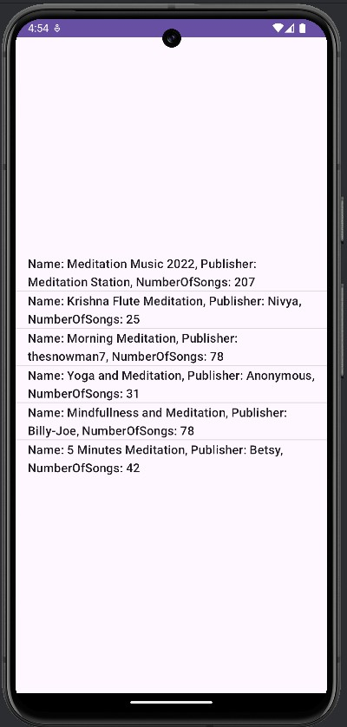
Output:

