**Practical 4**

Aim: Build an Artificial Neural Network by implementing the Backpropagation algorithm and test the same using appropriate data sets.

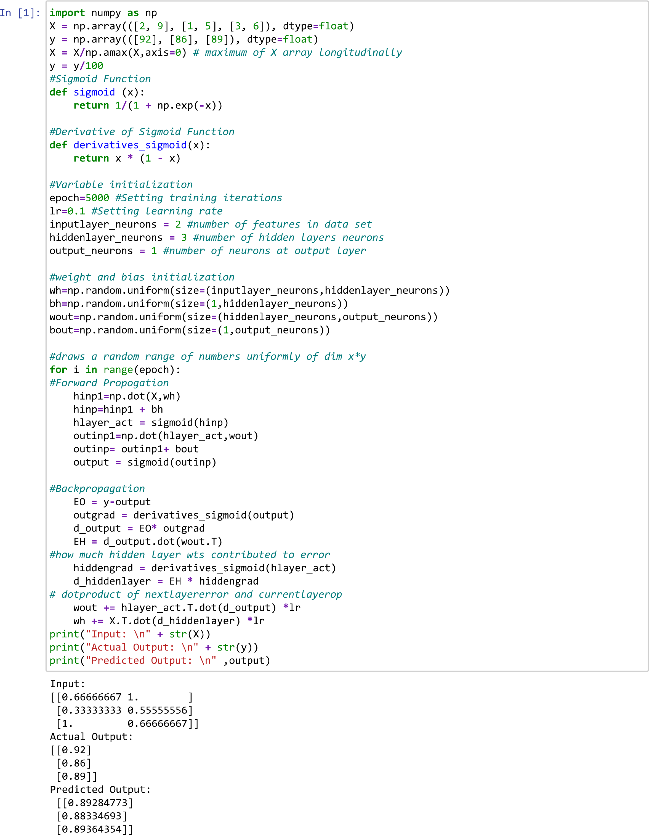

**Practical 5**

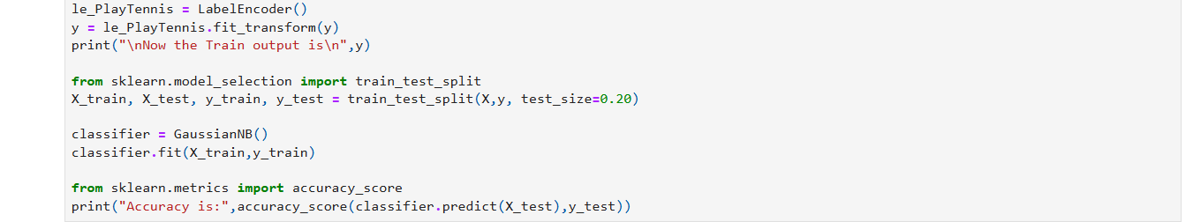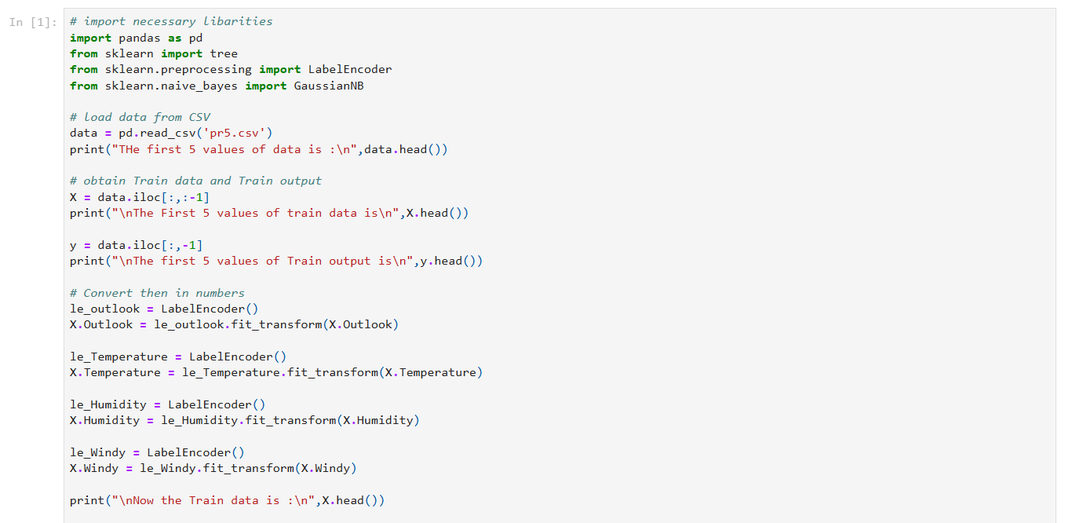Aim: Write a program to implement the naïve Bayesian classifier for a sample training data set stored as a .CSV file. Compute the accuracy of the classifier, considering few test data sets.

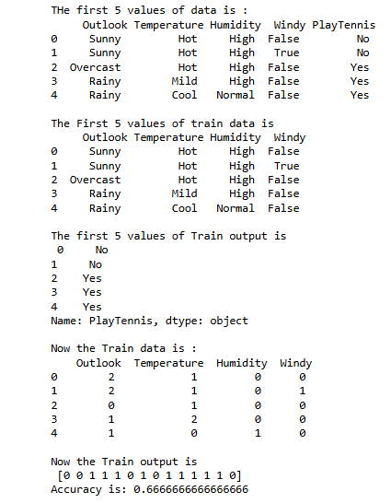

**Practical : 6**

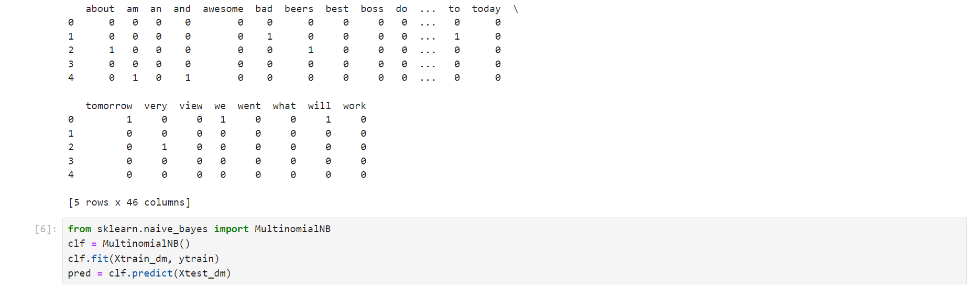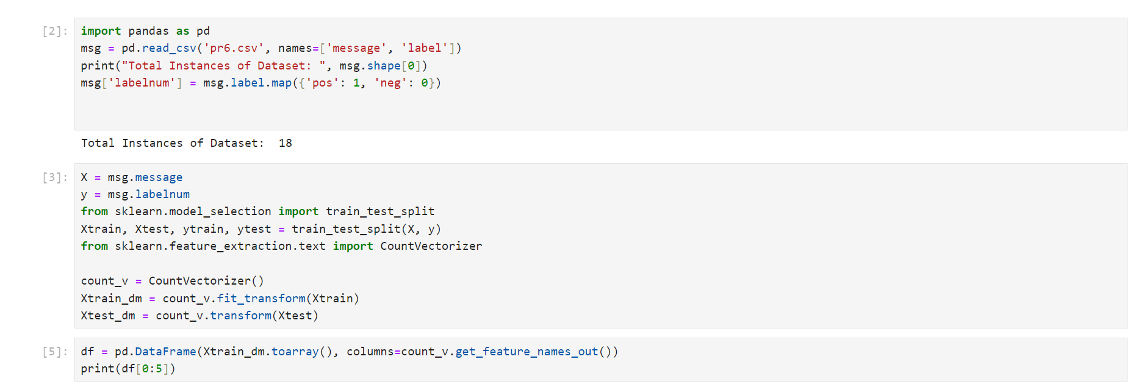Aim: Assuming a set of documents that need to be classified, use the naïve Bayesian Classifier model to perform this task. Built-in Java classes/API can be used to write the program. Calculate the accuracy, precision, and recall for your data set.

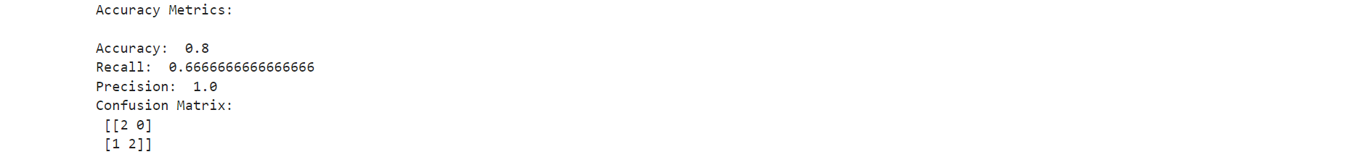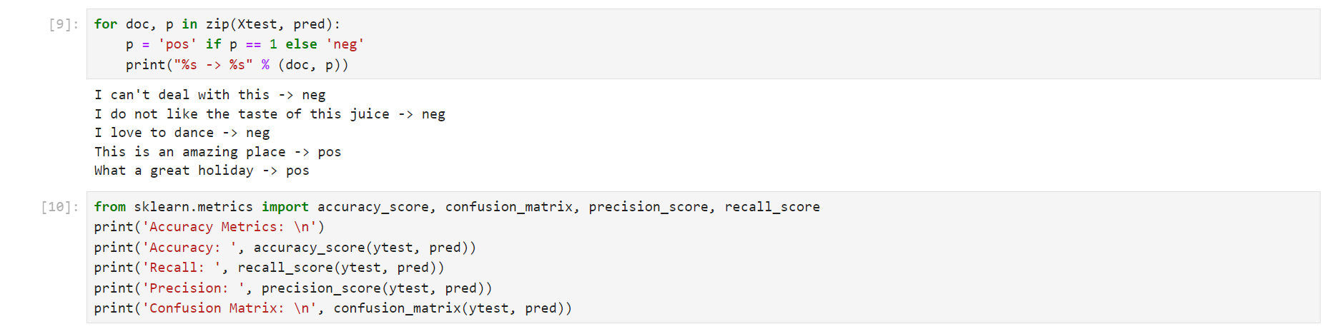

## Practical : 7

Aim: Write a program to construct a Bayesian network considering medical data. Use this model to demonstrate the diagnosis of heart patients using standard Heart Disease Data Set. You can use Java/Python ML library classes/API

