**Practical 1**

Aim: Implement and demonstrate the FIND-S algorithm for finding the most specific hypothesis based on a given set of training data samples. Read the training data from a .CSV file.

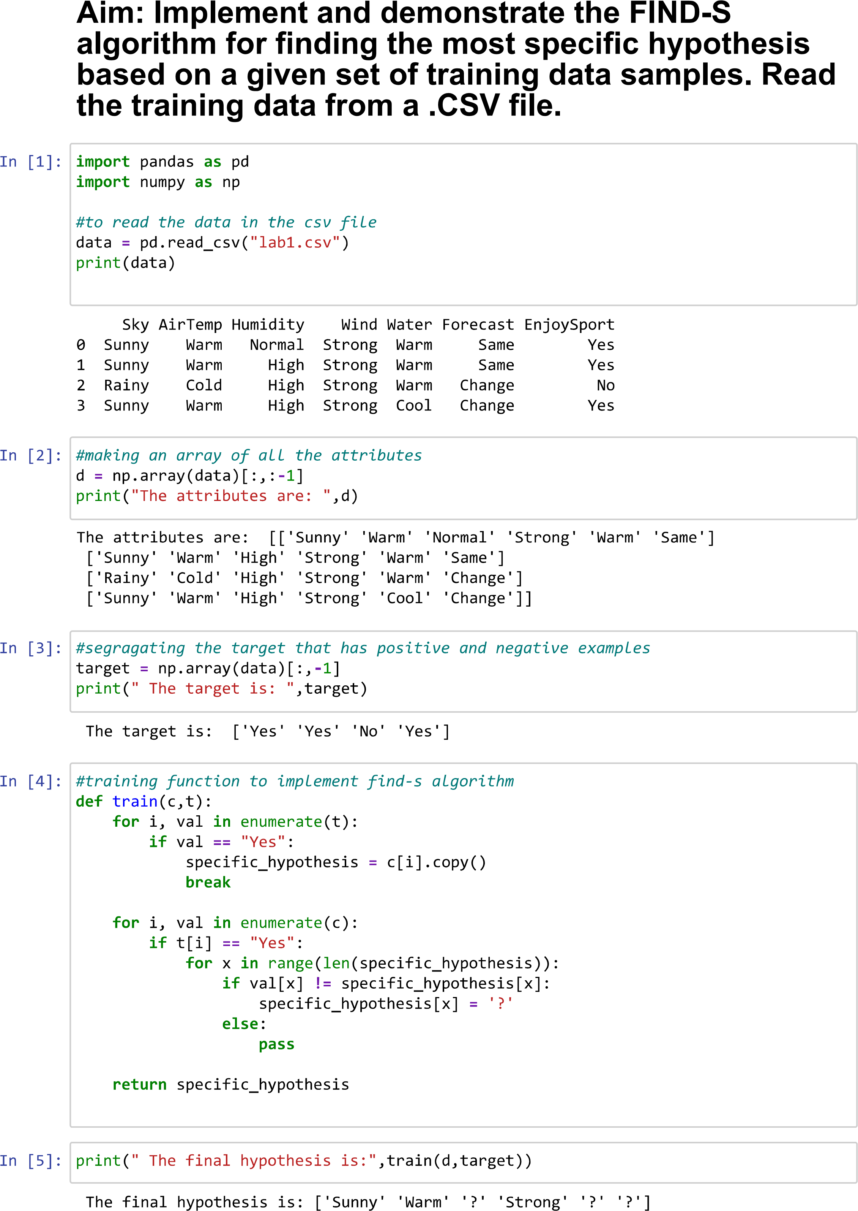

**Practical 2**

Aim: For a given set of training data examples stored in a .CSV file, implement and demonstratethe Candidate-Elimination algorithm to output a description of the set of all hypotheses consistent with the training examples.

