**Practical 8**

## Aim: Apply EM algorithm to cluster a set of data stored in a .CSV file. Use the same data set for clustering using k-Means algorithm. Compare the results of these two algorithms and comment on the quality of clustering. You can add Java/Python ML library classes/API in the program.

## Data Set:

## 

## 

## 

## 

## Practical : 9

## Aim: Write a program to implement k-Nearest Neighbour algorithm to classify the iris data set. Print both correct and wrong predictions. Java/Python ML library classes can be used for this problem.

## Dataset:

## 

## 

## 

**Practical : 10**

## Aim: Implement the non-parametric Locally Weighted Regression algorithm in order to fit data points. Select appropriate data set for your experiment and draw graphs.

## 

## 

##  tips.csv

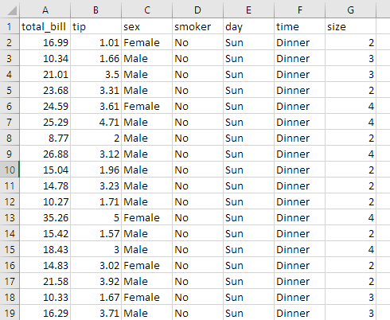

→ **Output:**

