# HalloDoc Platform

## AN INTERNSHIP PROJECT REPORT

***Submitted by***

## JEET VARSANI 200470107031

***In partial fulfillment for the award of the degree of***

# BACHELOR OF ENGINEERING

***In***

**Computer Engineering**

**V.V.P. Engineering College, Rajkot**

 

**Gujarat Technological University, Ahmedabad**

**[April – 2024]**

 

# V.V.P Engineering College

Virda-vajdi Rajkot. (Affiliated with GTU)

# DEPARTMENT OF COMPUTER ENGINEERING

# CERTIFICATE

### Date:

This is to certify that the IDP under the company **TATVASOFT PVT. LTD.** has been carried out by **JEET VARSANI** under my guidance in fulfilment of the degree of Bachelor Engineering in **COMPUTER ENGINEERING** (8th semester) of Gujrat Technological University, Ahmedabad during the academic year 2023-24

INTERNAL GUIDE HEAD OF THE DEPARTMENT

MRS. POOJA OZA DR. TEJAS PATALIA

# COMPANY CERTIFICATE

 

# V.V.P Engineering College

Virja-vajdi Rajkot. (Affiliated with GTU)

# DECLARATION

We hereby declare that the Internship / Project report submitted along with the Internship / Project entitled **HALLODOC PLATFORM** submitted in partial fulfilment for the degree of Bachelor of Engineering in **Computer Engineering** to Gujarat Technological University, Ahmedabad, is a bona-fide record of original project work carried out by me at **TATVASOFT PVT. LTD.** under the supervision of **MRS. SWEETY PATEL** and that no part of this report has been directly copied from any students’ reports or taken from any other source, without providing due reference.

JEET VARSANI 200470107031

 

# V.V.P Engineering College

Virda-vajdi Rajkot. (Affiliated with GTU)

# ACKNOWLEDGEMENT

I would like to express my sincere gratitude to my internal guide **Prof. POOJA OZA** for their constant guidance and advice throughout the internship. Also, I would like to thank Principal and HOD of the Computer Department **Dr. Tejas Pataliya** for their valuable guidance and support.

I would also like to extend my heartful gratitude to **TATVASOFT PVT. LTD.** for the internship opportunity. Your experience and knowledge in the field have been invaluable in helping me to gain a deeper understanding of the industry. Your constructive feedback and guidance have enabled me to develop my skills and become a more effective contributor to the organization.

In addition, my focus and dedication to learn something new helped me to clinch success in the internship and learn a lot of new things and get hands on experience on live projects.

# ABSTRACT

Industrial training is an important phase of a student life. A well planned, properly executed and evaluated industrial training helps a lot in developing a professional attitude. It develops an awareness of industrial approach to problem solving, based on a broad understanding of process and mode of operation of organization.

During a period of 12 weeks of training at TatvaSoft., I was assigned as a trainee Software developer. Throughout this industrial training, I have learned new technology such as Asp.net core, and PostgreSQL Server. And with that, I developed the HalloDoc Platform Website.

So, Basically, HalloDoc Platform is a dynamic and user-friendly web platform designed to revolutionize the healthcare experience by providing seamless interaction between patients, healthcare providers, and administrators. This project aims to streamline healthcare services by offering a centralized hub for patients to request disease-related information, seek provider services, and access their medical history, all while enabling administrators to efficiently manage and oversee operations.

# LIST OF FIGURES

Fig 5.2 Database Design………………………………………………...10

Fig 5.3.1 Dashboard of Admin Module…………………………………11

Fig 5.3.2 Admin Profile………………………………………………….11

Fig 5.3.3 Dashboard Page for Patient…………………………………...12

Fig 5.3.4 Patien details page…………………………………………….13

Fig 5.3.5 Patient login page……………………………………………..13

Fig 6.1.1 Visual Studio………………………………………………….14

Fig 6.1.2 Folder structure………………………………………………..14

Fig 6.2-1 Controller Data………………………………………………..15

Fig 6.2-2 Repository pattern…………………………………………….15

Fig 6.2-3Service call…………………………………………………….16

Fig 6.2-4 DB set………………………………………………………....16

Fig 6.2-5 HTML code…………………………………………………...17

TABLE OF CONTENT

TITLE PAGE 1

CERTIFICATE ii

COMPANY CERTIFICATE iii

DECLARATION iv

ACKNOWLEDGEMENT v

ABSTRACT vi

LIST OF FIGURES vii

TABLE OF CONTENT viii

CHAPTER 1: OVERVIEW OF THE COMPANY

* 1. HISTORY 1
  2. SCOPE OF WORK 2
  3. TECHNOLOGIES 3
  4. VALUES 4

CHAPTER 2: INTRODUCTION TO INTERNSHIP

* 1. INTERNSHIP SUMMARY 3
  2. PURPOSE 3
  3. SCOPE 3
  4. OBJECTIVE 4

CHAPTER 3: TOOLS & TECHNOLOGIES

* 1. ASP .NET CORE ENTITY FRAMEWORK……………………………………...5
  2. LANGUAGE INTEGRATED QUERY…………………………………………...5
  3. POSTGRESQL…………………………………………………………………….5
  4. FRONTEND TECHNOLOGY…………………………………………………….6
  5. SQL………………………………………………………………………………...6
  6. VISUAL STUDIO…………………………………………………………………6

CHAPTER 4: SYSTEM ANALYSIS

* 1. STUDY OF CURRENT SYSTEM………………………………………………..7
  2. WEAKNESS OF CURRENT SYSTEM…………………………………………..7
  3. FEATURES OF NEW SYSTEM………………………………………………….7

CHAPTER 5: SYSTEM DESIGN

* 1. ABSTRACT OF SYSTEM…………………………………………………………9
  2. DATABASE DESIGN……………………………………………………………10
  3. INTERFACE DESIGN…………………………………………………………...10

CHAPTER 6: IMPLEMENTATION

* 1. IMPLEMENTATION PLATFORM……………………………………………...14
  2. PROGRAM………………………………………………………………………..15

CHAPTER 7: TESTING

* 1. TESTING STRATEGIES…………………………………………………………..18
  2. TEST CASES………………………………………………………………………18

CHAPTER 8: CONCLUSIOON & DISCUSSION

* 1. OVERALL ANALYSIS OF INTERNSHIP 21
  2. SUMMARY OF INTERNSHIP 21
  3. FUTURE ENHANCEMENTS 22

# CHAPTER 1: OVERVIEW OF THE COMPANY

## HISTORY

TatvaSoft is a Consummate Custom Software Development company delivering splendid business IT Solutions and related services to customers across the globe. Our development services are led by our dedicated and passionate team to provide best industry practices combined with technology expertise and business domain knowledge to drive digital transformation. Our proficiency in understanding business challenges and professional competence allows us to create a better experience for our customers.

TatvaSoft has emerged and marked our presence in different continents by providing Be spoke software development services to all major Industry Domains.

## SCOPE OF WORK

* Asp.Net MVC, Asp.Net Core, NodeJS - Backend Technologies
* Android / IOS - Mobile Application
* Angular, Typescript, ReactJS - Frontend Technologies
* MSSQL, PostgreSQL, MongoDb - Database

## TECHNOLOGIES

* + 1. Web Development
* ASP.Net Core
* ASP.Net MVC
* Laravel
* React JS
  + 1. Database
* MS SQL
* MySQL
* POSTGRESQL
  + 1. Mobile App Development
* Android
* IOS

## VALUES

* Data Driven
* Innovation
* Well established process
* Ethics & Integrity
* Agility
* Collaboration

# CHAPTER 2: INTRODUCTION TO INTERNSHIP

## INTERNSHIP SUMMARY

GTU provides the opportunity to get experience before students step into professional life. In January 2024, I began my internship at **Tatvasoft Pvt. Ltd**. Working at the office, I found inspiration in my everyday journeys thanks to a fantastic work environment. It was an opportunity for me to demonstrate my worth as an employee, a trustworthy colleague, and a dedicated student. I have worked across several tools during my course of internship. The encouragement and honest responses I received were more than enough to put me at ease. I am grateful to my mentor for giving me the opportunity to grow both physically and personally.

## PURPOSE

Excelling in exams and earning a degree alone may not be enough to succeed in today’s job market. Real world experience through internships is crucial for professional growth, expanding knowledge, and determining the right career path.

## SCOPE

Internships offer valuable opportunities to gain real-world experience, expand knowledge and determine career direction in today’s job market. They bridge the gap between academic learning and workplace skills, providing essential professional development for success in the modern employment landscape.

## 2.4 OBJECTIVE

The main objective of this internship was to make candidates work-ready in web development using ASP .Net core technology. I was mainly focused on practical and self- learning. I aimed to build my programming base and write code by following coding standards. From an individual employee’s point of view, the main aims are:

* + 1. Be self-assured and introduce ourselves in professional settings.
    2. Be skillful in one or more areas of expertise.
    3. Develop soft skills like taking public speaking initiatives, taking responsibility for some work/task/event and many more.
    4. To gain leadership quality.

# CHAPTER 3: TOOLS & TECHNOLOGIES

### 3.1 ASP.Net Core Entity Framework

Entity framework is an Object Relational Mapping (ORM) framework .NET applications supported by Microsoft. that offers an automated mechanism to developers for storing and accessing the data in the database.

The Entity Framework enables developers to work with data in the form of domain-specific objects and properties, such as customers and customer addresses, without having to concern themselves with the underlying database tables and columns where this data is stored.

### 3.2 Language-Integrated Query (LINQ)

Language-Integrated Query (LINQ) is the name for a set of technologies based on the integration of query capabilities directly into the C# language. Traditionally, queries against data are expressed as simple strings without type checking at compile time or IntelliSense support. Furthermore, you have to learn a different query language for each type of data source: SQL databases, XML documents, various Web services, and so on. With LINQ, a query is a first-class language construct, just like classes, methods, and events.

### 3.3 PostgreSQL

PostgreSQL is an object-relational database management system (ORDMBS), which means that it has relational capabilities and an object-oriented design. Using object-oriented features of PostgreSQL, programmers can: Communicate with the database servers using objects in their code. Define complex custom data types

## 3.4 FRONTEND TECHNOLOGY

HTML is used to create the structure and content of web pages. It provides a set of markup tags that define the different elements on a webpage, such as headings, paragraphs, images and links.

CSS (Cascading Style Sheet) is used to style and layout webpages, allowing developers to control the visual appearance of HTML elements. It provides a set of rules for defining color, size, position, and other visual properties of HTML elements.

JavaScript is a scripting language used to create interactive and dynamic web pages. It allows developers to add behaviors and interactivity to web pages, such as responding to user input, manipulating HTML elements, and update content without refreshing the page.

## 3.5 SQL

SQL (Structured query language) databases are relational databases that use SQL as their primary programming language for managing and manipulating data. They organize data into tables, which are related to each other through common fields or keys. SQL databases are used to store and manage large amounts of structured data. They provide tools for creating, updating, and querying data, allowing developers to quickly retrieve specific information from a large database.

## 3.6 VISUAL STUDIO

Visual Studio is an Integrated Development Environment developed by Microsoft to develop GUI, console, web applications, mobile apps etc. With the help of this IDE, you can create manage code as well as native code. It is not a language specific IDE as you can use this to write code in python, HTML, CSS,manymore.

# CHAPTER 4: SYSTEM ANALYSIS

## 4.1 STUDY OF CURRENT SYSTEM

* First thing is that the Analysis model is the study of Existing Systems, Which is available. Without study of existing system analysis models cannot proceed.
* Here I create Database to manage the request, patient and user. All Admin must have logged in to access the system.
* Admin can manage roles, patient request, provider shifts and rules for the whole system.
* Patient can see their whole medical history in dashboard also create new request for him/her or someone else.

## WEAKNESS OF CURRENT SYSTEM

* Editing and maintenance of data is tedious as well as costlier
* If both service provider accept the service request at a time
* Lack of integration
* To operate manual system requires technical expertise on process detail

## 4.3 FEATURES OF NEW SYSTEM

The features that are available in the Website.

* Admin Panel Management
* Provider panel management
* Patient panel management
* The whole system works with 3 different modules: admin, provider and patient, in the patient module I have to implement filters and have to display their created request with time and status and also patient can request again with dashboard. Which is not available in the previous system.
* In this browser send request to the controller , controller send the request to the model & model send the data through PostgreSQl database and frontend can manage displaydata.

# CHAPTER 5: SYSTEM DESIGN

## ABSTRACT OF SYSTEM

#### Server

Operating System: Windows Processor:

Pentium 3.0 GHz or higher RAM: 2 GB or more

Hard Drive: 40 GB or more

**Development Tools:** Visual Studio, PostgreSQL database

Communication between database and application system needs the internet connection into the system. Because all the data will be available in the server database. Using the web services fetch the data from the server

#### Admin

1. Authentication – login with id and password
2. Accept Request, Block Request, Cancel Request
3. Schedule provider’s shift
4. Edit Their profile
5. Add New Roles

#### Customers

1. Authentication – login with id and password
2. Add request for themselves
3. Add request for family/friend
4. View previous all requests and status of request
5. Edit their profile

## DATABASE DESIGN

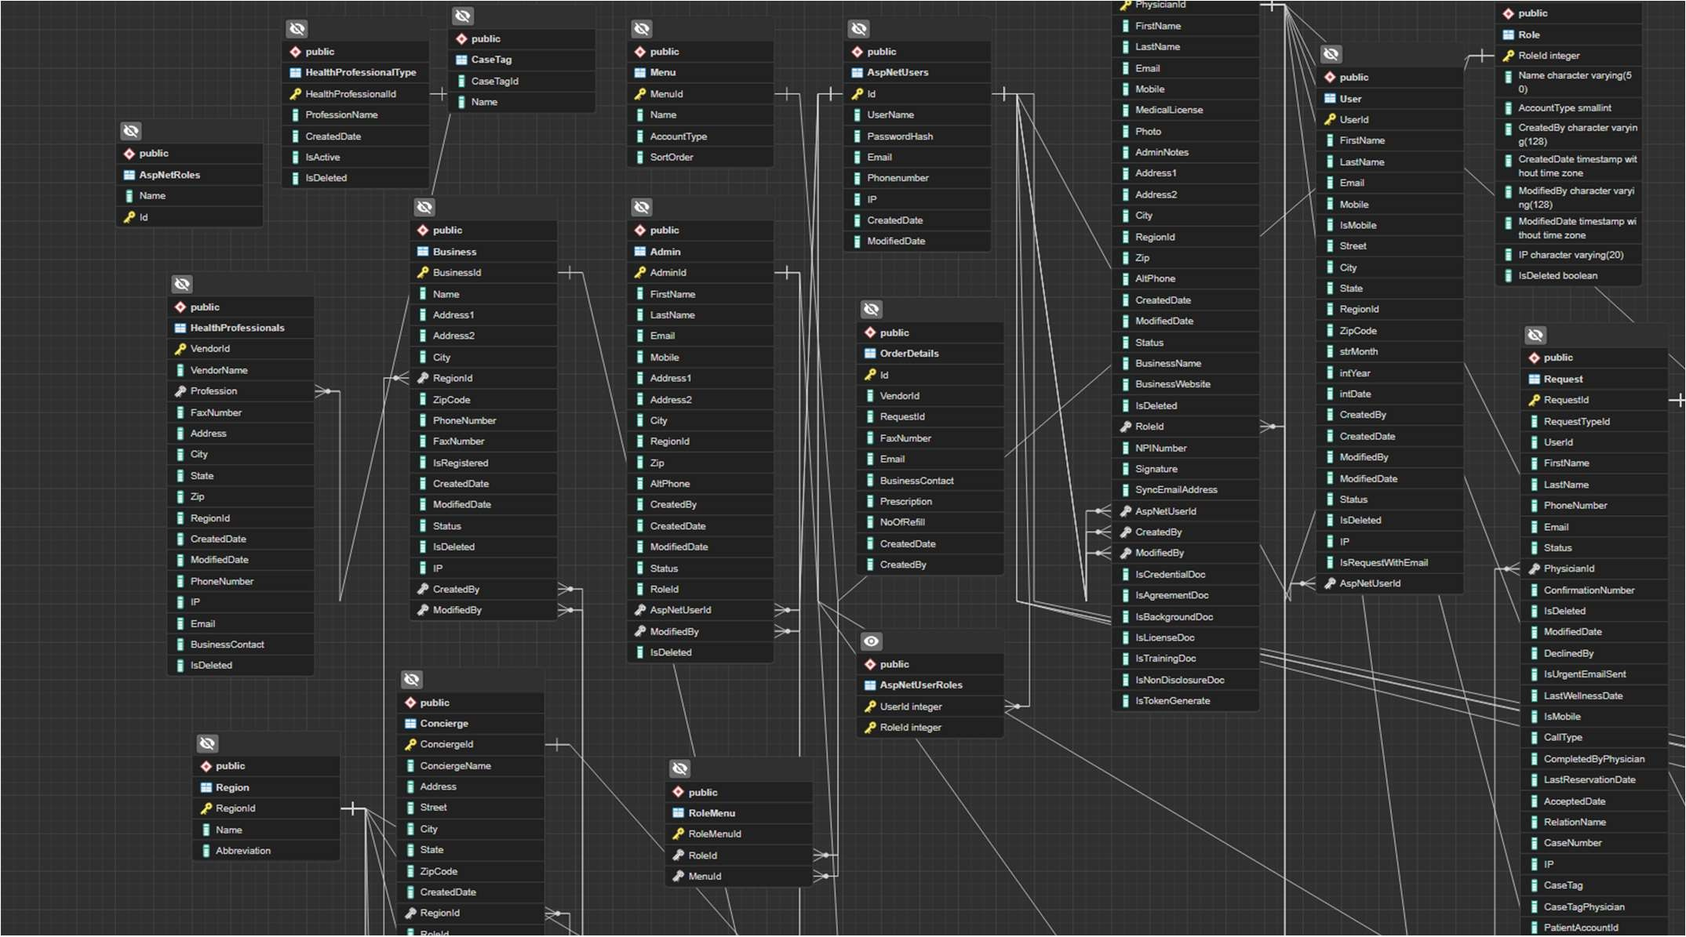

Fig5.2 Database Design

## INTERFACE DESIGN

#### Admin Module

* + - 1. It is a multi-vendor e-medical system consisting of admin, patient and provider modules. It manages patient request, provider shift, profiles and patient cases.
      2. Admin can manage patient request, provider shift, profiles and patient cases To cancel request admin can cancel any request of patient.

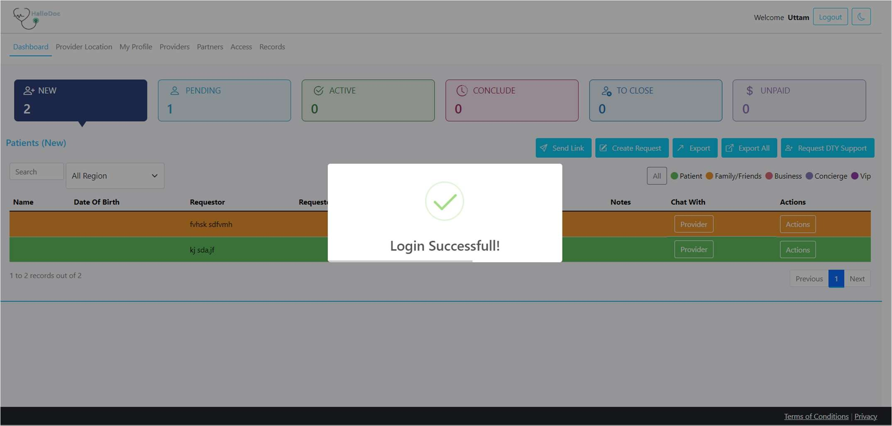

Fig 5.3.1 Dashboard of Admin Module

In admin dashboard provides a centralized interface for the admin to manage and oversee incoming requests. It offers quick access to different categories of requests based on their status, allowing the admin to efficiently review, approve, and take action as needed..

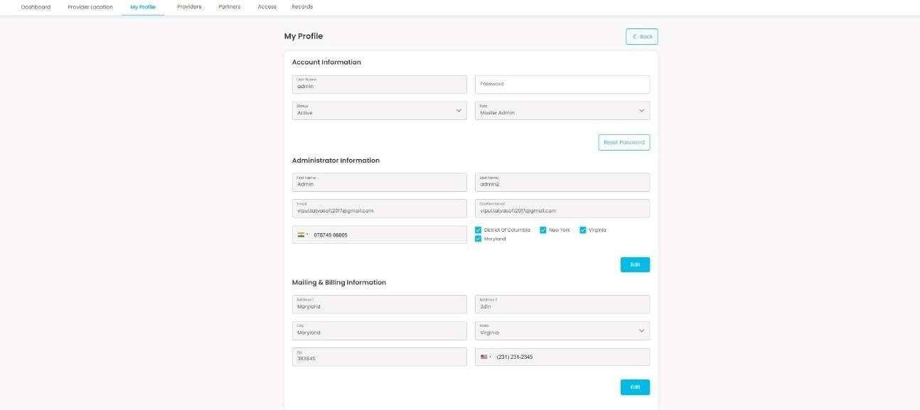

Fig 5.3.2 Admin Profile

This is admin profile, All details of admin include in this page, Admin can also edit his/her details whenever he/she want.

#### Patient Module

Patients can request of their diseases in this page, also patients can request for any otherperson. also they can access following features :

* + - 1. Request for family/friend
      2. Request for concierge
      3. Edit their profile
      4. View their all requests
      5. Login or change password whenever they want.

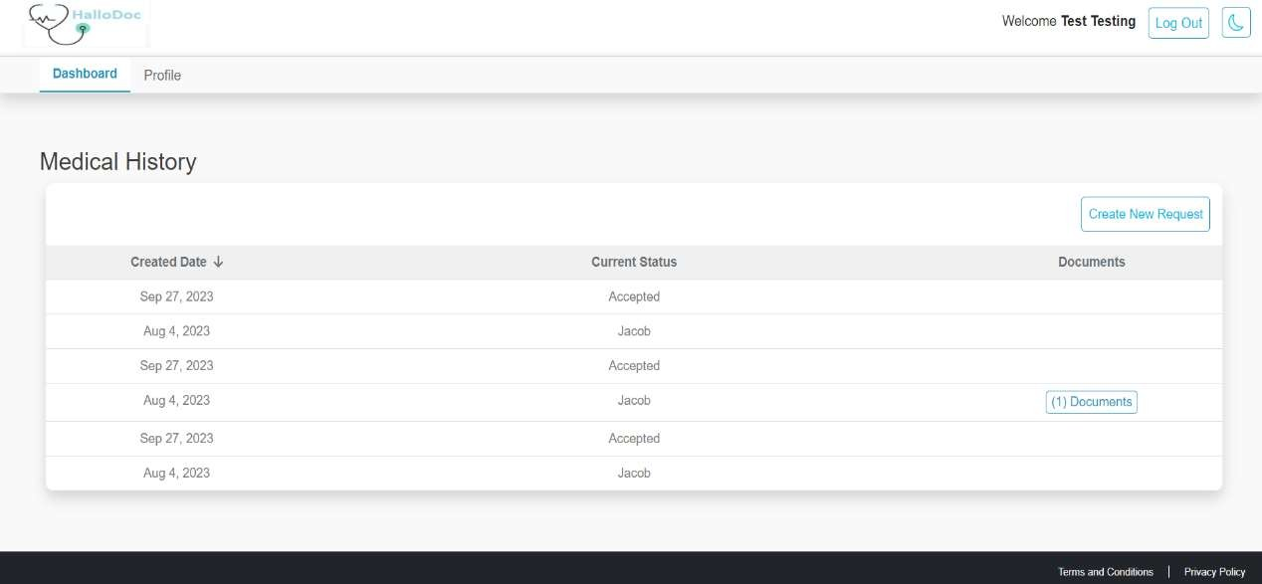

Fig 5.3.3 Dashboard Page for Patient

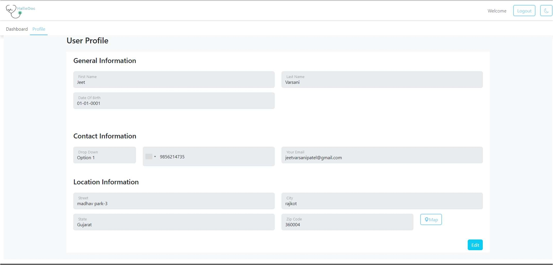

Fig 5.3.4 Patient detail page

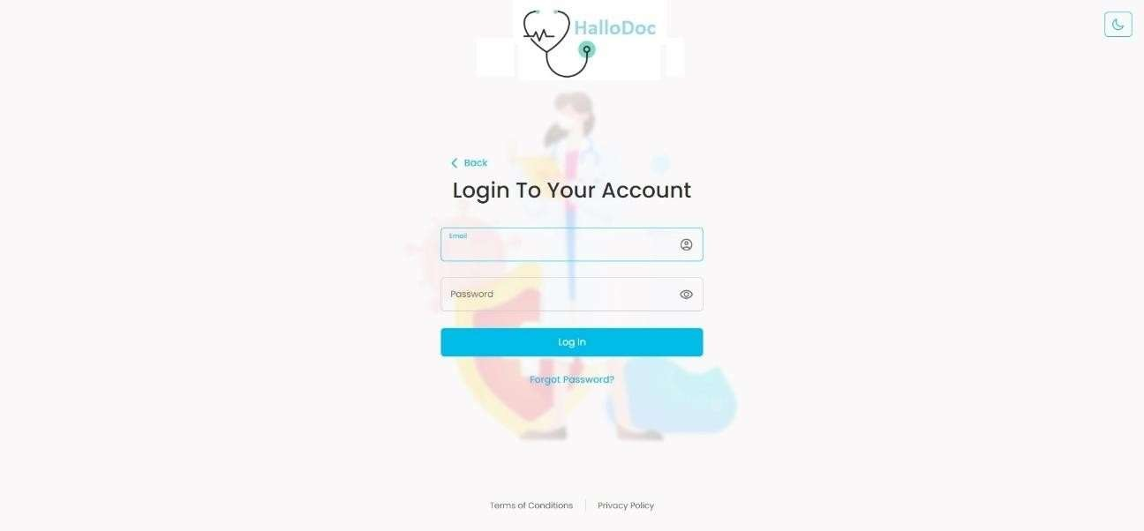

Fig 5.3.5 Patient Login Page

# CHAPTER 6: IMPLEMENTATION

## IMPLEMENTATION PLATFORM:

#### View-Cshtml

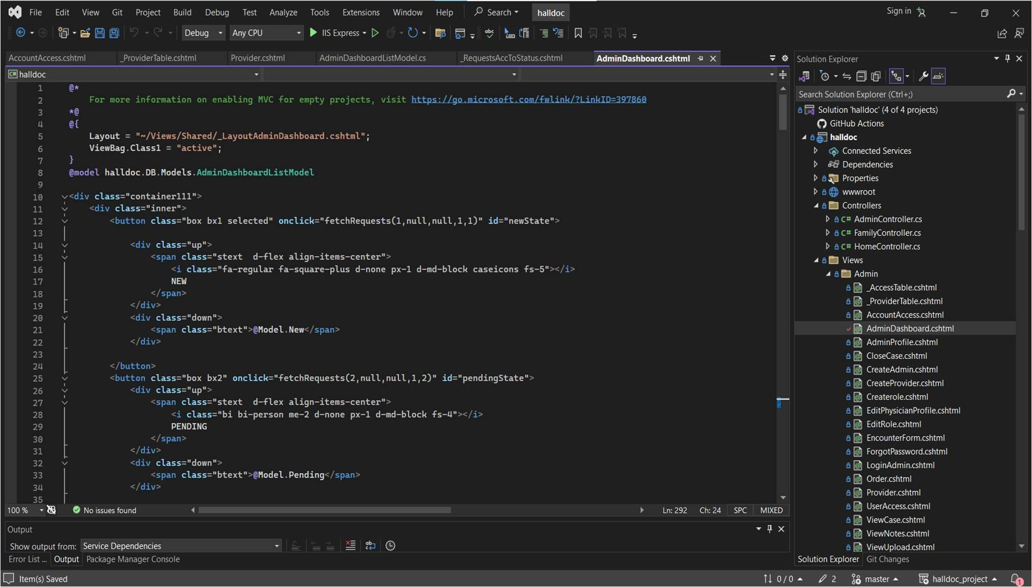

* + 1. **Folder Structure**

Fig 6.1.1 View-Cshtml

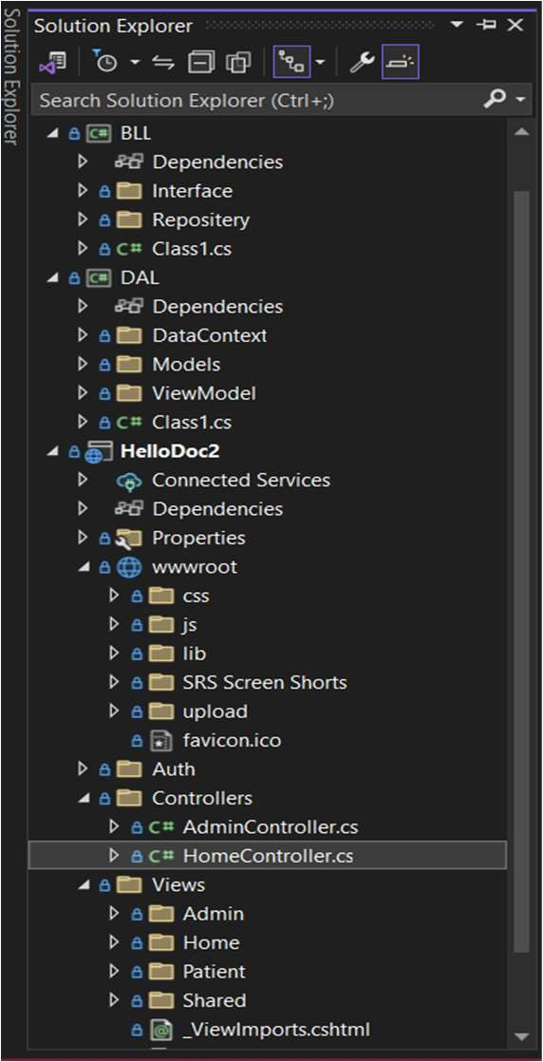

Fig 6.1.2 Folder Structure

## PROGRAM

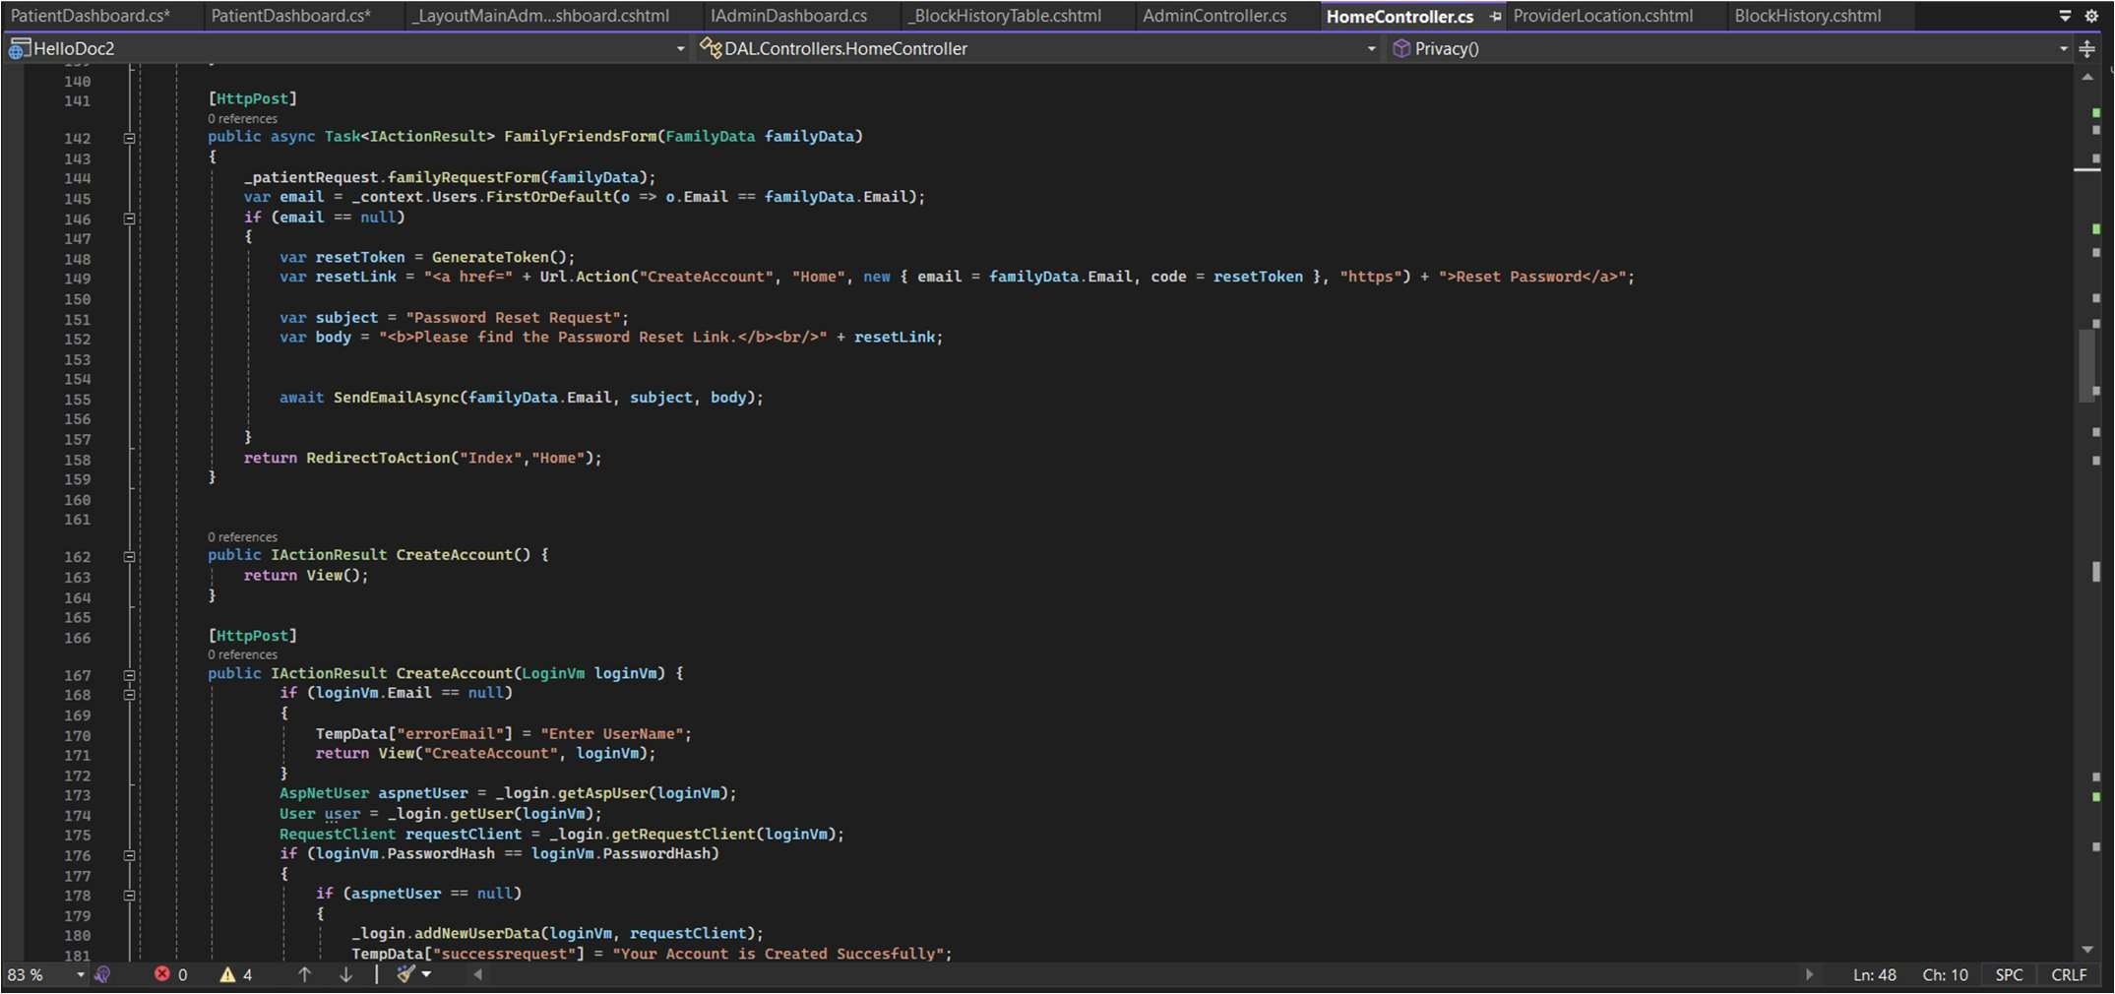

Fig 6.2-1 Controller data

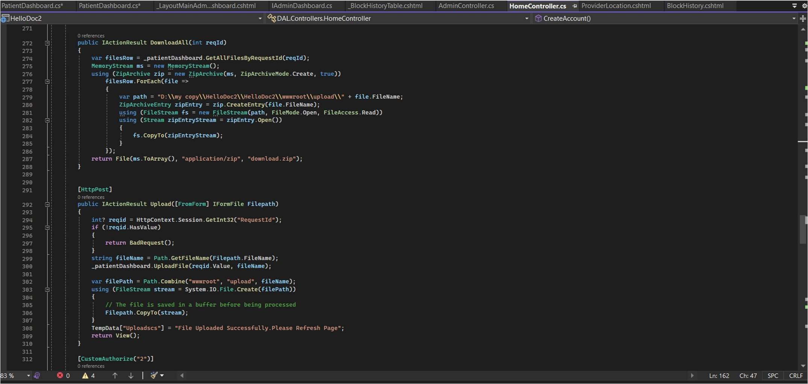

Fig 6.2-2 Repository Pattern.

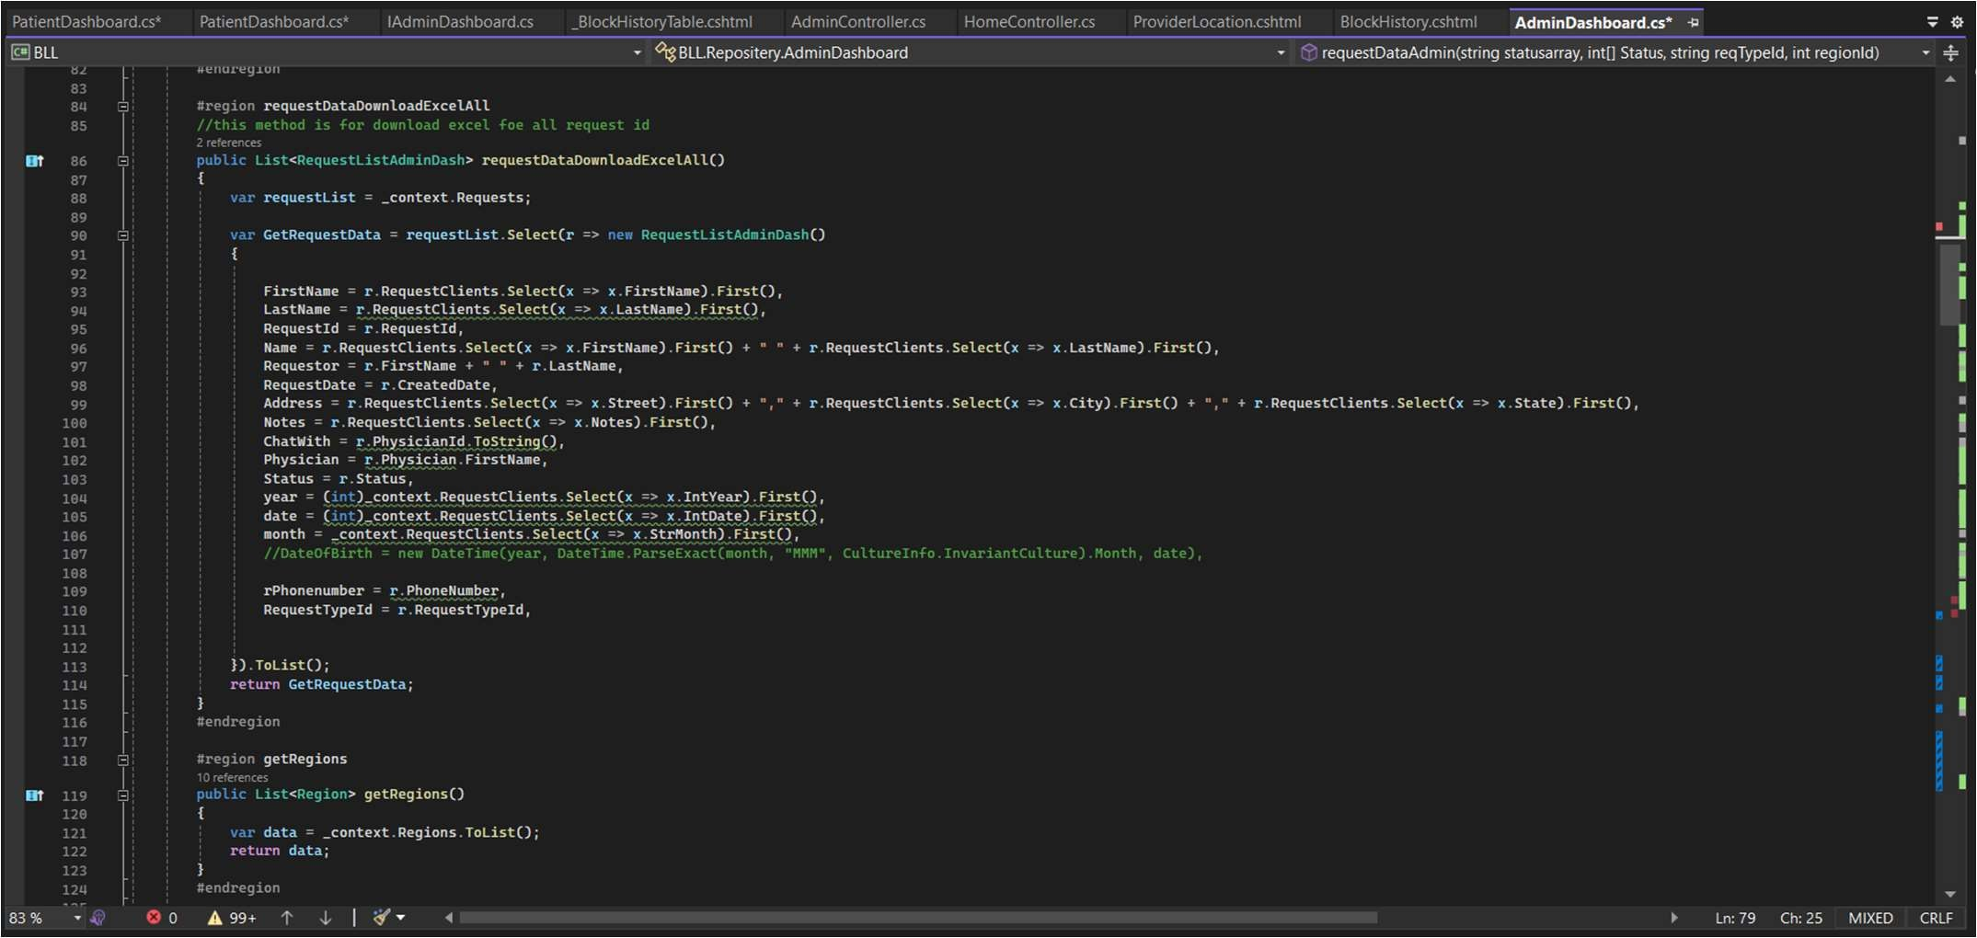

Fig 6.2-3 Service Call.

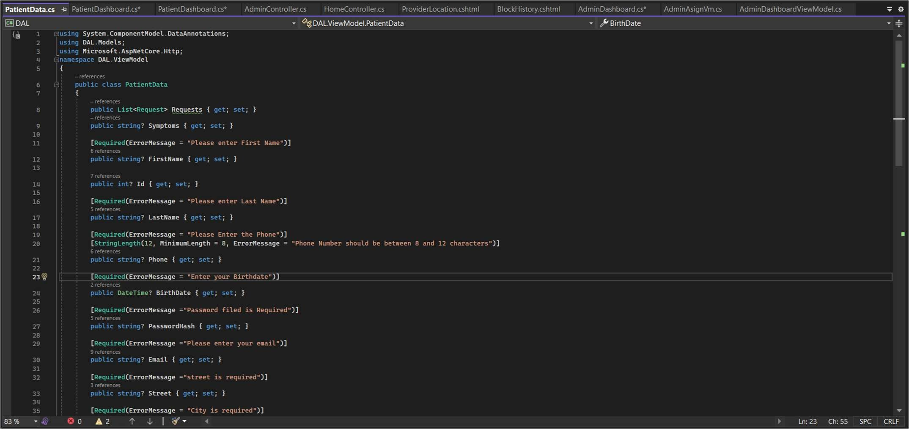

Fig 6.2-4 DB SET

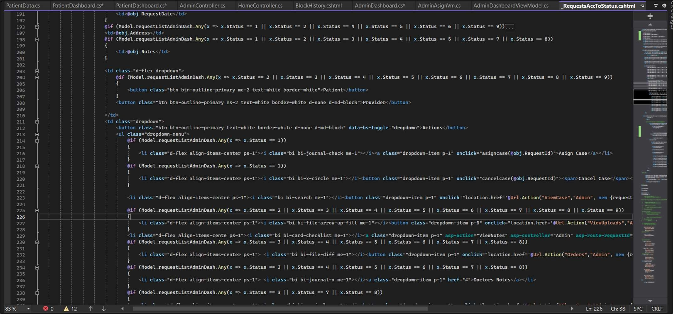

Fig 6.2-5 HTML code

# CHAPTER 7: TESTING

## 7.1 TESTING STRATEGIES

The objective of this testing plan is to ensure that the sentiment analysis model is accurate and performs well in classifying the sentiment of text inputs. The testing plan will cover various scenarios and inputs to evaluate the model’s performance and identify any issues or bugs that need to be addressed.

In this following testing were done:

* Unit Testing
* In this smallest piece of software is checked like login modal form.
* System Testing
* In this it conducts a complete, integrated system to evaluate the system’s compliance with its specific requirements.

## TESTING RESULT AND ANALYSIS

#### 7.2.1 Homepage – Hero Image

Dashboard of admin sites are busy. Because many patient request at the same time with that we can add this patient request in specific cache after that it can add to website:

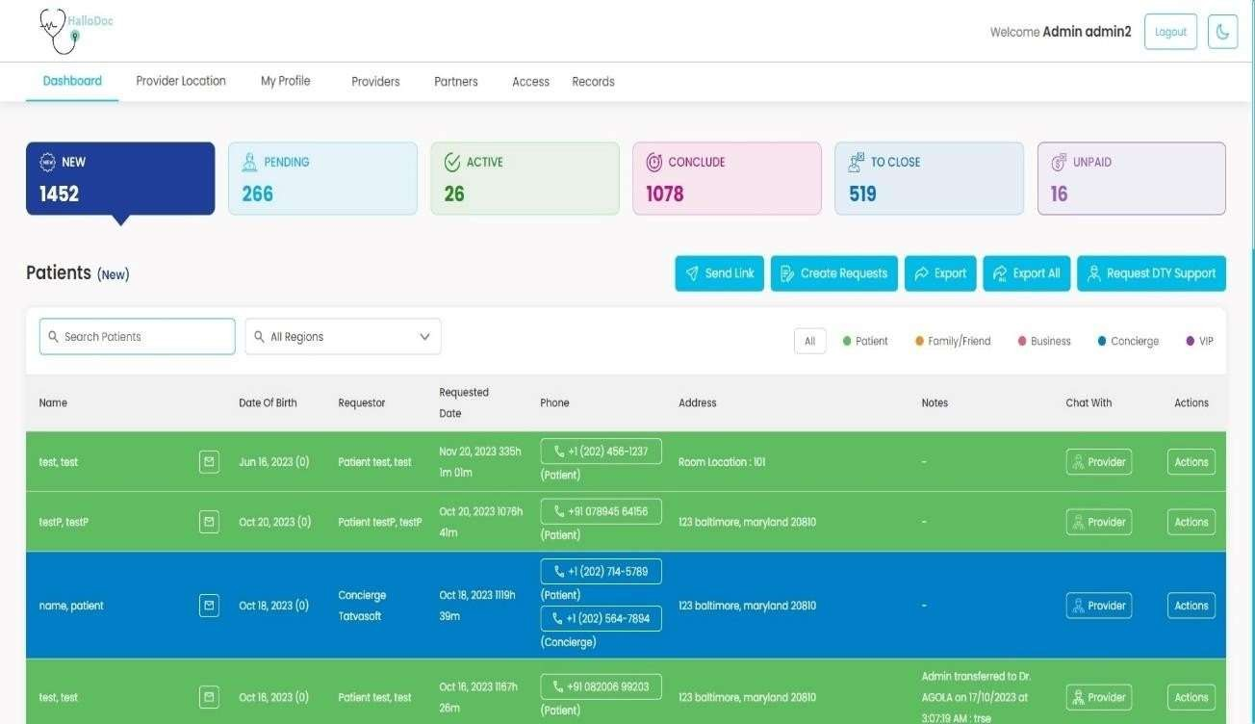

Fig 7.2 Dashboard Page

The following are a few things to test:

* Is it going to auto refresh after add new request?
* If yes, at what interval will the request be refreshed?
* When the admin hovers over it, is it still going to scroll to the next one?
* Can it be hovered on?
* Can it be clicked on?
* If yes, is it taking you to the right page and right deal?
* Is it loading along with the rest of the page or loads last in comparison to the other elements on the page?
* Can the rest of the content be viewed?
* Does it render the same way in different browsers and different screen resolutions?

#### Request Details Page

Once a admin see particular request either through search or by browsing or by clicking on it from the Dashboard, the admin will be taken to the request information page.

Check:

* Details symptoms of disease
* Date of the Request
* Disease specifications
* Consulting or not
* Provider details which consulting this request
* View Notes
* Add their own noted
* Created by details

# CHAPTER 8: CONCLUSION & DISCUSSION

## OVERALL ANALYSIS OF INTERNSHIP

The internship program has acquired a lot of knowledge related to improving practical skills. The different types of exercise and projects I worked on in the last three months of the internship have increased my knowledge of Data Science. I am very happy to be able to implement what I learned at university in the working industry. In this real situation, I was able to apply our theoretical knowledge.

I was able to satisfy my curiosity about how to develop any project from scratch through this internship. I am very thankful for the wonderful opportunity from **Tatvasoft Pvt. Ltd.**. and I hope this experience will surely help me in my future and also in shaping my career.

## SUMMARY OF INTERNSHIP

In January 2024, I began my internship at **TatvasoftPvt. Ltd.** Working at the office, I found inspiration in my everyday journeys thanks to a fantastic work environment. The personnel were pleasant, helpful, compassionate, and truthful. It was an opportunity for me to demonstrate my worth as an employee, a trustworthy co-worker, and a dedicated student. It was also a chance for me to obtain crucial office experience that I had lacked in my previous jobs.

My versatility was one of the most significant abilities I learned. Working across several technologies is typical in corporations, and that is precisely what I did. During my internship, I worked on an internship project.

As I completed more chores, I was given additional responsibilities, and I was always excited to get new assignments. The encouragement and honest responses I received were more than enough to put me at ease. I am grateful to all of my Protium co-workers for giving me the opportunity to grow both personally and professionally.

## FUTURE ENHANCEMENT

#### ENHANCEMENT:

* + 1. Easy to maintain attendance.
    2. We can use a complex database to handle the traffic.
    3. We can use the ACID property maintenance website.

By implementing these future enhancements, the Hallodoc Platform could provide an even more comprehensive and valuable tool for businesses and individuals looking to better understand public service and Doctor within their organization.



**PLAGIARISM SCAN REPORT**

|  |  |  |
| --- | --- | --- |
| 10%  Plagiarised | 90%  Unique | **Date** 2024-04-03 |
| **Words** 986 |
| **Characters** 7005 |

**Content Checked For Plagiarism**

ACKNOWLEDGEMENT

I would like to express my sincere gratitude to my internal guide Prof. POOJA OZA for their constant guidance and advice throughout the internship. Also, I would like to thank Principal and HOD of the Computer Department Dr. Tejas Pataliya for their valuable guidance and support.

I would also like to extend my heartful gratitude to TATVASOFT PVT. LTD. for the internship opportunity. Your experience and knowledge in the field have been invaluable in helping me to gain a deeper understanding of the industry. Your constructive feedback and guidance have enabled me to develop my skills and become a more effective contributor to the organization.

In addition, my focus and dedication to learn something new helped me to clinch success in the internship and learn a lot of new things and get hands on experience on live projects.

ABSTRACT

Industrial training is an important phase of a student life.

A well planned, properly executed and evaluated industrial training helps a lot in developing a professional attitude.

It develops an awareness of industrial approach to problem solving, based on a broad understanding of process and

mode of operation of organization.

During a period of 12 weeks of training at TatvaSoft., I was assigned as a trainee Software developer. Throughout this industrial training, I have learned new technology such as Asp.net core, and PostgreSQL Server. And with that, I developed the HalloDoc Platform Website.

Overall, this internship provided valuable experience in ASP .NET CORE MVC and POSTGRE SQL, and the skills gained are expected to be useful in future projects and career opportunities.

CHAPTER 1: OVERVIEW OF THE COMPANY

* 1. HISTORY

TatvaSoft is a Consummate Custom Software Development company delivering splendid business IT Solutions and related services to customers across the globe.

Our development services are led by our dedicated and passionate team to provide best industry practices combined with technology expertise and business domain knowledge to drive digital transformation.

Our proficiency in understanding business challenges and professional competence allows us to create a better experience for our customers.

CHAPTER 2: INTRODUCTION TO INTERNSHIP

* 1. INTERNSHIP SUMMARY

GTU provides the opportunity to get experience before students step into professional life. In January 2024, I began my internship at Tatvasoft Pvt. Ltd.. Working at the office, I found inspiration in my everyday journeys thanks to a fantastic work environment. It was an opportunity for me to demonstrate my worth as an employee, a trustworthy colleague, and a dedicated student. I have worked across several tools during my course of internship. The encouragement and honest responses I received were more than enough to put me at ease. I am grateful to my mentor for giving me the opportunity to grow both physically and personally.

CHAPTER 7: TESTING

* 1. TESTING STRATEGIES

The objective of this testing plan is to ensure that the sentiment analysis model is accurate and performs well in classifying the sentiment of text inputs. The testing plan will cover various scenarios and inputs to evaluate the model’s performance and identify any issues or bugs that need to be addressed.

In this following testing were done:

* Unit Testing
* In this smallest piece of software is checked like login modal form.
* System Testing
* In this it conducts a complete, integrated system to evaluate the system’s compliance with its specific requirements.
  1. TESTING RESULT AND ANALYSIS
     1. Homepage – Hero Image

Dashboard of admin sites are busy. Because many patient request at the same time with that we can add this patient request in specific cache after that it can add to website:

Check:

* + - * Details symptoms of disease
      * Date of the Request
      * Disease specifications
      * Consulting or not
      * Provider details which consulting this request
      * View Notes
      * Add their own noted
      * Created by details

CHAPTER 8: CONCLUSION & DISCUSSION

* 1. OVERALL ANALYSIS OF INTERNSHIP

The internship program has acquired a lot of knowledge related to improving practical skills. The different types of exercise and projects I worked on in the last three months of the internship have increased my knowledge of Data Science. I am very happy to be able to implement what I learned at university in the working industry. In this real situation, I was able to apply our theoretical knowledge.

I was able to satisfy my curiosity about how to develop any project from scratch through this internship. I am very thankful for the wonderful opportunity from Tatvasoft Pvt. Ltd.. and I hope this experience will surely help me in my future and also in shaping my career.

* 1. SUMMARY OF INTERNSHIP

In January 2024, I began my internship at Tatvasoft Pvt. Ltd. Working at the office, I found inspiration in my everyday journeys thanks to a fantastic work environment. The personnel were pleasant, helpful, compassionate, and truthful. It was an opportunity for me to demonstrate my worth as an employee, a trustworthy co-worker, and a dedicated student. It was also a chance for me to obtain crucial office experience that I had lacked in my previous jobs.

My versatility was one of the most significant abilities I learned. Working across several technologies is typical in corporations, and that is precisely what I did. During my internship, I worked on an internship project.

As I completed more chores, I was given additional responsibilities, and I was always excited to get new assignments. The encouragement and honest responses I received were more than enough to put me at ease. I am grateful to all of my Protium co-workers for giving me the opportunity to grow both personally and professionally.

* 1. FUTURE ENHANCEMENT ENHANCEMENT:
* Easy to maintain attendance.
* We can use a complex database to handle the traffic.
* We can use the ACID property maintenance website.

By implementing these future enhancements, the Halldoc Platform could provide an even more comprehensive and valuable tool for businesses and individuals looking to better understand public service and Doctor with

**Matched Source**

**Similarity** 12%

**Title**:Abstract - ABSTRACT Industrial training is an important phase of a ...

Industrial Ptraining is an important phase of a student lifeÇ. A well planned, properly executed and evaluated industrial training helps a lot in developing a professional attitude. It develop an awareness of industrial approach to problem solving, based on a broad understanding of process and mode of operation of organization.

<https://www.studocu.com/in/document/xavier-institute-of-engineering/information-technology/abstract/52979565>

**Similarity** 12%

**Title**:Industrial Training Report-Main - ABSTRACT Industrial...

Jul 5, 2016 — ... A well planned, properly executed and evaluated industrial training helps a lot in developing a professional attitude. It develop an ...

<https://www.coursehero.com/file/14862171/Industrial-Training-Report-Main/>

**Similarity** 12%

**Title**:Internship in Web Development - by Smit Anam

... It develops an awareness of industrial approach to problem solving, based on a broad understanding of process and mode of operation of ...

[https://medium.com/@d21it183/internship-in-web-development-577ba5b45012?responsesOpen=true](https://medium.com/%40d21it183/internship-in-web-development-577ba5b45012?responsesOpen=true)

**Similarity** 7%

**Title**:[www.tatvasoft.com](http://www.tatvasoft.com/) › about-usAbout our company- TatvaSoft

We are a Consummate Custom Software Development company delivering splendid business IT Solutions and related services to customers across the globe. Our development services are led by our dedicated and passionate team to provide best industry practices combined with technology expertise and business domain knowledge to drive digital ...

<https://www.tatvasoft.com/about-us/>

**Similarity** 7%

**Title**:About our company

... Our proficiency in understanding business challenges and professional competence allows us to create a better experience for our customers. We have emerged ...

<https://www.tatvasoft.com/software-outsourcing-aboutus/software-outsourcing-company>

