1. Algorithm of right triangle of number
2. Start
3. Let I be an integer number.
4. Let j be an integer number.
5. Let n be an integer number and initialize by 1.
6. Repeat step 6 to 9 until all value parsed.
7. Set I = 0 and check I<6;
8. Set j=2 and check j<=1;
9. Print number n.
10. Then n++
11. End

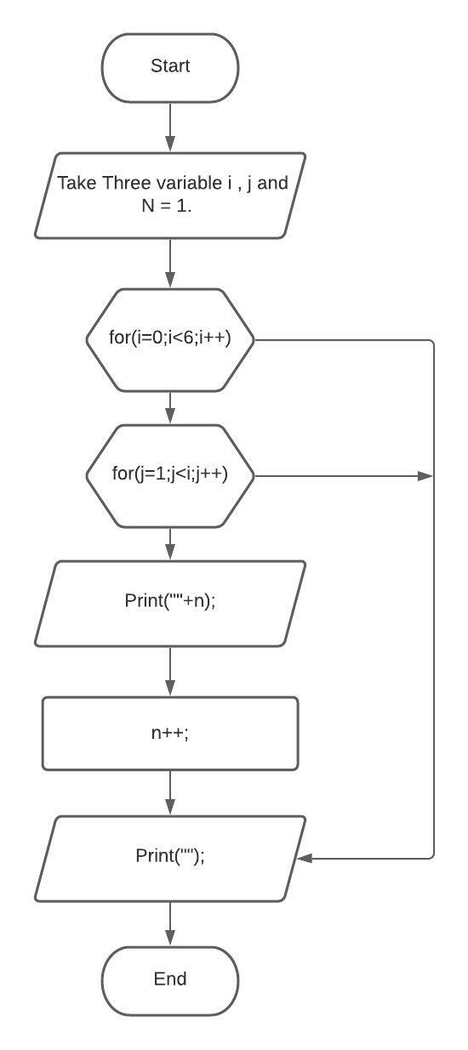

**2.Algorithm of Triangle Pattern.**

1. Start

2. Let i be an integer number.

3. Let j be an integer number.

4. Let n be a integer number and initialize by 5.

5. Repeat steps 6 until all value parsed.

6. Set i = 1 and check i<=n;

7. Set j =1 and check j<=1;

8. Check the condition i>=j;

9. Print “*”.

10. Print (“\n”)

11. End.

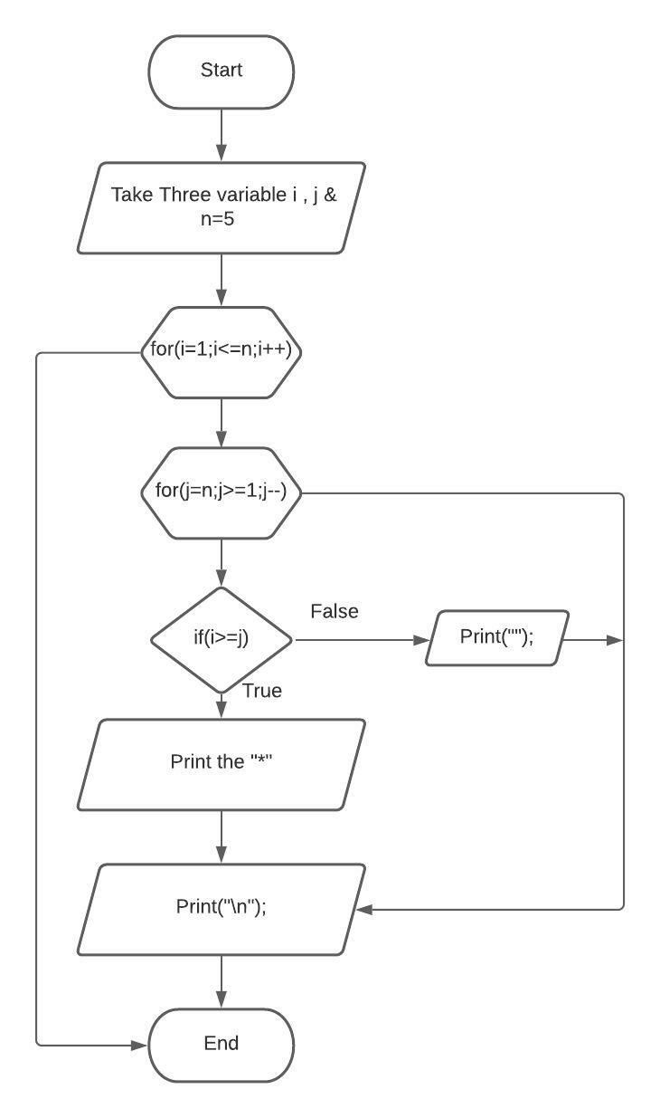

**3.Algorithm of Square Pattern.**

1. Start

2. Let i be an integer number.

3. Let j be an integer number.

4. Repeat steps 5 until all value parsed.

5. Set i = 1 and check i<=5;

6. Set j =1 and check j<=5;

7. Print “*”.

8. Print (“\n”)

9. End.

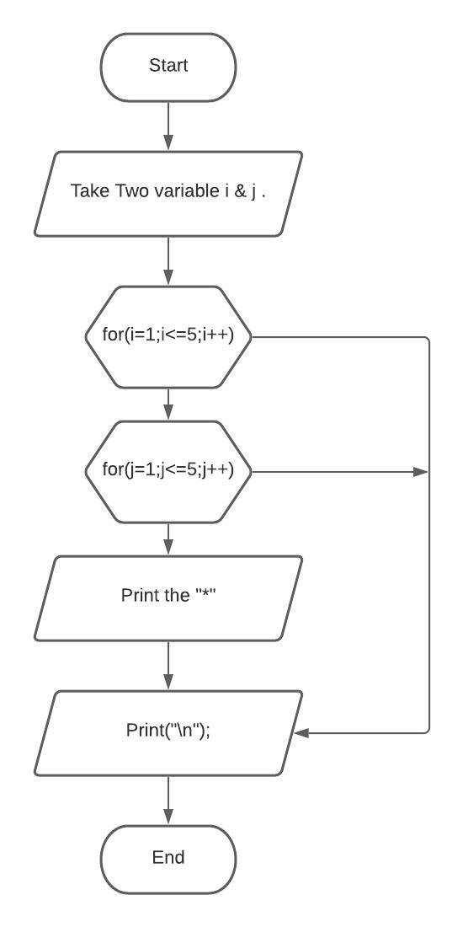

**4.Algorithm of T pattern.**

1. Start

2. Let i be an integer number.

3. Let j be an integer number.

4. Let n be a integer number and initialize by 5.

5. Repeat steps 6 until all value parsed.

6. Set i = 1 and check i<=n;

7. Set j =1 and check j<=n;

8. Check the condition j==n/2+1 || i==1;

9. Print “T”.

10. Print (“\n”)

11. End.

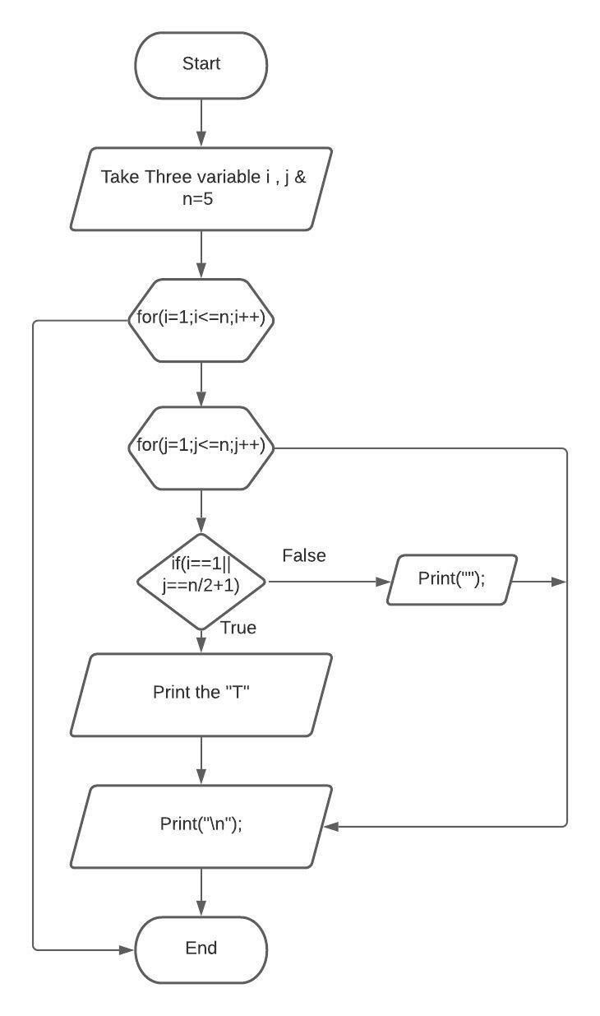

**5.Algorithm of Plus Pattern.**

1. Start

2. Let i be an integer number.

3. Let j be an integer number.

4. Repeat steps 5 until all value parsed.

5. Set i = 1 and check i<=5;

6. Set j =1 and check j<=5;

7. Check the condition j==3 & i==3;

8. Print “*”.

9. Print (“\n”)

10. End.

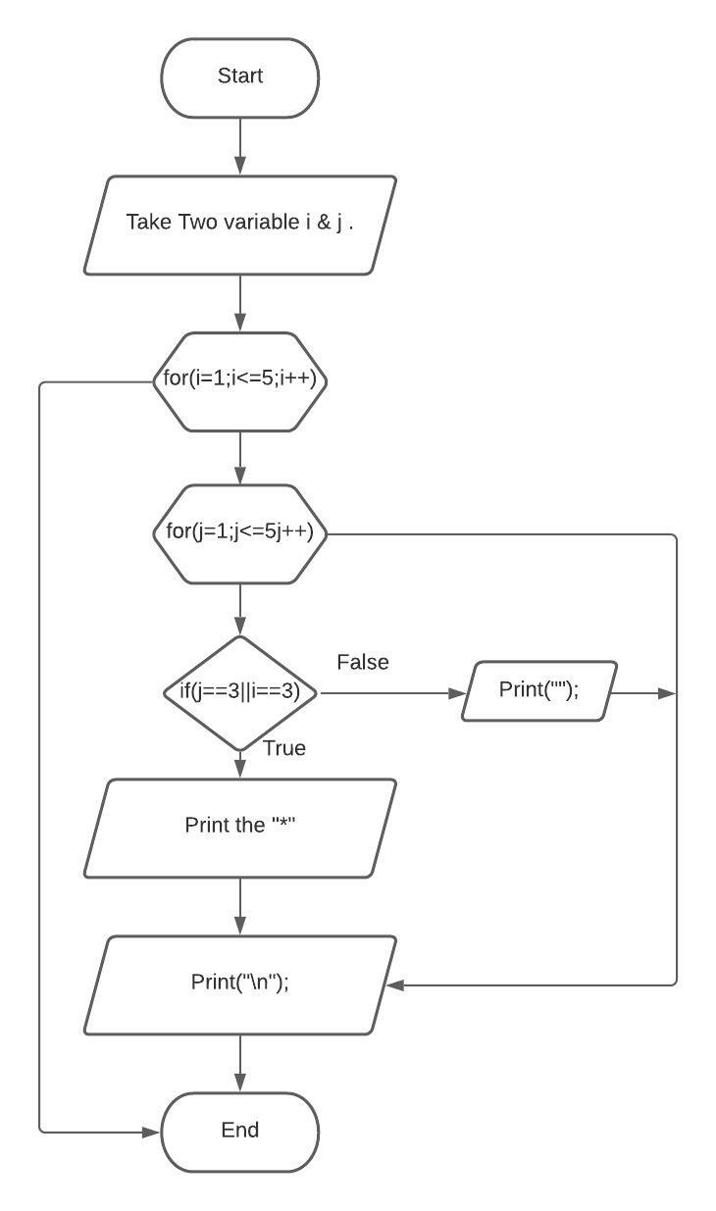

**6.Algorithm of cross multiplication pattern.**

1. Start

2. Let i be an integer number.

3. Let j be an integer number.

4.Let n be a integer number and initialize by 5.

5.Repeat step 6 until all value parsed.

6.set = 1 and check I<=n;

7. set j =1 and check j<=n;

8.check the condition I==j || I+j ==n+1;

9.print “*”

10.print(“/n”)

11.End

