

Prepaired By:

Santosh Lal Choudhury
Professional Background
Recently,I have completed my MCA.I have secured 67.2% and have several skills including Data Analysis,HTML,Java,Python & SQL .

I have worked as an intern in a company devine.AI, worked on an in-house project as developer as my MCA final year curriculum for 6 months .

As I am a fresher it would be great to experience the real challenges of the corporate world and understand how things work. Being a fresher, I think I am very flexible and adaptive to learn new things. I have theoretical knowledge. But I am waiting to use my theoretical knowledge in a practical way. And I believe by putting significant efforts I will learn.

Contents
Professional Background……………………………………2
Content………………………………………………………3
Data analytic process………………………………………5-9
Instagram user Analytics…………………………………..10-23
Operation & metric analysis………………………………24-40
Hiring process analytics…………………………………..41-52
IMDB movie analysis…………………………………….53-65
Bank loan case study…………………………………….66-113
Impact of car feature……………………………………114-131
ABC call volume trend…………………………………132-141
Conlusion………………………………………………….142
Appendix…………………………………………………..143

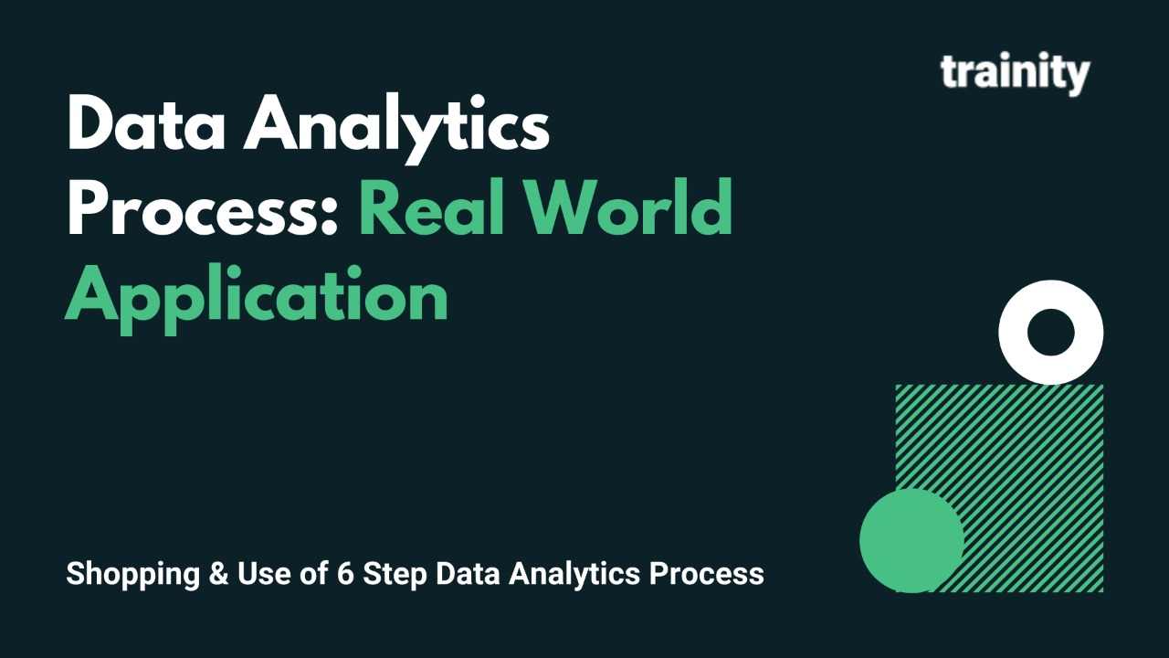
Description:
We use Data Analytics in everyday life without even knowing it.
For eg : Going to a market to buy something .
Plan
We first decide which things I need before going to market . Is it a shirt , jeans , footwear etc.
Prepare
Next I need to check how much I am willing to spend and how to get that money.
Process
Then I need to check how much I want from the data. Like if I am going to buy footwear what do I want - slippers / shoes / sandals etc.
Analyze
You obviously won't buy things which are out of trend, Also you need to check does the jeans which you have and the color of t-shirt you want to buy, will it make a good combination
Share
Now you communicate your idea to the shopkeeper to find the best suitable fit for you.
Act
Then you finally buy it!

Task:
Task is to give the example(s) of such a real-life situation where we use Data Analytics .

Analysis
Going to sport shop to buy badminton kit to take part in training session.

Plan:List of things we need
- Bag
- Racket
- Bottle
- T-Shirt
- Shorts
- Socks
- Footware
- Shuttlecock

Prepare:
- Minimum Budget estimation given for buying this stuff is around Rs.15000.
- Budget to buy the stuff was given by the family.
- Then the shop was decided from where we can get all this stuff.

Process:
- Bag(Badminton kit bag).
- Racket(Badminton racket).
- Bottle(sports water bottle).
- T-shirt(sport tshirt).
- Shorts(sport shorts).
- Socks(Badminton sport socks).
- Footware(Badminton shoes).
- Shuttlecock(Plastic yellow SC).

Analyze:
- Bag(Badminton kit bag)-need to buy bag of yonex brand.
- Racket(Badminton racket)-need to buy bag of yonex brand.
- Bottle(sports water bottle)-need to buy bottle of woodland brand because of its durability.
- T-shirt(sport tshirt)-need to buy tshirt of yonex or li-ning brand.
- Socks(Badminton sport socks )-need to buy thick ankle socks.
- Footware(Badminton shoes)-need to buy shoes of yonex or li-ning brand.
- Shuttlecock(Plastic yellow SC)-need to buy yonex marvis 350.
Share:
- now went to the shopkeeper to buy the kit according to my budget,brand & suitable fitting.
Act:
- Finally Buyed all the stuff required.

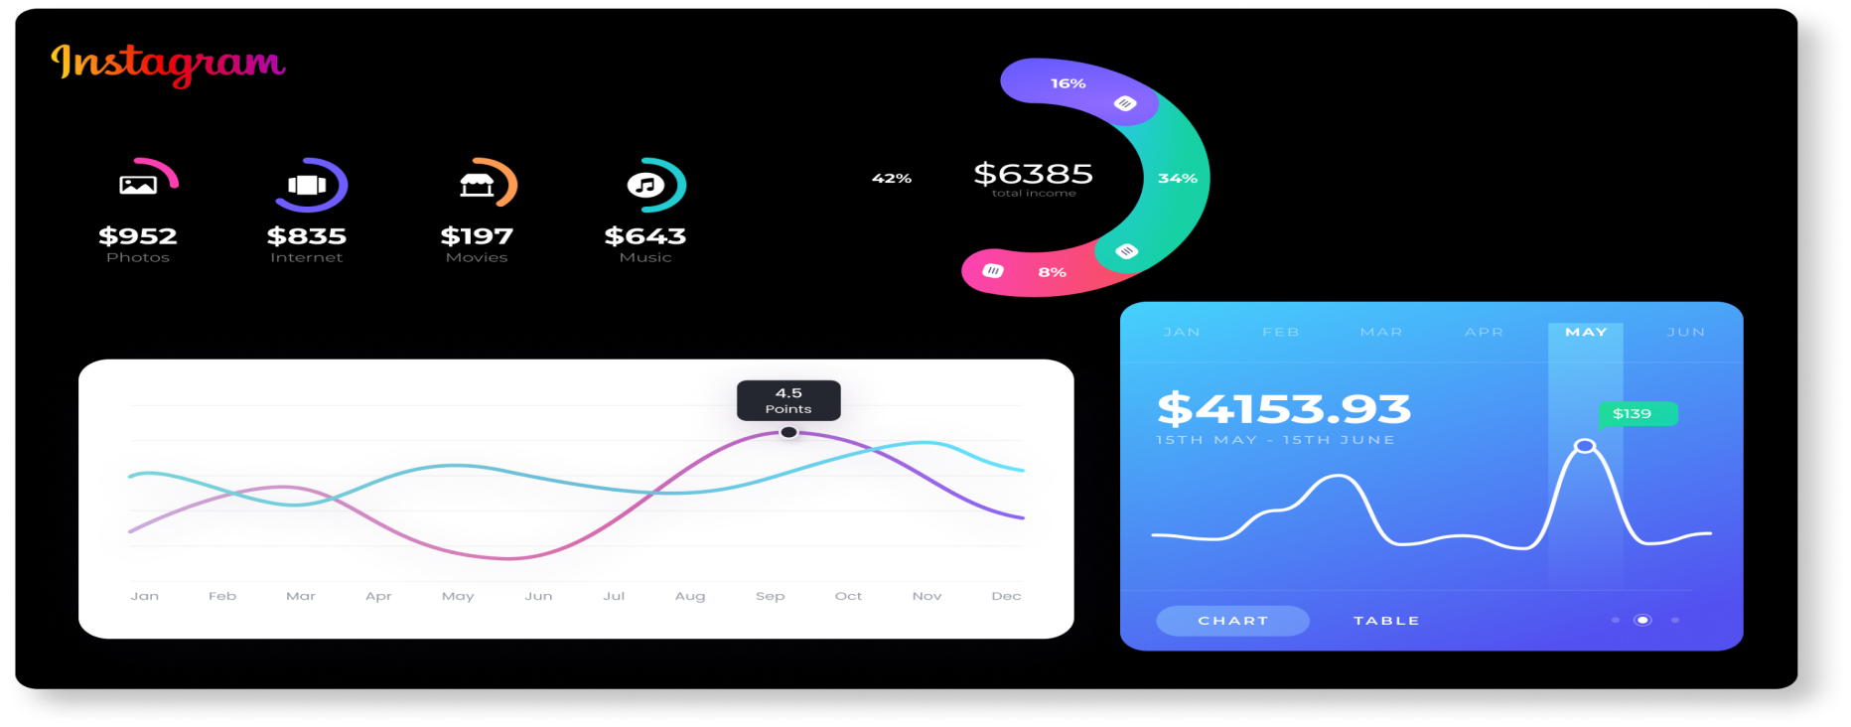Instagram user Analytics
Description:
Imagine you're a data analyst working with the product team at Instagram. Your role involves analyzing user interactions and engagement with the Instagram app to provide valuable insights that can help the business grow.
User analysis involves tracking how users engage with a digital product, such as a software application or a mobile app. The insights derived from this analysis can be used by various teams within the business. For example, the marketing team might use these insights to launch a new campaign, the product team might use them to decide on new features to build, and the development team might use them to improve the overall user experience.
In this project, you'll be using SQL and MySQL Workbench as your tool to analyze Instagram user data and answer questions posed by the management team. Your insights will help the product manager and the rest of the team make informed decisions about the future direction of the Instagram app.
Remember, the goal of this project is to use your SQL skills to extract meaningful insights from the data. Your findings could potentially influence the future development of one of the world's most popular social media platforms.

Task
SQL Task:
- Marketing Analysis:
- Loyal User Reward: The marketing team wants to reward the most loyal users, i.e., those who have been using the platform for the longest time.
Your Task: Identify the five oldest users on Instagram from the provided database.
- Inactive User Engagement: The team wants to encourage inactive users to start posting by sending them promotional emails.
Your Task: Identify users who have never posted a single photo on Instagram.
- Contest Winner Declaration: The team has organized a contest where the user with the most likes on a single photo wins.
Your Task: Determine the winner of the contest and provide their details to the team.
- Hashtag Research: A partner brand wants to know the most popular hashtags to use in their posts to reach the most people.
Your Task: Identify and suggest the top five most commonly used hashtags on the platform.
- Ad Campaign Launch: The team wants to know the best day of the week to launch ads.
Your Task: Determine the day of the week when most users register on Instagram. Provide insights on when to schedule an ad campaign.
- Investor Metrics:
- User Engagement: Investors want to know if users are still active and posting on Instagram or if they are making fewer posts.
Your Task: Calculate the average number of posts per user on Instagram. Also, provide the total number of photos on Instagram divided by the total number of users.
- Bots & Fake Accounts: Investors want to know if the platform is crowded with fake and dummy accounts.
Your Task: Identify users (potential bots) who have liked every single photo on the site, as this is not typically possible for a normal user.

Tech-Stack Used:-
I used my sql workbench 8.0 CE while making this project as i am familiar with this software & easy to use.
- Task: Find the 5 oldest users of the Instagram from the database provided.
Approach:-
first i analyse the user schema to get a brief idea about the data present in that schema and how to get 5 oldest user of the instagram.
Sql query- SELECT * FROM users ;
Secondly after getting a brief idea about the schema ,now i sorted the data according to their created_at which is the date and time of the user when they register to instagram.
Sql query- SELECT * FROM users ORDER BY created_at ASC LIMIT 5;

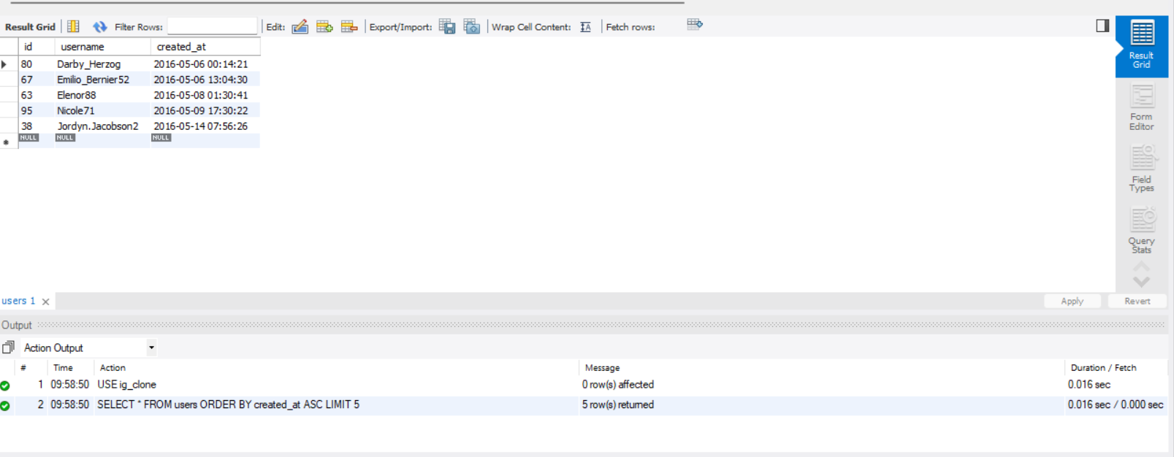
Fig.1-The 5 oldest users of the Instagram from the database provided.

- Task: Find the users who have never posted a single photo on Instagram.
Approach:-firstly i analyse the user and photo schema to get a brief idea ,how i can approach to this task.
Sql query:SELECT * FROM users, photos;
Secondly i search for id from users schema whose id is not present in photo schema because the id’s who have never
posted a single photo will not be present in photo schema.
Sql query:SELECT id FROM users EXCEPT SELECT user_id FROM photos;
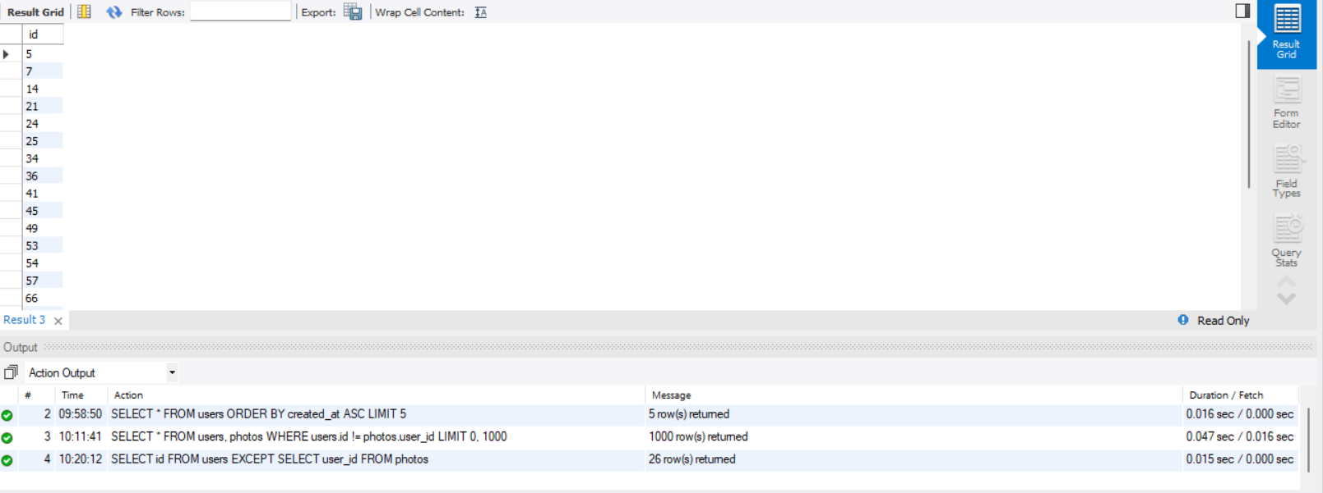
Fig.2-The users ID who have never posted a single photo on Instagram.
- Task: Identify the winner of the contest and provide their details to the team.
Approach:
firstly i analyse the like schema to get a brief idea ,how i can get the desire result.
Sql query:-SELECT * FROM Likes;
secondly I count the total likes got on each photo and which photo got the highest like thorough sorting i got the highest
liked photo.
Sql query:-SELECT photo_id, COUNT(photo_id) FROM likes GROUP BY photo_id ORDER BY COUNT(photo_id) DESC LIMIT 1;
thirdly i use the photo id which i got from likes schema to get the ID of the user who posted it from photo schema.
Sql query:-SELECT * FROM photos WHERE id=145;
At last we get the id of the user who posted it from photo schema,then we search the id in user schema to get the details
of the user.
Sql query:-SELECT * FROM users WHERE id=52; (The winner of the contest.)
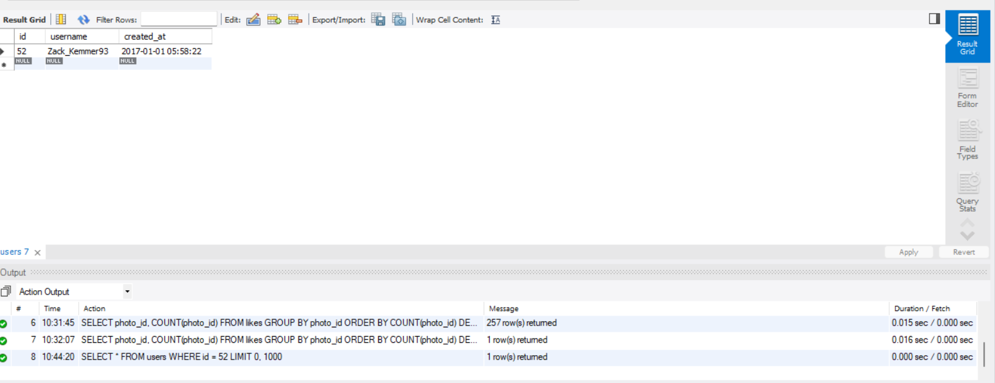
Fig.3-winner of the contest and their details

- Task: Identify and suggest the top 5 most commonly used hashtags on the platform.
Approach:
firstly i analyse the tags & photo_tags schema,to get a brief idea about the task and how to approach it.
sqlquery:-SELECT * FROM tags, photo_tags;
secondly i checked the top 5 tag id which is mostly used from photo_tags schema.
Sql quey:-SELECT tag_id, COUNT(tag_id) FROM photo_tags GROUP BY tag_id ORDER BY COUNT(tag_id) DESC LIMIT 5;
thirdly i use the tag id i got from photo_tag schema,to get the tags which are trending.
Sql query:-SELECT tag_name,id FROM tags WHERE id IN ('21','20','17','13','18');

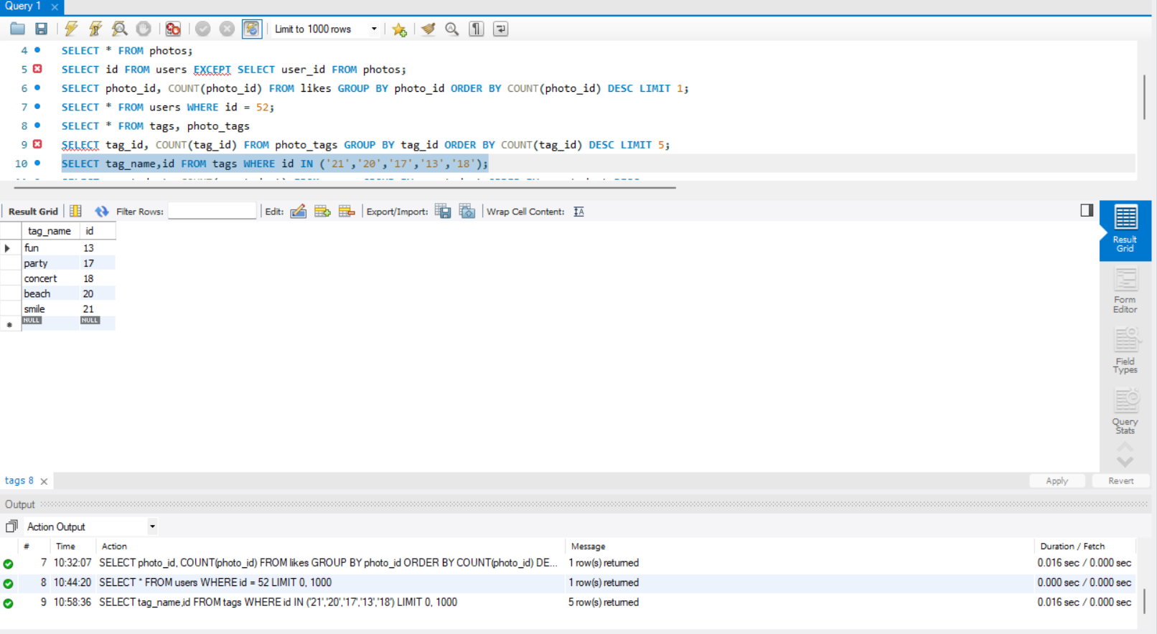
Fig.4-the top 5 most commonly used hashtags on the platform
- Task: What day of the week do most users register on? Provide insights on when to schedule an ad campaign.
Approach:
firstly i need to change the date and time to weekdays to known on which weekday the user has registered.
secondly i count and group the user according to their registration weekday,after that i get the the result on which weekday
their are more user registered.

Sql query:-SELECT weekday(created_at), count (weekday(created_at)) FROM users GROUP BY weekday(created_at) ORDER BY WEEKDAY (created_at);
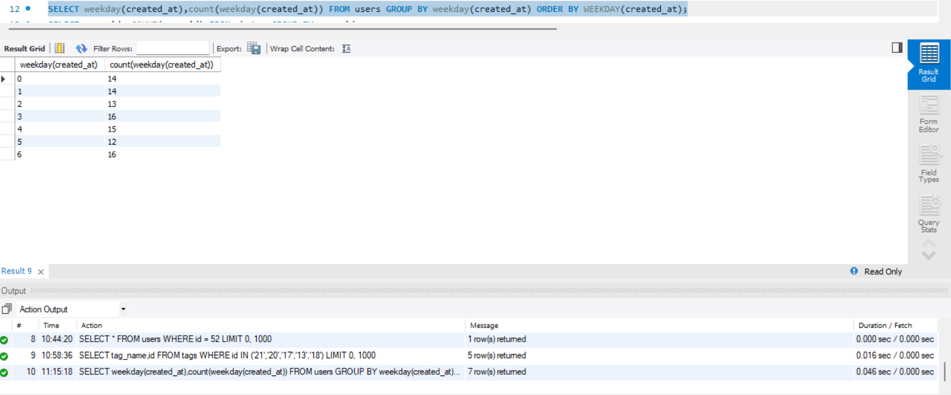
NOTE:(0 = Monday, 1 = Tuesday, 2 = Wednesday, 3 = Thursday, 4 = Friday, 5 = Saturday, 6 = Sunday.)
Fig.5-day of the week do most users register on
Insight:
On Thursday & Sunday most of the users has registered. Ad campaign can be schedule on either Thursday or Sunday.
- Task: Provide how many times does average user posts on Instagram. Also, provide the total number of photos on
Instagram/total number of users

Approach:
firstly i sort ,group & count the post posted by each and every user from photos schema.
Sql query:-SELECT user_id ,COUNT(user_id) FROM photos GROUP BY user_id ;
To know the total no of photos & total no of users.
Sql query:-SELECT COUNT(username) FROM users;
SELECT COUNT(id) FROM photos ;
- Task: Provide data on users (bots) who have liked every single photo on the site (since any normal user would
not be able to do this).
Approach:
first we need to find the total no of photos.
Sql query:SELECT COUNT(id) FROM photos ;
then we sort the like schema according to userid and total likes done by that user id then we got a list of user id and total likes done by that user id.
Sql query:-SELECT user_id, COUNT(user_id) FROM likes GROUP BY user_id ORDER BY COUNT(user_id) DESC;
As we know the total no of post present ,we can get the id of the user who have likes equal to total no of post.and then we can sort the user schema according to the result we got from like schema and we can get the user(bot) details.
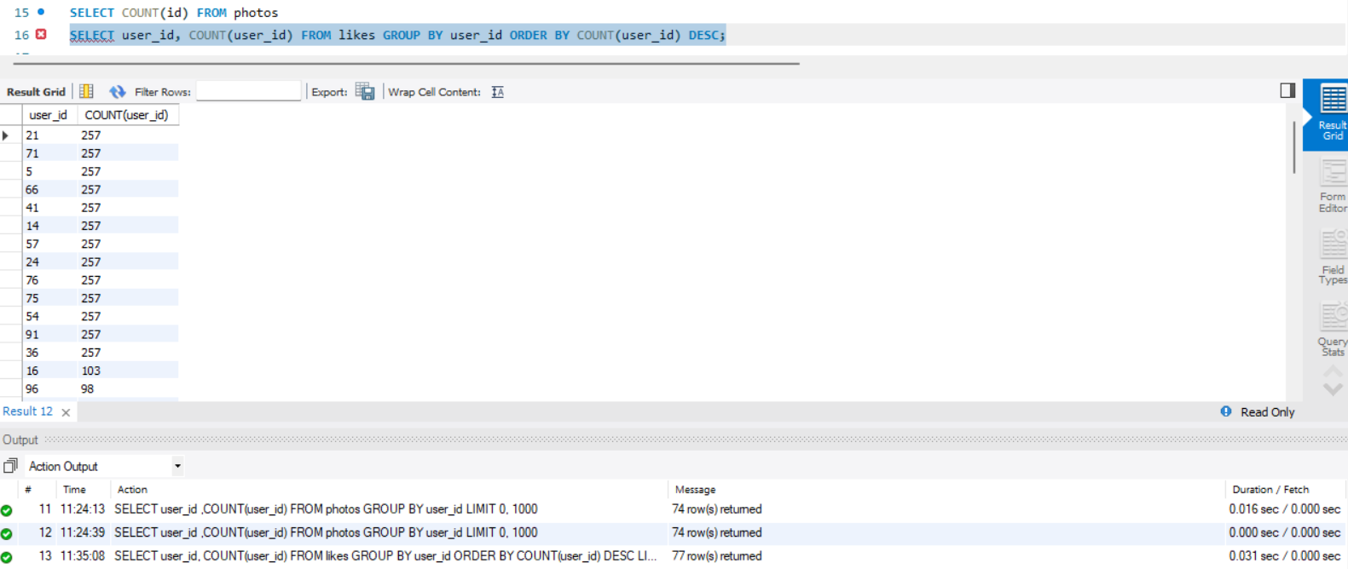
Fig.7-Data on users (bots) who have liked every single photo on the site (since any normal user would not be able to do this).

Conclusion
In conclusion, I would like to tell that after doing a thorough analysis we were able to derive the insights from the data.The data that once looked useless became useful and helped to understand the users.Analyzing the data proved helpful in
Finding bots.

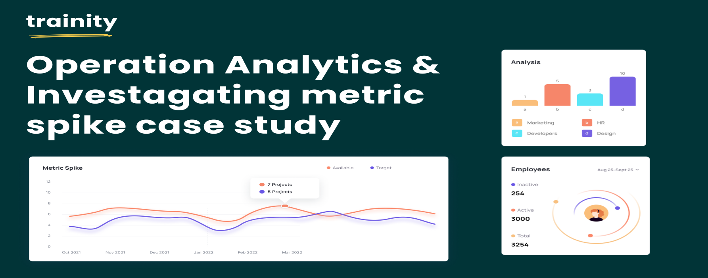
Description
Operational Analytics is a crucial process that involves analyzing a company's end-to-end operations. This analysis helps identify areas for improvement within the company. As a Data Analyst, you'll work closely with various teams, such as operations, support, and marketing, helping them derive valuable insights from the data they collect.
One of the key aspects of Operational Analytics is investigating metric spikes. This involves understanding and explaining sudden changes in key metrics, such as a dip in daily user engagement or a drop in sales. As a Data Analyst, you'll need to answer these questions daily, making it crucial to understand how to investigate these metric spikes.
In this project, you'll take on the role of a Lead Data Analyst at a company like Microsoft. You'll be provided with various datasets and tables, and your task will be to derive insights from this data to answer questions posed by different departments within the company. Your goal is to use your advanced SQL skills to analyze the data and provide valuable insights that can help improve the company's operations and understand sudden changes in key metrics.
Problem
Case Study 1: job_data Analysis
Working with a table name job_data with following columns
- job_id: Unique identifier of jobs
- actor_id: Unique identifier of actor
- event: The type of event (decision/skip/transfer).
- language: The Language of the content
- time_spent: Time spent to review the job in seconds.
- org: The Organization of the actor
- ds: The date in the format yyyy/mm/dd (stored as text).

Task:
- Jobs Reviewed Over Time:
  - Objective: Calculate the number of jobs reviewed per hour for each day in November 2020.
  - Your Task: Write an SQL query to calculate the number of jobs reviewed per hour for each day in November 2020.
- Throughput Analysis:
  - Objective: Calculate the 7-day rolling average of throughput (number of events per second).
  - Your Task: Write an SQL query to calculate the 7-day rolling average of throughput. Additionally, explain whether you prefer using the daily metric or the 7-day rolling average for throughput, and why.
- Language Share Analysis:
  - Objective: Calculate the percentage share of each language in the last 30 days.
  - Your Task: Write an SQL query to calculate the percentage share of each language over the last 30 days.

- Duplicate Rows Detection:
  - Objective: Identify duplicate rows in the data.
  - Your Task: Write an SQL query to display duplicate rows from the job_data table.
Case Study 2: Investigating Metric Spike
Will be working on 3 tables:
- users: Contains one row per user, with descriptive information about that user’s account.
- events: Contains one row per event, where an event is an action that a user has taken (e.g., login, messaging, search).
- email_events: Contains events specific to the sending of emails.
Task
- Weekly User Engagement:
  - Objective: Measure the activeness of users on a weekly basis.
  - Your Task: Write an SQL query to calculate the weekly user engagement.

- User Growth Analysis:
  - Objective: Analyze the growth of users over time for a product.
  - Your Task: Write an SQL query to calculate the user growth for the product.
- Weekly Retention Analysis:
  - Objective: Analyze the retention of users on a weekly basis after signing up for a product.
  - Your Task: Write an SQL query to calculate the weekly retention of users based on their sign-up cohort.
- Weekly Engagement Per Device:
  - Objective: Measure the activeness of users on a weekly basis per device.
  - Your Task: Write an SQL query to calculate the weekly engagement per device.
- Email Engagement Analysis:
  - Objective: Analyze how users are engaging with the email service.
  - Your Task: Write an SQL query to calculate the email engagement metrics.

Analysis:
A. Your task: Calculate the number of jobs reviewed per hour per day for November 2020?

first download the given data set as csv extension
then open sql workbench and create the job data schema
then import the downladed table data.
solution:-
As we know that the time spent is in sec to find the job review per hour we need to select the time spent.
sql query:-
select ds,count(job_id) as job_per_day,sum(time_spent)/3600 as hour_spent from `sql project-1 table - sheet1` where ds >='1-11-2020' and ds<='30-11-2020' group by ds;
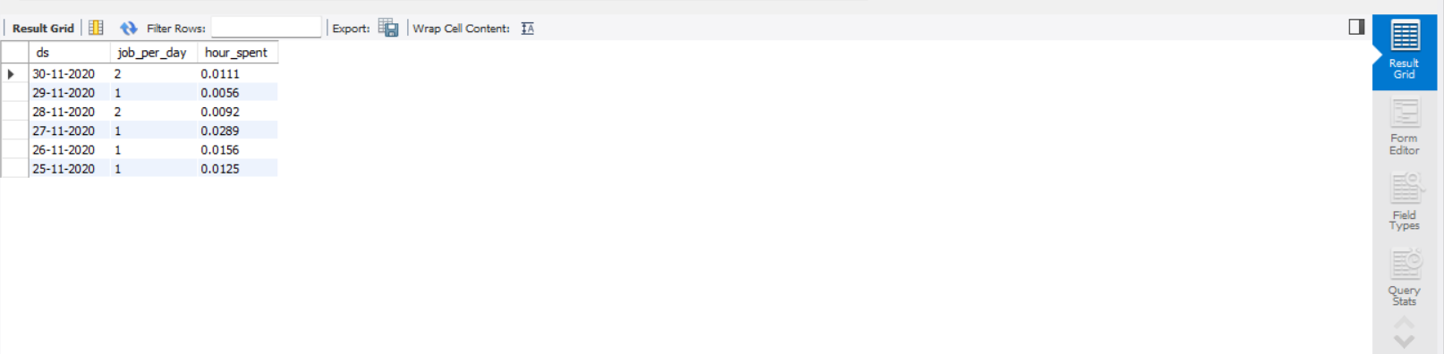
Fig.1-Showing the number of jobs reviewed per hour per day for November 2020

B. Your task: Let’s say the above metric is called throughput. Calculate 7 day rolling average of throughput?
For throughput, do you prefer daily metric or7-day rolling and why?
Solution:
For calculating the throughput we will be using the 7-day rolling because7-day rolling gives us the average for all the days right from day 1 to day 7 Whereas daily metric gives us average for only that particular day itself.For calculating the 7-day rolling daily metric average of throughput:-
We will be first taking the count of job_id(distinct and non-distinct) andordering them w.r.t ds (date of interview)
Then by using the ROW function we will be considering the rowsbetween6 preceding rows and the current row3.
Then we will be taking the average of the jobs_reviewed.

sql query:-
select ds,job_reviewed,avg(job_reviewed) over(order by ds rows between 6 preceding and current row)
as rolling_avg from(select ds,count(job_id)as job_reviewed from `sql project-1 table - sheet1`group by ds order by ds)a;
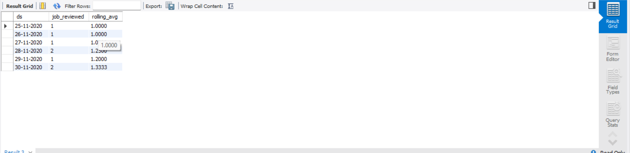
Fig.2- showing no. of events happening per second.

C. Percentage share of each language: Share of each language for differentcontents.
Your task: Calculate the percentage share of each language in the last 30days?
Solution:
To calculate the percentage share of each language (distinct and nondistinct):-
We will first divide the total number of languages (distinct/non-distinct) by thetotal number of rows presents in the table
Then we will do the grouping based on the languages.
Sql query:-
select language,count(language) as total ,((count(language)/(select count(*) from `sql project-1 table - sheet1`))*100) as percentage from `sql project-1 table - sheet1` group by language;
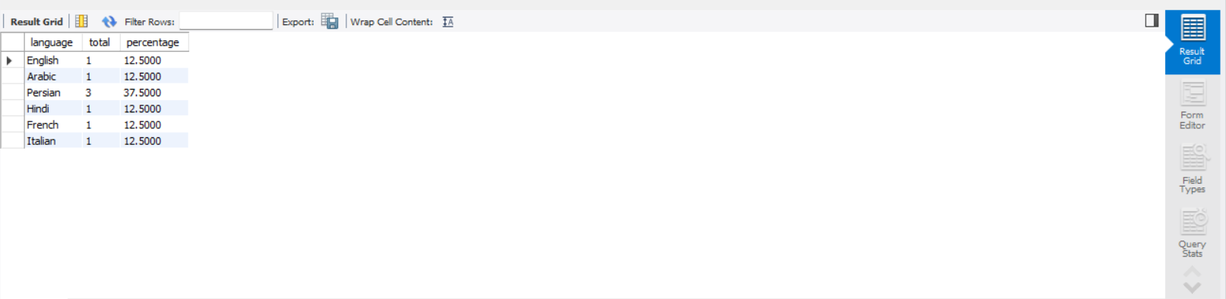
Fig.3-showing Percentage share of each language

D. Duplicate rows: Rows that have the same value present in them.
Your task: Let’s say you see some duplicate rows in the data. How will you display duplicates from the table?
Solution:
To view the duplicate rows having the same value we will:-
1. First decide in which do we need to find the duplicate row values
2. After deciding the column(parameter) we will use the ROW_NUMBER function to find therow numbers having the same value
3. Then we will portioning the ROW_NUMBER function over the column (parameter) thatwe decided i.e. job_id
4. Then using the WHERE function we will find the row_num having valuegreater than 1 i.e. row_num > 1 based on the occurrence of the job_id in the table

sql query:-
SELECT *FROM (SELECT * ,ROW_NUMBER()OVER(PARTITION BY job_id) AS row_num FROM `sql project-1 table - sheet1`) a WHERE row_num>1;
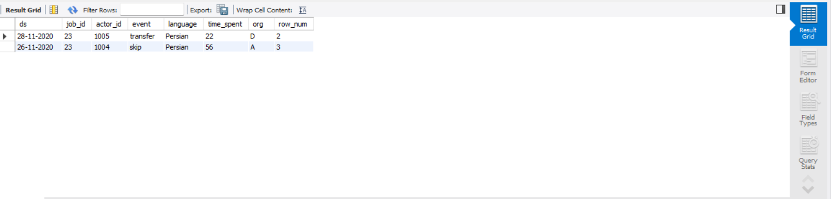
Fig.4-showing Rows that have the same value present in them.

Case Study 2 (Investigating metric spike)
A. User Engagement: To measure the activeness of a user. Measuring if the user finds quality in a product/service.
Your task: Calculate the weekly user engagement?To find the weekly user engagement:-
Solution:
We will extract the week from the occurred_at column of the events table using the EXTRACT function and WEEK function.
Then we will be counting the number of distinct user_id from the events table.
Then we will use the GROUP BY function to group the output week from occurred_at
SQL Query :-
SELECT extract (week from occurred_at) as week_number,count(distinct user_id)as number_of_users FROM events group by week_number;

B. User Growth: Amount of users growing over time for a product.
Your task: Calculate the user growth for product?User Growth = Number of active users per weekTo find the user
growth (number of active users per week):-
Solution:
First we will the extract the year and week for the occurred_at column of the users table using the extract, year and week functions
Then we will group the extracted week and year on the basis of year and weeknumber
Then we ordered the result on the basis of year and week number
Then we will find the cumm_active_users using the SUM, OVER and ROWfunction between unbounded preceding and
current row Investigating Metric Spike
sql query:-
select year_num,week_num,num_active_users,sum (num_active_users)
OVER(ORDER BY year_num,week_num ROWS BETWEEN UNBOUNDED PRECEDING AND CURRENT ROW)
AS cum_active_users from(select extract (year from a.activated_at) as year_num,extract (week from a.activated_at)
as week_num,count(distinct user_id)as num_active_users from users WHERE state ='active'group by year_num,
week_num order by year_num,week_num) a;
User Growth = Number of active users per week
SQL Query :-
select count(*)from users where state ='active'
Hence, there are in total 9381 active users from 1st week of 2013 to the 35thweek of 2014
count 18760

C. Weekly Retention: Users getting retained weekly after signing-up for a product.
Your task: Calculate the weekly retention of users-sign up cohort?The weekly retention of users-sign up cohort can be
calculated by two means i.e.either by specifying the week number (18 to 35) or for the entire column ofoccurred_at
of the events table.
Solution:
Firstly we will extract the week from occurred_at column using the extract,week functions
Then, we will select out those rows in which event_type = 'signup_flow’ and event_name = 'complete_sign up’
If finding for a specific week we will specify the week number using the extract function
Then using the left join we will join the two tables on the basis of user_id where event_type = 'engagement’
Then we will use the Group By function to group the output table on the basis of user_id
Then we will use the Order By function to order the result table on the basis of user_id
sql query:-
SELECT distinct user_id,COUNT(user_id),SUM(CASE WHEN retention_week =1Then 1Else 0END)as per_week_retention FROM (SELECT a.user_id,a.signup_week,b.engagement_week,b.engagement_week -a.signup_week as retention_week FROM ((SELECT distinct user_id, extract(week from occurred_at) as signup_week from events WHERE
event_type ='signup_flow'and event_name ='complete_signup')a LEFT JOIN(SELECT distinct user_id,
extract (week from occurred_at) as engagement_week FROM events where event_type ='engagement')b on
- user_id =b.user_id))d group by user_id order by user_id;

D. Weekly Engagement: To measure the activeness of a user. Measuring if the user finds quality in a product/service weekly.
Your task: Calculate the weekly engagement per device?To find the weekly user engagement per device:-
Solution:
Firstly we will extract the year_num and week_num from the occurred_at column of the events table using the extract,
year and week function
Then we will select those rows where event_type = 'engagement’ using the WHERE clause
Then by using the Group By and Order By function we will group and order there result on the basis of year_num,
week_num and device

sql query:-
SELECT extract(year from occurred_at) as year_num,extract(week fromoccurred_at) as week_num,device,
COUNT(distinct user_id)as no_of_users FROM events where event_type ='engagement' GROUP by 1,2,3 order by 1,2,3;

E. Email Engagement: Users engaging with the email service.
Your task: Calculate the email engagement metrics?Investigating Metric Spike To find the email engagement metrics(rate) of users:-
Solution:
We will first categorize the action on the basis of email_sent, email_opened and email_clicked using the CASE, WHEN, THEN functions
Then we select the sum of category of email_opened divide by the sum of the category of email_sent and multiply
the result by 100.0 and name is as email_opening_rate
Then we select the sum of category of email_clicked divide by the sum of the category of email_sent and multiply the
result by 100.0 and name is as email_clicking_rate
email_sent = ('sent_weekly_digest','sent_reengagement_email’)
email_opened = 'email_open’
email_clicked = 'email_clickthrough
sql query:-
SELECT 100.0*SUM(CASE when email_cat ='email_opened' then 1else 0end)/SUM(CASE when email_cat ='email_sent' then
1else 0end)as email_opening_rate, 100.0*SUM(CASE when email_cat ='email_clicked' then 1else 0end)/SUM(CASE when
email_cat ='email_sent' then 1else 0end)as email_clicking_rate FROM (SELECT *,CASE WHEN action in('sent_weekly_digest',
'sent_reengagement_email')then 'email_sent' WHEN action in ('email_open')then 'email_opened' WHEN action in
('email_clickthrough')then 'email_clicked' end as email_cat from email_events) a;

Conclusion

In conclusion, I would like to tell that after doing a
thorough analysis we were able to derive the insights
from the data.After doing all the analysis ,I got a better understanding of SQL Query’s.

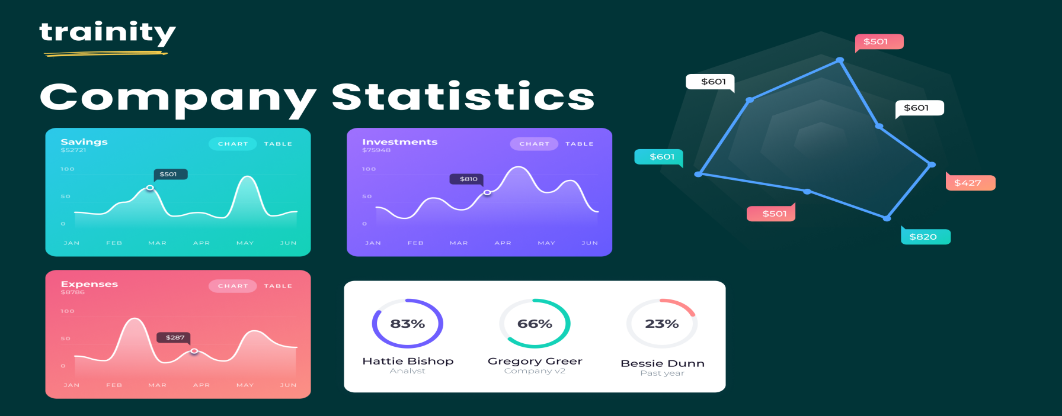
Hiring Process Analytics
Description:
As a data analyst, you'll be given a dateset containing records of previous hires. Your job is to analyze this data and answer certain questions that can help the company improve its hiring process
- Handling Missing Data: Check if there are any missing values in the dateset. If there are, decide on the best strategy to handle them.
- Clubbing Columns: If there are columns with multiple categories that can be combined, do so to simplify your analysis.
- Outlier Detection: Check for outliers in the dateset that may skew your analysis.
- Removing Outliers: Decide on the best strategy to handle outliers. This could be removing them, replacing them, or leaving them as is, depending on the situation.
- Data Summary: After cleaning and preparing your data, summarize your findings. This could involve calculating averages, medians, or other statistical measures. It could also involve creating visualizations to better understand the data.
Data Analytics Tasks:
A. Hiring Analysis: The hiring process involves bringing new individuals into the organization for various roles.
Your Task: Determine the gender distribution of hires. How many males and females have been hired by the company?

B. Salary Analysis: The average salary is calculated by adding up the salaries of a group of employees and then dividing the total by the number of employees.
Your Task: What is the average salary offered by this company? Use Excel functions to calculate this.

C. Salary Distribution: Class intervals represent ranges of values, in this case, salary ranges. The class interval is the difference between the upper and lower limits of a class.
Your Task: Create class intervals for the salaries in the company. This will help you understand the salary distribution.

D. Departmental Analysis: Visualizing data through charts and plots is a crucial part of data analysis.
Your Task: Use a pie chart, bar graph, or any other suitable visualization to show the proportion of people working in different departments.

E. Position Tier Analysis: Different positions within a company often have different tiers or levels.
Your Task: Use a chart or graph to represent the different position tiers within the company. This will help you understand the distribution of positions across different tiers
Tech-Stack Used :
APP-WPS OFFICE, Product Version-12.2.0.13085 ,Publisher-Kingsoft corp.

Analysis
A. Hiring Analysis: The hiring process involves bringing new individuals into the organization for various roles.
Your Task: Determine the gender distribution of hires. How many males and females have been hired by the company?

Approach:
- First create a pivot table with the given table in a new sheet .
- then add status to row label, event_name in row label and application_id in value label and change it’s field setting to count.
- then the gender distribution of hires can be seen on the table.

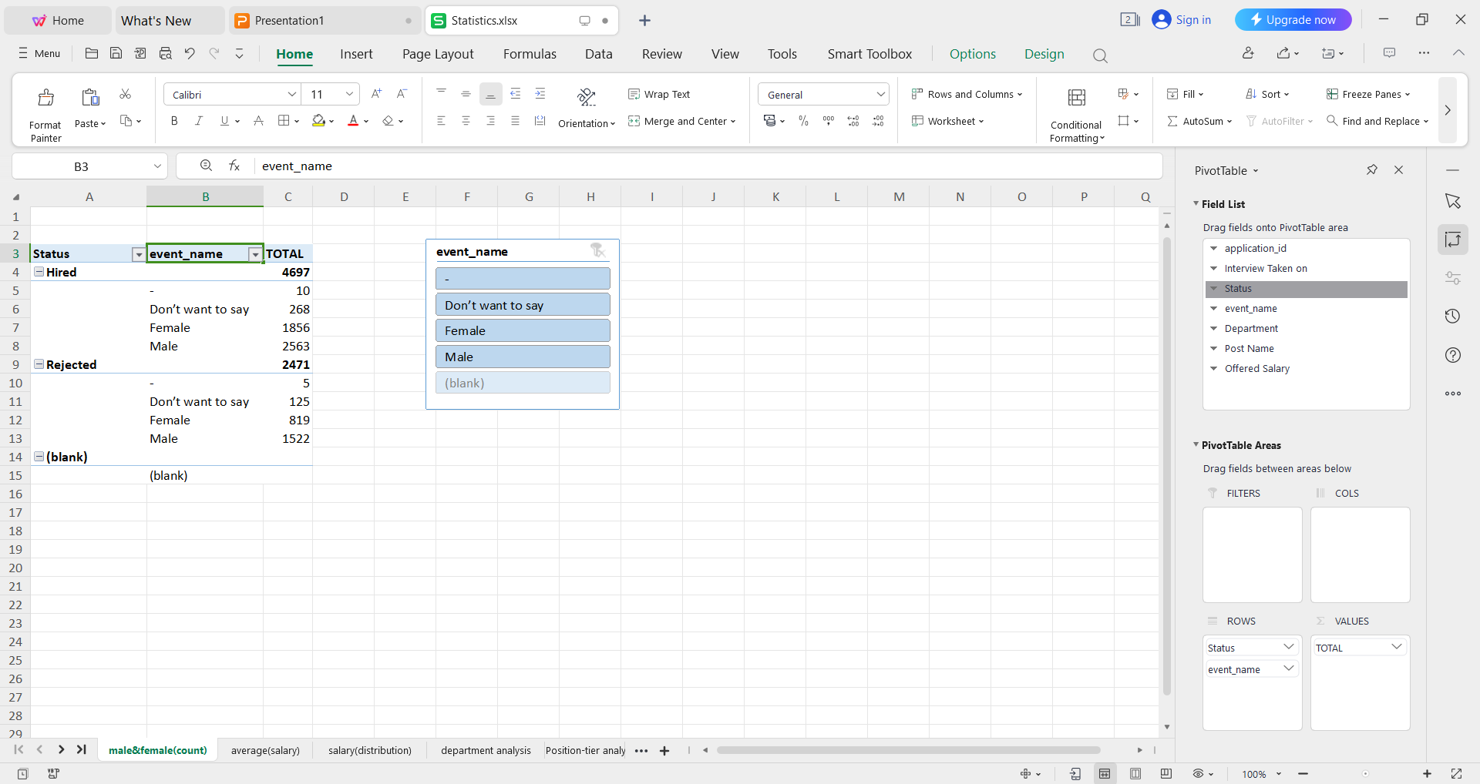
Fig.1-showing the gender distribution of hires
Insight:
Total 1856 female & 2563 males are hired by the company.

B. Salary Analysis: The average salary is calculated by adding up the salaries of a group of employees and then dividing the total by the number of employees.
Your Task: What is the average salary offered by this company? Use Excel functions to calculate this.

Approach:
- Select the cell where i want to show the average.
- Then filter the offered_salary to remove blank data to avoid calculation error.
- Then go to the home tab and click on autosum drop down buttom and click on average.
- After clicking on average it will ask for range for which the calculation has to be perform.
- After clicking enter we will get the average salary given by the company.

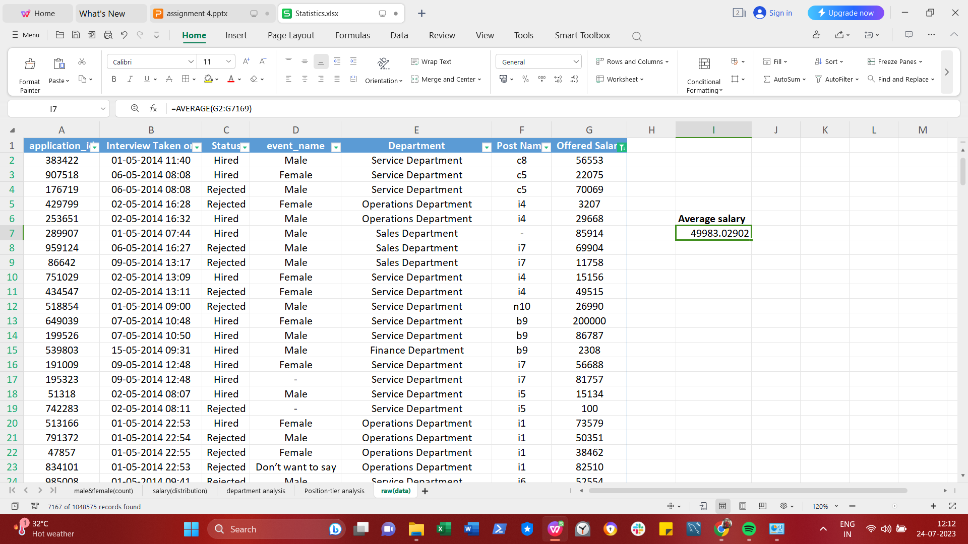
Fig.2-Showing average salary offered by this company
Insight:
Average Salary offered by this company is 49983.02902

C. Salary Distribution: Class intervals represent ranges of values, in this case, salary ranges. The class interval is the difference between the upper and lower limits of a class.
Your Task: Create class intervals for the salaries in the company. This will help you understand the salary distribution.

Approach:
- First create a pivot table in new sheet then add offered salary to row label and add application id to value label to count the application id.
- then select all the entry in offered salary to put class interval between them.
- after selecting ,go to option tab and select group selection.
- Then a popup dialog box will appear in which i set the starting & ending point and the interval between them,I choose 1000 as an interval.
- then you can see the class interval of salaries and no of employee getting the salary between that range.

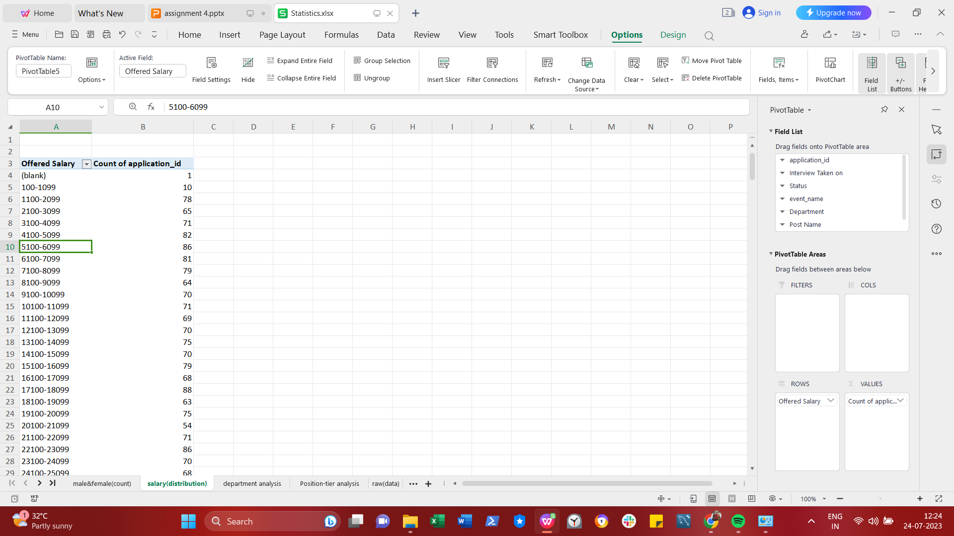
Fig.3- showing Salary Distribution

D. Departmental Analysis: Visualizing data through charts and plots is a crucial part of data analysis.
Your Task: Use a pie chart, bar graph, or any other suitable visualization to show the proportion of people working in different departments.
Approach:
- first created a pivot table in new worksheet.
- Then add department in row label and application id in values to count no of applicant.
- then we will get the table of all the department and no of applicant in that department.
- To show that data in graphical format ,we need to select option tab and select pivot chart.
- An insert chart dialog box appear from which we need to choose the suitable visualization according to the data,then double click on that chart to display it on the sheet.

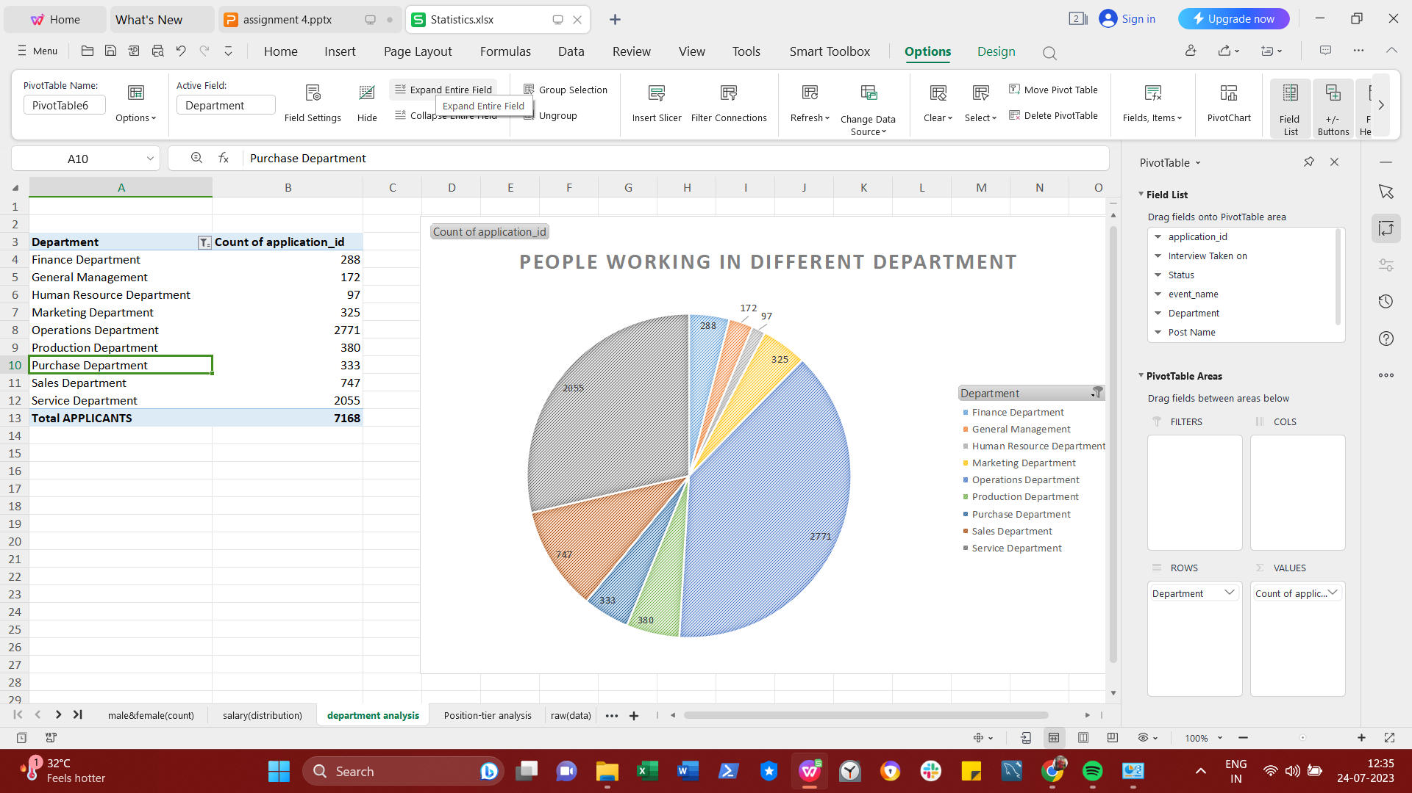
Fig.4-Showing the proportion of people working in different departments.

Insight:
- Operations department has the most higher no of people working.
- Human resource department has the lowest no of people working.

E. Position Tier Analysis: Different positions within a company often have different tiers or levels.
Your Task: Use a chart or graph to represent the different position tiers within the company. This will help you understand the distribution of positions across different tiers.
Approach:
- first created a pivot table in new worksheet.
- Then add post name in row label and application id in values to count no of applicant.
- then we will get the table of all the post name and no of applicant in that post.
- To show that data in graphical format ,we need to select option tab and select pivot chart.
- An insert chart dialog box appear from which we need to choose the suitable visualization according to the data,then double click on that chart to display it on the sheet.

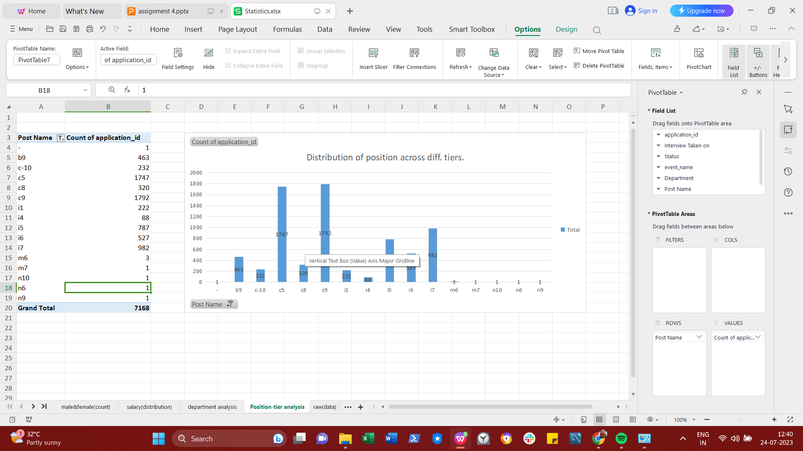
Fig.5-Showing distribution of positions across different tiers.

Conclusion
In conclusion, I would like to tell that after doing a thorough
analysis we were able to derive the insights from the data
and was able to plot various graphs using that data. The
data that once looked useless became useful .Analyzing the data proved helpful in understanding a company Employee Distribution of a company.

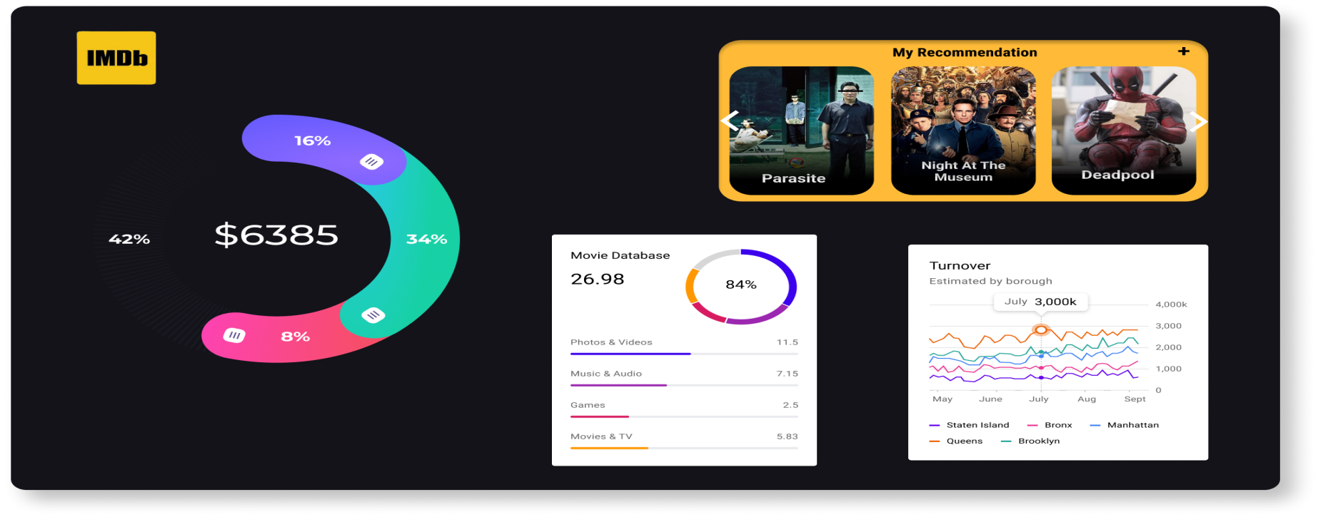
IMDB Movie Analysis
Description:
Problem Statement: The dataset provided is related to IMDB Movies. A potential problem to investigate could be: "What factors influence the success of a movie on IMDB?" Here, success can be defined by high IMDB ratings. The impact of this problem is significant for movie producers, directors, and investors who want to understand what makes a movie successful to make informed decisions in their future projects.

Tech-Stack Used :
APP- WPS OFFICE, Product Version-12.2.0.13085 ,Publisher -Kingsoft corp.
Data Analytics Tasks:
A. Movie Genre Analysis: Analyze the distribution of movie genres and their impact on the IMDB score.

Task: Determine the most common genres of movies in the dataset. Then, for each genre, calculate descriptive statistics (mean, median, mode, range, variance, standard deviation) of the IMDB scores.
Approach:
- First i created a pivot table with the given data.
- then add genre to row label and again genre to value label to count , because by counting the genre we can get the genre distribution like we can known how many movie of that genre are present.
- then i created another pivot table ,because so,if i manipulate the data it does not affect the whole data that i have extracted.
- then i added the genre to row label and genre to value label to count and filtered the genre to get the common genre of movies,so that the movie with multiple genre does not be counted more than once.
- then i added the imdb score to row label to get the imdb score of my filtered genre and calculated the descriptive statistic like mean,max,min,variance and standard deviation as this function was present in the value label.
- then to find the median and mode i had to manually entered the formula for the imdb score.
- To calculate the median the function i used was syntax: =MEDIAN(SELECT THE RANGE OF WHICH WE WANT TO FIND THE MEDIAN) AND PRESS ENTER.
- To FIND the mode from pivot table is little complicate because we cannot use mode function because mode calculates the highest repeated value and when we add the imdb score value to row label it merges all the repeated value automatically.
- So to get the mode i used INDEX,MATCH,IF & MAX function to get the desire result ,so to get the mode i first created another pivot chart having genre ,imdb score and count of imdb score and perform my calculation to get the mode.
- so to get the mode i used this function
- Syntax: =INDEX(RANGE OF IMDB SCORE,MATCH(IF(MAX(RANGE OF IMDB COUNT)>1,MAX(RANGE OF IMDB COUNT),FALSE),RANGE OF IMDB COUNT,0))
- This function will show the imdb score of highest no of occurring,which is called mode of imdb score.
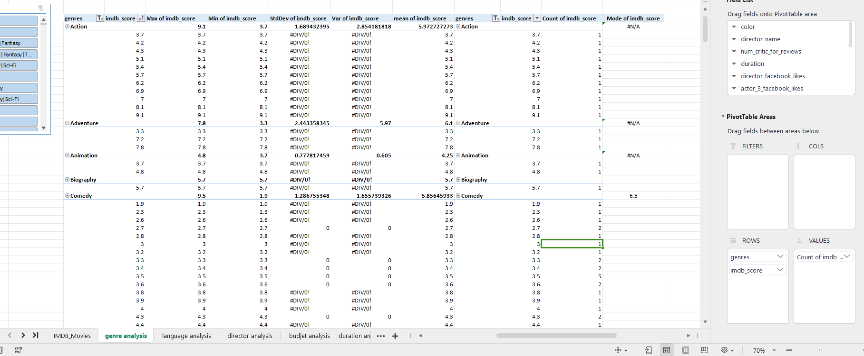
Fig.1-Showing distribution of movie genres

Insight:
From the statistic i get to know that drama genre got the average highest imdb score as compare to other genre.

B. Movie Duration Analysis: Analyze the distribution of movie durations and its impact on the IMDB score.
Task: Analyze the distribution of movie durations and identify the relationship between movie duration and IMDB score.
Approach:
- First i created 2 pivot table.
- in first pivot table i added duration and the imdb score and filtered the blank data.
- and then calculated the mean median and standard deviation on the imdb score of different duration .
- and then on another pivot table i added duration and imdb score and calculate the average imdb score of duration.
- And then i added the pivot chart with trendline to the second pivot table to known the relation between duration and imdb score.

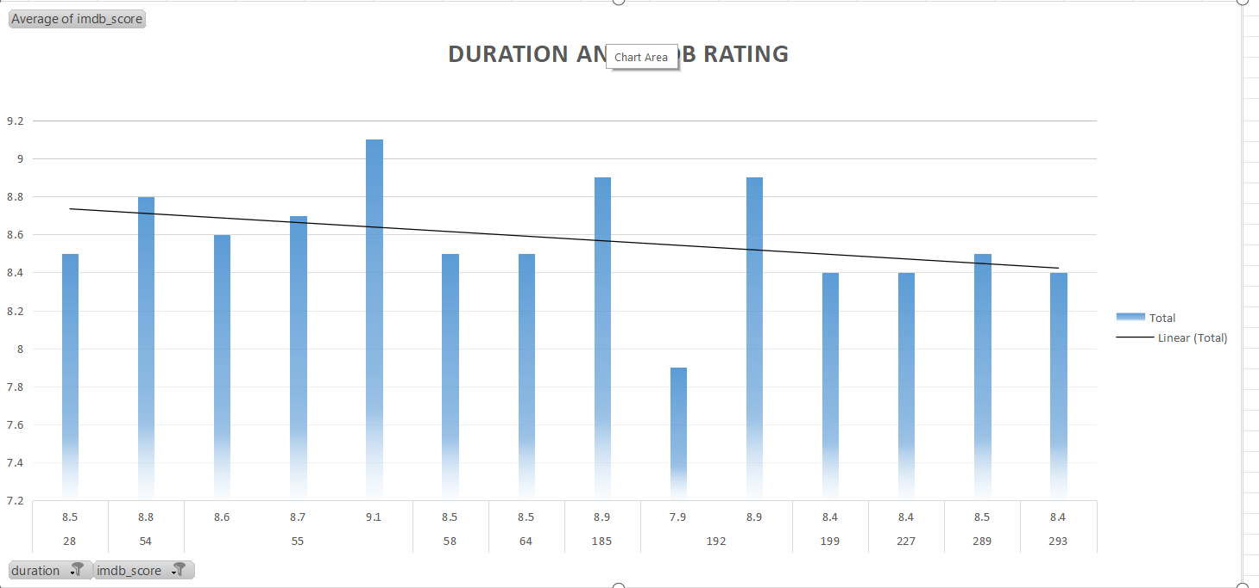
Fig.2- Showing distribution of movie duration and its impact on the IMDB score.

Insight:
Here after seeing the chart i got to know that ,it does not mean if the duration is high then the movie will get higher imdb score .

C. Language Analysis: Situation: Examine the distribution of movies based on their language.

Task: Determine the most common languages used in movies and analyze their impact on the IMDB score using descriptive statistics.
Approach:
- First i created a pivot table .
- And then added language ,imdb score ,and count of language to get the no of movie of that language.
- And calculated the mean median & standard deviation on the imdb score i got.
- And added pivot chart to the pivot table to understand the statistic i got after calculating.

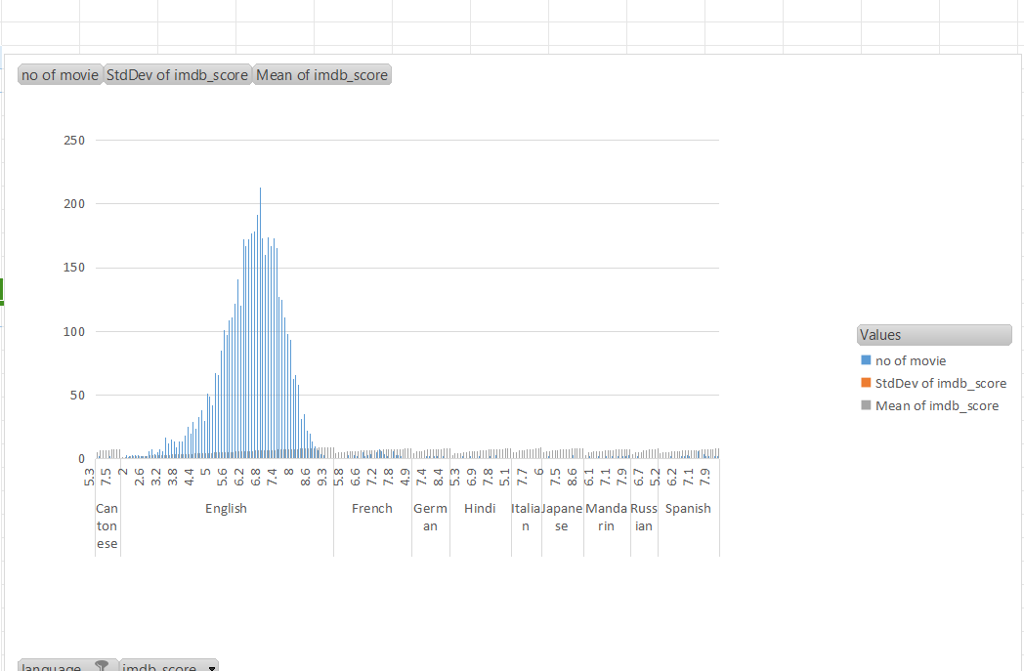
Fig.3- Showing distribution of movies based on their language.

Insight:
After looking at the chart i got to know that English language movie got the highest no of rating as compare to other languages.

D. Director Analysis: Influence of directors on movie ratings.

Task: Identify the top directors based on their average IMDB score and analyze their contribution to the success of movies using percentile calculations.
Approach:
- First i created a pivot table in new worksheet.
- then added director list ,and the count of movie directed by them and the average rating they got for their movie.
- Then i use 100-percentile on their average imdb score to get the highest imdb score director.
- And then i added a pivot chart to it to get a visualization of their rating.

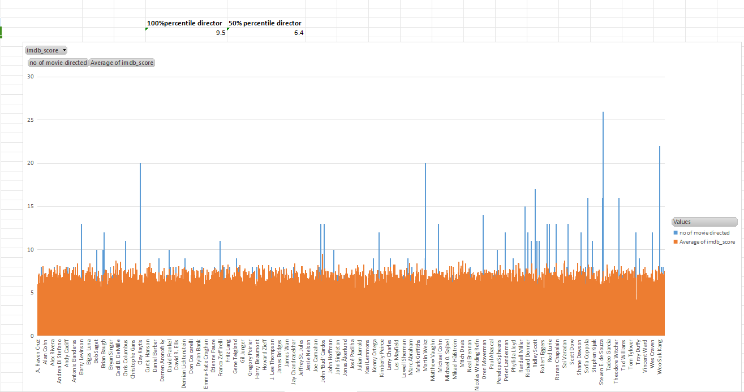
Fig.4-Showing Influence of directors on movie ratings

Insight:
I got to know that John Blanchard got the highest rating for his movie .

E. Budget Analysis: Explore the relationship between movie budgets and their financial success.

Task: Analyze the correlation between movie budgets and gross earnings, and identify the movies with the highest profit margin.
Approach:
- first i created another table in new worksheet .
- i included movie title ,budget,gross,imdb score & profit column.
- I imported the desire data and fitered the blank values,& calculated the profit earned .
- To calculate the profit i minused budget from gross earned.

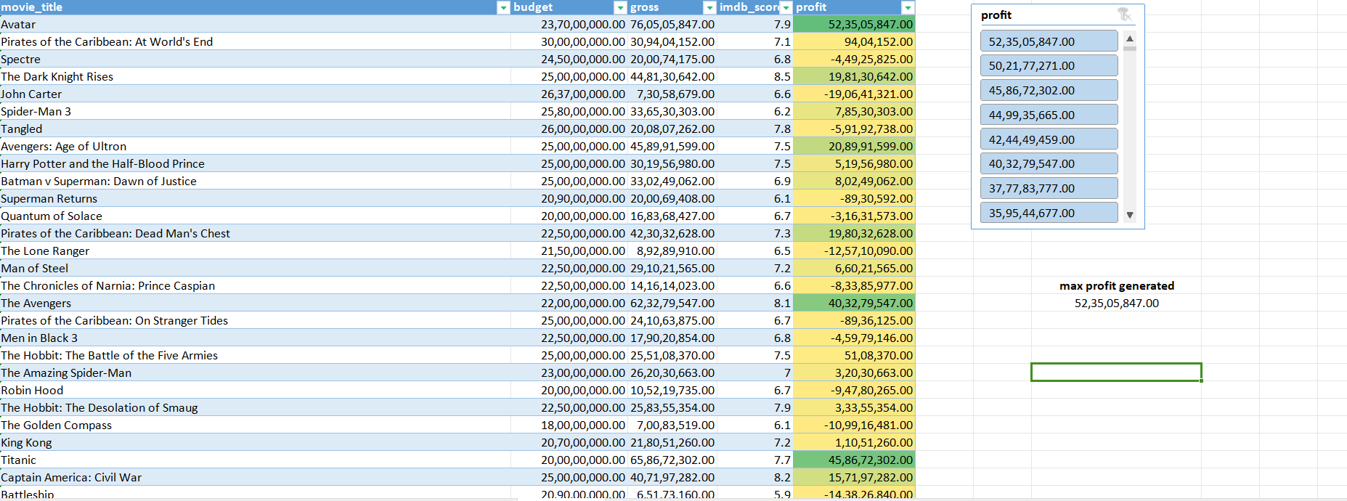
Fig.5-Showing the movies with the highest profit margin.

Insight:
After calculating i got to know that the gross earned is not depended on the movie budget,it depends on the genre of the movie and the director and the language.

Conclusion
In conclusion, I would like to tell that after doing a thorough
analysis we were able to derive the insights from the data
and was able to plot various graphs using that data. The
data that once looked useless became useful .Analyzing the data proved helpful in understanding various factor that affects IMDB score of a movie.

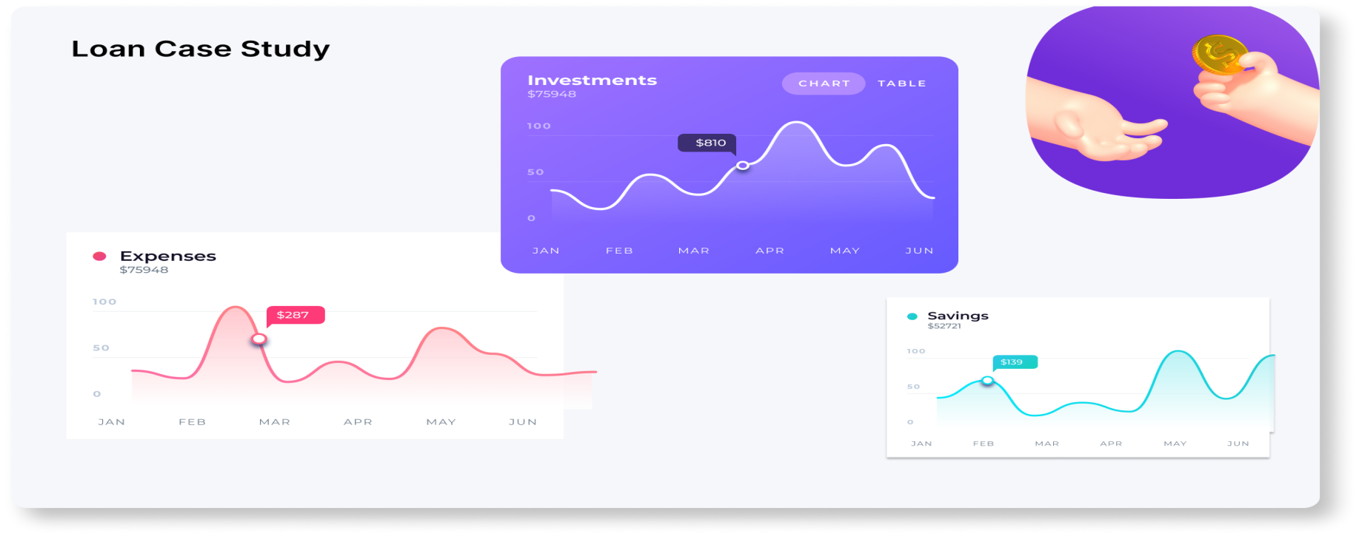
Bank Loan Case Study Analysis
Project Description:
- The main aim of this project is to identify patterns that indicate if a customer will have difficulty paying their installments.
- This information can be used to make decisions such as denying the loan, reducing the amount of loan, or lending at a higher interest rate to risky applicants.
- The company wants to understand the key factors behind loan default so it can make better decisions about loan approval.
- The dateset we will be working with contains information about loan applications. It includes two types of scenarios:

- Customers with payment difficulties (1): These are customers who had a late payment of more than X days on at least one of the first Y installments of the loan.
- All other cases(0): These are cases where the payment was made on time.
Tech-Stack Used
APP-WPS OFFICE, Product Version-12.2.0.13085 ,Publisher-Kingsoft corp.

Analysis done
steps:
- Identified Missing Data and handle missing data effectively to ensure the accuracy of the analysis by applying EDA to the Data Set.
- Identified outliers in the loan application dateset by using functions like QUARTILE, IQR, and conditional formatting to identify potential outliers.
- Analyzed Data Imbalance in the loan application dateset and calculated the ratio of data imbalance.
- Performed Uni-variate, Segmented Uni-variate, and Bi-variate Analysis to gain insights into the driving factors of loan default.
- Identified Top Correlations for Different Scenarios and identified the top correlations for each segmented data.
Data Analytics Tasks
- Missing values :
Task: Identify the missing data in the dataset and decide on an appropriate method to deal with it using Excel built-in functions and features.

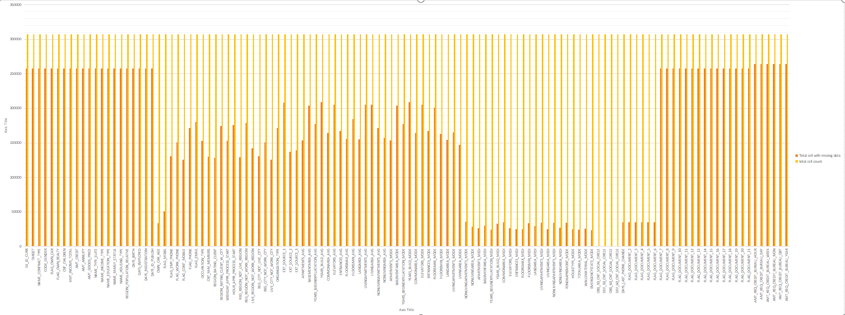
Insight:
- Bar with dark orange represents the missing values.
- Bar with light orange presents total no of values.
- Then removed the blank cells and unwanted column having more than 30% of blank value.

- Identify Outliers in the Dataset:
Task: Detect and identify outliers in the dataset using Excel statistical functions and features, focusing on numerical variables.
- Outliers in the cnt_children(for target 0 &1):
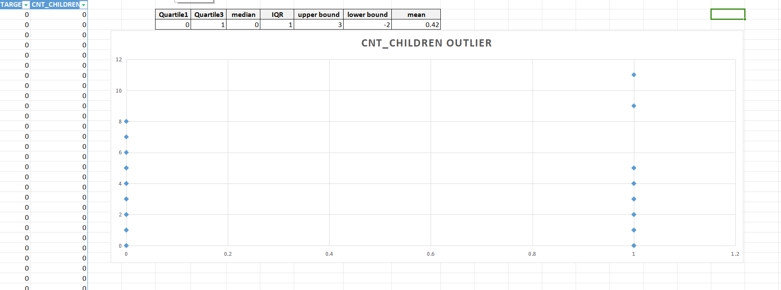
Insight:
- Considering the present world population senerio having more than 3 children is not possible for some but may be possible for some person,so it needs to be futher investigated to check if the data entered is accurate or not.
- According to the statistic performed on the data ,targets having more than 3 children is an outlier.

- Outliers in the amt_income(for target 0 &1):
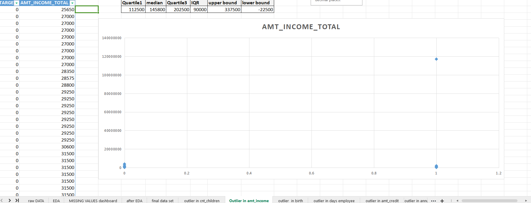
Insight:
- after applying statistic to the data i get to know that income greater than 337500 are outlier but in real case senerio income greater than 337500 are valid data points.

- Outliers in the age(for target 0 &1):
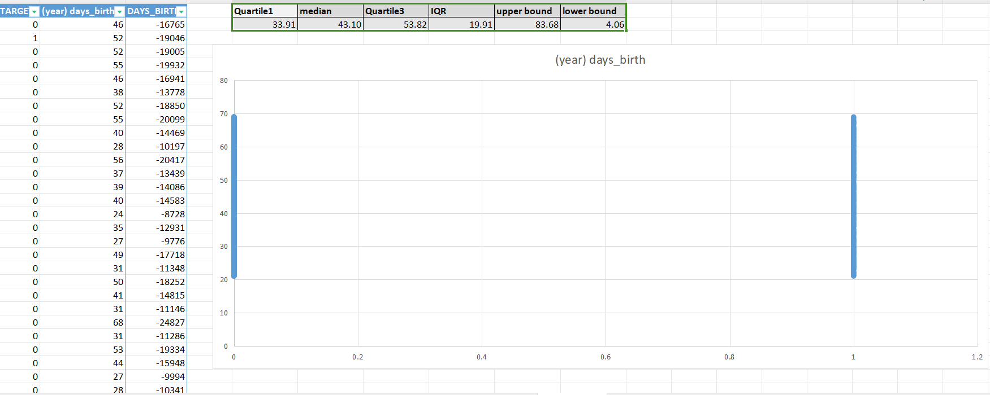

Insight:
- their are no outlier in age column data are valid.

- Outliers in the days_employed(for target 0 &1):
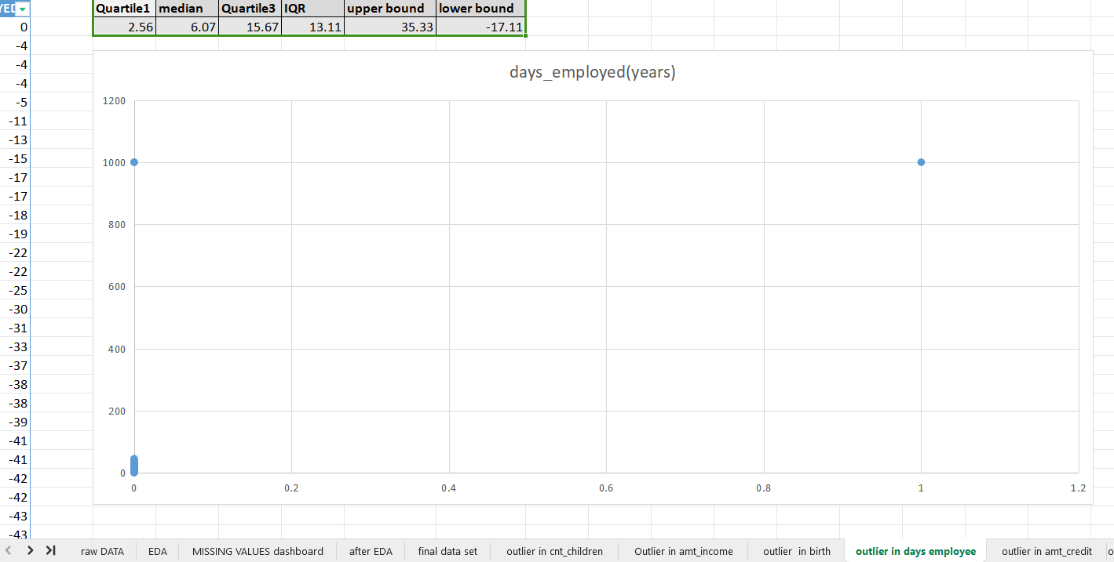
Insight:
- outlier present in the dataset are not valid as a human cant live for 1000 years so how can he be employed for 1000yr,so the data point is not valid and need futher investigation.

- Outliers in the Amt_credit(for target 0 &1):
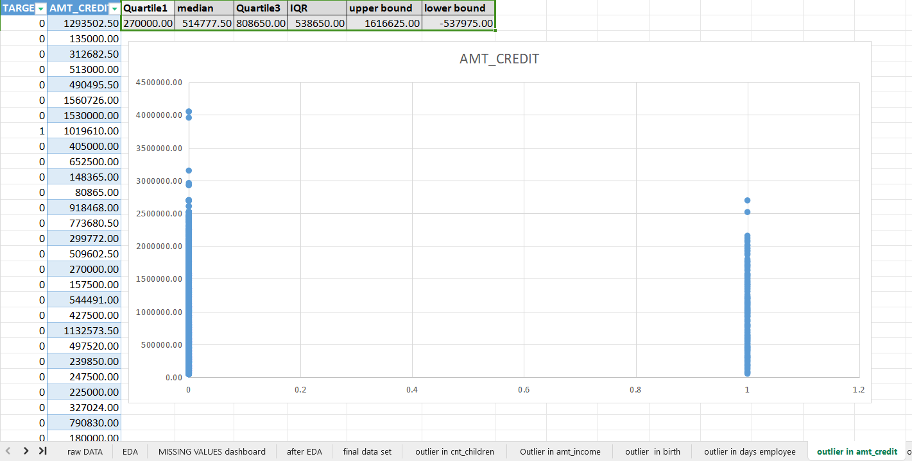
Insight:
- the outlier present in this data are valid because their is no fix amount given in credit.

- Outliers in the Amt_Annuity(for target 0 &1):
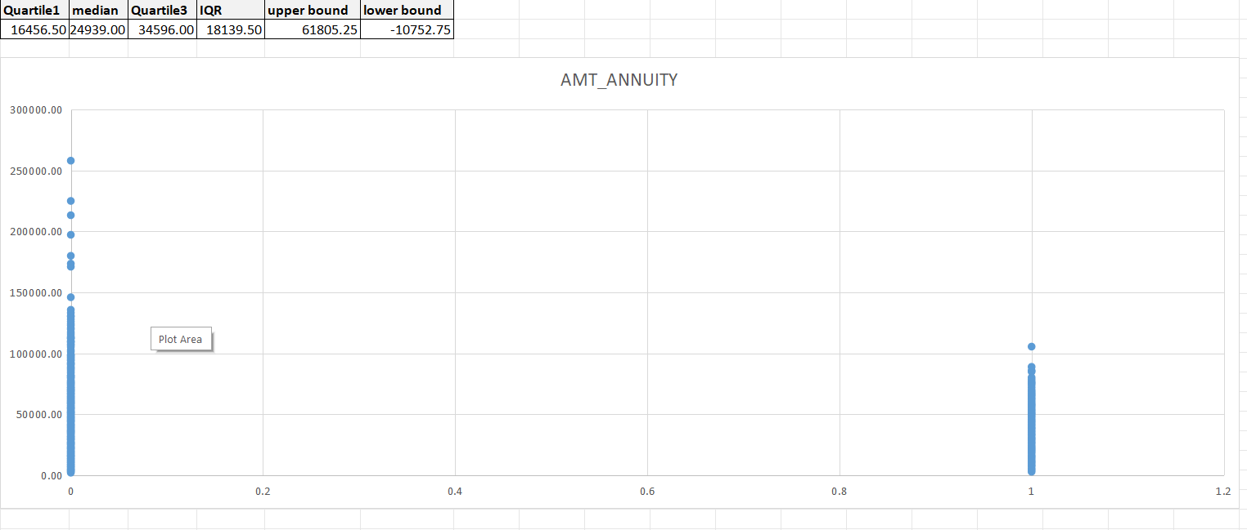
Insight:
- the outlier present in this are valid as annuity amount depends on the credit amount ie. higher credit amount=higher annuity to be paid.

- Analyze Data Imbalance:
Task: Determine if there is data imbalance in the loan application dataset and calculate the ratio of data imbalance using Excel functions.
- Data Imbalance in contract_type(for target 0 &1):
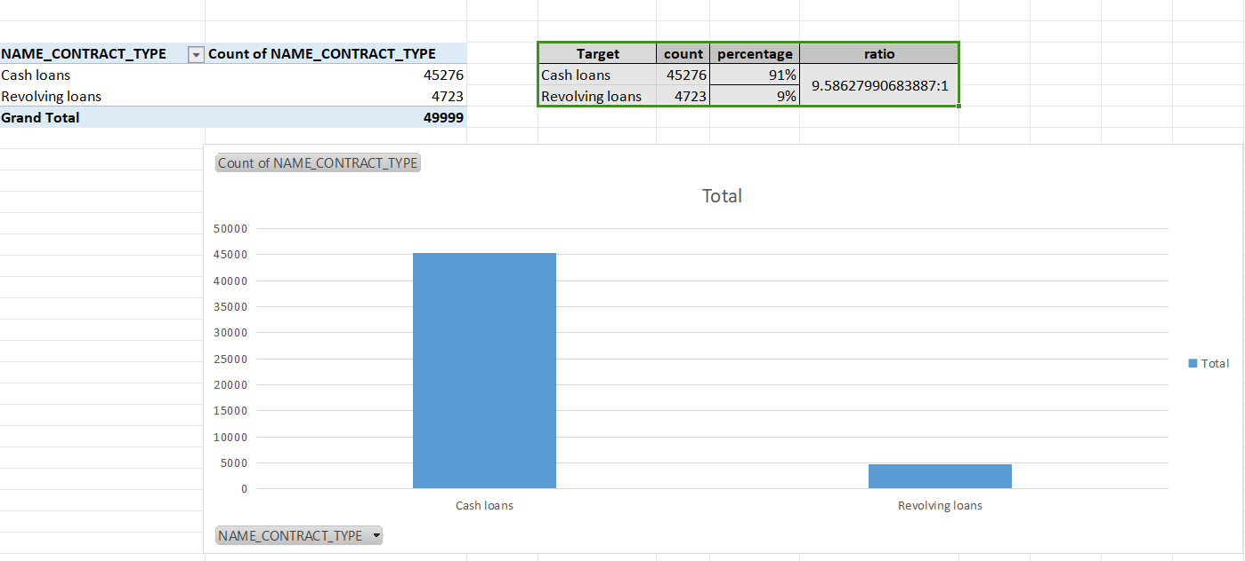
Insight:
- the data imbalance ratio is 9.5:1.
- their are more cash loan as compare to revolving loan

- Data Imbalance in target(for target 0 &1):
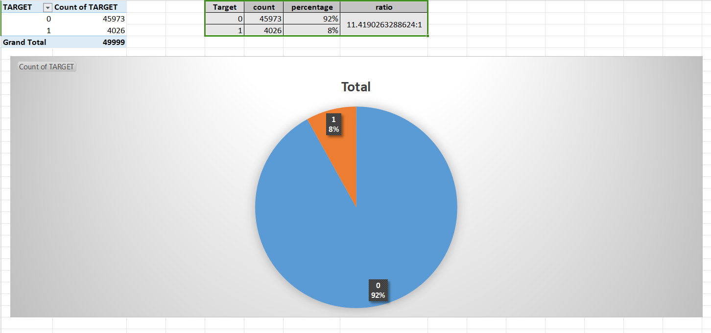
Insight:
- the ratio between 0&1 is 11.4:1
- target 1 is only 8% and target 0 is 92% total

- Data Imbalance in gender(for target 0 &1):
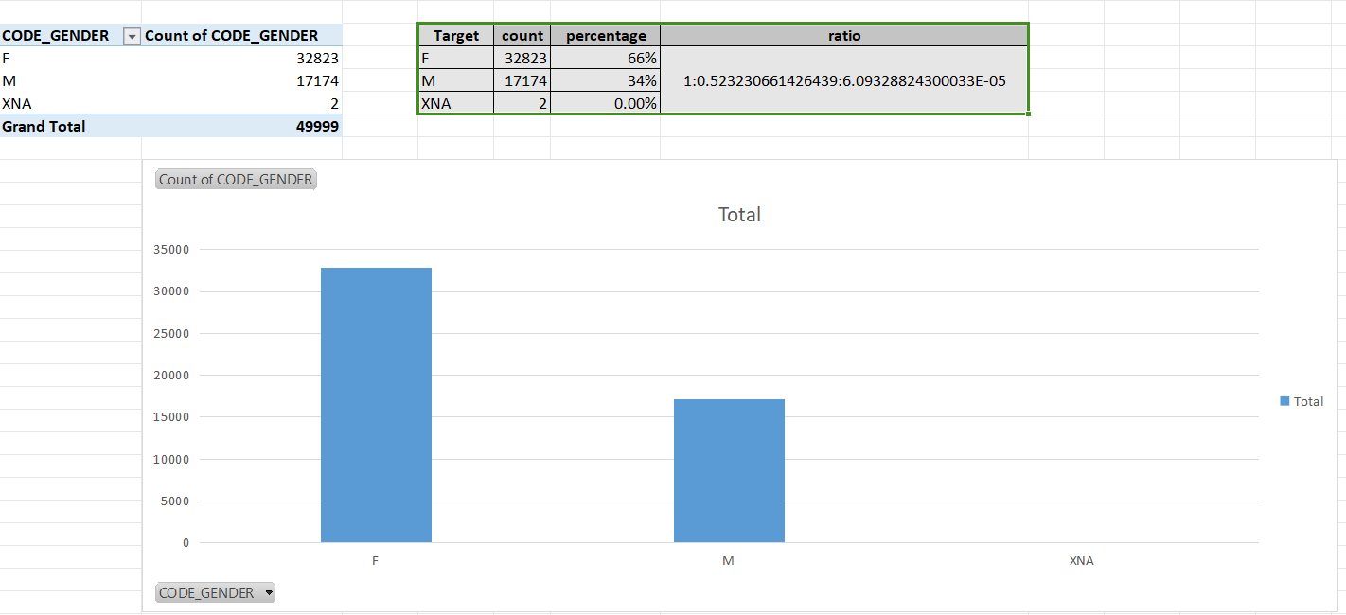
Insight:
- 66% are female
- 34%are male

- Data Imbalance in cnt_children(for target 0 &1):
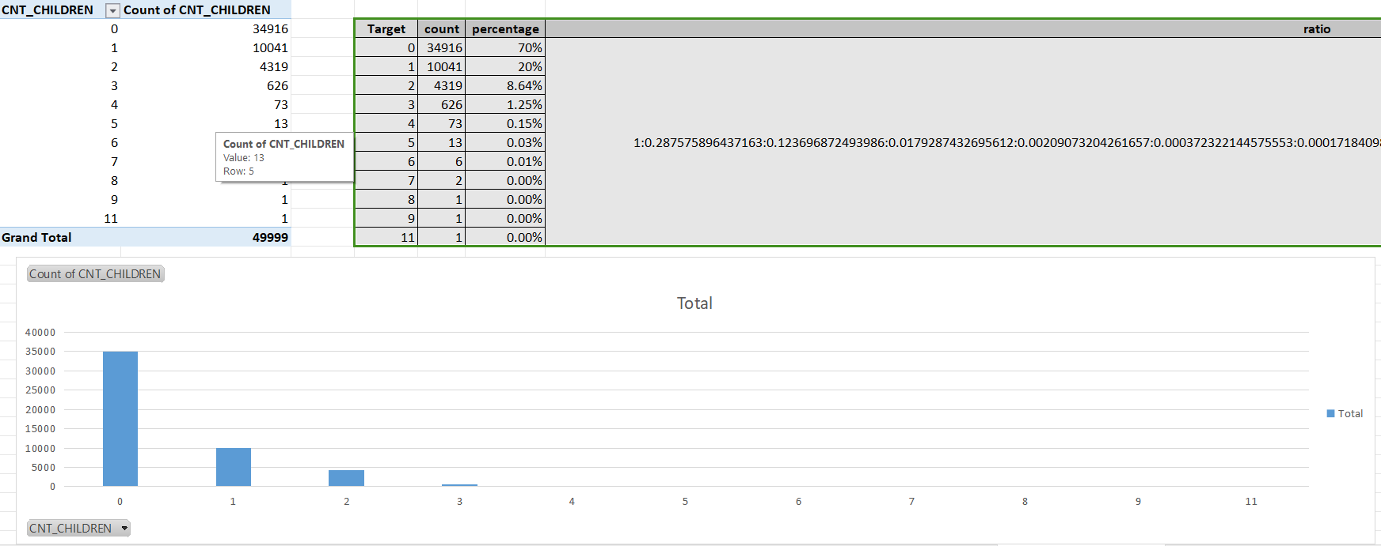
Insight:
- 70% are with no children
- 20% are with 1 children
- 8.6% are with 2children

- Data Imbalance in education(for target 0 &1):
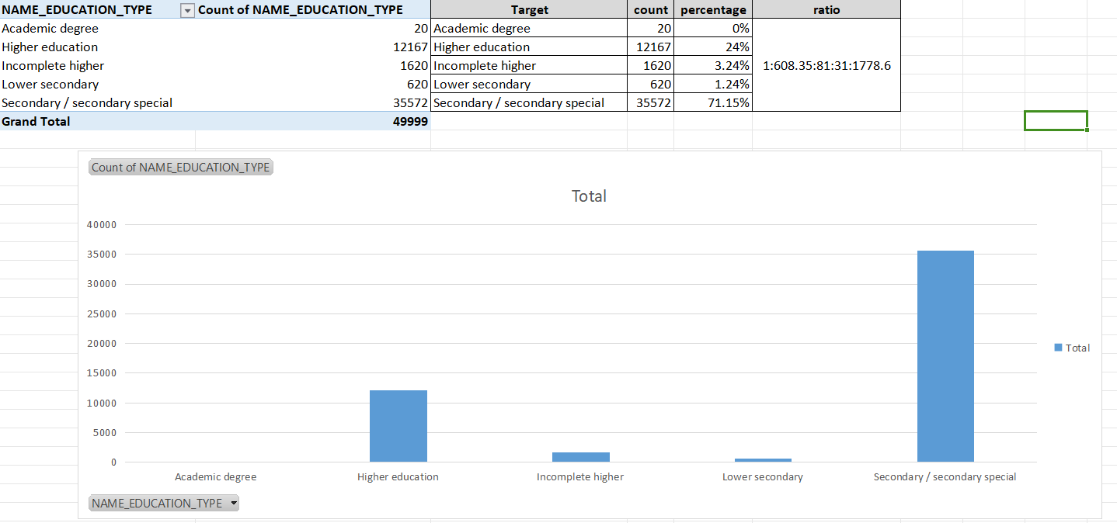
Insight:
- 71% are with secondary/secondary special education classification.

Perform Univariate, Segmented Univariate, and Bivariate Analysis:
Task: Perform univariate analysis to understand the distribution of individual variables, segmented univariate analysis to compare variable distributions for different scenarios, and bivariate analysis to explore relationships between variables and the target variable using Excel functions and features.
univeriate analysis of defatulters(1)
Univariate analysis is the simplest form of analyzing data. Uni means "one", so the data has only one variable (univariate).
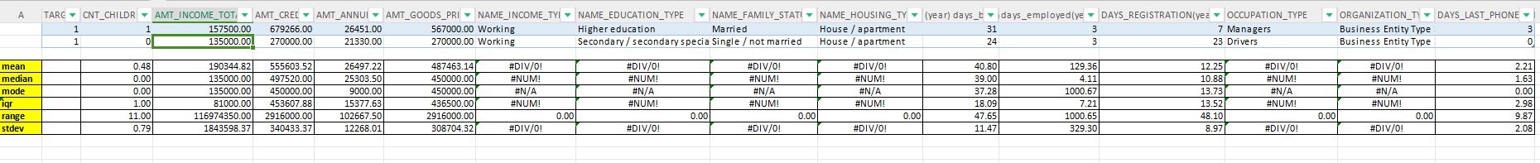

univeriate analysis of defatulters income(1)
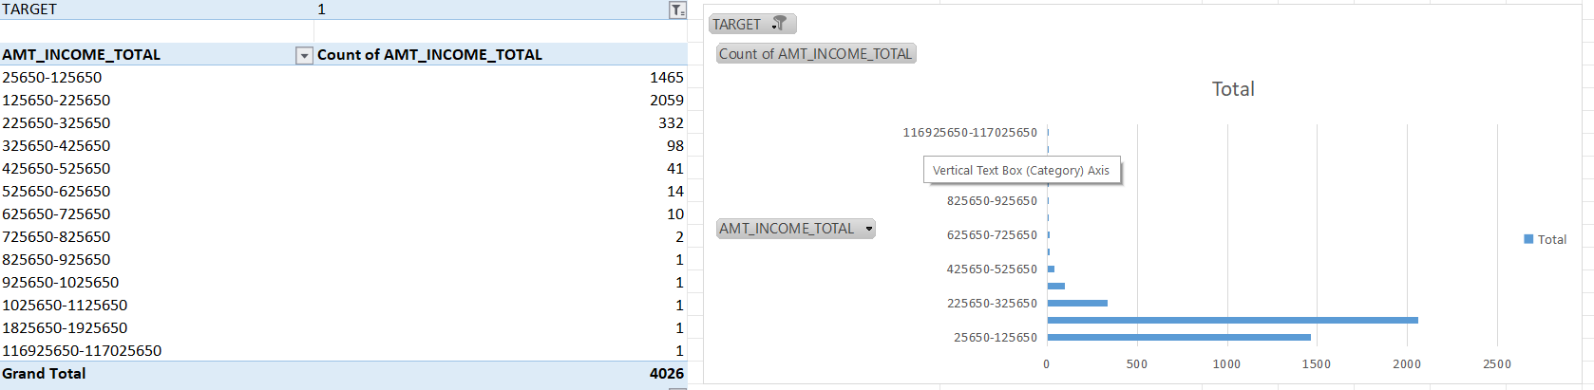
Insight:
- Defaulters are more with income range of 25650-725650 .

univeriate analysis of defatulters Amt_credit(1)
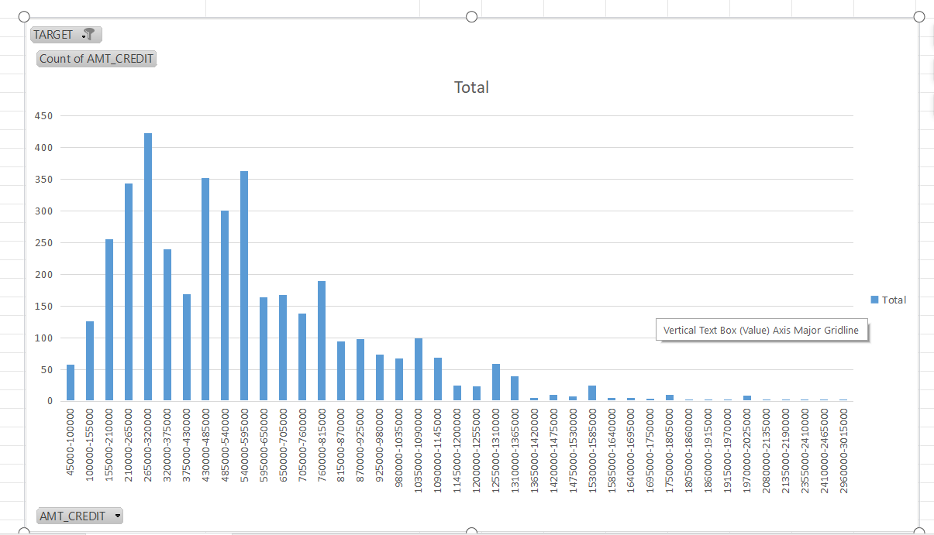
Insight:
- targets with higher credit amt will less likely to become a defaulter.

univeriate analysis of defatulters age(1)

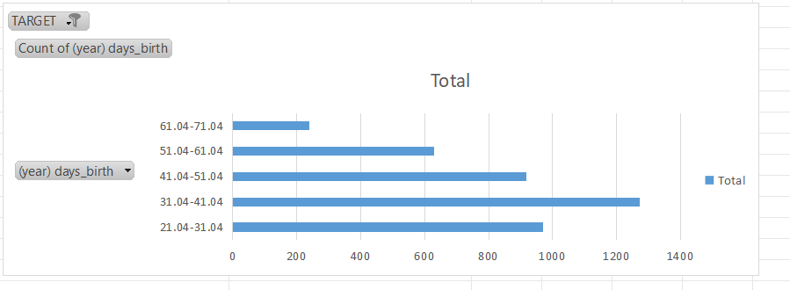
Insight:
- middle age or lower age people are more likey to default.
- the defaulters count decreases at higher age.

univeriate analysis of defatulters employment(1)
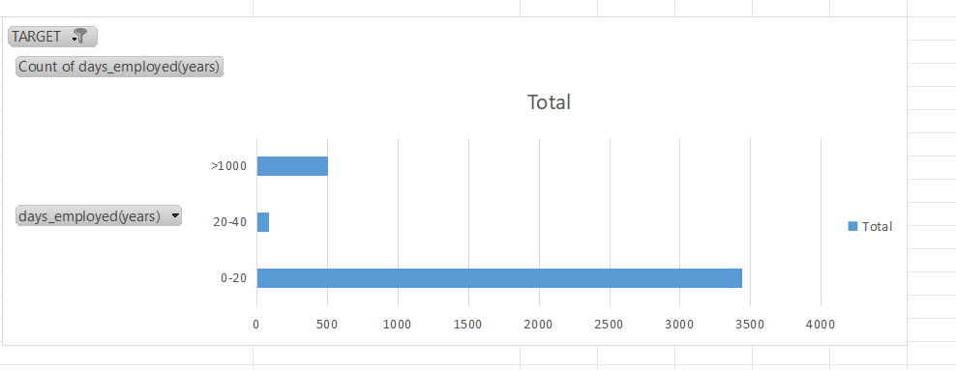
Insight:
- person with 0-20 yr of employment is more likely to default.

univeriate analysis of defatulters housing(1)
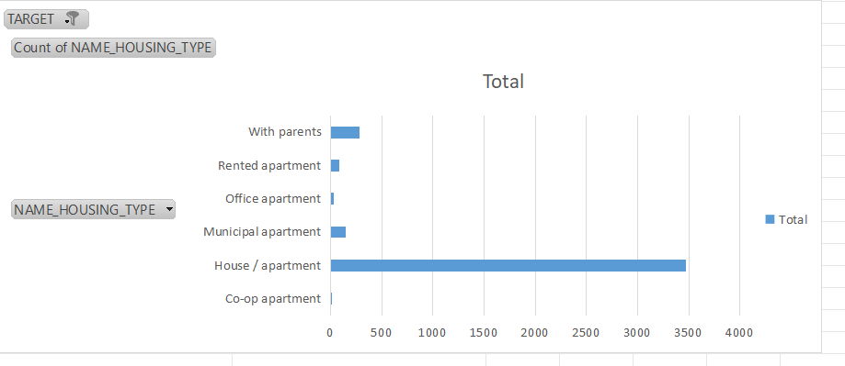
Insight:
- person with house/apartment are most likely to default.

univeriate analysis of defatulters Family status(1)
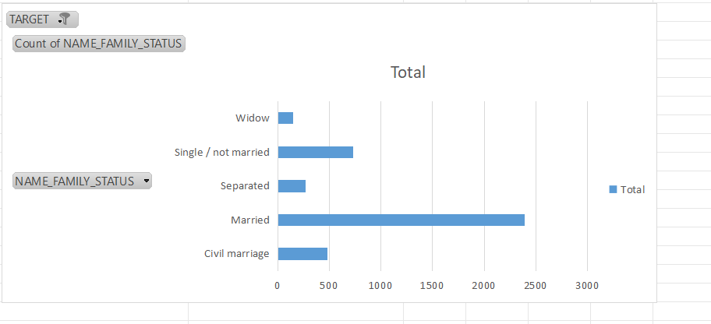
Insight:
- married persons are more likely to default.

univeriate analysis of defatulters income type(1)
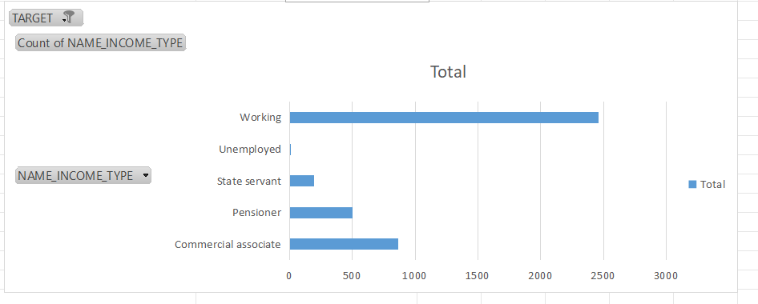
Insight:
- count of defaulter is more in working type
- And count of defaulter is less in unemployed and state servant.

univeriate analysis of defatulters Education type(1)
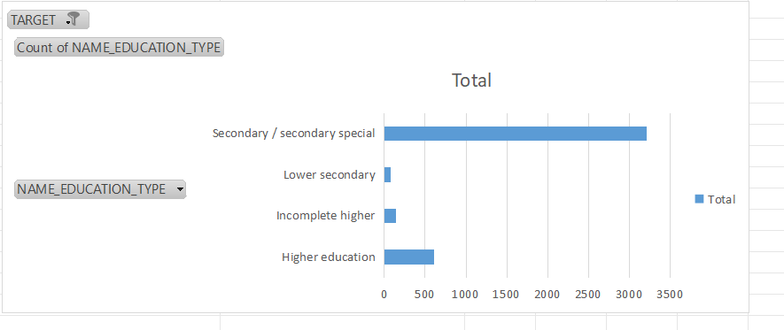
Insight:
- Person with secondary/secondary special education have higher rate of defaulters
- person with higher education are less likely to default.

univeriate analysis of defatulters occupation type(1)
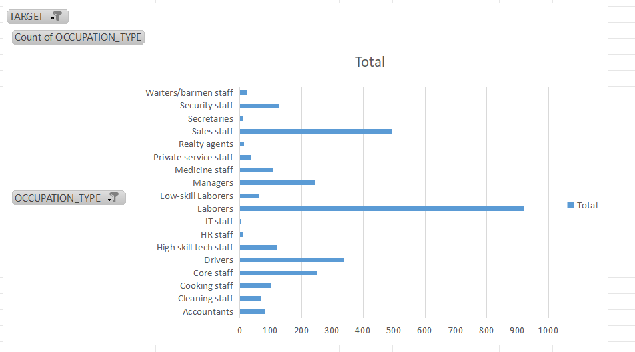
Insight:
- person with laborers and sales staff occupation has the higher rate of defaulters.
- person with it or hr occupation has the lowest rate of defaulters.

univeriate analysis of defatulters annuity amt(1)
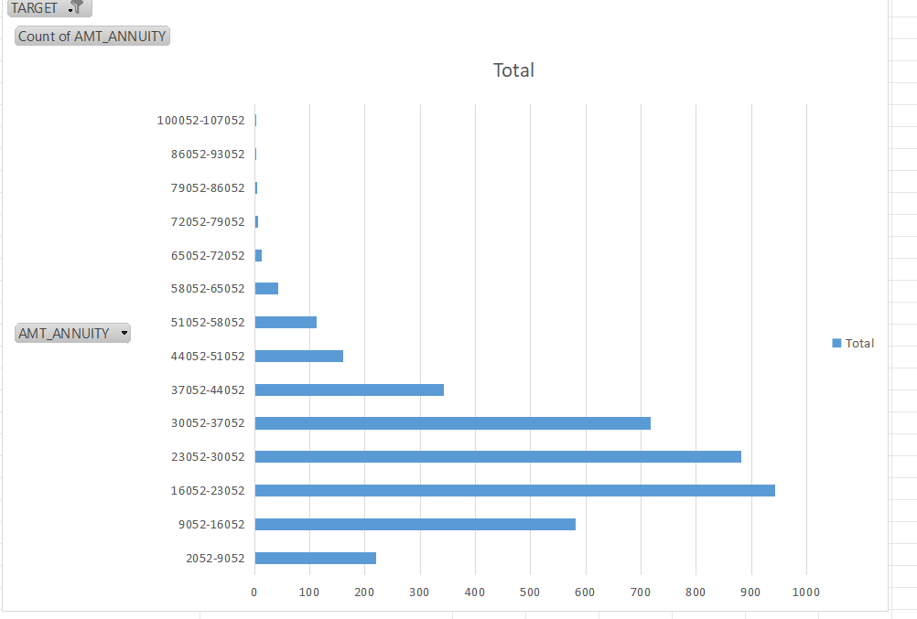
Insight:
- rate of defaulter decreases as the annuity amt increases.
- If the annuity amt is high then a person is less likely to default.

univeriate analysis of defatulters cnt_children(1)
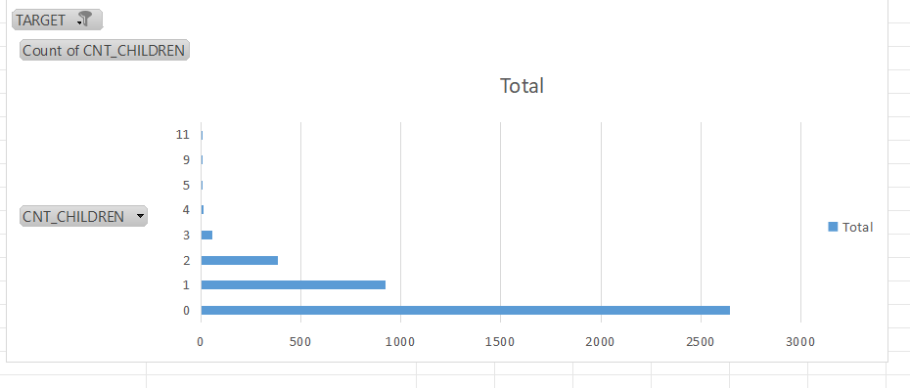
Insight:
- person with no children will most likely to default.

univeriate analysis of defatulters goods price(1)
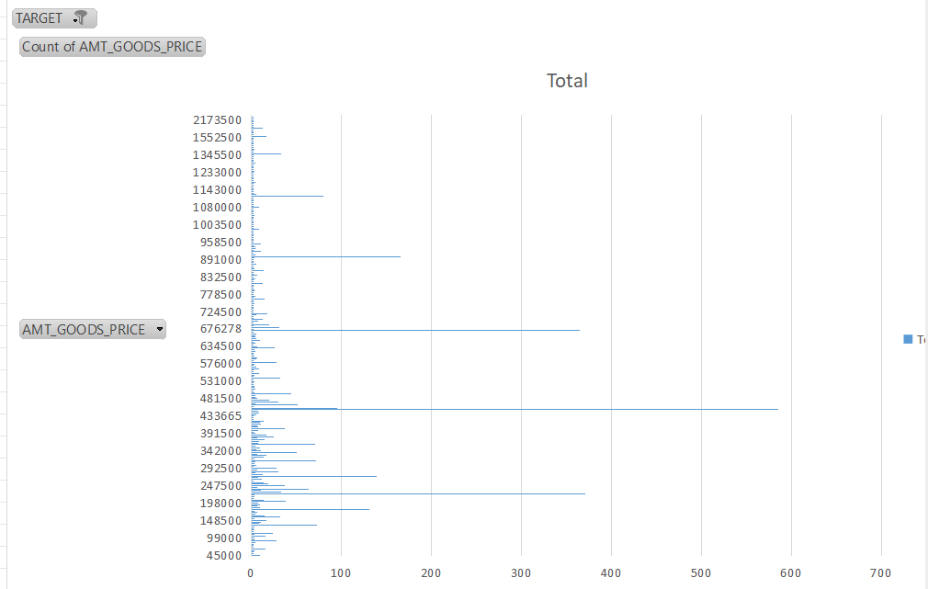
Insight:
- loan given to a person with good price range between 433665-481500 is most likely to default.

univeriate analysis of defatulters days registration(1)
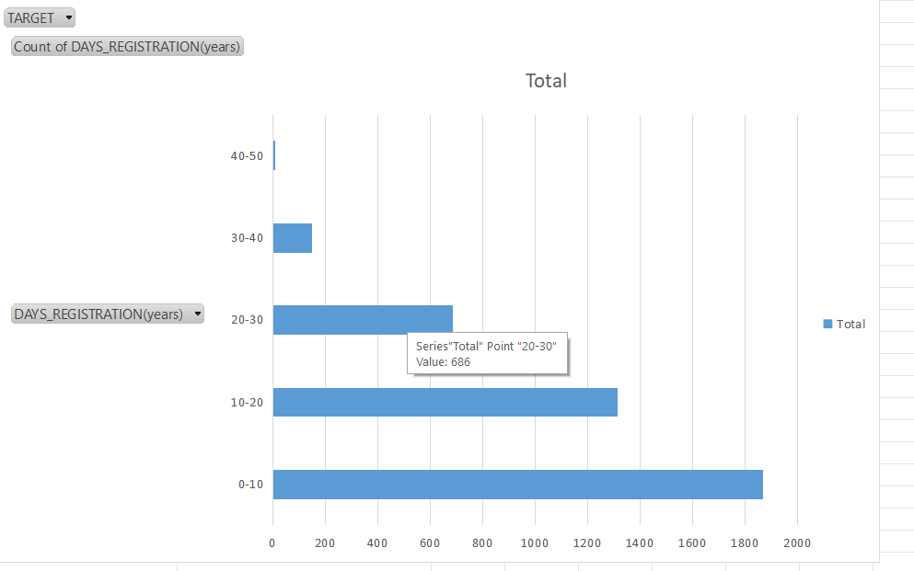
Insight:
- if a person change its registration within 31 yr , the person might default its payment.
- As the day of registration increases the count of defaulters decreases.

univeriate analysis of defatulters organization type(1)
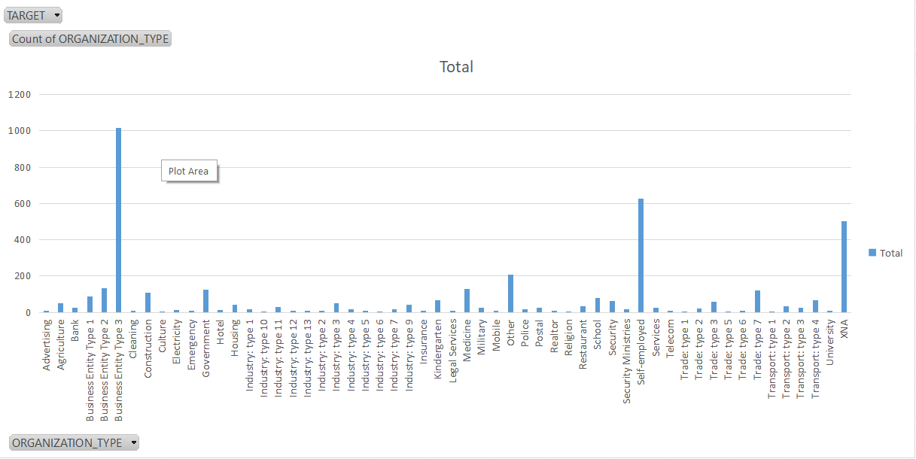
Insight:
- person from organization like bussiness entity type 3 , self employed & xna are more likely to default.

univeriate analysis of defatulters phone_change(1)
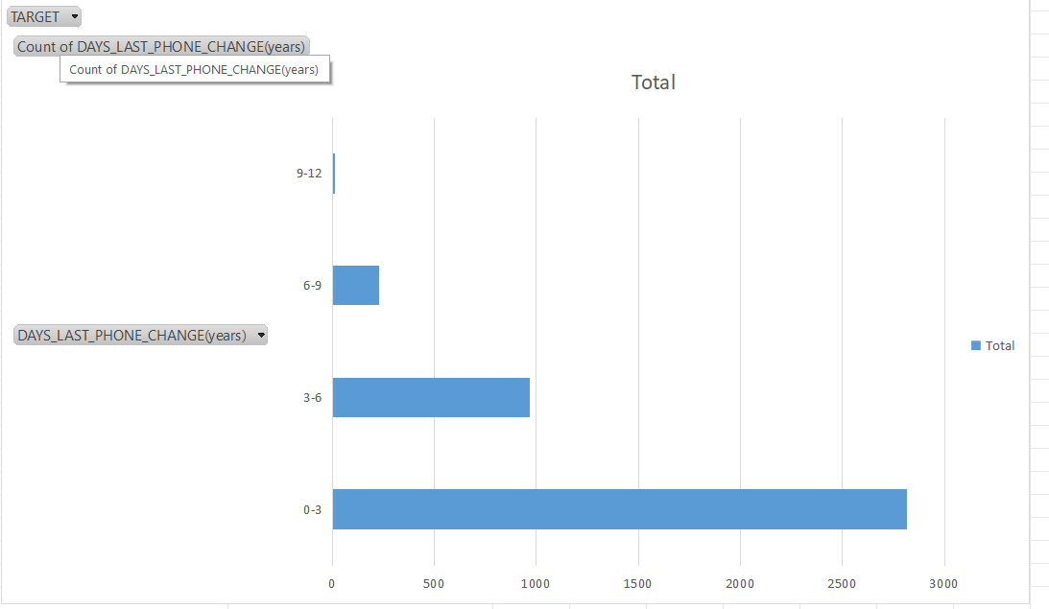
Insight:
- if a person changed its phone within 0-6 yr before applying for loan,then he/she is more likely to default.
- if a person did not change the number before applying for loan the he/she will less likely to default its payment.

Segmented univeriate analysis by gender
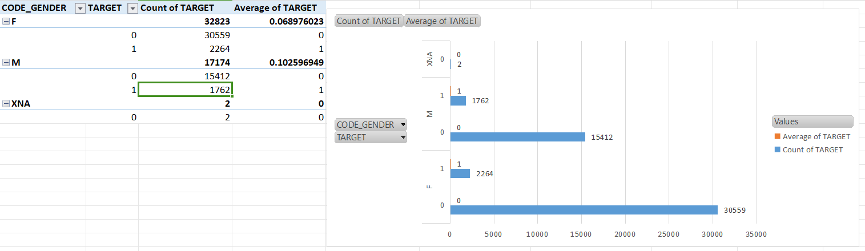
Insight:
- Female target took more loan as compare to males.
- males tend to default more as compare to female.

Segmented univeriate analysis by amt_income
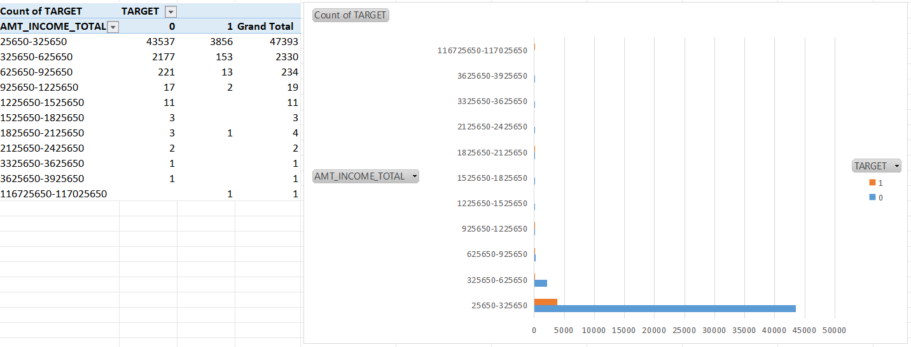
Insight:
- a preson with income 25650-325650 is likely to take loan.
- a person with higher income does not need a loan.

Segmented univeriate analysis by amt_credit
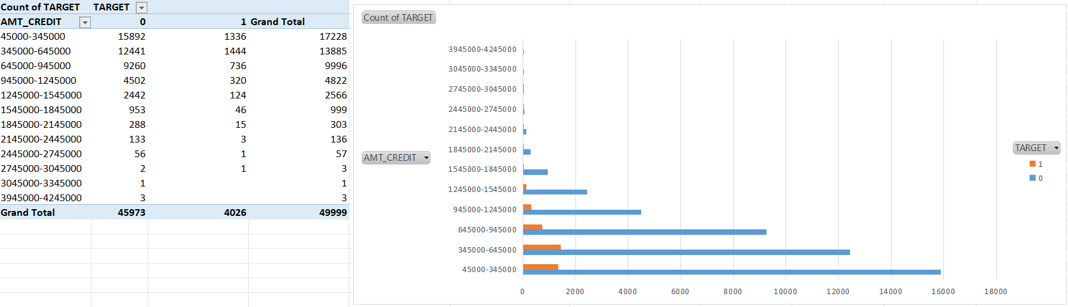
Insight:
- the higher the credit amount the lesser chance of getting a defaulters.
- the defaulter count is high at lower credit amt.

Segmented univeriate analysis by amt_annuity
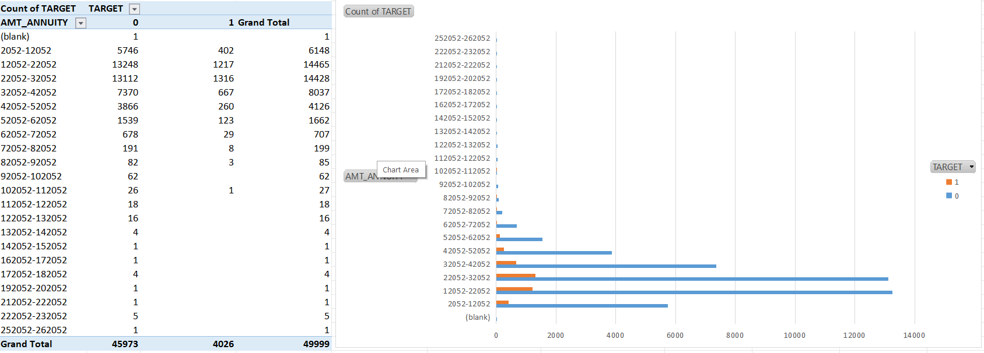
Insight:
- the higher the annuity amt the less chance of getting defaulters.
- but count of payers are more as compare to defaulters at low annuity amt.

Segmented univeriate analysis by housing
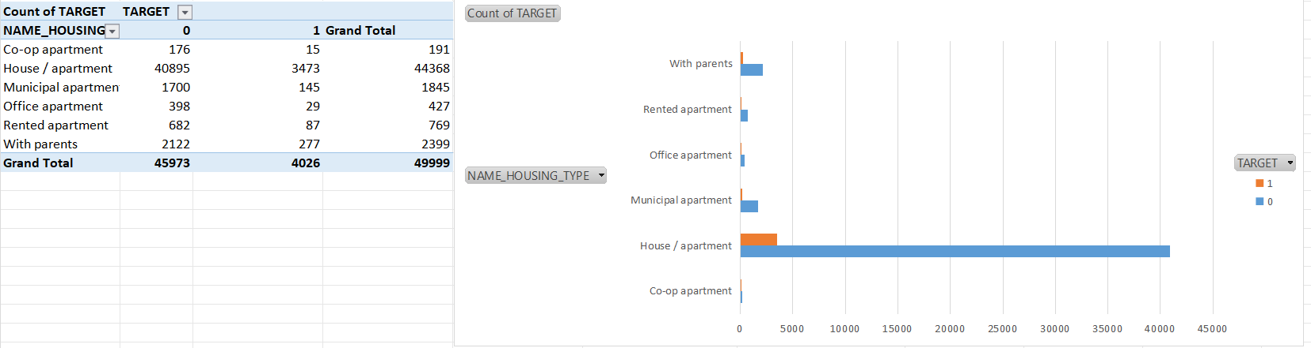
Insight:
- a person with house/apartment has a high chance to take a loan
- But defaulter rate is also high with the person having house/apartment as they may have other emi’s to pay.

Biveriate analysis
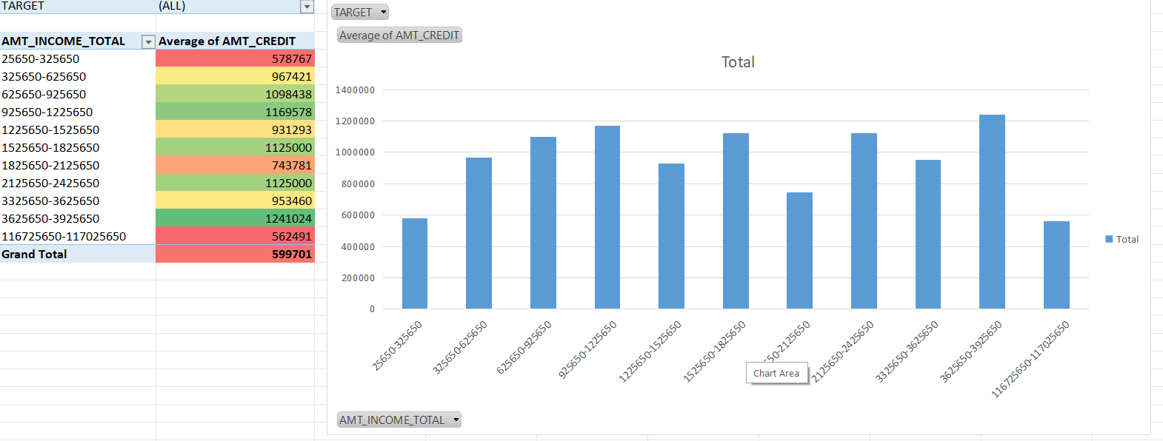
Insight:
- their is an uneven relationship between income and credit.

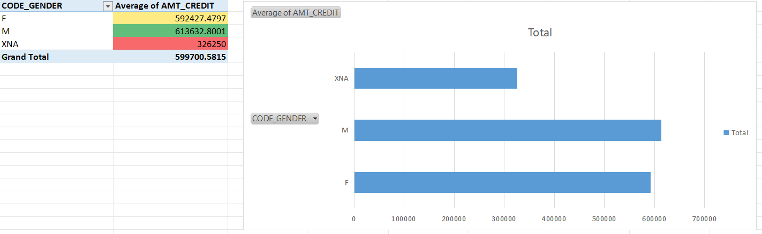
Insight:
- male tends to take higher credit amt as compair to female.

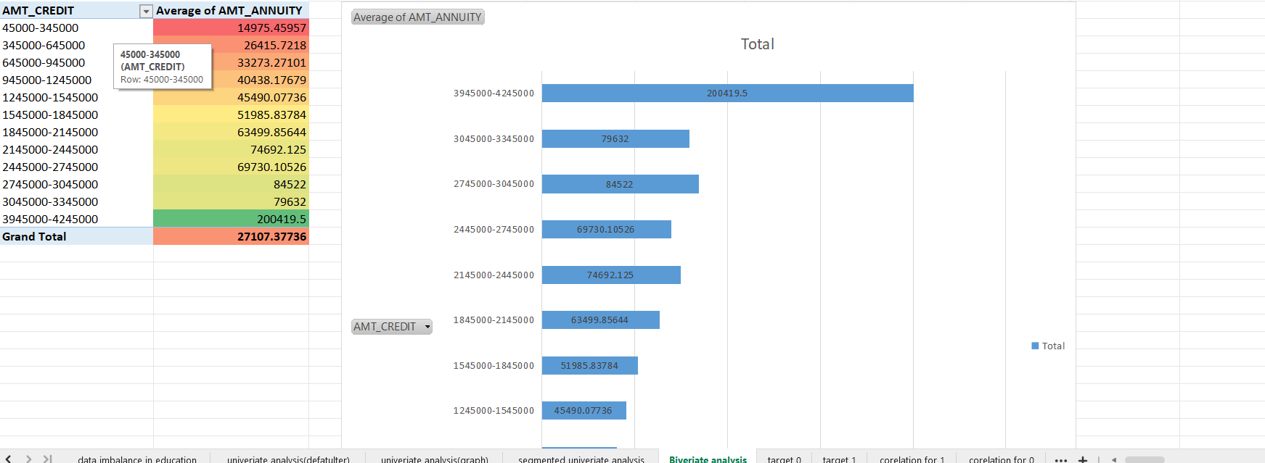
Insight:
- amt_credit and amt_annuity has a posivite relation between them,the higher the credit the higher the annuity amt.

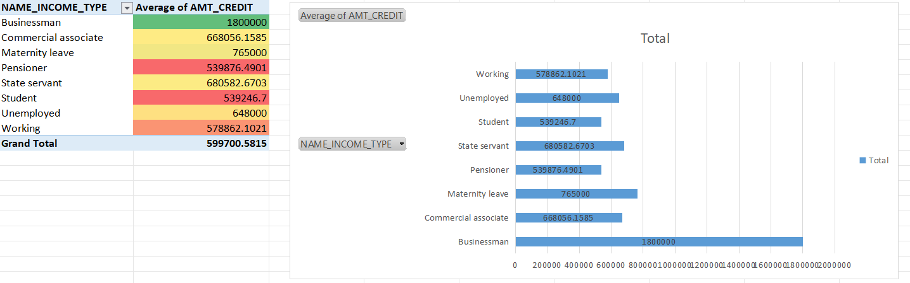
Insight:
- businessman tends to get higher credit_amt.

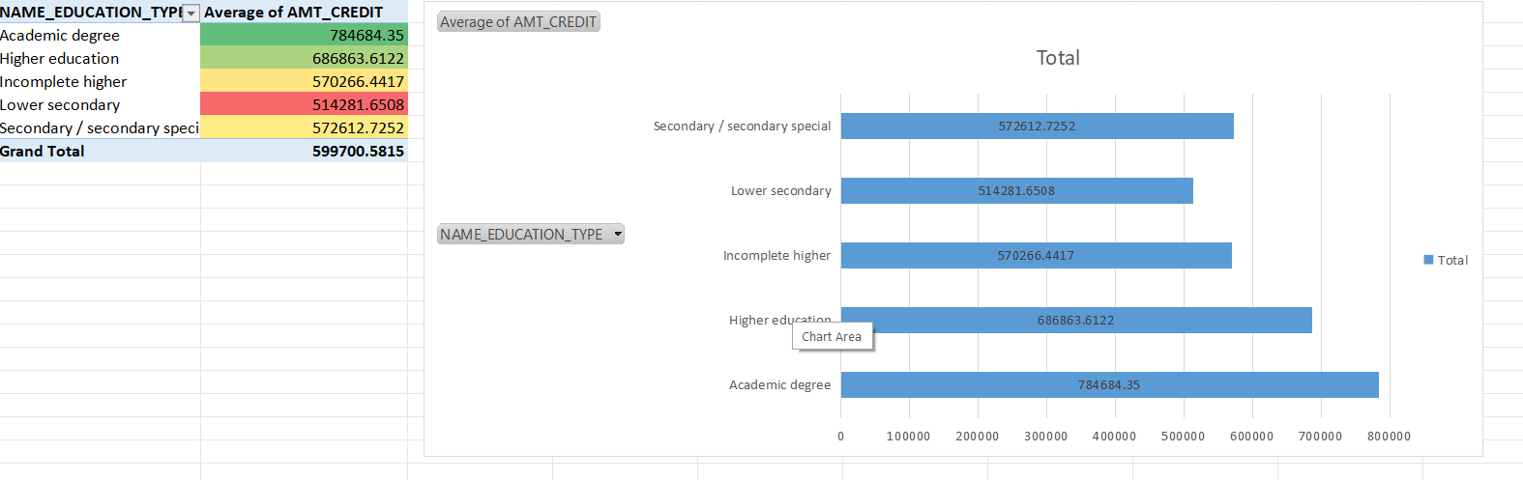
Insight:
- academic degree & higher education person takes high credit amt.

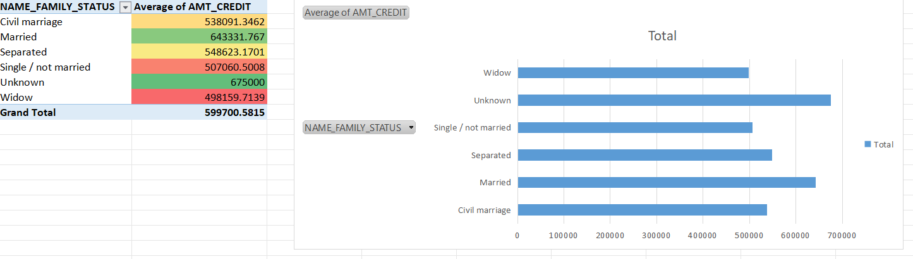
Insight:
- married person takes high loan.

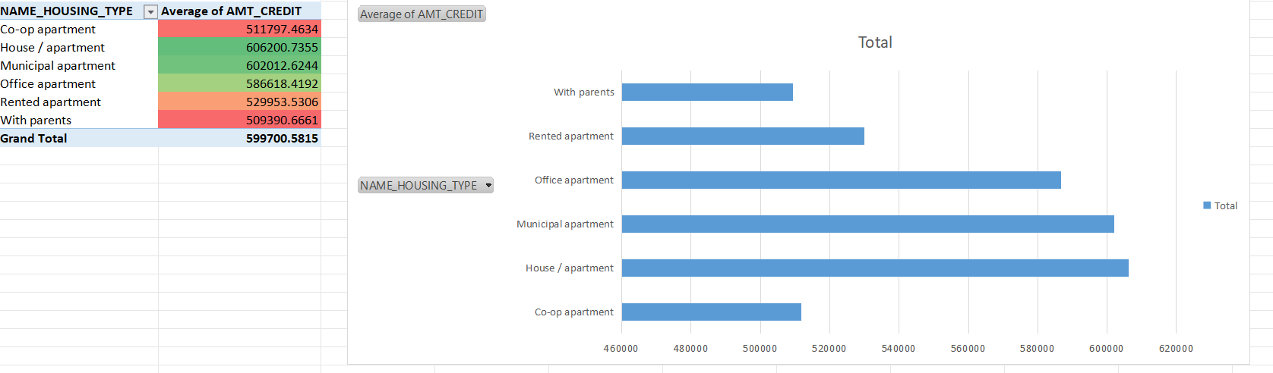
Insight:
- person with house/apartment,municipal apartment and office apartment takes high loan.

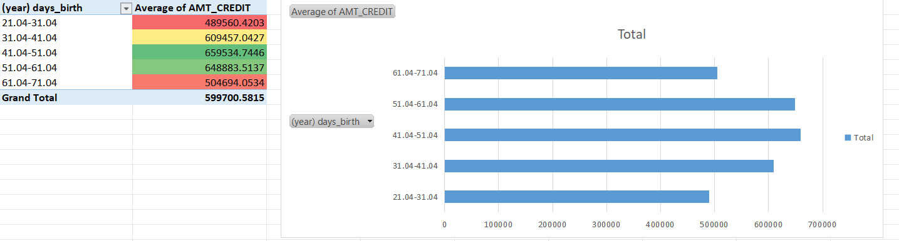
Insight:
- person with age between 41-61 takes higher loan.

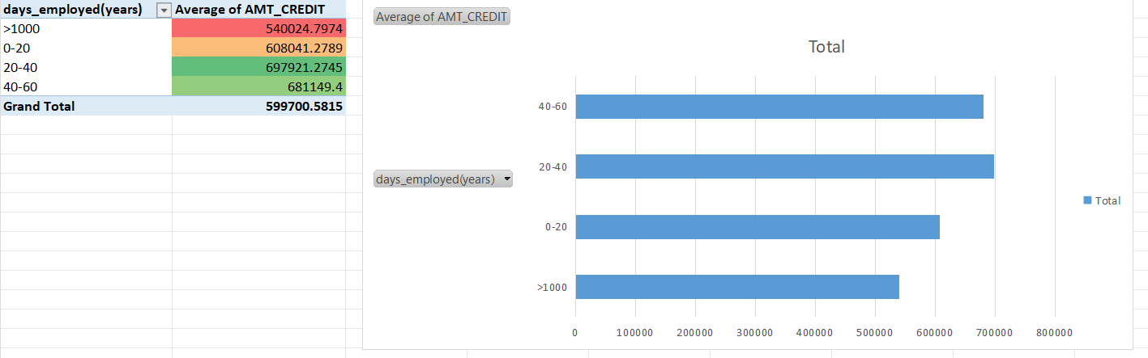
Insight:
- person with days employed between 20-60 take high loan.

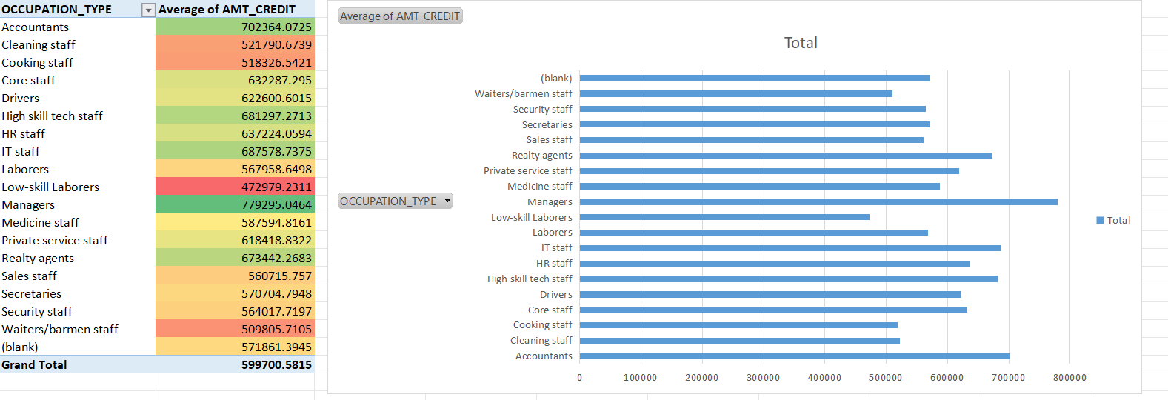
Insight:
- person with occupation type accountants,managers,etc take high loans

- Identify Top Correlations for Different Scenarios:
Task: Segment the dataset based on different scenarios (e.g., clients with payment difficulties and all other cases) and identify the top correlations for each segmented data using Excel functions.
Correlation of defaulters
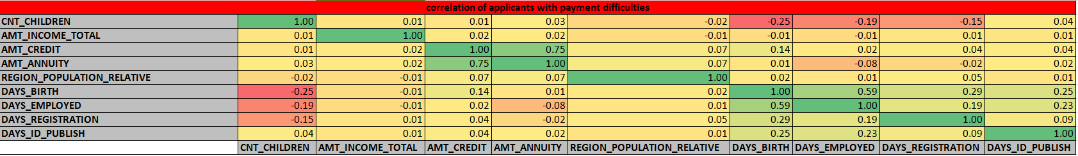
correlation of payers
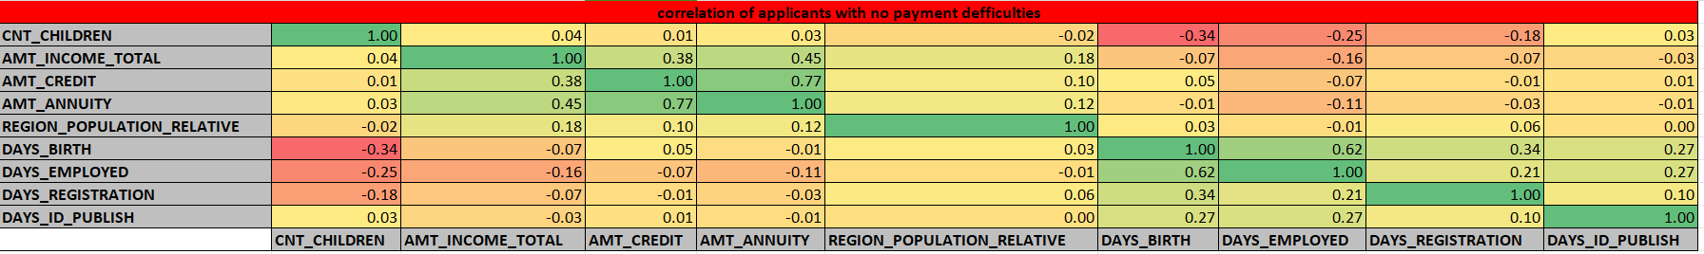
- cells mark with green has strong correlation,cells mark with yellow &orange has moderate correlation & cells with red mark has weak correlation.

Insights:
- Their are less count of defaulters in total loan in comparison to count of non-defaulters.
- Amt_income_total :Applicants with income more than 3,25,650 are less likely to default.
- amt_credit:risk of having a defaulter is high at low credit amount.
- The bank can earn profit by keeping higher annuity amount as their are less defaulters at higer annuity.
- Education type:academic degree has no defaulter.
- Income_type:Student,bussinessman & maternity leave have no defaulters.
- Organization_type:Applicants from organization like bussiness entity type 3 , self employed & xna are more likely to default.
- Days_birth:People above age 50 have low probability of defaulting.
- Days_employeed:applicants with 40+ year of experience has less default rate.
- Cnt_children:Applicants with children are less likely to default.
- Code_gender:Mens are at relatively have higher default rate.
- Name_family_status:Applicants who are single/civilmarriage default a lot.
- Occupation_type:avoid lowskill laborers,Sales_staff,drivers,waiter staff,securirt staff ,laborers&cooking staff as their default rate is high.
- Phone_change:if an applicant changed its phone within 0-6 yr before applying for loan,then he/she is more likely to default.

Result:
- After performing the analysis we can rectify whether a applicant will repay the loan or not.
- The people who are likely to face problem in loan repayment are labourers.
- people with secondary/secondary special education might face problem in loan repayment.
- Moreover those who are living in house/apartment are facing difficulty in loan repayment.
- loan highly recommended group:married client,senior clients, more educated clients,applicants with high income,females,applicants with strong work experience.
- loan highly risk group:Applicants that are unemployed,youth applicants,applicants with low income,applicants with little work experience,applicants with no children,applicants who have recently changed their phone.

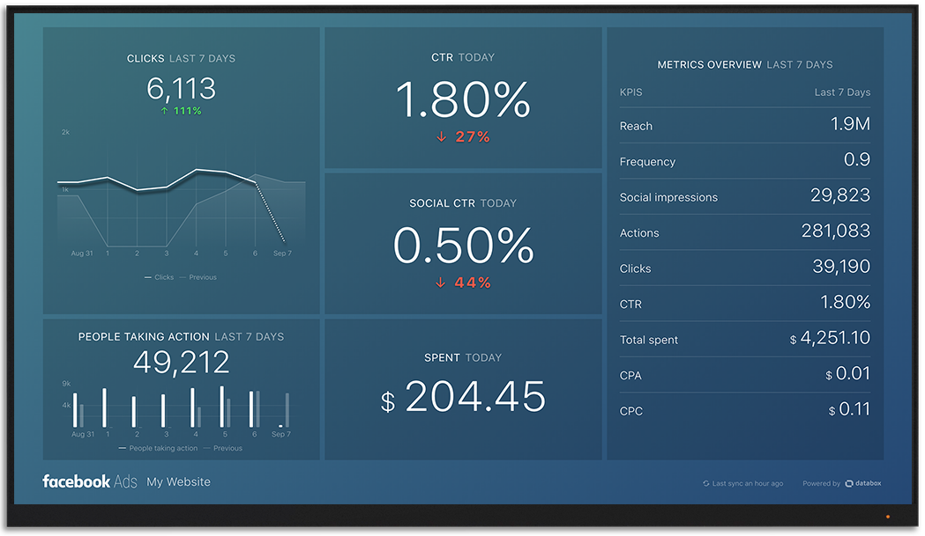
Impact Of Car Features On Price And Profitability
PROJECT DESCRIPTION:
The automotive industry has been rapidly evolving over the past few decades, with a growing focus on fuel efficiency, environmental sustainability, and technological innovation. With increasing competition among manufacturers and a changing consumer landscape, it has become more important than ever to understand the factors that drive consumer demand for cars.
In recent years, there has been a growing trend towards electric and hybrid vehicles and increased interest in alternative fuel sources.At the same time, traditional gasoline-powered cars remain dominant in the market, with varying fuel types and grades available to consumers.
For the given dataset, as a Data Analyst, the client has asked How can a car manufacturer optimize pricing and product development decisions to maximize profitability while meeting consumer demand?.
This problem could be approached by analyzing the relationship between a car's features, market category, and pricing, and identifying which features and categories are most popular among consumers and most profitable for the manufacturer. By using data analysis techniques such as regression analysis and market segmentation, the manufacturer could develop a pricing strategy that balances consumer demand with profitability, and identify which product features to focus on in future product development efforts. This could help the manufacturer improve its competitiveness in the market and increase its profitability over time.

APPROACH :
- In this project, I used wps Excel and Tableau to visualize the data.
- After reading the data, I performed eda to know the total missing values in each variables.
- performed data analysis techniques such as regression analysis, pivot tables, sensitivity analysis, optimization, and time series analysis.
- then build an interactive dashboard.

TECK STACK USED:
I have used wps Excel and Tableau Public 2023.2 because wps Excel is a free popular spreadsheet software widely used for data analysis, modeling, and visualization. Tableau public is a free business analytics service that provides interactive visualizations and business intelligence capabilities, and integrates with a wide range of data sources. It allows users to create customized dashboards and reports.

Analysis:
Insight Required: How does the popularity of a car model vary across different market categories?
Task 1.A: Create a pivot table that shows the number of car models in each market category and their corresponding popularity scores.
Ans:The flex fuel & crossover market category has the highest popularity among customers.

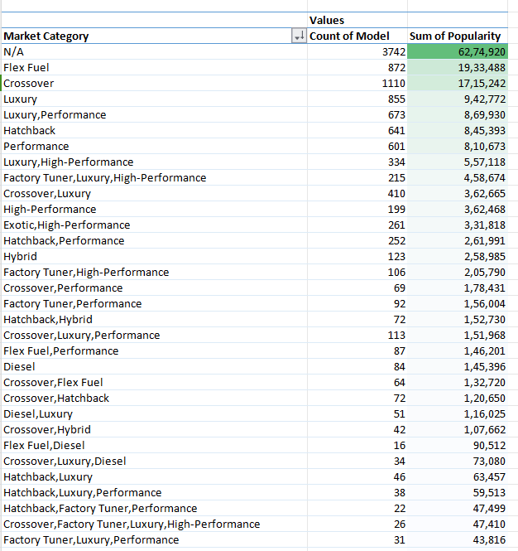
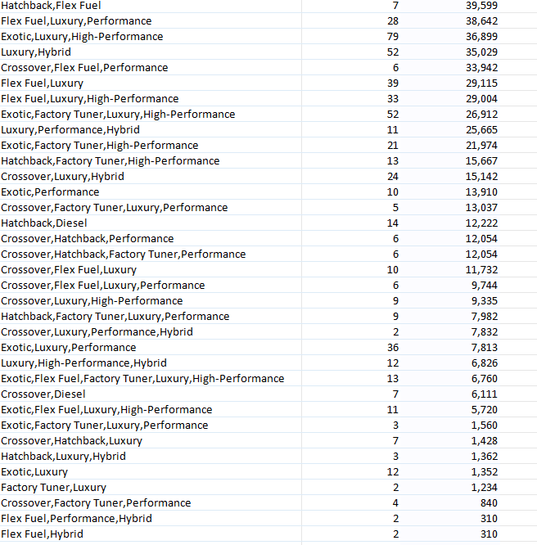

Task 1.B: Create a combo chart that visualizes the relationship between market category and popularity.
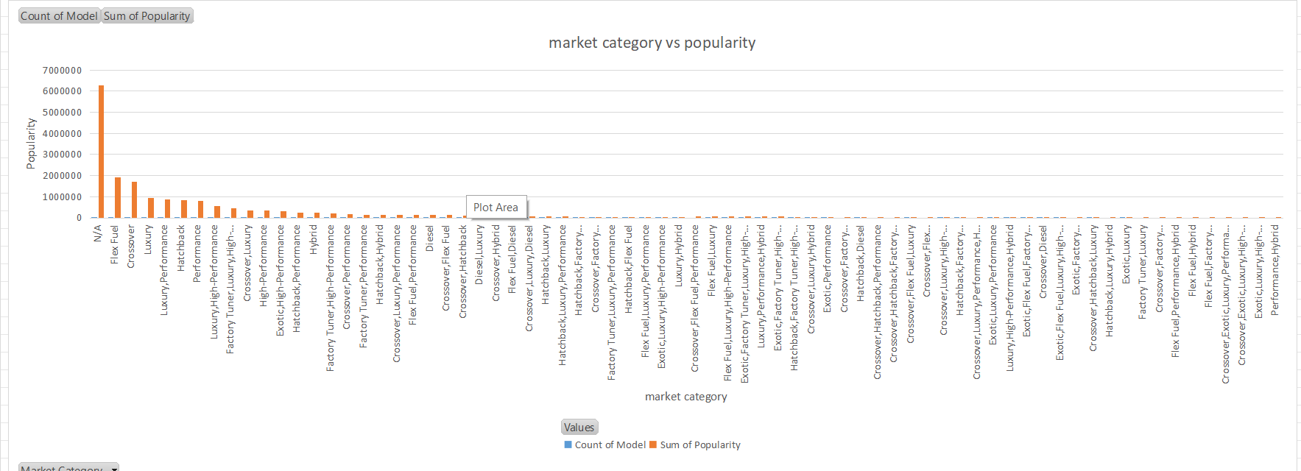

Insight Required: What is the relationship between a car's engine power and its price?
Task 2: Create a scatter chart that plots engine power on the x-axis and price on the y-axis. Add a trendline to the chart to visualize the relationship between these variables.
Ans:There is a positive relationship between a car's engine power and its price, where the price increases as the engine power increases.
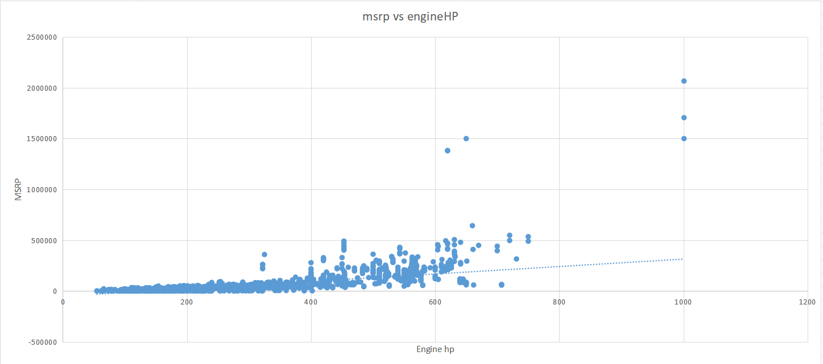

Insight Required: Which car features are most important in determining a car's price?
Task 3: Use regression analysis to identify the variables that have the strongest relationship with a car's price. Then create a bar chart that shows the coefficient values for each variable to visualize their relative importance.
Ans:As we have to perform regression analysis with the dependent variable 'MSRP', we cannot perform regression analysis on categorical values. Therefore, we performed regression analysis based on numerical values, and found that the Engine hp & Engine cylinder has the strongest moderate relationship with MSRP. We plotted a bar graph of Engine hp vs price, and found that it is a car feature that we can include to make the car more appealing.
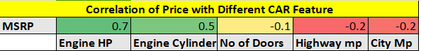
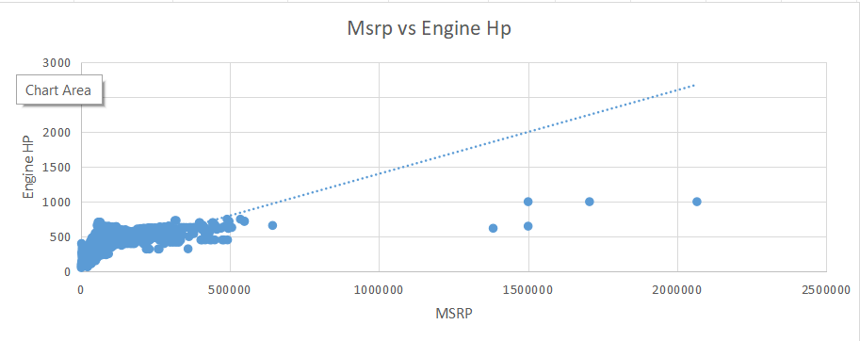
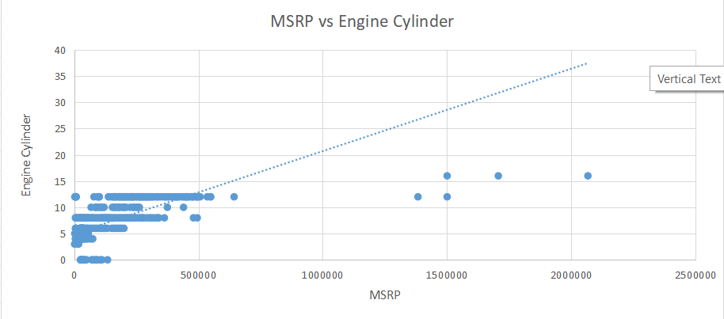

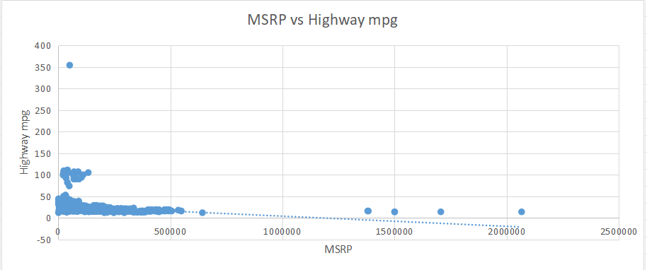
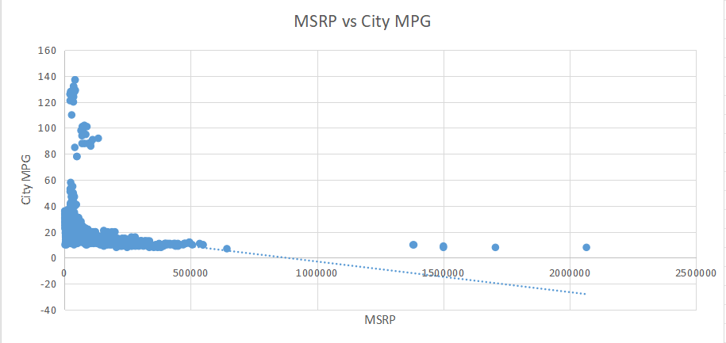
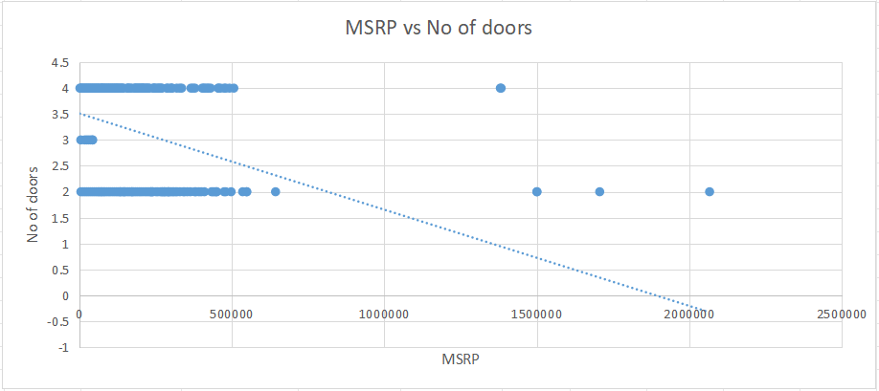

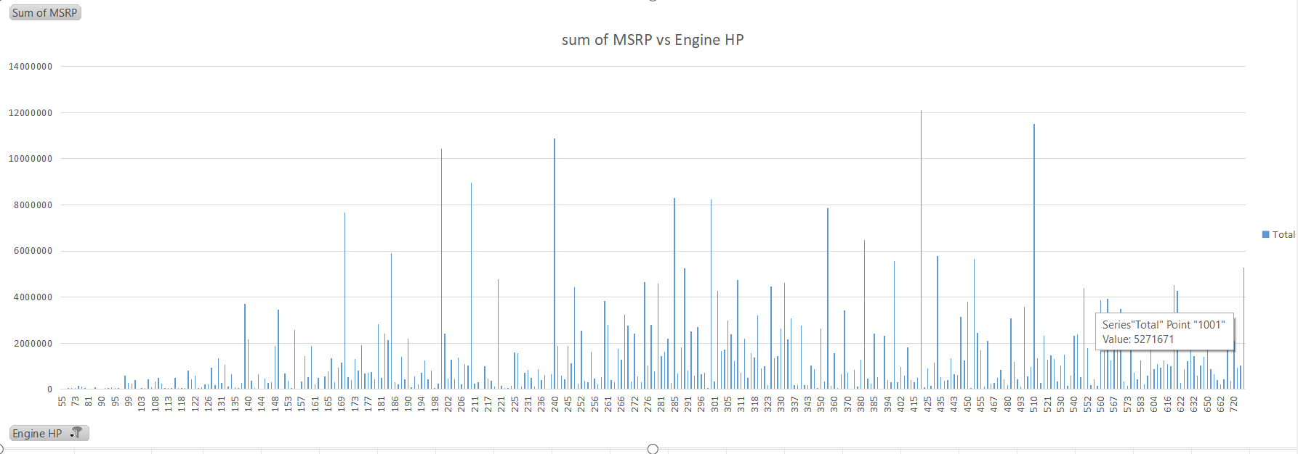

Insight Required: How does the average price of a car vary across different manufacturers?
Task 4.A: Create a pivot table that shows the average price of cars for each manufacturer.
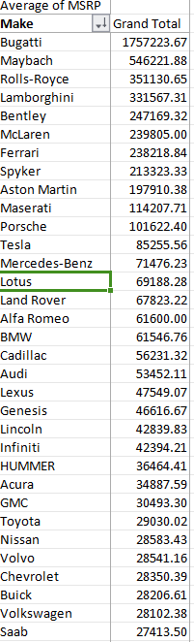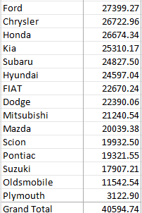

Task 4.B: Create a bar chart or a horizontal stacked bar chart that visualizes the relationship between manufacturer and average price.
Ans:
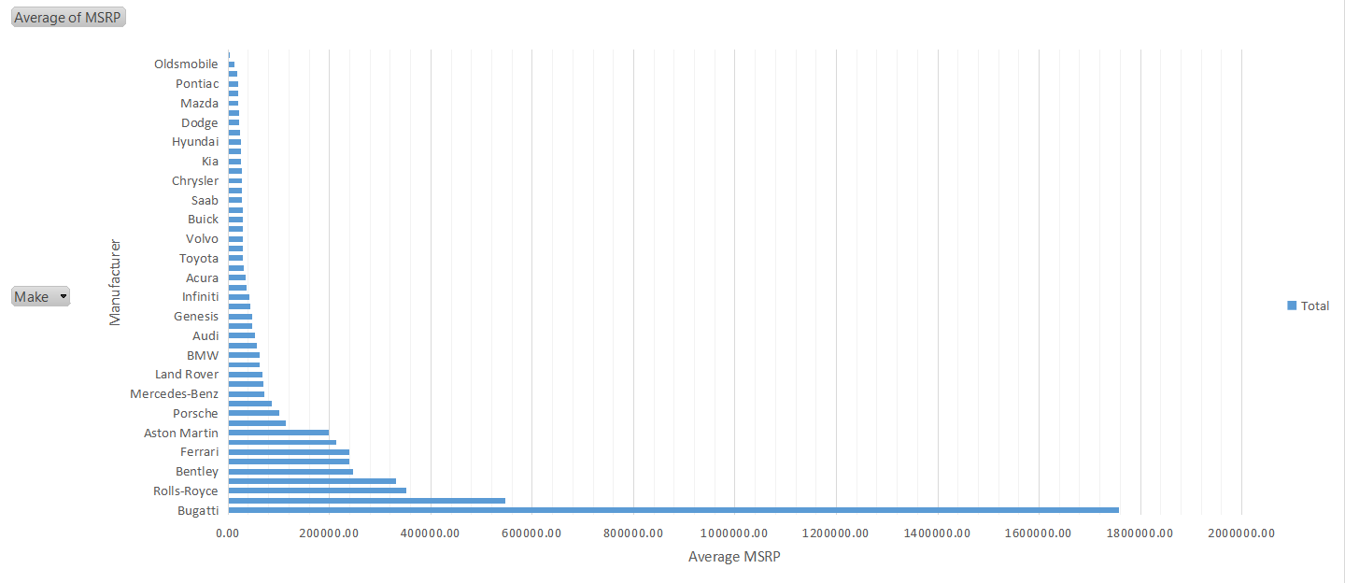

Insight Required: What is the relationship between fuel efficiency and the number of cylinders in a car's engine?
Task 5.A: Create a scatter plot with the number of cylinders on the x-axis and highway MPG on the y-axis. Then create a trendline on the scatter plot to visually estimate the slope of the relationship and assess its significance.
Ans:
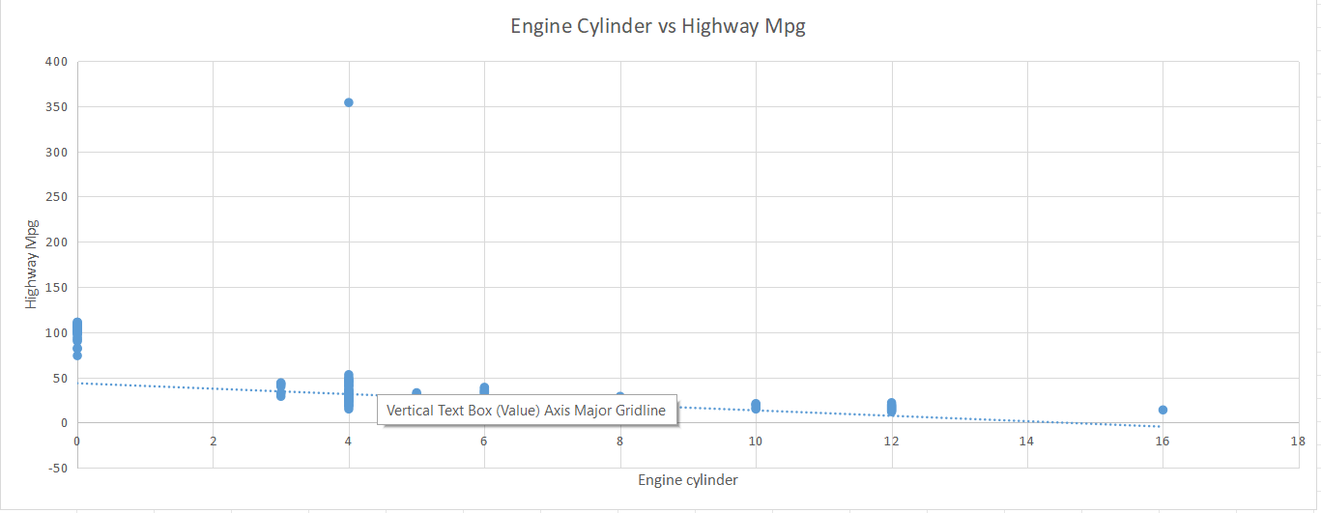

Task 5.B: Calculate the correlation coefficient between the number of cylinders and highway MPG to quantify the strength and direction of the relationship.
Ans:We can see that there is an indirect relationship between these two variables. As the number of cylinders increases, the highway miles per gallon decreases. This means that as fuel efficiency increases, the number of cylinders decreases.
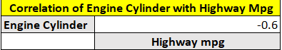

Dashboard Task

DASHBOARD
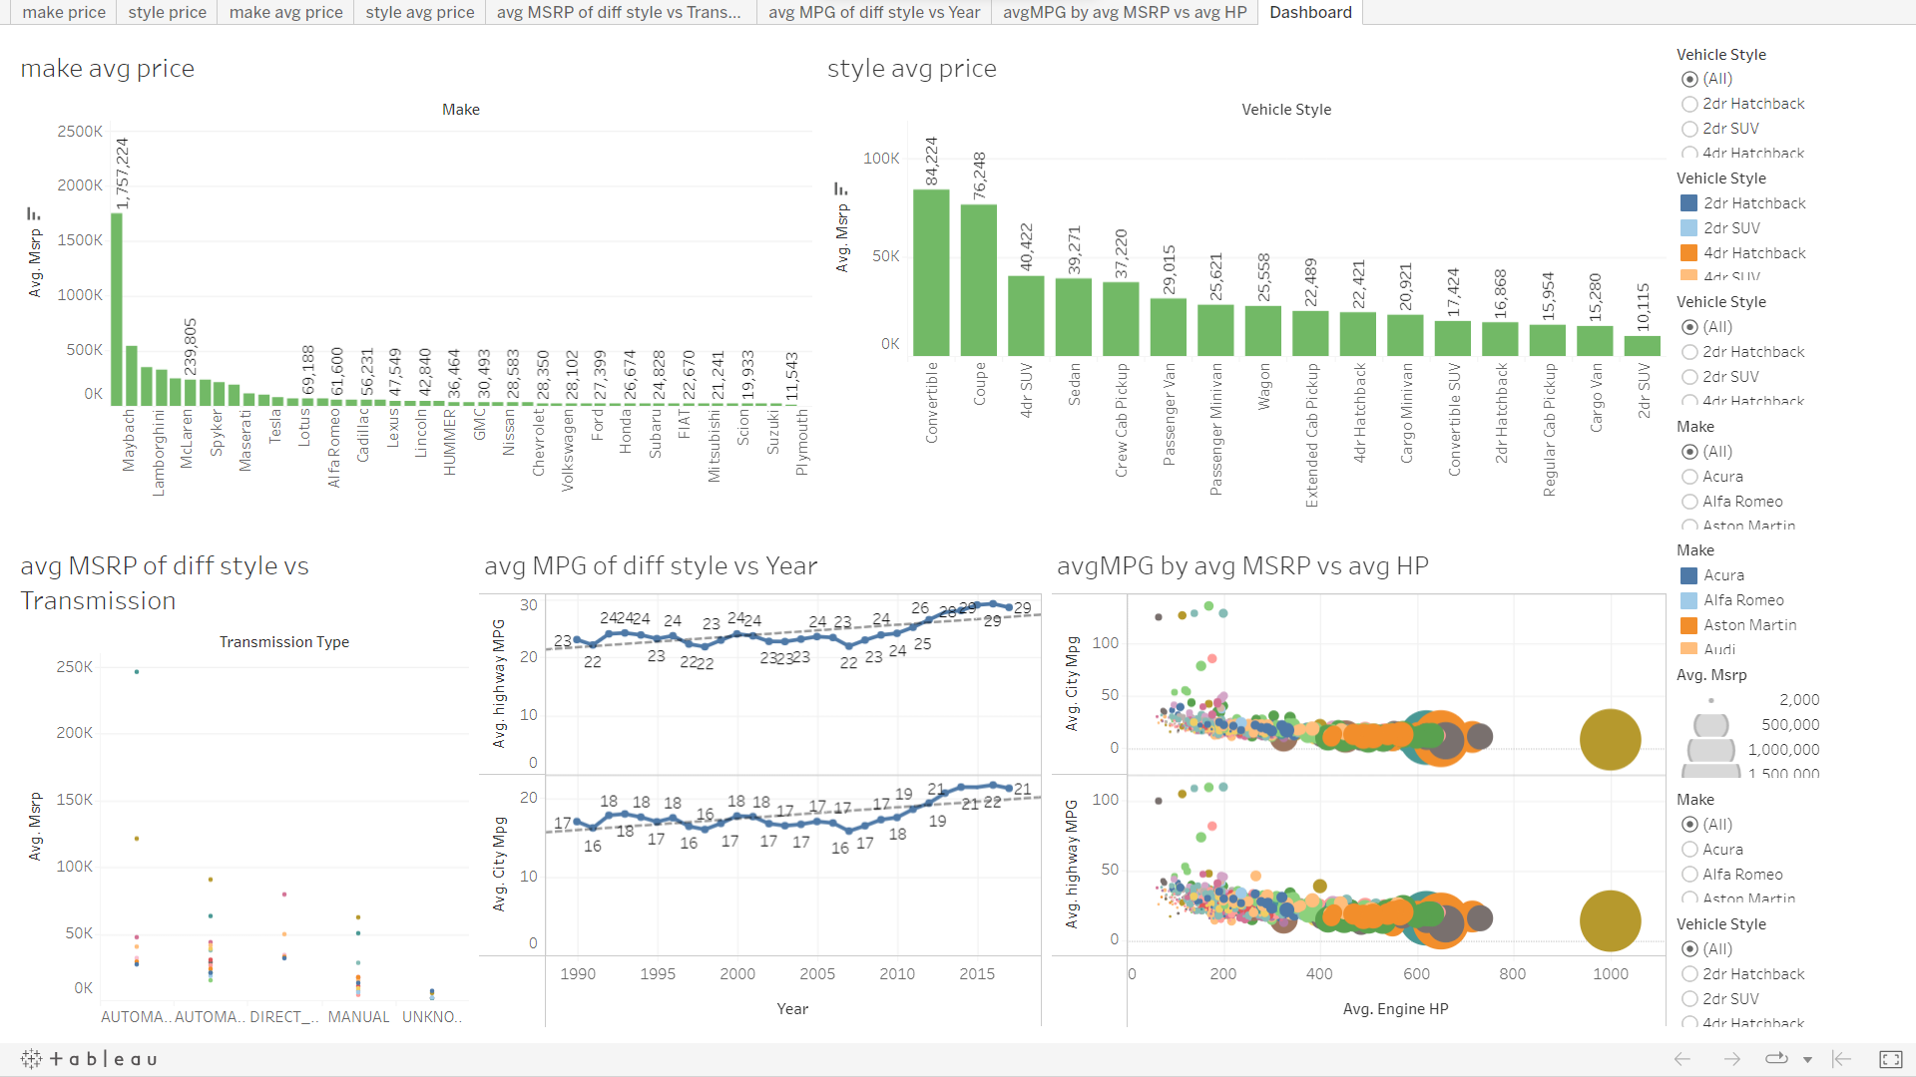

INSIGHTS :
- In the crossover market category, a high number of models are built, which means people are liking the crossover category more.
- The higher the engine hp the higher the price.
- The engine cylinder has the strongest relationship with price.
- The no of door,Highway mpg & city mpg has a weak relation with price.
- Buggati brand car has the higest avg MSRP & plymouth brand car has the lowest avg MSRP.
- Fewer engine cylinders give more highway MPG, which can attract customers to buy the car.
- Sedan, 4-door SUV, and coupe vehicle styles have high MRP, which we can use to make the car profitable.
- Automatic and automatic manual transmissions are loved by customers and can be priced high. From insights, we can see that people are continuously buying them despite their high price, which can be used to make our cars profitable.
- New models have high MPG due to modifications .
- Sedans and hatchbacks give higher average MPG.
- By utilizing the insights , we can make data-driven decisions to optimize the cost and profitability of our cars, as well as establish our position in the car market. This will help us create more appealing and competitive models that attract customers and increase sales.

RESULTS:
- Based on the analysis, it appears that the crossover market category are more popular among customers, indicating that more people are buying them at a higher rate.
- Sedan, 4-door SUV, and coupe vehicle styles have high MRP, which we can use to make the car profitable.
- In the future, as people appreciate vehicles that provide high fuel efficiency at a low cost, electric cars with high mileage and fewer cylinders may be more popular.
- We cannot perform regression analysis on categorical values when the dependent variable is a numerical value such as price.

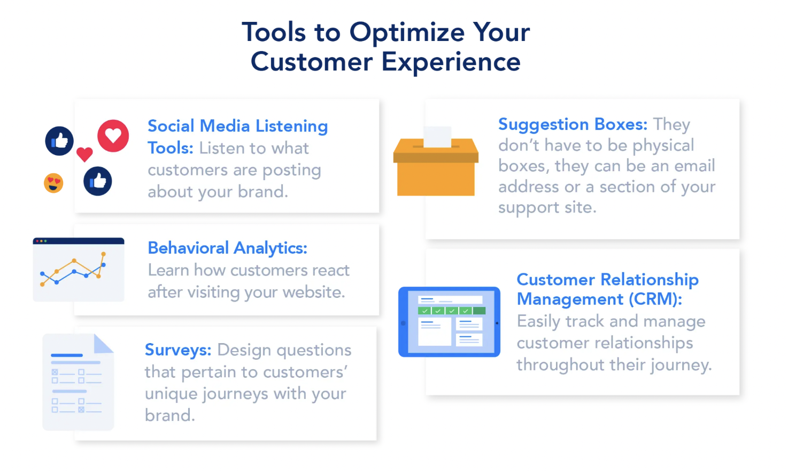
ABC Call Volume Trend Analysis
Project Description:
ABC is a Call centre which has a Customer Experience team for the voiceprocess. Typically, these teams fulﬁl various roles and responsibilities such as:Customer experience programs (CX programs), Digital customer experience,Design and processes, Internal communications, Voice of the customer (VoC),User experiences, Customer experience management, Journey mapping,Nurturing customer interactions, Customer success, Customer support,Handling customer data, Learning about the customer journey. I have been provided with the data of ABC call centre for the last 23 days and I should analyze the data and help the company answer some of the business questions.

Approach :
- Check the data for consistencies.
- Create a table in Excel.
- Create extra columns if required.
- Create Pivot Tables and charts.

Tech Stack Used :
APP-WPS OFFICE Excel, Product Version-12.2.0.13085 ,Publisher-Kingsoft corp.

About the Dataset :
- There are 117988 rows and 13 columns.
- Agent name is a categorical column containing names of the agents attending the phone call.
- Agent Id column contains the agent id .
- Customer column contains the contact number of the customer.
- Queue time contains the seconds customer has waited before the agent has picked the call.
- Date_&_Time, Time & Time_Bucket are used for time intelligence.
- Duration and Call_seconds contains the duration of the call.
- Call Status and Wrapped are also categorical columns.

Cleaning the dataset :
- The agent Name and Agent Id has null values.
- The columns Ringing and IVR duration are not used since ringing has only one variable and IVR duration is not of any use to our analysis.
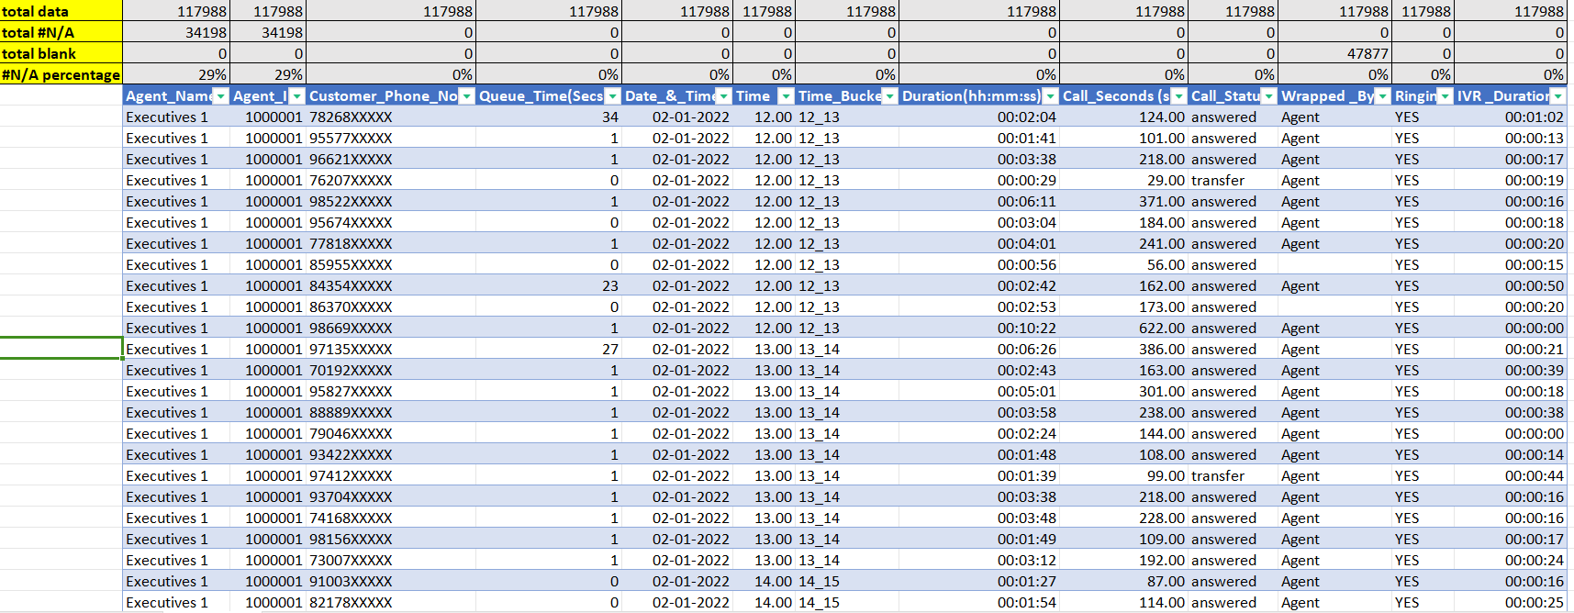

Data Analytics Tasks:
Average Call Duration: Determine the average duration of all incoming calls received by agents. This should be calculated for each time bucket.
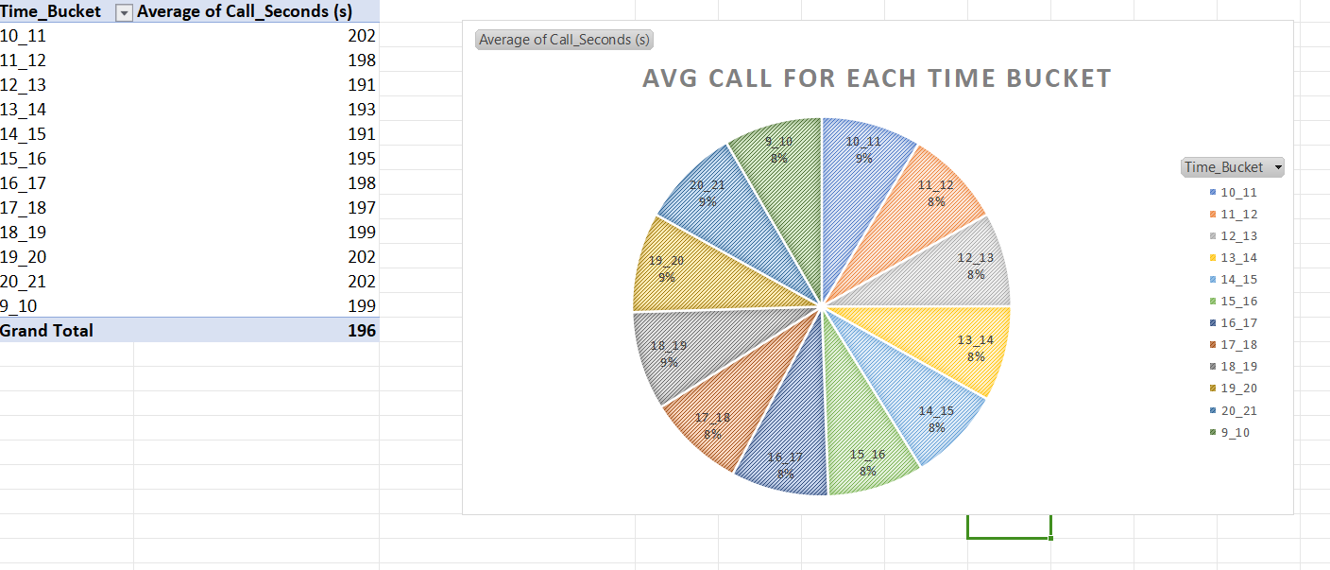
Insight:
- As it can be seen that avg call duration increases between 10-11 & 18-21 time bucket.

Call Volume Analysis: Visualize the total number of calls received. This should be represented as a graph or chart showing the number of calls against time. Time should be represented in buckets (e.g., 1-2, 2-3, etc.).
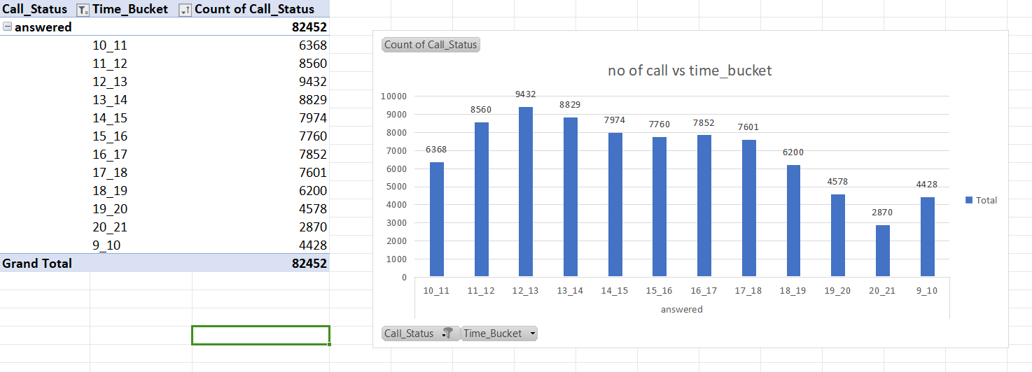

Insight:
- It can be seen that the Number of calls recieve in a day increases from 9 to 13 and then it starts decreasing.

Manpower Planning: The current rate of abandoned calls is approximately 30%. Propose a plan for manpower allocation during each time bucket (from 9 am to 9 pm) to reduce the abandon rate to 10%. In other words, you need to calculate the minimum number of agents required in each time bucket to ensure that at least 90 out of 100 calls are answered.
Assumptions: An agent works for 6 days a week; On average, each agent takes 4 unplanned leaves per month; An agent's total working hours are 9 hours, out of which 1.5 hours are spent on lunch and snacks in the office. On average, an agent spends 60% of their total actual working hours (i.e., 60% of 7.5 hours) on calls with customers/users. The total number of days in a month is 30.
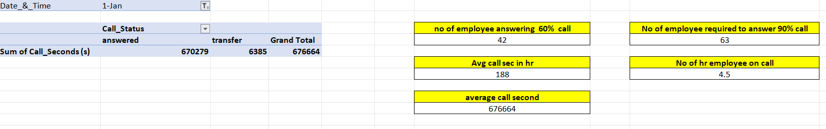
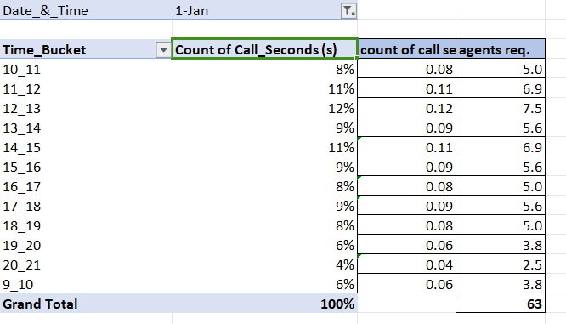
Solution:
- Total time spend on calls by agents(according to given assuptions) =7.5*60%(occupancy) =4.5
- (1st Jan)Average call duration is 676664.sec
- Average call duration in hrs is 188.hr
- No of agents attending 60% calls= Avg call duration/total time spend on call by agents=42.
- No of agents required to attend 90% call= 90*42/60=63.
- Formula that I have used to find number of agent first count the call percentage then convert it into decimal then multiply with the total agents required.

Night Shift Manpower Planning: Customers also call ABC Insurance Company at night but don't get an answer because there are no agents available. This creates a poor customer experience. Assume that for every 100 calls that customers make between 9 am and 9 pm, they also make 30 calls at night between 9 pm and 9 am. The distribution of these 30 calls is as follows:
Your Task: Propose a manpower plan for each time bucket throughout the day, keeping the maximum abandon rate at 10%.
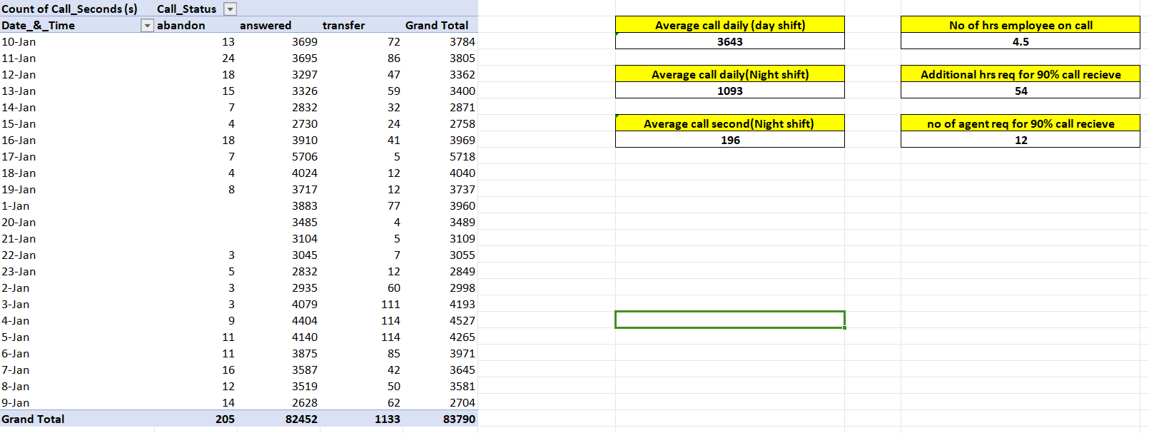
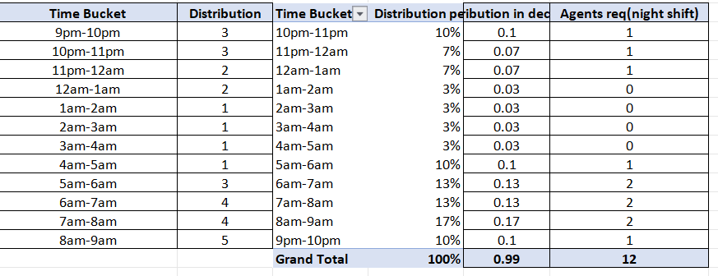

Solution:
- we know that total average calls between 9 am to 9 pm is 3643.sec.
- so we can say no of call between 9 pm to 9 am is 3643*30/100. That is 1093.sec.
- Time to answer 90% of calls in hrs =(total avg calls * total avg duration * 90%)/3600(convert sec into hrs) =(1093*196*90/100)/3600 =54
- So number of person required in night =total call time/total time spend on calls
- =54/4.5 =12
- Formula that I have used to find number of agent first count the call percectage then convert it into decimal then multiply with the total agents required.

Result:
After doing this project, I get to know pivot table more. Pivot helps to compare columns and makes calculation more simple also helps in grouping.
In this project ABC Call Volume Trend Analysis we analysis customer experience. A customer experience team consists of professionals who analyse customer feedback and data, and share insights with the rest of the organization. Keep a good customer relationship that help business for future growth. The project done through using wps office excel. So it help me to increase my technical skills and knowledge in excel. In this analysis project I have analysis the customer relationship, to solve customer problem that keep good relationship between the business and customer. After doing this project this help me to improve my data analytical skills, visualization skills etc.

Conclusion
In conclusion, I would like to tell that after doing a
thorough analysis we were able to derive the insights
from the data and was able to plot various graphs
using that data. The data which once looked useless
gave some very useful insights.

Appendix
Link for excel sheets & ppt for all of the project
https://drive.google.com/drive/folders/1RC8o8kk_NZawntAEXNOhdv18UWG1Exsf

