1. Introduction

1.1 Purpose of the project

This project was made because I specifiacally wanted to learn more about microservices, back-end development, event driven architecture using message queues and overall the practices used in the real industries.

1.2 Problem statement

I knew what I wanted to learn, but wasnt sure about what I wanted to build, so I turned to my real life problems, one of which was keeping track of my expenses, so finally settled on building an expense tracker app, but I wanted to integrate a chatbot as AI is hype right now.

1.3 Overview

The project is basically an expense tracker that tracks your expenses, it allows you to see your daily transactions, create categories, set daily, monthly budgets for those categories and finally an AI chatbot that allows you to understand your finances better.

2. Microservice Architecture

2.1 Definition of Microservice Architecture

Microservice architecture is an architectural design pattern designed for large-scale distributed software systems. It is a distributed system design approach in which application is composed of multiple independent services, each responsible for single buisness capability. These services are loosely coupled, and are independently deployable and communicate with each other typically with light weight mechanisms.
Each microservice :
- has its own encapsulated buisness logic
- manages its own data
- runs as a seperate process
- can be developed, deployed, scaled, and maintained independently
So basically microservice architecture is all about where a project is broken down into independent services that cooperate and communicate with each other for the entire system to work.

2.2 Characteristics of Microservice

a) Service independence
Each service acts as an independent unit, it can be changed and deployed without the whole system being redeployed, changes in the service doesn’t impact the other services in the system enables faster development cycles and avoids system wide risks.

b) Single responsibilty
Each service has a specific buisness capability, This ensures that there are clear service boundaries and prevents services from becoming overly complicated or tightly coupled.

c) Decentraliazed data management
In microservice architecture each service manages its own data store, there is no sharing of database across the services. This is to prevent tight coupling at the data level which allows each service to have the freedom to choose own database technology which suites it.

d) Distributed communication
Services communicate with each other using either synchronous (HTTP/REST API’s) or asynchronous (Message queues) communication.

2.3 Use of microservice architecture in this project

The reason to use microservices in this project is that it contains many different independent modules/features, one is the auth service mainly for login and user profile related functions, finance service for handling the finance related functions and then AI service for the chatbot.

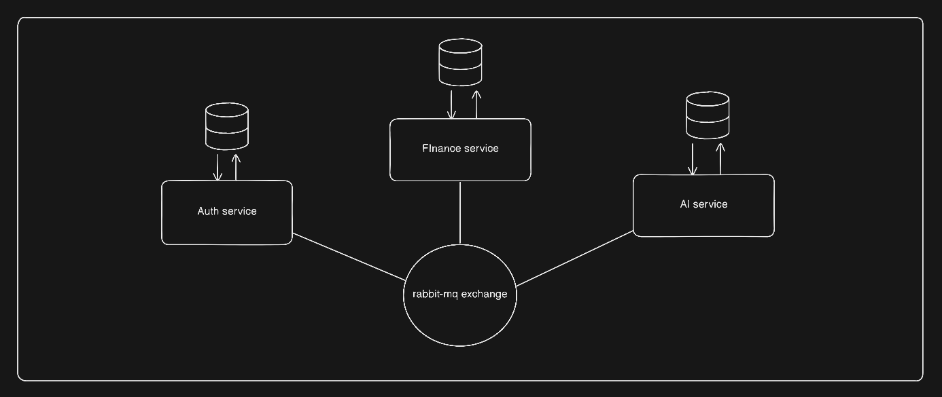

3. Event Driven Architecture

3.1 Definition of Event Driven Architecture (EDA)

EDA is an architectural design paradigm in which the system components communicate with each other by producing and reacting to events. An event is basically a significant change in the system. This type of architecture is chosen to design loosely coupled, scalable and reactive systems.
In EDA the flow of the system is basically production, detection and consumption of events rather than synchronous function or API calls.

In this architecture:
- Components produce an event whenever something major happens in the system, these are known as producers.

- Components then consume these events and react to it by doing things asynchronously, these are known as consumers.

- The producers do not know who the consumers are and the consumers do not know who the producers are.

3.2 Components of EDA

a) Event :
An event is an immutable fact that is produced when something happens in the system.
For example orderCreated, billPayed, transactionCreated etc.

b) Event Producer :
It is a component or a service that publishes an event when its internal state changes.

c) Event consumers:
It is a component or a service that subscribes to that event and reacts to it.

d) Event channel:
Its is also called as the event bus, it has the responsibility of transporting the events from the producers to the consumer. It has responsibilities such as event delivery, message buffering, handling retires and failures.
