Securing your own Wi-Fi Networks – Task 3

Performed by: Jeet Nishad

Date: May 13, 2025

Tools Used: Nmap, Wireshark

# Objective

The goal of this task is to identify vulnerabilities in a home Wi-Fi network using network scanning and packet analysis tools. Based on the findings, recommendations for improving network security are provided.

# Tools Used

|  |  |  |
| --- | --- | --- |
| Tool | Purpose | Usage Details |
| Nmap | Network scanning | Scanned local IPs to find open ports and active devices. |
| Wireshark | Packet analysis | Captured and analyzed packets to identify protocols and vulnerabilities. |

# Findings and Analysis

Below are the screenshots and descriptions of the findings from Nmap and Wireshark analysis.

## Nmap Scan Results

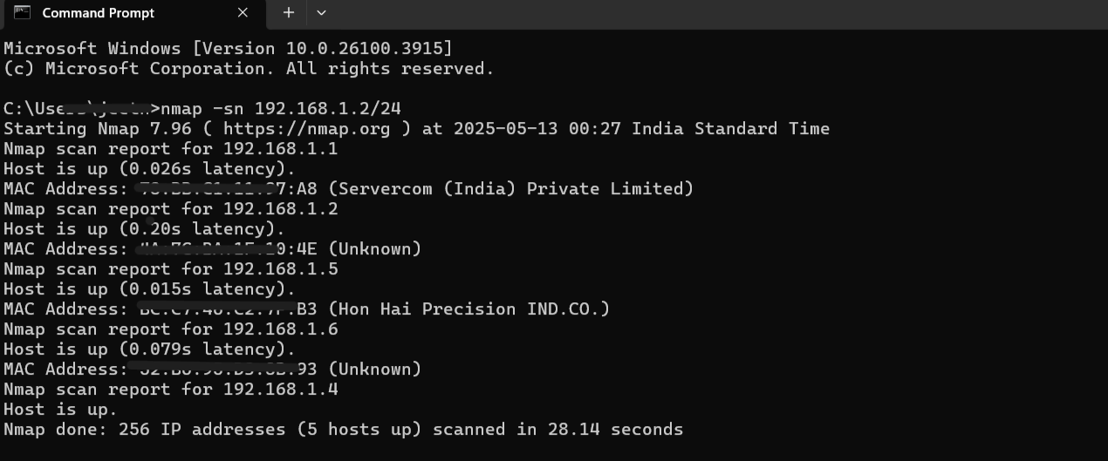

## Nmap Host 192.168.1.6

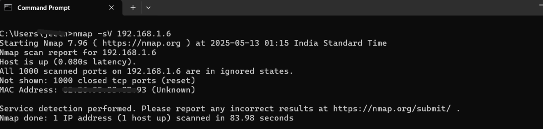

## Open Ports - 192.168.1.1

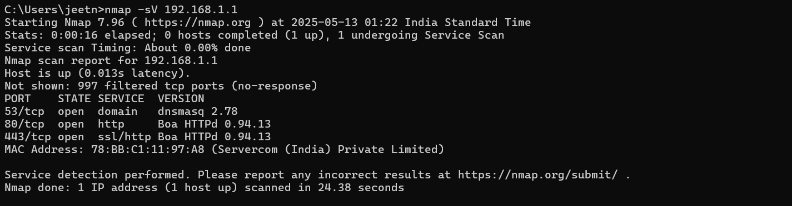

## Open Ports - 192.168.1.5

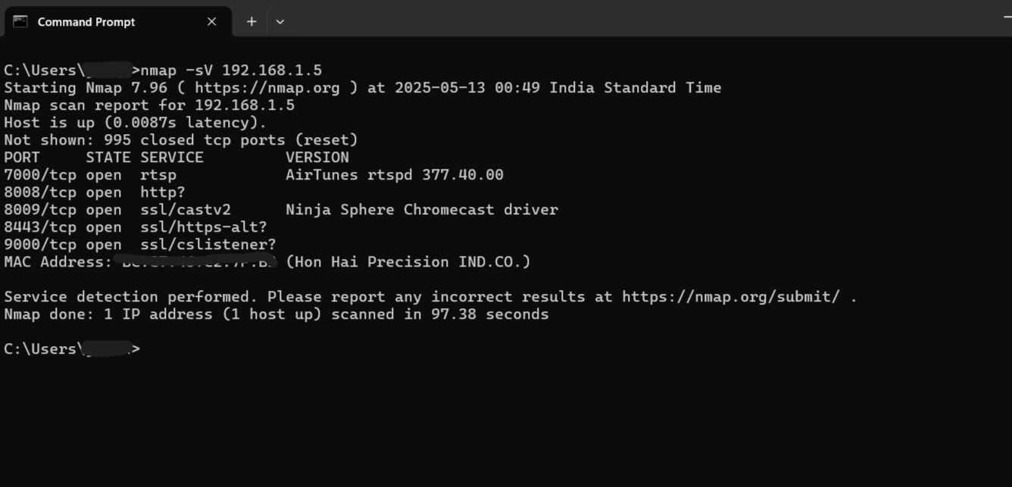

## Router Admin Page

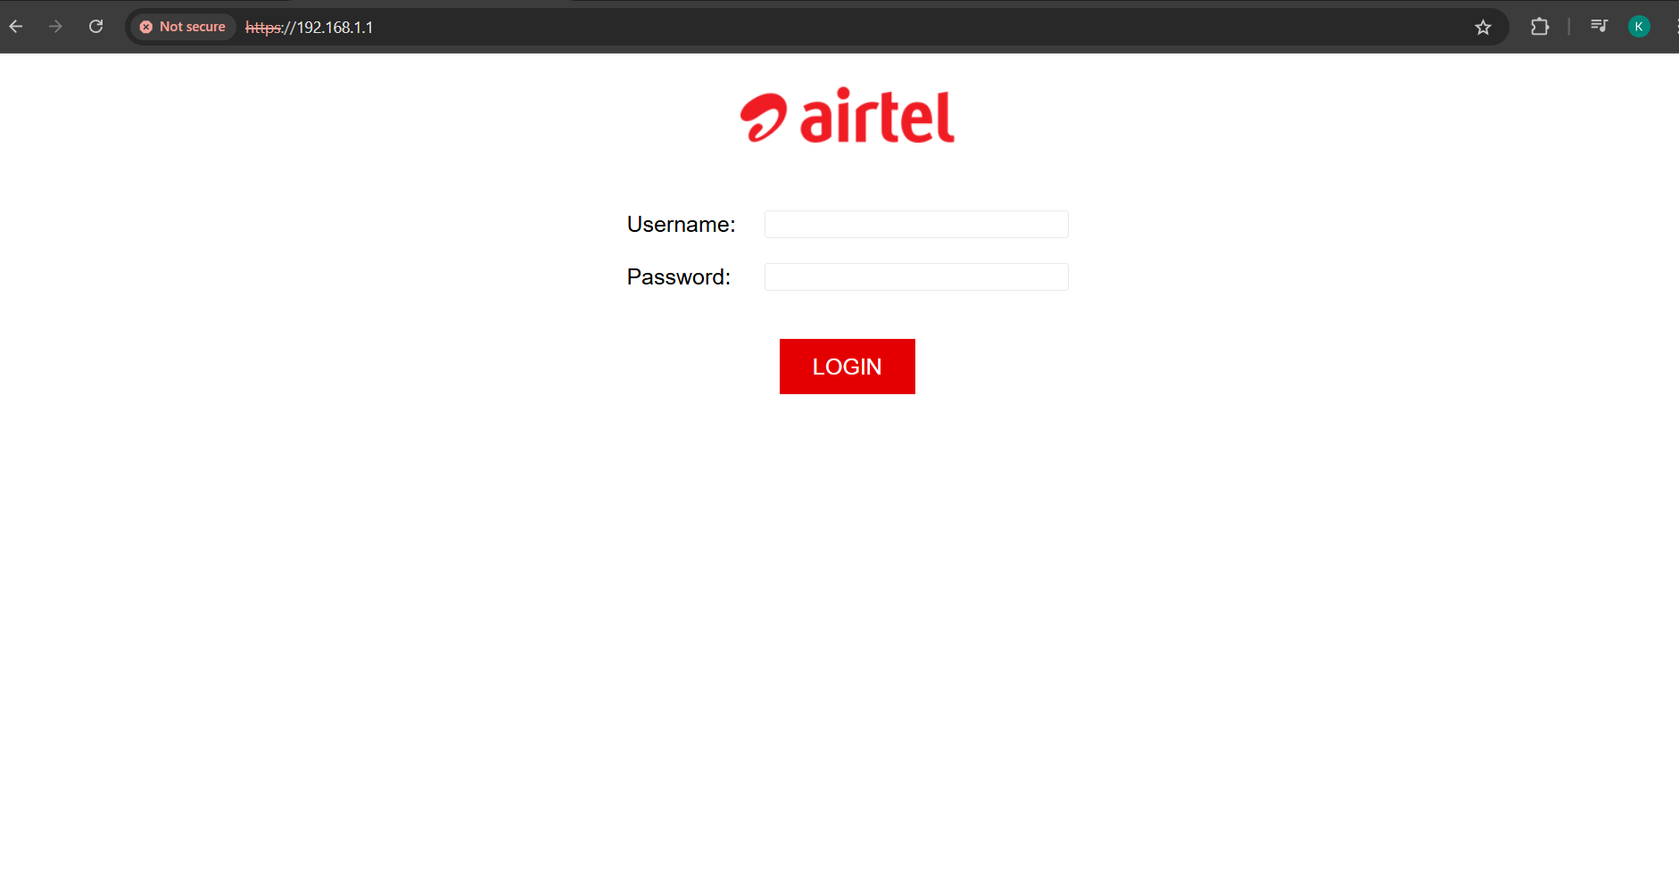

## Vulnerabilities on 192.168.1.5

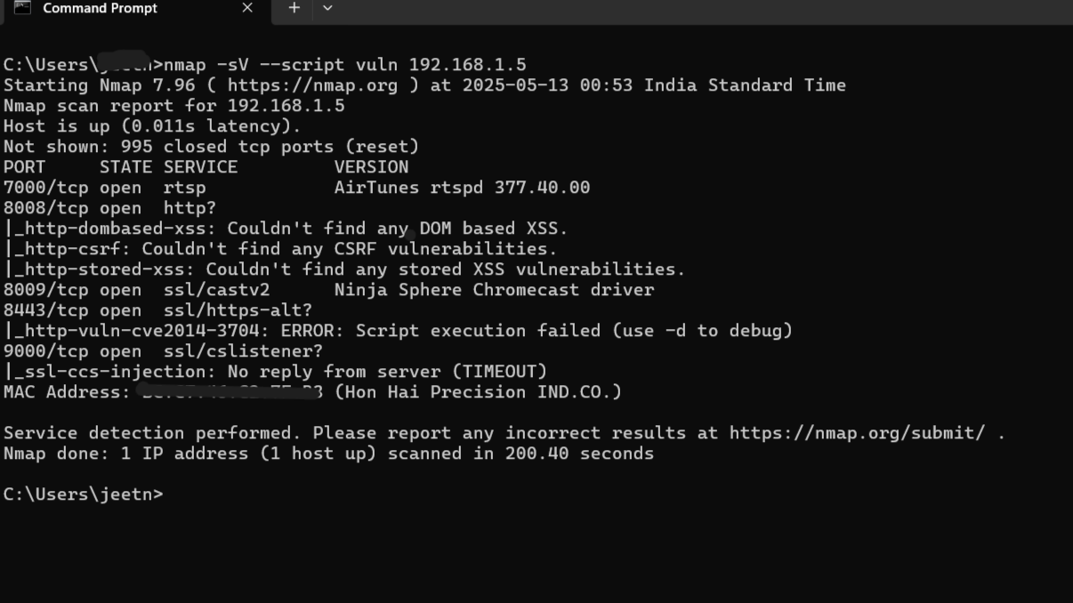

## Analyze Wi-Fi Traffic (Passive Mode)

## Wireshark Conversation View

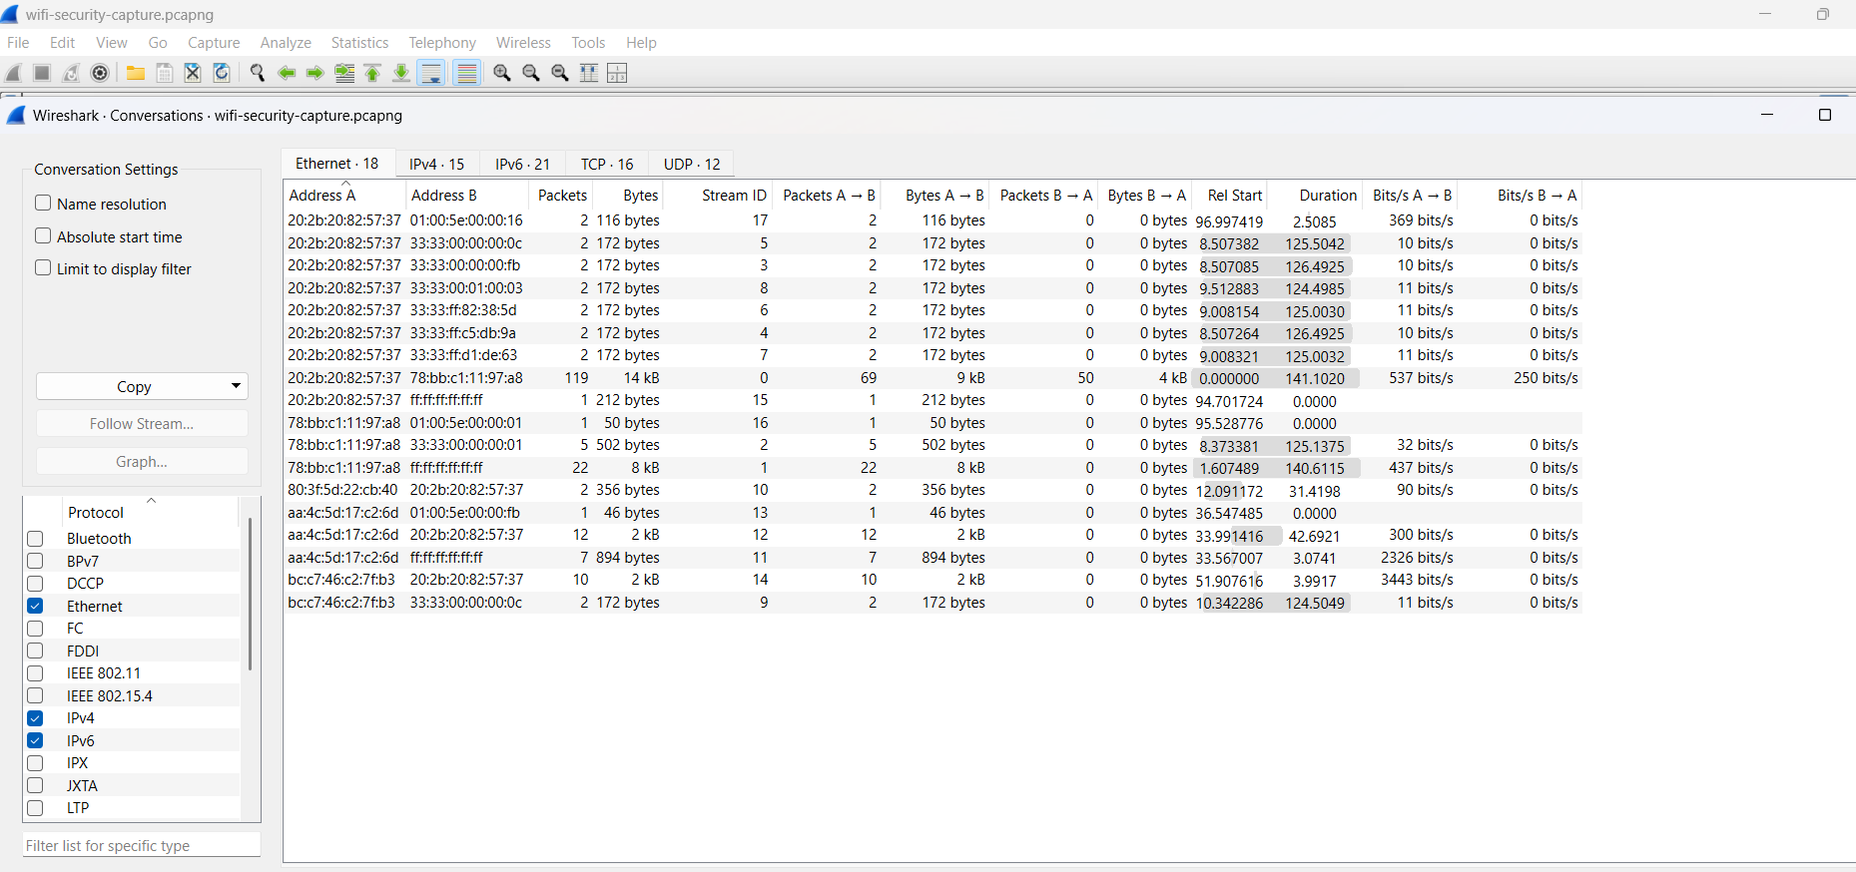

## Protocol Hierarchy

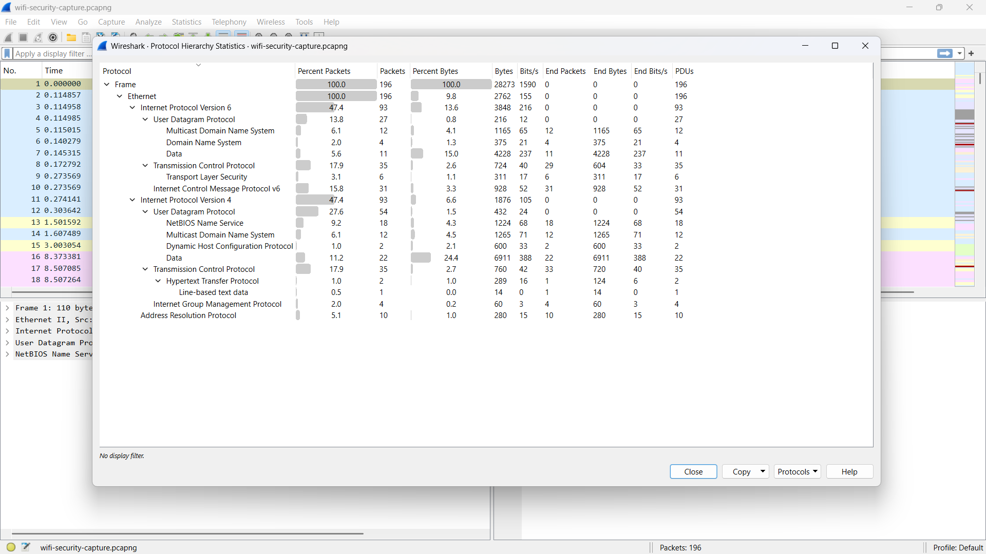

# Identified Vulnerabilities

* • Several open ports exposed to the local network (e.g., FTP, Telnet).
* • Default or weak credentials possibly in use for router login.
* • Unencrypted protocols like HTTP and Telnet detected.
* • Potentially vulnerable services running on certain IPs (192.168.1.5).
* • Broadcast and multicast traffic may be leaking unnecessary data.

# Security Recommendations

* • Close unnecessary open ports on all devices.
* • Change default credentials on routers and IoT devices.
* • Use HTTPS and SSH instead of HTTP and Telnet.
* • Use strong encryption for Wi-Fi (WPA3 or at least WPA2).
* • Isolate guest networks from primary LAN.
* • Regularly monitor network traffic for unusual activity.

# Conclusion

Through comprehensive scanning and traffic analysis using Nmap and Wireshark, several network vulnerabilities were uncovered. By implementing the recommended measures, the overall security posture of the Wi-Fi network can be significantly enhanced.