KARON INFOTECH INTERNSHIP
2026
A PROJECT REPORT
Submitted by
Patel Jeet
230090107137
In partial fulfillment for the award of the degree of
BACHELOR OF ENGINEERING
in
Computer Engineering
C. K. Pithawala College of Engineering and Technology, Surat
 | 
Gujarat Technological University, Ahmedabad
August, 2026

 | 
C. K. Pithawala College of Engineering and Technology
Opposite Surat Airport, Behind DPS School, Near Malvan Mandir, Dumas Road, Surat

CERTIFICATE

This is to certify that the project report entitled "IPL DATA ANALYTICS & INTERACTIVE PERFORMANCE DASHBOARD (2008 – 2024)" submitted along with the project has been carried out and successfully completed by Patel Jeet Hasmukhhai (Enrollment No: 230090107137) under my supervision and guidance in partial fulfillment for the degree of Bachelor of Engineering in Computer Engineering, 7th Semester of Gujarat Technological University, Ahmedabad during the academic year 2026–2027

Ms. Stephanie Tamakuwala  Internal Guide | Dr. Saurabh S. Tandel  Head of the Department



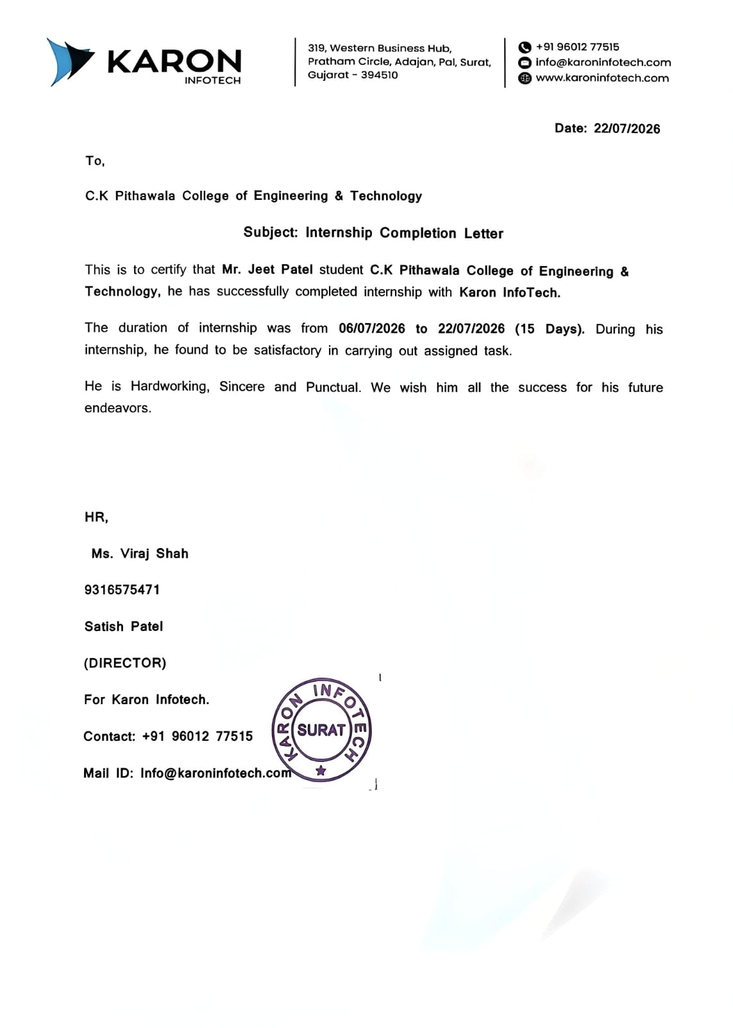



C. K. Pithawala College of Engineering and Technology
Opposite Surat Airport, Behind DPS School, Near Malvan Mandir, Dumas Road, Surat

DECLARATION
I hereby declare that the Internship / project report entitled "IPL DATA ANALYTICS & INTERACTIVE PERFORMANCE DASHBOARD (2008 – 2024)" submitted in partial fulfilment for the award of the degree of Bachelor of Engineering in Computer Engineering to Gujarat Technological University, Ahmedabad, is an authentic record of original project work carried out by me with technical reference from Karon Infotech, Surat.
Patel Jeet
230090107137
7th Semester, Computer Engineering Department
C. K. Pithawala College of Engineering and Technology, Surat
Gujarat Technological University
I confirm that the multi-season IPL dataset was gathered from open Kaggle repositories, cleaned and structured using Python and SQL scripts written by me, and visualized into an interactive 5-page Power BI dashboard. I further declare that no part of this report has been directly copied from any student report or taken from any source without providing explicit references and citations.

Acknowledgement
I would like to express my deepest gratitude to Gujarat Technological University (GTU), Ahmedabad, and the management of C. K. Pithawala College of Engineering and Technology, Surat, for establishing a forward-looking academic curriculum and providing modern laboratory resources that enabled the completion of this data analytics project.
I am sincerely grateful to Karon Infotech, Surat for their invaluable professional insights into enterprise data engineering, scalable software design patterns, and industry-grade Business Intelligence standards. Their practical guidance significantly enhanced my perspective on data transformation and analytical reporting.
I would like to extend my heartfelt thanks to my internal faculty guide and the Head of the Computer Engineering Department for their continuous encouragement, critical feedback, and technical direction throughout all phases of dataset acquisition, cleaning, schema structuring, DAX formula formulation, and visual design.
I also acknowledge Kaggle and the open-source cricket data contributor community for maintaining comprehensive ball-by-ball and match summary datasets spanning 2008 to 2024. Finally, I thank my parents, classmates, and colleagues whose constant support and constructive critiques were essential in bringing this project to fruition.

Patel Jeet
230090107137

Abstract
This comprehensive project report presents the complete lifecycle development of the IPL Data Analytics & Interactive Performance Dashboard (2008 – 2024). The analytics system
This internship report presents the development of an IPL Analytics and Performance Intelligence Dashboard completed during the internship at Karon Infotech, Surat. The primary objective of the project is to transform historical Indian Premier League match and delivery-level data into meaningful analytical insights through Microsoft Power BI.
The project uses IPL data obtained from Kaggle and follows a structured workflow involving data collection, validation, cleaning, transformation, data modeling, DAX-based calculations and interactive visualization. The dashboard provides analysis across five major areas: overall IPL overview, team analysis, match insights, venue analysis and player insights.
The developed dashboard enables users to examine 1,095 matches across 16 seasons and 14 teams in the analyzed dataset. It provides KPIs and visualizations for match counts, average first-innings score, team wins and losses, batting-first versus chasing performance, venue scoring, player runs, wickets, batting average and strike rate.
The internship strengthened practical skills in data preprocessing, Power Query, data modeling, DAX, Business Intelligence, visualization, dashboard design and analytical thinking. The project demonstrates how historical sports data can be converted into an interactive decision-support dashboard.
Keywords: Power BI, IPL Analytics, Business Intelligence, DAX, Power Query, Data Visualization, Sports Analytics, Data Analysis.

List of Figures
Figure 1.1 Internship Project Structure............................................................
Figure 3.1 Project Methodology............................................................
Figure 5.1 IPL Analytics System Architecture............................................................
Figure 5.2 Functional Workflow of IPL Analytics System.....................................
Figure 6.1 IPL Analytics Dashboard............................................................
Figure 6.2 Team Analysis Dashboard............................................................
Figure 6.3 IPL Match Insights Dashboard............................................................
Figure 6.4 Venue Analysis Dashboard............................................................
Figure 6.5 IPL Player Insights Dashboard............................................................
Figure 7.1 Dashboard Testing and Validation.........................................................

List of Tables
Table 1.1 Scope of Internship Work............................................................
Table 1.2 Karon Infotech Technology / Service Areas........................................................
Table 2.1 Technical Specifications............................................................
Table 2.2 Project Activity Schedule............................................................
Table 3.1 Internship and Project Objectives............................................................
Table 4.1 IPL Dataset Attributes............................................................
Table 4.2 System Modules............................................................
Table 5.1 System Design Components............................................................
Table 5.2 Analytical Dataset Attributes............................................................
Table 6.1 Software & Development Environment............................................................
Table 6.2 Dashboard Performance Summary............................................................
Table 7.1 Test Cases............................................................

List of Symbols, Abbreviations and Nomenclature

Abbreviation | Full Form
BI | Business Intelligence
CSV | Comma Separated Values
DAX | Data Analysis Expressions
ETL | Extract, Transform and Load
IPL | Indian Premier League
KPI | Key Performance Indicator
PBIX | Power BI Report File
Power BI | Microsoft Power BI
UAT | User Acceptance Testing
UI | User Interface
ODI | One Day International

Table of Contents

1 OVERVIEW OF THE COMPANY

1.1 History

1.2 Different Products / Scope of Work

1.3 Organization Chart

1.4 Capacity and Capabilities

2 COMPANY OVERVIEW

2.1 Department Working

2.2 Technical Specifications

2.3 Sequence of Operations

2.4 Internship / Project Stages

3 INTRODUCTION TO INTERNSHIP

3.1 Project / Internship Summary

3.2 Purpose

3.3 Objective

3.4 Scope

3.5 Technology and Literature Review

3.6 Project / Internship Planning

3.6.1 Approach with Justification

3.6.2 Cost Estimation

3.7 Project / Internship Scheduling

4 SYSTEM ANALYSIS

4.1 Study of Current System

4.2 Problem and Weaknesses of Current System

4.3 Requirements of New System

4.4 System Feasibility

4.4.1 Technical Feasibility

4.4.2 Constraints

4.4.3 Integration

4.5 Process Flow

4.6 Features

4.7 Modules

4.8 Methodology

5 SYSTEM DESIGN

5.1 System Design & Methodology

5.2 Design Details

5.3 Dataset Design

5.4 Functional Workflow

6 IMPLEMENTATION

6.1 Environment

6.2 Technology Specifications

6.3 Results

6.4 Result Analysis

7 TESTING

7.1 Plan

7.2 Test Results

7.2.1 Test Cases

8 CONCLUSION AND FUTURE SCOPE

8.1 Conclusion

8.2 Future Scope

REFERENCES

1 OVERVIEW OF THE COMPANY

1.1 HISTORY

KARON INFOTECH
Karon Infotech is a web designing and technology solutions company that emerged from Surat, India. The company provides web design and development services in India as well as abroad and focuses on technology-driven solutions for businesses. According to the company's official website, Karon Infotech supports clients from consultation and business initiation through online portal development and digital visibility activities.
The company describes itself as a team of web developers, web designers and quality control professionals working together to deliver projects according to customer requirements and timelines. Its stated mission is to provide robust web solutions to customers across the globe, while its vision is to utilize technology and skills to create a smooth user experience.
The organization emphasizes creativity, timely delivery, communication, teamwork and passion as important working principles. These principles are relevant to an internship project because an analytical dashboard also requires requirement understanding, design, development, testing and final delivery.

1.2 DIFFERENT PRODUCTS / SCOPE OF WORK
Karon Infotech provides a range of technology and digital services. The major areas presented on its official website include:
- Website Design and Development
- Mobile Application Design and Development
- Search Engine Optimization (SEO)
- Digital / Social Media Marketing
- Creative Graphic Designing
- IT Consultation
- Technology-driven business solutions and online portals

The company's work process described on its official website follows a structured sequence beginning with an idea, followed by research, design, build, test and launch. This structured process provides a useful professional framework for developing the IPL analytics dashboard.

Table 1.1 Scope of Internship Work
Area | Scope
Data Analytics | Analysis of historical IPL match and delivery data
Business Intelligence | Development of interactive Power BI dashboards
Data Preparation | Cleaning and transformation using Power Query
DAX Analytics | Creation of calculated measures and KPIs
Visualization | Charts, tables, KPI cards, maps and interactive filters
Sports Analytics | Match, team, venue and player performance analysis
Testing | Validation of filters, calculations and dashboard visuals
Documentation | Preparation of technical internship report

1.3 ORGANIZATION CHART
The internship can be represented through the following functional structure:
Karon Infotech
↓
Internship / Project Guidance
↓
IPL Analytics Project
↓
Power BI Development
↓
Testing & Documentation
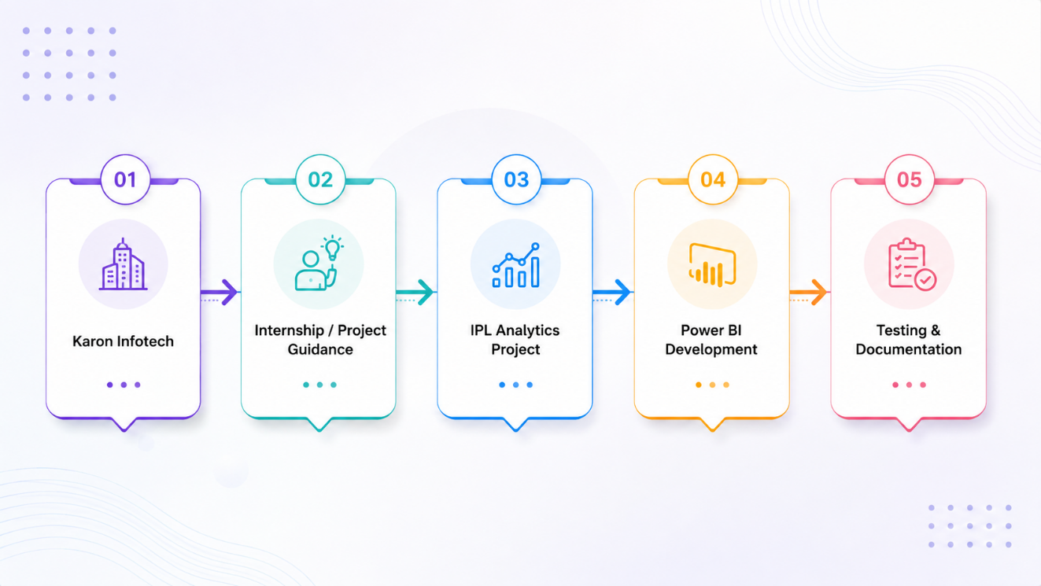
Figure 1.1: Microsoft Skill-Based Training Ecosystem

1.4 CAPACITY AND CAPABILITIES

Table 1.2 Technologies Covered
Capability | Description
Web Technology | Web design, development and online solutions
Mobile Technology | Mobile application design and development
Digital Marketing | SEO and digital/social media marketing
Creative Design | Graphic and creative design solutions
IT Consulting | Technology and business consultation
Data Analytics Project | Interactive Power BI dashboard development during internship

2 COMPANY OVERVIEW

2.1 DEPARTMENT WORKING
The internship work was carried out in the technology and project-development context of Karon Infotech. The project activity focused on data analytics and Business Intelligence using Microsoft Power BI. The work involved understanding the analytical requirement, preparing the IPL dataset, developing calculations, designing visuals and validating the final dashboard.
The project was organized around the following activities:
- Understanding the requirement for an IPL analytics dashboard.
- Studying the available Kaggle IPL dataset.
- Preparing and cleaning the dataset.
- Building the Power BI data model.
- Creating DAX measures for cricket performance metrics.
- Designing interactive dashboard pages.
- Testing slicers, calculations and visual interactions.
- Preparing project documentation and final report.

2.2 TECHNICAL SPECIFICATIONS
Category | Technology / Concept
Operating System | Windows
BI Platform | Microsoft Power BI Desktop
Data Source | Kaggle IPL Dataset
Data Preparation | Power Query
Analytical Language | DAX
File Format | CSV / structured tabular data
Dashboard File | PBIX
Visualization | Power BI Charts, Tables, KPI Cards and Map
Development Approach | Data preparation → Modeling → DAX → Visualization → Testing

2.3 SEQUENCE OF OPERATIONS
The internship followed the following sequence:
Step 1 – Requirement Analysis: Identify the need for a consolidated IPL analytics dashboard.
Step 2 – Data Collection: Obtain historical IPL data from Kaggle.
Step 3 – Data Validation: Inspect records, data types, missing values and inconsistencies.
Step 4 – Data Preparation: Clean and transform the dataset using Power Query.
Step 5 – Data Modeling: Establish relationships and analytical fields in Power BI.
Step 6 – DAX Analytics: Create measures for runs, wickets, averages, strike rate, wins and other KPIs.
Step 7 – Dashboard Development: Build overview, team, match, venue and player pages.
Step 8 – Testing and Documentation: Validate calculations, filters and visual behavior and prepare the report.

2.4 TRAINING STAGES
Stage | Activity
1 | Requirement understanding and dashboard planning
2 | Kaggle IPL dataset study and data inspection
3 | Data cleaning and transformation using Power Query
4 | Data modeling and calculated columns / fields
5 | DAX measure development
6 | Dashboard design and visualization
7 | Testing, validation and correction
8 | Final documentation and presentation

3 INTRODUCTION TO INTERNSHIP
3.1 PROJECT / INTERNSHIP SUMMARY
The internship at Karon Infotech provided practical exposure to technology-oriented project work. As part of the project, an IPL Analytics and Performance Intelligence Dashboard was developed using Microsoft Power BI and historical IPL data obtained from Kaggle.
The project focuses on transforming raw sports data into an interactive Business Intelligence solution. The dashboard allows users to explore overall IPL statistics, team performance, match outcomes, venue patterns and player performance through interactive filters and visualizations.
The developed solution contains five major dashboard pages: IPL Dashboard, Team Analysis, Match Insights, Venue Analysis and Player Insights. These pages collectively provide a multi-dimensional view of the IPL.

3.2 PURPOSE
The main purpose of the internship project was to provide practical exposure to data analytics and Business Intelligence while applying academic knowledge to a real-world style dataset.
The purpose of the IPL dashboard is to:
- Convert raw IPL records into understandable analytical information.
- Reduce manual effort required to analyze match and player statistics.
- Provide interactive filtering by season, team, venue and toss decision.
- Compare teams, players and venues using consistent KPIs.
- Support data-driven interpretation of IPL trends and performance.

3.3 OBJECTIVE
The main objectives of the internship and project were:
1. To understand the fundamentals of Business Intelligence and data analytics.
2. To study historical IPL match and delivery data.
3. To clean and transform IPL data using Power Query.
4. To design an appropriate Power BI data model.
5. To develop DAX measures for cricket performance analysis.
6. To analyze IPL matches across multiple seasons.
7. To compare team wins, losses and seasonal performance.
8. To analyze batting-first and chasing outcomes.
9. To analyze venue-wise match and scoring patterns.
10. To analyze player runs, wickets, batting average, strike rate, fours and sixes.
11. To develop an interactive Power BI dashboard.
12. To validate dashboard calculations and filter interactions.
13. To generate meaningful insights through data visualization.
14. To develop professional technical documentation.

3.4 SCOPE
The scope of the IPL Analytics and Performance Intelligence Dashboard includes:
- Historical IPL match analysis from the available dataset.
- Season-wise match and performance analysis.
- Team-wise wins and losses.
- Match-result and toss-decision analysis.
- Batting-first versus chasing analysis.
- Venue and city-wise analysis.
- Player batting and bowling performance.
- Runs, wickets, batting average and strike-rate analysis.
- Interactive Power BI filters and dashboard navigation.
- Data validation and dashboard testing.

3.5 TECHNOLOGY AND LITERATURE REVIEW
Sports analytics uses historical match and player data to identify performance patterns, compare teams and players, understand venue characteristics and support evidence-based interpretation. Modern Business Intelligence platforms make it possible to combine data preparation, analytical calculations and visual reporting within a single environment.
Microsoft Power BI is used in this project as the Business Intelligence platform. Power Query provides data transformation capabilities, while DAX supports analytical measures. Interactive visualizations allow users to filter and explore the same dataset from different perspectives.
The project follows a structured analytical workflow:
IPL Data Collection → Data Validation → Data Preprocessing → Data Modeling → DAX Analysis → Dashboard Visualization → Testing
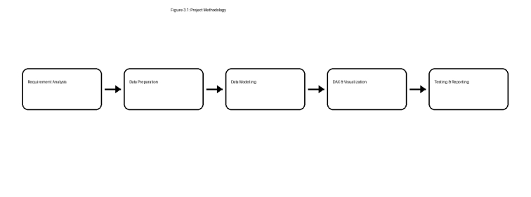
Figure 3.1: Project Methodology

3.6 PROJECT / INTERNSHIP PLANNING

3.6.1 APPROACH WITH JUSTIFICATION
The project was planned using a phased development approach. A phased approach was selected because the dashboard depends on the accuracy of the underlying data and calculations. Data preparation was therefore completed before final visualization.
Phase 1 – Requirement Analysis: Define dashboard objectives and required KPIs.
Phase 2 – Data Study: Understand match-level and delivery-level IPL fields.
Phase 3 – Data Processing: Clean, standardize and transform the dataset.
Phase 4 – Data Modeling: Build the Power BI model and analytical relationships.
Phase 5 – DAX Development: Create measures for match, team, venue and player analysis.
Phase 6 – Dashboard Development: Create the five interactive dashboard pages.
Phase 7 – Testing & Validation: Verify filters, calculations and visuals.
Phase 8 – Documentation: Prepare results, findings and internship report.

3.6.2 COST ESTIMATION
The project was developed using the available educational and desktop tools. No dedicated production server or paid cloud infrastructure was required for the dashboard development described in this report.
Resource | Purpose
Microsoft Power BI Desktop | Dashboard development and visualization
Power Query | Data cleaning and transformation
DAX | Analytical calculations
Kaggle | IPL dataset source
Windows PC / Laptop | Development environment
Internet | Dataset access and documentation research

3.7 PROJECT / INTERNSHIP SCHEDULING
The project schedule was organized around requirement analysis, data preparation, Power BI development, testing and documentation. The exact internship dates and institutional schedule should be filled in according to the official internship communication.
Stage | Activity | Output
1 | Requirement Analysis | Project objectives and KPIs
2 | Dataset Study | Understanding of IPL fields
3 | Data Cleaning | Prepared dataset
4 | Data Modeling | Power BI analytical model
5 | DAX Development | Calculated measures
6 | Dashboard Development | Five dashboard pages
7 | Testing | Validated calculations and interactions
8 | Documentation | Final internship report

4 SYSTEM ANALYSIS

4.1 STUDY OF CURRENT SYSTEM
Historical IPL datasets contain a large amount of match-level and delivery-level information. Such records can include season, teams, venues, toss information, match results, batters, bowlers and runs. When these records are analyzed directly in raw CSV files or spreadsheets, users need to repeatedly filter, aggregate and calculate statistics.
For example, identifying the highest run scorers, comparing team wins across seasons, calculating venue averages or comparing chasing success requires multiple operations. A centralized Business

4.2 PROBLEM AND WEAKNESSES OF CURRENT SYSTEM

1. Manual Processing – Raw records require repeated filtering, sorting and aggregation.

2. Distributed Information – Match, delivery, team, venue and player information can be difficult to interpret together.

3. Calculation Complexity – Metrics such as batting average and strike rate require appropriate formulas and context.

4. Limited Visual Analysis – Raw datasets do not immediately communicate trends and comparisons.

5. Time Consumption – Repeated analysis of seasons, teams and players increases manual effort.

6. Difficulty in Comparing Dimensions – Cross-analysis of team, venue, season and player dimensions is harder without an analytical model.

7. Limited Interactivity – Static tables do not provide dynamic exploration through slicers and linked visuals.

4.3 REQUIREMENTS OF NEW SYSTEM

The proposed IPL Analytics and Performance Intelligence Dashboard is designed to automate the calculation and visualization of historical IPL statistics. The system should satisfy the following requirements:
Requirement | Description
IPL Data Import | The system should support importing the available IPL match and delivery datasets.
Data Validation | The system should identify missing, inconsistent, duplicate or invalid records before analysis.
Data Transformation | The system should clean and standardize fields required for analysis.
Match Analysis | The system should analyze seasons, match results, batting-first and chasing outcomes.
Team Analysis | The system should calculate team wins, losses and seasonal performance.
Venue Analysis | The system should compare venues by hosted matches, chasing wins and scoring patterns.
Player Analysis | The system should calculate player runs, wickets, batting average, strike rate, fours and sixes.
Interactive Dashboard | The system should provide filters for season, team, venue and toss decision.
KPI Reporting | The system should present important analytical metrics through KPI cards.

4.4 SYSTEM FEASIBILITY

The feasibility study evaluates whether the proposed IPL analytics system can be successfully implemented using the available data and technologies. The system is analyzed from technical, operational and data perspectives.

4.4.1 TECHNICAL FEASIBILITY
The proposed system is technically feasible because Power BI provides integrated capabilities for data import, Power Query transformation, data modeling, DAX calculations and interactive visualization. The historical IPL dataset is suitable for descriptive and comparative analysis.

4.4.2 CONSTRAINTS
- The analysis is based on the available historical Kaggle dataset.
- The dashboard is not a live IPL match monitoring system.
- Results depend on the quality and definitions of the source dataset.
- Historical team and venue naming may require standardization.
- Player metrics require careful context-aware calculations.
- Predictive modeling is outside the current project scope.

4.4.3 INTEGRATION
The solution integrates the IPL dataset with Power Query, the Power BI data model, DAX measures and interactive visualizations. The same analytical model supports multiple dashboard pages, allowing filters to affect relevant visuals across the report.

4.5 PROCESS FLOW
The IPL Analytics system follows a structured workflow that converts raw historical IPL records into meaningful analytical insights.
1. Data Collection – Obtain IPL match and delivery data from Kaggle.
2. Data Validation – Verify completeness, types, consistency and duplicates.
3. Data Preprocessing – Clean and transform the data using Power Query.
4. Data Modeling – Build relationships and analytical fields in Power BI.
5. DAX Analytics – Calculate runs, wickets, averages, strike rates, wins and other KPIs.
6. Dashboard & Reports – Present analytical results through interactive Power BI pages.

4.6 FEATURES
1. Automated Data Preparation – Power Query transformations prepare the dataset for analysis.
2. Interactive Match Analysis – Users can explore seasons, results and batting/chasing patterns.
3. Team-wise Analysis – Teams can be compared using wins, losses and seasonal performance.
4. Venue Analysis – Venues can be compared by matches, scoring and chasing success.
5. Player Analysis – Batting and bowling performance can be explored at player level.
6. Interactive Dashboard – KPI cards, charts, maps, tables and slicers provide a unified analytical interface.
7. Reusable DAX Measures – Calculations can be reused across multiple visuals and dashboard pages.

4.7 MODULES
Module | Function
IPL Data Import Module | Imports the historical IPL datasets into the Power BI environment.
Data Validation & Preprocessing Module | Checks and cleans data before analytical use.
Match Analysis Module | Generates season, result, toss and batting/chasing insights.
Team Analysis Module | Generates team-wise wins, losses and seasonal performance.
Venue Analysis Module | Analyzes venues, cities, hosted matches and scoring patterns.
Player Analysis Module | Analyzes runs, wickets, batting average, strike rate, fours and sixes.
Visualization Module | Presents KPIs, charts, tables, maps and interactive report pages.

4.8 METHODOLOGY
The IPL Analytics project follows a structured data analytics methodology that transforms raw IPL records into interactive Business Intelligence dashboards.
1. IPL Data Collection – Historical match and delivery data is obtained from Kaggle.
2. Data Validation & Preprocessing – Records are checked and cleaned to improve consistency.
3. Data Modeling – Tables and fields are prepared for analytical relationships.
4. Cricket Analytics – Match, team, venue and player measures are calculated.
5. Dashboard Visualization – Analytical results are presented through interactive Power BI pages.
6. Testing – Calculations, filters, tables and visual interactions are validated.

5 SYSTEM DESIGN

5.1 SYSTEM DESIGN & METHODOLOGY
The IPL Analytics and Performance Intelligence Dashboard is designed as a Business Intelligence solution that converts historical IPL data into interactive analytical reports. The system combines data preparation, data modeling, DAX calculations and visualization within Microsoft Power BI.
The overall architecture consists of five major layers:
- Data Layer – Historical IPL data obtained from Kaggle.
- Processing Layer – Power Query performs validation, cleaning and transformation.
- Modeling Layer – Power BI relationships and analytical fields organize the data.
- Analytics Layer – DAX measures calculate cricket performance metrics.
- Visualization Layer – Interactive dashboard pages present KPIs, charts, maps and tables.
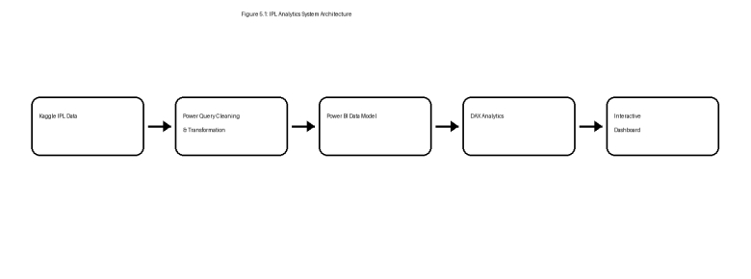
Figure 5.1: IPL Analytics System Architecture

5.2 DESIGN DETAILS
The system is divided into logical components that work together to process IPL information and visualize the results.
1. Input Layer
The input layer accepts historical IPL match and delivery data containing season, teams, venue, toss, result, batter, bowler and run information.
2. Processing Layer
Power Query is used to clean, standardize and transform the imported data. This includes data-type corrections, field preparation and handling of inconsistent records.
3. Analytics Layer
- Match and season analysis
- Team wins and losses
- Batting-first versus chasing comparison
- Venue scoring analysis
- Player runs and wickets
- Batting average and strike rate
- Fours and sixes analysis
- 4. Dashboard Layer
- The processed data is displayed through five interactive pages: IPL Dashboard, Team Analysis, Match Insights, Venue Analysis and Player Insights.

Table 5.1 System Design Components
Component | Purpose
IPL Data | Historical match and delivery information
Power Query | Validation, cleaning and transformation
Power BI Model | Structured analytical relationships and fields
DAX Measures | Cricket KPIs and analytical calculations
Dashboard | Visualization and interactive reporting

5.3 DATASET DESIGN

The IPL Analytics project uses historical IPL data obtained from Kaggle. The dataset includes match-level information and delivery-level information used for detailed player and team analysis.

Table 5.2 Trade Dataset Attributes
Expiry | Contract expiry information
Algorithm | Trading algorithm identifier
The processed dataset is used to generate client-wise summaries, symbol-wise analysis, trading volume reports, BUY vs SELL comparison, and participant activity dashboards.
Attribute | Description
Match ID | Unique identifier for a match
Season | IPL season / year
Date | Match date
Venue | Stadium or match venue
City | City in which the match was played
Team 1 | First participating team
Team 2 | Second participating team
Toss Winner | Team winning the toss
Toss Decision | Bat or field decision after toss
Winner | Match-winning team
Result | Match result category
Batting Team | Team batting in a delivery
Bowling Team | Team bowling in a delivery
Batter | Player facing the delivery
Bowler | Player delivering the ball
Batter Runs | Runs scored by the batter
Extra Runs | Runs awarded as extras
Total Runs | Total runs from the delivery
Wicket Information | Dismissal information where available
The dataset is transformed into an analytical structure so that match-level and player-level measures can be calculated correctly.

5.4 FUNCTIONAL WORKFLOW
The functional workflow describes how IPL records are transformed into analytical dashboards.
1. Data Collection – Import IPL datasets.
2. Data Validation – Verify fields, types and records.
3. Data Preprocessing – Clean and transform data using Power Query.
4. Data Analysis – Generate match, team, venue and player analytics.
5. DAX Calculation – Calculate reusable performance measures.
6. Dashboard Generation – Display KPIs, charts, maps and tables.
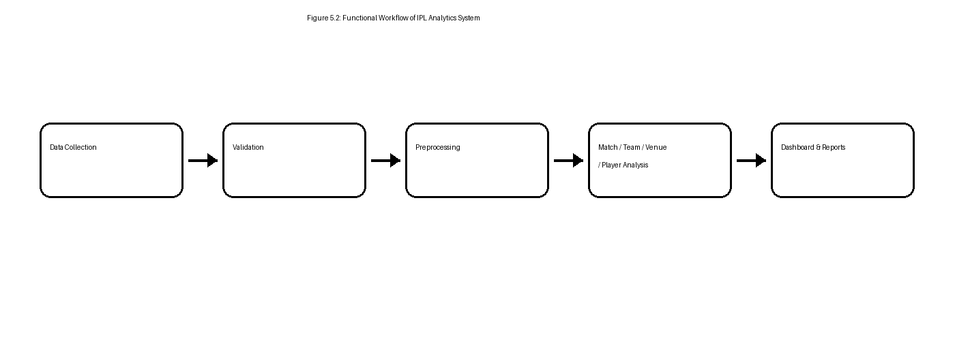
Figure 5.2: Functional Workflow of IPL Analytics System

6 IMPLEMENTATION

6.1 Environment
The IPL Analytics and Performance Intelligence Dashboard was implemented using Microsoft Power BI Desktop on a Windows-based development environment. Power Query was used for data preparation and DAX was used for analytical measures.

Table 6.1 Software & Development Environment
Component | Technology Used
Operating System | Windows
BI Platform | Microsoft Power BI Desktop
Data Source | Kaggle IPL Dataset
Data Transformation | Power Query
Analytics Language | DAX
Dashboard File | PBIX
Visualization | Power BI Visuals
Development Tool | Power BI Desktop

6.2 TECHNOLOGY SPECIFICATIONS
Power Query was used to prepare the imported IPL data. The Power BI data model was then used to support filtering and analytical context. DAX measures were developed for cricket-specific KPIs and reusable calculations.
Examples of analytical measures include total matches, total runs, wickets, average first-innings score, team wins, team losses, chasing wins, batting average and strike rate.
For player-level metrics, particular attention was required because delivery-level records contain multiple rows per player. Measures must therefore use appropriate context and definitions instead of simply averaging row-level values.

6.3 Results
6.3.1 IPL Analytics Dashboard
The main IPL Dashboard provides an overall view of the historical IPL dataset. The dashboard displays KPI cards for total matches, seasons, teams, average first-innings score, highest team score, lowest team score and toss win conversion.

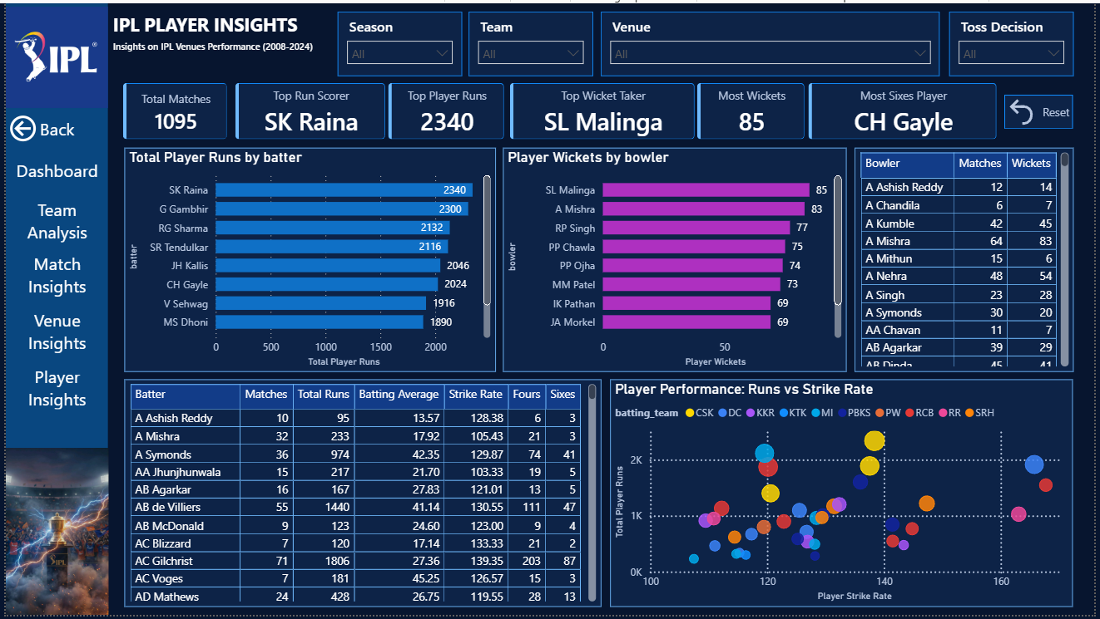

Figure 6.1: IPL Analytics Dashboard

The dashboard also includes total matches by season, batting-first versus chasing advantage, total matches by venue, monthly match distribution, top match-winning teams and a detailed match table.

6.3.2 Team Analysis Dashboard
The Team Analysis dashboard provides detailed performance insights for IPL teams. It includes total matches, number of teams, highest score, team win percentage and team loss percentage.
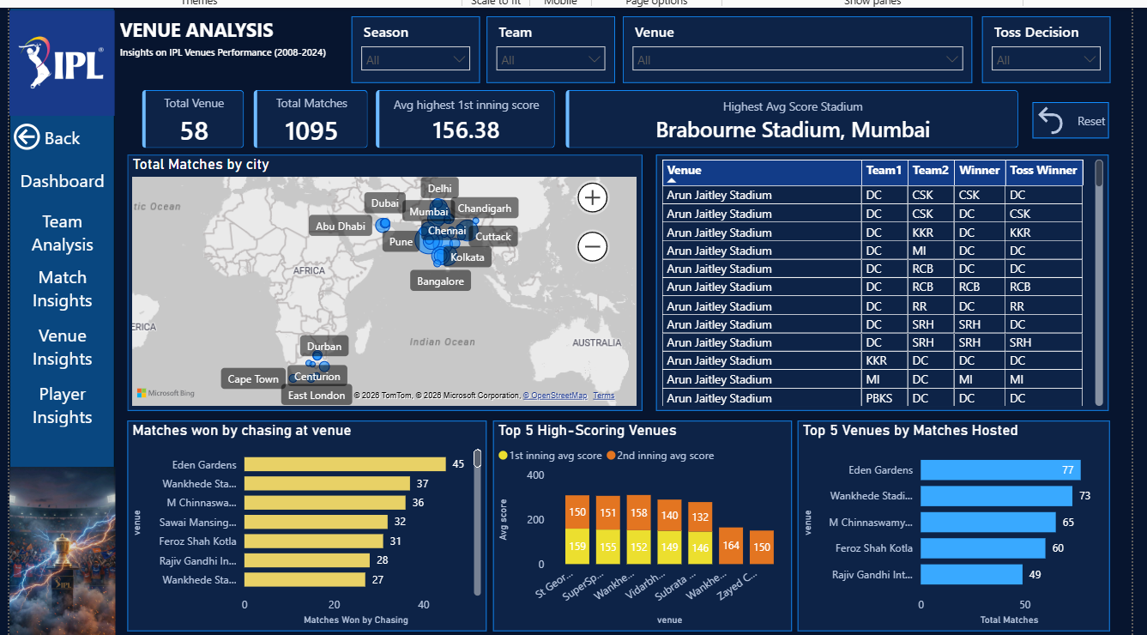

Figure 6.2: Team Analysis Dashboard
The page compares matches won and lost by team, shows team score distribution, provides a seasonal win-performance chart and presents a detailed team table containing matches played, wins, losses and toss-related percentages

6.3.3 IPL Match Insights Dashboard
The Match Insights dashboard focuses on match-level patterns. It presents total matches, average first-innings score, highest first-innings score, lowest defended score, highest chase score and matches won by chasing.
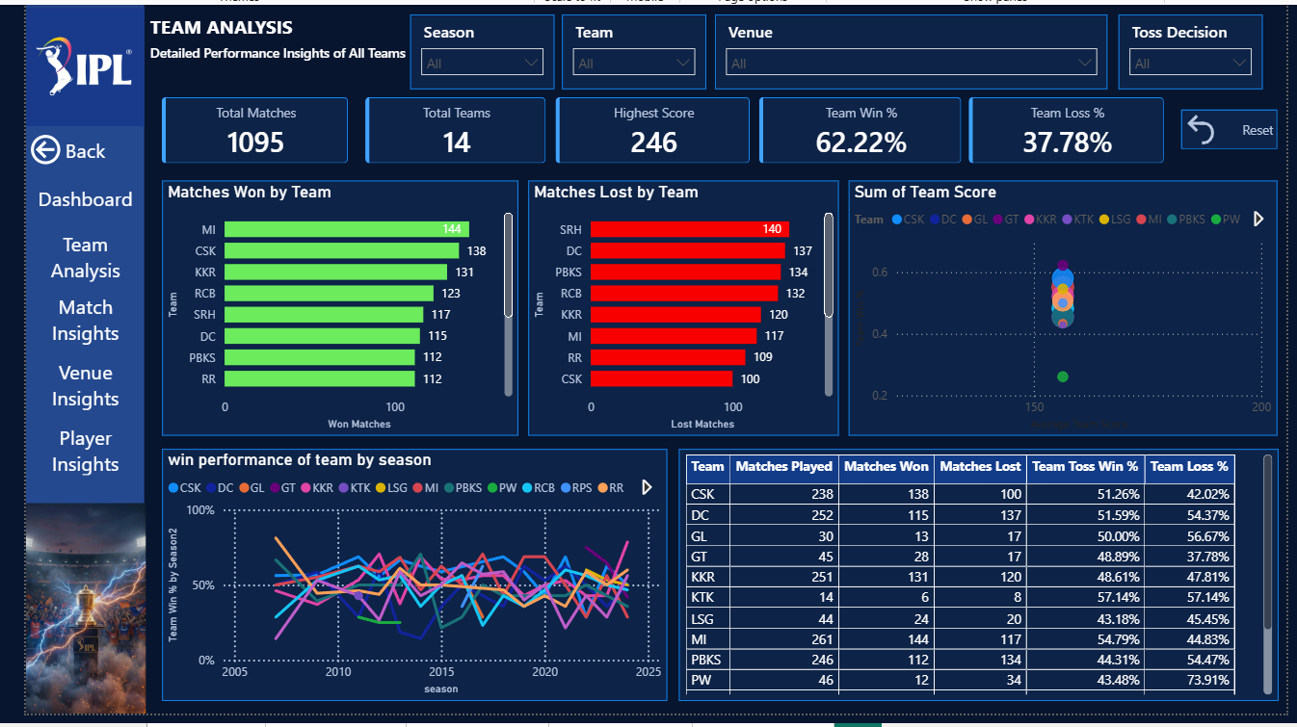

Figure 6.3: IPL Match Insights Dashboard
The dashboard compares batting-first and chasing outcomes, ranks venues by average first-innings score, categorizes match results and presents chasing wins for selected teams across seasons.

6.3.4 Azure Virtual Network Configuration
The Venue Analysis dashboard provides location and venue-based insights. It includes the number of venues, total matches, average first-innings score and the venue with the highest displayed average score.
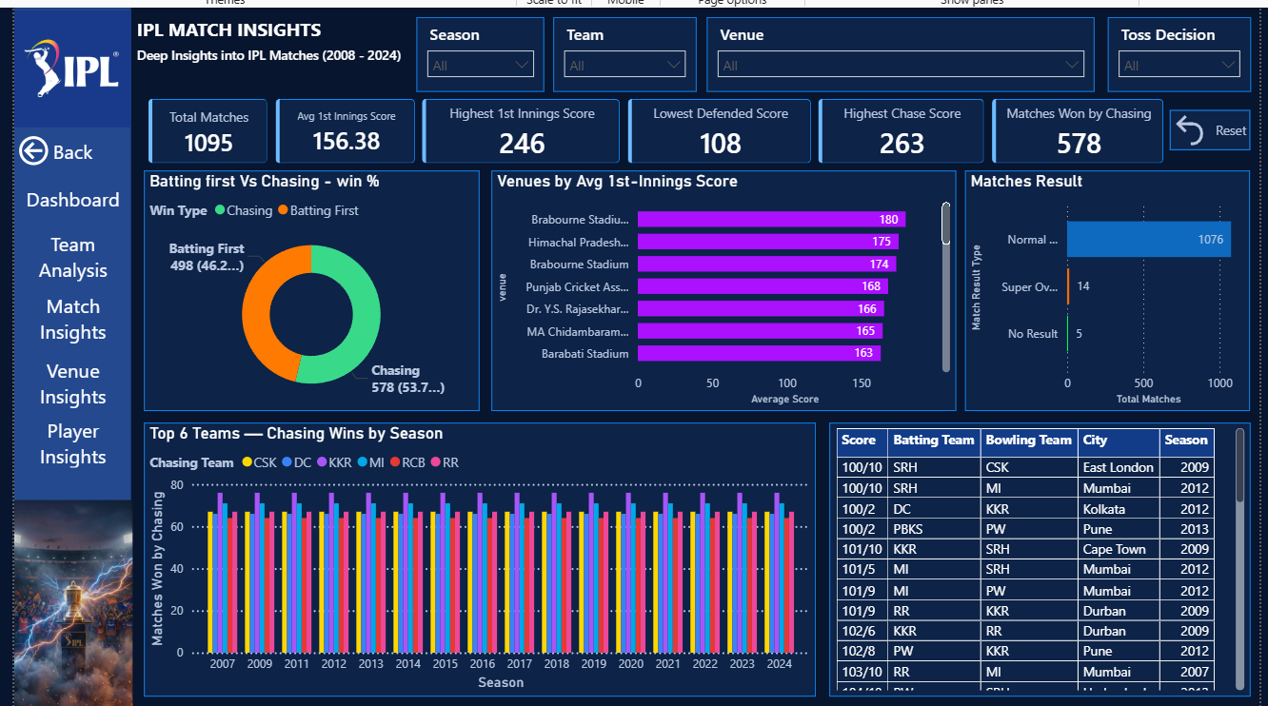

Figure 6.4: Venue Analysis Dashboard
A map visual displays match locations, while additional visuals compare chasing wins at venues, high-scoring venues and the top venues by matches hosted.
6.3.5 IPL Player Insights Dashboard
The Player Insights dashboard focuses on individual player performance. It provides KPIs for total matches, top run scorer, top player runs, top wicket taker, most wickets and the player with the most sixes.
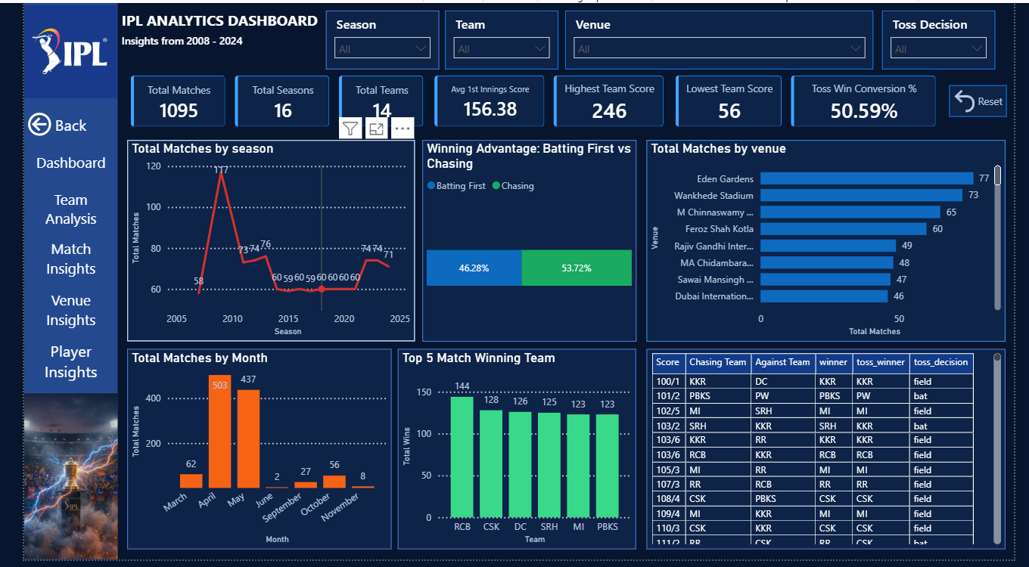

Figure 6.5: IPL Player Insights Dashboard

The dashboard includes player run rankings, wicket rankings, a detailed batting table containing matches, total runs, batting average, strike rate, fours and sixes, and a scatter plot comparing total runs against strike rate.

6.4 Result Analysis

The developed Power BI dashboard successfully converts historical IPL data into an interactive analytical solution. The five dashboard pages provide complementary perspectives across matches, teams, venues and players.

Table 6.2 Dashboard Performance Summary
Metric | Observed Value in Dashboard
Total Matches | 1,095
Total Seasons | 16
Total Teams | 14
Total Venues | 58
Average 1st Innings Score | 156.38
Highest Team Score | 246
Matches Won by Chasing | 578
Chasing Win Share shown | 53.72%
Batting First Win Share shown | 46.28%
Top Run Scorer shown | SK Raina
Top Player Runs shown | 2,340
Top Wicket Taker shown | SL Malinga
Most Wickets shown | 85
The results show that the dashboard provides a consolidated analytical view of the IPL. The interface allows users to move from overall KPIs to detailed team, match, venue and player analysis.

7 TESTING

7.1 Testing Plan
The IPL Analytics dashboard was tested to verify the accuracy of data processing, DAX calculations, dashboard interactivity, filtering operations and visualization outputs. Testing focused on ensuring that the report responds correctly to user selections and that KPI values are consistent with the underlying data.
Testing objectives:
- Verify correct loading of IPL datasets.
- Validate season, team, venue and toss-decision filters.
- Check match, team, venue and player calculations.
- Verify batting-first versus chasing calculations.
- Verify player run and wicket calculations.
- Check batting average and strike-rate calculations.
- Verify dashboard visualizations and tables.
- Ensure reset/filter interactions work correctly.

7.2 Test Results

The dashboard testing confirmed that the major analytical modules and visual interactions operate as intended. Testing was performed using the historical IPL dataset and by comparing selected dashboard values with the underlying data and expected analytical definitions.

7.2.1 Test Cases
Table 7.1 Test Cases
Test ID | Test Scenario | Expected Result | Status
TC-01 | Load IPL dataset | IPL records load correctly | Pass
TC-02 | Season filter | Dashboard updates for selected season | Pass
TC-03 | Team filter | Team visuals update correctly | Pass
TC-04 | Venue filter | Venue analysis updates correctly | Pass
TC-05 | Toss decision filter | Relevant visuals update | Pass
TC-06 | Match KPI calculation | Total match KPI matches data | Pass
TC-07 | Team win calculation | Team win counts display correctly | Pass
TC-08 | Chasing analysis | Chasing/batting-first comparison updates correctly | Pass
TC-09 | Player runs | Player run totals match underlying records | Pass
TC-10 | Player wickets | Player wicket totals display correctly | Pass
TC-11 | Batting average | Average follows defined dismissal logic | Pass
TC-12 | Strike rate | Strike rate is calculated correctly | Pass
TC-13 | Cross-filtering | Relevant visuals respond to selections | Pass
TC-14 | Reset filters | Dashboard returns to default state | Pass

8 CONCLUSION AND FUTURE SCOPE

8.1 Conclusion
The internship at Karon Infotech provided practical exposure to Business Intelligence, data analytics and interactive dashboard development. During the internship, an IPL Analytics and Performance Intelligence Dashboard was designed and developed using Microsoft Power BI and historical IPL data obtained from Kaggle.
The dashboard successfully organizes IPL information into five analytical pages covering overall IPL statistics, team performance, match insights, venue analysis and player performance. The solution provides interactive KPIs, charts, tables, maps and filters that allow users to explore historical IPL patterns efficiently.
The project strengthened practical skills in data cleaning, Power Query, data modeling, DAX, dashboard design, data visualization and analytical reasoning. It also demonstrated the importance of validating context-dependent measures such as batting average and player-level statistics when working with delivery-level data.
Overall, the project demonstrates how Business Intelligence tools can convert a large historical sports dataset into a structured and user-friendly analytical solution, bridging academic knowledge with practical project development.

8.2 Future Scope
The current dashboard can be further enhanced by incorporating advanced analytical and technology features.
1. Real-Time IPL Data – Integrate a reliable live data source or API for current match information.
2. Predictive Match Analytics – Apply machine learning models to predict match outcomes and first-innings scores.
3. Player Performance Prediction – Predict player runs, wickets and consistency based on historical performance.
4. Advanced Venue Analytics – Include pitch behavior, powerplay scoring, death-over performance and pace/spin analysis.
5. Fantasy Cricket Analytics – Add fantasy points and player recommendation capabilities.
6. AI-Powered Cricket Assistant – Allow natural-language questions about teams, players, venues and matches.
7. Power BI Service Deployment – Publish the report online with scheduled refresh where an appropriate data source is available.
8. Advanced DAX Analytics – Add rolling averages, season-over-season comparisons and player consistency indicators.

REFERENCES
1. Karon Infotech, “About Karon Infotech,” Official Company Website, https://karoninfotech.com/about/.
2. Karon Infotech, Official Website and Services Information, https://karoninfotech.com/.
3. Kaggle, IPL historical dataset used for the project.
4. Microsoft, Power BI Documentation, Business Intelligence and Data Visualization documentation.
5. Microsoft, Power Query documentation and data transformation guidance.
6. Microsoft, DAX documentation and Data Analysis Expressions reference.
7. Indian Premier League historical match and player statistics represented in the Kaggle dataset.

