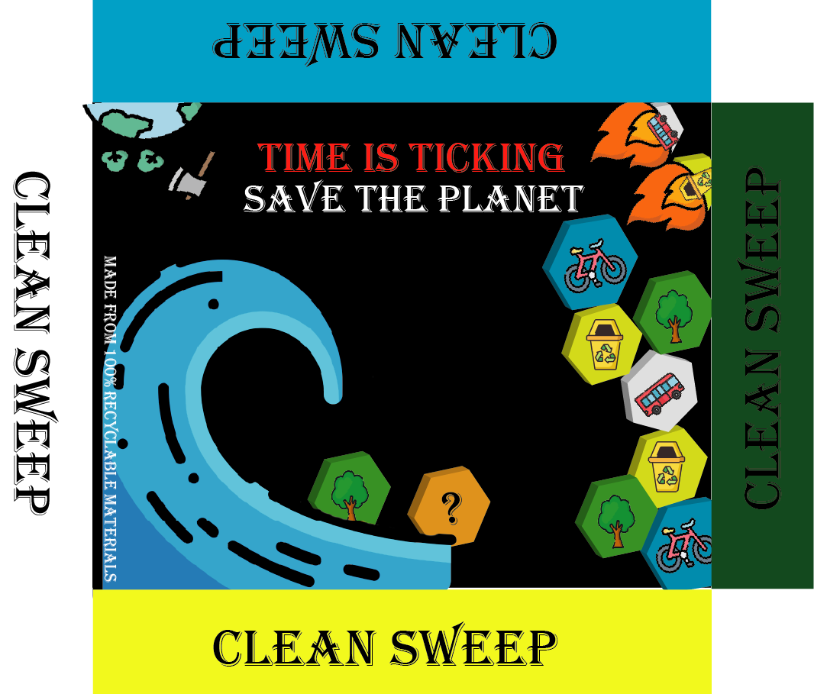
CLEAN SWEEEP
RULEBOOK
FIRST EDITION
2-4 Players

OVERVIEW
Welcome to the immersive world of "Clean Sweep," a captivating board game that challenges your strategic prowess and tactical acumen. In this 2-4 player contest of wits, the game board unfolds as a mesmerizing landscape of 66 hexagonal tiles, each holding the promise of victory.
Armed with a unique set of coloured hexagon tiles, your goal is as clear as it is ambitious: emerge triumphant by meticulously placing the most tiles on the expansive game board.
As the landscape takes shape before your eyes, you'll be tasked with seizing opportunities, formulating calculated moves, and outmanoeuvring your rivals. The dance of hexagons is a symphony of strategy—each placement a testament to your cunning and foresight.
Will you opt for swift expansion, claiming territory in a blitz of activity? Or is a more measured approach your strategy, positioning each tile with the precision of a grandmaster? The beauty of "Clean Sweep" lies in its flexibility, allowing you to adapt your approach based on the ever-changing dynamics of the game.
As the final hexagon finds its place and the dust settles, victory belongs to the player who has most skilfully woven their tapestry of tiles across the canvas of possibility. "Clean Sweep" is a masterpiece of strategy, a testament to your cunning and vision. Enter the fray, stake your claim, and let the tiles fall where they may—your triumph awaits in this exhilarating battle of wits.

LIST OF CONTENTS:
- Game board
- Events Cards
- Action Cards
- ? tiles
- Green Tiles
- Yellow Tiles
- Blue Tiles
- White Tiles
- Recycling Bin – Yellow Player
- Bus – White Player
- Bicycle – Blue Player
- Tree – Green Player
- Dice

THE SETUP
The board is set up by placing 10 “?” tiles and 4 Event tiles at random on the board. Make sure the “?” and “EVENT” are facing upwards.
Each Player chooses their colour tile (Green, yellow, white, or blue) and their game model (tree, recycling bin, bus, or bicycle) respectively. Each player receives two (or four if only 2 players are playing) Actions cards at random.

START OF THE PLAY
Each player rolls the 6-sided dice and highest roll goes first. Player places their first colour tiles whenever they wish to on the game board. And they place their player model on top of their tile.
GAMEPLAY
Player use 6-sided dice to move around the board in any directions. Whenever they land, they can place their colour tile on that space.
Players are not allowed to land on another player’s tile. Player can move thru other players tiles but the number of tiles you move thru, you must remove that many of your tiles. For example: If your path is blocked by one of the other colour tiles, you can go over the blocked tile, but you must remove one of your tiles anywhere from the board.
If landed on an empty space, they can simply claim that space as theirs.
Player can only land on “?” tiles if they have 3 or more of their colour tiles on the board, player do what the tile says and the “?” tile is removed from the board.
If the player land on “EVENT” tile, they must pay by removing one of their tiles from the board to play what the event is. Now the player must roll whatever it says on the event tile to win the event.
- If player successfully rolls what it says on the event tiles, event tile is removed from the board, and it replaces the winning players colour tiles.
- If unsuccessful, player goes back to their last position on the board, and the next closest player to the event can chose to play the event by removing one of their colour tiles from the board.
- If no other player wishes to play the event or no other player wins the event, event tile stays on the board and can be played again in future turns.
If the player successfully creates a loop by using their colour tiles with no “Event” or “?” or “other players” tiles inside the loop, player can claim that area by filling the inside of the loop with their colour tiles.
Players are allowed to move anywhere within their coloured connected territory without having to roll for it.
Action cards can be used anytime during the gameplay.

HOW TO WIN
Player with most tiles on the board when no empty and “?” and “event” tiles are left will win the game.

