ISC Assignment-02

Jeetu Mehra
U24AI032

Question 1 : Implement a Caesar Cipher to encrypt and decrypt messages by shifting characters.
Examples:
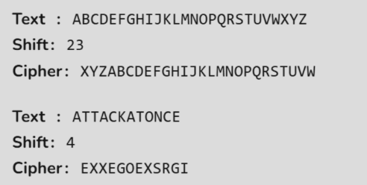

Code:
#include <iostream>
#include <string>
using namespace std;

int main() {

// Original alphabet
string alphabet = "ABCDEFGHIJKLMNOPQRSTUVWXYZ";

int shift;

// Take shift as input
cout << "Enter shift: ";
cin >> shift;

// Keep shift within 0-25
shift = shift % 26;

// Create shifted alphabet
string shiftedAlphabet = "";

for (int i = 0; i < 26; i++) {
shiftedAlphabet += alphabet[(i + shift) % 26];
}

// Display alphabets
cout << "\nOriginal Alphabet : " << alphabet << endl;
cout << "Shifted Alphabet : " << shiftedAlphabet << endl;

// Take string to encrypt
string input;
cout << "\nEnter string to encrypt: ";
cin >> input;

// Encrypt the input
string encrypted = "";

for (char ch : input) {

// Find character in original alphabet
for (int i = 0; i < 26; i++) {

if (ch == alphabet[i]) {
// Replace with corresponding shifted character
encrypted += shiftedAlphabet[i];
break;
}
}
}
// Display encrypted string
cout << "Encrypted String : " << encrypted << endl;
return 0;
}
Output:-
