WPP Assignment-09

By-Jeetu Mehra
U24AI032

- Design a Webpage for online food delivery system using HTML and CSS.
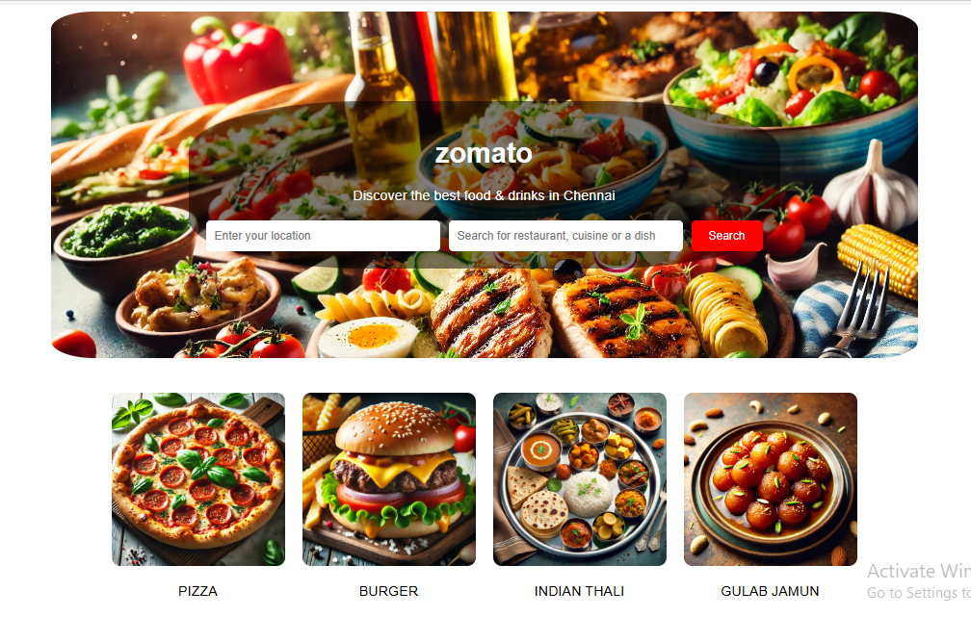

<!DOCTYPE html>
<html lang="en">
<head>
<meta charset="UTF-8">
<meta name="viewport" content="width=device-width, initial-scale=1.0">
<title>Zomato Clone</title>
<link rel="stylesheet" href="style1.css">
<style>
body {
margin: 100;
font-family: Arial, sans-serif;
text-align: center;
}
.hero {
background: url('food1.jpg') no-repeat center center/cover;
height: 400px;
width: 1000px;
color: white;
display: flex;
align-items: center;
justify-content: center;
text-align: center;
position: relative;
border-radius: 5%;
}
.overlay {
background: rgba(0, 0, 0, 0.5);
padding: 20px;
border-radius: 10px;
border-radius: 30%;
}
.search-bar {
margin-top: 20px;
display: flex;
justify-content: center;
gap: 10px;
}
.search-bar input {
padding: 10px;
width: 250px;
border-radius: 5px;
border: none;
}
.search-bar button {
padding: 10px 20px;
background: red;
color: white;
border: none;
cursor: pointer;
border-radius: 5px;
}
.categories {
display: flex;
justify-content: center;
gap: 20px;
padding: 40px;
}
.category {
text-align: center;
max-width: 200px;
}
.category img {
width: 100%;
height: auto;
border-radius: 10px;
}
</style>
</head>
<body>
<center>
<header class="hero">
<div class="overlay">
<h1 class="logo">zomato</h1>
<p class="tagline">Discover the best food & drinks in Chennai</p>
<div class="search-bar">
<input type="text" placeholder="Enter your location">
<input type="text" placeholder="Search for restaurant, cuisine or a dish">
<button>Search</button>
</div>
</div>
</header>
</center>
<section class="categories">
<div class="category">
<img src="pizza.jpg" alt="Order Food Online">
<p>PIZZA</p>
</div>
<div class="category">
<img src="burger.jpg" alt="Go out for a meal">
<p>BURGER</p>
</div>
<div class="category">
<img src="thali.jpg" alt="Night Life & Clubs">
<p>INDIAN THALI</p>
</div>
<div class="category">
<img src="gulab_jamun.webp" alt="Zomato Pro">
<p>GULAB JAMUN</p>
</div>
</section>
</body>
</html>

- Design a design college website using HTML and CSS.

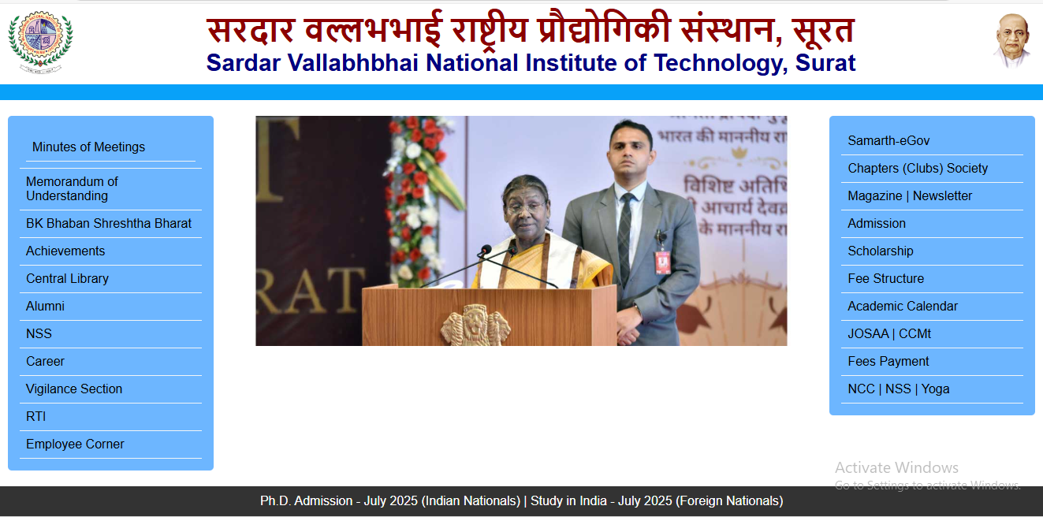

<!DOCTYPE html>
<html lang="en">
<head>
<meta charset="UTF-8">
<meta name="viewport" content="width=device-width, initial-scale=1.0">
<title>SVNIT Surat</title>
<link rel="stylesheet" href="styles.css">
</head>
<body>
<!-- Header Section -->
<header style="display: flex; align-items: center; justify-content: space-between; padding: 10px 20px;">
<!-- Logo -->
<img src="https://www.svnit.ac.in/images/logo.png" alt="SVNIT Logo" style="height: 80px;">

<!-- Title (Heading) -->
<div style="text-align: center; flex-grow: 1;">
<h1 style="color: darkred; font-size: 40px; margin: 0;">सरदार वल्लभभाई राष्ट्रीय प्रौद्योगिकी संस्थान, सूरत</h1>
<h2 style="color: navy; font-size: 30px; margin: 0;">Sardar Vallabhbhai National Institute of Technology, Surat</h2>
</div>

<!-- Gandhi Profile -->
<img src="https://www.svnit.ac.in/images/sardar_vallabhbhai_patel.png" alt="Gandhi Profile" style="height: 80px;">
</header>

<!-- Navigation Bar -->
<style>
/* Style the navigation bar */
.navbar {
width: 100%;
background-color: #08a1f9; /* Dark background */
overflow: hidden;
text-align: center;
padding: 10px 0;
display:flex;
flex-wrap: wrap; /* Allow items to wrap */
justify-content: center; /* Center the items */
gap: 5px; /* Small space between links */
}

/* Style the links inside the bar */
.navbar a {
display: inline-block;
color: white;
text-decoration: none;
padding: 12px 20px;
font-size: 18px;
}

/* Change color on hover */
.navbar a:hover {
background-color: #0799b6;
border-radius: 5px;
}
</style>
</head>
<body>

<!-- Full-width navigation bar -->
<div class="navbar">
<a href="ABOUT US.html">ABOUT US</a>
<a href="ADMISSION.html">ADMISSION</a>
<a href="ACADEMIC.html">ACADEMIC</a>
<a href="DEPARTMENT.html">DEPARTMENT</a>
<a href="STUDENT LLFE">STUDENT LIFE</a>
<a href="RESEARCH & CONSULTANCY">RESEARCH AND CONSULTANCY</a>
<a href="CAREER DEVELOPMENT">CAREER DEVELOPMENT</a>
<a href="CENTRAL FACULTY">CENTRAL FACULTY</a>
<a href="CONTACH US">CONTACT US</a>
</div>

<!-- Main Content Section -->

<main>
<!-- Left Sidebar -->
<div>
<style>
/* Ensure full-page layout */
html, body {
height: 100%;
margin: 0;
display: flex;
flex-direction: column; /* Stack main and footer */
}

/* Main content container */
.container {
flex: 1; /* Takes available space */
display: flex;
justify-content: space-between; /* Aligns sections side by side */
align-items: flex-start;
gap: 20px;
padding: 20px;
}

/* Sidebar common styles */
.sidebar-left, .sidebar-right {
width: 20%;
background-color: #6db6ff;
padding: 15px;
border-radius: 5px;
}

/* Center content */
.content {
width: 55%;
text-align: center;
}

/* Style for images */
.content img {
width: 100%;
max-width: 1000px;
height: auto;
border-radius: 5px;
}

/* Style for sidebar lists */
ul {
list-style: none;
padding: 0;
}

ul li, ul a {
display: block;
padding: 8px;
text-decoration: none;
color: black;
border-bottom: 1px solid #f2f5f7;
}

ul a:hover, ul li:hover {
background-color: #f3f6f9;
border-radius: 3px;
}

/* Footer */
footer {
background-color: #333;
color: white;
text-align: center;
padding: 10px;
width: 100%;
}
</style>
</head>
<body>

<!-- Main Content -->
<div class="container">
<!-- Left Sidebar -->
<aside class="sidebar-left">
<ul>
<li><a href="#">Minutes of Meetings</a></li>
<li>Memorandum of Understanding</li>
<li>BK Bhaban Shreshtha Bharat</li>
<li>Achievements</li>
<li>Central Library</li>
<li>Alumni</li>
<li>NSS</li>
<li>Career</li>
<li>Vigilance Section</li>
<li>RTI</li>
<li>Employee Corner</li>
</ul>
</aside>

<!-- Center Image Section -->
<section class="content">
<img src="https://www.svnit.ac.in/images/convocation24-1/3b.jpg" alt="President Speech">
</section>

<!-- Right Sidebar -->
<aside class="sidebar-right">
<ul>
<li>Samarth-eGov</li>
<li>Chapters (Clubs) Society</li>
<li>Magazine | Newsletter</li>
<li>Admission</li>
<li>Scholarship</li>
<li>Fee Structure</li>
<li>Academic Calendar</li>
<li>JOSAA | CCMt</li>
<li>Fees Payment</li>
<li>NCC | NSS | Yoga</li>
</ul>
</aside>
</div>

<!-- Footer Section -->
<footer>
<p>Ph.D. Admission - July 2025 (Indian Nationals) | Study in India - July 2025 (Foreign Nationals)</p>
</footer>

</body>
</html>

- Design Shopping Website Using HTML And CSS
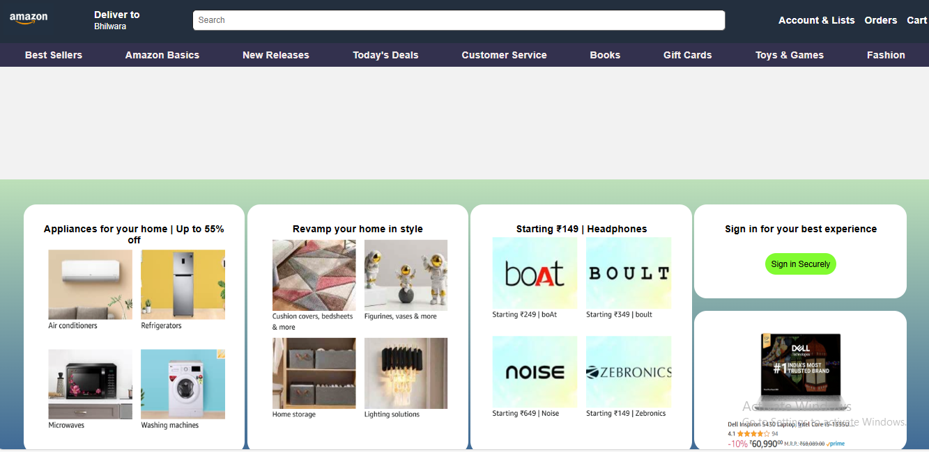

<!DOCTYPE html>
<html lang="en">

<head>
<meta charset="UTF-8">
<meta name="viewport" content="width=device-width, initial-scale=1.0">
<title>Shopping Website</title>
<style>
* {
margin: 0;
padding: 0;
box-sizing: border-box;
font-family: Arial, sans-serif;
}

body {
background-color: #f2f2f2;
}

.navbar {
background-color: #232f3e;
padding: 10px;
display: flex;
align-items: center;
justify-content: space-between;
color: white;

}

img {
height: 50px;
width: 80px;
}

.search-bar {
flex-grow: 0;
margin: 0 20px;
width: 850px;
display: flex;
justify-content: center;
}

.search-bar input {
width: 100%;
padding: 8px;
border-radius: 6px;
}

.nav-links {
display: flex;
gap: 15px;
}

.nav-links a {
color: white;
text-decoration: none;
font-weight: bold;
}

.categories {
background-color: #33314e;
display: flex;
justify-content: space-around;
padding: 10px;
}

.categories a {
text-decoration: none;
color: rgb(243, 235, 235);
font-weight: bold;
}

.main-section {
display: flex;
justify-content: space-around;
padding: 20px;
}

.box {
background: white;
padding: 30px;
width:25%;
text-align: center;
font-weight: bold;
border-radius: 20px;
}

.boxx {
background: white;
padding: 30px;
text-align: center;
height: 150px;
border-radius: 20px;
}

.boxx1 {
background: white;
padding: 30px;
text-align: center;
height: 225px;
border-radius: 20px;
}

.box img {
height: 300px;
width: 300px;
}

.boxx1 img {
height: 195px;
width: 240px;
}

.back {
background-image: url("https://images-eu.ssl-images-amazon.com/images/G/31/img18/HomeImprovement/harsmisc/2025/March/HMD/Starting_99_HI_3000x1200.CB547857789.jpg");
background-position: top;
background-size: cover;
padding: 90px 30px;
}

.backx {
background: linear-gradient(to bottom, #bde0b9, #325d92);
padding: 40px;
;
}

.btn {
background-color: #81fb30;
color: #060202;
padding: 10px 10px;
text-decoration: none;
font-size: 13px;
border-radius: 20px;
margin-top: 30px;
display: inline-block;
}

.flex {
display: flex;
flex-direction: column;
width: 24%;
gap: 5%;
}
</style>
</head>

<body>
<header class="navbar">
<div><img src="https://www.hatchwise.com/wp-content/uploads/2022/05/amazon-logo-1024x683.png-1.webp" alt="">
</div>
<div>
<pre><b>Deliver to</b></pre>
<small>Bhilwara</small>
</div>
<div class="search-bar">
<input type="text" placeholder="Search">
</div>
<div class="nav-links">
<a href="#">Account & Lists</a>
<a href="#">Orders</a>
<a href="#">Cart</a>
</div>
</header>
<nav class="categories">
<a href="#">Best Sellers</a>
<a href="#">Amazon Basics</a>
<a href="#">New Releases</a>
<a href="#">Today's Deals</a>
<a href="#">Customer Service</a>
<a href="#">Books</a>
<a href="#">Gift Cards</a>
<a href="#">Toys & Games</a>
<a href="#">Fashion</a>
</nav>

<section class="back"></section>
<section class="main-section backx">
<div class="box">
Appliances for your home | Up to 55% off
<br>
<img src="Screenshot 2025-03-19 234242.png" alt="">
</div>
<div class="box">
Revamp your home in style
<br>
<img src="Screenshot 2025-03-19 234301.png" alt="">
</div>
<div class="box">
Starting ₹149 | Headphones
<br>
<img src="Screenshot 2025-03-19 234309.png" alt="">
</div>
<div class="flex">
<div class="boxx">
<b>Sign in for your best experience</b>
<br>
<a href="" class="btn">Sign in Securely</a>
</div>
<div class="boxx1">
<img src="Screenshot 2025-03-20 002328.png" alt="">
</div>
</div>
</section>
</body>

</html>

