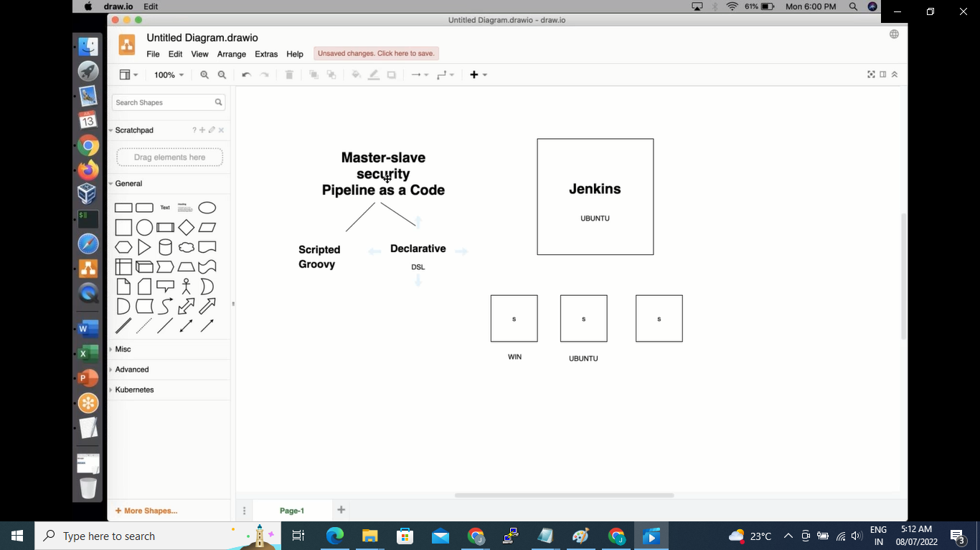http://ip172-18-0-45-cb45pks1d7o000fhok60-8081.direct.labs.play-with-docker.com/artifactory