**Design Database for Zen Class Programme**

**Create database**

use task

1 ) Creating users Collection:

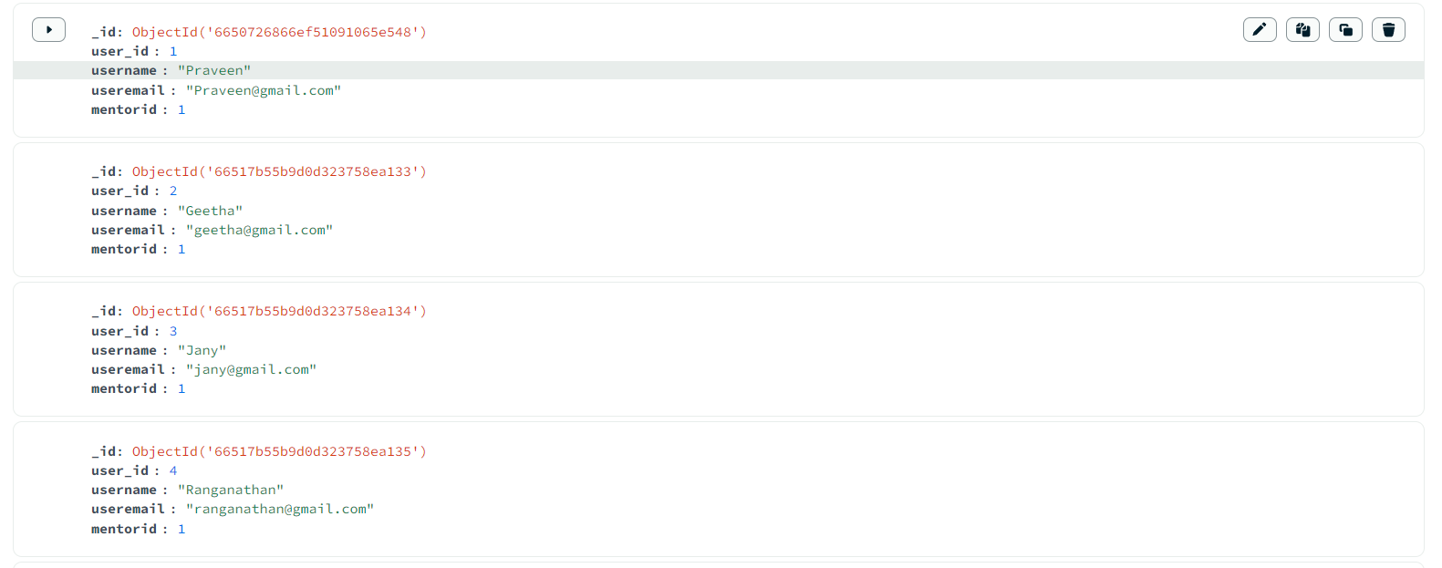

2 ) Creating code kata Collection:

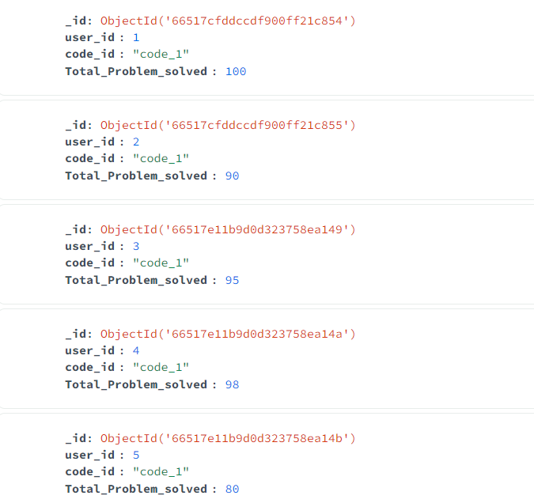

3 ) Creating attendance Collection:

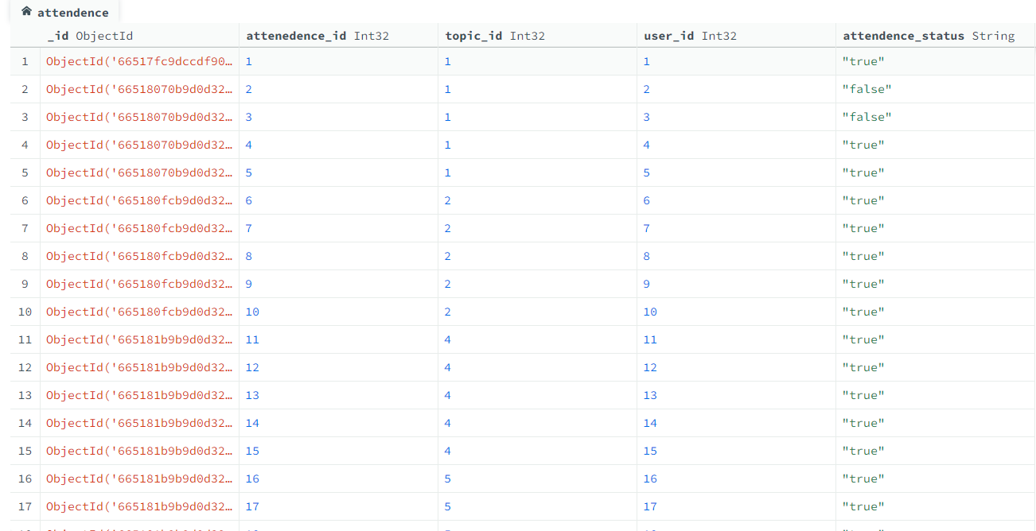

4 ) Creating topics Collection:

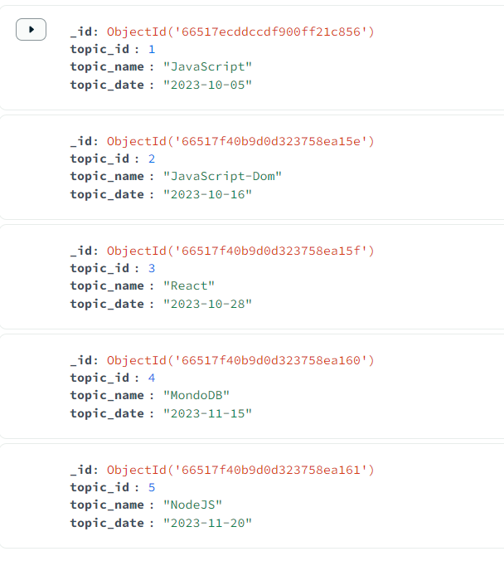

5 ) Creating tasks Collection:

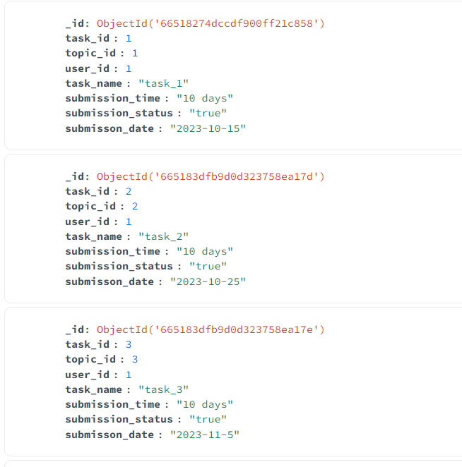

6 ) Creating company drives Collection:

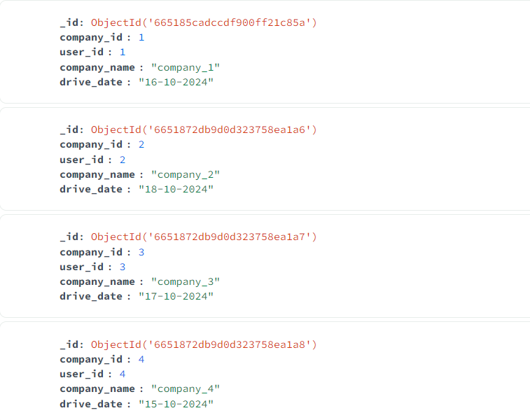

7 ) Creating mentors Collection:

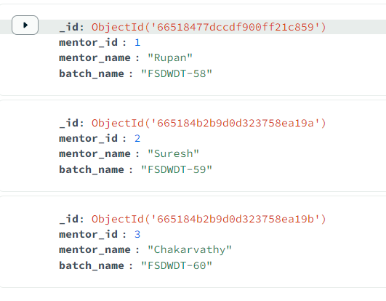

**Tasks :**

**1.** **Find all the topics and tasks which are thought in the month of October :**

**Solution :**

**db.topic.aggregate([**

**{**

**$lookup:{**

**from:'task',**

**localField:'topic_id',**

**foreignField:'topic_id',**

**as:'task_info'**

**}**

**},**

**{**

**$match:{**

**topic_date:{$regex:'2023-10'}**

**}**

**},**

**{**

**$unwind:'$task_info'**

**},**

**{**

**$project:{**

**_id:0,**

**topic_name:1,**

**topic_date:1,**

**User_ID:"$task_info.user_id",**

**Task_Name:"$task_info.task_name",**

**Submission_Date:"$task_info.submisson_date",**

**Submission_Time:"$task_info.submission_time",**

**Submission_Status:"$task_info.submission_status",**

**}**

**}**

**]**

**).toArray();**

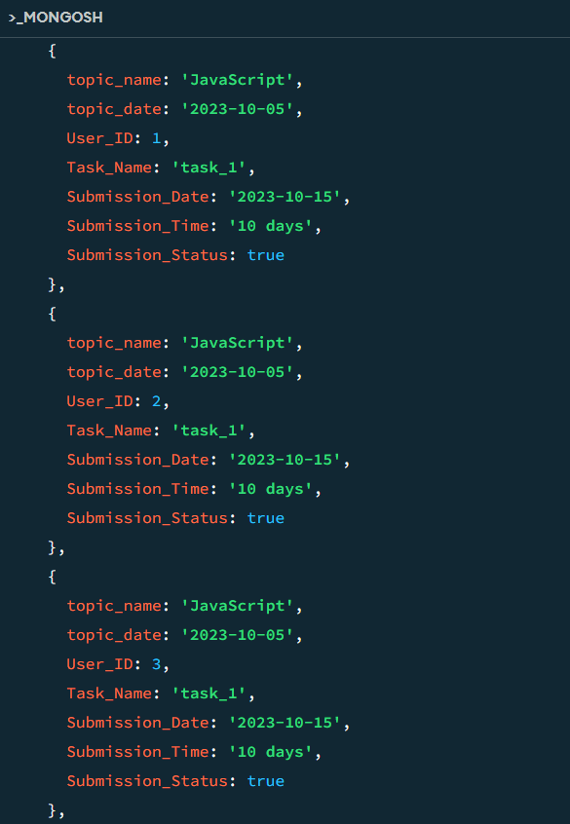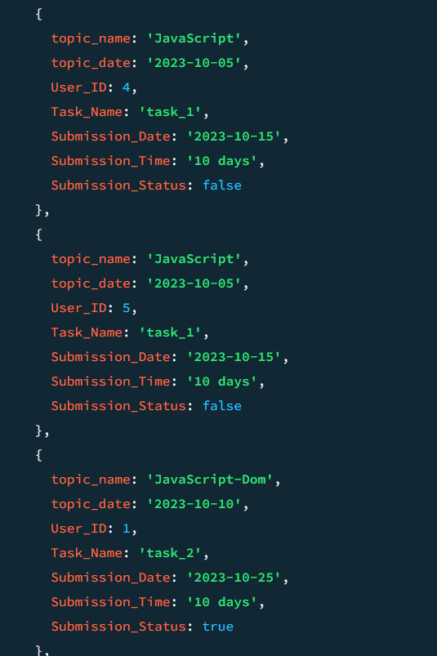

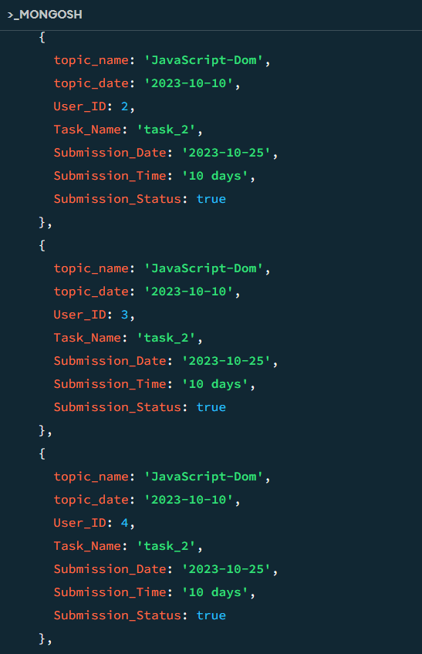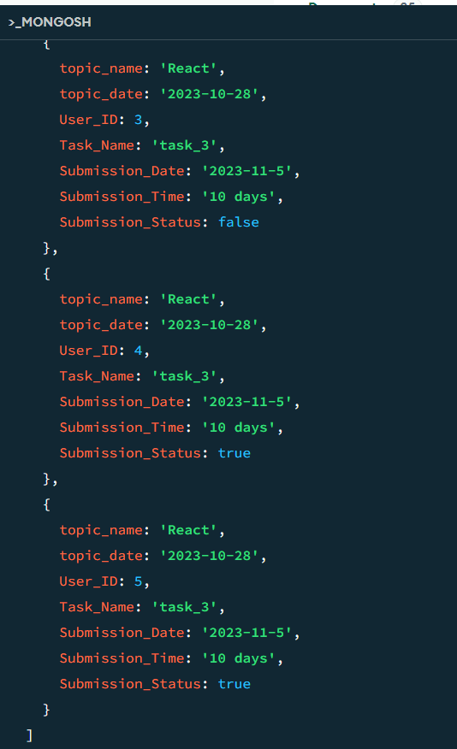

**2.** **Find all the company drives which appeared between 15 oct-2020 and 31-oct-2020 :**

**Solution :**

**db.company.find({**

**drive_date: {**

**$gte: '15-10-2024',**

**$lte: '31-10-2024'**

**}**

**});**

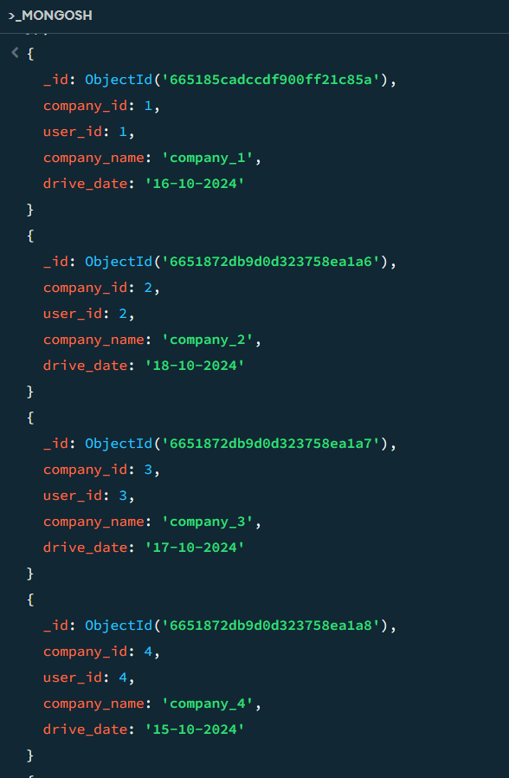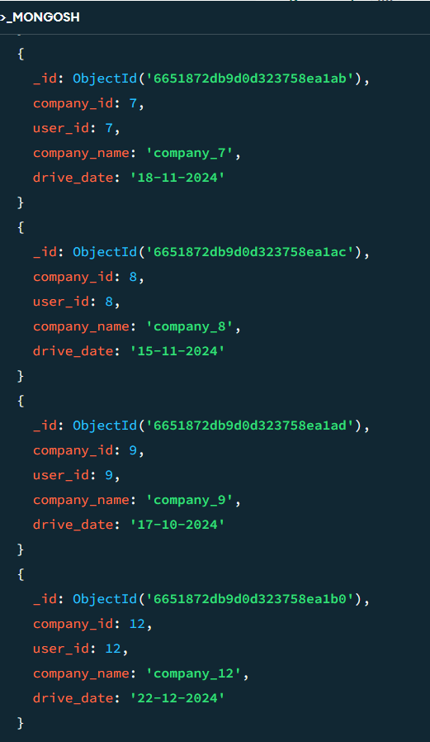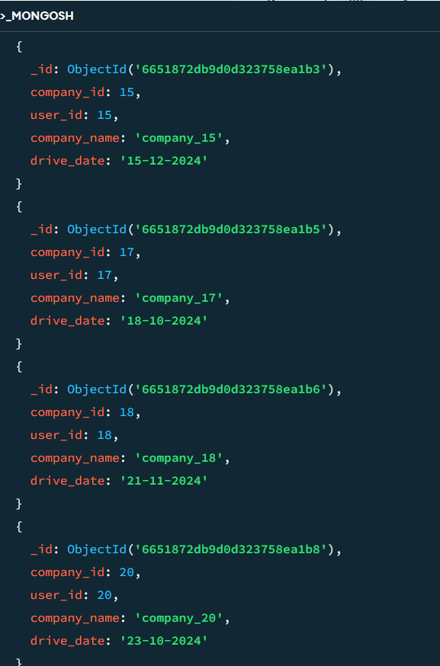

**3.** **Find all the company drives and students who are appeared for the placement :**

**Solution :**

**db.company.aggregate([**

**{**

**$lookup:{**

**from:'users',**

**localField:'user_id',**

**foreignField:'user_id',**

**as:'User_Companydrives'**

**}**

**},**

**{**

**$unwind:'$User_Companydrives'**

**},**

**{**

**$project:{**

**_id:0,**

**company_id:1,**

**company_name:1,**

**drive_date:1,**

**User_ID:'$User_Companydrives.user_id',**

**User_Name:'$User_Companydrives.username',**

**User_Email:'$User_Companydrives.useremail'**

**}**

**}**

**]).toArray();**

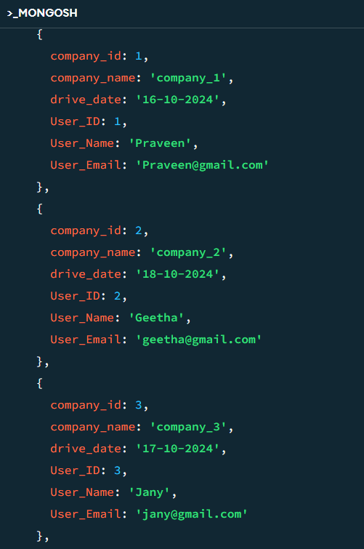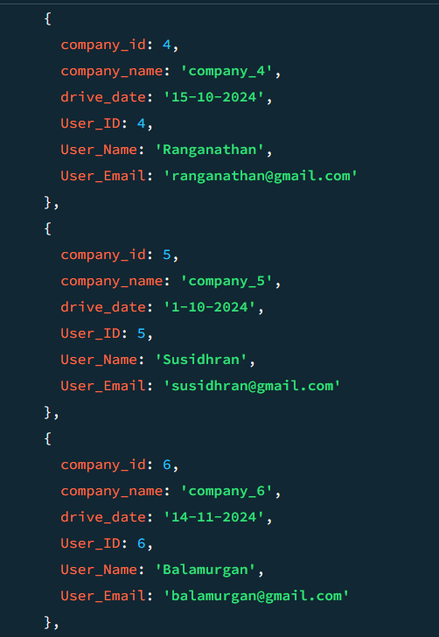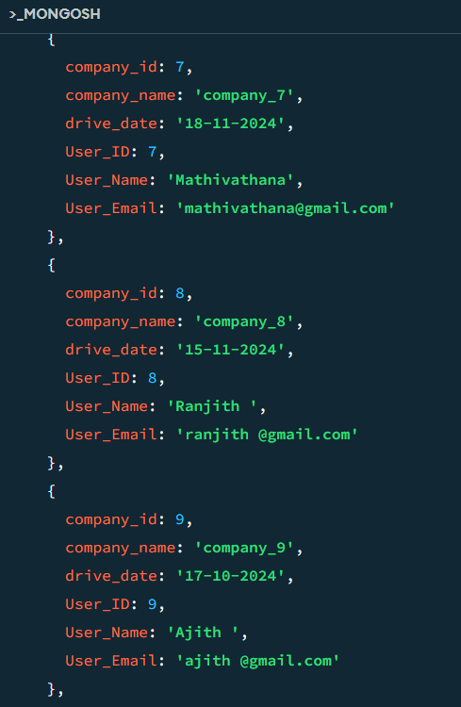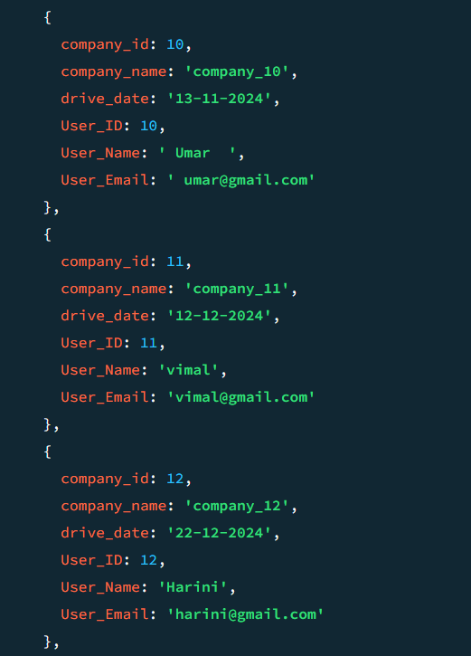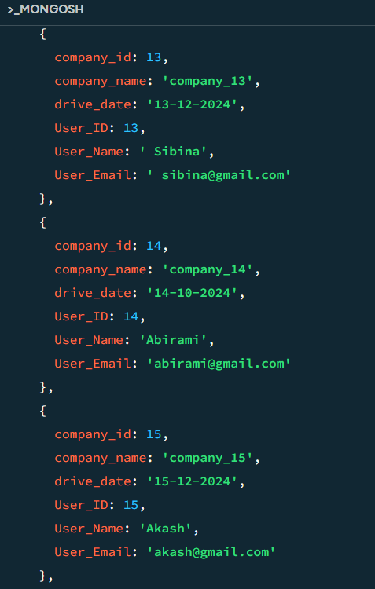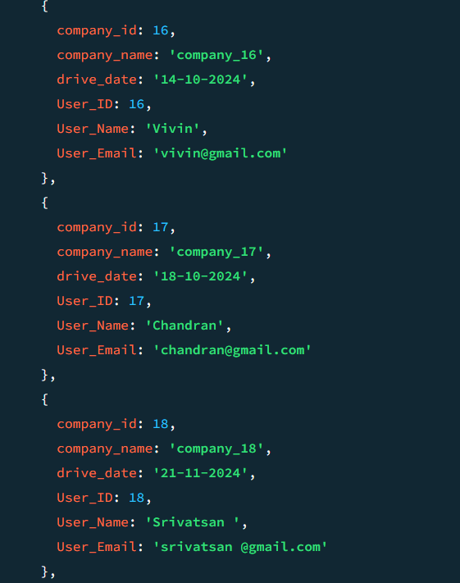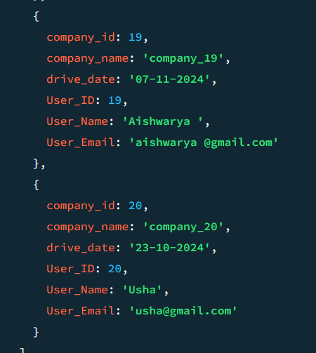

**4.** **Find the number of problems solved by the user in codekata :**

**Solution :**

**db.codekata.aggregate([**

**{**

**$lookup:{**

**from:'users',**

**localField:'user_id',**

**foreignField:'user_id',**

**as:'User_ProblemsSolved'**

**}**

**},**

**{**

**$unwind:'$User_ProblemsSolved'**

**},**

**{**

**$project:**

**{**

**_id:0,**

**code_id:1,**

**User_Name:'$User_ProblemsSolved.username',**

**User_Email:'$User_ProblemsSolved.useremail',**

**User_ID:'$User_ProblemsSolved.user_id',**

**Total_Problem_solved:1**

**}**

**}**

**]).toArray();**

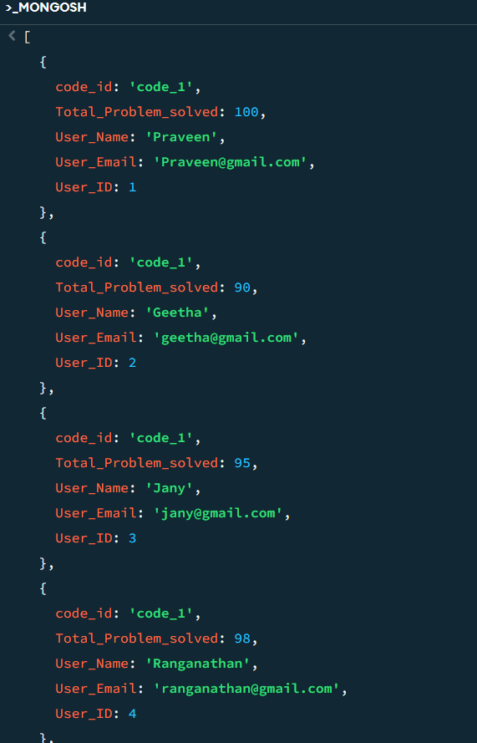

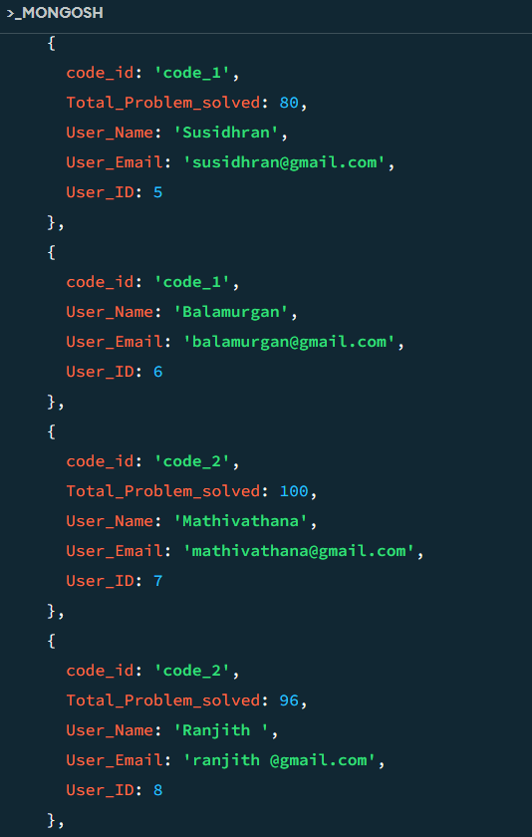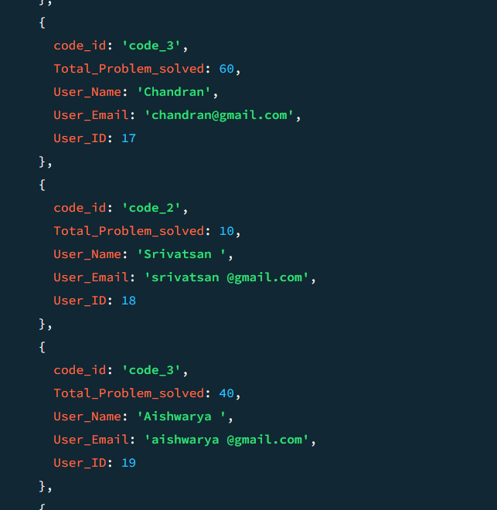

**5. Find all the mentors with who has the mentee's count more than 15 :**

**Solution :**

**db.mentors.aggregate([**

**{**

**$lookup:{**

**from:'users',**

**localField:'mentor_id',**

**foreignField:'mentorid',**

**as:'Mentee_Count'**

**}**

**},**

**{**

**$project:{count:{$size:'$Mentee_Count'},**

**_id:0,**

**mentor_name:1,**

**mentor_id:1**

**}**

**},**

**{**

**$match:{count:{$gt:15}}**

**}**

**]**

**);**

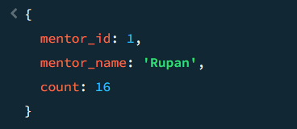

**6.** **Find the number of users who are absent and task is not submitted between 15 oct-2020 and 31-oct-2020 :**

**Solution :**

**db.attendence.aggregate([**

**{**

**$lookup:{**

**from:'topic',**

**localField:'topic_id',**

**foreignField:'topic_id',**

**as:'topics'**

**}**

**},**

**{**

**$lookup: {**

**from: 'task',**

**localField: 'user_id',**

**foreignField: 'user_id',**

**as: 'task-info'**

**}**

**},**

**{**

**$unwind:'$topics'**

**},**

**{**

**$unwind:'$task-info'**

**},**

**{**

**$match: {**

**attendence_status: 'false',**

**'topics.topic_date': {**

**$gte: '2023-10-15',**

**$lte: '2023-10-31'**

**}**

**}**

**},**

**{**

**$match: {**

**'task-info.submisson_date': {**

**$gte: '2023-10-15',**

**$lte: '2023-10-31'**

**},**

**'task-info.submission_status': 'false'**

**}**

**},**

**{**

**$project:{**

**_id:0,**

**user_id:1,**

**attendence_status:1,**

**Topic_id:"$topics.topic_id",**

**Topic_Name:"$topics.topic_name",**

**Topic_date:"$topics.topic_date",**

**Task_id:"$task-info.task_id",**

**Task_name:"$task-info.task_name",**

**Task_submission_status:"$task-info.submission_status"**

**}**

**}**

**]).toArray();**

